Simplicity is prerequisite for reliability

Edsger Dijkstra

Simplicity is the ultimate sophistication

Leonardo da Vinci

Branding
As an open source project, all software authorship and copy right statements must follow a strict branding requirement. The current project branding is to use “Ai-Fi” as the label for all related products and interfaces. It is easy to pronounce (Ai Fi, like in Wi-Fi or I-Fi), with Ai denoting AI under suitable context and Fi implying network or connectivity in general. Currently we own the domain Ai-Fi.net (unfortunately Ai-Fi.com is not available). The standard spelling is “Ai-Fi”. It may be adjusted according to specific application scenarios, e.g. “aifi” in the software as an indication of its relationship with the Ai-Fi service cloud.
Ai-Fi is also going to be “primarily” open sourced, with the standard “community open source” version and the separate “enterprise” version, which is fee-based with perhaps:
- cost- incurring shared VPN cloud
- Multi-tenant SaaS-like VPN administration
- Network management,
- Dual-factor Ai-Fi issued SSL client certificates
- TBD
The web site at https://www.Ai-Fi.net is for both the Ai-Fi web site and the entrance to the multi-tenant VPN management by the owning administrators, similar to the arrangement of https://www.salesforce.com.
Ai-Fi, inc.
爱法耐科技股份有限公司

Pay to Play Billing Support
TBD

Software Engineering
All published packages must offer “one-click” build and installation.
All implementations are to follow the standard software engineering process, including:
- Architectural specification
- Design spec
- Test spec, test program design and regression script (use libuv as a reference case)
- Code and code documentation review
Tools for publishing open sources and public web presentation are TBD.

Subsystems
There are three major requirements to be embodied in the Ai-Fi.net:
- Client/Cloud/Server architecture and protocols; Spines-based P2P connectivity with spines_lib on the clients, Babel/OpenR for routing, node.js thread with redis pub/sub for DB replication handling and Open Whisper for end-to-end encryption
- User account registration/sign-up and authentication involving:
  - User ID and password
  - An email account verified and confirmed
  - Mobile authentication (OTP or SMS verification code)
  - OAuth to services such as Google/Facebook/Twitter, etc.:
    - All levels of authentication are made available to the Ai-Fi.net users if desired, including U2F tokens
    - Ai-Fi.net implementation must be proven without the vulnerability reported by the paper: https://www.blackhat.com/docs/eu-16/materials/eu-16-Yang-Signing-Into-Billion-Mobile-Apps-Effortlessly-With-OAuth20-wp.pdf
  - U2F tokens supported natively by Ai-Fi.net.
  - A digital identity certificate with Wi-Fi.net as the PKI CA through user- submitted CSR with the private key owned and protected by the users themselves.
  - CAPCHA if U2F option not adopted by the user
  - IoT authentication and security requirements
  - Enterprise authentication through AD or LDAP, with SSO (https://www.youtube.com/watch?v=BdKmZ7mPNns)
- VPN configuration wizard:
  - Multi-tenant Saas architecture
  - JSON spec as the interface spec
  - Web server on every relay: working through redis DB local to the relays, on node JSON spec downloaded/locked on the central DB.
  - Chat Bot
- End-to-end Signal Messenger integrated, through Ai-Fi public key directory

Architecture
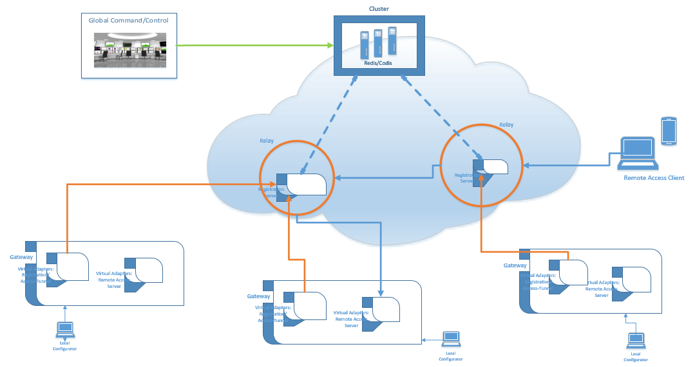

Packages
The Ai-Fi architecture consists of the following software packages:
- Cluster of redis servers (Codis)
- Network Management command/control server
- Relay servers
- Gateways
  - Windows
  - Linux
  - Other hardware (custom or proprietary)
, including software installation packages for the general public.
- Remote access client for the following platforms:
  - Windows
  - iOS
  - psAndroid
  - Mac OS
, including the highly critical client software installation packages.
- Brave browser for supporting WebPush and other privacy/performance enhancing functions
- Value-added services such as WebPush, Dropbox, RE, privacy protecting cover traffic, etc.
- One-click open source packages for the community version.
- www.ai-fi.net web site design and implementation

Ai-Fi Time Service
Ai-Fi provides a global NTP service sourced from the same outlet at the CBASE Central site. All Ai-Fi servers, including relays and registered gateways and remote clients, are to synchronize with the system-wide NTP time.
On the other hand, for any GUI interacting with Ai-Fi servers the displayed time is that local to the viewing administrator unless otherwise specified.

CBASE Central (Database and Cloud Global Service)

Management Configuration
The CBASE is a redis-based data store maintained at central.ai-fi.net as a non-stop cluster with replication for global distribution. Each relay in the network core retrieves the relevant configuration data from CBASE in order to maintain their relay function. The information retrieved by the relay is maintained as a real-time cache by the redis client. The freshness of the cache is preserved by a combination of periodical updates (pull) and real-time push by the CBASE as update change notification. Effectively all the configuration information maintained at relays constitutes a read-only and up-to-date local CBASE copy.
Disaster recovery and performance issues of cross-continent access to CBASE is TBD
The data store contains both configuration definitions and real-time status of various network elements as follows:
- VPN configuration database, including mostly those specified by subscribing users or enterprises as owners of individual VPNs, for their gateways and remote access clients, including the latest software versions of relays, gateways, and remote clients.
- Network core configuration database, including all the relays, inter-relay overlay links, subnet redistribution filters, software version number, etc., managed only by CBASE administrators.
- Real time network management notification: This includes the up/down status of the relays, list of registered gateways with their assigned access sockets, etc. This is also responsible for refreshing the cached configuration data maintained on all the relays, implemented based on the redis Pub/Sub mechanism which ties various online network statuses (VPN configuration changes, link up/down, relay up/down, various RTTs, etc.) with redis channels so that those relay cache affected by the changes may be brought up to date.
- Relay list
- Log entry stores for additional network management information streaming and analytics.
The management of the CBASE is through a web interface to a CBASE server at where the CBASE is physically located. The CBASE VPN configuration is designed as a SaaS-like multi-tenant network management system with each VPN administrated only by its owners.

Relay List
To support the gateways and remote clients on the edge of the Ai-Fi core, particularly at the time when they first come up, a list of all candidate relays is required to bootstrap them and the follow-on RTT sampling with switch-over option. This is the only piece of information which is retrievable outside of the ai-fi core. All other CBASE retrievals are proxyed through the relays for optimized performance by taking advantage of the ai-fi core.
For scalability CBASE offers only a subset of those relays specific to the requester’s geographical location. CBASE is responsible to filter the list to exclude any “offline” relays.

Configuration

Base Address Plan
There are a few options for the base address plan for a particular VPN to adopt:
- It is all closed in and does not allow Internet access. In this case all addresses are allowed.
- Internet access is allowed. There are several options:
  - Follow the standard address assignment standard, with private addresses restricted to those allocated by IANA such as 10.0.0.0/8, 172.16.0.0/12 and 192.168.0.0/16.
  - List all allowed public Internet address ranges, with or without the Ai-Fi Global Services.
Each relay may elect to redistribute some public Internet addresses with measured RTT as the basis for its metric setting.
Each relay has an option switch for allowing Internet traffic or not.
Consistent with this approach to Internet access, all relays or at least those assigned with the task to seed the Ai-Fi cloud as start-up relays are to redistribute their connectivity to the Central with either assigned metric or measured RTT as the basis for their metric to the Central, which is where the Ai-Fi cloud configuration resides. The Ai-Fi overlay of relays bootstraps from those which have direct access to Central and grow the overlay from those seed relays gradually.
Each relay must own a relay certificate as part of the Ai-Fi cloud and an ID consistent with what is on the certificate in order to be part of the cloud.

Ai-Fi Global Services
A participating VPN of the Ai-Fi network services operates in their own private IPv4 address space isolated from all other VPNs even though the same Ai-Fi network core is shared by all. However, in order to take advantage of those Ai-Fi services, a set of addresses in the base plan is reserved to support those shared services, such as:
- The CBASE Central
- Ai-Fi Secure Email
- Ai-Fi Private Messenger
- Private and Accelerated Web Access
Each of the above services requires static public addresses, which are to be isolated from all subscribing VPNs as reserved subnets or IP addresses of the offered services are to be subscribed.

Locally Configured for Remote Access Client
- central.ai-fi.net: The domain name for where the central server is.
- Time zone
- VPN ID
- Target Branch ID
- Login credentials (certificate)
- Log repository

Locally Configured for Branch Gateway
- central.ai-fi.net: The domain name of where the central server is
- Time zone
- VPN ID
- Local Branch ID
- Login credentials (certificate)
- Local network interfaces
- Local log repository

Centrally configured (CBASE)
- Relay RTT sampling frequency
- Maximum relay discovery size (in terms of number of relays)

Centrally configured for Relays
- TBD

Centrally configured for each VPN
See Appendix A for details.
- Administrator list
- Gateway list, each entry configured with:
  - Subnet list with ACL (allowed administrator, ingress subnet filters, etc.)
  - Virtual remote access subnets (DHCP) assignment
  - Remote access client list, each client configured with:
    - Allowed subnets
  - Log repository option: Gateway-local/Ai-Fi Cloud/None

CBASE Central

Redis Database
This is the network management system as the command/control center of the whole Ai-Fi cloud based on the CBASE central database implemented through redis/codis. It also supports various network analytics and re-configurator based on streaming inputs by reports of congestion, link outages, gateway up/down, relay up/down, etc. The network management system is built in as a functional component, mainly GUI, with the CBASE management system and is an integral part of the complete cloud management infrastructure.
One of the design goals is to maintain minimal amount of persistent data on relays, gateways and remote clients, sufficient to bootstrap their respective running software by retrieving most required configuration data from the CBASE.
The preferred redis API to CBASE is node_redis.

CBASE Schema

User DB
All the users ever registered for an Ai-Fi.net account owns their user id created during the registration process. Once created, those accounts will never be deleted until the clean-up time when de-registered accounts and “expired due to inactivity” accounts are clean up. An expired account would lose its user id but not its historical tracks, such as its position in some ACL list. An expired account and those newer accounts re-using the same user id are distinguished through it internal serial number, which is a 64-bit number that is guaranteed to never recycled in, say, 100 years.
The user DB is maintained separately from the subnet/routing related configuration (VPN DB). This makes the editing of VPN DB simpler when the editing session is completed without the worry of non-existing users when the VPN DB is written back to the CBASE. An “expired” or “de-commissioned” account with the same user id can be discovered by comparing its internal serial numbers. This makes the authentication and authorization task unambiguous.
When a user logs in, their account is checked against the newest active account. Expired account is considered invalid.

VPN configuration

Configuration Lock
For the sake of simplicity, the updating of CBASE data relative to a specific VPN doesn’t allows concurrency. There is at most one update session of the configuration database going on at any one time. This is to utilize the distributed RedLock mechanism supported by Redis.

User IDs
User IDs are global. For simplicity, when a VPN is locked for maintenance, a snapshot of all involved users or admins is taken, which will be acted on during the maintenance session. At the end of the session, all involved user IDs are checked for possible removal/expiration while the session was going on. Only removals of users are taken care of. The logic is based on an internal 64-bit ID for each user. The primary user ID and its associated internal ID must be the same to be considered identical.
The internal ID starts out at 0, and is assumed large enough without the risk of ever wrapping around.
The redis hash designed for User record is:
- Primary ID (any character string of legal characters, allowing space)
- iSerial
- Password hash
- Public PKI certificate
- Email address
- Phone number
- Public certificate
- Elected authentication policy and the associated credential verification history (TBD)

Relays

CBASE Cache
A relay supports node_redis, a redis client in node.js, for getting all relevant CBASE data cached locally at its resident relay and reporting the real-time status of various elements registered locally. This redis cache is a partial view of the CBASE, covering only local components and supporting various registrations and routing logic. A sufficient amount of memory resources are supplied for each relay so that almost all read accesses to the CBASE are found in the local cache except perhaps the first time.
Since the CBASE is a database also designed to reflect ever-changing real-time status of various components in the whole Ai-Fi cloud, the local cache at the relay utilizes the redis pub/sub mechanism to maintain its freshness and consistency with the CBASE.

Routing Service
The following components have Ai-Fi addressability:
- A host in a branch, accessible through one of the successfully registered branch’s gateways.
- A remote access client
- All public Internet sites, subject to the ACL filtering, through either a gateway or a relay directly.
Babel is selected as the dynamic routing service for the following reasons:
- We don’t expect to grow to more than 1000 relays in the initial phase
- Although not planned for the initial phase, Ai-Fi expects to provide dynamic routing with adjustment based on the ever changing RTT measurement, which make the link status to fluctuate frequently that will impact the link status.
Babel supports dual stacks for both IPv6 and IPv4. For relay to relay routing, the IPv6 routes are expected to be utilized. For remote access tunnels, IPv4 routing based on access socket (Spines socket/port) is planned.

Access Sockets and the Tunnel
To utilize the shared Ai-Fi core, the gateway or the remote client requires a Spines socket (access socket) in order to be reachable through Spines, as the gateways and RA clients have no public IP addresses. The connection from the gateway or the remote client to the relay where its access socket resides is supported through an access tunnel, which is a simple SSL tunnel with virtual adapter on both ends. For the first release, this access tunnel runs TCP with perhaps a one-way BBR as an option. There are several TCP connections maintained through this access tunnel per Spines sessions.

Support for Relay Selection Process
Relays are the conduits employed by edge components (branch gateways and remote access clients) in their accessing to the shared network core. Those edge components first select the appropriate relay based on certain selection criteria such as administrative control, services subscribed, latency, QoS, etc. before initiating the registration process with the selected relay. Relays support the selection process by answering the following queries:
- RTT pings (not necessarily ICMP) from edge components
- Core overlay link parameters and performance sampling data
- TBD

Registration Service
Both the gateways and remote access clients are required to register themselves to a selected relay before their normal operation, due to the following requirements:
- The registering agents (gateways and remote access clients) must be authenticated before their authorization to various modes of access.
- The gateway announces its presence as a conduit to those subnets configured globally.
- Remote access clients acquire the tunnels to their destined branch.
The authentication requirements are documented in the Appendix.
A successful registration sets up the data passing framework for the follow-on data traffic.
Architecturally the registration service is supported by two separate subsystems:
- CBASE proxy: This is implemented in Node.js, due to the lack of redis client support on Windows (which is not necessary for our implementation as all the gateways/remote-access-clients are not directly interacting with redis. However, for ease of testability, we adopt Node.js instead of only running Hiredis on relays.)
- Ai-Fi routing and filtering: This is to accept the subnet configurations and filtering rules for individual registered gateways supplied by the CBASE proxy in order to carry out the routing/forwarding and filtering functions of the relay. The bulk of the registration is CBASE related and therefore delegated to the CBASE proxy. The interface to CBASE proxy is message based.

Gateway Registration

Events
Access session/tunnel up/down is monitored by a continuous keep-alive handshakes.
The following events are handled:
- Gateway registration request:
  - Request to CBASE proxy, expecting a “cascaded” returns:
    - Subnet specifications (for route redistribution)
    - Traffic filters.
    - Remote access TBD.
    - Registration to CBASE proxy Status return
  - Response to gateway registration request, reacting to the conclusion of the abovementioned cascaded returns.
- Gateway CBASE channel notification (from local CBASE proxy):
  - Gateway subnet configuration changes:
- Subnet addition: Redistribute the new subnet specification
- Subnet removal: Remove the subnet specification from the redistribution list
- Modification to ingress filters: Apply the changes.
- Modification to egress filters: Apply the changes.
- Software upgrade command
- Announcement to relays
- Announcement to registered gateways
- Announcement to registered remote clients for a specific VPN
- Gateway access session/tunnel down
  - Remove all subnet redistribution entries
- Gateway access session/tunnel up
- Outgoing traffic from gateway
  - Check against egress filters
- Incoming traffic to gateway
  - Check against ingress filters, sound alarm if violation discovered. This is the indication of an attack originated externally, as the outgoing traffic from other branches has all been filtered already.

Request to redis CBASE Proxy
{
“RequestID”: “GTW_REGISTRATION”,
“VPNID”: “abc”,
“BranchID”: “shanghai1”
}
, where BranchID is what is recorded on the ID certificate of the gateway.
It returns either an error code or OK, in which case the response is as follows:
{
“RStatus”: “OK”,
“Subnets”: [
“10.9.0.0/16”,
“10.97.0.0/16”
],
// filters TBD
“RemoteDHCPAlloc”: [
“10.99.0.0/16”
],
}

Errors include:
- VPNID not defined
- Not a valid BranchID
- Duplicated BranchID

Remote Access Client Registration Request
{
“RequestID”: “RA_REGISTRATION”,
“VPNID”: “abc”,
“BranchID”: “shanghai1”,
“RUserID”: “J Smith”
}
, where BranchID is what is recorded on the client certificate.
It returns either an error code or OK, in which case the response is as follows:
{
“RStatus”: “OK”,
“GatewayID”: “10.9.0.254”,
“Port”: 40039
}
, where the GatewayID and Port identify the access socket of the remote gateway application attached to the remote access VTUN.
Errors include:
- VPNID not defined
- Not a valid BranchID
- Branch not online
- Client not authorized for remote access

Subsequent to a successful login the relay contacts the Remote Access Server at the remote gateway through the returned access socket for the following:
{
“RequestID”: “RA_LOGIN”,
“VPNID”: “abc”,
“BranchID”: “shanghai1”,
“RUserID”: “J Smith”
}
Note that this request is proxied through the relay for security reasons.
A successful return is as follows:
{
“RStatus”: “OK”,
“AllocIP”: “10.9.0.0”,
}

Remote Access Client Login Request
TBD.

Gateways

Registration Client and VTUN Tunneling into the Ai-Fi Cloud
Each gateway has a simple UI for locally defined parameters as defined previously, based on which the gateway may be authenticated and establish its identity in its appropriate VPN. All other additional parameters such as redundancy configuration, configured subnets, access filtering, etc. are managed through the relay it registers to.
A gateway has no direct access to the CBASE. All data storage and retrieval requirements are proxyed and translated via the relay. Those status logs recorded locally prior to the registration to the elected relay are kept initially locally. After the successful registration the accumulated “off line” logs, if any, are then delivered to the relay for their final disposition.
The issues of maintaining a single database across the globe are TBD.

Remote Access Server
This is the component responsible for answering access request from a remote access client. It is assisted by the DHCP service for allocating addresses on the virtual remote access LAN for the requesting client. It maintains an access socket on the relay where the gateway is registered to, the ID of which is recorded in the CBASE.

Remote Access Client

Requirements
The function of a remote access client covers the following:
- Enter and collects the client identity-related information in preparation for authentication including the entry of user id, password and the mandatary SSL client certificate issued by Ai-Fi.
- Multi-factor authentication, including user-name/password confirmed by SSL certificate, verification through text messages, fingerprint on supported platforms. This is highly critical as the privacy and security is the main design goals.
- Collects other operational parameters such as reconnect-option, system start-up initialization option, target VPN and branch, etc.
- Carries out the registration process, creates the VTUN for intercepting remote traffic and adjusts the local route map in order to access the specified remote destination gateway
- Presents the relay list which is made accessible to the client. The relay may be automatically selected for the registering or registered client, or alternatively as an option manually selectable by the client himself.
- Preferably adopts React Active so all UI’ versions
Ai-Fi offers appropriate protection of those locally collected authentication parameters against popular security attacks (TBD).

GUI
The client GUI on various platforms is designed to present an Ai-Fi on/off switch with settings for sign-in credentials and destination gateway address. Since there are multiple relays to select from, regardless of whether the selection can be automated or not, the main GUI emulates the standard Wi-Fi control panel from various platforms and presents the relay list as outlined below:

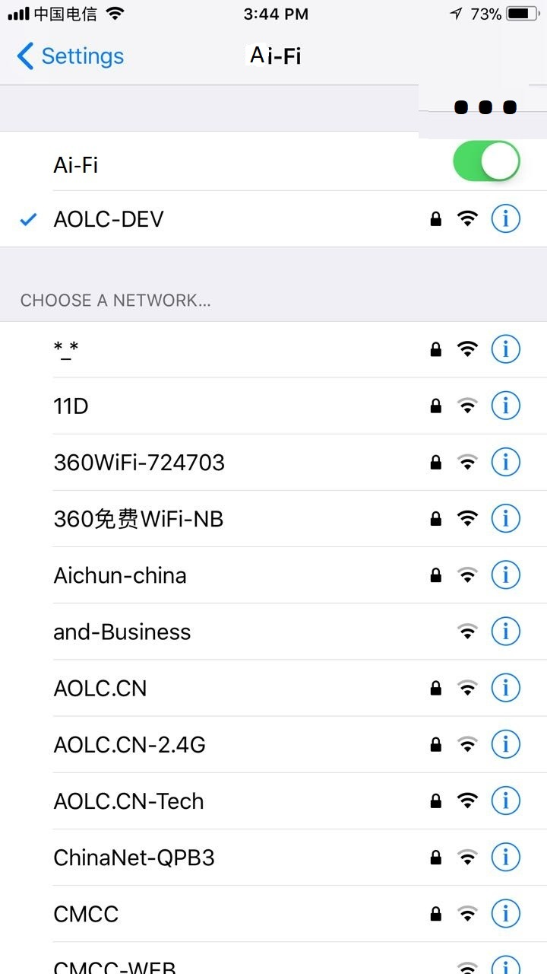

The style of the GUI must be made consistent with the running platform. Instead of the “signal strength” as displayed in the above example, the list of accessible relays may be arranged in the ascending order of each relay’s confirmed RTTs with their numeric values displayed. As the sampling results from various relays fluctuate ceaselessly, much like the situation in the sampling the signal strength for Wi-Fi Aps, the Ai-Fi GUI can simply emulate its Wi-Fi counterpart.
The upper right corner has a settings icon for launching the settings menu for entering the following:
- Customer/Enterprise ID (or VPN ID): This is selected during sign-up.
- Destination Gateway ID: Entry for the destination gateway to log into. This may be implied by entering a valid IPv4 address, which will be located by the relay
- Administrator ID: email address is assumed and must be verified for a successful sign-up.
- Login credentials: for entering/managing SSL certificate, such as certificate location
- Auto Reconnect option
The support for the following platforms is planned:
- iOS
- Android
- Windows
- Mac

Relay Sampling
Typedef struct dummy_relay_sample {
Node_ID RelayID;
Int rtt_weighted;
Int rtt_raw;
} relay_sample;

STATUS RelaySampling(int &RelayCount, struct relay_sample *r);
This returns an array of relay RTT structure up to the maximum of RelayCount as inputted. The pointer r points to a pre-allocated storage for returning the array of relay RTT sample structures. The actual number of array entries is returned through the same RelayCount.
It is assumed that a background process or thread is carrying out a continuous process in acquiring the list of active relays relevant to the current instance of the client. The original list came from the CBASE maintained at a central site. This background process is configurable in terms of the sampling frequency, sampling logic, sample sizes based on the configured relay list, etc.

Access Tunnel as Spines Session
Client maintains a Spines session with the elected relay, including the following persistent tunnels:
- Session identification tunnel, a TCP connection
- Access tunnel, either in UDP or TCP: This is to maintain both the data traffic and in-band control traffic.
spines_lib.cpp is adopted to create these tunnels. spines_lib will be streamlined to retain only those functions adopted by Ai-Fi. For the first release we may opt to support only TCP sessions with the relay supporting BBR along the delivery direction to the gateway.
Both session tunnels are to be protected by SSL or DTLS (not currently supported by Spines).
Spines controls are extended to include Ai-Fi registration commands and the keep-alive required in maintaining the tunnel states and up/down events. The Ai-Fi extension is as follows:
// spines_lib() is to be extended to support SSL
ret = aifi_get_rlist(rlist_array);
ret = aifi_init(rlist_array[selected], VPN-ID, gw_credentials,subnetlist);
// spines_init() implied
// subnet as char strings in CIDR format
AifiSocket = aifi_socket();
// spines_socket() implied, with additional aifi
// registration logic;
// relay-addr, type, protocol both use defaults
// use spines_sendto() for sending data
// use spines_recvfrom() for receiving data (datagrams)

The gateway to gateway logic can be tested from a remote client pretending as a gateway with the local IP as a single host subnet and additional subnet descriptors if "internet sharing" allowed

Client Flow
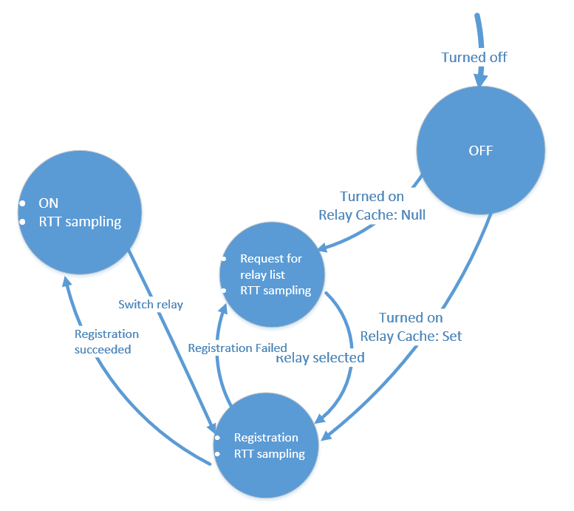
RTT sampling is running in the background, subject to the limitation of power consumptions on mobile units. The GUI starts out using the cached relay value as the default registration proxy. It is replaceable by a “better” relay based on the measurement of RTT and some switch-over criteria, perhaps involving some hysteresis consideration, when a new candidate relay is deemed a better option based on various selection criteria.

Relay List Manager
This is delegated to periodically collect relay list and sample the RTT on those on the list. It services the query request and triggers RELAY_RESELECT event.

VTUN Manager

UI
It triggers the following events:
- Turning ON/OFF: Terminate all active (registration) processes when OFF. Start the registration when first turned ON.
- RELAY_RESELECT
- ACCOUNT_SWITCH: account id, password, VPN ID, branch ID. This is handled as a session. The changes take effect when “SAVE” is pressed, at which time the system is put to the OFF state with a new registration session starting.
- REGISTRATION_SUCCEEDED: The system should be in the OFF state while the registration process is going on. This event brings the system from OFF to ON.

Logs

Format
Log entries are in JSON format, with JSON object names “timestamp”, “SourceID”, “address”, “severity”, “type” and “id” as required and other optional objects that vary per specified “id”. Most significant log entries are list below, with the “timestamp” and “id” omitted:

Gateway Log Entry Type: “configuration”
- “Subnet Configuration:”
  - “severity”: “informational”
  - “id”: nnn
  - Array of CIDRs
- “Source address not part of the allowed subnet list:”
  - “severity”: “violation”
  - Array of addresses

General Req/Rsp Format

Request: Daemon to DBProxy
As a convention, requests/responses to/from DBProxy are in text format, sometimes structured as JSON.
This category of interfaces to/from DBProxy is in the following format:
// Req: topic, code, m0, ...
// Rsp: topic, rcode, sess_id, m0, ...
// if rcode < 0, failure occurred, in which case rcode is followed by err string
Request:
- Req code, used as the Topic for DBProxy to ZMQ-subscribe to.
- ID per request, such as session ID for session related requests or log ID for logging requests
- Parameter array
Response:
- Code: used to indicate the original request if it is a response, or some identification of the type of “response” if not originally prompted by requests
- Status code: code reflecting the execution outcome for the original request, or 0 otherwise. Error if negative.
- ID per the response: for instance, session id if this is prompted by a session request.
- Parameter array: returning requested data, or error texts if an error was returned./

Address Plans for Network Management and Web Acceleration
For scalability reasons, the relays and gateways are on two separate routing plans. A protocol conversion takes place when the network traffic needs to get through the shared cloud to reach other gateways involving multiple relays.
For network management local to a particular VPN, as all hosts in the same VPN are directly reachable end to end, there is no problem in managing any hosts or servers from a central network manager using the VPN-specific IPv4 addresses. Notice that a gateway must have a private address specific to the VPN to which it belongs. For a gateway belonging to multiple VPNs, it is reachable from within any one of those encompassing VPNs.
For global network management, a specific “global NM” VPN is defined such that all gateways are assigned with addresses specific to the global NM address plan. This global NM VPN may offer addresses to any hosts or servers requiring addressability from within the special global NM VPN (e.g. Observium polling)

Appendix

Authentication

SSL Client Certificate
Both Ai-Fi signed client certificates and those from the third-party AC are supported.
On remote access client, a client-id/password and the one-time-valid, dynamic passcode pushed to mobile handsets are also supported as the second factor in login protection.

Data Traffic Passing
Please see the document titled: Traffic Passing.xlsx

Branch Gateway CBASE specification
All configuration information belonging to a particular VPN is maintained in a few JSON structures. For simplicity, the administrative functions, namely changes to those structures, are performed in a single reconfiguration session, created per the request by the administrator. All relevant JSON structures are downloaded to the web client and administrative specifications are modified within the session until they are completed, in which case the VPN configuration is then uploaded back to the CBASE. There is only one administrative session allowed to be active at any one time, protected by a redis “lock” (TBD) mechanism on the VPN configuration database.
All changes made to the VPN configuration are to be “pushed” to all the relays where the changes may have impacts.
To guarantee the consistency of the configuration, in addition to the measure of applying the changes pushed in, a periodic refresh of configuration database is carried out by the relay and potential discrepancies are checked and handled.
The important configuration data structures are listed below:

VPN
{
“VPNID”: “abc”,
“Branches”: [
{ “BranchID”: “shanghai1”,
“AdminList”: [
“Mike Bender”,
“Jean Smith”,
“Ed Wesley”
],
“Subnets”: [
“10.9.0.0/16”,
“10.97.0.0/16”
],
“RemoteDHCPAlloc”: [
“10.99.0.0/16”
],
“RemoteClients”: “remote-client-list:Shanghai1”
},
{ “BranchID”: “Boston”,
“AdminList”: [
“Mike Bender”,
“Jean Smith”
],
“Subnets”: [
“1.1.0.0/16”,
“1.2.0.0/16”
],
“RemoteDHCPAlloc”: [
“10.254.0.0/16”
],
“RemoteClients”: “remote-client-list:Boston”
}
],
“//”: “end of Branches”
}

The general approach to update the database through GUI for a particular VPN is to write-lock the VPN database and takes a snapshot of it to make offline edits until done. Use “sunionstore” to copy various sets through a pipeline. There is no need for transaction as the database is locked at the outset. It may involve retrieving all the branches and executing a “for” loop over all those branches.
Alternatively:
- Keep the database for a VPN in JSON format and maintain it in the central database.
- When needed, replicate the content of the JSON data in the relay and expand it for ease of retrieving useful information and for configuration editing session.
- At the relay when notified that the VPN database is out of date, delete the local copy and reload the database.

Relay: Spines Server

GW Registration
Parameters:
- Command code
- VPNId: 24-bit number
- BranchId: text string up to 16-character
- GatewayId: text string up to 16-charcter. A gateway may redistribute a subset of the subnets assigned to a specific BranchId. The first GatewayId defaults to BranchId if not otherwise specified.
- Make sure the VPNId/BranchId/GatewayId is supported by the gateway certificate retrieved through the SSL session.
- Make sure it is not already registered (duplicate found) locally
- If branch configuration data not in the cache, send request to DB proxy until responded. Included in the returned configuration data:
  - Count followed by subnet descriptors: Redistribute
  - Count followed by remote access address range, if allowed and configured: Assign a local access socket for the RA server on the requesting gateway
- Store both the VPN and branch admin lists if resources available
- Return registration status to the requesting gateway with.
  - RA virtual address ranges
  - RA access socket assignment

RA Registration
Parameters:
- Command code
- DestinationVPNId/DestinationBranchId
- ClientId/PwdHash
- Make sure the VPNId/BranchId/ ClientId is supported by the gateway certificate retrieved through the SSL session. If authenticated by a SSL certificate, send request to DB proxy for:
  - Second factor username/pwdhash authentication.
  - Make sure the client is not already registered (duplicate found)
- Make sure if the destination branch is online and locate the 2nd relay
- Send request to the 2nd relay (which agent ??) where the destination branch is registered to for the RA access socket of the destination branch.
- Return registration status to the requesting RA client with:
  - Destination relay ID and Spines port: RA access socket of the destination RA server

RA Remote Socket Inquiry
This is the request by the 1st relay looking for the access socket of a registered gateway with parameters:
- Command code
- DestinationVPNId
- DestinationBranchId
- TBD

Relay: DB Proxy
Locally managed:
- Sub-messaging for DB changes affecting registered gateways
- Sub-messaging for DB changes affecting registered RA clients
- Sub-messaging for other push services:
  - Software updates
  - Notification to local relay
  - Notification to gateways registered locally
  - Notification to RA clients registered locally
- Log services

Gateway Registration
- Inputs: VPNId/BranchId/GatewayId
- Outputs: subnet descriptors/RA address range
- Error: Gateway already registered.

RA Client Registration
- Inputs: DestinationVPNId/DestinationBranchId/ClientId/PwdHash
- Outputs: TBD
- Error: Incorrect RA client password
- Error: RA Client already registered

Remote Access Client
Note that there may be multiple VPNs defined for the same branch gateway for the extranet use case, which is not shown above.
All subnets belonging to the same VPN must not overlap, including those allocated to RemtoeDHCPAlloc.
RemtoeDHCPAlloc is local to the branch, therefore allows duplicating with other RemtoeDHCPAlloc specification.
All remote clients are listed in remote-client-list.
As a security measure each client in the remote-client-list may be further restricted only to a set of allowed subnets.

The relay subscribes to all channels of those branches registered locally, such as abc:shanghai1 and abc:Boston depicted in the example, which signals changes to any branch configuration. The publisher would push the changes in the “delta” format, or the “diff” format so the relay knows how to react:
If changes affect the subnets, re-distributes the specification through Babel of all subnets
If changes affect RemoteDHCPAlloc, terminates all remote access connections and re-start remote access.
For other changes, re-apply ACLs.

The relay also subscribes to channel RemoveVPN:abc, RemoveBranch:abc:shanghai1 and RemoveBranch:abc:Boston, if the VPN or its components is to be removed from the system. The required removal actions will be carried out.

RA Access Socket Discovery: Spines Server
This is the request by a RA client, after the successful registration to the access relay.
- spines_connect() to the remote RA server
- Request for client VA address assignment
- Start RA pings after the address assignment.
- Log: RA client UP

Prototype I

Test Scenarios
- Redis-cli to CBASE on any relays
- Ping from a branch to any successfully registered gateways
- Ping any ping-able public Internet sites

Relay/Babel
- Test IPv6 stack.
- API for querying the next hop.

Redis
- Single-server basic operations

Gateway and Remote Access Client

Registration Proxy
Once a gateway or remote access client has successfully registered itself, the gate of its associated VTun opens and the IP traffic would flow both ways. The packets sent to the daemon can be automatically routed to their destination. This is a valid first phase implementation if we skip the process involving registration credentials or subnet descriptors.
For testing purposes, the test component Registration Proxy stub will be provided so that the relevant VTUNs may connect to it (in both TCP and UDP protocol) and send/receive from it. This Registration Proxy runs as a standalone component on either Windows or Linux.
(It requires only:
muxsock = spines_socket(PF_SPINES, SOCK_DGRAM, UDP_LINKS, NULL);
spines_sendto(client_socket,DgramString,strlen(DgramString)+1,0,(struct sockaddr *) &dst_address,0);)

Relay

Prototype II

Relay/Babel

Overlay Links
  - OpenVPN between relays with one VTUN per virtual link.

Registration
- Integrate Babel with Spines, supporting:
  - Routing for both IPv4 and IPv6 addresses
  - Redistribution of IPv6 subnets
  - Mapping from IPv4 to IPv6 address plan for routing, skipping existing Spines hop-to-hop optimization logic.
- Modify SpinesClient and SpinesServer to perform:
  - An independent process to perform Ai-Fi registration with gateway credentials, involving both the gateway and the elected relay. Invoke this registration logic on both the client and server residing on two separate hosts. Redistribute the subnets in IPv6 through Babel.
  - Test the registration logic with the Spines version of client/server.
The above 2 prototypes may be coded independently if we hard-code the forwarding/routing logic of 2. The authentication logic may be placed in a place holder initially.

Redis/Codis
- Event notification/push, redis channels and the supporting architecture
- Cluster support

To-do Features

Google Map Based Nearest Relay Discovery

Network Management with Analytics
- Observium
- Zabbix

Chatbot
- Chatscript

Auto-discovery of Nearest Relay to Specific Internet Sites

Auto-discovery of Intelligent Home Appliances

Installation of various packages

Redis
- Redis 4.0.2 was made by:
  - Followed instructions in https://redis.io/download, in working folder /etc/redis
  - The server is made into /etc/redis/redis-4.0.2/src/redis-server and copied to /usr/bin
  - rejson module was made from /etc/redis as well. The /etc/redis/redis.conf was modified to loadmodule rejson.so
- /usr/bin/redis-server /etc/redis/redis.conf
- Sudo ufw disable (to disable all firewall rules)
- tcpdump

OPEN/r
- Install Ubuntu 16.4
- Install Open/R from Github, no errors
- Create makefile for Netbeans by cmake the Open/R with –G option chosen for eclipse (there is no option for Netbeans)

Open Sources

Owncloud

Jekyll

DokiWiki

Scrollout F1

Artica

References
https://stackoverflow.com/questions/11641741/how-to-use-pub-sub-with-hiredis-in-c
https://docs.microsoft.com/en-us/azure/sql-database/sql-database-design-patterns-multi-tenancy-saas-applications
https://www.jetbrains.com/webstorm/specials/webstorm/webstorm.html?utm_source=quora&utm_campaign=ws&utm_medium=cpc
https://usa.kaspersky.com/about/transparency
https://www.reuters.com/article/us-usa-security-kaspersky-russia/kaspersky-lab-to-open-software-to-review-says-nothing-to-hide-idUSKBN1CS0Y1
https://www.cnet.com/news/vpn-protect-online-privacy-its-complicated/
https://ilt.eff.org/index.php/Privacy:_Stored_Communications_Act
https://blog.cloudflare.com/keyless-ssl-the-nitty-gritty-technical-details/
https://www.technologyreview.com/s/532256/dark-web-version-of-facebook-shows-a-new-way-to-secure-the-web/
https://www.quad9.net/#/privacy
http://czmq.zeromq.org/czmq4-0:_start
Variadic templates: https://eli.thegreenplace.net/2014/variadic-templates-in-c/
lvalue/rvalue: https://eli.thegreenplace.net/2011/12/15/understanding-lvalues-and-rvalues-in-c-and-c

