# The Curator

Welcome Curator, you have taken on a role that will create the questions and answers that make up the knowledge base of the chat bot. The chat bot is nothing without a solid amount of expected questions and the answers to support the ask. Today we are not writing code and although with code you can have a conversation flow, images, menu options and many other choices, you can still simulate this with the questions and answers you are going to write. For example, an answer could in fact be a clarifying question.

## Getting Started

The **Architect** will be setting up the Knowledge Base for you in the QnAMaker <https://www.qnamaker.ai/> which you will access with your own Microsoft Account login. The **Architect** will grant you access and so will ask you for an email address. If the email you have chosen is already a Microsoft Account, you are able to go into the QnAMaker and see the knowledge base created for you.

If you have not yet setup a Microsoft Account with the email you have provided, you can either wait for the email granting access and then setup a Microsoft account using this email or, you can set up the email address as a Microsoft Account now at <https://signup.live.com>

## Adding the Questions and Answers

Sign in with your Microsoft Account to QnAMaker <https://www.qnamaker.ai/> and click on **My Knowledge Bases**, you will see the one the **Architect** has created, lets click into this to start adding question and answer pairs.

If the **Parent** advised the **Architect** to add a personality at setup, you will already see questions and answers that relate to this personality style, for example the **Friend** or the **Comic**.

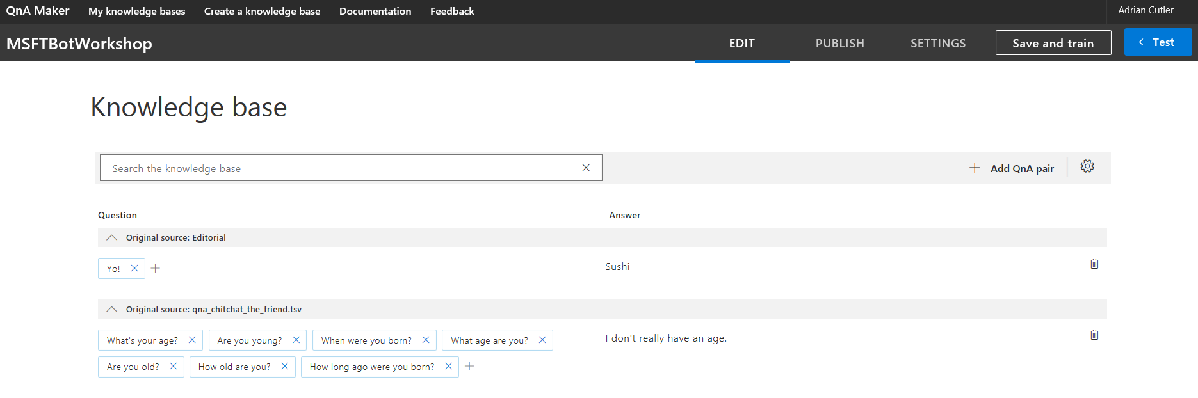

You can now start to **Add QnA pair** by clicking on this on the top right. If you wish to add a file of questions and answers or collect questions and answers from a URL such as a FAQ page, you can do this by clicking on Settings.

Once you feel you have added enough that you want to test, click on **Save and Train** so that the Knowledge Base is updated and then on **Publish**. The **Architect** will be linking this to an actual Chat Bot, it is the **Publish** command that makes it possible to chat to your Knowledge Base outside of the QnAMaker.

You can test the conversation at any time by clicking on **Test**.

Enjoy creating this and remember that you can add multiple questions or variations of the question to the give the same answer, for example Hi, Hello, Hiya could all respond with Hi.