# The PArent

Welcome Parent, you have taken on a role that will govern the questions and answers that make up the knowledge base of the chat bot. The chat bot is nothing without a personality. Your role is to be the **Parent** to the Chat Bot and ensure the identity and personality style comes through in the responses the Chat Bot gives. You will be working closely with the Curator who will be adding the question and answers pairs.

## Getting Started

The **Architect** will be setting up the Knowledge Base for the **Curator** and you to access in the QnAMaker <https://www.qnamaker.ai/>. You will access the QnA Maker with your own Microsoft Account login. The **Architect** will grant you access and so will ask you for an email address. If the email you have chosen is already a Microsoft Account, you are able to go into the QnAMaker and see the knowledge base created for you.

If you have not yet setup a Microsoft Account with the email you have provided, you can either wait for the email granting access and then setup a Microsoft account using this email or, you can set up the email address as a Microsoft Account now at <https://signup.live.com>

## Adding the PErsonality

The **Architect** while setting up the Knowledge Base will already ask you if you want to include a personality style, for example, the **Friend** or the **Comic**. If you choose one of these, a default set of questions and answers will be loaded into the Knowledge Base, you can always delete or edit them afterwards.

Sign in with your Microsoft Account to QnAMaker <https://www.qnamaker.ai/> and click on **My Knowledge Bases**, you will see the one the **Architect** has created

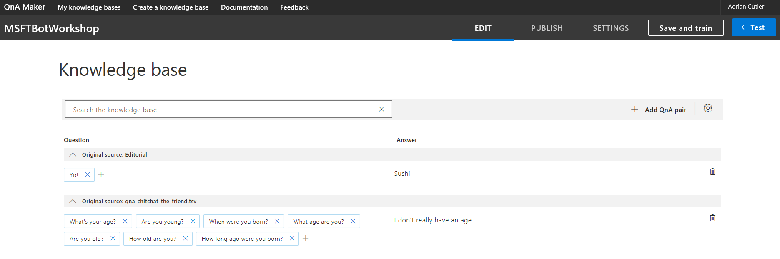The **Curator** will be adding questions and answers and you can either work side by side or edit the answers after the **Curator** has added one in.

Once you feel you have edited enough that you want to test, click on **Save and Train** so that the Knowledge Base is updated and then on **Publish**. The **Architect** will be linking this to an actual Chat Bot, it is the **Publish** command that makes it possible to chat to your Knowledge Base outside of the QnAMaker.

You can test the conversation at any time by clicking on **Test**.

Enjoy editing this and remember that you can add multiple questions or variations of the question to the give the same answer, for example Hi, Hello, Hiya could all respond with Hi.