# THE ARCHITECTure

Welcome Architect, you have taken on a role that will create the structure of the bot, connect it to chat channels and generally deal with everything slightly technical. Don’t worry, you will NOT need to know how to write code, just follow a set flow of processes which we will cover here.

Curator – Role to update and enrich the knowledge base

Parent – To test and validate the model and knowledge behaviour is valid and acceptable for deployment to production.

## Getting started

We are using the Microsoft Azure Portal to create the bot, if you have login details already, great if not the first thing we need to do is to get you a Microsoft Account and a free trial of Azure.

**Microsoft Account**

<https://signup.live.com>

**Azure Account**

<https://azure.microsoft.com/en-us/free/>

You will be asked to add credit card details for verification, but nothing is taken from the card. A new subscription would need to be created to begin being charged, NO auto switch happens after the 30 days. Think of this as the main administrator account for the workshop.

## Create the QnA Maker

Got to <https://www.qnamaker.ai/> and login with the Microsoft Account you have created or have a login for.

Now you are going to get the knowledge base ready for the Curator to start adding Questions and Answers.

Click on **Create a knowledge base**

Click on Step 1 **Create a QnA Service** which will take you to the Azure portal <https://portal.azure.com> you will be redirected to <https://portal.azure.com/#create/Microsoft.CognitiveServicesQnAMaker>.

You will need to fill in the form by following the steps below:

* Enter the **Name** of your Knowledge Base, it can be the name you will call the bot or your team name, if the name is already used you will need another name.
* Use the correct **subscription**
* If the pricing is greyed out change the **Location** to **West US** (this is a known bug)
* Then choose the **F0 management pricing tier**
* On **Resource Group**, Create New and call it the same name as the bot
* Choose the **F Search pricing tier**
* Set **Search location** to a location near you, for example: **UK South**
* **App name** should have been automatically created for you based on your Knowledge Base name, if the name is already used you will need another name
* Set **Website location** to a location near you, for example: **UK South**
* Enable **App insights,** you can learn more about app insights from here <https://aka.ms/botappinsights> which also shows you how to get your bot insights into Power BI
* Set **App Insights location** to a location near you, for example: **North Europe**
* Click **Create**

Once this is done, wait until you get a notification saying this was created. You can check the status of the Deployment by clicking on the Bell icon on the top bar.

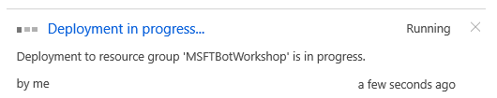

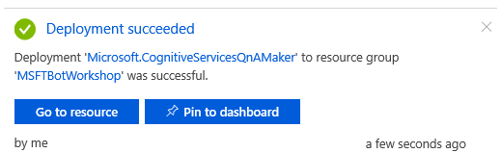You will be able to refresh the screen and see a list of the resources you have created once you see this screen in the notifications.

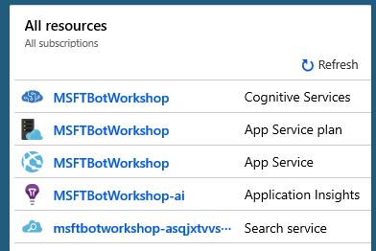

Now head back to the QnaMaker <https://www.qnamaker.ai/Create> refresh the page and fill in from step 2, this should be the free trial you have setup.

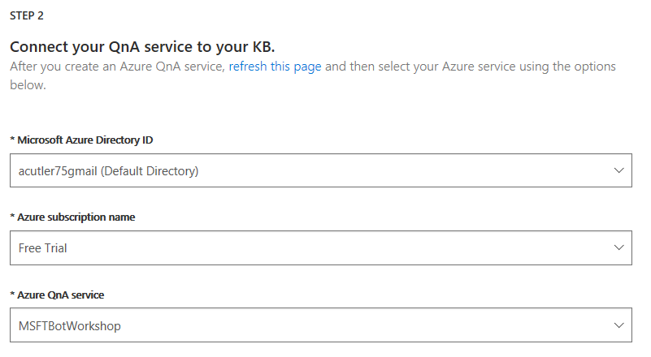

In Step 3, name the Knowledge Base the same name as your bot.

For Step 4, skip the populate for now, the **Curator** can add this later but check with the **Parent** if they wish to select a pre-defined personality in Chit Chat, for example: **The Friend**.

Step 5, click on **Create your KB**.

This will take you to the Knowledge Base and if you selected a personality, you will already have questions and answers pre-populated based on that personality style.

Click on **Publish**. You will see you bot name, click on the blue **Publish** to get your Knowledge Base ready to be connected to a Chat Bot interface.

You will need to copy the text as you will need this shortly, copy the text not just a screen capture or snip.

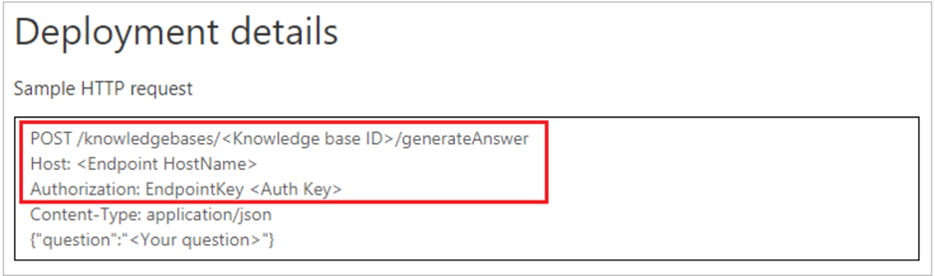

The parts you will need from this are the **Knowledge Base ID**, a string of numbers, letters and characters either side of the /’s.

The **Endpoint** **HostName** including the Http

Finally, the **Auth Key**, a string of numbers, letters and characters after the word EndpointKey.

You will now be able to hand over to the **Curator** and the **Parent** to add the questions and answers for the Knowledge Base. To get them started, let’s give them access to the Knowledge Base you have created in the QnAMaker.

## Grant Access to the Knowledgebase for the Curator and PArent

Got to the Azure portal <https://portal.azure.com> and under All resources you should see the Knowledge Base you have created, the resource we need to give them access is the Knowledge Base name with the words **Cognitive Services** after it.



* Click on this resource.
* On the left, go to **Access Control (IAM)**.
* Click **Add**.
* Select the **Owner** or the **Contributor role**.
* Enter the email you want to share with and click **Save**.
* Repeat this process for each of the Curators and the Parent.

An email will be sent to each email address for them to click and access the Knowledge Base, if the email is not already setup as a Microsoft Account, they will be asked to create a password and then will have access.

By default, after clicking the accept to access they are taken to the Azure Portal but they can close this and go back to the QnAMaker <https://www.qnamaker.ai/>

Now when the person you shared your Knowledge Base resource with, logs into the [QnAMaker portal](https://qnamaker.ai/) <https://www.qnamaker.ai/> they can see the Knowledge Base you created.

While the **Parent** and the **Curator** start adding questions and answers to build the Knowledge Base, you can create the Chat Bot (**Web App Bot**) that will connect to this Knowledge Base.

## Create the Chat Bot (web app bot) in Azure

Now you are free to work independently to setup the Chat Bot (**Web App Bot**) that will enable you and the team to Demo the bot in a Chat environment.

Let’s head to the Azure Portal <https://portal.azure.com> and click on **Create a Resource**, it’s the plus sign on the left

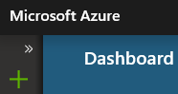

Go to **AI + Machine Learning** and click on **Web App Bot**. Fill in the form using the steps below:

* Enter your **Bot Name**, this can be the same as the Knowledge Base name
* On **Resource Group**, leave the automatically inputted **Resource Group**, it should be the same as your Knowledge Base Resource Group
* Set the **Location** to a location near you, for example: **UK South**
* Choose the **Pricing tier** **F0**.
* **App name** is already populated, leave this as it is.
* Click **Bot template** and
  + Change **SDK Version** to **SDK vs 3**
  + Make sure **SDK Language** is set to **C#**
  + Select **Question and Answer C#** , it will become highlighted to show you have selected it
  + Now click **Select**
* The **App Service Plan** should be already created, click **Create New** if it is not and name it after your bot, then choose a location near you, for example: **UK South**
* **Azure Storage** with Create New should already be selected with a name in the box, leave this as it is.
* Leave **Application Insights** On.
* Set **Application Insights location** to a location near you, for example: **North Europe**
* Double check that the **Bot Template** is set to Question and Answer (C#), if not, go back to this step above and Click **Bot Template**.
* Click **Create**.

Once this is done, wait until you get a notification saying this was created. You can check the status of the Deployment by clicking on the Bell icon on the top bar.

## Connect the Knowledge Base to the Web App Bot

Using the Deployment details, you captured earlier from publishing the Knowledge Base in QnAMaker, you are going to connect the Web App Bot you just created to the Knowledge Base you created at the start.

If you do not have the Deployment details from the earlier step, ask the **Curator** in QnAMaker to click on **Save and Train** and then **Publish** to provide you with the details outlined below.

**

Got to the Azure portal <https://portal.azure.com> and under All resources you should see the Chat Bot (**Web App Bot**) you created, the resource we need to work on next is has the words **Web App Bot** after it.

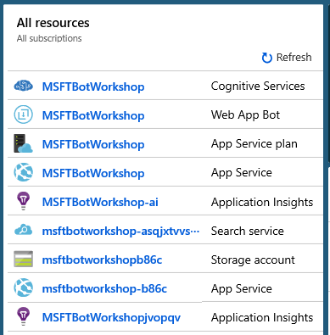

* Click on this resource.
* On the left, go to **Application Settings**.
* Scroll down to the section called **Application Settings**.
* Enter in the **Deployment details** next to the relevant **App Setting name** in the box that currently says ***Hidden Value. Click to edit.***
  1. Add to the **QnAAuthKey** the *Value* called **Auth Key**
  2. Add to the **QnAEndpointHostName** the *Value* called **Endpoint Hostname**
  3. Add to the **QnAKnowledgebaseId** the *Value* called **Knowledge Base ID**
* Don’t tick the boxes for **Slot Setting**
* You can check you have entered correctly by clicking on **Show Values**
* Now click on **Save**

## Test the Connection and get Ready to Demo

From the **Web App Bot** in the Azure Portal you can click on the left on **Test in Web Chat** and ask the questions the Curator and Parent have created.

If you are not seeing the latest questions and answers, ask the Curator to go into the QnAMaker and click on **Save and Train** and then **Publish**.

You are now ready tot demo the bot, it is here you can demo from as this shows you have connected a Chat bot tot the Knowledge Base. You can now help the **Curator** and **Parent** with questions and answers as a bot is nothing without a well thought out Knowledge Base.

## Connect the Web App Bot to Chat Channels

You could now explore more complex connects of the Web App Bot you have created.

If you wish to connect to external Chat Channels, you can click on **Channels**. It is best to select **Teams**, if you have a license and the admin setup already done by your central IT to allow you to chat to the bot in Teams, or you can use Facebook messenger. These two works in a developer mode which means you can only access them if you have the relevant link. Other channels require your bot to go through an approval process before you can chat in this way.

Full instructions on how to connect and chat to the bot in these channels can be found here. <https://docs.microsoft.com/en-us/azure/bot-service/bot-service-manage-channels>

**Teams** Channel setup is here

<https://docs.microsoft.com/en-gb/microsoftteams/platform/concepts/bots/bots-test>