create table student (

student_id INT NOT NULL,

fname VARCHAR (45) NOT NULL,

lname VARCHAR (45) NOT NULL,

date_birth DATE NOT NULL,

student_email VARCHAR (45) NOT NULL,

student_address VARCHAR (45) NOT NULL,

parent_id INT REFERENCES parent(parent_id),

class_id INT REFERENCES classes(class_id),

attendance_id INT REFERENCES attendance(attendance_id),

exam_id INT REFERENCES exam(exam_id),

grade_id INT REFERENCES grade(grade_id),

primary key (student_id)

);



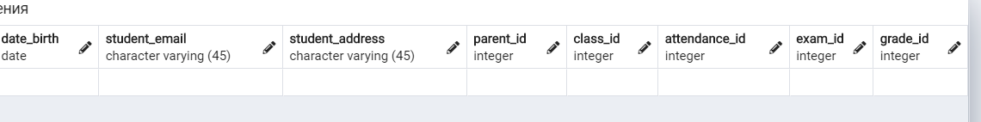

create table parent(

parent_id INT NOT NULL,

fname VARCHAR (45) NOT NULL,

lname VARCHAR (45) NOT NULL ,

date_birth DATE NOT NULL,

parent_email VARCHAR(45) NOT NULL,

parent_address VARCHAR (45) NOT NULL,

primary key (parent_id)

);

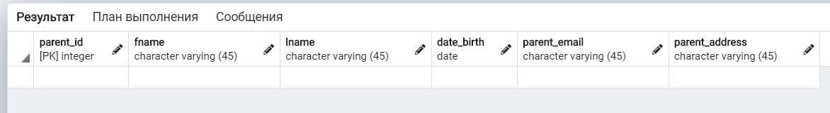

create table attendance(

attendance_id INT NOT NULL,

date DATE NOT NULL,

description VARCHAR(45) NOT NULL,

primary key (attendance_id)

);

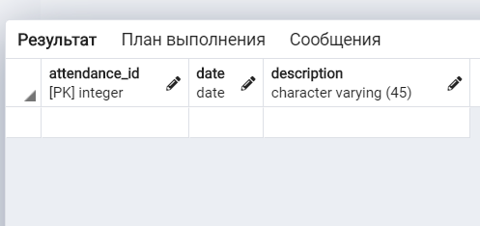

create table course(

course_id INT NOT NULL,

course_name VARCHAR (45) NOT NULL,

primary key (course_id)

);

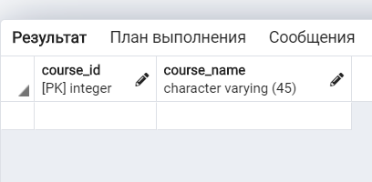

create table classroom(

classroom_id INT NOT NULL,

description VARCHAR (45) NOT NULL,

primary key (classroom_id)

);

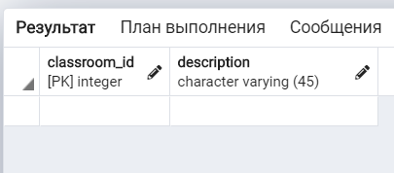

create table teacher(

teacher_id INT NOT NULL,

fname VARCHAR (45) NOT NULL,

lname VARCHAR (45) NOT NULL,

date_birth DATE NOT NULL,

teacher_email VARCHAR(45) NOT NULL,

teacher_address VARCHAR (45) NOT NULL,

primary key (teacher_id),

course_id INT REFERENCES course(course_id)

);



create table classes(

class_id INT NOT NULL,

class_name VARCHAR (45) NOT NULL,

primary key (class_id),

classroom_id INT REFERENCES classroom(classroom_id),

teacher_id INT REFERENCES teacher(teacher_id)

);

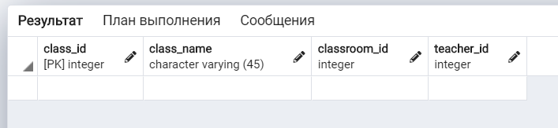

create table final_grade(

final_id INT NOT NULL,

course_name VARCHAR (45) NOT NULL,

final_grade INT NOT NULL,

primary key (final_id)

);

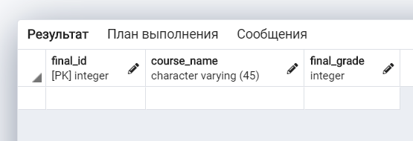

create table grade(

grade_id INT NOT NULL,

grade INT NOT NULL,

description VARCHAR (45) NOT NULL,

grade_1 INT NOT NULL,

grade_2 INT NOT NULL,

grade_3 INT NOT NULL,

grade_4 INT NOT NULL,

grade_5 INT NOT NULL,

primary key (grade_id),

final_id INT REFERENCES final_grade(final_id)

); 

create table exam(

exam_id INT NOT NULL,

exam_name VARCHAR (45) NOT NULL,

description VARCHAR(45) NOT NULL,

exam_date DATE NOT NULL,

exam_grade INT NOT NULL,

grade_id INT NOT NULL,

primary key (exam_id)

);

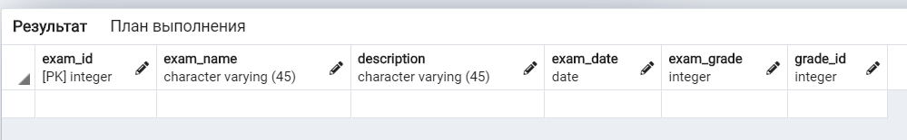

1. COURSE

insert into course (course_id, course_name) values (1001, 'geometry'), (1002, 'biology'), (1003, 'english'), (1004, 'chemistry'), (1005, 'physics'), (1006, 'geography'), (1007, 'history'), (1008, 'culturology'), (1009, 'literacy'), (1010, 'social study');

2) TEACHER

insert into teacher (teacher_id, fname, lname, date_birth, teacher_email, teacher_address, course_id) values (411, 'Alfi', 'Von Der Empten', '1987-09-25', 'avonderempten0@icq.com', '3244 Dawn Trail', 1001);

insert into teacher (teacher_id, fname, lname, date_birth, teacher_email, teacher_address, course_id) values (412, 'Desiri', 'Sketcher', '1994-03-06', 'dsketcher1@mayoclinic.com', '764 Schurz Park', 1002);

insert into teacher (teacher_id, fname, lname, date_birth, teacher_email, teacher_address, course_id) values (413, 'Juline', 'Kiellor', '1987-11-12', 'jkiellor2@telegraph.co.uk', '5983 Montana Trail', 1003);

insert into teacher (teacher_id, fname, lname, date_birth, teacher_email, teacher_address, course_id) values (414, 'Manon', 'Sarrell', '1977-06-21', 'msarrell3@theglobeandmail.com', '70972 Warner Point', 1004);

insert into teacher (teacher_id, fname, lname, date_birth, teacher_email, teacher_address, course_id) values (415, 'Carrie', 'Pocklington', '1981-07-31', 'cpocklington4@economist.com', '9939 Manufacturers Point', 1005);

insert into teacher (teacher_id, fname, lname, date_birth, teacher_email, teacher_address, course_id) values (416, 'Virgina', 'Dukesbury', '1984-08-14', 'vdukesbury0@meetup.com', '3 Dayton Plaza', 1006);

insert into teacher (teacher_id, fname, lname, date_birth, teacher_email, teacher_address, course_id) values (417, 'Arlena', 'Bontine', '1983-05-17', 'abontine1@pinterest.com', '532 Logan Way', 1007);

insert into teacher (teacher_id, fname, lname, date_birth, teacher_email, teacher_address, course_id) values (418, 'Sascha', 'Cushion', '1983-02-15', 'scushion2@nytimes.com', '38233 Thierer Parkway', 1008);

insert into teacher (teacher_id, fname, lname, date_birth, teacher_email, teacher_address, course_id) values (419, 'Loria', 'Werndley', '1992-08-10', 'lwerndley3@businessweek.com', '821 Schiller Trail', 1009);

insert into teacher (teacher_id, fname, lname, date_birth, teacher_email, teacher_address, course_id) values (420, 'Herculie', 'Trevance', '1992-07-27', 'htrevance4@technorati.com', '1 Ridgeview Pass', 1010);

3) CLASSES

insert into classes (class_id, class_name, classroom_id, teacher_id) values (901, '11a',511, 411), (902, '11b',512,412), (903, '11v',513,413), (904, '11g',514,414), (905, '11d',515,415), insert into classes (class_id, class_name, classroom_id, teacher_id) values (906, '10a',516, 416), (907, '10b',517,417), (908, '10v',518,418), (909, '10g',519,419), (910, '10d',520,420);

4) CLASSROOM

insert into classroom (classroom_id, description) values (511, 'geometry cabinet'), (512, 'biology cabinet '), (513, 'english cabinet'), (514, 'chemistry cabinet'), (515, 'physics cabinet'), insert into classroom (classroom_id, description) values (516, 'geography cabinet'), (517, 'history cabinet '), (518, 'culturology cabinet'), (519, 'literacy cabinet'), (520, 'social study cabinet');

5) EXAM

insert into exam (exam_id, exam_name, description, exam_date) values (701, 'geometry final exam', 'variant 1', '2020-11-25');

insert into exam (exam_id, exam_name, description, exam_date) values (702, 'algebra final exam', 'variant 1', '2020-11-23');

insert into exam (exam_id, exam_name, description, exam_date) values (703, 'biology final exam', 'variant 2', '2020-11-24');

insert into exam (exam_id, exam_name, description, exam_date) values (704, 'chemistry final exam', 'variant 2', '2020-11-23');

insert into exam (exam_id, exam_name, description, exam_date) values (705, 'physics final exam', 'variant 3', '2020-11-23');

insert into exam (exam_id, exam_name, description, exam_date) values (706, 'english final exam', 'variant 1', '2020-11-25');

insert into exam (exam_id, exam_name, description, exam_date) values (707, 'biology final exam', 'variant 3', '2020-11-25');

insert into exam (exam_id, exam_name, description, exam_date) values (708, 'geometry final exam', 'variant 1', '2020-11-25');

insert into exam (exam_id, exam_name, description, exam_date) values (709, 'english final exam', 'variant 2', '2020-11-24');

insert into exam (exam_id, exam_name, description, exam_date) values (710, 'algebra final exam', 'variant 2', '2020-11-24');

insert into exam (exam_id, exam_name, description, exam_date) values (711, 'chemistry final exam', 'variant 3', '2020-11-23');

insert into exam (exam_id, exam_name, description, exam_date) values (712, 'physics final exam', 'variant 3', '2020-11-24');

insert into exam (exam_id, exam_name, description, exam_date) values (713, 'physics final exam', 'variant 1', '2020-11-25');

insert into exam (exam_id, exam_name, description, exam_date) values (714, 'english final exam', 'variant 2', '2020-11-24');

insert into exam (exam_id, exam_name, description, exam_date) values (715, 'algebra final exam', 'variant 2', '2020-11-25');

insert into exam (exam_id, exam_name, description, exam_date) values (716, 'geometry final exam', 'variant 1', '2020-11-24');

insert into exam (exam_id, exam_name, description, exam_date) values (717, 'chemistry final exam', 'variant 1', '2020-11-25');

insert into exam (exam_id, exam_name, description, exam_date) values (718, 'physics final exam', 'variant 3', '2020-11-25');

insert into exam (exam_id, exam_name, description, exam_date) values (719, 'biology final exam', 'variant 3', '2020-11-24');

insert into exam (exam_id, exam_name, description, exam_date) values (720, 'english final exam', 'variant 2', '2020-11-25');

insert into exam (exam_id, exam_name, description, exam_date) values (721, 'algebra final exam', 'variant 3', '2020-11-24');

insert into exam (exam_id, exam_name, description, exam_date) values (722, 'geometry final exam', 'variant 1', '2020-11-25');

insert into exam (exam_id, exam_name, description, exam_date) values (723, 'chemistry final exam', 'variant 2', '2020-11-23');

insert into exam (exam_id, exam_name, description, exam_date) values (724, 'physics final exam', 'variant 3', '2020-11-25');

insert into exam (exam_id, exam_name, description, exam_date) values (725, 'biology final exam', 'variant 3', '2020-11-23');

insert into exam (exam_id, exam_name, description, exam_date) values (726, 'geograpry exam', 'variant 1', '1995-01-16');

insert into exam (exam_id, exam_name, description, exam_date) values (727, 'history exam', 'variant 3', '1994-10-18');

insert into exam (exam_id, exam_name, description, exam_date) values (728, 'cultorology exam', 'variant 3', '1994-06-16');

insert into exam (exam_id, exam_name, description, exam_date) values (729, 'literacy exam', 'variant 1', '1986-05-10');

insert into exam (exam_id, exam_name, description, exam_date) values (730, 'social study exam', 'variant 2', '1993-12-17');

insert into exam (exam_id, exam_name, description, exam_date) values (731, 'geograpry exam', 'variant 1', '1988-06-04');

insert into exam (exam_id, exam_name, description, exam_date) values (732, 'history exam', 'variant 3', '1985-05-16');

insert into exam (exam_id, exam_name, description, exam_date) values (733, 'cultorology exam', 'variant 1', '1989-04-04');

insert into exam (exam_id, exam_name, description, exam_date) values (734, 'literacy exam', 'variant 1', '1987-01-01');

insert into exam (exam_id, exam_name, description, exam_date) values (735, 'social study exam', 'variant 2', '1990-09-15');

insert into exam (exam_id, exam_name, description, exam_date) values (736, 'geograpry exam', 'variant 2', '1985-01-06');

insert into exam (exam_id, exam_name, description, exam_date) values (737, 'history exam', 'variant 3', '1983-11-30');

insert into exam (exam_id, exam_name, description, exam_date) values (738, 'cultorology exam', 'variant 1', '1992-06-26');

insert into exam (exam_id, exam_name, description, exam_date) values (739, 'literacy exam', 'variant 1', '1982-01-11');

insert into exam (exam_id, exam_name, description, exam_date) values (740, 'social study exam', 'variant 3', '1984-12-23');

insert into exam (exam_id, exam_name, description, exam_date) values (741, 'geograpry exam', 'variant 3', '1986-10-20');

insert into exam (exam_id, exam_name, description, exam_date) values (742, 'history exam', 'variant 1', '1994-02-13');

insert into exam (exam_id, exam_name, description, exam_date) values (743, 'cultorology exam', 'variant 1', '1992-05-06');

insert into exam (exam_id, exam_name, description, exam_date) values (744, 'literacy exam', 'variant 2', '1986-07-30');

insert into exam (exam_id, exam_name, description, exam_date) values (745, 'social study exam', 'variant 1', '1987-07-03');

insert into exam (exam_id, exam_name, description, exam_date) values (746, 'geograpry exam', 'variant 2', '1982-11-25');

insert into exam (exam_id, exam_name, description, exam_date) values (747, 'history exam', 'variant 1', '1993-06-17');

insert into exam (exam_id, exam_name, description, exam_date) values (748, 'cultorology exam', 'variant 3', '1986-12-16');

insert into exam (exam_id, exam_name, description, exam_date) values (749, 'literacy exam', 'variant 1', '1992-07-06');

insert into exam (exam_id, exam_name, description, exam_date) values (750, 'social study exam', 'variant 1', '1994-01-08');

6) ATTENDANCE

insert into attendance (attendance_id, date, description) values (310, '2020-11-23', 'present');

insert into attendance (attendance_id, date, description) values (311, '2020-11-23', 'present');

insert into attendance (attendance_id, date, description) values (312, '2020-11-23', 'late');

insert into attendance (attendance_id, date, description) values (313, '2020-11-23', 'present');

insert into attendance (attendance_id, date, description) values (314, '2020-11-23', 'present');

insert into attendance (attendance_id, date, description) values (315, '2020-11-23', 'present');

insert into attendance (attendance_id, date, description) values (316, '2020-11-23', 'late');

insert into attendance (attendance_id, date, description) values (317, '2020-11-23', 'absent');

insert into attendance (attendance_id, date, description) values (318, '2020-11-23', 'present');

insert into attendance (attendance_id, date, description) values (319, '2020-11-23', 'present');

insert into attendance (attendance_id, date, description) values (320, '2020-11-23', 'present');

insert into attendance (attendance_id, date, description) values (321, '2020-11-23', 'absent');

insert into attendance (attendance_id, date, description) values (322, '2020-11-23', 'absent');

insert into attendance (attendance_id, date, description) values (323, '2020-11-23', 'present');

insert into attendance (attendance_id, date, description) values (324, '2020-11-23', 'present');

insert into attendance (attendance_id, date, description) values (325, '2020-11-23', 'present');

insert into attendance (attendance_id, date, description) values (326, '2020-11-23', 'late');

insert into attendance (attendance_id, date, description) values (327, '2020-11-23', 'present');

insert into attendance (attendance_id, date, description) values (328, '2020-11-23', 'present');

insert into attendance (attendance_id, date, description) values (329, '2020-11-23', 'present');

insert into attendance (attendance_id, date, description) values (330, '2020-11-23', 'present');

insert into attendance (attendance_id, date, description) values (331, '2020-11-23', 'late');

insert into attendance (attendance_id, date, description) values (332, '2020-11-23', 'late');

insert into attendance (attendance_id, date, description) values (333, '2020-11-23', 'present');

insert into attendance (attendance_id, date, description) values (334, '2020-11-23', 'present');

insert into attendance (attendance_id, date, description) values (335, '2020-11-23', 'present');

insert into attendance (attendance_id, date, description) values (336, '2020-11-23', 'present');

insert into attendance (attendance_id, date, description) values (337, '2020-11-23', 'present');

insert into attendance (attendance_id, date, description) values (338, '2020-11-23', 'absent');

insert into attendance (attendance_id, date, description) values (339, '2020-11-23', 'absent');

insert into attendance (attendance_id, date, description) values (340, '2020-11-23', 'present');

insert into attendance (attendance_id, date, description) values (341, '2020-11-23', 'present');

insert into attendance (attendance_id, date, description) values (342, '2020-11-23', 'present');

insert into attendance (attendance_id, date, description) values (343, '2020-11-23', 'late');

insert into attendance (attendance_id, date, description) values (344, '2020-11-23', 'late');

insert into attendance (attendance_id, date, description) values (345, '2020-11-23', 'absent');

insert into attendance (attendance_id, date, description) values (346, '2020-11-23', 'present');

insert into attendance (attendance_id, date, description) values (347, '2020-11-23', 'present');

insert into attendance (attendance_id, date, description) values (348, '2020-11-23', 'late');

insert into attendance (attendance_id, date, description) values (349, '2020-11-23', 'present');

insert into attendance (attendance_id, date, description) values (350, '2020-11-23', 'present');

insert into attendance (attendance_id, date, description) values (351, '2020-11-23', 'present');

insert into attendance (attendance_id, date, description) values (352, '2020-11-23', 'absent');

insert into attendance (attendance_id, date, description) values (353, '2020-11-23', 'present');

insert into attendance (attendance_id, date, description) values (354, '2020-11-23', 'present');

insert into attendance (attendance_id, date, description) values (355, '2020-11-23', 'late');

insert into attendance (attendance_id, date, description) values (356, '2020-11-23', 'late');

insert into attendance (attendance_id, date, description) values (357, '2020-11-23', 'present');

insert into attendance (attendance_id, date, description) values (358, '2020-11-23', 'present');

insert into attendance (attendance_id, date, description) values (359, '2020-11-23', 'present');

insert into attendance (attendance_id, date, description) values (360, '2020-11-23', 'present');

insert into attendance (attendance_id, date, description) values (361, '2020-11-23', 'present');

insert into attendance (attendance_id, date, description) values (362, '2020-11-23', 'late');

insert into attendance (attendance_id, date, description) values (363, '2020-11-23', 'present');

insert into attendance (attendance_id, date, description) values (364, '2020-11-23', 'present');

insert into attendance (attendance_id, date, description) values (365, '2020-11-23', 'present');

insert into attendance (attendance_id, date, description) values (366, '2020-11-23', 'late');

insert into attendance (attendance_id, date, description) values (367, '2020-11-23', 'absent');

insert into attendance (attendance_id, date, description) values (368, '2020-11-23', 'present');

insert into attendance (attendance_id, date, description) values (369, '2020-11-23', 'present');

insert into attendance (attendance_id, date, description) values (370, '2020-11-23', 'present');

insert into attendance (attendance_id, date, description) values (371, '2020-11-23', 'absent');

insert into attendance (attendance_id, date, description) values (372, '2020-11-23', 'absent');

insert into attendance (attendance_id, date, description) values (373, '2020-11-23', 'present');

insert into attendance (attendance_id, date, description) values (374, '2020-11-23', 'present');

insert into attendance (attendance_id, date, description) values (375, '2020-11-23', 'present');

insert into attendance (attendance_id, date, description) values (376, '2020-11-23', 'late');

insert into attendance (attendance_id, date, description) values (377, '2020-11-23', 'present');

insert into attendance (attendance_id, date, description) values (378, '2020-11-23', 'present');

insert into attendance (attendance_id, date, description) values (379, '2020-11-23', 'present');

insert into attendance (attendance_id, date, description) values (380, '2020-11-23', 'present');

insert into attendance (attendance_id, date, description) values (381, '2020-11-23', 'late');

insert into attendance (attendance_id, date, description) values (382, '2020-11-23', 'late');

insert into attendance (attendance_id, date, description) values (383, '2020-11-23', 'present');

insert into attendance (attendance_id, date, description) values (384, '2020-11-23', 'present');

insert into attendance (attendance_id, date, description) values (385, '2020-11-23', 'present');

insert into attendance (attendance_id, date, description) values (386, '2020-11-23', 'present');

insert into attendance (attendance_id, date, description) values (387, '2020-11-23', 'present');

insert into attendance (attendance_id, date, description) values (388, '2020-11-23', 'absent');

insert into attendance (attendance_id, date, description) values (389, '2020-11-23', 'absent');

insert into attendance (attendance_id, date, description) values (390, '2020-11-23', 'present');

insert into attendance (attendance_id, date, description) values (391, '2020-11-23', 'present');

insert into attendance (attendance_id, date, description) values (392, '2020-11-23', 'present');

insert into attendance (attendance_id, date, description) values (393, '2020-11-23', 'late');

insert into attendance (attendance_id, date, description) values (394, '2020-11-23', 'late');

insert into attendance (attendance_id, date, description) values (395, '2020-11-23', 'absent');

insert into attendance (attendance_id, date, description) values (396, '2020-11-23', 'present');

insert into attendance (attendance_id, date, description) values (397, '2020-11-23', 'present');

insert into attendance (attendance_id, date, description) values (398, '2020-11-23', 'late');

insert into attendance (attendance_id, date, description) values (399, '2020-11-23', 'present');

insert into attendance (attendance_id, date, description) values (400, '2020-11-23', 'present');

insert into attendance (attendance_id, date, description) values (401, '2020-11-23', 'present');

insert into attendance (attendance_id, date, description) values (402, '2020-11-23', 'absent');

insert into attendance (attendance_id, date, description) values (403, '2020-11-23', 'present');

insert into attendance (attendance_id, date, description) values (404, '2020-11-23', 'present');

insert into attendance (attendance_id, date, description) values (405, '2020-11-23', 'late');

insert into attendance (attendance_id, date, description) values (406, '2020-11-23', 'late');

insert into attendance (attendance_id, date, description) values (407, '2020-11-23', 'present');

insert into attendance (attendance_id, date, description) values (408, '2020-11-23', 'present');

insert into attendance (attendance_id, date, description) values (409, '2020-11-23', 'present');

7) FINAL_GRADE

insert into final_grade (final_id, course_name, final_grade) values (201, 'geometry', 4);

insert into final_grade (final_id, course_name, final_grade) values (702, 'geometry', 4.4);

insert into final_grade (final_id, course_name, final_grade) values (203, 'algebra', 4);

insert into final_grade (final_id, course_name, final_grade) values (204, 'algebra', 3);

insert into final_grade (final_id, course_name, final_grade) values (205, 'biology', 5);

insert into final_grade (final_id, course_name, final_grade) values (206, 'biology', 3);

insert into final_grade (final_id, course_name, final_grade) values (207, 'chemistry', 4);

insert into final_grade (final_id, course_name, final_grade) values (208, 'chemistry', 5);

insert into final_grade (final_id, course_name, final_grade) values (209, 'physics', 3);

insert into final_grade (final_id, course_name, final_grade) values (210, 'physics', 4);

insert into final_grade (final_id, course_name, final_grade) values (211, 'english', 5);

insert into final_grade (final_id, course_name, final_grade) values (212, 'english', 3);

insert into final_grade (final_id, course_name, final_grade) values (213, 'biology', 4);

insert into final_grade (final_id, course_name, final_grade) values (214, 'biology', 4);

insert into final_grade (final_id, course_name, final_grade) values (215, 'geometry', 5);

insert into final_grade (final_id, course_name, final_grade) values (216, 'geometry', 3);

insert into final_grade (final_id, course_name, final_grade) values (217, 'english', 5);

insert into final_grade (final_id, course_name, final_grade) values (218, 'english', 5);

insert into final_grade (final_id, course_name, final_grade) values (219, 'slgebra', 4);

insert into final_grade (final_id, course_name, final_grade) values (220, 'algebra', 5);

insert into final_grade (final_id, course_name, final_grade) values (221, 'chemistry', 4);

insert into final_grade (final_id, course_name, final_grade) values (222, 'chemistry', 4);

insert into final_grade (final_id, course_name, final_grade) values (223, 'physics', 3);

insert into final_grade (final_id, course_name, final_grade) values (224, 'physics', 4);

insert into final_grade (final_id, course_name, final_grade) values (225, 'physics', 5);

insert into final_grade (final_id, course_name, final_grade) values (226, 'physics', 4);

insert into final_grade (final_id, course_name, final_grade) values (227, 'english', 4);

insert into final_grade (final_id, course_name, final_grade) values (228, 'english', 4);

insert into final_grade (final_id, course_name, final_grade) values (229, 'algebra', 5);

insert into final_grade (final_id, course_name, final_grade) values (230, 'algebra', 4);

insert into final_grade (final_id, course_name, final_grade) values (231, 'geometry', 3);

insert into final_grade (final_id, course_name, final_grade) values (232, 'geometry', 3);

insert into final_grade (final_id, course_name, final_grade) values (233, 'chemistry', 3);

insert into final_grade (final_id, course_name, final_grade) values (234, 'chemistry', 4);

insert into final_grade (final_id, course_name, final_grade) values (235, 'physics', 4);

insert into final_grade (final_id, course_name, final_grade) values (236, 'physics', 4);

insert into final_grade (final_id, course_name, final_grade) values (237, 'biology', 5);

insert into final_grade (final_id, course_name, final_grade) values (238, 'bilogy', 5);

insert into final_grade (final_id, course_name, final_grade) values (239, 'enlgish', 5);

insert into final_grade (final_id, course_name, final_grade) values (240, 'english', 4);

insert into final_grade (final_id, course_name, final_grade) values (241, 'algebra', 4);

insert into final_grade (final_id, course_name, final_grade) values (242, 'algebra', 4);

insert into final_grade (final_id, course_name, final_grade) values (243, 'geometry', 3);

insert into final_grade (final_id, course_name, final_grade) values (244, 'geometry', 4);

insert into final_grade (final_id, course_name, final_grade) values (245, 'chemistry', 5);

insert into final_grade (final_id, course_name, final_grade) values (246, 'chemistry', 4);

insert into final_grade (final_id, course_name, final_grade) values (247, 'physics', 4);

insert into final_grade (final_id, course_name, final_grade) values (248, 'physics', 3);

insert into final_grade (final_id, course_name, final_grade) values (249, 'biology', 3);

insert into final_grade (final_id, course_name, final_grade) values (250, 'biology', 5);

insert into final_grade (final_id, course_name, final_grade) values (251, ' geography ', 4);

insert into final_grade (final_id, course_name, final_grade) values (252, ‘ geography’, 4.4);

insert into final_grade (final_id, course_name, final_grade) values (253, 'history', 4);

insert into final_grade (final_id, course_name, final_grade) values (254, ' history ', 3);

insert into final_grade (final_id, course_name, final_grade) values (255, 'culturology', 5);

insert into final_grade (final_id, course_name, final_grade) values (256, ' culturology ', 3);

insert into final_grade (final_id, course_name, final_grade) values (257, 'literacy', 4);

insert into final_grade (final_id, course_name, final_grade) values (258, 'literacy', 5);

insert into final_grade (final_id, course_name, final_grade) values (259, 'social study', 3);

insert into final_grade (final_id, course_name, final_grade) values (260, 'physics', 4);

insert into final_grade (final_id, course_name, final_grade) values (261, ' social study'', 5);

insert into final_grade (final_id, course_name, final_grade) values (262, ' social study'', 3);

insert into final_grade (final_id, course_name, final_grade) values (263, ' history ', 4);

insert into final_grade (final_id, course_name, final_grade) values (264, ' history ', 4);

insert into final_grade (final_id, course_name, final_grade) values (265, ' culturology ', 5);

insert into final_grade (final_id, course_name, final_grade) values (266, ' culturology ', 3);

insert into final_grade (final_id, course_name, final_grade) values (267, 'geography', 5);

insert into final_grade (final_id, course_name, final_grade) values (268, ' geography ', 5);

insert into final_grade (final_id, course_name, final_grade) values (269, 'history', 4);

insert into final_grade (final_id, course_name, final_grade) values (270, 'history', 5);

insert into final_grade (final_id, course_name, final_grade) values (271, 'culturology', 4);

insert into final_grade (final_id, course_name, final_grade) values (272, 'culturology', 4);

insert into final_grade (final_id, course_name, final_grade) values (273, 'literacy', 3);

insert into final_grade (final_id, course_name, final_grade) values (274, 'literacy', 4);

insert into final_grade (final_id, course_name, final_grade) values (275, ‘social study', 5);

insert into final_grade (final_id, course_name, final_grade) values (276, 'social study', 4);

insert into final_grade (final_id, course_name, final_grade) values (277, ' geography ', 4);

insert into final_grade (final_id, course_name, final_grade) values (278, ' geography ', 4), (279, ' history ', 5);

insert into final_grade (final_id, course_name, final_grade) values (280, ' history ', 4);

insert into final_grade (final_id, course_name, final_grade) values (281, ' culturology, 3);

insert into final_grade (final_id, course_name, final_grade) values (282, ' culturology ', 3);

insert into final_grade (final_id, course_name, final_grade) values (283, ' literacy ', 3);

insert into final_grade (final_id, course_name, final_grade) values (284, ' literacy ', 4);

insert into final_grade (final_id, course_name, final_grade) values (285, ' geography ', 4);

insert into final_grade (final_id, course_name, final_grade) values (286, ' geography ', 4);

insert into final_grade (final_id, course_name, final_grade) values (287, ' history ', 5);

insert into final_grade (final_id, course_name, final_grade) values (288, ' history ', 5);

insert into final_grade (final_id, course_name, final_grade) values (289, ' culturology ', 5);

insert into final_grade (final_id, course_name, final_grade) values (290, ' culturology ', 4);

insert into final_grade (final_id, course_name, final_grade) values (291, ' literacy ', 4);

insert into final_grade (final_id, course_name, final_grade) values (292, ' literacy ', 4);

insert into final_grade (final_id, course_name, final_grade) values (293, ' social study ', 3);

insert into final_grade (final_id, course_name, final_grade) values (294, ' social study ', 4);

insert into final_grade (final_id, course_name, final_grade) values (295, ' geography ', 5);

insert into final_grade (final_id, course_name, final_grade) values (296, ' geography ', 4);

insert into final_grade (final_id, course_name, final_grade) values (297, ' history ', 4);

insert into final_grade (final_id, course_name, final_grade) values (298, ' history ', 3);

insert into final_grade (final_id, course_name, final_grade) values (299, ' culturology ', 3);

insert into final_grade (final_id, course_name, final_grade) values (300, ' culturology ', 5);

8) GRADE

insert into grade (grade_id, description, grade_1, grade_2, grade_3, grade_4, grade_5, final_id) values (601, 'good', 4,4,5,3,4, 201);

insert into grade (grade_id, description, grade_1, grade_2, grade_3, grade_4, grade_5, final_id) values (602, 'good', 5,5, 5, 3, 4, 702);

insert into grade (grade_id, description, grade_1, grade_2, grade_3, grade_4, grade_5, final_id) values (603, 'good', 3, 3, 3, 3, 3, 203);

insert into grade (grade_id, description, grade_1, grade_2, grade_3, grade_4, grade_5, final_id) values (604, 'bad', 5, 2, 3, 4, 3, 204);

insert into grade (grade_id, description, grade_1, grade_2, grade_3, grade_4, grade_5, final_id) values (605, 'exellent', 5, 5, 5, 4, 5, 205);

insert into grade (grade_id, description, grade_1, grade_2, grade_3, grade_4, grade_5, final_id) values (606, 'bad', 4, 4, 3, 2, 3, 206);

insert into grade (grade_id, description, grade_1, grade_2, grade_3, grade_4, grade_5, final_id) values (607, 'good', 3, 3, 3, 4, 3, 207);

insert into grade (grade_id, description, grade_1, grade_2, grade_3, grade_4, grade_5, final_id) values (608, 'exellent', 5, 5, 4, 5, 5, 208);

insert into grade (grade_id, description, grade_1, grade_2, grade_3, grade_4, grade_5, final_id) values (609, 'bad',4 , 4, 4, 3, 4, 209);

insert into grade (grade_id, description, grade_1, grade_2, grade_3, grade_4, grade_5, final_id) values (610, 'good', 3, 4, 5, 5, 4, 210);

insert into grade (grade_id, description, grade_1, grade_2, grade_3, grade_4, grade_5, final_id) values (611, 'exellent', 4, 4, 5, 5, 5, 211);

insert into grade (grade_id, description, grade_1, grade_2, grade_3, grade_4, grade_5, final_id) values (612, 'bad', 4, 3, 3, 3, 3, 212);

insert into grade (grade_id, description, grade_1, grade_2, grade_3, grade_4, grade_5, final_id) values (613, 'good', 4, 3, 4, 5, 4, 213);

insert into grade (grade_id, description, grade_1, grade_2, grade_3, grade_4, grade_5, final_id) values (614, 'good', 4, 4, 4, 4, 4, 214);

insert into grade (grade_id, description, grade_1, grade_2, grade_3, grade_4, grade_5, final_id) values (615, 'exellent', 5, 5, 4, 5, 5, 215);

insert into grade (grade_id, description, grade_1, grade_2, grade_3, grade_4, grade_5, final_id) values (616, 'bad', 4, 5 ,3, 3, 2, 216);

insert into grade (grade_id, description, grade_1, grade_2, grade_3, grade_4, grade_5, final_id) values (617, 'exellent', 5, 5,5, 5, 5, 217);

insert into grade (grade_id, description, grade_1, grade_2, grade_3, grade_4, grade_5, final_id) values (618, 'exellent', 4, 5, 5, 5, 5, 218);

insert into grade (grade_id, description, grade_1, grade_2, grade_3, grade_4, grade_5, final_id) values (619, 'good', 5, 4, 4,3,4, 219);

insert into grade (grade_id, description, grade_1, grade_2, grade_3, grade_4, grade_5, final_id) values (620, 'exellent', 5, 4, 5, 5, 5, 220);

insert into grade (grade_id, description, grade_1, grade_2, grade_3, grade_4, grade_5, final_id) values (621, 'good', 5, 4, 5, 2, 4, 221);

insert into grade (grade_id, description, grade_1, grade_2, grade_3, grade_4, grade_5, final_id) values (622, 'good', 3, 4,4 , 3, 4, 222);

insert into grade (grade_id, description, grade_1, grade_2, grade_3, grade_4, grade_5, final_id) values (623, 'good', 5, 2, 3, 3, 3, 223);

insert into grade (grade_id, description, grade_1, grade_2, grade_3, grade_4, grade_5, final_id) values (624, 'good', 4, 4, 5, 4, 4, 224);

insert into grade (grade_id, description, grade_1, grade_2, grade_3, grade_4, grade_5, final_id) values (625, 'exellent', 5, 5, 5, 5, 4, 225);

insert into grade (grade_id, description, grade_1, grade_2, grade_3, grade_4, grade_5, final_id) values (626, 'good', 5, 4, 3, 3, 4, 226);

insert into grade (grade_id, description, grade_1, grade_2, grade_3, grade_4, grade_5, final_id) values (627, 'good', 4, 4, 4, 4, 4, 227);

insert into grade (grade_id, description, grade_1, grade_2, grade_3, grade_4, grade_5, final_id) values (628, 'good', 5, 5, 4, 4, 3, 228);

insert into grade (grade_id, description, grade_1, grade_2, grade_3, grade_4, grade_5, final_id) values (629, 'exellent', 4, 5, 5, 5, 5, 229);

insert into grade (grade_id, description, grade_1, grade_2, grade_3, grade_4, grade_5, final_id) values (630, 'good', 4, 4, 4, 4, 4, 230);

insert into grade (grade_id, description, grade_1, grade_2, grade_3, grade_4, grade_5, final_id) values (631, 'bad', 3, 3, 3, 3, 4, 231);

insert into grade (grade_id, description, grade_1, grade_2, grade_3, grade_4, grade_5, final_id) values (632, 'bad', 3, 3, 3, 3, 3, 232);

insert into grade (grade_id, description, grade_1, grade_2, grade_3, grade_4, grade_5, final_id) values (633, 'bad', 3, 3, 5, 3, 3, 233);

insert into grade (grade_id, description, grade_1, grade_2, grade_3, grade_4, grade_5, final_id) values (634, 'good', 4, 3, 4, 4, 5, 234);

insert into grade (grade_id, description, grade_1, grade_2, grade_3, grade_4, grade_5, final_id) values (635, 'good', 5, 3,3, 5, 5, 235);

insert into grade (grade_id, description, grade_1, grade_2, grade_3, grade_4, grade_5, final_id) values (636, 'good', 3, 5, 3, 4, 4, 236);

insert into grade (grade_id, description, grade_1, grade_2, grade_3, grade_4, grade_5, final_id) values (637, 'exellent', 5, 4, 5, 5, 4, 237);

insert into grade (grade_id, description, grade_1, grade_2, grade_3, grade_4, grade_5, final_id) values (638, 'exellent', 5, 5, 5, 5, 5, 238);

insert into grade (grade_id, description, grade_1, grade_2, grade_3, grade_4, grade_5, final_id) values (639, 'exellent', 4, 4, 5, 5, 5, 239);

insert into grade (grade_id, description, grade_1, grade_2, grade_3, grade_4, grade_5, final_id) values (640, 'good', 4, 5, 3, 4, 4, 240);

insert into grade (grade_id, description, grade_1, grade_2, grade_3, grade_4, grade_5, final_id) values (641, 'good', 4, 4, 4, 4, 5, 241);

insert into grade (grade_id, description, grade_1, grade_2, grade_3, grade_4, grade_5, final_id) values (642, 'good', 4, 3, 3, 4, 4, 242);

insert into grade (grade_id, description, grade_1, grade_2, grade_3, grade_4, grade_5, final_id) values (643, 'bad', 3, 5, 5, 2, 4, 243);

insert into grade (grade_id, description, grade_1, grade_2, grade_3, grade_4, grade_5, final_id) values (644, 'good', 4, 4, 3,5,3, 244);

insert into grade (grade_id, description, grade_1, grade_2, grade_3, grade_4, grade_5, final_id) values (645, 'exellent', 5, 5, 4, 4, 5, 245);

insert into grade (grade_id, description, grade_1, grade_2, grade_3, grade_4, grade_5, final_id) values (646, 'good', 4, 4, 4, 3, 5, 246);

insert into grade (grade_id, description, grade_1, grade_2, grade_3, grade_4, grade_5, final_id) values (647, 'good', 4, 3, 5, 5, 3, 247);

insert into grade (grade_id, description, grade_1, grade_2, grade_3, grade_4, grade_5, final_id) values (648, 'bad', 4, 3, 3, 3, 3, 248);

insert into grade (grade_id, description, grade_1, grade_2, grade_3, grade_4, grade_5, final_id) values (649, 'bad', 3, 4, 5, 4, 2, 249);

insert into grade (grade_id, description, grade_1, grade_2, grade_3, grade_4, grade_5, final_id) values (650, 'exellent', 5, 5, 5, 5, 5, 250);

insert into grade (grade_id, description, grade_1, grade_2, grade_3, grade_4, grade_5, final_id) values (651, 'good', 4,4,5,3,4, 251);

insert into grade (grade_id, description, grade_1, grade_2, grade_3, grade_4, grade_5, final_id) values (652, 'good', 5,5, 5, 3, 4, 252);

insert into grade (grade_id, description, grade_1, grade_2, grade_3, grade_4, grade_5, final_id) values (653, 'good', 3, 3, 3, 3, 3, 253);

insert into grade (grade_id, description, grade_1, grade_2, grade_3, grade_4, grade_5, final_id) values (654, 'bad', 5, 2, 3, 4, 3, 254);

insert into grade (grade_id, description, grade_1, grade_2, grade_3, grade_4, grade_5, final_id) values (655, 'exellent', 5, 5, 5, 4, 5, 255);

insert into grade (grade_id, description, grade_1, grade_2, grade_3, grade_4, grade_5, final_id) values (656, 'bad', 4, 4, 3, 2, 3, 256);

insert into grade (grade_id, description, grade_1, grade_2, grade_3, grade_4, grade_5, final_id) values (657, 'good', 3, 3, 3, 4, 3, 257);

insert into grade (grade_id, description, grade_1, grade_2, grade_3, grade_4, grade_5, final_id) values (658, 'exellent', 5, 5, 4, 5, 5, 258);

insert into grade (grade_id, description, grade_1, grade_2, grade_3, grade_4, grade_5, final_id) values (659, 'bad',4 , 4, 4, 3, 4, 259);

insert into grade (grade_id, description, grade_1, grade_2, grade_3, grade_4, grade_5, final_id) values (660, 'good', 3, 4, 5, 5, 4, 260);

insert into grade (grade_id, description, grade_1, grade_2, grade_3, grade_4, grade_5, final_id) values (661, 'exellent', 4, 4, 5, 5, 5, 261);

insert into grade (grade_id, description, grade_1, grade_2, grade_3, grade_4, grade_5, final_id) values (662, 'bad', 4, 3, 3, 3, 3, 262);

insert into grade (grade_id, description, grade_1, grade_2, grade_3, grade_4, grade_5, final_id) values (663, 'good', 4, 3, 4, 5, 4, 263);

insert into grade (grade_id, description, grade_1, grade_2, grade_3, grade_4, grade_5, final_id) values (664, 'good', 4, 4, 4, 4, 4, 264);

insert into grade (grade_id, description, grade_1, grade_2, grade_3, grade_4, grade_5, final_id) values (665, 'exellent', 5, 5, 4, 5, 5, 265);

insert into grade (grade_id, description, grade_1, grade_2, grade_3, grade_4, grade_5, final_id) values (666, 'bad', 4, 5 ,3, 3, 2, 266);

insert into grade (grade_id, description, grade_1, grade_2, grade_3, grade_4, grade_5, final_id) values (667, 'exellent', 5, 5,5, 5, 5, 267);

insert into grade (grade_id, description, grade_1, grade_2, grade_3, grade_4, grade_5, final_id) values (668, 'exellent', 4, 5, 5, 5, 5, 268);

insert into grade (grade_id, description, grade_1, grade_2, grade_3, grade_4, grade_5, final_id) values (669, 'good', 5, 4, 4,3,4, 269);

insert into grade (grade_id, description, grade_1, grade_2, grade_3, grade_4, grade_5, final_id) values (670, 'exellent', 5, 4, 5, 5, 5, 270);

insert into grade (grade_id, description, grade_1, grade_2, grade_3, grade_4, grade_5, final_id) values (671, 'good', 5, 4, 5, 2, 4, 271);

insert into grade (grade_id, description, grade_1, grade_2, grade_3, grade_4, grade_5, final_id) values (672, 'good', 3, 4,4 , 3, 4, 272);

insert into grade (grade_id, description, grade_1, grade_2, grade_3, grade_4, grade_5, final_id) values (673, 'good', 5, 2, 3, 3, 3, 273);

insert into grade (grade_id, description, grade_1, grade_2, grade_3, grade_4, grade_5, final_id) values (674, 'good', 4, 4, 5, 4, 4, 274);

insert into grade (grade_id, description, grade_1, grade_2, grade_3, grade_4, grade_5, final_id) values (675, 'exellent', 5, 5, 5, 5, 4, 275);

insert into grade (grade_id, description, grade_1, grade_2, grade_3, grade_4, grade_5, final_id) values (676, 'good', 5, 4, 3, 3, 4, 276);

insert into grade (grade_id, description, grade_1, grade_2, grade_3, grade_4, grade_5, final_id) values (677, 'good', 4, 4, 4, 4, 4, 277);

insert into grade (grade_id, description, grade_1, grade_2, grade_3, grade_4, grade_5, final_id) values (678, 'good', 5, 5, 4, 4, 3, 278);

insert into grade (grade_id, description, grade_1, grade_2, grade_3, grade_4, grade_5, final_id) values (679, 'exellent', 4, 5, 5, 5, 5, 279);

insert into grade (grade_id, description, grade_1, grade_2, grade_3, grade_4, grade_5, final_id) values (680, 'good', 4, 4, 4, 4, 4, 280);

insert into grade (grade_id, description, grade_1, grade_2, grade_3, grade_4, grade_5, final_id) values (681, 'bad', 3, 3, 3, 3, 4, 281);

insert into grade (grade_id, description, grade_1, grade_2, grade_3, grade_4, grade_5, final_id) values (682, 'bad', 3, 3, 3, 3, 3, 282);

insert into grade (grade_id, description, grade_1, grade_2, grade_3, grade_4, grade_5, final_id) values (683, 'bad', 3, 3, 5, 3, 3, 283);

insert into grade (grade_id, description, grade_1, grade_2, grade_3, grade_4, grade_5, final_id) values (684, 'good', 4, 3, 4, 4, 5, 284);

insert into grade (grade_id, description, grade_1, grade_2, grade_3, grade_4, grade_5, final_id) values (685, 'good', 5, 3,3, 5, 5, 285);

insert into grade (grade_id, description, grade_1, grade_2, grade_3, grade_4, grade_5, final_id) values (686, 'good', 3, 5, 3, 4, 4, 286);

insert into grade (grade_id, description, grade_1, grade_2, grade_3, grade_4, grade_5, final_id) values (687, 'exellent', 5, 4, 5, 5, 4, 287);

insert into grade (grade_id, description, grade_1, grade_2, grade_3, grade_4, grade_5, final_id) values (688, 'exellent', 5, 5, 5, 5, 5, 288);

insert into grade (grade_id, description, grade_1, grade_2, grade_3, grade_4, grade_5, final_id) values (689, 'exellent', 4, 4, 5, 5, 5, 289);

insert into grade (grade_id, description, grade_1, grade_2, grade_3, grade_4, grade_5, final_id) values (690, 'good', 4, 5, 3, 4, 4, 290);

insert into grade (grade_id, description, grade_1, grade_2, grade_3, grade_4, grade_5, final_id) values (691, 'good', 4, 4, 4, 4, 5, 291);

insert into grade (grade_id, description, grade_1, grade_2, grade_3, grade_4, grade_5, final_id) values (692, 'good', 4, 3, 3, 4, 4, 292);

insert into grade (grade_id, description, grade_1, grade_2, grade_3, grade_4, grade_5, final_id) values (693, 'bad', 3, 5, 5, 2, 4, 293);

insert into grade (grade_id, description, grade_1, grade_2, grade_3, grade_4, grade_5, final_id) values (694, 'good', 4, 4, 3,5,3, 294);

insert into grade (grade_id, description, grade_1, grade_2, grade_3, grade_4, grade_5, final_id) values (695, 'exellent', 5, 5, 4, 4, 5, 295);

insert into grade (grade_id, description, grade_1, grade_2, grade_3, grade_4, grade_5, final_id) values (696, 'good', 4, 4, 4, 3, 5, 296);

insert into grade (grade_id, description, grade_1, grade_2, grade_3, grade_4, grade_5, final_id) values (697, 'good', 4, 3, 5, 5, 3, 297);

insert into grade (grade_id, description, grade_1, grade_2, grade_3, grade_4, grade_5, final_id) values (698, 'bad', 4, 3, 3, 3, 3, 298);

insert into grade (grade_id, description, grade_1, grade_2, grade_3, grade_4, grade_5, final_id) values (699, 'bad', 3, 4, 5, 4, 2, 299);

insert into grade (grade_id, description, grade_1, grade_2, grade_3, grade_4, grade_5, final_id) values (700, 'exellent', 5, 5, 5, 5, 5, 300);

9) PARENT

insert into parent (parent_id, fname, lname, date_birth, parent_email, parent_address) values (101, 'Renaud', 'Nealon', '1969-05-08', 'rnealon0@cafepress.com', '852 Grayhawk Lane');

insert into parent (parent_id, fname, lname, date_birth, parent_email, parent_address) values (102, 'Lyndy', 'Wennam', '1972-04-29', 'lwennam1@ustream.tv', '380 Merrick Terrace');

insert into parent (parent_id, fname, lname, date_birth, parent_email, parent_address) values (103, 'Dieter', 'Cancelier', '1965-07-18', 'dcancelier2@t-online.de', '79 Forest Dale Avenue');

insert into parent (parent_id, fname, lname, date_birth, parent_email, parent_address) values (104, 'Hyacinth', 'Gilardi', '1976-05-30', 'hgilardi3@toplist.cz', '974 Cherokee Place');

insert into parent (parent_id, fname, lname, date_birth, parent_email, parent_address) values (105, 'Nanny', 'Stobart', '1968-01-28', 'nstobart4@paypal.com', '511 Farwell Road');

insert into parent (parent_id, fname, lname, date_birth, parent_email, parent_address) values (106, 'Bartholemy', 'Keetch', '1973-03-17', 'bkeetch5@amazon.com', '5205 Ruskin Junction');

insert into parent (parent_id, fname, lname, date_birth, parent_email, parent_address) values (107, 'Jess', 'Cristou', '1971-05-03', 'jcristou6@free.fr', '43028 Fordem Drive');

insert into parent (parent_id, fname, lname, date_birth, parent_email, parent_address) values (108, 'Tabb', 'Climie', '1975-07-09', 'tclimie7@reddit.com', '98 Longview Way');

insert into parent (parent_id, fname, lname, date_birth, parent_email, parent_address) values (109, 'Alia', 'O''Kuddyhy', '1962-06-04', 'aokuddyhy8@about.com', '7814 Bunting Road');

insert into parent (parent_id, fname, lname, date_birth, parent_email, parent_address) values (110, 'Vick', 'Felder', '1967-06-04', 'vfelder9@nasa.gov', '0766 Anzinger Way');

insert into parent (parent_id, fname, lname, date_birth, parent_email, parent_address) values (111, 'Waly', 'Moorrud', '1963-06-06', 'wmoorruda@sciencedaily.com', '26 Tennessee Parkway');

insert into parent (parent_id, fname, lname, date_birth, parent_email, parent_address) values (112, 'Constantine', 'Scrimgeour', '1976-08-26', 'cscrimgeourb@engadget.com', '50 Messerschmidt Lane');

insert into parent (parent_id, fname, lname, date_birth, parent_email, parent_address) values (113, 'Jacqueline', 'Daville', '1961-09-27', 'jdavillec@google.co.jp', '48 Daystar Street');

insert into parent (parent_id, fname, lname, date_birth, parent_email, parent_address) values (114, 'Muire', 'MacGragh', '1975-06-02', 'mmacgraghd@drupal.org', '76 Fisk Pass');

insert into parent (parent_id, fname, lname, date_birth, parent_email, parent_address) values (115, 'Rockwell', 'Dallow', '1968-11-01', 'rdallowe@wikia.com', '3 Crest Line Hill');

insert into parent (parent_id, fname, lname, date_birth, parent_email, parent_address) values (116, 'Fred', 'Grigorian', '1968-04-20', 'fgrigorianf@imdb.com', '3317 Sunnyside Center');

insert into parent (parent_id, fname, lname, date_birth, parent_email, parent_address) values (117, 'Walsh', 'Lambard', '1962-10-23', 'wlambardg@oracle.com', '87 Magdeline Hill');

insert into parent (parent_id, fname, lname, date_birth, parent_email, parent_address) values (118, 'Benjie', 'Brocket', '1971-05-30', 'bbrocketh@linkedin.com', '68660 Spaight Court');

insert into parent (parent_id, fname, lname, date_birth, parent_email, parent_address) values (119, 'Harper', 'Wearden', '1980-10-07', 'hweardeni@wsj.com', '38 Duke Alley');

insert into parent (parent_id, fname, lname, date_birth, parent_email, parent_address) values (120, 'Esme', 'Derrington', '1977-01-21', 'ederringtonj@uol.com.br', '01 Lakeland Place');

insert into parent (parent_id, fname, lname, date_birth, parent_email, parent_address) values (121, 'Nestor', 'Lante', '1967-12-11', 'nlantek@telegraph.co.uk', '7930 Basil Street');

insert into parent (parent_id, fname, lname, date_birth, parent_email, parent_address) values (122, 'Tabor', 'Lindup', '1978-03-22', 'tlindupl@webeden.co.uk', '91862 Di Loreto Park');

insert into parent (parent_id, fname, lname, date_birth, parent_email, parent_address) values (123, 'Ware', 'Rosenfeld', '1961-08-09', 'wrosenfeldm@toplist.cz', '88238 Randy Road');

insert into parent (parent_id, fname, lname, date_birth, parent_email, parent_address) values (124, 'Annmarie', 'Fautley', '1973-03-09', 'afautleyn@zdnet.com', '2 Lien Center');

insert into parent (parent_id, fname, lname, date_birth, parent_email, parent_address) values (125, 'Calida', 'Cicci', '1966-08-15', 'cciccio@cbslocal.com', '3477 Toban Street');

insert into parent (parent_id, fname, lname, date_birth, parent_email, parent_address) values (126, 'Ricki', 'Fenkel', '1961-11-03', 'rfenkelp@mashable.com', '277 Crownhardt Lane');

insert into parent (parent_id, fname, lname, date_birth, parent_email, parent_address) values (127, 'Paola', 'Edmundson', '1961-04-14', 'pedmundsonq@sun.com', '8416 Hanover Junction');

insert into parent (parent_id, fname, lname, date_birth, parent_email, parent_address) values (128, 'Ronny', 'Prattin', '1979-12-25', 'rprattinr@omniture.com', '94865 Mcbride Point');

insert into parent (parent_id, fname, lname, date_birth, parent_email, parent_address) values (129, 'Joan', 'Swiffin', '1973-09-08', 'jswiffins@apple.com', '8 Sauthoff Drive');

insert into parent (parent_id, fname, lname, date_birth, parent_email, parent_address) values (130, 'Manolo', 'Greveson', '1961-01-06', 'mgrevesont@cornell.edu', '563 Dovetail Pass');

insert into parent (parent_id, fname, lname, date_birth, parent_email, parent_address) values (131, 'Alister', 'Glancy', '1967-12-26', 'aglancyu@nyu.edu', '2 Mayer Pass');

insert into parent (parent_id, fname, lname, date_birth, parent_email, parent_address) values (132, 'Eleen', 'Crop', '1963-01-06', 'ecropv@com.com', '07 Fisk Parkway');

insert into parent (parent_id, fname, lname, date_birth, parent_email, parent_address) values (133, 'Keith', 'Darrington', '1977-06-02', 'kdarringtonw@shutterfly.com', '1 Marcy Avenue');

insert into parent (parent_id, fname, lname, date_birth, parent_email, parent_address) values (134, 'Hildagard', 'Kilius', '1964-04-17', 'hkiliusx@gmpg.org', '3078 Oxford Street');

insert into parent (parent_id, fname, lname, date_birth, parent_email, parent_address) values (135, 'Hannis', 'Enos', '1974-03-23', 'henosy@java.com', '149 Rieder Junction');

insert into parent (parent_id, fname, lname, date_birth, parent_email, parent_address) values (136, 'Horton', 'Dare', '1961-03-06', 'hdarez@chron.com', '54 Talmadge Avenue');

insert into parent (parent_id, fname, lname, date_birth, parent_email, parent_address) values (137, 'Alf', 'Pedrocchi', '1974-04-01', 'apedrocchi10@narod.ru', '296 Warbler Alley');

insert into parent (parent_id, fname, lname, date_birth, parent_email, parent_address) values (138, 'Talya', 'Lafuente', '1961-09-19', 'tlafuente11@amazon.co.uk', '278 Sunfield Road'), (139, 'Humfried', 'McNab', '1969-07-25', 'hmcnab12@t-online.de', '19 Division Drive');

insert into parent (parent_id, fname, lname, date_birth, parent_email, parent_address) values (140, 'Vikki', 'Dowey', '1980-10-23', 'vdowey13@eepurl.com', '32295 Glacier Hill Park');

insert into parent (parent_id, fname, lname, date_birth, parent_email, parent_address) values (141, 'Johnette', 'Beccero', '1974-11-23', 'jbeccero14@simplemachines.org', '3 3rd Pass');

insert into parent (parent_id, fname, lname, date_birth, parent_email, parent_address) values (142, 'Dolli', 'Creane', '1976-05-06', 'dcreane15@tiny.cc', '536 Golf View Alley');

insert into parent (parent_id, fname, lname, date_birth, parent_email, parent_address) values (143, 'Reider', 'Velten', '1962-07-06', 'rvelten16@imgur.com', '8605 Katie Street');

insert into parent (parent_id, fname, lname, date_birth, parent_email, parent_address) values (144, 'Randolph', 'Ullett', '1980-10-17', 'rullett17@yahoo.com', '03 Clemons Avenue');

insert into parent (parent_id, fname, lname, date_birth, parent_email, parent_address) values (145, 'Leonidas', 'Glencrosche', '1973-04-27', 'lglencrosche18@nature.com', '3 Red Cloud Trail');

insert into parent (parent_id, fname, lname, date_birth, parent_email, parent_address) values (146, 'Lea', 'Burrass', '1966-04-05', 'lburrass19@berkeley.edu', '1332 Hanson Circle');

insert into parent (parent_id, fname, lname, date_birth, parent_email, parent_address) values (147, 'Mercedes', 'Habberjam', '1978-10-05', 'mhabberjam1a@blog.com', '954 Old Shore Hill');

insert into parent (parent_id, fname, lname, date_birth, parent_email, parent_address) values (148, 'Alanah', 'Knowller', '1965-02-04', 'aknowller1b@dagondesign.com', '4242 Superior Avenue');

insert into parent (parent_id, fname, lname, date_birth, parent_email, parent_address) values (149, 'Trstram', 'Vertey', '1974-04-03', 'tvertey1c@linkedin.com', '460 Arkansas Place');

insert into parent (parent_id, fname, lname, date_birth, parent_email, parent_address) values (150, 'Bridgette', 'Noorwood', '1977-06-21', 'bnoorwood1d@plala.or.jp', '5 Gateway Pass');

insert into parent (parent_id, fname, lname, date_birth, parent_email, parent_address) values (151, 'Glynda', 'Gowar', '1961-01-05', 'ggowar0@trellian.com', '064 Annamark Trail');

insert into parent (parent_id, fname, lname, date_birth, parent_email, parent_address) values (152, 'Goldi', 'Ibarra', '1973-08-18', 'gibarra1@archive.org', '5 Londonderry Circle');

insert into parent (parent_id, fname, lname, date_birth, parent_email, parent_address) values (153, 'Caesar', 'Gero', '1961-05-13', 'cgero2@seattletimes.com', '87 Coolidge Point');

insert into parent (parent_id, fname, lname, date_birth, parent_email, parent_address) values (154, 'Mair', 'Guichard', '1961-03-23', 'mguichard3@umich.edu', '060 Larry Park');

insert into parent (parent_id, fname, lname, date_birth, parent_email, parent_address) values (155, 'Penny', 'Reuter', '1975-04-22', 'preuter4@opensource.org', '59825 Gateway Center');

insert into parent (parent_id, fname, lname, date_birth, parent_email, parent_address) values (156, 'Minnie', 'Strange', '1978-02-16', 'mstrange5@amazon.co.uk', '13 Moulton Center');

insert into parent (parent_id, fname, lname, date_birth, parent_email, parent_address) values (157, 'Rurik', 'Sellstrom', '1967-08-19', 'rsellstrom6@alexa.com', '82310 Coleman Trail');

insert into parent (parent_id, fname, lname, date_birth, parent_email, parent_address) values (158, 'Lindsay', 'Bascombe', '1974-06-25', 'lbascombe7@apache.org', '038 Kinsman Terrace');

insert into parent (parent_id, fname, lname, date_birth, parent_email, parent_address) values (159, 'Jaynell', 'Eisikowitz', '1967-03-25', 'jeisikowitz8@bigcartel.com', '73 Bellgrove Way');

insert into parent (parent_id, fname, lname, date_birth, parent_email, parent_address) values (160, 'Parrnell', 'MacGahy', '1976-03-03', 'pmacgahy9@nhs.uk', '2 Jenifer Road');

insert into parent (parent_id, fname, lname, date_birth, parent_email, parent_address) values (161, 'Curr', 'Lording', '1967-03-28', 'clordinga@posterous.com', '116 Bartillon Plaza');

insert into parent (parent_id, fname, lname, date_birth, parent_email, parent_address) values (162, 'Rey', 'Redhouse', '1978-05-08', 'rredhouseb@alexa.com', '69659 Merchant Circle');

insert into parent (parent_id, fname, lname, date_birth, parent_email, parent_address) values (163, 'Barrett', 'Enrique', '1961-02-23', 'benriquec@typepad.com', '67 Village Green Alley');

insert into parent (parent_id, fname, lname, date_birth, parent_email, parent_address) values (164, 'Devondra', 'Spradbery', '1962-08-24', 'dspradberyd@ca.gov', '075 Eagan Place');

insert into parent (parent_id, fname, lname, date_birth, parent_email, parent_address) values (165, 'Nelson', 'Cruikshanks', '1976-10-15', 'ncruikshankse@who.int', '7 Fieldstone Circle');

insert into parent (parent_id, fname, lname, date_birth, parent_email, parent_address) values (166, 'Byrom', 'Gasperi', '1975-08-09', 'bgasperif@naver.com', '809 Clyde Gallagher Center');

insert into parent (parent_id, fname, lname, date_birth, parent_email, parent_address) values (167, 'Fons', 'Hayter', '1966-10-16', 'fhayterg@geocities.jp', '9259 Cordelia Lane');

insert into parent (parent_id, fname, lname, date_birth, parent_email, parent_address) values (168, 'Mitchel', 'Edge', '1962-07-15', 'medgeh@intel.com', '1926 Granby Parkway');

insert into parent (parent_id, fname, lname, date_birth, parent_email, parent_address) values (169, 'Othilie', 'Archard', '1972-07-15', 'oarchardi@yelp.com', '159 American Lane');

insert into parent (parent_id, fname, lname, date_birth, parent_email, parent_address) values (170, 'Thea', 'Satyford', '1971-05-25', 'tsatyfordj@utexas.edu', '07910 Mariners Cove Pass');

insert into parent (parent_id, fname, lname, date_birth, parent_email, parent_address) values (171, 'Lorrie', 'Steet', '1968-07-05', 'lsteetk@ihg.com', '1304 Waywood Parkway');

insert into parent (parent_id, fname, lname, date_birth, parent_email, parent_address) values (172, 'Jesse', 'Bremmer', '1960-05-03', 'jbremmerl@cafepress.com', '380 Surrey Parkway');

insert into parent (parent_id, fname, lname, date_birth, parent_email, parent_address) values (173, 'Cecil', 'Grigorey', '1964-07-09', 'cgrigoreym@tripod.com', '5 Nobel Pass');

insert into parent (parent_id, fname, lname, date_birth, parent_email, parent_address) values (174, 'Fidelio', 'Farlam', '1964-06-17', 'ffarlamn@prlog.org', '1913 Spenser Drive');

insert into parent (parent_id, fname, lname, date_birth, parent_email, parent_address) values (175, 'Vally', 'Blasl', '1978-11-15', 'vblaslo@patch.com', '6348 Harper Trail');

insert into parent (parent_id, fname, lname, date_birth, parent_email, parent_address) values (176, 'Clotilda', 'McGeachie', '1962-03-24', 'cmcgeachiep@jiathis.com', '9 Division Lane');

insert into parent (parent_id, fname, lname, date_birth, parent_email, parent_address) values (27, 'Burk', 'Stobbs', '1965-09-21', 'bstobbsq@hexun.com', '1162 Fisk Avenue');

insert into parent (parent_id, fname, lname, date_birth, parent_email, parent_address) values (178, 'Deena', 'Bohden', '1962-10-30', 'dbohdenr@ibm.com', '83289 Grim Avenue');

insert into parent (parent_id, fname, lname, date_birth, parent_email, parent_address) values (179, 'Bren', 'Barrass', '1963-06-19', 'bbarrasss@businessweek.com', '7677 Warrior Point');

insert into parent (parent_id, fname, lname, date_birth, parent_email, parent_address) values 180, 'Farley', 'Fernan', '1968-10-17', 'ffernant@epa.gov', '0718 Bluestem Center');

insert into parent (parent_id, fname, lname, date_birth, parent_email, parent_address) values (181, 'Craggie', 'Spincke', '1966-08-24', 'cspinckeu@arstechnica.com', '51 Donald Drive');

insert into parent (parent_id, fname, lname, date_birth, parent_email, parent_address) values (182, 'Kacy', 'Whittet', '1973-09-12', 'kwhittetv@reuters.com', '110 Mcguire Drive');

insert into parent (parent_id, fname, lname, date_birth, parent_email, parent_address) values (183, 'Heinrick', 'Alebrooke', '1975-08-13', 'halebrookew@123-reg.co.uk', '9 Saint Paul Crossing');

insert into parent (parent_id, fname, lname, date_birth, parent_email, parent_address) values (184, 'Ludovika', 'Greenside', '1976-02-11', 'lgreensidex@reverbnation.com', '09964 Elka Plaza');

insert into parent (parent_id, fname, lname, date_birth, parent_email, parent_address) values (185, 'Dru', 'Winsor', '1974-12-01', 'dwinsory@netscape.com', '465 Elgar Court');

insert into parent (parent_id, fname, lname, date_birth, parent_email, parent_address) values (186, 'Celestyn', 'Brum', '1979-05-13', 'cbrumz@lycos.com', '13 Heath Avenue');

insert into parent (parent_id, fname, lname, date_birth, parent_email, parent_address) values (187, 'Rogerio', 'Morrissey', '1961-10-08', 'rmorrissey10@google.com.br', '61172 Glendale Street');

insert into parent (parent_id, fname, lname, date_birth, parent_email, parent_address) values (188, 'Heida', 'Skipp', '1966-02-24', 'hskipp11@shinystat.com', '5 Daystar Circle');

insert into parent (parent_id, fname, lname, date_birth, parent_email, parent_address) values (189, 'Pennie', 'Kitcat', '1963-05-17', 'pkitcat12@usda.gov', '9813 Nelson Circle');

insert into parent (parent_id, fname, lname, date_birth, parent_email, parent_address) values (190, 'Erv', 'Montez', '1967-01-04', 'emontez13@businessweek.com', '9 La Follette Junction');

insert into parent (parent_id, fname, lname, date_birth, parent_email, parent_address) values (191, 'Beverlie', 'Yurlov', '1977-06-23', 'byurlov14@fda.gov', '031 Loomis Point');

insert into parent (parent_id, fname, lname, date_birth, parent_email, parent_address) values (192, 'Cassy', 'Trawin', '1972-08-07', 'ctrawin15@altervista.org', '4 Golf Circle');

insert into parent (parent_id, fname, lname, date_birth, parent_email, parent_address) values (193, 'Odie', 'Seer', '1979-01-13', 'oseer16@pbs.org', '74395 Sycamore Crossing');

insert into parent (parent_id, fname, lname, date_birth, parent_email, parent_address) values (194, 'Lion', 'Lening', '1967-09-17', 'llening17@wufoo.com', '330 Independence Hill');

insert into parent (parent_id, fname, lname, date_birth, parent_email, parent_address) values (195, 'Mathilda', 'Osbidston', '1967-09-07', 'mosbidston18@prweb.com', '79265 Monica Point');

insert into parent (parent_id, fname, lname, date_birth, parent_email, parent_address) values (196, 'Chaddie', 'Lapping', '1978-07-28', 'clapping19@latimes.com', '2552 Pennsylvania Point');

insert into parent (parent_id, fname, lname, date_birth, parent_email, parent_address) values (197, 'Charley', 'Molian', '1970-01-02', 'cmolian1a@economist.com', '8528 Coleman Circle');

insert into parent (parent_id, fname, lname, date_birth, parent_email, parent_address) values (198, 'Marieann', 'Liff', '1978-10-11', 'mliff1b@behance.net', '23804 5th Park');

insert into parent (parent_id, fname, lname, date_birth, parent_email, parent_address) values (199, 'Melisenda', 'Phethean', '1961-04-26', 'mphethean1c@squarespace.com', '83 David Road');

insert into parent (parent_id, fname, lname, date_birth, parent_email, parent_address) values (200, 'Renaud', 'Demonge', '1961-12-29', 'rdemonge1d@tinypic.com', '6400 Glacier Hill Alley');

10) STUDENT

insert into student (student_id, fname, lname, date_birth, student_email, student_address, parent_id, class_id, attendance_id, exam_id, grade_id) values (1, 'Arman', 'Luesley', '2003-07-13', 'aluesley0@com.com', '8969 Buell Pass', 101, 901, 310, 701, 601);

insert into student (student_id, fname, lname, date_birth, student_email, student_address, parent_id, class_id, attendance_id, exam_id, grade_id) values (2, 'Joane', 'Marshal', '2002-04-07', 'jmarshal1@mediafire.com', '0 Melrose Way', 102, 901, 311, 701, 602);

insert into student (student_id, fname, lname, date_birth, student_email, student_address, parent_id, class_id, attendance_id, exam_id, grade_id) values (3, 'Barrett', 'Cannan', '2003-07-04', 'bcannan2@boston.com', '0 Morrow Point', 103, 901, 312, 702, 603);

insert into student (student_id, fname, lname, date_birth, student_email, student_address, parent_id, class_id, attendance_id, exam_id, grade_id) values (4, 'Roddy', 'Saturley', '2001-04-24', 'rsaturley3@youtube.com', '663 Farragut Crossing', 104, 901, 313, 702, 604);

insert into student (student_id, fname, lname, date_birth, student_email, student_address, parent_id, class_id, attendance_id, exam_id, grade_id) values (105, 'Silvain', 'Decayette', '2002-02-25', 'sdecayette4@networkadvertising.org', '077 North Park', 105, 901, 314, 703, 605);

insert into student (student_id, fname, lname, date_birth, student_email, student_address, parent_id, class_id, attendance_id, exam_id, grade_id) values (6, 'Guenna', 'Scarr', '2003-12-29', 'gscarr5@cdbaby.com', '15 Holmberg Pass', 106, 901, 315, 703, 606);

insert into student (student_id, fname, lname, date_birth, student_email, student_address, parent_id, class_id, attendance_id, exam_id, grade_id) values (7, 'Jennine', 'Buglass', '2002-05-15', 'jbuglass6@webnode.com', '59 Mesta Drive', 107, 901, 316, 704, 607);

insert into student (student_id, fname, lname, date_birth, student_email, student_address, parent_id, class_id, attendance_id, exam_id, grade_id) values (8, 'Tully', 'Andraud', '2001-09-20', 'tandraud7@examiner.com', '559 Sheridan Trail', 108, 901, 317, 704, 608);

insert into student (student_id, fname, lname, date_birth, student_email, student_address, parent_id, class_id, attendance_id, exam_id, grade_id) values (9, 'Ree', 'Roughsedge', '2001-02-03', 'rroughsedge8@drupal.org', '514 5th Street', 109, 901, 318, 705, 609);

insert into student (student_id, fname, lname, date_birth, student_email, student_address, parent_id, class_id, attendance_id, exam_id, grade_id) values (10, 'Quinn', 'Jickles', '2002-07-06', 'qjickles9@skyrock.com', '79 Westport Terrace', 110, 901, 319, 705, 610);

insert into student (student_id, fname, lname, date_birth, student_email, student_address, parent_id, class_id, attendance_id, exam_id, grade_id) values (11, 'Ruby', 'Naris', '2003-01-27', 'rnarisa@barnesandnoble.com', '2826 Spohn Hill', 111, 902, 320, 706, 611);

insert into student (student_id, fname, lname, date_birth, student_email, student_address, parent_id, class_id, attendance_id, exam_id, grade_id) values (12, 'Berty', 'Scandwright', '2001-03-29', 'bscandwrightb@ted.com', '34 Spenser Junction', 112, 902, 321, 706, 612);

insert into student (student_id, fname, lname, date_birth, student_email, student_address, parent_id, class_id, attendance_id, exam_id, grade_id) values (13, 'Kally', 'Schimpke', '2003-03-25', 'kschimpkec@geocities.com', '72 Debra Alley', 113, 902, 322, 707, 613);

insert into student (student_id, fname, lname, date_birth, student_email, student_address, parent_id, class_id, attendance_id, exam_id, grade_id) values (14, 'Gunar', 'Dunstone', '2003-06-30', 'gdunstoned@walmart.com', '78 Porter Court', 114, 902, 323, 707, 614);

insert into student (student_id, fname, lname, date_birth, student_email, student_address, parent_id, class_id, attendance_id, exam_id, grade_id) values (15, 'Christye', 'Gutowski', '2002-12-20', 'cgutowskie@accuweather.com', '735 Sutteridge Place', 115, 902, 324, 708, 615);

insert into student (student_id, fname, lname, date_birth, student_email, student_address, parent_id, class_id, attendance_id, exam_id, grade_id) values (16, 'Daniele', 'Breem', '2001-02-27', 'dbreemf@de.vu', '27800 Dakota Trail', 116, 902, 325, 708, 616);

insert into student (student_id, fname, lname, date_birth, student_email, student_address, parent_id, class_id, attendance_id, exam_id, grade_id) values (17, 'Malinda', 'Gerardi', '2002-02-11', 'mgerardig@java.com', '6 Annamark Plaza', 117, 902, 326, 709, 617);

insert into student (student_id, fname, lname, date_birth, student_email, student_address, parent_id, class_id, attendance_id, exam_id, grade_id) values (18, 'Aylmar', 'Hubber', '2003-11-09', 'ahubberh@devhub.com', '66 Sauthoff Alley', 118, 902, 327, 709, 618);

insert into student (student_id, fname, lname, date_birth, student_email, student_address, parent_id, class_id, attendance_id, exam_id, grade_id) values (19, 'Malcolm', 'Beggin', '2002-06-10', 'mbeggini@gravatar.com', '669 Cardinal Place', 119, 902, 328, 710, 619);

insert into student (student_id, fname, lname, date_birth, student_email, student_address, parent_id, class_id, attendance_id, exam_id, grade_id) values (20, 'Ailyn', 'Freeburn', '2002-06-16', 'afreeburnj@free.fr', '2025 Old Shore Road', 120, 902, 329, 710, 620);

insert into student (student_id, fname, lname, date_birth, student_email, student_address, parent_id, class_id, attendance_id, exam_id, grade_id) values (21, 'Harp', 'Rudgley', '2001-05-31', 'hrudgleyk@hugedomains.com', '2715 Northland Center', 121, 903, 330, 711, 621);

insert into student (student_id, fname, lname, date_birth, student_email, student_address, parent_id, class_id, attendance_id, exam_id, grade_id) values (22, 'Caye', 'Nester', '2003-08-12', 'cnesterl@engadget.com', '011 Scott Pass', 122, 903, 331, 711, 622);

insert into student (student_id, fname, lname, date_birth, student_email, student_address, parent_id, class_id, attendance_id, exam_id, grade_id) values (23, 'Melloney', 'Provost', '2002-11-17', 'mprovostm@blogs.com', '98524 Green Court', 123, 903, 332, 712, 623);

insert into student (student_id, fname, lname, date_birth, student_email, student_address, parent_id, class_id, attendance_id, exam_id, grade_id) values (24, 'Ramonda', 'Gilmartin', '2001-12-04', 'rgilmartinn@stumbleupon.com', '854 Dennis Way', 124, 903, 333, 712, 624);

insert into student (student_id, fname, lname, date_birth, student_email, student_address, parent_id, class_id, attendance_id, exam_id, grade_id) values (25, 'Valerye', 'Dana', '2002-11-11', 'vdanao@barnesandnoble.com', '48551 Gulseth Place', 125, 903, 334, 713, 625);

insert into student (student_id, fname, lname, date_birth, student_email, student_address, parent_id, class_id, attendance_id, exam_id, grade_id) values (26, 'Carola', 'Kier', '2001-06-27', 'ckierp@macromedia.com', '93190 Redwing Alley', 126, 903, 335, 713, 626);

insert into student (student_id, fname, lname, date_birth, student_email, student_address, parent_id, class_id, attendance_id, exam_id, grade_id) values (27, 'Hank', 'Semple', '2003-07-22', 'hsempleq@wunderground.com', '547 Jay Center', 127, 903, 336, 714, 627);

insert into student (student_id, fname, lname, date_birth, student_email, student_address, parent_id, class_id, attendance_id, exam_id, grade_id) values (28, 'Dionysus', 'Vinker', '2002-06-02', 'dvinkerr@java.com', '0 Dawn Park', 128, 903, 337, 714, 628);

insert into student (student_id, fname, lname, date_birth, student_email, student_address, parent_id, class_id, attendance_id, exam_id, grade_id) values (29, 'Clare', 'Ganning', '2001-10-20', 'cgannings@t-online.de', '50 Beilfuss Drive',129, 903, 338, 715, 629);

insert into student (student_id, fname, lname, date_birth, student_email, student_address, parent_id, class_id, attendance_id, exam_id, grade_id) values (30, 'Aurelie', 'Slym', '2003-12-08', 'aslymt@tamu.edu', '2 Brown Alley', 130, 903, 339, 715, 630);

insert into student (student_id, fname, lname, date_birth, student_email, student_address, parent_id, class_id, attendance_id, exam_id, grade_id) values (31, 'Sophey', 'Romagnosi', '2001-11-11', 'sromagnosiu@twitpic.com', '58 Chinook Road', 131, 904,340,716, 631);

insert into student (student_id, fname, lname, date_birth, student_email, student_address, parent_id, class_id, attendance_id, exam_id, grade_id) values (32, 'Cristi', 'Van Velden', '2003-06-13', 'cvanveldenv@google.co.uk', '54 Gulseth Drive', 132, 904, 341, 716, 632);

insert into student (student_id, fname, lname, date_birth, student_email, student_address, parent_id, class_id, attendance_id, exam_id, grade_id) values (33, 'Sheelagh', 'Dibbert', '2002-06-11', 'sdibbertw@chronoengine.com', '7 Sugar Trail', 133, 904, 342, 717, 633);

insert into student (student_id, fname, lname, date_birth, student_email, student_address, parent_id, class_id, attendance_id, exam_id, grade_id) values (34, 'Alberto', 'Whittington', '2003-11-05', 'awhittingtonx@hugedomains.com', '63 Westport Way', 134, 904, 343, 717, 634);

insert into student (student_id, fname, lname, date_birth, student_email, student_address, parent_id, class_id, attendance_id, exam_id, grade_id) values (35, 'Sabine', 'De Minico', '2003-08-14', 'sdeminicoy@google.pl', '12 Becker Way', 135, 904, 344, 718, 635);

insert into student (student_id, fname, lname, date_birth, student_email, student_address, parent_id, class_id, attendance_id, exam_id, grade_id) values (36, 'Sheppard', 'Mapes', '2002-08-02', 'smapesz@ftc.gov', '80 Northview Plaza', 136, 904, 345, 718, 636);

insert into student (student_id, fname, lname, date_birth, student_email, student_address, parent_id, class_id, attendance_id, exam_id, grade_id) values (37, 'Aidan', 'Kingham', '2003-03-25', 'akingham10@amazon.co.uk', '3705 Di Loreto Way', 137, 904, 346, 719, 637);

insert into student (student_id, fname, lname, date_birth, student_email, student_address, parent_id, class_id, attendance_id, exam_id, grade_id) values (38, 'Latrena', 'Auty', '2002-10-31', 'lauty11@networksolutions.com', '50 Lerdahl Way', 138, 904, 347, 719, 638);

insert into student (student_id, fname, lname, date_birth, student_email, student_address, parent_id, class_id, attendance_id, exam_id, grade_id) values (39, 'Monroe', 'Bradberry', '2003-12-23', 'mbradberry12@state.gov', '4 Portage Street', 139, 904, 348, 720, 639);

insert into student (student_id, fname, lname, date_birth, student_email, student_address, parent_id, class_id, attendance_id, exam_id, grade_id) values (40, 'Markus', 'Tomlett', '2003-04-02', 'mtomlett13@people.com.cn', '27945 Walton Road', 140, 904, 349, 720, 640);

insert into student (student_id, fname, lname, date_birth, student_email, student_address, parent_id, class_id, attendance_id, exam_id, grade_id) values (41, 'Alanah', 'Beauchop', '2003-12-27', 'abeauchop14@blog.com', '84 Larry Lane', 141,905, 350, 721, 641);

insert into student (student_id, fname, lname, date_birth, student_email, student_address, parent_id, class_id, attendance_id, exam_id, grade_id) values (42, 'Cathyleen', 'Dymott', '2001-05-31', 'cdymott15@sciencedirect.com', '120 Schiller Hill', 142, 905, 351, 721, 642);

insert into student (student_id, fname, lname, date_birth, student_email, student_address, parent_id, class_id, attendance_id, exam_id, grade_id) values (43, 'Ashlen', 'Snadden', '2003-04-14', 'asnadden16@eventbrite.com', '78 Burning Wood Junction', 143, 905, 352, 722, 643);

insert into student (student_id, fname, lname, date_birth, student_email, student_address, parent_id, class_id, attendance_id, exam_id, grade_id) values (44, 'Crin', 'Sketch', '2003-10-07', 'csketch17@liveinternet.ru', '199 Welch Park', 144, 905, 353, 722, 644);

insert into student (student_id, fname, lname, date_birth, student_email, student_address, parent_id, class_id, attendance_id, exam_id, grade_id) values (45, 'Lesly', 'Champney', '2002-07-11', 'lchampney18@si.edu', '9513 Blaine Point', 145, 905, 354, 723, 645);

insert into student (student_id, fname, lname, date_birth, student_email, student_address, parent_id, class_id, attendance_id, exam_id, grade_id) values (46, 'Merle', 'Howitt', '2002-12-11', 'mhowitt19@networkadvertising.org', '09 Algoma Center',146, 905, 355, 723, 646);

insert into student (student_id, fname, lname, date_birth, student_email, student_address, parent_id, class_id, attendance_id, exam_id, grade_id) values (47, 'Jania', 'Knee', '2003-12-01', 'jknee1a@dropbox.com', '3779 Hanson Crossing', 147, 905, 356, 724, 647);

insert into student (student_id, fname, lname, date_birth, student_email, student_address, parent_id, class_id, attendance_id, exam_id, grade_id) values (48, 'Gabbi', 'Doubleday', '2003-05-21', 'gdoubleday1b@cdbaby.com', '18597 Riverside Hill', 148, 905, 357, 724, 648);

insert into student (student_id, fname, lname, date_birth, student_email, student_address, parent_id, class_id, attendance_id, exam_id, grade_id) values (49, 'Boyd', 'Crake', '2003-05-08', 'bcrake1c@biglobe.ne.jp', '8 Blue Bill Park Drive', 149, 905, 358, 725, 649), (50, 'Oralee', 'Rotham', '2001-11-20', 'orotham1d@nba.com', '74 Claremont Trail', 150, 905, 359, 725, 650),(51, 'Frazier', 'Satterley', '2002-05-07', 'fsatterley0@howstuffworks.com', '33 Havey Road', 151, 906, 360, 726, 651), (52, 'Westbrooke', 'Webben', '2001-01-09', 'wwebben1@cdc.gov', '69 Derek Road', 152, 906, 361, 726, 652), (53, 'Josepha', 'Siddens', '2001-01-03', 'jsiddens2@netscape.com', '5 Dennis Lane', 153, 906, 362, 727, 653), (54, 'Yvon', 'Fontenot', '2003-07-19', 'yfontenot3@yolasite.com', '60 Porter Street', 154, 906, 363, 727, 654), (55, 'Klemens', 'Cadogan', '2003-02-24', 'kcadogan4@reuters.com', '431 Green Trail', 155, 906, 364, 728, 655), (56, 'Halsey', 'Trunkfield', '2001-05-11', 'htrunkfield5@drupal.org', '7726 Wayridge Junction', 156, 906, 365, 728, 656), (57, 'Victoria', 'Paffley', '2003-11-11', 'vpaffley6@fema.gov', '82 Meadow Valley Street', 157, 906, 366, 729, 657), (58, 'Marilin', 'Raye', '2001-07-20', 'mraye7@japanpost.jp', '0821 Ridgeview Place', 158, 906, 367, 729, 658), (59, 'Selena', 'McCusker', '2002-08-09', 'smccusker8@weibo.com', '48 Esch Parkway', 159, 906, 368, 730, 659), (60, 'Mohammed', 'Maycey', '2002-02-05', 'mmaycey9@t.co', '3 Talmadge Crossing', 160, 906, 369, 730, 660), (61, 'Jamill', 'Semrad', '2003-10-27', 'jsemrada@oracle.com', '795 Warner Plaza', 161, 907, 370, 731, 661), (62, 'Quintina', 'Dykes', '2002-12-27', 'qdykesb@seattletimes.com', '418 Petterle Avenue', 162, 907, 371, 731,662), (63, 'Weston', 'Coolson', '2002-02-23', 'wcoolsonc@technorati.com', '7 Westport Park', 163, 907, 372, 732, 663), (64, 'Ado', 'Cherry', '2003-02-25', 'acherryd@illinois.edu', '331 Maryland Street', 164, 907, 373, 732, 664), (65, 'Milty', 'Blann', '2003-02-14', 'mblanne@smh.com.au', '019 Monica Terrace', 165, 907, 374, 733, 665), (66, 'Bonnibelle', 'Bohlsen', '2002-09-09', 'bbohlsenf@gravatar.com', '13685 Truax Pass', 166, 907, 375, 733, 666), (67, 'Edyth', 'Shenley', '2002-12-29', 'eshenleyg@mozilla.org', '3 Brickson Park Parkway', 167, 907, 376, 734, 667), (68, 'Ninetta', 'Iacovucci', '2002-04-25', 'niacovuccih@dagondesign.com', '22791 Warbler Park', 168, 907, 377, 734, 668), (69, 'Cheri', 'Orrin', '2001-09-07', 'corrini@amazon.com', '4060 Toban Center', 169, 907, 378, 735, 669), (70, 'Georgina', 'Fakes', '2003-11-25', 'gfakesj@cdc.gov', '63848 Goodland Road', 170, 907, 379, 735, 670), (71, 'Monte', 'Cornillot', '2003-05-22', 'mcornillotk@163.com', '70 Sutherland Place', 171, 908, 380, 736, 671), (72, 'Bonnie', 'Caddie', '2002-05-17', 'bcaddiel@arizona.edu', '45946 Mallard Center', 172, 908, 381, 736, 672), (73, 'Alphard', 'Andreev', '2003-10-04', 'aandreevm@fastcompany.com', '2345 Lindbergh Pass', 173, 908, 382, 737, 673), (74, 'Batholomew', 'Downie', '2003-11-22', 'bdownien@pen.io', '33235 Warner Drive', 174, 908, 383, 737, 674), (75, 'Nicolle', 'Cratere', '2003-07-03', 'ncratereo@stumbleupon.com', '4012 Michigan Circle', 175, 908, 384, 738, 675), (76, 'Maryellen', 'Eberst', '2003-12-27', 'meberstp@loc.gov', '17210 Kennedy Circle', 176, 908, 385, 738, 676), (77, 'Johnette', 'Bour', '2002-11-08', 'jbourq@webeden.co.uk', '8 Union Junction', 177, 908, 386, 739, 677), (78, 'Nikolas', 'Petkov', '2001-03-09', 'npetkovr@ucla.edu', '1 Hazelcrest Circle', 178, 908, 387, 739, 678), (79, 'Gayle', 'Nisco', '2002-09-22', 'gniscos@barnesandnoble.com', '30341 Kropf Lane', 179, 908, 388, 740, 679), (80, 'Martguerita', 'Cicccitti', '2002-12-17', 'mcicccittit@vimeo.com', '38 Sunnyside Pass', 180, 908, 389, 740, 680), (81, 'Matthieu', 'Paynes', '2003-12-10', 'mpaynesu@g.co', '39932 Heath Terrace', 181, 909, 390, 741, 681), (82, 'Kayley', 'Starmore', '2001-01-04', 'kstarmorev@noaa.gov', '20996 Caliangt Terrace', 182, 909, 391, 741, 682), (83, 'Marla', 'Cabane', '2001-10-15', 'mcabanew@smh.com.au', '56735 Shopko Plaza', 183, 909, 392, 742, 683), (84, 'Ilse', 'Everall', '2003-05-21', 'ieverallx@wired.com', '87 Summerview Plaza', 184, 909, 393, 742, 684), (85, 'Dione', 'Auten', '2003-10-21', 'dauteny@oakley.com', '9 Dexter Drive', 185, 909, 394, 743, 685), (86, 'Betteanne', 'Tingly', '2002-02-09', 'btinglyz@is.gd', '26662 Monterey Junction', 186, 909, 395, 743, 686), (87, 'Blakelee', 'Grabban', '2002-02-16', 'bgrabban10@netvibes.com', '65 Mitchell Center', 187, 909, 396, 744, 687), (88, 'Sileas', 'Quixley', '2002-10-28', 'squixley11@fotki.com', '3 Vernon Park', 188, 909, 397, 744, 688), (89, 'Rancell', 'Foort', '2003-12-17', 'rfoort12@linkedin.com', '57 Bay Avenue', 189, 909, 398, 745, 689), 90, 'Rasia', 'Tolland', '2002-01-26', 'rtolland13@themeforest.net', '334 Meadow Ridge Court', 190, 909, 399, 745, 690), (91, 'Moss', 'Fyrth', '2003-06-30', 'mfyrth14@themeforest.net', '10 Fieldstone Way', 191, 910, 400, 746, 691), (92, 'Pembroke', 'Blair', '2002-12-07', 'pblair15@vistaprint.com', '52 Grasskamp Trail', 192, 910, 401, 746, 692), (93, 'Kaela', 'Ibell', '2003-01-16', 'kibell16@blinklist.com', '05277 Eastlawn Lane', 193, 910, 402, 747, 693), (94, 'Timmi', 'Codrington', '2001-11-21', 'tcodrington17@yandex.ru', '298 Lakeland Crossing', 194, 910, 403, 747, 694), (95, 'Antonietta', 'Sired', '2003-06-19', 'asired18@aol.com', '8866 Dottie Junction', 195, 910, 404, 748, 695), (96, 'Rodger', 'Lynskey', '2001-12-12', 'rlynskey19@businessinsider.com', '1095 Tennyson Park', 196, 910, 405, 748, 696);

insert into student (student_id, fname, lname, date_birth, student_email, student_address, parent_id, class_id, attendance_id, exam_id, grade_id) values (97, 'Belva', 'Bergin', '2002-03-01', 'bbergin1a@unblog.fr', '4 Helena Circle', 197, 910, 406, 749, 697);

insert into student (student_id, fname, lname, date_birth, student_email, student_address, parent_id, class_id, attendance_id, exam_id, grade_id) values (98, 'Adelbert', 'Iacovacci', '2002-10-16', 'aiacovacci1b@instagram.com', '3940 Sundown Park', 198, 910, 407, 749, 698);

insert into student (student_id, fname, lname, date_birth, student_email, student_address, parent_id, class_id, attendance_id, exam_id, grade_id) values (99, 'Helen-elizabeth', 'Matkin', '2002-01-07', 'hmatkin1c@rediff.com', '5350 Wayridge Alley', 199, 910, 408, 750, 699);

insert into student (student_id, fname, lname, date_birth, student_email, student_address, parent_id, class_id, attendance_id, exam_id, grade_id) values (100, 'Hedwig', 'Jaffa', '2003-11-04', 'hjaffa1d@tmall.com', '36 Steensland Circle', 200, 910, 409, 750, 700);

6)

1. select student.student_id, student.fname, student.lname, final_grade.final_grade from student inner join grade on grade.grade_id=student.grade_id inner join final_grade on grade.final_id=final_grade.final_id;

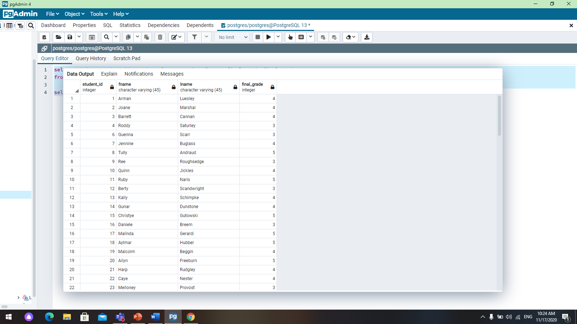

2. select student.student_id, student.fname, student.lname, final_grade.final_grade from student inner join grade on grade.grade_id=student.grade_id inner join final_grade on grade.final_id=final_grade.final_id where final_grade=5;

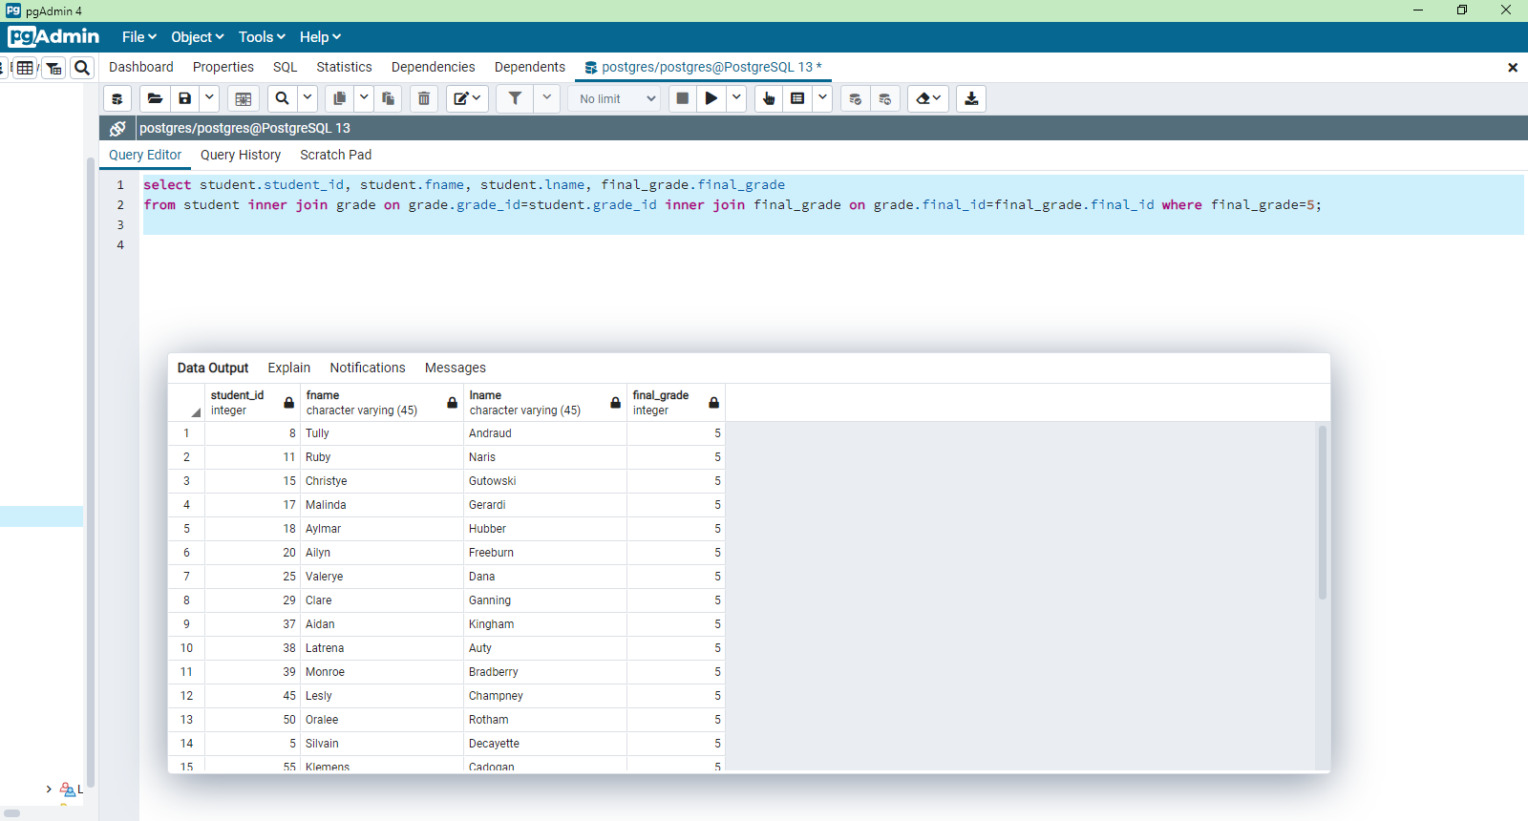

3. select count (attendance.description) from attendance inner join student on student.attendance_id=attendance.attendance_id where attendance.description='absent' group by attendance.description;

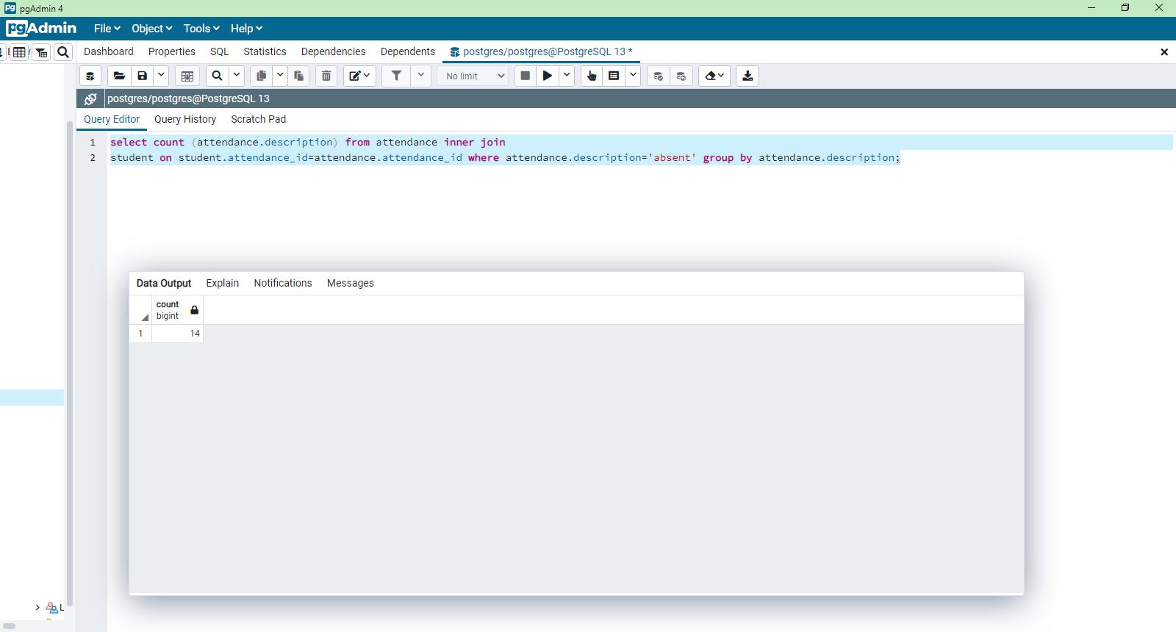

4. select student.student_id, student.fname, student.lname, parent.fname, parent.lname from parent inner join student on parent.parent_id=student.parent_id where student.date_birth between '2001-01-01' and '2002-12-31';

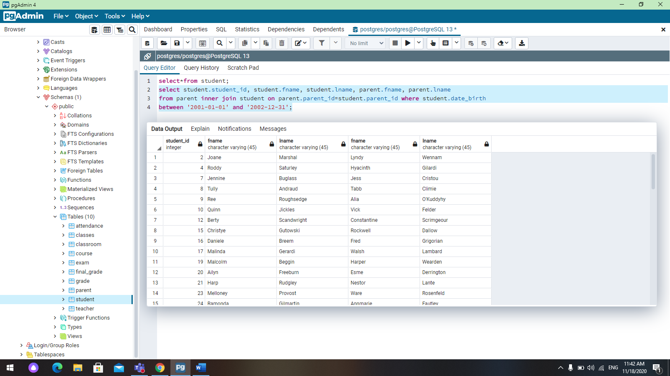

5. select student.student_id, student.fname, student.lname, exam.exam_name from exam left join student on exam.exam_id=student.exam_id where exam.description in ('variant 1');

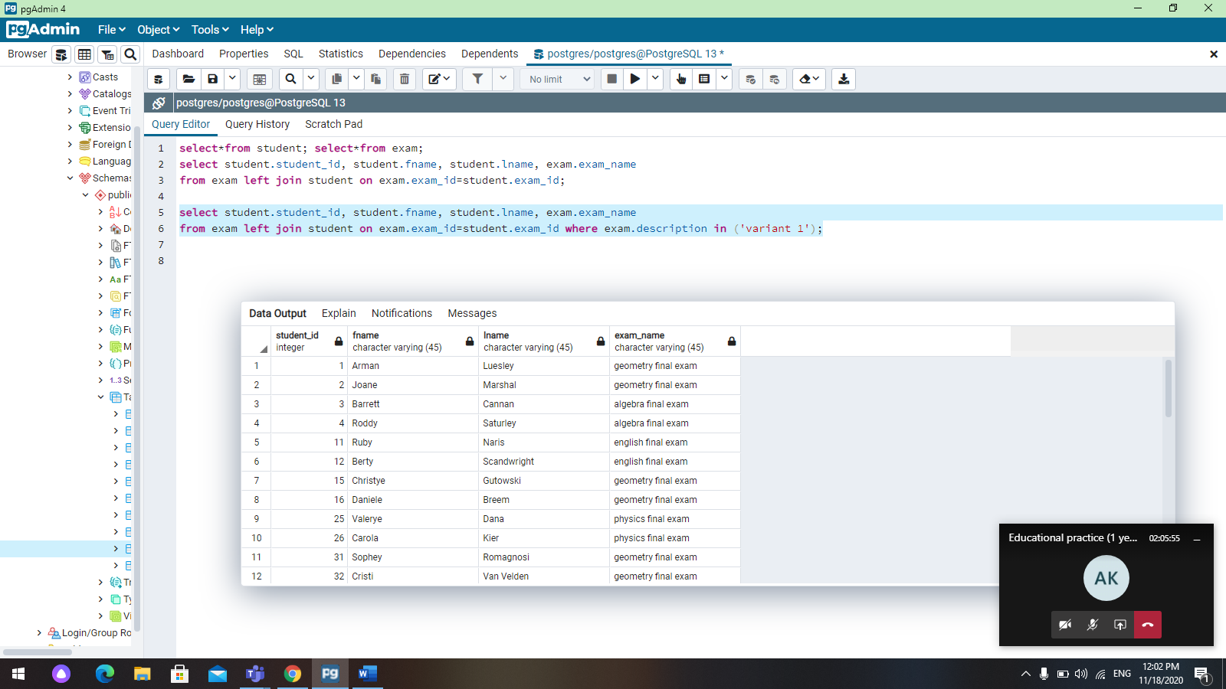

6.

select classes.class_name, teacher.fname, teacher.lname, teacher.course_id from classes right join teacher on teacher.teacher_id=classes.teacher_id;

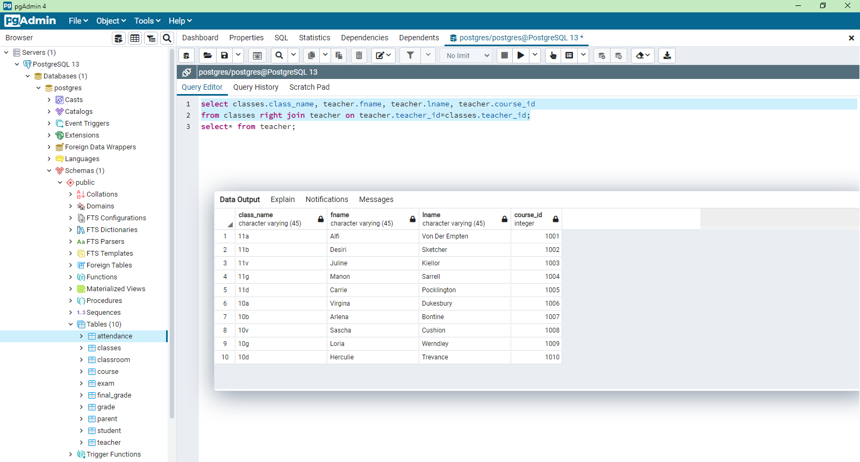

7.

select *from classroom full outer join classes on classes.classroom_id=classroom.classroom_id;

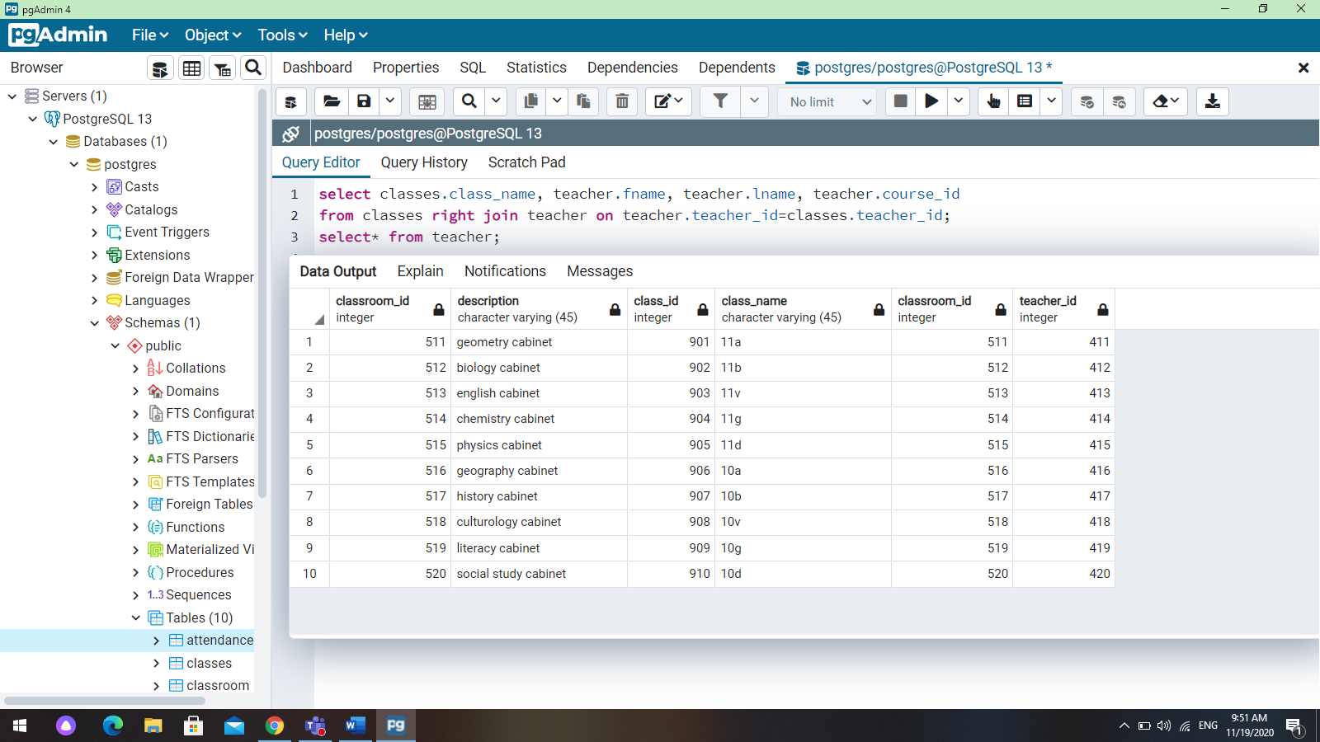

8.

select student.fname, student.lname, classes.class_name, teacher.fname, teacher.lname from student inner join classes on student.class_id=classes.class_id inner join teacher on classes.teacher_id=teacher.teacher_id where teacher.date_birth>'01-01-1985';

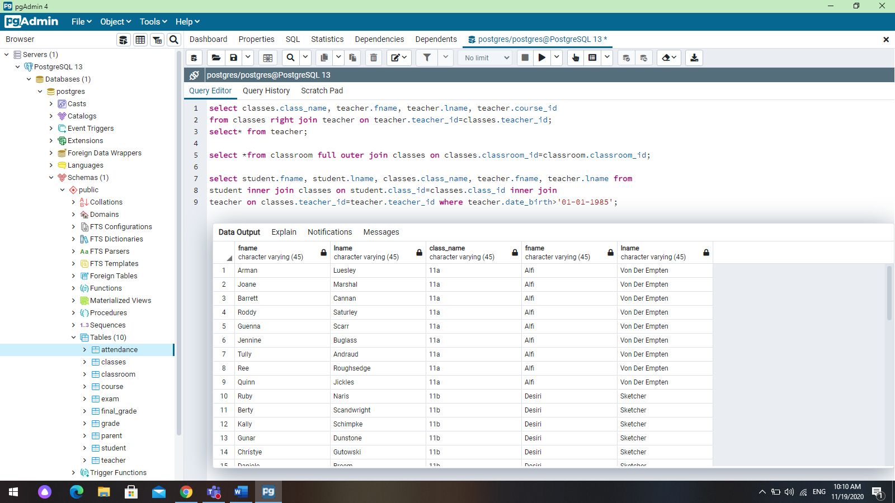

9.

select student.fname, student.lname, student.date_birth, parent.parent_id from parent right join student on parent.parent_id=student.parent_id where student.fname like 'A%';

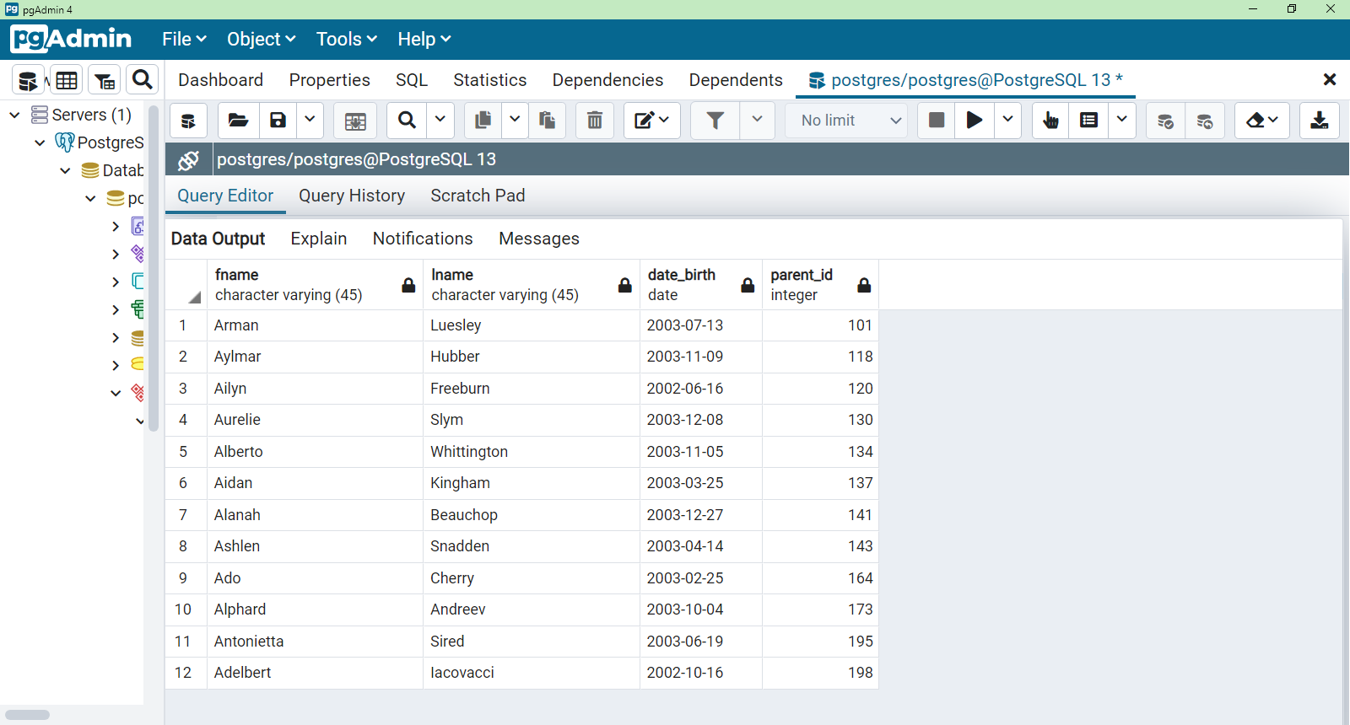

10.

select avg(final_grade) from final_grade where course_name='geometry';

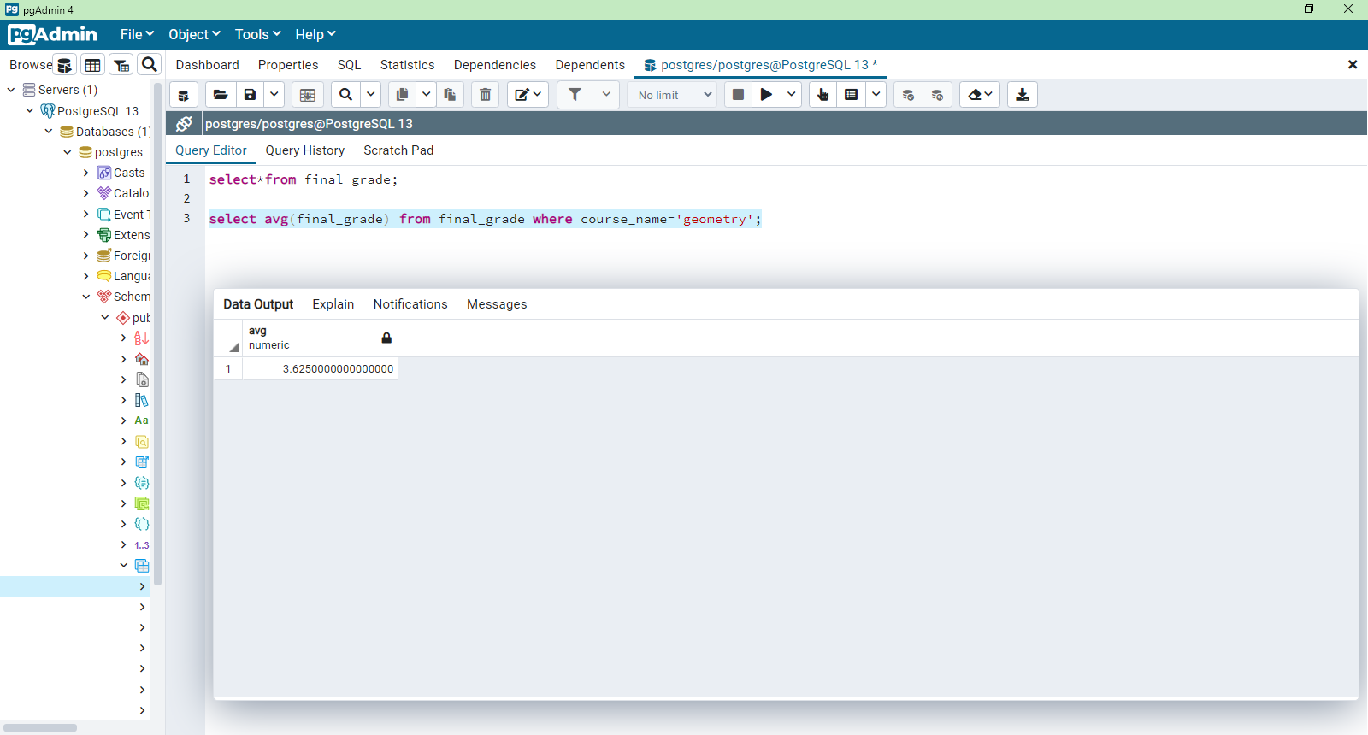

11. select student.fname, student.lname, teacher.teacher_id, course.course_name from student inner join classes on student.class_id=classes.class_id inner join teacher on classes.teacher_id=teacher.teacher_id inner join course on teacher.course_id=course.course_id;

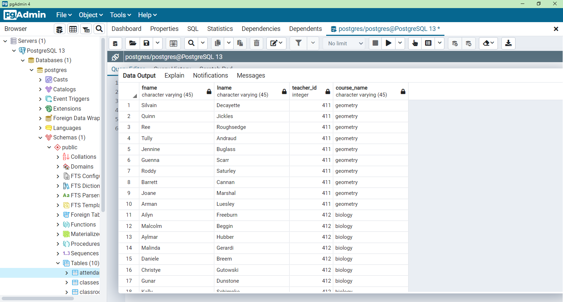

**7-task.**

1. select student.fname, student.lname, grade.grade_1 from student, grade where student.grade_id=grade.grade_id and grade_1>(select grade_1 from grade where grade_id=607 );

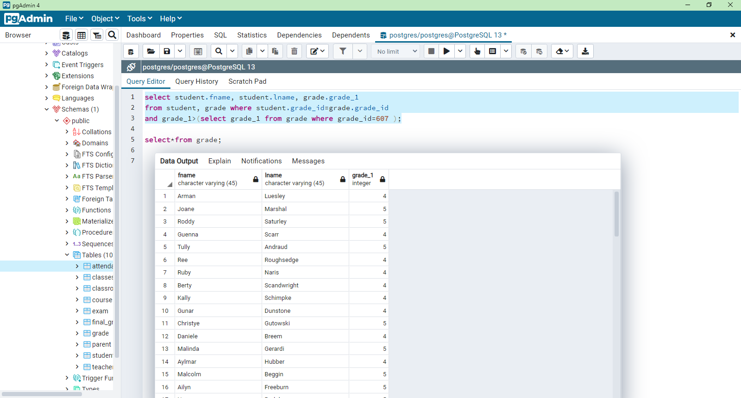

1. select student.fname, student.lname, attendance.date, attendance.description from student, attendance where student.attendance_id=attendance.attendance_id and description=(select description from attendance where attendance_id=312 );

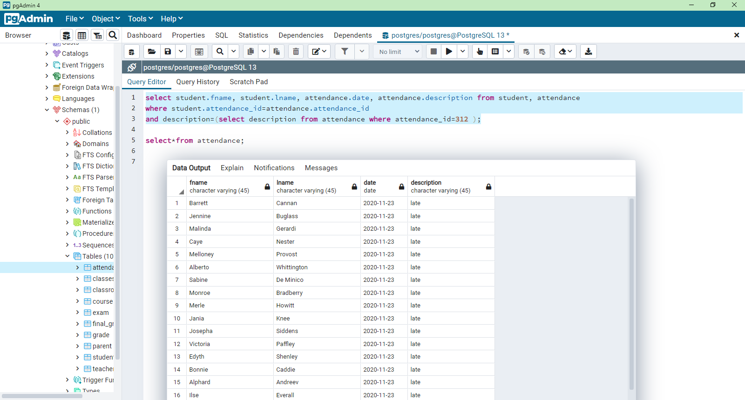

3. select grade_id, description, grade_1, grade_2, grade_3, grade_4, grade_5, final_id from grade where final_id IN (select final_id from final_grade where course_name='algebra' );

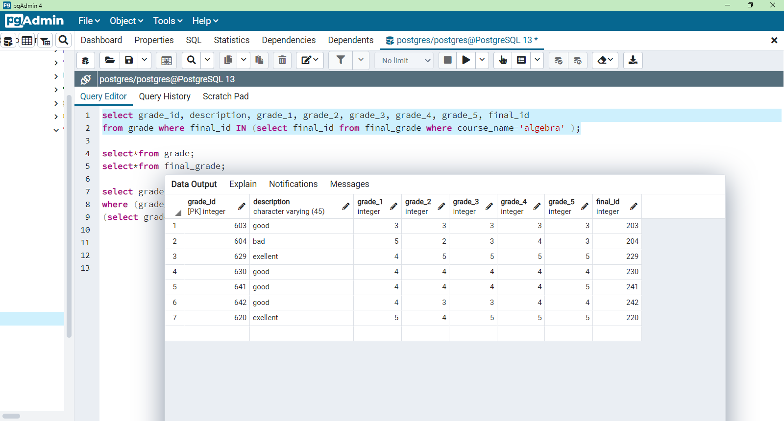

4. select student_id, fname, lname, grade_id, student_email from student where grade_id=any(select grade_id from grade where description='bad' );

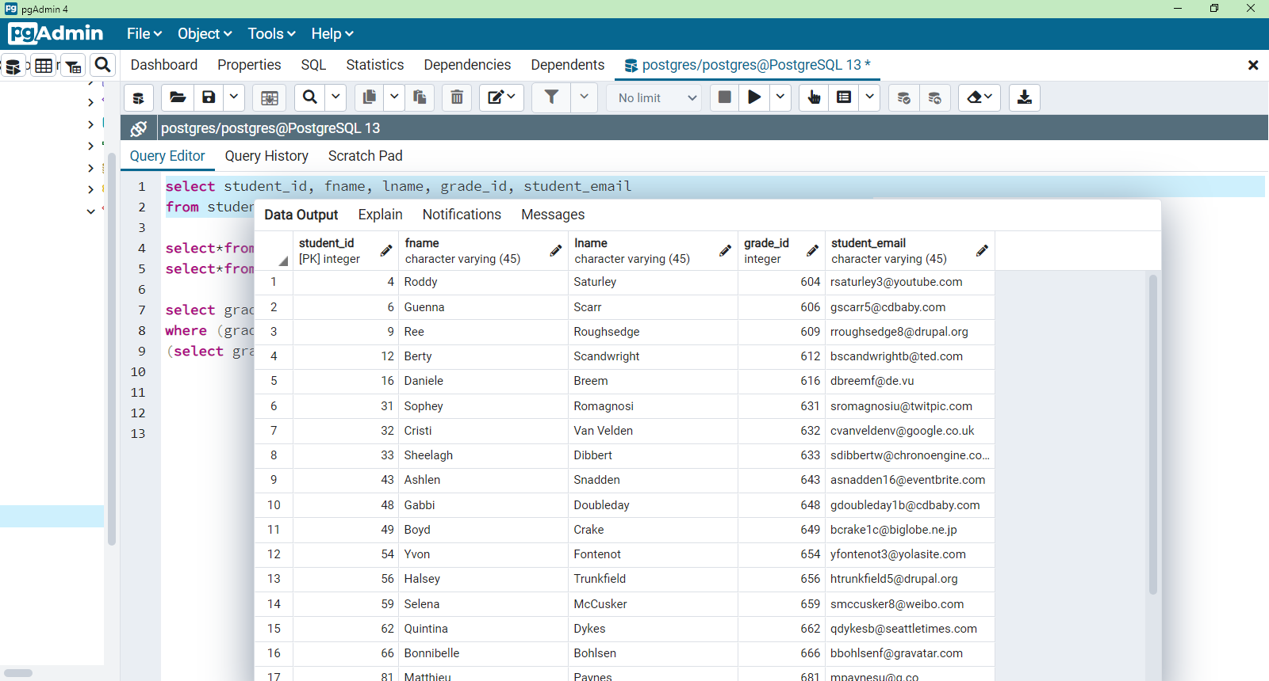

5.

select grade_id, description, grade_1, grade_2, grade_3, grade_4, grade_5, final_id from grade where final_id NOT IN (select final_id from final_grade where course_name='geometry' );

