**For questions Q 1 ∼ Q 5, consider a rapid COIVD-19 test kit A. Suppose 2.2% of people in a town are infected with COVID-19. Let C19 be the event that a person in the town is infected with COVID-19. Let P(C19) = 0.022 and P(Ĉ19) be the priori probabilities of infected and not infected COVID-19, correspondingly. Let A+ and A− be the events that the test result using the test kit A are positive and negative, respectively. The test kit A has the specificity, (ability to correctly identify a true negative sample) to be 97.9%, i.e., 2.1% of people who are not infected incorrectly tested positive. The test kit A has the sensitivity, (ability to correctly identify a true positive sample) to be 92.5%, i.e., 7.5% of people who are actaully infected incorrectly tested negative.**

P(C19) = 0.022

P(Ĉ19) = 0.978

P(A+/C19) = 0.925

P(A-/C19) = 0.075

P(A-/Ĉ19) = 0.979

P(A+/Ĉ19) = 0.021

**Q 1. Suppose you encountered a random person q in the town. Based on prior knowledge, what decision can be drawn about the COVID-19 infection?**

The maximum priori knowledge (MPK) hypothesis can be found by

MPK(q) = argmax P(c)

|C| = 2 because C = {c1, c2}

Since P(C19) = 0.022 and P(Ĉ19) = 0.978, the person did not infected with Covid-19

**Q 2. Suppose a random person q in the town is tested positive using the test kit A. Based on likelihood, what decision can be drawn about the COVID-19 infection? In other words, what is the maximum likelihood (ML) hypothesis?**

The maximum likelihood (ML) hypothesis given the evidence E can be found by

ML(q) = argmax P(E/c)

Since [P(A+/C19) = 0.925] >[ P(A+/Ĉ19) = 0.021] the person is infected with COVID-19.

**Q 3. Suppose a random person q in the town is tested positive using the test kit A. Based on the Bayes decision rule, what decision can be drawn about the COVID-19 infection? In other words, what is the maximum a posteriori (MAP) hypothesis?**

The maximum a posteriori (MAP) hypothesis given the evidence E can be found by

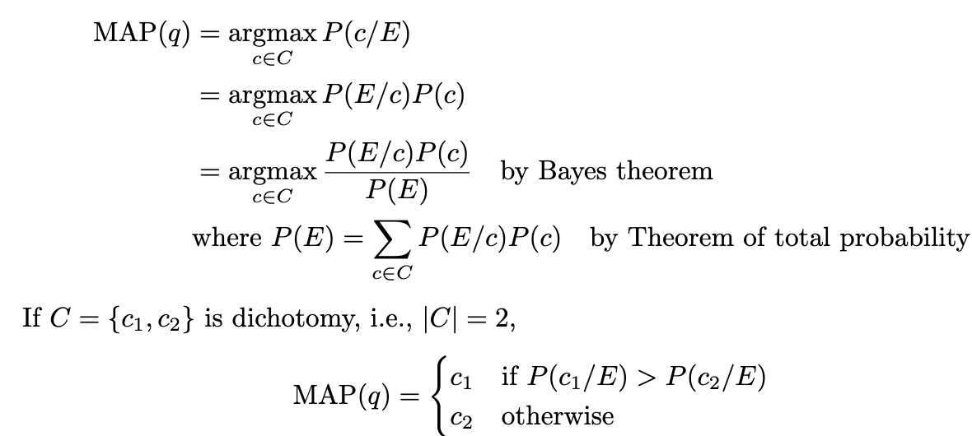

**Since** [P(A+/C19)P(C19) = 0.925 x 0.022 ≈ 0.02035] < [P(A+/Ĉ19)P(Ĉ19) = 0.021 x 0.978 ≈ 0.020538], the person is not infected with COVID-19.

**Q 4. Compute the posteriori probability that a random person q in the town is infected with COVID-19 when the test kit A shows positive.**

P(C19/A+) = P(A+/C19)P(C19)/P(A+) = P(A+/C19)P(C19) / P(A+/C19)P(C19) + P(A+/Ĉ19)P(Ĉ19) = 0.925 x 0.022 / 0.925 x 0.022 **+** 0.021 x 0.978 = 0.02035/(0.02035+0.020538) = 0.02035/0.040888 = 0.4977

**Q 5. Suppose the test using the kit A is conducted twice independently. Both test results are positive. Based on the Bayes decision rule, what decision can be drawn about the COVID-19 infection? What is the maximum a posteriori (MAP) hypothesis?**

Since the test is conducted independently, it can be assumed that

P(A+,A+/C19)= P(A+/C19)P(A+/C19)

Since [P(A+/C19)P(A+/C19)P(C19)=0.0188] > [P(A+/Ĉ19)P(A+/Ĉ19)P(Ĉ19) = 0.00043] the person is infected with COVID-19.

**For questions Q 6 ∼ Q 10, consider a table of the COVID-19 symptom probabilities. Possible symptoms of COVID-19 include the followings: Congestion or runny nose (Cg), Cough (Co), Diarrhea (Di), Fatigue (Fa), Fever or chills (FC), Muscle or body aches (Ma), and Sore throat (St). Each symptoms values are either ‘Y’ or ‘N.’ Let P(C19) and P(Ĉ19) be the priori probabilities of infected and not infected COVID-19, correspondingly.**

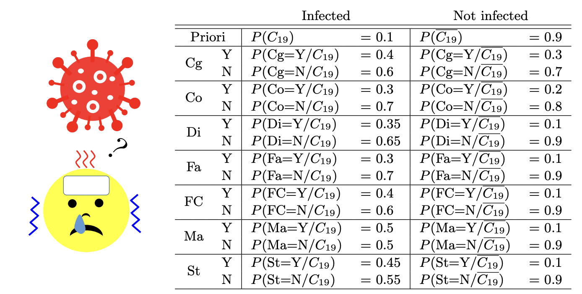

**Q 6. Compute the posteriori probability that a random person q is infected with COVID-19 when the person has congestion: P(C19/Cg=Y).**

P(C19/Cg = Y) = P(Cg = Y/C19)P(C19)/P(Cg = Y) = P(Cg = Y/C19)P(C19)/(P(Cg = Y/C19)P(C19) + P(Cg = Y/Ĉ19)P(Ĉ19)) =

= 0.4 x 0.1/( 0.4 x 0.1+0.3 x 0.9) = 0.129

**Q 7. Based on likelihood with two na¨ıve assumptions that the priori probabilities are equal and each attribute is independent, what conclusion can you make most likely about the COVID-19 infection if the person has (Cg = Y, Co = Y, Di = N, Fa = Y, FC = N, Ma = Y, St = N)? In other words, what is the na¨ıve maximum likelihood (ML) hypothesis or what does the na¨ıve likelihood classifier (NLC) classify?**

The na ̈ıve likelihood classifier (NLC) given the evidence q= (Y, Y,N,Y,N,Y,N) can be found by

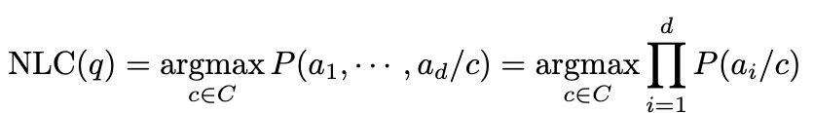

P(Cg,Co,Di,Fa,FC,Ma,St/C19) = (Cg = Y/C19)(Co = Y/C19)(Di = N/C19)(Fa = Y/C19)(FC = N/C19)(Ma = Y/C19)(St = N/C19) = 0.4 x 0.3 x 0.65 x 0.3 x 0.6 x 0.5 x 0.55 = 0.003861

P(Cg,Co,Di,Fa,FC,Ma,St/Ĉ19) = (Cg = Y/Ĉ19)(Co = Y/Ĉ19)(Di = N/Ĉ19)(Fa = Y/Ĉ19)(FC = N/Ĉ19)(Ma = Y/Ĉ19)(St = N/Ĉ19) = 0.3 x 0.2 x 0.9 x 0.1 x 0.9 x 0.1 x 0.9 = 0.0004374

Therefore, the person with these symptoms is infected COVID-19.

**Q 9. Suppose that a person has (Cg = Y, Co = Y, Di = N, Fa = Y, FC = N, Ma = Y, St = N)? What does the na¨ıve Bayes classifier (NBC) classify about the COVID-19 infection?**

The na ̈ıve Bayes classifier (NBC) given the evidence q= (Y, Y,N,Y,N,Y,N) can be found by

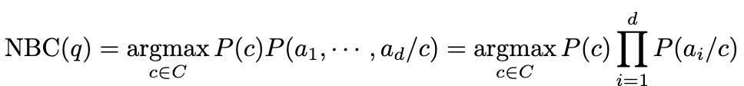

For infected, P(C19)(Cg = Y/C19)(Co = Y/C19)(Di = N/C19)(Fa = Y/C19)(FC = N/C19)(Ma = Y/C19)(St = N/C19) = 0.1 x 0.003861 = 0.0003861

For not infected, P(Ĉ19) (Cg = Y/Ĉ19)(Co = Y/Ĉ19)(Di = N/Ĉ19)(Fa = Y/Ĉ19)(FC = N/Ĉ19)(Ma = Y/Ĉ19)(St = N/Ĉ19) = 0.9 x 0.0004374 = 0.00039366

Therefore, the person with these symptoms is not infected COVID-19.