**CSCI 241 Database Final Project**

**Universe trade**

**Bekzhan Kassenov and Aigerim Bazarbayeva**

**Date**

1. **Overview**

The universe trading database system is an imaginary project targeted to buy and sale space objects in galaxy like stars or planets. User will be able to make buy or sale offers for space objects. We created web based platform with database for storing related data of user profiles, procedures of buying and selling of space objects in store and descriptions of stars and planets. Another feature will allow filtering and searching information about stars and planets. User also can add (insert), delete and update description of his profile. User also may retrieve data from system like star or planet description, other users profile, information about galaxies, etc.

1. **ER Model Design**

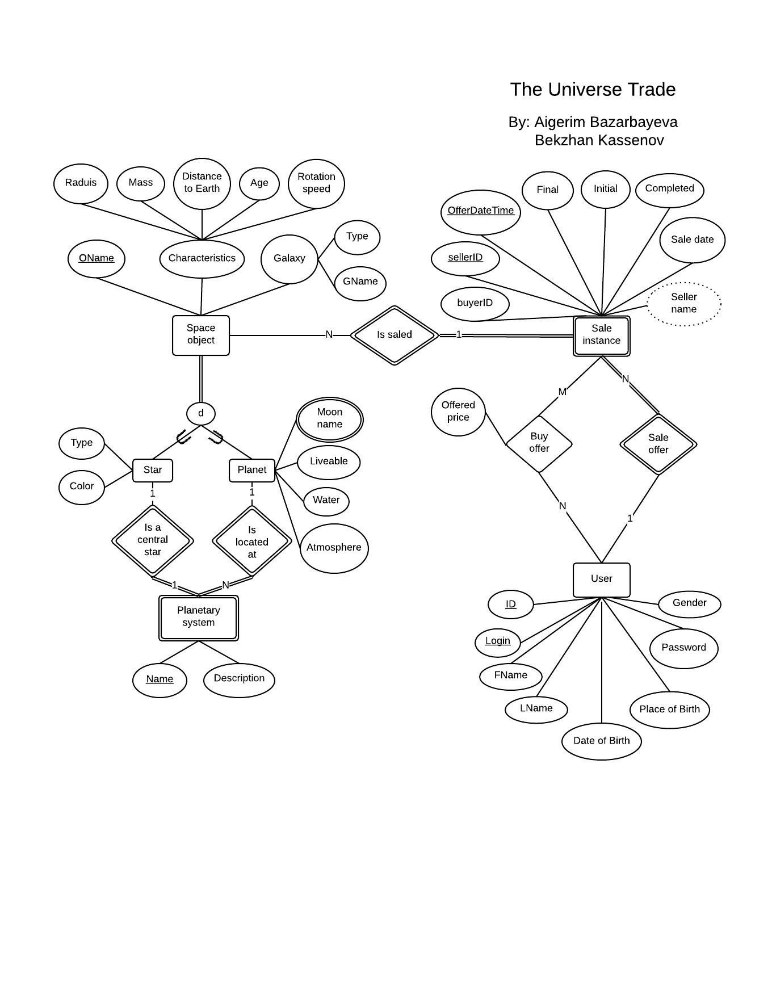

Fig. 1. EER diagram of UT project (the original diagram in PDF format is attached).

Here put your ER diagram, plus about 1 paragraph discussing it: for example, why you included or left things out, assumptions you made, etc.

There are a lot of changes in EER diagram. In comparison with initial version galaxy entity was removed due to its uselessness. User profile and sale instance entities were improved and completed with new attributes. For example we added gender, place of birth, first and last names. We mad assumption that we will implement sign in page later and on this stage we included 'login' attribute to 'user' entity.

1. **Relational Model Design**

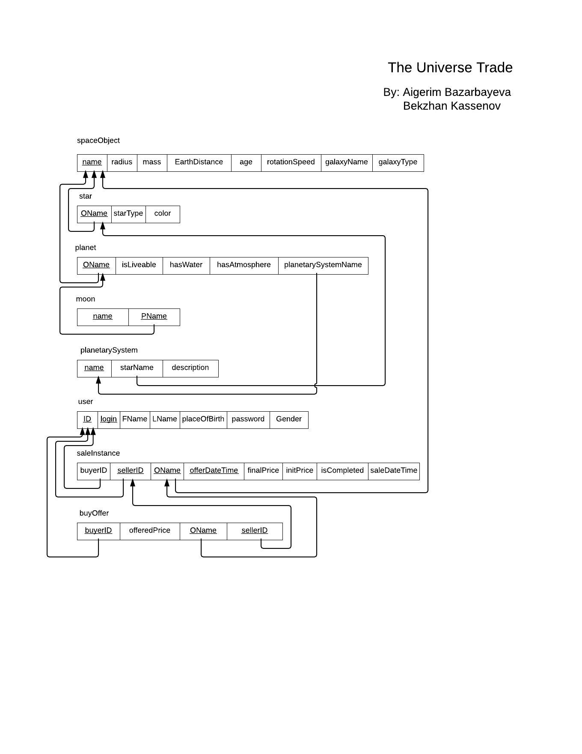

Fig. 2. Relational diagram of UT project (the original version in PDF format is attached).

Attributes of space object had to be included in 'star' and 'planet' tables. But in that case 'saleInstance' should contain 'starID' and 'planetID' attributes and one of them is always NULL. That's why we split these tables into 3: 'start', 'planet', 'spaceObject'. Also adding 'login' attribute to 'user' table made some queries during signing in, updating user profile and storing PHP session easier.

1. **UI Design**

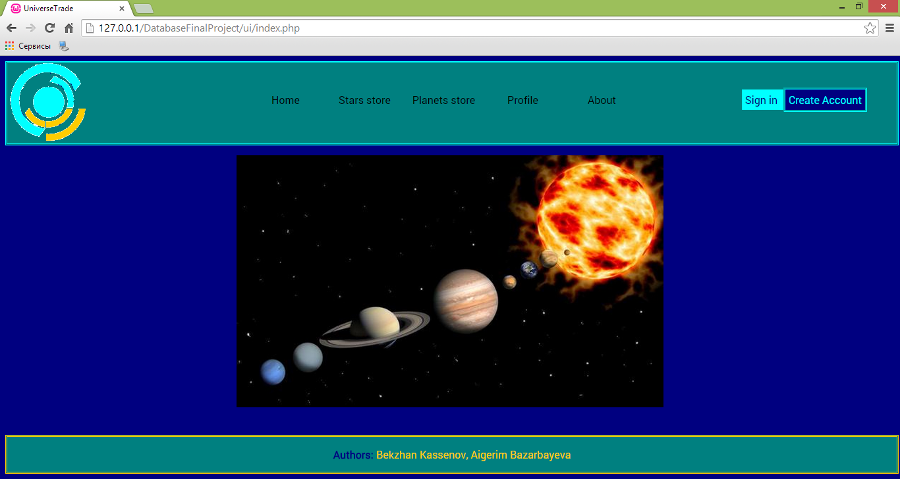

Fig. 3. Screenshot of home page.

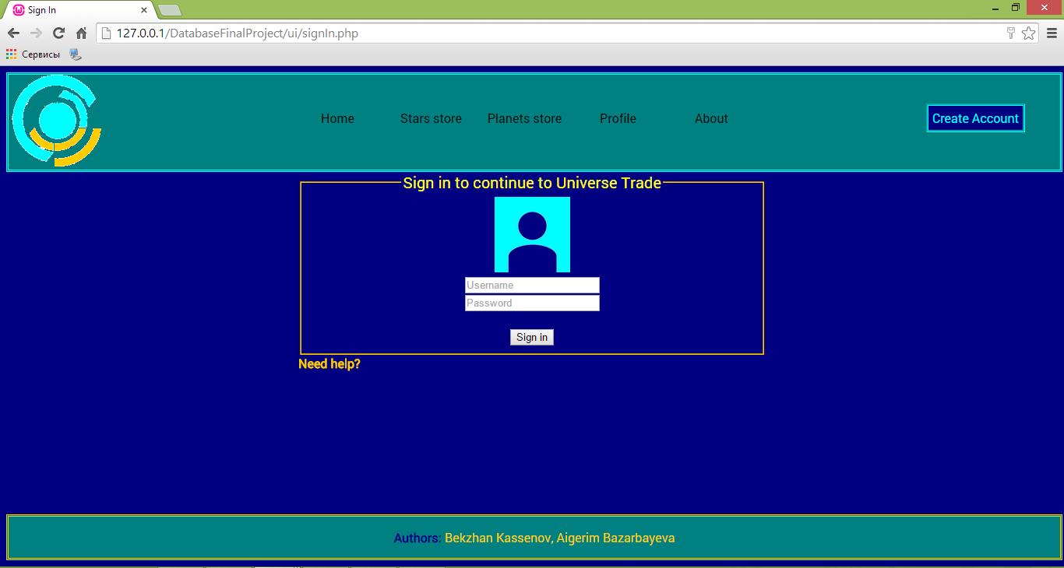

Fig. 4 Screenshot of Sign in page

When user is trying to sign in, web page should check some constraints like existence of user, correctness of username and password. This check was performed using PHP and "SELECT id, password FROM user WHERE user.login = $username" SQL statement.

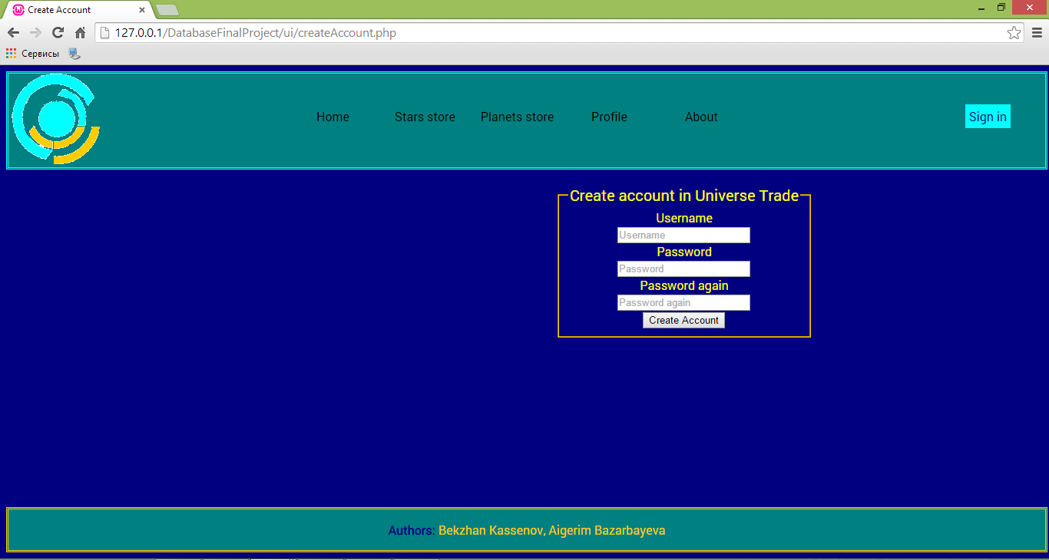Fig. 5. Screenshot of create account page

On create account we have to check several conditions like correctness of input data (using only PHP) and existence of this user (using "SELECT login FROM user WHERE user.login = $username" SQL statement) and inserting new user (user "INSERT INTO user (login, password) VALUES ($username, $password)");

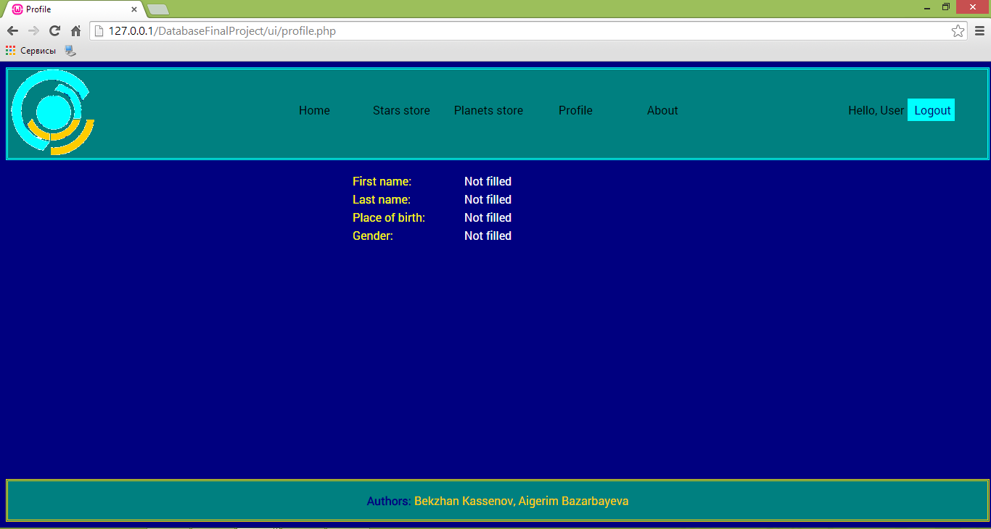

Fig. 6.Screenshot of Profile page

Data for profile page was populated using following SQL statement:

SELECT * FROM user WHERE user.id = $_SESSION['loggedin']

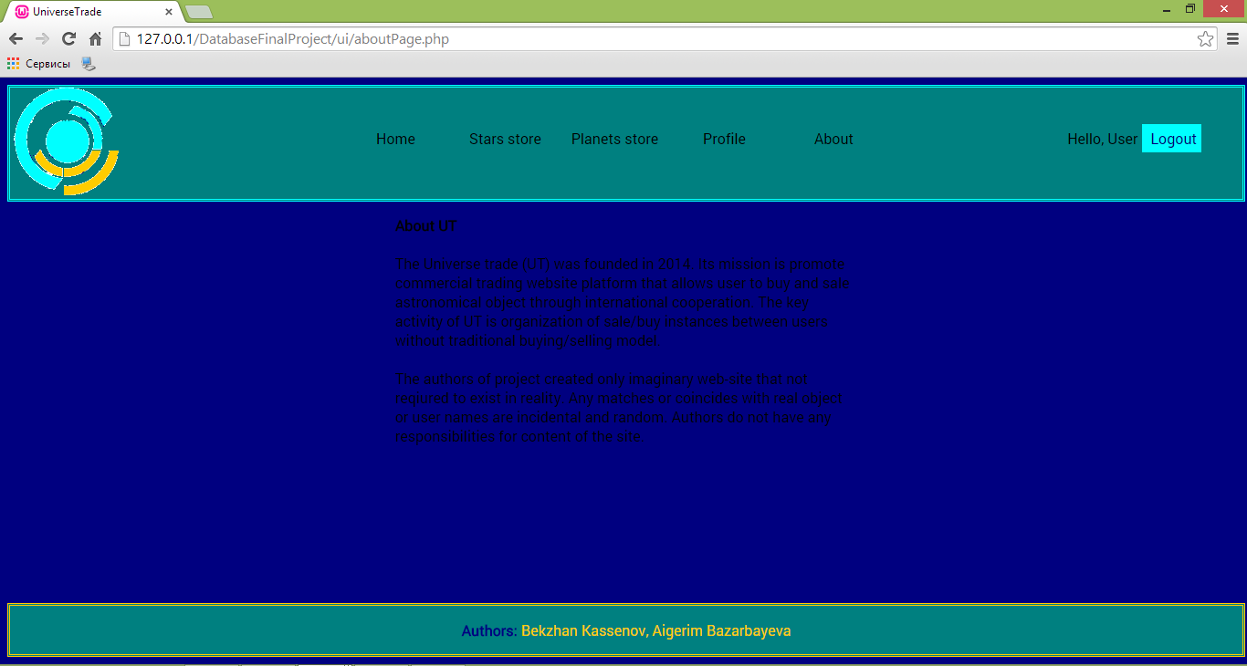

Fig. 7. Screenshot of about page.

1. **Implementation**

This application is based on PHP and uses PDO class for connecting to database. HTML + CSS was used for creating UI. Currently site is running on localhost.

During implementation we faced with some problems with sessions storing and they were solved using server file for storing them instead of MySQL database.

On current stage most part of implementation is done. The only uncompleted parts are start/planet stores and profile editing.

**Appendix**

Table creation script:

DROP TABLE IF EXISTS `sessions`;

DROP TABLE IF EXISTS `buyOffer`;

DROP TABLE IF EXISTS `saleInstance`;

DROP TABLE IF EXISTS `user`;

DROP TABLE IF EXISTS `moon`;

DROP TABLE IF EXISTS `planet`;

DROP TABLE IF EXISTS `planetarySystem`;

DROP TABLE IF EXISTS `star`;

DROP TABLE IF EXISTS `spaceObject`;

CREATE TABLE `spaceObject` (

`name` VARCHAR(255) NOT NULL DEFAULT '' COLLATE 'utf8_unicode_ci',

`radius` INT(11) NULL DEFAULT NULL,

`mass` INT(11) NULL DEFAULT NULL,

`EarthDistance` INT(11) NULL DEFAULT NULL,

`age` INT(11) NULL DEFAULT NULL,

`rotationSpeed` INT(11) NULL DEFAULT NULL,

`galaxyName` VARCHAR(255) NULL DEFAULT NULL COLLATE 'utf8_unicode_ci',

`galaxyType` VARCHAR(255) NULL DEFAULT NULL COLLATE 'utf8_unicode_ci',

PRIMARY KEY (`name`)

)

COLLATE='utf8_unicode_ci'

ENGINE=InnoDB;

CREATE TABLE `star` (

`OName` VARCHAR(255) NOT NULL DEFAULT '' COLLATE 'utf8_unicode_ci',

`starType` VARCHAR(255) NULL DEFAULT NULL COLLATE 'utf8_unicode_ci',

`color` VARCHAR(255) NULL DEFAULT NULL COLLATE 'utf8_unicode_ci',

PRIMARY KEY (`OName`),

CONSTRAINT `star_ibfk_1` FOREIGN KEY (`OName`) REFERENCES `spaceObject` (`name`)

)

COLLATE='utf8_unicode_ci'

ENGINE=InnoDB;

CREATE TABLE `planetarySystem` (

`name` VARCHAR(255) NOT NULL DEFAULT '' COLLATE 'utf8_unicode_ci',

`starName` VARCHAR(255) NULL DEFAULT NULL COLLATE 'utf8_unicode_ci',

`description` LONGTEXT NOT NULL DEFAULT '' COLLATE 'utf8_unicode_ci',

PRIMARY KEY (`name`),

INDEX `starName` (`starName`),

CONSTRAINT `planetarySystem_ibfk_1` FOREIGN KEY (`starName`) REFERENCES `star` (`OName`)

)

COLLATE='utf8_unicode_ci'

ENGINE=InnoDB;

CREATE TABLE `planet` (

`OName` VARCHAR(255) NOT NULL DEFAULT '' COLLATE 'utf8_unicode_ci',

`isLiveable` TINYINT(1) NOT NULL DEFAULT '0',

`hasWater` TINYINT(1) NOT NULL DEFAULT '0',

`hasAtmosphere` TINYINT(1) NOT NULL DEFAULT '0',

`planetarySystemName` VARCHAR(255) NULL DEFAULT NULL COLLATE 'utf8_unicode_ci',

PRIMARY KEY (`OName`),

INDEX `planetarySystemName` (`planetarySystemName`),

CONSTRAINT `planet_ibfk_1` FOREIGN KEY (`OName`) REFERENCES `spaceObject` (`name`),

CONSTRAINT `planet_ibfk_2` FOREIGN KEY (`planetarySystemName`) REFERENCES `planetarySystem` (`name`)

)

COLLATE='utf8_unicode_ci'

ENGINE=InnoDB;

CREATE TABLE `moon` (

`name` VARCHAR(255) NOT NULL DEFAULT '' COLLATE 'utf8_unicode_ci',

`Pname` VARCHAR(255) NOT NULL DEFAULT '' COLLATE 'utf8_unicode_ci',

PRIMARY KEY (`name`, `Pname`),

INDEX `Pname` (`Pname`),

CONSTRAINT `moon_ibfk_1` FOREIGN KEY (`Pname`) REFERENCES `planet` (`OName`)

)

COLLATE='utf8_unicode_ci'

ENGINE=InnoDB;

CREATE TABLE `user` (

`ID` INT(11) NOT NULL AUTO_INCREMENT,

`login` VARCHAR(255) NOT NULL DEFAULT '' COLLATE 'utf8_unicode_ci',

`fname` VARCHAR(255) COLLATE 'utf8_unicode_ci',

`lname` VARCHAR(255) COLLATE 'utf8_unicode_ci',

`password` VARCHAR(255) COLLATE 'utf8_unicode_ci',

`placeOfBirth` VARCHAR(255) COLLATE 'utf8_unicode_ci',

`gender` VARCHAR(255) COLLATE 'utf8_unicode_ci',

PRIMARY KEY (`ID`, `login`)

)

COLLATE='utf8_unicode_ci'

ENGINE=InnoDB;

CREATE TABLE `saleInstance` (

`buyerID` INT(11) NULL DEFAULT NULL,

`sellerID` INT(11) NOT NULL DEFAULT '0',

`OName` VARCHAR(255) NOT NULL DEFAULT '' COLLATE 'utf8_unicode_ci',

`initPrice` INT(11) NOT NULL,

`finalPrice` INT(11) NOT NULL,

`offerDateTime` DATETIME NOT NULL DEFAULT '0000-00-00 00:00:00',

`saleDateTime` DATETIME NULL DEFAULT NULL,

`isCompleted` TINYINT(1) NULL DEFAULT NULL,

PRIMARY KEY (`sellerID`, `offerDateTime`, `OName`),

INDEX `buyerID` (`buyerID`),

INDEX `OName` (`OName`),

CONSTRAINT `saleInstance_ibfk_1` FOREIGN KEY (`buyerID`) REFERENCES `user` (`ID`),

CONSTRAINT `saleInstance_ibfk_2` FOREIGN KEY (`sellerID`) REFERENCES `user` (`ID`),

CONSTRAINT `saleInstance_ibfk_3` FOREIGN KEY (`OName`) REFERENCES `spaceObject` (`name`)

)

COLLATE='utf8_unicode_ci'

ENGINE=InnoDB;

CREATE TABLE `buyOffer` (

`buyerID` INT(11) NOT NULL DEFAULT '0',

`offeredPrice` INT(11) NULL DEFAULT NULL,

`OName` VARCHAR(255) NOT NULL DEFAULT '' COLLATE 'utf8_unicode_ci',

`sellerID` INT(11) NOT NULL DEFAULT '0',

PRIMARY KEY (`buyerID`, `OName`, `sellerID`),

INDEX `OName` (`OName`),

INDEX `sellerID` (`sellerID`),

CONSTRAINT `buyOffer_ibfk_1` FOREIGN KEY (`buyerID`) REFERENCES `user` (`ID`),

CONSTRAINT `buyOffer_ibfk_2` FOREIGN KEY (`OName`) REFERENCES `spaceObject` (`name`),

CONSTRAINT `buyOffer_ibfk_3` FOREIGN KEY (`sellerID`) REFERENCES `saleInstance` (`sellerID`)

)

COLLATE='utf8_unicode_ci'

ENGINE=InnoDB;

CREATE TABLE `sessions` (

`id` varchar(32) NOT NULL,

`access` int(10) unsigned DEFAULT NULL,

`data` text,

PRIMARY KEY (`id`)

) ENGINE=InnoDB DEFAULT CHARSET=latin1;

Table creation script:

insert into spaceObject (name, radius, mass, EarthDistance, age, rotationSpeed, galaxyName) values ('morbi', 92.17, 15.47, 26.78, 96.45, 95.03, 'nibh');

insert into spaceObject (name, radius, mass, EarthDistance, age, rotationSpeed, galaxyName) values ('tristique', 87.73, 3.57, 11.74, 1.05, 98.79, 'aliquet');

insert into spaceObject (name, radius, mass, EarthDistance, age, rotationSpeed, galaxyName) values ('parturient', 54.46, 55.07, 20.41, 77.58, 96.71, 'etiam');

insert into spaceObject (name, radius, mass, EarthDistance, age, rotationSpeed, galaxyName) values ('mauris', 94.39, 88.93, 50.87, 37.51, 11.63, 'hac');

insert into spaceObject (name, radius, mass, EarthDistance, age, rotationSpeed, galaxyName) values ('sapien', 83.55, 32.14, 9.52, 61.58, 5.57, 'diam');

insert into spaceObject (name, radius, mass, EarthDistance, age, rotationSpeed, galaxyName) values ('quis', 73.31, 82.73, 98.02, 25.02, 5.57, 'tincidunt');

insert into spaceObject (name, radius, mass, EarthDistance, age, rotationSpeed, galaxyName) values ('pulvinar', 74.2, 49.11, 54.73, 90.32, 39.29, 'vestibulum');

insert into spaceObject (name, radius, mass, EarthDistance, age, rotationSpeed, galaxyName) values ('lacinia', 11.27, 97.93, 53.65, 27.74, 61.11, 'consequat');

insert into spaceObject (name, radius, mass, EarthDistance, age, rotationSpeed, galaxyName) values ('suspendisse', 76.57, 92.81, 26.93, 29.26, 76.06, 'donec');

insert into spaceObject (name, radius, mass, EarthDistance, age, rotationSpeed, galaxyName) values ('mauris', 63.29, 80.74, 81.83, 37.35, 43.97, 'pellentesque');

insert into spaceObject (name, radius, mass, EarthDistance, age, rotationSpeed, galaxyName) values ('dignissim', 34.47, 18.22, 8.82, 93.54, 71.87, 'nisi');

insert into spaceObject (name, radius, mass, EarthDistance, age, rotationSpeed, galaxyName) values ('vel', 90.79, 35.13, 31.91, 65.06, 45.76, 'felis');

insert into spaceObject (name, radius, mass, EarthDistance, age, rotationSpeed, galaxyName) values ('purus', 23.6, 44.12, 50.25, 85.96, 26.68, 'eu');

insert into spaceObject (name, radius, mass, EarthDistance, age, rotationSpeed, galaxyName) values ('nulla', 42.95, 37.26, 80.37, 72.05, 78.34, 'id');

insert into spaceObject (name, radius, mass, EarthDistance, age, rotationSpeed, galaxyName) values ('volutpat', 54.49, 11.87, 61.94, 39.13, 26.75, 'vulputate');

insert into spaceObject (name, radius, mass, EarthDistance, age, rotationSpeed, galaxyName) values ('elementum', 87.4, 25.32, 59.93, 5.39, 83.41, 'ipsum');

insert into spaceObject (name, radius, mass, EarthDistance, age, rotationSpeed, galaxyName) values ('diam', 2.46, 29.57, 84.67, 98.92, 56.25, 'in');

insert into spaceObject (name, radius, mass, EarthDistance, age, rotationSpeed, galaxyName) values ('cras', 83.13, 88, 48.79, 18.26, 42.15, 'vestibulum');

insert into spaceObject (name, radius, mass, EarthDistance, age, rotationSpeed, galaxyName) values ('nunc', 79.45, 81.02, 68.64, 98.08, 50.1, 'mauris');

insert into spaceObject (name, radius, mass, EarthDistance, age, rotationSpeed, galaxyName) values ('augue', 13.2, 70.54, 11.27, 40.04, 70.9, 'potenti');

insert into spaceObject (name, radius, mass, EarthDistance, age, rotationSpeed, galaxyName) values ('neque', 81.65, 35.17, 51.87, 49.09, 47.77, 'tristique');

insert into spaceObject (name, radius, mass, EarthDistance, age, rotationSpeed, galaxyName) values ('et', 70.55, 81.77, 71.5, 99.09, 95.4, 'pede');

insert into spaceObject (name, radius, mass, EarthDistance, age, rotationSpeed, galaxyName) values ('pede', 85.58, 50.73, 1.75, 18.42, 69.49, 'aenean');

insert into spaceObject (name, radius, mass, EarthDistance, age, rotationSpeed, galaxyName) values ('justo', 99.16, 20.95, 89.49, 7.06, 67.35, 'odio');

insert into spaceObject (name, radius, mass, EarthDistance, age, rotationSpeed, galaxyName) values ('duis', 88.41, 85.02, 26.85, 52.91, 64.12, 'felis');

insert into star (OName, starType, color) values ('morbi', 'est', 'morbi');

insert into star (OName, starType, color) values ('tristique', 'porta', 'tellus');

insert into star (OName, starType, color) values ('parturient', 'turpis', 'maecenas');

insert into star (OName, starType, color) values ('mauris', 'curabitur', 'proin');

insert into star (OName, starType, color) values ('sapien', 'velit', 'posuere');

insert into star (OName, starType, color) values ('quis', 'vivamus', 'sed');

insert into star (OName, starType, color) values ('pulvinar', 'non', 'posuere');

insert into star (OName, starType, color) values ('lacinia', 'facilisi', 'vestibulum');

insert into star (OName, starType, color) values ('suspendisse','feugiat', 'erat');

insert into star (OName, starType, color) values ('mauris', 'porta', 'ipsum');

insert into star (OName, starType, color) values ('dignissim', 'vitae', 'dui');

insert into star (OName, starType, color) values ('vel', 'luctus', 'fusce');

insert into star (OName, starType, color) values ('purus', 'accumsan', 'sem');

insert into star (OName, starType, color) values ('nulla', 'suspendisse', 'blandit');

insert into star (OName, starType, color) values ('volutpat', 'a', 'etiam');