class04.R

Айгерим

2024-01-20

# This is just a text file  
x <- 1:50  
  
plot(x,sin(x))

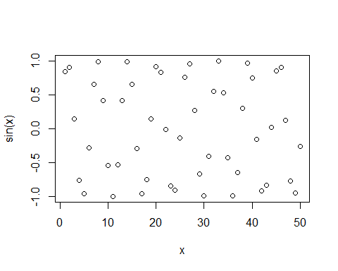

plot(x,sin(x), typ="l")

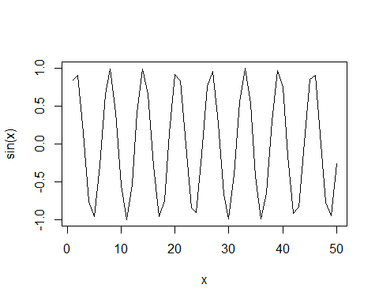

plot(x,sin(x), typ="l", col="blue")

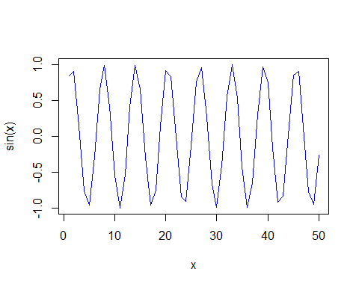

plot(x,sin(x), typ="l", col="blue", lwd=2, xlab="hello")

