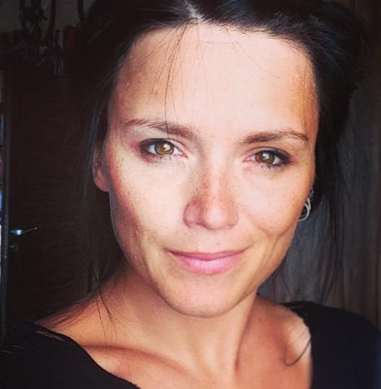
Anna Kułakowska Mosiężna 27/30, 53-441 Wrocław, Poland
+48 661 942 069

anna.kulakowska@gmail.com
Profile:

Experienced embedded software engineer, specialized in DVB and Set-Top-Boxes development / integration. Also passionate about graphics.

Main skills:

C, Java, C++

Employment history:

Senior Embedded Software Engineer
Alticast
01.2010 - now (4 years, 7 months)
Responsibilities: Development of software for Set-Top-Boxes: drivers, middleware, applications, GUI,
software integration for multiple hardware vendors,
cooperation with customers in international projects.
Used technologies: C, Java, Adobe Photoshop

Embedded Software Engineer
Osmosys / Vidiom
11.2006 - 12. 2009 (3 years, 2 months)
Responsibilities: Development of software for Set-Top-Boxes: middleware, applications, GUI,
design and development of graphical engine,
demos for international customers & exhibitions (IBC),
development of server side application (Content Management System for VOD).
Used technologies: C/C++, Java (JDE, JEE, JBoss, JSF), JNI, Perl, PostgreSQL

Embedded Software Developer
BenQ Mobile Wroclaw
08.2006 - 10.2009 (3 months - short period of employment due to company bankruptcy)
Responsiblities: Developing software for mobile phones produced in Germany for European market; implementation of security features for mobile phones (code name: Diamond).
Used technlogies: C++, APOXI, Agile

Embedded Software Developer
Pruftechnik Technology
09.2004 - 08.2006 (2 years)
Responsibilities: Design and development of software for laser based alignment devices,
user requirements specification, architecture & GUI design,
mathematical algorithms for measurements.
Used technologies: C++, Qt 3/4

Developer
Lower Silesia Voivodship Office – Informatics Department
01.2004 - 09.2004 (9 months)
Responsibilities: Designing and developing software tools for administration,
IT administration tasks.

Education:
1999 - 2003: Wroclaw University Of Technology, Faculty of Fundamental Problems of Technology,
Engineer

Additional Information:
Interests : Gliders, snowboarding, painting (digital & oil), tattoos, SF and fantasy novels.
Languages: English (IELTS exam 6.5), German (basic), Polish (native)
LinkedIn Profile: http://www.linkedin.com/in/annakulakowska

