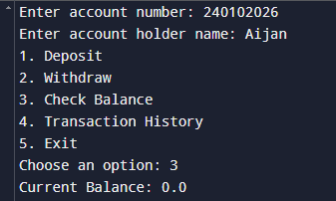1st request

Choose an option: 3.

**Action:**

Check Balance  
**Output:**  
Current Balance: 0.0

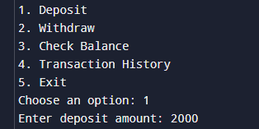2nd request

Choose an option: 1  
**Action:**

Deposit money

**Input:**

Enter deposit amount: 2000  
**Output:**  
Deposit of 2000 successful.

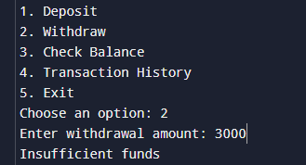3rd request

Choose an option: 2

**Input:**  
Enter withdrawal amount: 3000  
**Action:**

Withdraw money  
**Output:**  
Insufficient funds

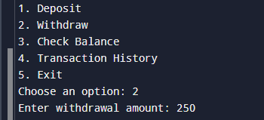4th request

Choose an option: 2

**Input:**  
Enter withdrawal amount: 250  
**Action:** Withdraw money  
**Output:**  
Withdrawal of 250 successful.

5th request

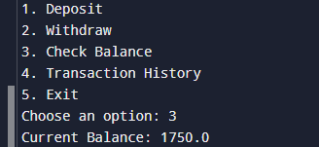  
Choose an option: 3  
**Action:**

Check Balance  
**Output:**  
Current Balance: 1750.0

6th request

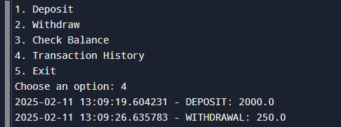

Choose an option: 4

**Action:**

View Transaction History  
**Output:**2025-02-11 13:12:01.466296 - DEPOSIT: 2000.0  
2025-02-11 13:12:10.378157 - WITHDRAWAL: 250.0

7th request

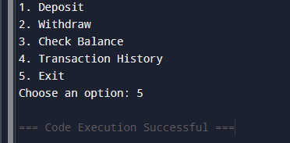

Choose an option: 5  
**Action:**

Exit program  
**Output:**  
=== Code Execution Successful ===