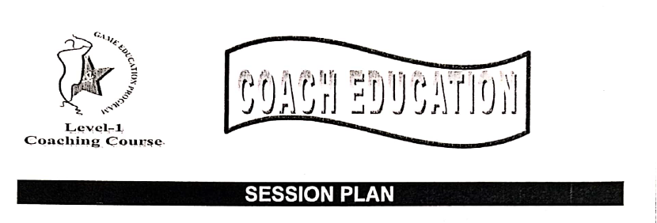

Produced by: PCB GAME EDUCATION PROGRAM  
THIS DOCUMENT IS PROPERTY OF National Cricket Academy

|  |  |  |  |
| --- | --- | --- | --- |
| **Coach: Shahzaib Nazar** | **Venue: Hill Park cricket Ground** | | **Date: 24/2/2020** |
| **No. of Players: 8** | **Age Group: U-12** | | **Duration: 40minutes** |
| **Skill Name: Close Catching** | | | |
| **Warm Up Routines:**  Start with Jogging, High knees, Back kicking, side to side move, And stretching. **(10 minutes)**  Warm up passing the ball game. **(5minutes)** | | | |
| **Skill Development** | | | |
| **Coaching Points of Skills:**  **(5minutes)**  (1)Stand on your toes, feet wider then  shoulder knees & back bend.  (2) Palm towards ball, fingers towards  Ground.  (3) Above waist height reverse cup. | **Reverse Chaining of Skill:**  **(10minutes)**  (1)Stand on your toes, feet width same as  Your shoulder width or little bit more then that  & under arm catches.  (2) Catches moving right side.  (3) Catches moving left side.  (4) Above waist height Reverse cup. | | **Progression of Skill:**  -Catches with partner right to left  With soft ball.  -Catches with the bat. |
| **Skill Related Game Rules: (5minutes)**  Partner Stand opposite to each other, and throw under arm ball, and try to catch maximum catches in given time. Eg (3minutes).  -Who will caught maximum catches will get 500 points.  If someone drops the catch will get 200 points. | | **Skill Related Game Layout:**  C:\Users\Sony\AppData\Local\Microsoft\Windows\INetCache\Content.Word\c31012.gif | |
| **Cool Down/Feedback:**  End with slow jogging and Static exercise for cool down the body parts. **(05 minutes)** | | | |
| **Equipment Required:**  Soft balls. (4)  Plate cones (8) | | **After Session Evaluation**  -It was good session  -Boys enjoyed a lot, | |