Module 1 Challenge

# Module Data Conclusions

Given the provided report data, there are 3 conclusions I have found after analyzing the crowdfunding campaigns.

1. One: The relationship between the outcome or the success of a crowdfunding campaign depends on the attempt to meet or exceed the organizations initial donation goal. Some trends that are found in the data were the primary categories Film & Video, Music, and Theater having the most successful campaigns. On the other hand, these categories also had the most failed, canceled, and least donated to campaigns respectively.
2. Two: The most successful campaign was for Plays; with an average of 187 donations. The least successful campaign, being World Music, only had an average of 3 successful donations. While Plays had over 130 failed donation attempts, the sub-category still, overall, was more successful than the 3 donations to World Music.
3. Three: Lastly, after analyzing the data between successful or failed campaigns and when the crowdfunding began, the most successful crowdfunding occurred between May and July; thus, spiking and dropping in August. Withing that same timeframe, the most failures for campaign happen in the month of August.

Some of the limitations of this dataset are:

1. The amount of campaigns happening for each category within the year of time frame is limited to this specifically online resource; while popular, there are other areas and ways campaigns can obtain money. The sample we have of data is also a limitation in most cases, but the range in years for the data shows and ample amount of information to come to a conclusion.

Other possible tables or graphs that could be used are:

* A box and whisker plot.
* A Pivot Table

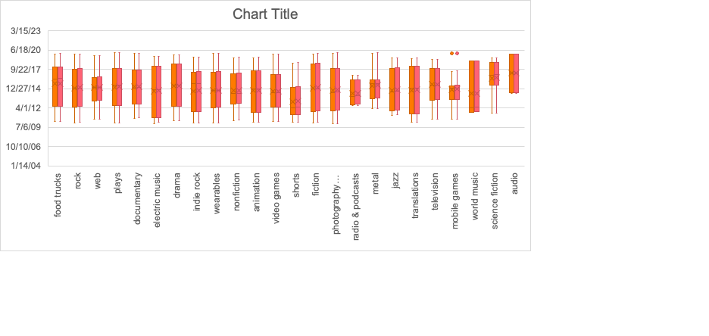

A box and whisker chat, shown above, can visualize the outliers per category when trying to analyze outcomes of average donations. The value a pivot table would show is to look at months and quarterly’s to the analyze the economic climate at the time or cultural influence.