Reflection

Kevin, Michael A, Nura and myself decided to go with doing the map for Auckland Council secenario because we all enjoy doing maps and it would be a good challenge but also fun to use API’s.

Research

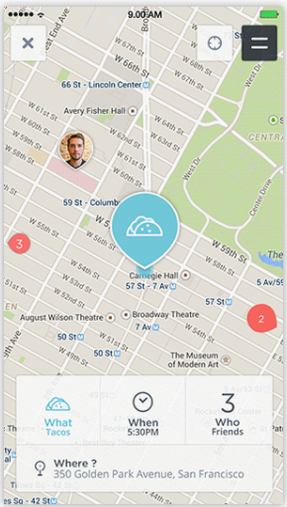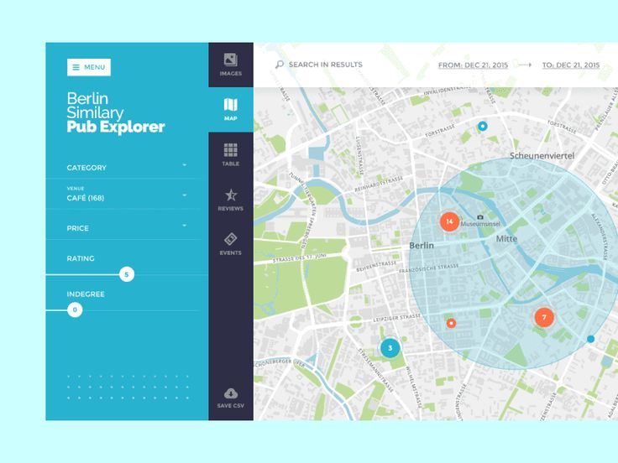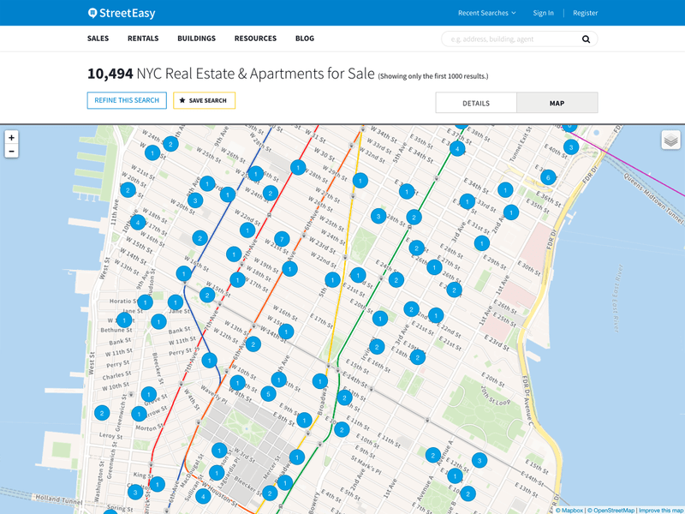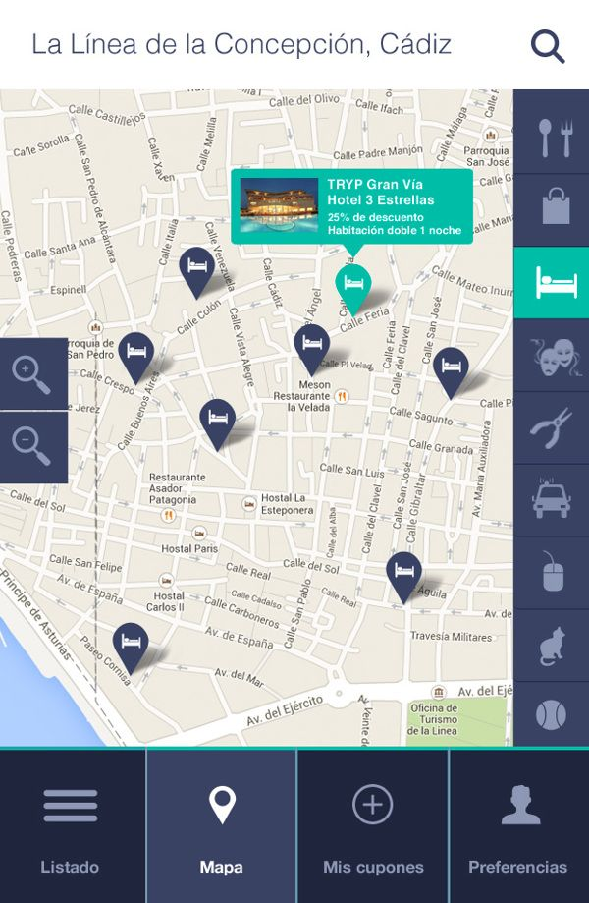Looked at a lot of map interfaces on google and got some inspiration from them.

1. Things they have in common are that they have well recognised icons and everything is well placed too. Easy to use and to understand that even 7 – 60 year old could use and that’s what our app should consider.
2. Information about each place (cafes, restuartants, parks etc.) Enough for the user to understand what it is and this will be scoured from the API.
3. Each map displayed above is different in its own way and we should do something different but also not too complex.
4. Colour plaettes are friendly colours (blues-dark and light, greens, orange, whites) which is nice and soft to the eye.

User Case

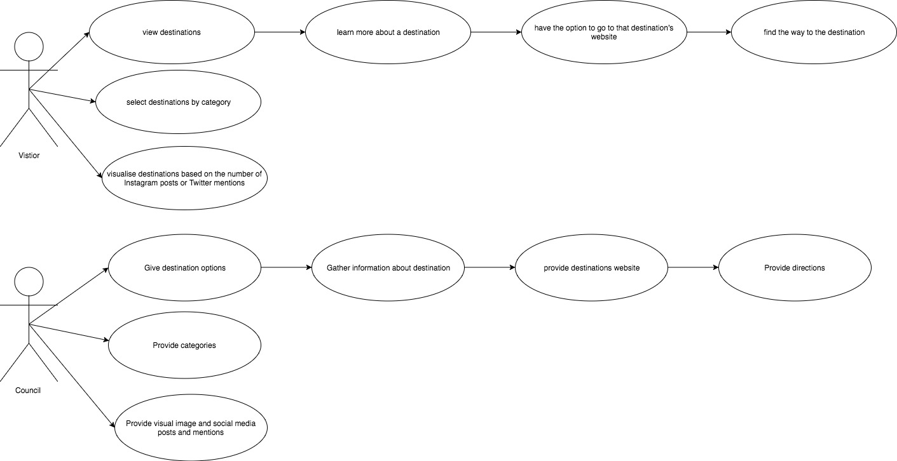

1. The use cases begins when the user wants to go to a local pub.
2. The system searches a set of appropriate pubs in the area.
3. The user selects a pub that user is interested in.
4. System displays information that user has selected.
5. The system generate direction and time to destination.
6. User arrives to destination.

3a. The system informs the user that pub they’ve selected no longer exsit.

3b. The system shows other options again.

MacHD:Users:845862900:Downloads:Activity_Diagram.png

Uxpin Mockup

**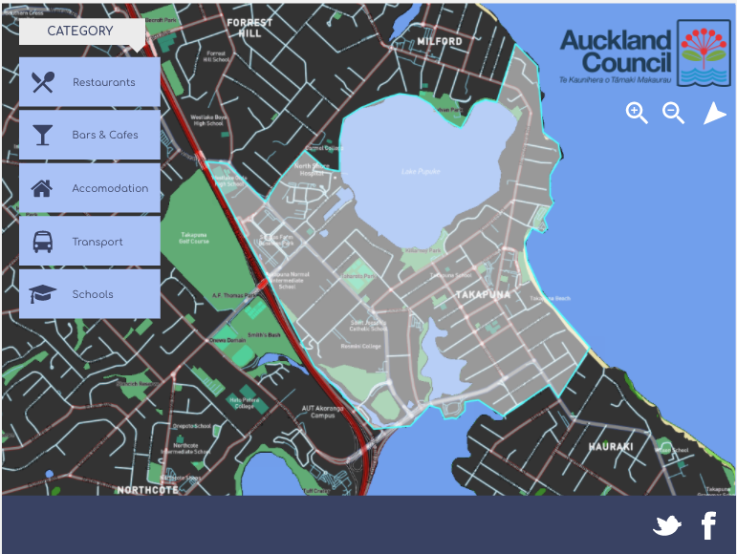**First Mockup

ZAME  
Layout looks good, seems like it would be pretty easy and straight forward to navigate, font on buttons look like a great choice, maybe a different colour scheme for the map itself would be easier to read.

It would look lovely with rounded buttons  
if you moved the buttons from the left side down to the free space in the blue bar at the bottom it would free up more space on the left for the map.

ANNE-MARIE  
Colours are really nice and easy on the eye.  
Good fonts are used.  
Contrast is good  
Icons are good

Perhaps play around with the nav buttons - they are good but they might be the only thing that needs to be looked at.  
A contrast behind the place names?

Second Mockup

**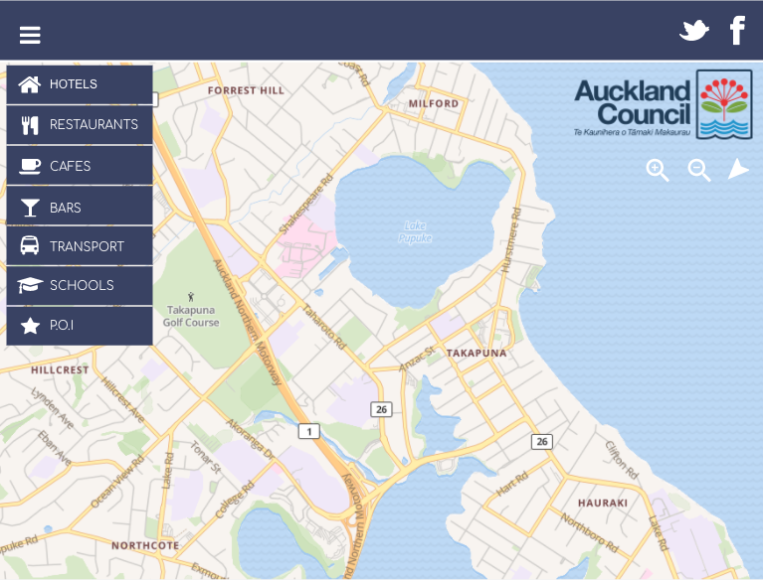**

WANDA  
Map – Like the lighter map option, when looking at accessibility lighter colours are easier for users to see.

The Nav at the top is also a good move as again is a convention for it to be at the top – users don’t have to learn something new.

Magnification tools on the right work well as natural eye-flow is left to right / top to bottom and again users are used to it being where you have put it.

Third Mockup

**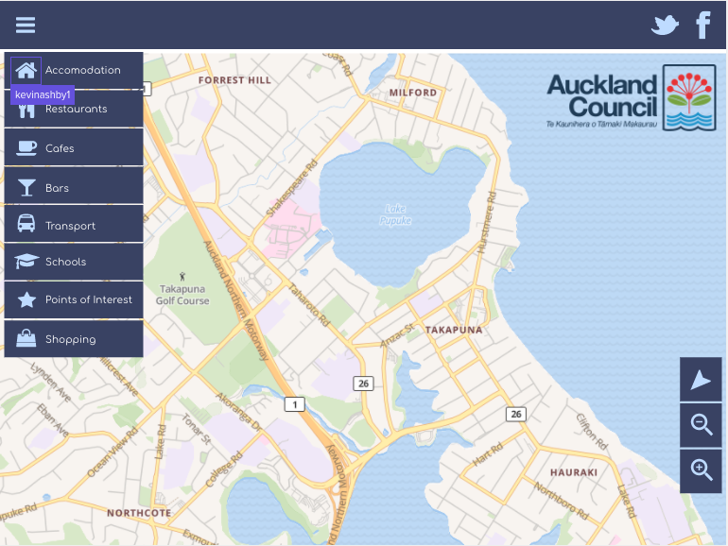**

JASON  
Good contrast with the use of white type on the blue background, icons are clear and identifiable, navigation appears clear and obvious. Icons used are traditional and recognisable. I agree with Kevins thoughts on using Title Case type rather than all caps.

TRACY  
Overall, the design is clean and fresh. Easy to see how to navigate the app.  
The lighter map feels easier to see, this would be dependant on the target market, as a younger target market possibly would prefer the darker.  
The typefaces chosen are simple, easy to read and elegant. I find upper and lower case friendlier and easier to read than Caps, so that was a good choice from my point of view.  
Restaurants, Cafes, Bars could possibly be joined in a group, as there is little distinction now days between cafes and restaurants.  
i didn’t understand the centre point icon, but that could just be something I have missed in life. :)

The street names etc on the map are great as they are really easy to read and clear to see.  
Eye flow is good, a natural flow to find all the icons etc.  
The dark blue is a great colour choice, as it is taken from the logo and gives the overall look sophistication and authority.  
It feels smart, simple and clear to use.

Group Contribution

Michael and Kevin worked on coding the application template. Nura and myself worked on paper work and uxpin together. Once template and paper work was done we broke off and focused on doing out own makers and changed some categories. Together the team worked real efficiently and had no major problems.

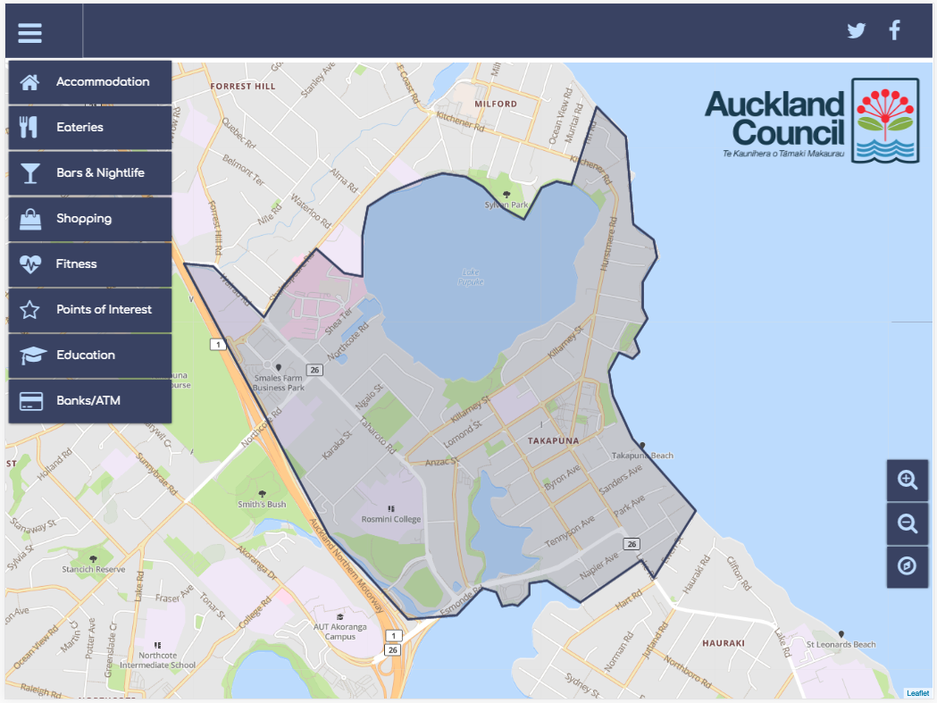Final Product

Code Validator HTML

Had a couple of errors with having the links into the header tag and one I didn’t screenshot was closing the drop down tag and leaving a gap between the end of the closing body and html.

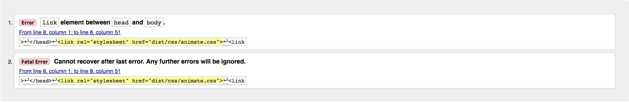

MacHD:Users:845862900:Desktop:Screen Shot 2017-10-12 at 1.09.07 PM.pngFixed up all the errors and ran it through the validator again and all clear now ☺

CSS Validator

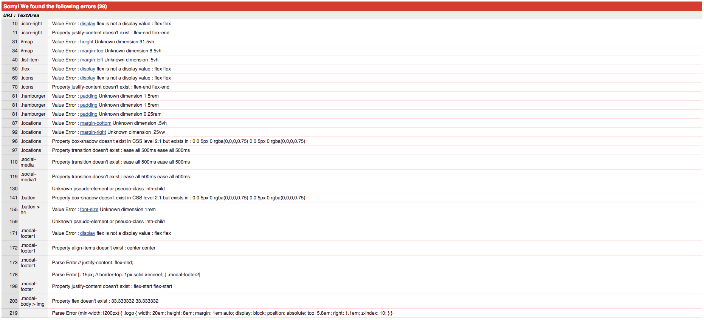

Had a few errors but the validator was version 2 and wouldn’t accept flex. So I decided to upload my scss file and it was accepted.



Javascript

Michael and Kevin started with doing the template the bounding perimeter of Takapuna and the dropdown hamburger.