Document 2: Web Application Architecture & Experimental User Flow
This document details the web system developed for the HCI credit underwriting experiment, including the database schema, API design, interface layout groups, and telemetry tracking capabilities.
__________________________________________________

1. Web Application Framework
The system is built as a modern, high-performance web application utilizing:
- Frontend: Next.js 15, React 19, and TailwindCSS for responsive layout.
- Database ORM: Prisma Client mapped to a PostgreSQL database hosted on Supabase.
- State Management: React state hooks coupled with local storage persistence.
- API Layer: Next.js API Routes (`/api/users`, `/api/responses`, `/api/survey`, `/api/chat`).
__________________________________________________

2. Dynamic Bilingual Support & Configuration
The application features a dynamic bilingual switcher (English/Vietnamese) located in the header bar.
- Mechanism: A custom `translations.json` dictionary maps all user interface strings, buttons, descriptions, and glossary tooltips.
- On-the-fly Translation: Underwriter profiles, AI chatbot interactions, and SHAP explanation texts are dynamically translated using a lookup pattern, minimizing client-side overhead and avoiding database synchronization issues.
__________________________________________________

3. UI Layout and Group Walkthroughs
The application implements three distinct interfaces tailored for each test group.

3.1. Group A (Black-box AI)
Displays only the client's financial profile and the AI's final recommendation (Approve/Reject) with a confidence level. No explanation charts or models are shown.
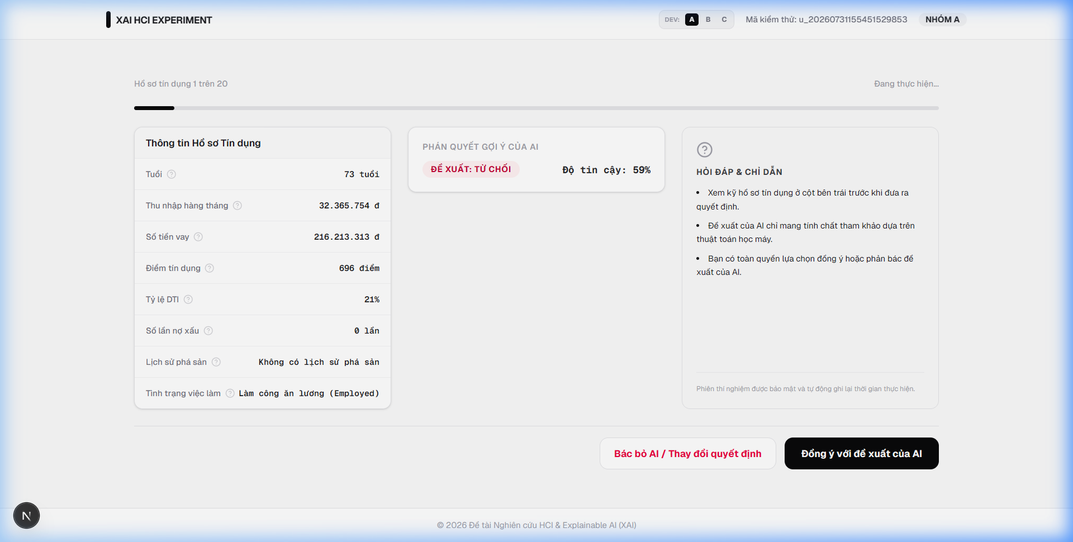
Hình: Group A Interface Layout
__________________________________________________

3.2. Group B (Visual XAI)
Displays the profile, AI recommendation card, and a basic SHAP Bar Chart illustrating the positive (emerald) and negative (rose) weights of attributes contributing to the prediction, along with a natural language summary.
[Hình ảnh không tìm thấy: ../assets/group_b_explanation.png]
__________________________________________________

3.3. Group C (Interactive & Contextual XAI)
An advanced dashboard designed to study cognitive overload. The interface changes the standard layout flow completely:
- SHAP Force Plot: Positioned prominently at the top to visualize opposing forces pushing the decision probability away from the 65% base rate.
- AI Recommendation Card & Natural Language Explanation: Located alongside the Force Plot.
- Detailed Analytics Row: Embeds the client credit profile, SHAP Bar Chart, and the Conversational AI Explainer (Gemini Chatbot).
- Decision Mathematics (Pearson Correlation Matrix): Located at the bottom to show advanced statistical indicators (ROC-AUC, Log-Loss, Standard Error).
[Hình ảnh không tìm thấy: ../assets/group_c_explanation.png]
__________________________________________________

4. Telemetry & HCI Tracking Mechanism
To capture granular human behavior before decisions are finalized, the system registers:
- Response Time (Decision Time): Tracks elapsed milliseconds from scenario mount to submission.
- Hover Events: Logs the count and total duration (seconds) that a user hovers over specific financial attributes (e.g. credit score tooltip lookup).
- Chatbot Logs: Records all user queries and AI responses (number of questions asked, chat history).
- NASA-TLX Survey: Collects six-dimensional workload ratings upon completing all 20 scenarios.
Data is saved to the PostgreSQL database on Supabase via the Prisma schema.

