Ergonomic Risk Factor Prediction
Per-rider risk profiling for last-mile quick-commerce delivery riders. Complete project report covering background, methods, results, web application, limitations, and reproducibility.
A single write-up of the whole project. Covers the background, every step the pipeline performs (with formulae, thresholds, and hyperparameters), the results, the web app, the limitations, and where every output number lives in the repo.
Contents
- Background
- What the project does
- The six risk factors
- Data sources
- Phase 1: Data cleaning
- Phase 2: Feature engineering
- Phase 3: Risk scoring
- Phase 4: Exploratory data analysis
- Phase 5: Statistical analysis
- Phase 6: Machine learning modelling
- Phase 7: Evaluation
- Sample and findings
- The web app
- Reproducibility
- Limitations
- Recommendations
- Where things live in the repository
- Index of output files
1. Background
Last-mile quick-commerce delivery riders for platforms like Blinkit and Zepto spend long hours on bikes, climb stairs, carry packages, and ride in heavy traffic. Over time this kind of work causes musculoskeletal disorders (MSDs): back pain, shoulder pain, wrist injuries, knee problems. The risk is not the same for every rider. Someone who is 22 and works 4 hours a day on a scooter is in a very different situation from a 45-year-old who works 10 hours a day on a motorbike with a handheld bag.
Standard ergonomic methods cover different facets of this problem. RULA and QEC handle the observational side (posture, body-region exposure), while NMQ, NASA-TLX, and Borg CR10 cover what the rider reports about pain, mental load, and perceived exertion. None of them on its own gives a complete picture. The project pulls all of them together into one per-rider profile across six ergonomic dimensions: Force, Repetition, Posture, Duration, Contact Stress, Vibration.
2. What the project does
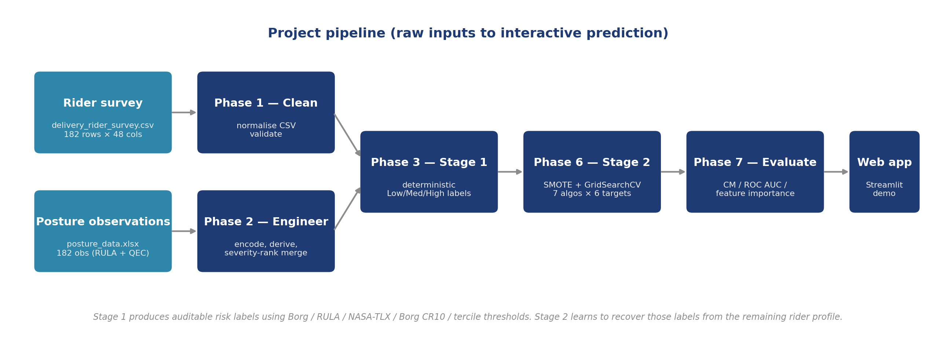
Figure 1. Pipeline overview: raw inputs to interactive prediction. The two-stage split keeps the Stage-1 risk labels auditable while letting Stage 2 generalise from the rider profile to new riders.
The pipeline runs in two stages.
Stage 1 computes Low/Medium/High labels for the six ergonomic risk factors using deterministic rules from standard ergonomic methods (operational thresholds on the Borg CR10 lifting rating, RULA action levels collapsed into three bands, sample terciles, and simple duration/deliveries-per-hour cuts). Stage 1 is the ground truth that Stage 2 tries to learn.
Stage 2 trains a supervised classifier per risk factor that maps a rider profile to that factor's Stage-1 label. Per-target feature exclusions remove the inputs that define the label so the model has to learn from the remaining profile rather than memorising the rule. Each classifier is evaluated by 5-fold stratified cross-validation.
The two-stage split lets us audit the labels (Stage 1 is auditable by hand) and at the same time produce a screening tool that can run on a rider's profile without re-applying the ergonomic worksheets.
The work is split across seven Jupyter notebooks:
- 01_data_cleaning normalises the raw CSV and validates row counts
- 02_feature_engineering encodes categoricals, derives composite
scores, and merges the posture observations into the survey by severity rank
- 03_risk_scoring applies standard thresholds to compute the six
Low/Medium/High labels per rider
- 04_eda produces demographics, NMQ prevalence, risk
distribution, discomfort-by-group, and correlation-heatmap figures
- 05_stats runs chi-square and logistic regression
- 06_modeling runs SMOTE + GridSearchCV across 7 algorithms per
target and keeps the best by F1 macro
- 07_evaluation produces confusion matrices, ROC curves, and
feature importance plots
The end product is a Streamlit web app where someone fills in the rider's questionnaire (plus optional RULA and QEC scores), clicks Predict, and reads six coloured risk levels.
3. The six risk factors
Each factor is computed in Phase 3 using a standard ergonomic method and binned into Low, Medium, or High.
Force. How hard the rider has to lift or push. We apply the Borg CR10 rating (used for perceived exertion) to the task-specific item that asks about lifting and carrying parcels, and bin the resulting 0-10 rating using operational thresholds: 0-3 Low, 4-6 Medium, 7-10 High. Borg CR10 does not carry official regulatory action levels the way RULA does; these cutoffs are a common practical convention.
Repetition. Deliveries per hour, computed as deliveries_num / work_hours_num. The earlier Phase 3 binning used pandas.qcut(q=3) into terciles, but the upper tercile boundary landed exactly on 35 / 9 = 3.889 (the worst real combination in the sample) and 55 of 182 riders tied at that value, all falling into Medium. We switched to fixed cuts at 2.5 and 3.75 so the worst case ends up in High. The trade-off is documented under Limitations.
Posture. RULA Table C, the final score from the standard RULA worksheet. RULA defines four action levels (AL1 score 1-2 acceptable, AL2 score 3-4 further investigation, AL3 score 5-6 investigation and change soon, AL4 score 7 investigation and change immediately). We collapse them into three bands to align with the other five factors: Low = AL1 (1-2), Medium = AL2 (3-4), High = AL3+AL4 combined (5+).
Duration. Continuous riding hours. 5 hours or less is Low, 6-7 is Medium, more than 7 is High.
Contact Stress. How much load presses against the rider's body. A composite of carrying mode (storage box, backpack, handlebar, handheld), working hours, and a small age multiplier. We bin into terciles.
Vibration. Vehicle type multiplied by working hours per day. Scooter is 1 and motor bike is 2, so a motorbike rider working 9 hours scores 18 (the worst observed). This is a proxy because we did not have per-rider accelerometer data; what we can measure is the relative exposure.
4. Data sources
4.1 Rider survey
data/raw/delivery_rider_survey.csv contains 182 self-administered responses. The questionnaire has 36 items grouped into the following modules:
- Q1-17: demographics, lifestyle, and work pattern. Gender, age
band, education band, region, marital status, delivery platform, job duration band, monthly income band, type of vehicle, mode of carrying deliveries, working hours per day band, working days per week band, deliveries per day band, duration of rest break, type of break, tobacco consumption category, alcohol consumption category.
- Q18: Nordic Musculoskeletal Questionnaire 12-month items. Nine
Yes/No items, one per body area: neck, shoulders, upper back, lower back, elbows, wrists/hands, hips/thighs, knees, ankles/feet.
- Q19: 7-day discomfort. Four Yes/No items for neck, lower back,
knees, wrists/hands.
- Q20-24: discomfort follow-ups. Five Yes/No items asking whether
the discomfort reduced delivery performance, whether the rider took leave, consulted a doctor or physiotherapist, whether long riding worsened the discomfort, and whether carrying heavy packages worsened it.
- Q25-30: NASA Task Load Index. Six 0-100 ratings for mental
demand, physical demand, time pressure, satisfaction with performance, effort, and frustration/stress.
- Q31-36: Borg CR10 perceived exertion. Six 0-10 ratings for
overall effort, leg tiredness, breathing effort, lifting/carrying parcels, traffic/weather stress, and end-of-shift exhaustion.
After cleaning, the file contains 182 rows and 48 columns.
4.2 Posture observations
data/raw/posture_data.xlsx contains 182 ergonomic observation rows spread across the workbook's sheets. Each row carries:
- 11 RULA components: upper_arm, lower_arm, wrist,
wrist_twist, neck_position, trunk_position, legs, muscle_a, force_a, muscle_b, force_b.
- 3 RULA derived scores: rula_table_a (Group A score),
rula_table_b (Group B score), rula_table_c (final action-level score).
- 8 QEC scores: qec_back, qec_shoulder_arm, qec_wrist_hand,
qec_neck, qec_driving, qec_vibration, qec_work_pace, qec_stress.
The observation rows do not carry rider identifiers. The pairing to the survey is the severity-rank merge described in §6.6.
5. Phase 1: Data cleaning
Phase 1 (notebooks/01_data_cleaning.ipynb) performs the following:
- Reads the raw CSV with pandas.read_csv.
- Drops rows where every cell is empty.
- Strips leading and trailing whitespace from every cell.
- Normalises "Yes"/"yes"/"YES" to "Yes" and "No"/"no"/"NO" to "No".
- Validates that all expected categorical answers fall within the
permitted option set and reports any out-of-set values.
- Writes data/processed/cleaned.csv.
No imputation is performed at this stage. Missing values, if any, are left as NaN so Phase 2 can decide how to handle them on a per-column basis.
6. Phase 2: Feature engineering
Phase 2 (notebooks/02_feature_engineering.ipynb) builds data/processed/model_ready.csv (182 rows by 121 columns).
6.1 Ordinal encodings
A machine-learning model cannot work directly with text answers like "25-35" or "Degree". We convert each ordered category into a number, preserving the order. For example, the age band gets a code from 0 (under 25) to 3 (46 or older), and similar codes are assigned to education, income, job duration, hours per day, days per week, deliveries per day, and rest-break duration:
- age_ord: <25 -> 0, 25-35 -> 1, 36-45 -> 2, >=46 -> 3
- education_ord: Middle / Primary school -> 0, High school -> 1,
Degree / Master's or higher -> 2
- income_ord: <10,000 -> 0, 10,000-19,999 -> 1,
20,000-35,000 -> 2, >35,000 -> 3
- job_duration_ord: <6 months -> 0, 6-12 months -> 1,
12-24 months -> 2, >24 months -> 3
- work_hours_ord: <3 hrs -> 0, 3-5 -> 1, 6-8 -> 2, >8 -> 3
- work_days_ord: <3 -> 0, 3-4 -> 1, 5-6 -> 2, 7 -> 3
- deliveries_ord: <=10 -> 0, 11-20 -> 1, 21-30 -> 2,
>=31 -> 3
- rest_break_ord: <5 min -> 0, 5-15 -> 1, 16-30 -> 2,
>30 min -> 3
The same idea is applied to the remaining demographic and lifestyle items in Step 5b. Each category is given a numeric rank in the order that makes physical sense:
- gender_rank: Male -> 1, Female -> 2
- region_rank: Local -> 1, Non-Local -> 2
- marital_rank: Unmarried -> 0, Married -> 1
- platform_rank: Blinkit -> 1, Zepto -> 2, Both -> 3
- break_type_rank: Uneven -> 0, Even -> 1
- tobacco_ord: Never -> 0, Former User -> 1, Occasionally -> 2,
Regularly -> 3
- alcohol_ord: same scale as tobacco
6.2 Numeric midpoints
Some bins need to be used in arithmetic later (for example, computing deliveries per hour). For those, we assign each bin a sensible midpoint value rather than just an order code. A rider in the "6-8 hours" band is treated as working 7 hours, the "11-20 deliveries" band as 15 deliveries, and so on:
- work_hours_num: <3 hrs -> 2, 3-5 -> 4, 6-8 -> 7, >8 -> 9
- deliveries_num: <=10 -> 5, 11-20 -> 15, 21-30 -> 25,
>=31 -> 35
- work_days_num: <3 -> 2, 3-4 -> 3.5, 5-6 -> 5.5, 7 -> 7
- rest_break_num: <5 min -> 2.5, 5-15 -> 10, 16-30 -> 23,
>30 min -> 40
6.3 Vehicle and carrying mode ranks
Vehicle type and the way a rider carries packages both affect ergonomic exposure, so each is given a rank. Motorbikes vibrate more than scooters; a handheld bag stays in contact with the body more than a fitted bike-storage box:
- vehicle_rank: Scooter -> 1, Motor bike -> 2
- carrying_contact_rank: Bike storage / carrier -> 1,
Backpack -> 2, Bike handle -> 3, Handheld -> 4
6.4 Binary aliases
The survey contains 18 Yes/No items: 9 NMQ 12-month pain items, 4 seven-day discomfort items, and 5 follow-up questions. Their original column names are long (the full survey question text). Step 4b makes short-named copies of each so later code stays readable:
- nmq_neck, nmq_shoulders, nmq_upper_back, nmq_lower_back,
nmq_elbows, nmq_wrists_hands, nmq_hips_thighs, nmq_knees, nmq_ankles_feet
- d7_neck, d7_lower_back, d7_knees, d7_wrist_hands
- out_reduced_perf, out_taken_leave, out_consulted_doctor,
out_riding_worsens, out_carrying_worsens
6.5 Composite scores
Four single numbers summarise heavy chunks of the survey. Combining related items into one composite score makes the downstream models easier to interpret and reduces noise.
Workload score. The six NASA-TLX items are averaged into one overall workload measure. This is the Raw NASA-TLX (RTLX) formulation: a simple unweighted mean, rather than the pairwise- weighted score from the original 1988 method. RTLX is widely used in field studies where administering the paired-comparison weighting step is impractical, and it correlates strongly with the weighted score in most work contexts. The performance item (Q28) is reversed before averaging because higher performance satisfaction corresponds to lower cognitive load:
workload_score = (mental + physical + time_pressure
+ (100 - satisfied)
+ effort + frustration) / 6

In the web form the satisfaction slider is re-labelled as "dissatisfied" so the user sees a single load-direction scale and the reversal is no longer needed at the form layer.
Fatigue score. The six Borg CR10 items are similarly averaged into a single physical-fatigue measure. No reversal is needed because all six items already point the same way (higher means harder):
fatigue_score = (overall + legs + breathing
+ lifting + traffic + exhaustion) / 6

Force exertion. Phase 3 needs a separate task-specific rating to compute the Force risk level, so we pull out the survey item that applies the Borg CR10 scale to the lifting and carrying task (Q34):
force_exertion = borg_lifting

Vibration index. Without an actual vibration sensor, we approximate exposure by multiplying the vehicle type (scooters vibrate less than motorbikes) by working hours per day:
vibration_index = vehicle_rank * work_hours_num

This ranges from 2 (scooter, less than 3 hours) to 18 (motorbike, more than 8 hours).
6.6 Interaction features
Sometimes the effect of two factors together is bigger than either one alone. An older rider with high workload is at extra risk on top of what age and workload would each suggest separately. We add five features that capture these combinations by multiplying the relevant inputs:
- workload_x_fatigue = workload_score * fatigue_score / 100
- workload_x_age = workload_score * age_ord / 10
- force_x_age = force_exertion * age_ord
- fatigue_x_jobdur = fatigue_score * job_duration_ord
- deliv_x_days = deliveries_num * work_days_num
The /100 and /10 divisions keep the interaction values in single-digit ranges so they do not dominate the feature scale.
6.7 Outcome variable
The Phase 5 statistical analysis needs a single Yes/No outcome to compare against. We define "discomfort" as 1 if the rider reported pain in any of the 9 NMQ body areas in the last 12 months, otherwise 0:
discomfort = 1 if any nmq_* == 1 else 0

This is only used as the outcome inside the statistical models. It is not fed as an input to any of the six Stage-2 risk classifiers, because those predict the Stage-1 risk labels, not discomfort.
6.8 Severity-rank merge for posture observations
The posture xlsx file contains 182 RULA and QEC observation records, but they do not carry any rider identifier. There is no direct way to say "this observation belongs to rider 57". Phase 2 Step 8 handles this with a severity-rank merge. The idea is simple: the rider who looks the most strained based on the survey is paired with the observation that has the worst RULA score, and so on down the list.
The five steps:
- Compute an exposure-severity score for each rider. It combines
reported pain count, fatigue score, and working hours per day, each normalised to its maximum so they contribute on the same scale:
exposure_severity = (nmq_count / nmq_count.max()
+ fatigue_score / fatigue_score.max()
+ work_hours_num / work_hours_num.max())

where nmq_count is the count of "Yes" answers across the 9 NMQ 12-month items.
- Sort riders by their severity score from most to least severe.
The most-strained rider gets rank 1, the least gets rank 182.
- Read and concatenate the posture xlsx sheets. Drop any rows that
have no RULA Table C value. Fill any blank muscle/force cells with 0, which is the standard worksheet's default for "no static or repetitive component".
- Sort the posture rows by RULA Table C from highest (worst) to
lowest (best). The worst observation gets rank 1, the mildest gets rank 182.
- Match rank 1 to rank 1, rank 2 to rank 2, and so on. Every rider
ends up paired with one posture observation.
The honest implication is that a rider's "own" RULA score is approximate, not a direct measurement of that specific person. This is discussed under Limitations.
7. Phase 3: Risk scoring
Phase 3 (notebooks/03_risk_scoring.ipynb) applies the following deterministic rules and writes data/processed/risk_profile.csv.
7.1 Force
Operational thresholds on the Borg CR10 rating for the lifting / carrying task (force_exertion). Borg CR10 has no officially-defined regulatory action levels; the 0-3 / 4-6 / 7-10 split is a common practical convention:
- force_exertion in [0, 3] -> Low
- force_exertion in [4, 6] -> Medium
- force_exertion in [7, 10] -> High
Sample distribution: Low 90, Medium 57, High 35.
7.2 Repetition
The Repetition factor is about how fast a rider works: how many deliveries they make per hour:
deliveries_per_hour = deliveries_num / work_hours_num

The first version of the binning split the riders into three equal- sized groups (using pd.qcut(deliveries_per_hour, q=3)). That ran into a real problem. The boundary between the Medium and High groups landed on the value 3.889 deliveries per hour, which happens to be exactly 35 deliveries over 9 hours. 55 of the 182 riders worked at that pace. Because of how pd.qcut resolves boundaries, all 55 of them fell into the Medium group. The model never saw a High example that matched the busiest real schedule and so could never predict High for that rider. Phase 3 now uses fixed cuts instead of equal- sized groups:
deliveries_per_hour <= 2.5 -> Low
2.5 < dph < 3.75 -> Medium
dph >= 3.75 -> High

Implemented as pd.cut(dph, bins=[-0.01, 2.5, 3.75, dph.max() + 0.01], labels=[Low, Medium, High], include_lowest=True).
Sample distribution: Low 26, Medium 82, High 74.
7.3 Duration
Continuous riding hours:
- work_hours_num <= 5 -> Low
- work_hours_num in [6, 7] -> Medium
- work_hours_num > 7 -> High
Sample distribution: Low 37, Medium 56, High 89.
7.4 Vibration
vibration_index = vehicle_rank * work_hours_num. Binned by sample tercile via pd.qcut(q=3, duplicates='drop').
Sample distribution: Low 67, Medium 68, High 47.
7.5 Contact Stress
contact_stress_index = carrying_contact_rank
* work_hours_num
* (1 + 0.1 * age_ord)

Binned by sample tercile via pd.qcut(q=3, duplicates='drop').
Sample distribution: Low 68, Medium 58, High 56.
7.6 Posture
The four official RULA action levels (AL1 acceptable, AL2 investigate, AL3 investigate soon, AL4 investigate immediately) are collapsed into three bands to align with the other five factors:
- rula_table_c in [1, 2] -> Low (AL1)
- rula_table_c in [3, 4] -> Medium (AL2)
- rula_table_c >= 5 -> High (AL3 + AL4 combined)
Sample distribution: Low 0, Medium 29, High 153. The minimum rula_table_c in the dataset is 3, which explains the empty Low bucket. The Posture model is therefore a binary Medium-vs-High classifier, not a 3-class classifier.
8. Phase 4: Exploratory data analysis
Phase 4 (notebooks/04_eda.ipynb) produces six figures saved to outputs/figures/:
- demographics.png: count plots of gender, age band, platform,
vehicle, carrying mode.
- nordic_prevalence.png: horizontal bar chart of 12-month
prevalence per body area, sorted descending.
- risk_factor_distribution.png: stacked bar of Low/Medium/High
counts per factor.
- discomfort_by_demographic.png: discomfort prevalence broken
down by age, gender, vehicle, carrying mode.
- risk_vs_discomfort.png: per-factor bar of discomfort
prevalence within each risk band.
- correlation_heatmap.png: Pearson correlation matrix across the
numeric feature pool, masked above the diagonal. Pearson correlation for two variables x and y is
r = sum((xi - x_mean) * (yi - y_mean))
/ sqrt(sum((xi - x_mean)^2) * sum((yi - y_mean)^2))

computed pairwise by pandas.DataFrame.corr(method='pearson').
9. Phase 5: Statistical analysis
Phase 5 (notebooks/05_stats.ipynb) runs two analyses.
9.1 Chi-square test (factor vs discomfort)
The chi-square test asks a simple question: are riders in the High band of this risk factor more likely to report discomfort than riders in the Low band, beyond what random chance would explain?
For each of the six risk factors, we build a small 2 by 3 table counting how many riders reported discomfort and how many did not, broken down by Low / Medium / High. The chi-square test of independence (scipy.stats.chi2_contingency) compares the observed counts against the counts we would expect if discomfort and risk were unrelated. We treat p < 0.05 as significant.
The Pearson chi-square statistic adds up the squared differences between observed and expected, scaled by expected:
chi2 = sum_over_cells((observed - expected)^2 / expected)

where expected_ij = row_total_i * col_total_j / grand_total, evaluated against the chi-square distribution with (rows - 1) * (cols - 1) degrees of freedom. For our 2 x 3 tables the degrees of freedom is 2.
Table 1. Chi-square test of independence between each risk factor and self-reported 12-month discomfort.
Factor | chi-square | dof | p | Significant
Posture | 45.67 | 1 | <0.001 | yes
Repetition | 8.62 | 2 | 0.014 | yes
Force | 6.72 | 2 | 0.035 | yes
Duration | 0.62 | 2 | 0.73 | no
Vibration | 0.60 | 2 | 0.74 | no
Contact Stress | 0.54 | 2 | 0.76 | no

The very large effect on Posture partly reflects the severity-rank merge (see Limitations).
9.2 Multivariable logistic regression
A chi-square test treats one factor at a time. Logistic regression goes one step further: it estimates the effect of each predictor while controlling for the others, so we can tell whether (say) age is still a significant predictor of discomfort after accounting for work hours and workload.
We fit a logistic regression (statsmodels.api.Logit) with discomfort as the outcome and these predictors: workload_score, age_ord, job_duration_ord, fatigue_score, income_ord, education_ord, deliveries_num, work_hours_num, vehicle_rank, carrying_contact_rank, gender_rank.
The model itself estimates the probability that a rider reports discomfort as a function of their profile:
P(discomfort = 1 | X) = 1 / (1 + exp(-(b0 + b1*x1 + b2*x2 + ... + bk*xk)))

equivalently
logit(P) = log(P / (1 - P)) = b0 + b1*x1 + b2*x2 + ... + bk*xk

The coefficients bj are fit by maximum likelihood (Newton-Raphson iterations under the hood). The result for each predictor is typically reported as an odds ratio. An odds ratio of 2 means that each one-unit increase in that predictor doubles the odds of reporting discomfort. The odds ratio is exp(bj), and the 95 percent confidence interval is exp(bj +/- 1.96 * SE(bj)) where SE(bj) is the standard error of the coefficient.
Table 2. Multivariable logistic regression of discomfort on rider profile, significant predictors (p < 0.05) reported with odds ratio and 95% confidence interval.
Predictor | OR | 95% CI | p
Workload score (per unit) | 1.06 | 1.02 to 1.09 | 0.0005
Age (per band) | 3.58 | 1.70 to 7.56 | 0.0008
Job duration (per band) | 2.89 | 1.54 to 5.41 | 0.001
Fatigue score (per unit) | 1.43 | 1.13 to 1.80 | 0.003
Income (per band) | 2.00 | 1.25 to 3.20 | 0.004
Education (per band) | 0.33 | 0.12 to 0.94 | 0.04
Deliveries per day | 1.05 | 1.00 to 1.10 | 0.045

The model converges in 7 iterations. Pearson residuals are inspected for outliers. The Hosmer-Lemeshow test is not run because the sample size and binary outcome distribution make it unreliable here.
10. Phase 6: Machine learning modelling
Phase 6 (notebooks/06_modeling.ipynb) trains a classifier for each of the six targets.
10.1 Feature pool
A "feature pool" is the full list of inputs the model is allowed to look at. All five survey-based factors share the same starting pool of 44 features, which is everything we engineered in Phase 2 minus the items unique to the observation worksheets:
feature_pool = [
'workload_score', 'fatigue_score',
'age_ord', 'income_ord', 'education_ord', 'job_duration_ord',
'work_hours_num', 'work_days_num', 'deliveries_num', 'rest_break_num',
'vehicle_rank', 'carrying_contact_rank',
'force_exertion', 'vibration_index',
'workload_x_fatigue', 'workload_x_age', 'force_x_age',
'fatigue_x_jobdur', 'deliv_x_days',
'gender_rank', 'region_rank', 'marital_rank', 'platform_rank',
'break_type_rank', 'tobacco_ord', 'alcohol_ord',
'nmq_neck', 'nmq_shoulders', 'nmq_upper_back', 'nmq_lower_back',
'nmq_elbows', 'nmq_wrists_hands', 'nmq_hips_thighs', 'nmq_knees',
'nmq_ankles_feet',
'd7_neck', 'd7_lower_back', 'd7_knees', 'd7_wrist_hands',
'out_reduced_perf', 'out_taken_leave', 'out_consulted_doctor',
'out_riding_worsens', 'out_carrying_worsens',
]

The Posture model is special. On top of the 44 survey features, it also gets the 11 RULA components and the 8 QEC scores. These are the real ergonomic observation inputs:
rula_components = [
'upper_arm', 'lower_arm', 'wrist', 'wrist_twist',
'neck_position', 'trunk_position', 'legs',
'muscle_a', 'force_a', 'muscle_b', 'force_b',
]
qec_scores = [
'qec_back', 'qec_shoulder_arm', 'qec_wrist_hand', 'qec_neck',
'qec_driving', 'qec_vibration', 'qec_work_pace', 'qec_stress',
]

10.2 Per-target exclusions
There is one important fairness rule. Phase 3 uses certain survey inputs directly to decide the Low/Medium/High label. If we then let a model see those same inputs, it would just memorise the rule instead of learning to predict. This is called label leakage. To prevent it, each target removes the inputs that define its own Stage-1 rule before training:
Table 3. Per-target feature exclusions and final feature count.
Target | Excluded | Final feature count
Force | force_exertion, force_x_age | 42
Repetition | deliveries_num, work_hours_num, deliv_x_days | 41
Duration | work_hours_num, vibration_index | 42
Vibration | vibration_index, vehicle_rank, work_hours_num | 41
Contact Stress | carrying_contact_rank, work_hours_num | 42
Posture | (none from the survey pool) | 44 + 11 + 8 = 63

A note on Duration: vibration_index had to be added to its exclusion list after an earlier run reported a suspicious 100 percent accuracy. The decision trees had figured out that vibration_index = vehicle_rank * work_hours_num, so they were recovering work_hours_num indirectly even though we had blocked it directly. The fix is documented in the Limitations section.
For Posture, the derived RULA Table A, B, and C scores are also left out, even though they sit in the same xlsx file. The Posture Stage-1 label is just rula_table_c divided into bands, so handing that column to the model would be like giving it the answer key. The 11 raw components and 8 QEC scores are fine, because the model has to learn the lookup relationship between them and the final band.
10.3 The seven candidate algorithms
We do not commit to a single algorithm up front. For each of the six targets, we train seven different classifiers and pick whichever one performs best (measured by F1 macro, defined later). The seven candidates cover a wide range of model families:
LogisticRegression (sklearn.linear_model). The simplest of the seven. It draws a straight (linear) boundary between classes and is the same family as the statistical model in Phase 5. We configure it with class_weight='balanced' so minority classes are not ignored, max_iter=2000 so it has enough iterations to settle on a final fit, and random_state=42. The one hyperparameter we tune is the regularisation strength C across {0.1, 1.0, 10.0}, which controls how much the model is penalised for using large coefficients.
DecisionTreeClassifier (sklearn.tree). A single tree that asks a series of Yes/No questions about the features and lands the rider in a leaf with a predicted class. With only 182 rows the tree can easily memorise the data, so we tune max_depth over {3, 5, 7} to limit how many questions deep it can go and min_samples_leaf over {1, 3, 5} to require each leaf to cover at least a few riders. Class balance and random seed are the same as Logistic Regression.
RandomForestClassifier (sklearn.ensemble). A forest of many trees, each trained on a slightly different random subsample of the data and looking at a random subset of features at each split. The final prediction is the most-voted class across the forest. This averaging usually makes the forest more accurate and more stable than any single tree. Tuned: n_estimators (300 or 500 trees) and max_depth (5, 10, or unlimited).
ExtraTreesClassifier (sklearn.ensemble). A close cousin of Random Forest, but each split point inside a tree is chosen randomly instead of being optimised. The extra randomness reduces variance further and often helps on small samples like ours. Configuration and tuned hyperparameter grid are identical to Random Forest.
HistGradientBoostingClassifier (sklearn.ensemble). Boosting builds trees one after the other, with each new tree trying to fix the mistakes the previous trees made. The "Hist" version groups similar values into bins for speed and works very well on tabular data like ours. Tuned: max_depth (3, 5, or unlimited) and learning_rate (0.05 or 0.1), which controls how much each new tree is allowed to change the running prediction.
XGBClassifier (xgboost). Another boosted-trees implementation that adds an extra regularisation term, often topping leaderboards on tabular problems. We track multi-class log-loss during fitting (eval_metric='mlogloss'), keep the console quiet (verbosity=0), and fix the random seed. Tuned: n_estimators (200 or 400 trees), max_depth (3, 4, or 6), learning_rate (0.05 or 0.1).
StackingClassifier (sklearn.ensemble). The most complex of the seven. Stacking takes the predictions of several base models and feeds them into a final model that learns the best way to combine them. We use four base models: a Random Forest (n_estimators=300, max_depth=8), an Extra Trees with the same settings, an XGBoost (n_estimators=300, max_depth=4, learning_rate=0.1), and a Hist Gradient Boosting (max_depth=5, learning_rate=0.1). The final combiner is a Logistic Regression with balanced class weights. Internal three-fold stacking is used. No additional grid search is run at the stacking level because the base models inside it are already tuned.
10.4 SMOTE oversampling
Several of the risk factors have a small class. Repetition has only 26 Low riders, Posture has only 29 Medium observations. A model trained on this kind of skewed data tends to play it safe by predicting the majority class for everyone, which gives high raw accuracy but is useless as a screening tool.
SMOTE (Synthetic Minority Over-sampling Technique) fixes this by generating extra minority-class examples during training. It picks a minority rider, finds one of their nearest minority neighbours, and creates a new synthetic rider somewhere on the line between the two. Formally, for a minority sample x_i and one of its k nearest minority neighbours x_nn chosen at random:
x_new = x_i + lambda * (x_nn - x_i) with lambda ~ Uniform(0, 1)

The nearest neighbours are found using straight-line (Euclidean) distance in the original feature space. Crucially we run SMOTE inside an imblearn.Pipeline so the oversampling happens only on the training data within each cross-validation fold; the held-out validation rows are never touched by synthetic data.
The number of neighbours SMOTE looks at (k_neighbors) cannot be larger than the number of real minority examples available in the training fold. We set it per target with this rule:
min_class = min(Counter(y).values())
k = max(1, min(5, int(min_class * 0.8) - 1))

The * 0.8 accounts for the fact that in 5-fold cross-validation only 4/5 of the data goes into training. The max(1, ...) floor keeps k_neighbors at least 1 even when the minority class is tiny.
10.5 Pipeline composition
Every candidate algorithm gets wrapped in a two-step pipeline: first SMOTE, then the classifier itself. Wrapping like this means both steps are applied together every time cross-validation runs:
pipe = ImbPipeline([
('smote', SMOTE(random_state=42, k_neighbors=k)),
('clf', model),
])

This pipeline is then handed to the grid search. The clf__C and clf__max_depth style prefixes tell the search to apply each hyperparameter to the clf step, not the SMOTE step.
10.6 Cross-validation strategy
Cross-validation is how we test the model fairly. We split the 182 riders into 5 groups, then repeat the same training-and-testing procedure 5 times, so that each group serves once as the test set. The split (StratifiedKFold(n_splits=5, shuffle=True, random_state=42)) keeps the Low/Medium/High proportions roughly the same in every fold. For each fold:
- SMOTE oversamples the training fold to balance classes.
- The classifier is fit on the oversampled training fold.
- The classifier is evaluated on the held-out validation fold.
- The validation fold is left untouched by SMOTE so the reported
metrics reflect performance on the natural class distribution.
10.7 Hyperparameter tuning
Each algorithm has knobs (hyperparameters) that affect how it learns. GridSearchCV tries every combination in the small grids defined above and reports the best. It is run with these settings:
- scoring='f1_macro'
- cv=StratifiedKFold(5, shuffle=True, random_state=42)
- n_jobs=-1
- refit=False
We use refit=False so the grid search just reports the best parameters without immediately retraining. We then explicitly refit the pipeline with those parameters inside a separate cross_validate run that records the full set of metrics we want to report (accuracy, f1_macro, precision_macro, recall_macro, train_accuracy).
10.8 Model selection and persistence
For each risk factor we pick the algorithm with the highest cv_f1_macro. We then refit the chosen pipeline on the entire 182-row sample (with SMOTE k_neighbors recomputed against the full class distribution) and save it to disk so the web app can load it later. The saved file is a dict with three keys:
joblib.dump({
'model': pipe, # fitted ImbPipeline
'features': feats, # list of feature names
'classes': sorted(set(data[target])), # original 0/1/2 codes
}, out_path)

The features list is what the predict-time code uses to assemble the input vector in the correct order. The classes list maps the model's internal class index back to the original 0/1/2 Low/Medium/High codes. This matters specifically for the Posture model because its classes list is [1, 2] only (no Low class exists in the data).
The exact hyperparameters that GridSearchCV settled on per target (introspected from the saved bundles) are listed in Table 10. These are the values to reproduce if you want a bit-identical refit.
Table 10. Winning hyperparameters per target.
Factor | Best model | Tuned hyperparameters | SMOTE k
Force | HistGradientBoosting | max_depth=None, learning_rate=0.05 | 5
Repetition | RandomForest | n_estimators=300, max_depth=None, min_samples_leaf=1 | 5
Duration | RandomForest | n_estimators=500, max_depth=5, min_samples_leaf=1 | 5
Vibration | ExtraTrees | n_estimators=300, max_depth=None, min_samples_leaf=1 | 5
Contact Stress | RandomForest | n_estimators=500, max_depth=None, min_samples_leaf=1 | 5
Posture | HistGradientBoosting | max_depth=5, learning_rate=0.05 | 5

10.9 Output tables
Phase 6 also saves three CSV tables so we can look at the numbers behind the model selection later:
- outputs/tables/cv_results.csv: every target x model combination
with mean and std of cv_accuracy, cv_f1_macro, cv_precision_macro, cv_recall_macro, train_accuracy, and overfit_gap = train_accuracy - cv_accuracy.
- outputs/tables/best_models.csv: one row per target listing the
selected model and its headline metrics.
- outputs/tables/phase6_summary.csv: best_models plus an
overfit_flag column for overfit_gap > 0.15.
11. Phase 7: Evaluation
Phase 7 (notebooks/07_evaluation.ipynb) takes the best model per target and produces confusion matrices, ROC curves, and feature importance, using cross_val_predict so the predictions are honest out-of-fold values.
11.1 Metric definitions
Several different numbers are used to judge how well a model works because no single number tells the whole story. For each class c in a target, treating class c as positive and all others as negative, we count true positives, false positives, and false negatives:
precision_c = TP_c / (TP_c + FP_c)
recall_c = TP_c / (TP_c + FN_c)
F1_c = 2 * precision_c * recall_c / (precision_c + recall_c)

Precision asks "of the riders the model said were in class c, what fraction actually were". Recall asks "of the riders who actually were in class c, what fraction did the model catch". F1 combines both into a single number.
Macro-averaged scores treat each class equally, so a model that ignores the Medium or High band cannot hide behind raw accuracy:
precision_macro = mean over c of precision_c
recall_macro = mean over c of recall_c
F1_macro = mean over c of F1_c

F1 macro is what GridSearchCV optimises during model selection for exactly this reason: it punishes a model that gets the majority right while ignoring the minorities.
Raw accuracy is the simplest measure, the share of predictions that match the true label:
accuracy = correct_predictions / total_predictions

We also track the gap between training accuracy and cross- validation accuracy. If a model fits training data well but tests poorly, it has overfit. The overfit_gap = train_accuracy - cv_accuracy column flags this; we mark any factor with overfit_gap > 0.15 in phase6_summary.csv.
ROC-AUC (Area Under the Receiver Operating Characteristic Curve) measures how well a model ranks classes rather than how often it gets the exact threshold right. AUC is the probability that a randomly chosen positive case gets a higher predicted score than a randomly chosen negative case. A perfect ranker scores 1.0, a coin flip scores 0.5. The Mann-Whitney U statistic gives a closed-form equivalent. We compute per-class AUC in a one-vs-rest setup and report the macro AUC as the unweighted mean across classes.
11.2 Confusion matrices
A confusion matrix is the simplest way to see where a model gets things right and where it gets things wrong. Each row is a true class, each column is a predicted class, and each cell counts the riders. The diagonal counts the correct predictions; everything off-diagonal is a mistake.
We build one with sklearn.metrics.confusion_matrix(y_true, y_pred, labels=present_codes) per target. The figure outputs/figures/confusion_matrices.png arranges the six matrices in a 2x3 grid (one per target). The same numbers in long form are saved to outputs/tables/confusion_matrices.csv.
11.3 Classification reports
The classification report sums up precision, recall, F1, and support (the number of true cases) for each class, along with macro and weighted averages. We generate it with sklearn.metrics.classification_report(y_true, y_pred, target_names=label_names, output_dict=True, zero_division=0) and save the long-form table to outputs/tables/classification_reports.csv.
11.4 ROC curves and macro AUC
For each target, the best model is wrapped in a one-vs-rest setup so each class gets its own ROC curve. We compute the predicted probabilities with cross_val_predict and method='predict_proba', then build the curve and area for each class:
fpr, tpr, _ = roc_curve(y_true == class_code, y_proba[:, class_idx])
auc = auc(fpr, tpr)

The per-class AUC is saved to outputs/tables/roc_auc.csv. The macro AUC is the simple mean across classes and is reported in outputs/tables/phase7_summary.csv. The figure outputs/figures/roc_curves.png plots every class for every target in a 2x3 grid; the closer a curve hugs the top-left corner, the better that class is being ranked.
11.5 Feature importance
Feature importance tells us which inputs each model leans on most. For tree-based models (Random Forest, Extra Trees, Hist Gradient Boosting, XGBoost) we read it from clf.feature_importances_. For Logistic Regression we use the absolute value of the coefficients (abs(clf.coef_)). For Stacking the importance is taken from the final-estimator coefficients applied to the base-learner outputs. The figure outputs/figures/feature_importance.png shows the top 10 features per target.
12. Sample and findings
The sample is 152 male and 30 female. Age skews young: 78 riders under 25, 66 in the 25-35 band, 30 in 36-45, and 8 in 46 and above. 49 percent of the sample works more than 8 hours per day. 94 ride scooters and 88 ride motor bikes. Blinkit accounts for 97 riders, Zepto for 80, with 5 working both platforms.
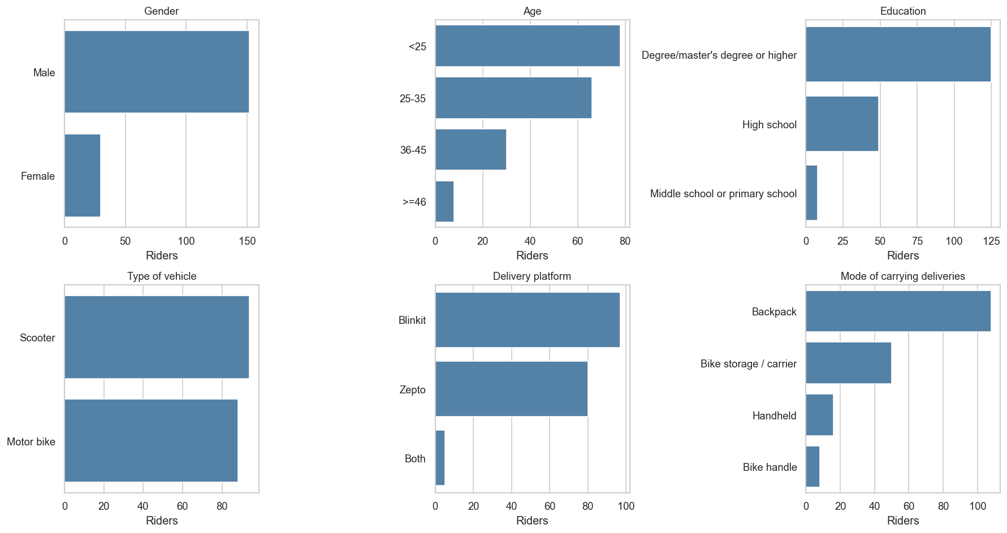
Figure 2. Sample profile across gender, age band, delivery platform, vehicle type, and carrying mode.
84.6 percent of the riders reported pain in at least one body area in the last 12 months.
Table 4. NMQ 12-month pain prevalence per body area.
Body area | Prevalence
Lower back | 61.5%
Upper back | 49.5%
Shoulders | 46.7%
Wrists / Hands | 45.1%
Hips / Thighs | 41.2%
Ankles / Feet | 40.7%
Knees | 39.6%
Neck | 37.9%
Elbows | 33.5%

Lower back is the most-affected region, with upper back and shoulders close behind. The pattern is consistent across age and platform sub-groups.
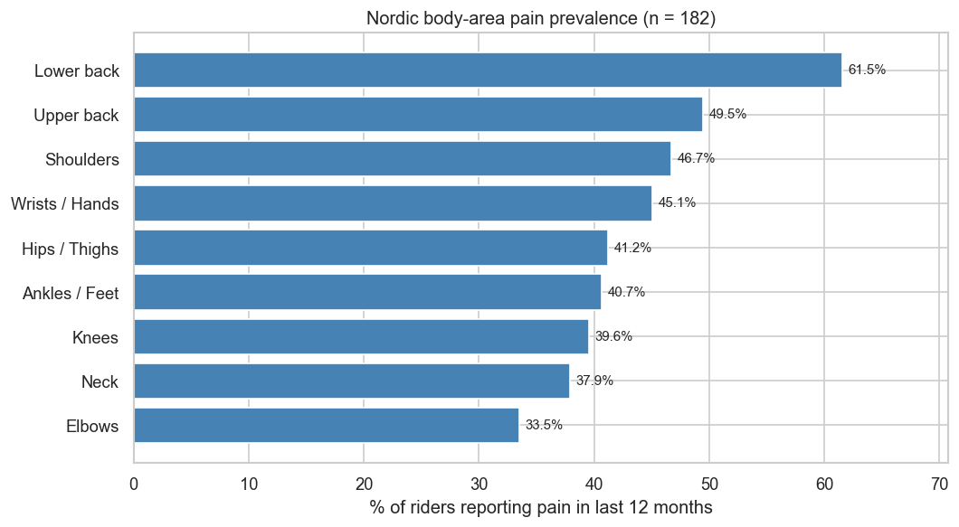
Figure 3. NMQ 12-month pain prevalence per body area, sorted by frequency.
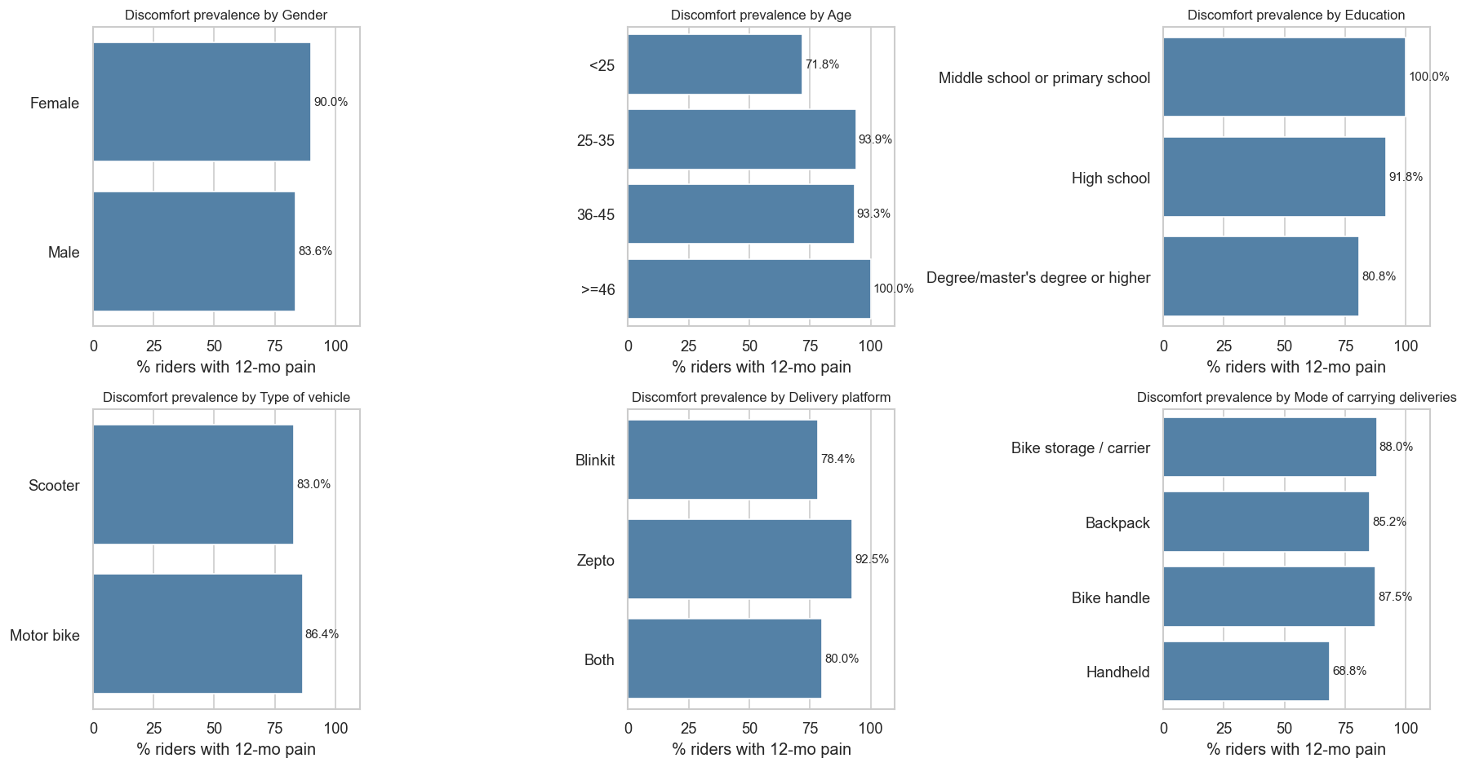
Figure 4. Discomfort prevalence broken down by age, gender, vehicle, and carrying mode.
12.1 Stage-1 risk distribution
Table 5. Stage-1 risk band counts per factor (n = 182).
Factor | Low | Medium | High
Force | 90 | 57 | 35
Repetition | 26 | 82 | 74
Duration | 37 | 56 | 89
Vibration | 67 | 68 | 47
Contact Stress | 68 | 58 | 56
Posture | 0 | 29 | 153

Posture, Duration, and Repetition are the three factors where the High band dominates. Posture is at 84 percent High (153 of 182 observations), Duration at 49 percent, Repetition at 41 percent after the binning fix.
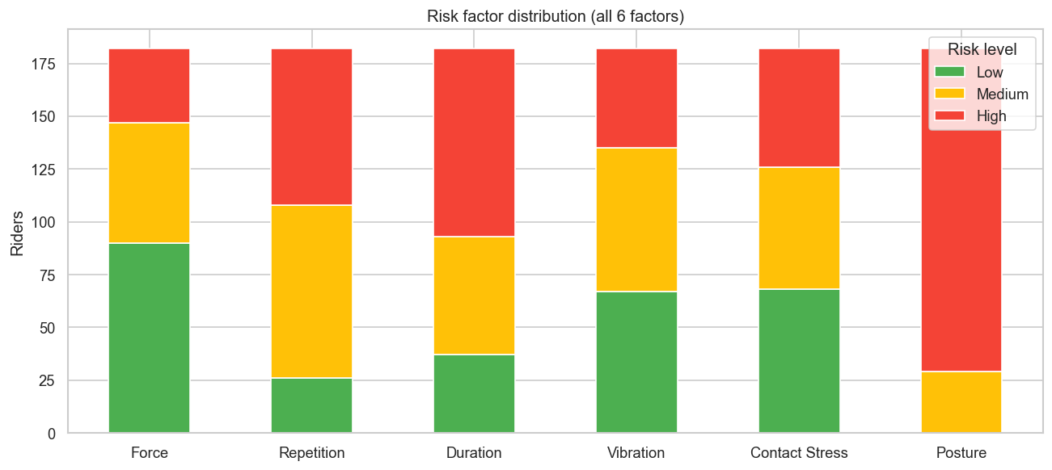
Figure 5. Stage-1 Low / Medium / High counts per risk factor.
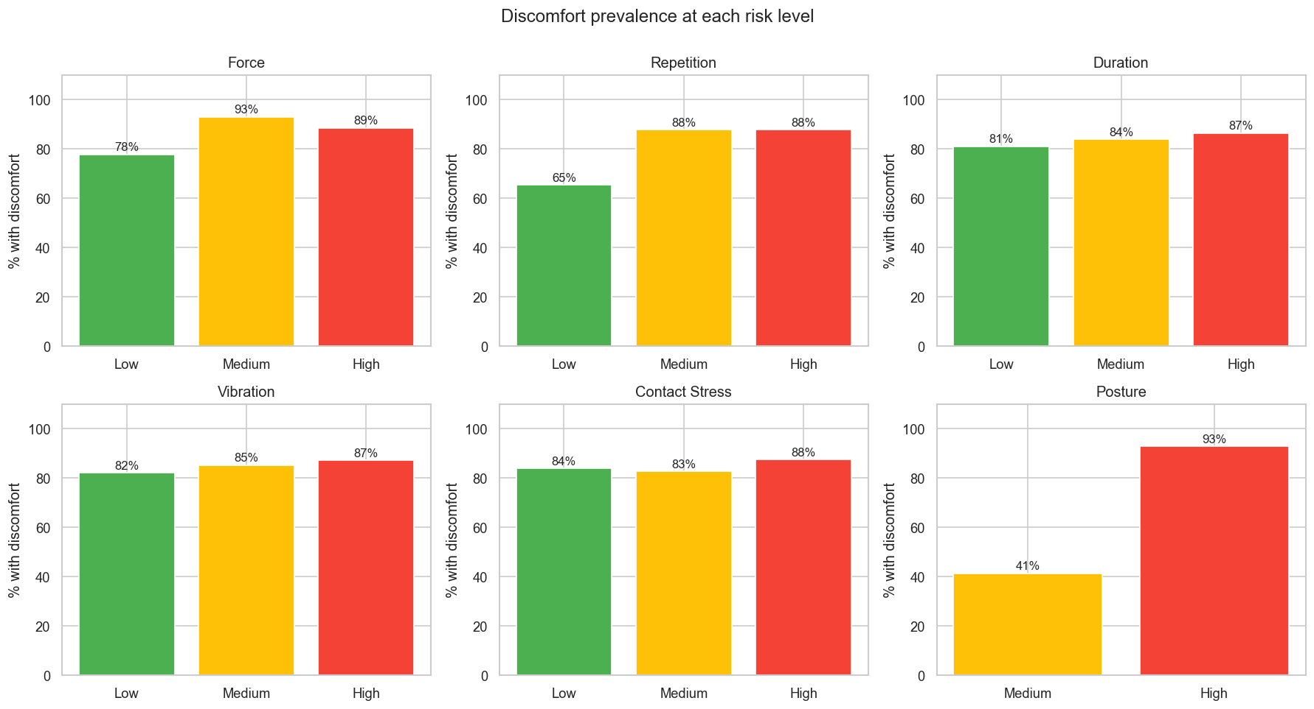
Figure 6. Discomfort prevalence within each Low / Medium / High band, per risk factor.
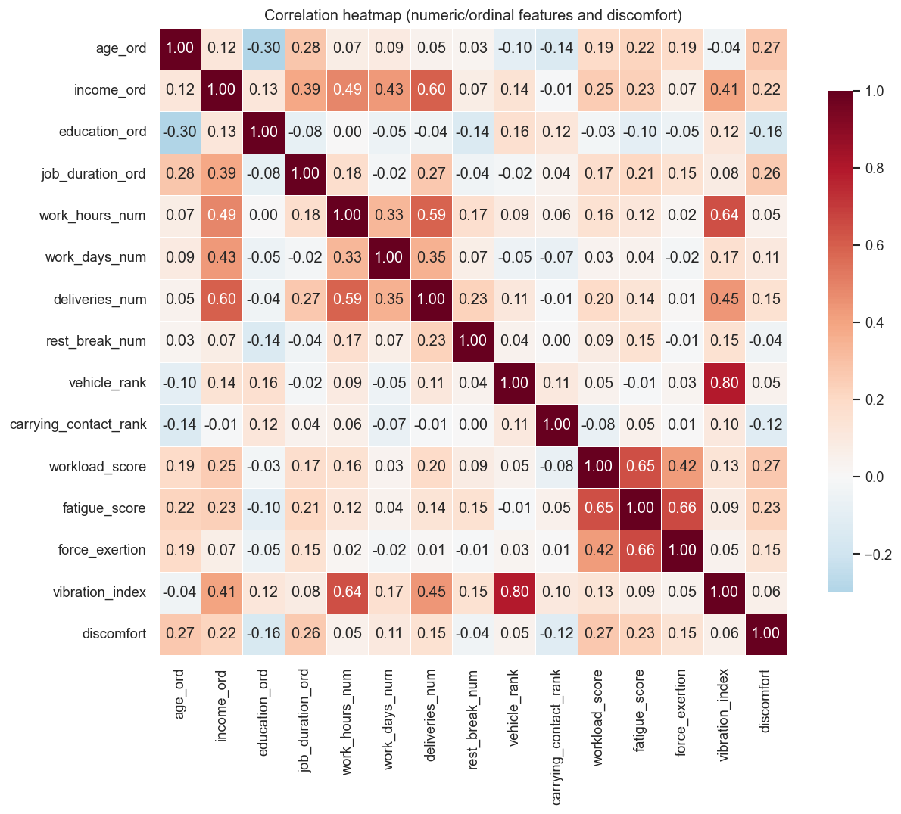
Figure 7. Pearson correlation matrix across the numeric feature pool.
12.2 Stage-2 model performance
Table 6. Best Stage-2 model per risk factor, 5-fold stratified CV.
Factor | Best model | Accuracy | F1 macro | Macro AUC | Features
Force | HistGradientBoosting | 62% | 57% | 71% | 42
Repetition | RandomForest | 62% | 57% | 73% | 41
Duration | RandomForest | 61% | 58% | 76% | 42
Vibration | ExtraTrees | 58% | 57% | 72% | 41
Contact Stress | RandomForest | 60% | 59% | 74% | 42
Posture | HistGradientBoosting | 97% | 95% | 98% | 63

The five survey-derived factors land between 58 and 62 percent accuracy with macro AUC in the 71-76 percent range. Posture reaches 97 percent accuracy and 98 percent AUC because it is the only model that receives real observation inputs (11 RULA components and 8 QEC scores) on top of the survey features.
Table 7. Per-class ROC AUC (one-vs-rest) for the best model per factor.
Factor | Low | Medium | High
Force | 0.798 | 0.580 | 0.760
Repetition | 0.745 | 0.669 | 0.782
Duration | 0.822 | 0.649 | 0.797
Vibration | 0.775 | 0.615 | 0.779
Contact Stress | 0.763 | 0.651 | 0.791
Posture | - | - | 0.984

Table 8. Per-class precision, recall, F1, and support for the best model per factor.
Factor | Class | Precision | Recall | F1 | Support
Force | Low | 0.734 | 0.767 | 0.750 | 90
Force | Medium | 0.490 | 0.421 | 0.453 | 57
Force | High | 0.487 | 0.543 | 0.514 | 35
Repetition | Low | 0.562 | 0.346 | 0.429 | 26
Repetition | Medium | 0.593 | 0.622 | 0.607 | 82
Repetition | High | 0.650 | 0.703 | 0.675 | 74
Duration | Low | 0.583 | 0.757 | 0.659 | 37
Duration | Medium | 0.450 | 0.321 | 0.375 | 56
Duration | High | 0.691 | 0.730 | 0.710 | 89
Vibration | Low | 0.583 | 0.627 | 0.604 | 67
Vibration | Medium | 0.551 | 0.559 | 0.555 | 68
Vibration | High | 0.610 | 0.532 | 0.568 | 47
Contact Stress | Low | 0.658 | 0.588 | 0.621 | 68
Contact Stress | Medium | 0.526 | 0.552 | 0.539 | 58
Contact Stress | High | 0.617 | 0.661 | 0.638 | 56
Posture | Medium | 0.724 | 0.724 | 0.724 | 29
Posture | High | 0.948 | 0.948 | 0.948 | 153

Table 9. Top 5 most important features per factor (from `feature_importances_` for tree-ensemble models). Force and Posture are omitted because the best model for both is HistGradientBoosting, which does not expose split-based importances directly; the Figure 10 panel is built from a parallel logistic-coefficient fit instead.
Factor | Rank 1 | Rank 2 | Rank 3 | Rank 4 | Rank 5
Repetition | income_ord | vibration_index | fatigue_score | workload_x_fatigue | out_riding_worsens
Duration | deliveries_num | deliv_x_days | income_ord | fatigue_x_jobdur | rest_break_num
Vibration | deliveries_num | income_ord | deliv_x_days | rest_break_num | workload_score
Contact Stress | vibration_index | workload_x_fatigue | fatigue_score | workload_x_age | deliv_x_days

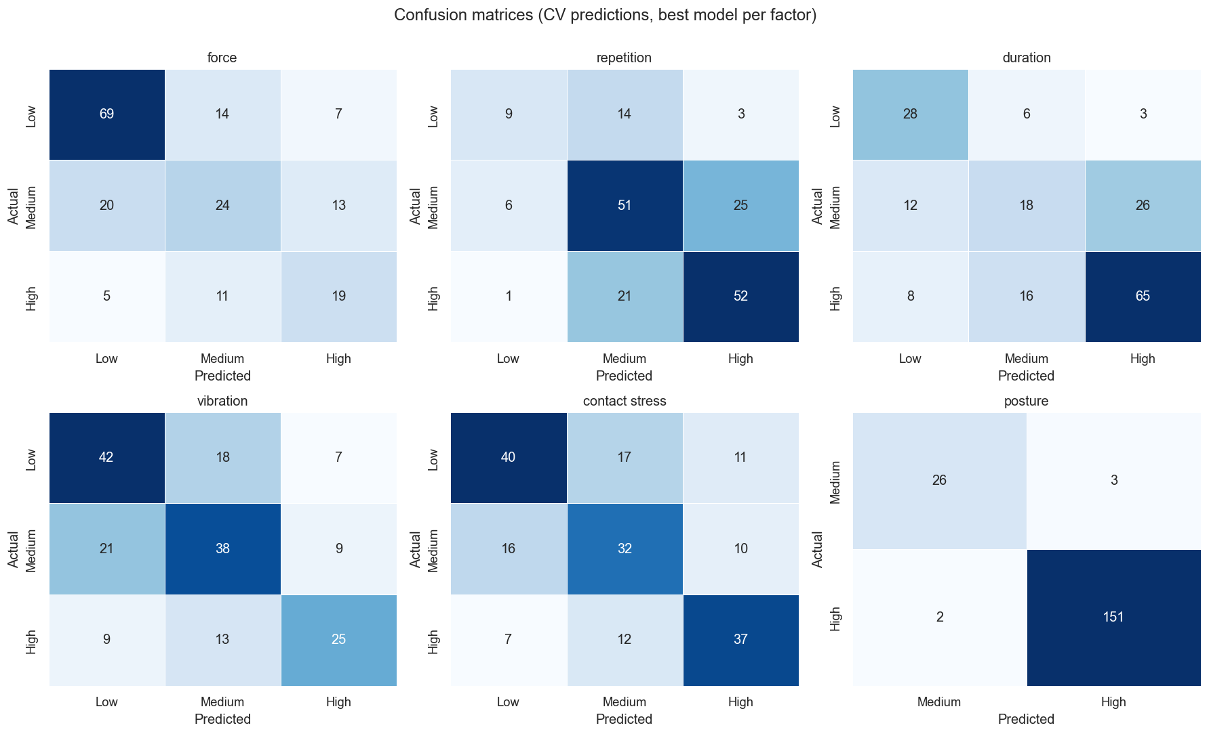
Figure 8. Confusion matrices for the best model per factor (rows = true class, columns = predicted class).
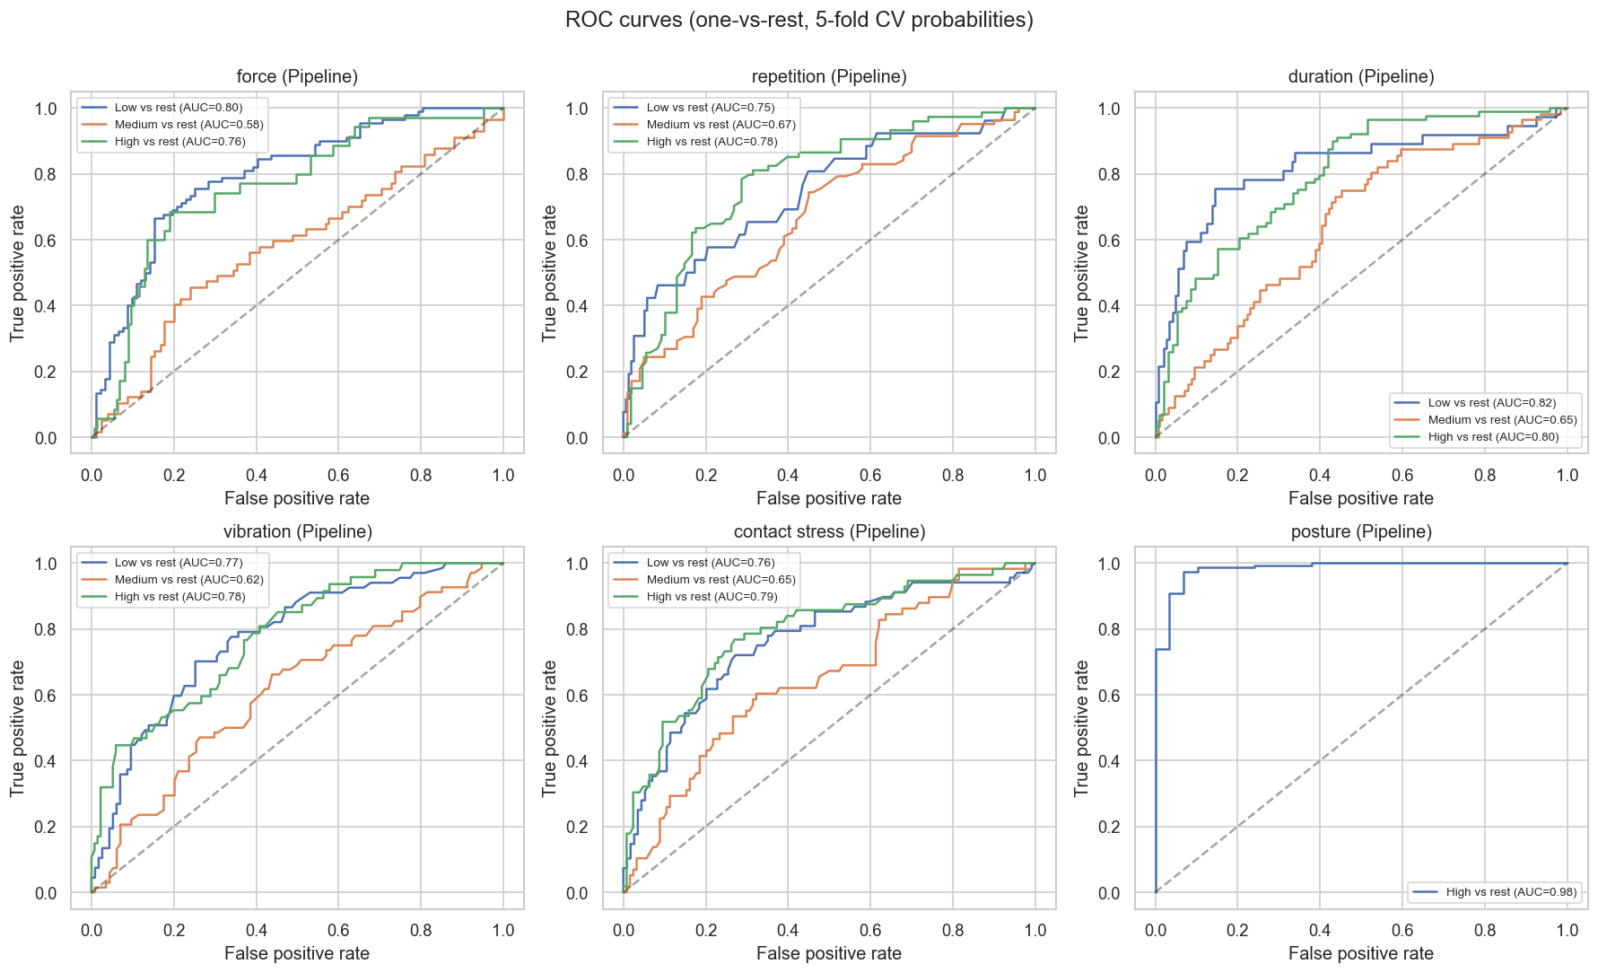
Figure 9. ROC curves (one-vs-rest) for the best model per factor.
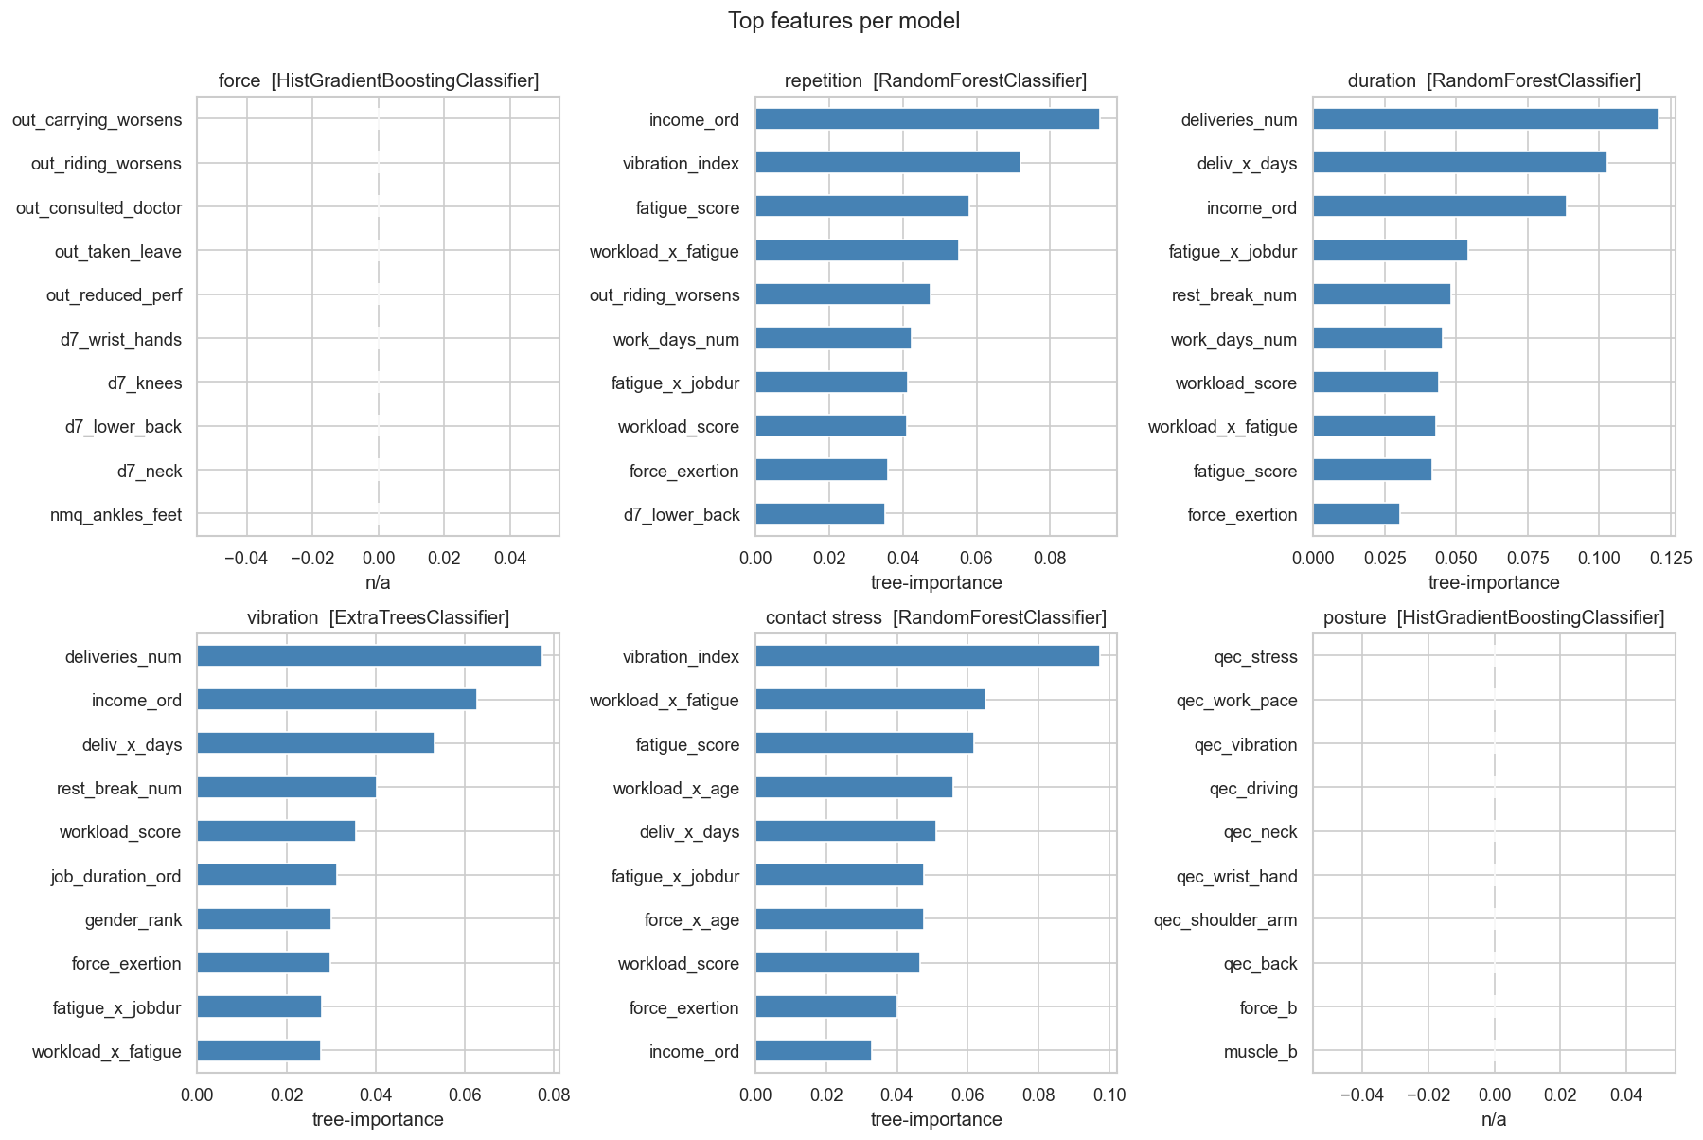
Figure 10. Top 10 features by importance for the best model per factor.
12.3 Statistical predictors of discomfort
The Phase 5 logistic regression identifies seven significant predictors of discomfort. The strongest individual predictor is age: each step up in the age band multiplies the odds of discomfort by 3.6 (95% CI 1.70 to 7.56, p = 0.0008). Job duration is next at 2.89 per step (p = 0.001). Education runs the other way as a protective factor (OR 0.33, p = 0.04). Income, fatigue score, workload score, and deliveries per day are all significant at smaller magnitudes.
The chi-square test in the same phase finds that Posture and Force are the only two risk factors with a significant association with discomfort in this sample.
13. The web app
app/streamlit_app.py is the interactive demo. It is a multi-page Streamlit application (Home, Assessment, Results, Methodology, About) that loads the six saved model bundles once via @st.cache_resource and exposes a sidebar navigation across pages. The Assessment page holds a form with six sections covering every column in the CSV and xlsx.
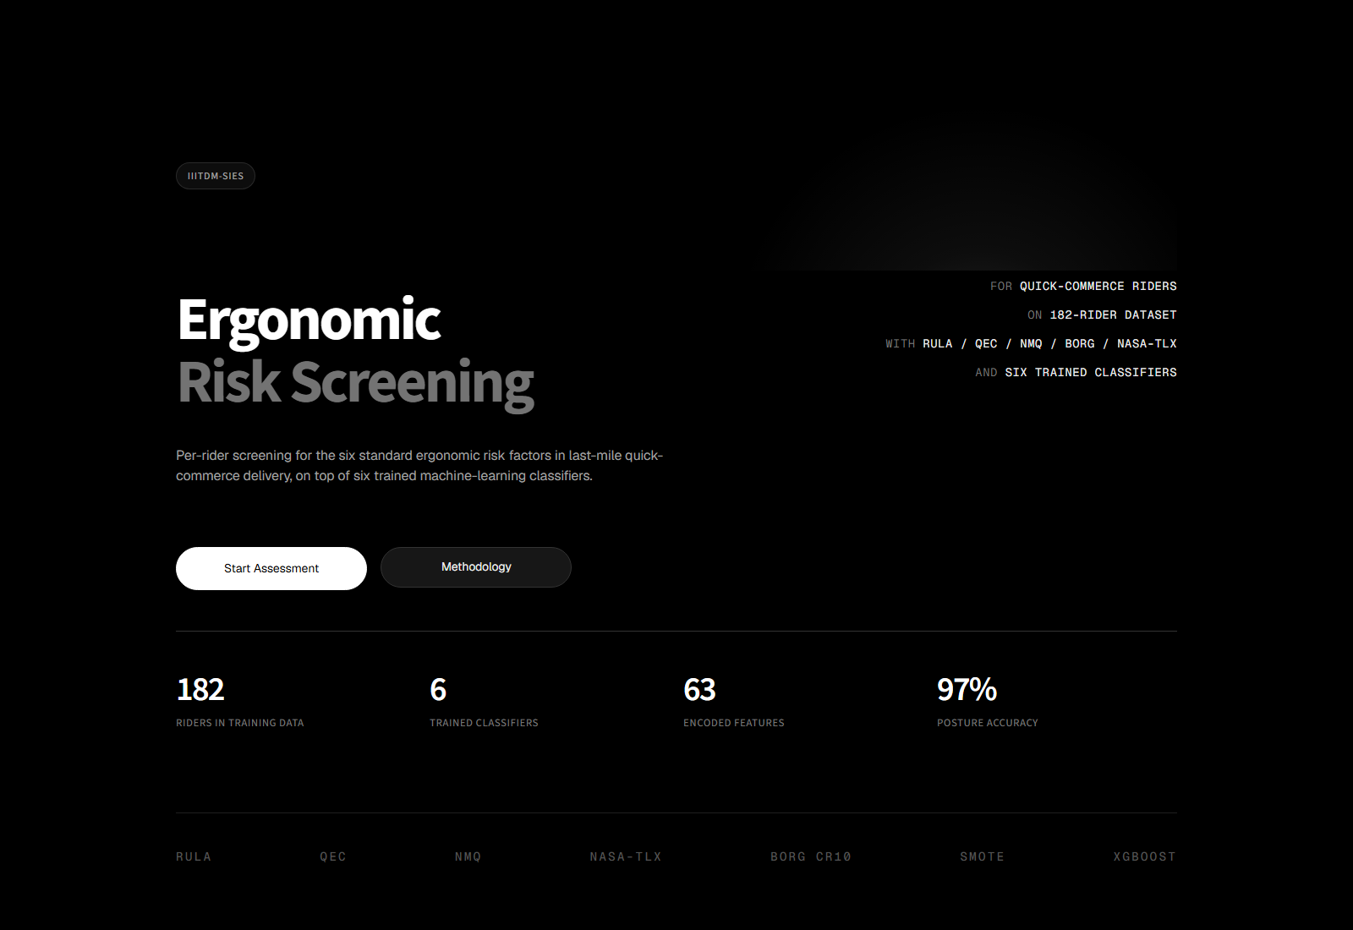
Figure 11. Web app Home page: project introduction, six risk factor cards, and headline stats.
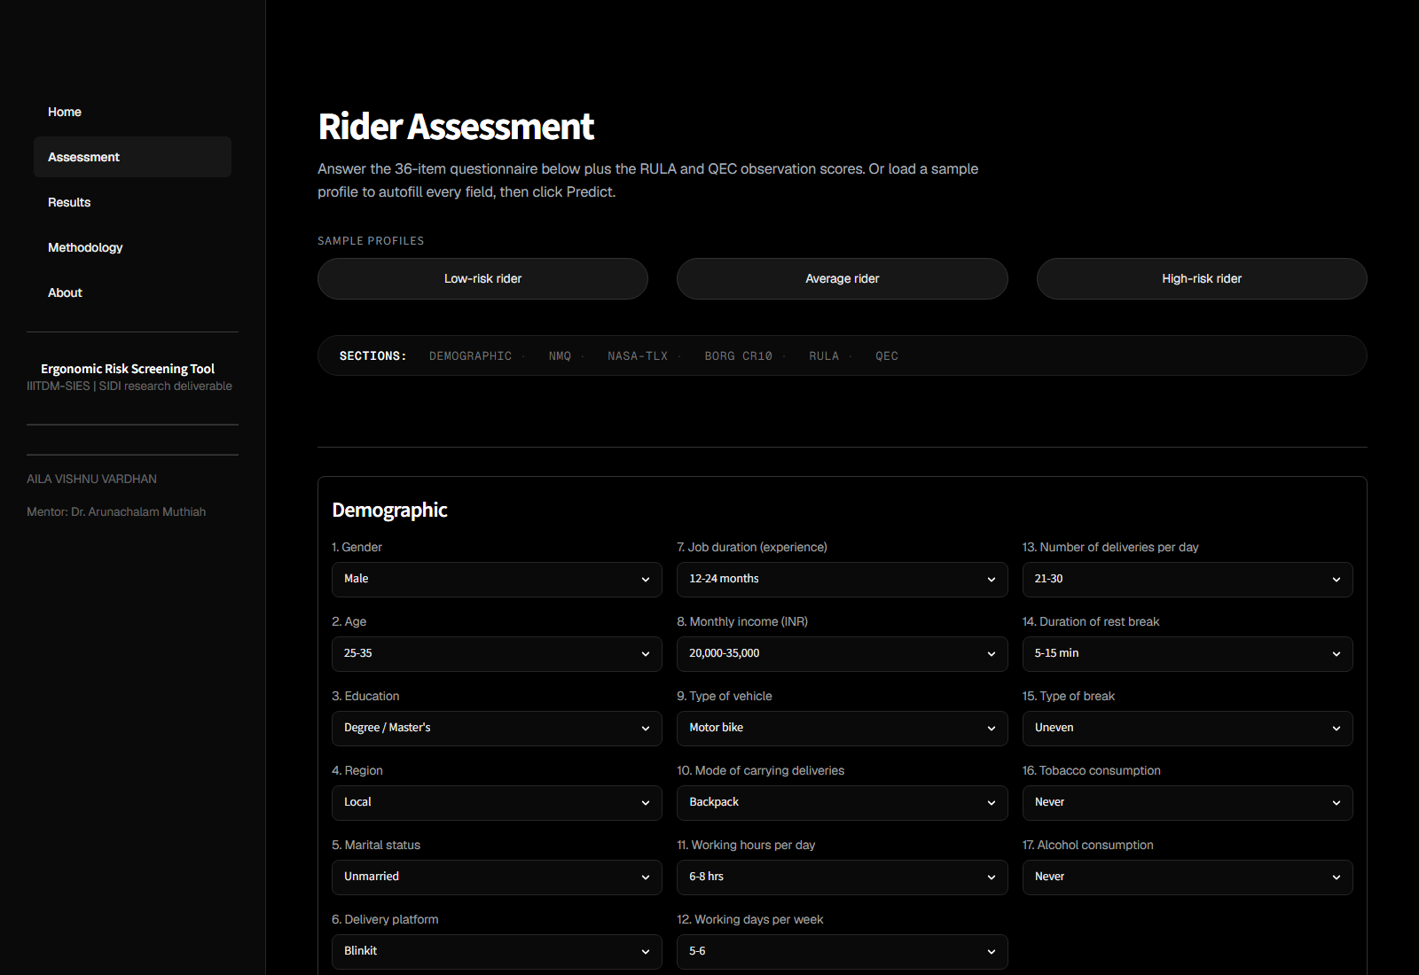
Figure 12. Web app Assessment page top: sample-profile shortcuts and demographic section (Q1-17).
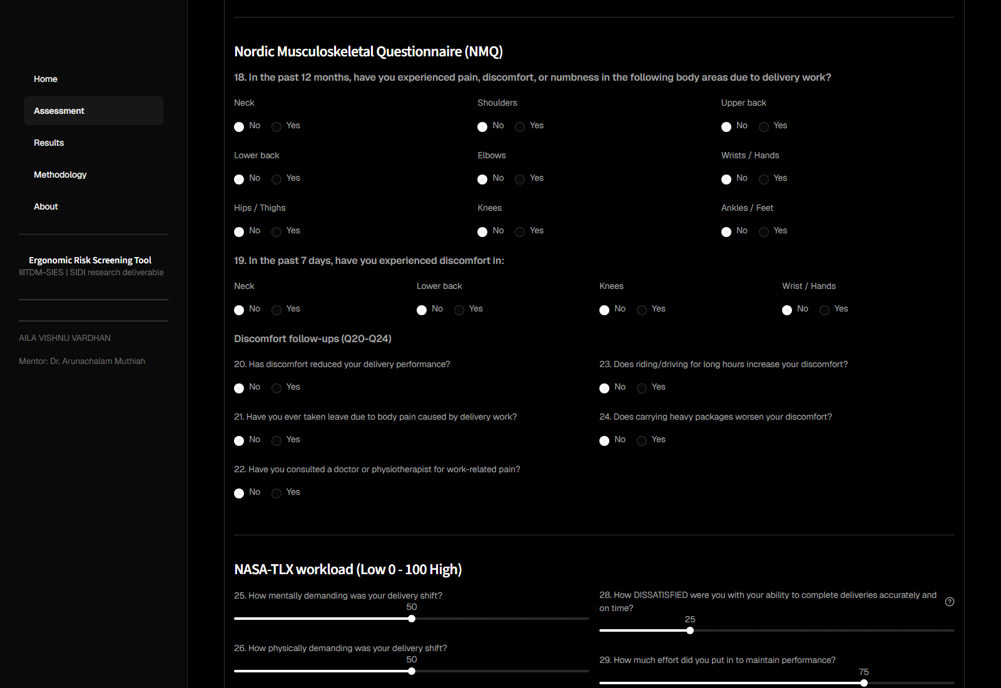
Figure 13. Web app Assessment page: Nordic Musculoskeletal Questionnaire and discomfort follow-ups (Q18-24).
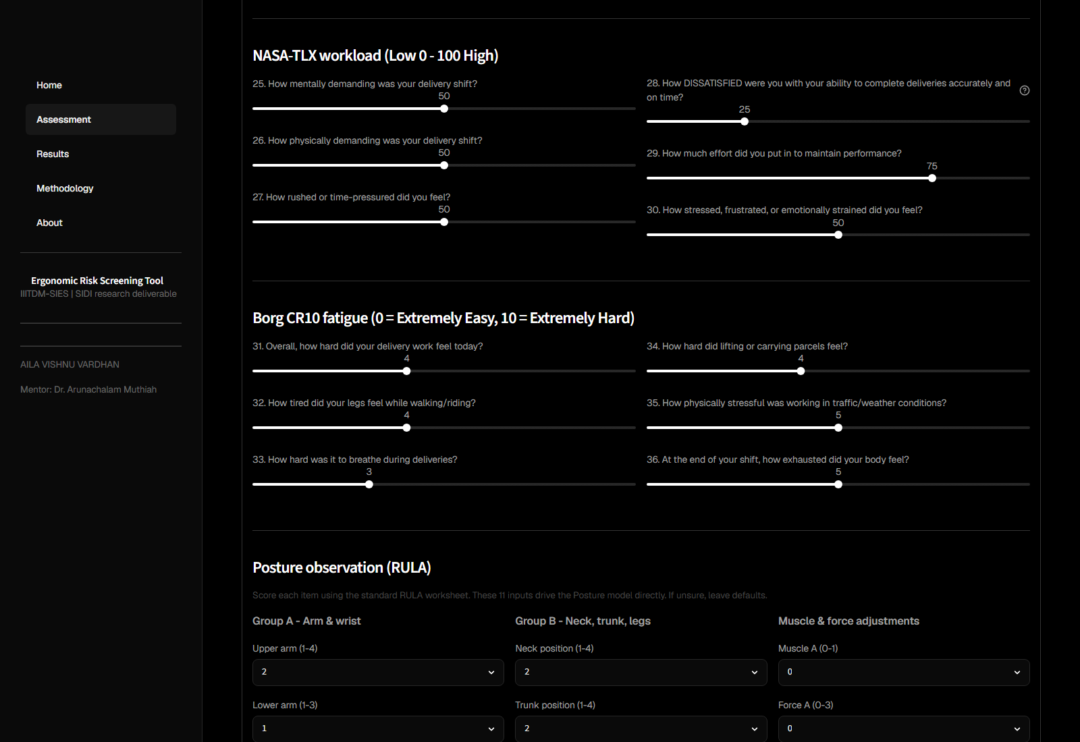
Figure 14. Web app Assessment page: NASA-TLX workload (Q25-30) and Borg CR10 fatigue (Q31-36) sliders.
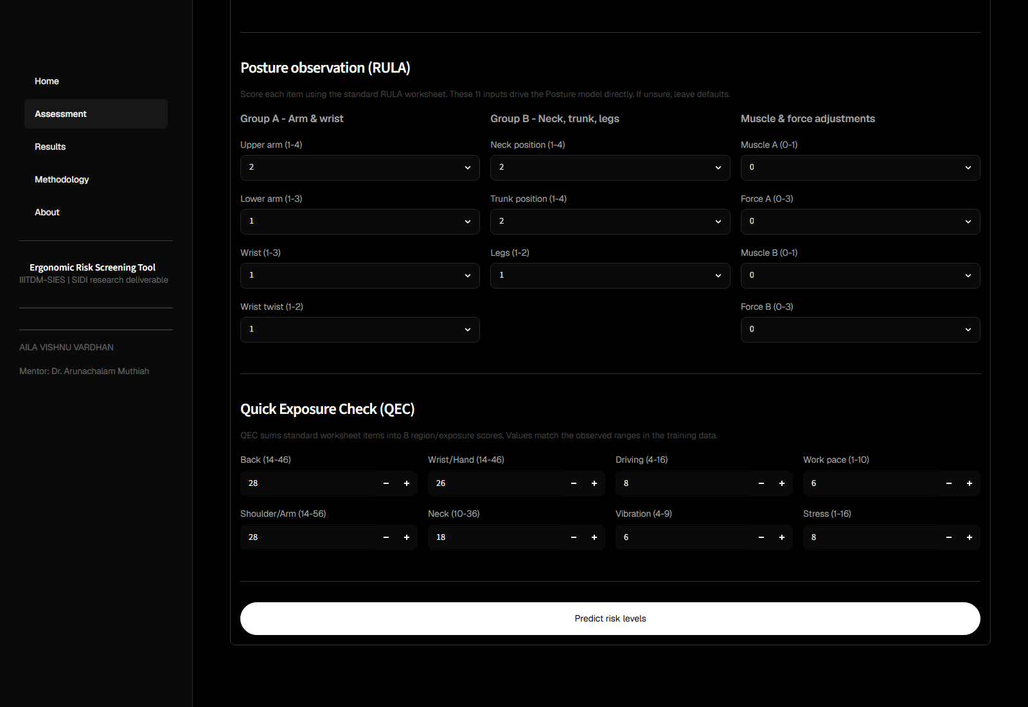
Figure 15. Web app Assessment page: RULA posture observation (11 inputs) and Quick Exposure Check (8 inputs) followed by the Predict button.
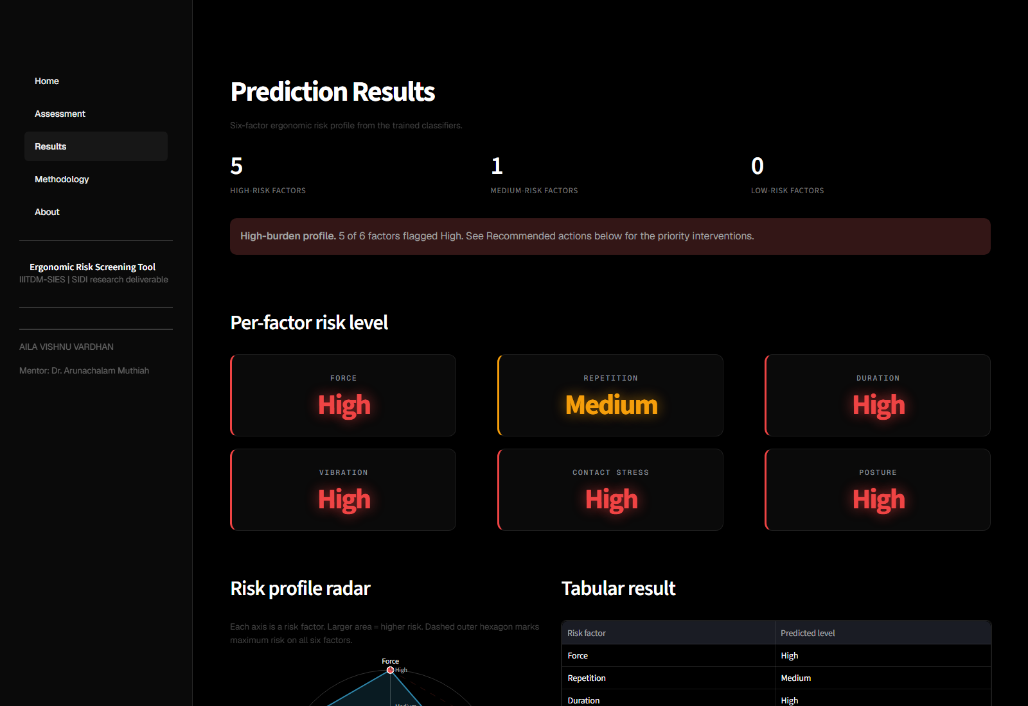
Figure 16. Web app Results page: summary banner, six colour-coded risk cards, radar profile chart, tabular result, and per-factor recommendations.
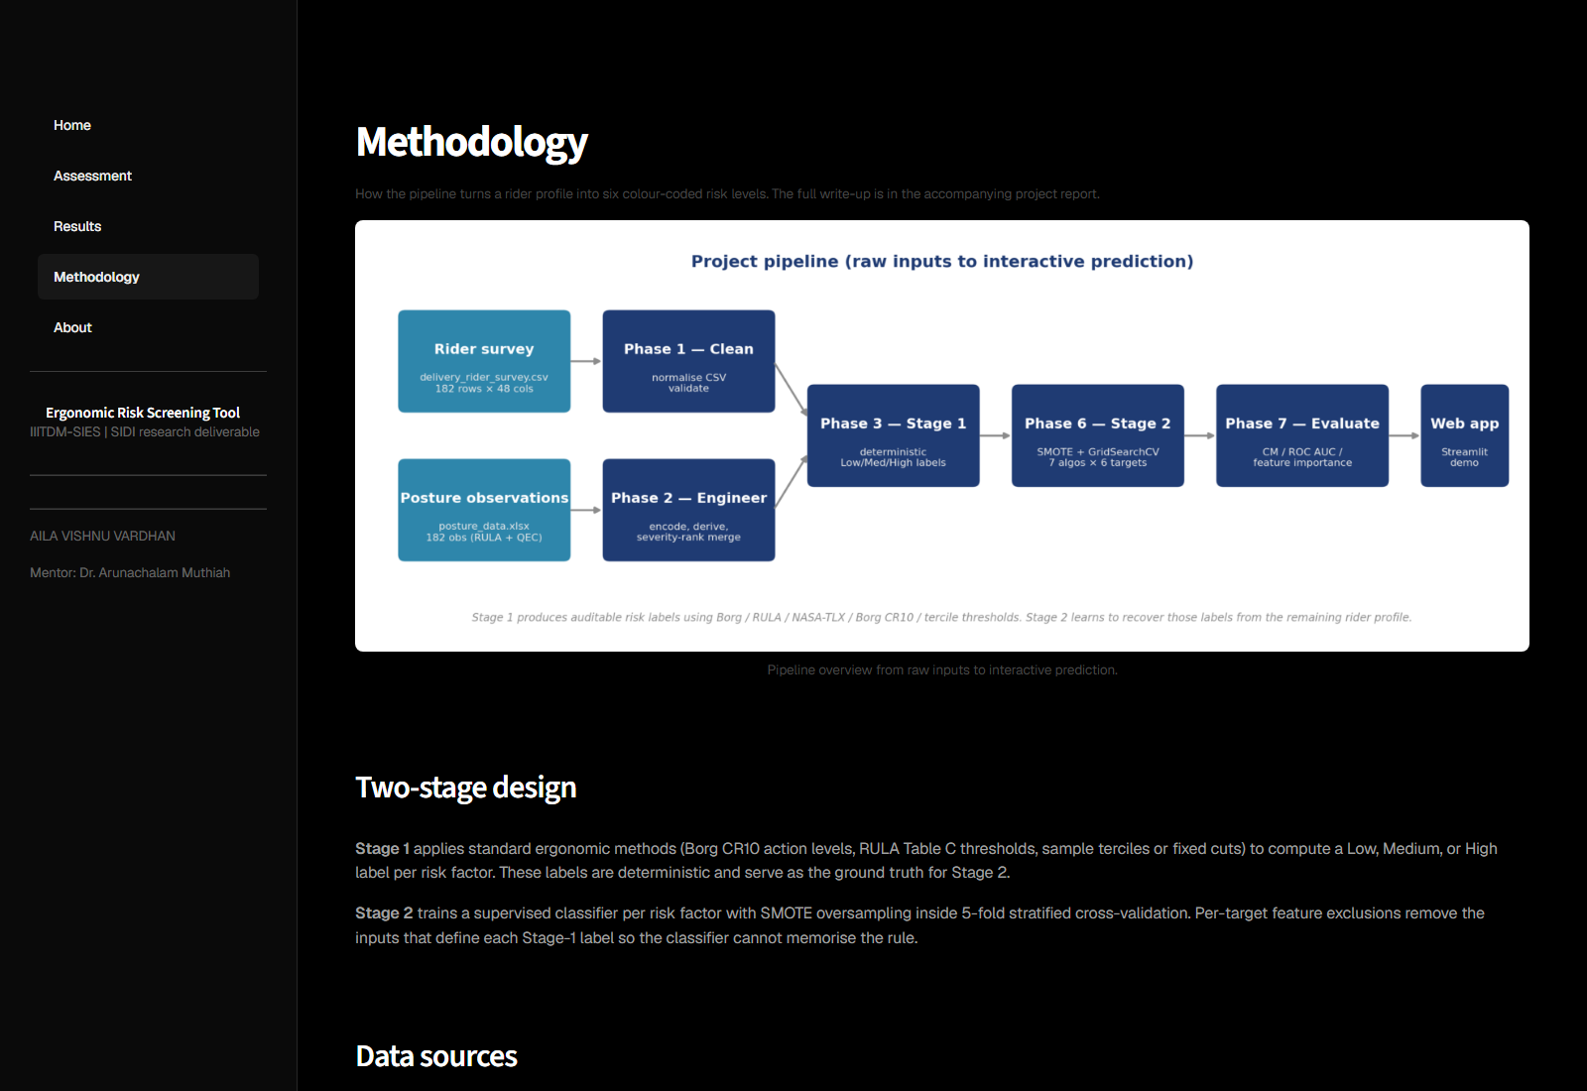
Figure 17. Web app Methodology page: pipeline flowchart, two-stage design description, candidate algorithms, and model performance table.
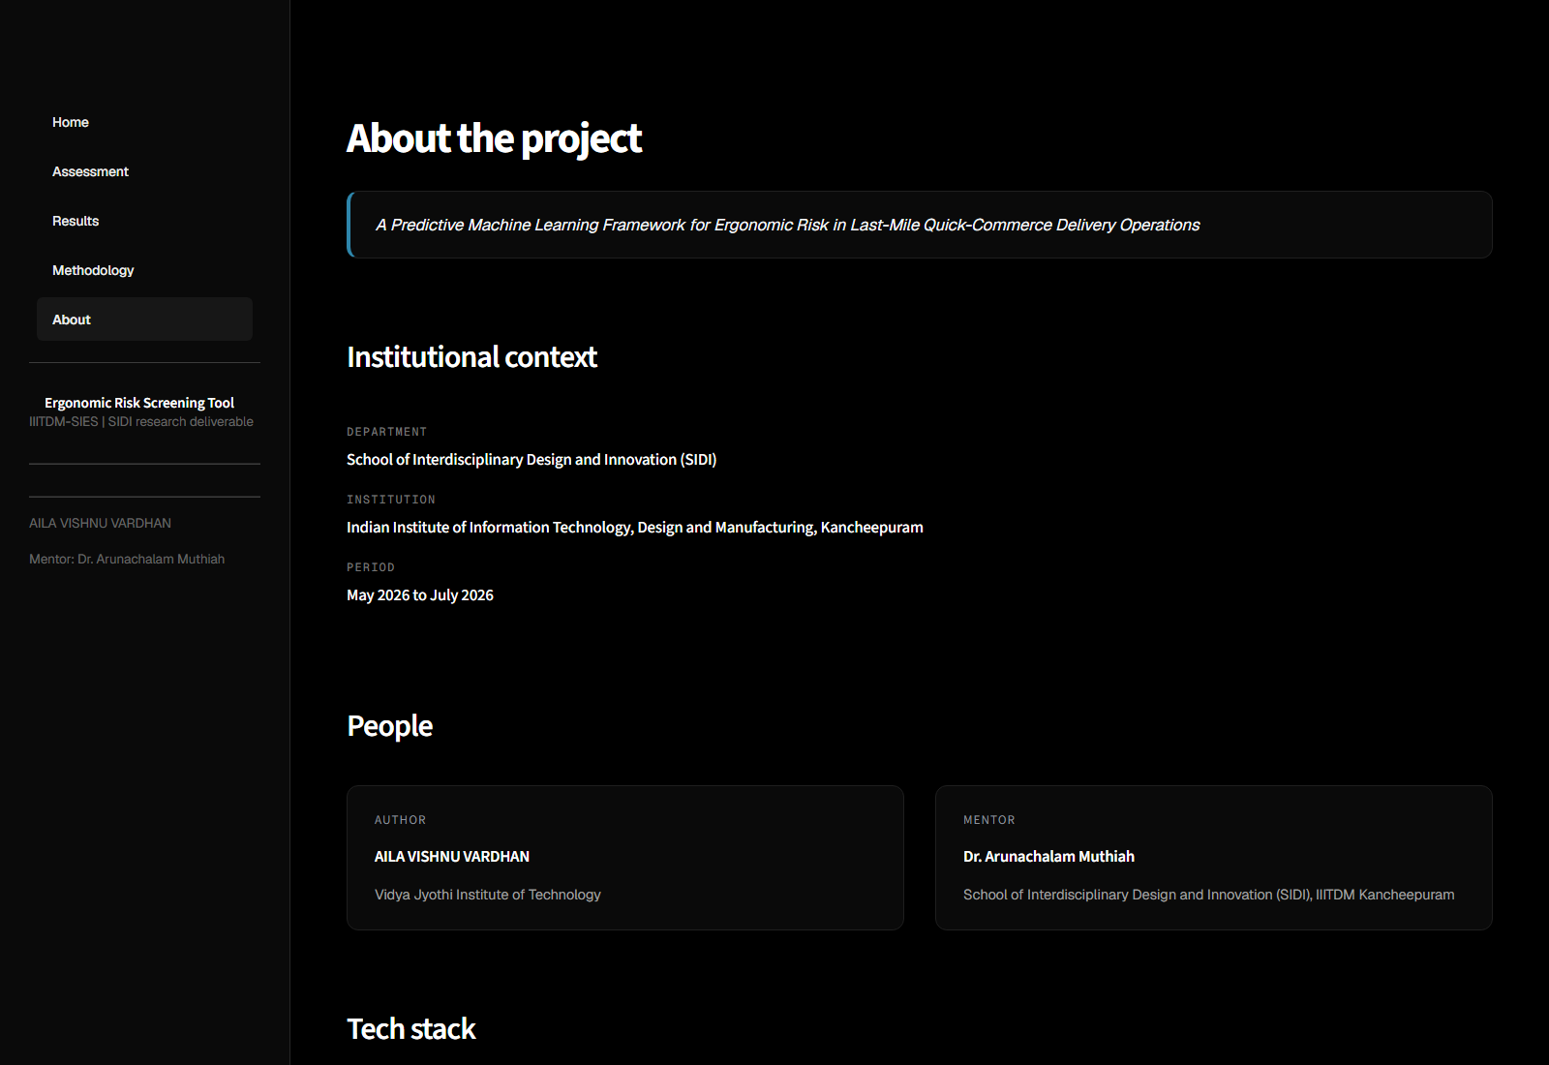
Figure 18. Web app About page: project title, internship context, author and mentor, tech stack.
13.1 Page structure
The web app has five pages accessible from the sidebar:
- Home: project introduction, six risk-factor cards, headline
statistics, and a Start Assessment call-to-action.
- Assessment: the six-section rider questionnaire (below), plus
three sample-profile shortcut buttons that pre-fill the form for Low-risk, Average, and High-risk example riders.
- Results: shown after a prediction. Summary banner, six large
colour-coded risk cards, a radar chart of the six-factor profile, a tabular view, and per-factor recommendations.
- Methodology: pipeline flowchart, two-stage design description,
candidate-algorithm list, and model performance table.
- About: project title, IIITDM-SIES internship context, author
and mentor information, and tech-stack list.
13.2 Form layout (Assessment page)
- Section 1 (Q1-17): demographics, lifestyle, work pattern,
vehicle, carrying. Selectboxes laid out across three Streamlit columns.
- Section 2 (Q18-24): 9 NMQ 12-month radios, 4 seven-day radios, 5
follow-up radios.
- Section 3 (Q25-30): six NASA-TLX 0-100 sliders. Q28 is rephrased
as "How dissatisfied" so all six sliders run in load-direction and the user is not asked to mentally invert one of them.
- Section 4 (Q31-36): six Borg CR10 0-10 sliders.
- Section 5: 11 RULA component selectboxes with min/max ranges
matched to the standard worksheet, plus help text per item.
- Section 6: 8 QEC st.number_input fields with min/max matched
to the observed ranges in the training data.
13.3 Encoding
encode_rider(raw) returns a single dict of all engineered features. Demographic and lifestyle selections are looked up in the same mapping dicts that Phase 2 uses. Workload and fatigue scores are computed from the slider values. Interaction features are computed inline. NMQ, 7-day, and outcome radios are converted to 0/1. RULA and QEC values are passed through.
13.4 Prediction
predict_risks(features, models) builds a single-row DataFrame, selects the relevant feature subset per target using the saved bundle's features list, calls model.predict(), then maps the returned class index back to the original code via the bundle's classes list, and finally to the Low/Medium/High label:
pred_idx = int(bundle['model'].predict(df_row[bundle['features']])[0])
code = int(bundle['classes'][pred_idx])
out[factor] = LABELS[code]

13.5 Output rendering
The result is displayed as a styled table with badge emojis per risk level, a summary banner that flags high-burden profiles (3 or more factors at High triggers an error banner; 4 or more Medium-or-High triggers a warning banner; otherwise a success banner). An expandable JSON view shows the 55-63 feature values that were fed to the models.
13.6 Starting the app
streamlit run app/streamlit_app.py

The same prediction is also available from the command line:
python src/predict.py --json data/example_rider.json

14. Reproducibility
- Random seed: RNG = 42 is the single shared seed used in
StratifiedKFold, SMOTE, all sklearn classifiers, and XGBoost.
- Library list: pandas, numpy, scikit-learn, scipy, matplotlib,
seaborn, xgboost, statsmodels, imbalanced-learn, python-pptx, joblib, streamlit, python-docx, openpyxl.
- The full pipeline runs end to end from raw inputs with:
python -m nbconvert --to notebook --execute notebooks/01_data_cleaning.ipynb --output 01_data_cleaning.ipynb
python -m nbconvert --to notebook --execute notebooks/02_feature_engineering.ipynb --output 02_feature_engineering.ipynb
python -m nbconvert --to notebook --execute notebooks/03_risk_scoring.ipynb --output 03_risk_scoring.ipynb
python -m nbconvert --to notebook --execute notebooks/04_eda.ipynb --output 04_eda.ipynb
python -m nbconvert --to notebook --execute notebooks/05_stats.ipynb --output 05_stats.ipynb
python -m nbconvert --to notebook --execute notebooks/06_modeling.ipynb --output 06_modeling.ipynb
python -m nbconvert --to notebook --execute notebooks/07_evaluation.ipynb --output 07_evaluation.ipynb

All saved artefacts (CSV tables, PNG figures, PKL models) are regenerated bit-identically on re-run (modulo PNG metadata timestamps inserted by matplotlib).
15. Limitations
These should be stated up front rather than buried at the end.
Self-report bias. Most of the model inputs come from the rider's own answers (NMQ pain, NASA-TLX workload, Borg fatigue, the demographic items). A rider in a bad mood reports more pain than the same rider would on a good day. Nothing in the pipeline can correct for this.
The Posture link is approximate. The 182 RULA + QEC observations do not carry rider identifiers. The Phase 2 Step 8 severity-rank merge pairs them to the survey by ranking riders by exposure severity (NMQ pain count + fatigue + working hours) and posture observations by RULA Table C, then matching the two ranks one to one. This means rider 1 in severity gets observation 1 in RULA, and so on. The 97 percent Posture accuracy is therefore the upper bound of what the linked data can support. A study where every rider is observed individually would settle slightly lower because rider-to-observation noise would re-enter.
Repetition binning fix. The earlier Phase 3 used pandas.qcut(q=3) on deliveries_per_hour. The 75th percentile landed exactly on 3.889 dph (= 35 deliveries / 9 hours, which is the worst real combination in the sample), and 55 of 182 riders were tied at that value. qcut is right-inclusive at the upper edge, so all 55 fell into Medium. That left the Stage-2 model with no High example matching the busiest schedule and so it could not predict High for that rider whatever the features. Replacing qcut with fixed cuts at 2.5 and 3.75 puts the worst case in High where it belongs. The accompanying cost is a drop in Stage-2 accuracy from 74 to 62 percent (Stage-1 High grew from 19 to 74 examples). The lower number is the more meaningful one because the model is now solving a real 3-class problem instead of memorising a 19-row minority.
Duration leakage fix. An earlier Phase 6 run reported 100 percent CV accuracy on Duration. After investigating we found that vibration_index (= vehicle_rank * work_hours_num) was still in the feature pool, so the trees were recovering work_hours_num from it. We added vibration_index to the Duration exclusion list and capped max_depth + min_samples_leaf. Duration settled at 61 percent accuracy and 76 percent AUC.
Cross-sectional design. Each rider was surveyed once. The fact that older riders report more pain could mean that long delivery careers cause MSDs, or that riders who develop MSDs quit, leaving the survivors. A follow-up study would settle this.
Sample size and region. n = 182 is reasonable for descriptive statistics but small for multivariable ML. The cross-validation results have a natural wobble of around 5 percentage points. All riders came from one regional platform deployment, so the numbers may not transfer to other regions.
Proxy inputs for Vibration and Repetition. Without per-shift accelerometer data, Vibration is approximated as vehicle_rank * work_hours_num. Without per-task timing, Repetition is approximated as deliveries-per-hour. Both proxies map onto what the survey can capture but neither carries the per-event signal a wearable would.
Posture's empty Low class. The minimum rula_table_c in the sample is 3, so no rider falls in the Low band. The Posture model is in practice a binary Medium-vs-High classifier.
16. Where things live in the repository
Ergonomic_Project/
README.md
docs/
PROJECT_REPORT.md / .docx this write-up
data/
raw/ delivery_rider_survey.csv, posture_data.xlsx
processed/ cleaned.csv, model_ready.csv, risk_profile.csv
example_rider.json
notebooks/ 01..07 (the seven phases)
src/
predict.py command-line predictor
app/streamlit_app.py interactive demo
deck/ presentation slides
outputs/
figures/ all PNGs
tables/ result CSVs
models/ the six saved joblib bundles

17. Index of output files
Number / claim | File
Sample profile | notebooks/04_eda.ipynb, outputs/figures/demographics.png
NMQ prevalence | notebooks/04_eda.ipynb, outputs/figures/nordic_prevalence.png
Stage-1 risk distribution | data/processed/risk_profile.csv, outputs/figures/risk_factor_distribution.png
Chi-square table | outputs/tables/chi_square.csv
Logistic regression coefficients | outputs/tables/phase5_summary.csv
Stage-2 CV metrics | outputs/tables/cv_results.csv
Per-factor best-model headline | outputs/tables/best_models.csv
Confusion matrices | outputs/tables/confusion_matrices.csv, outputs/figures/confusion_matrices.png
Per-class precision/recall/F1 | outputs/tables/classification_reports.csv
ROC AUC per class and macro | outputs/tables/roc_auc.csv, outputs/tables/phase7_summary.csv
Feature importance per target | outputs/tables/feature_importance.csv, outputs/figures/feature_importance.png
Saved models | outputs/models/best_*.pkl
Presentation deck | deck/Ergonomic_Risk_Factor_Prediction_Project_Plan_WITH_RESULTS.pptx

