Report Figures and Tables
A Predictive Machine Learning Framework for Ergonomic Risk in Last-Mile Quick-Commerce Delivery Operations

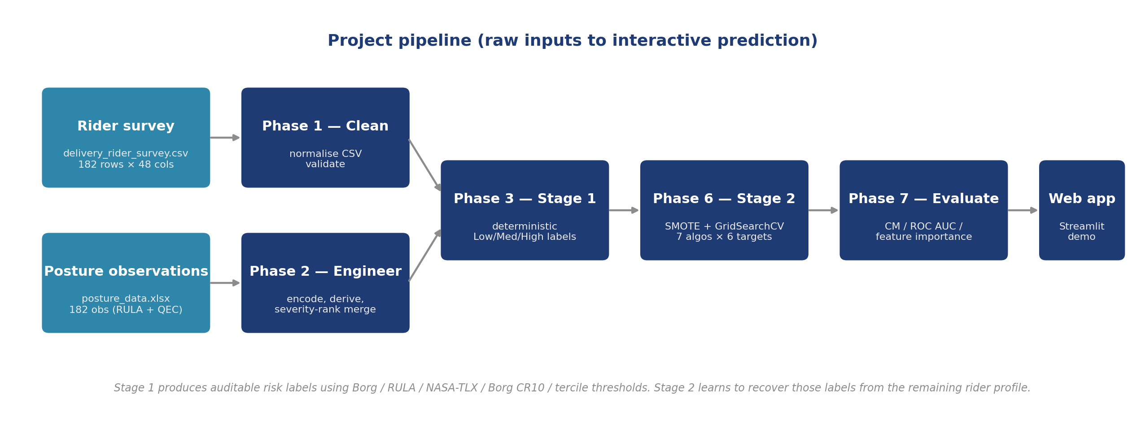
Figure 2.1: Pipeline overview from raw inputs to interactive prediction.

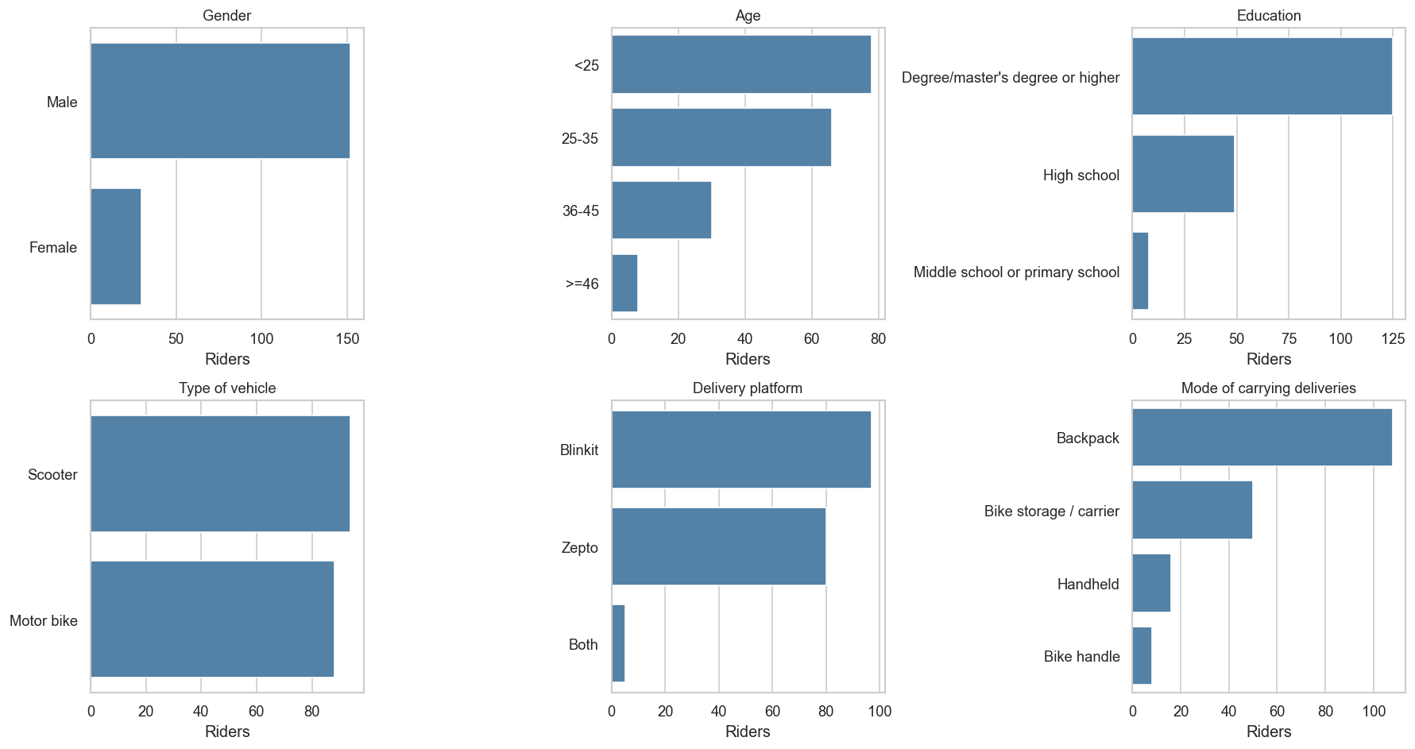
Figure 4.1: Sample profile: age, platform, vehicle, and carrying mode.

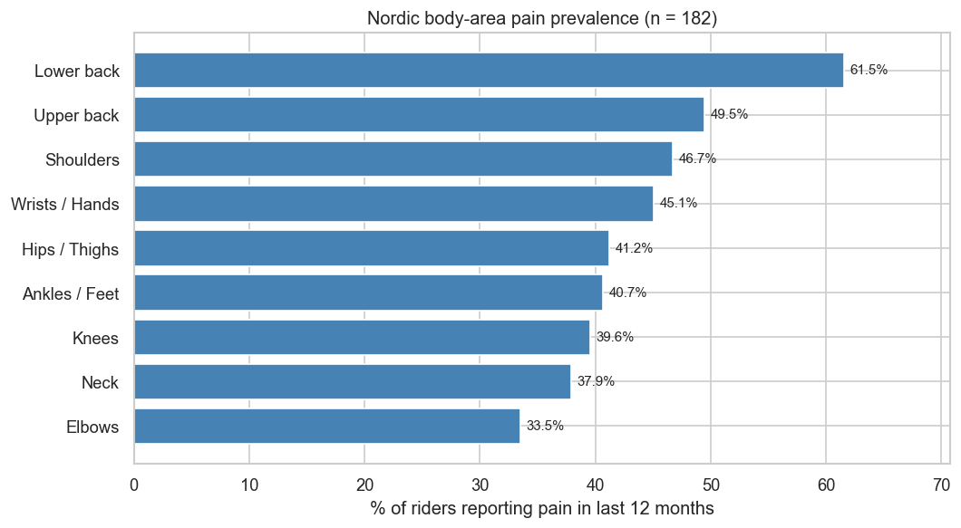
Figure 4.2: NMQ 12-month pain prevalence per body area.

Figure 4.3: Discomfort prevalence broken down by demographic group.

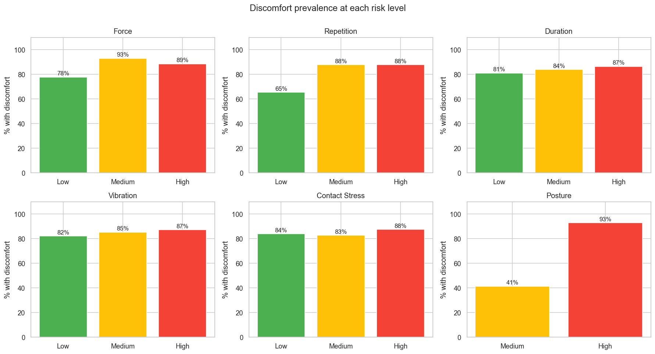
Figure 4.4: Discomfort prevalence within each Low / Medium / High band, per risk factor.

Figure 4.5: Pearson correlation matrix across the numeric feature pool, upper triangle masked.

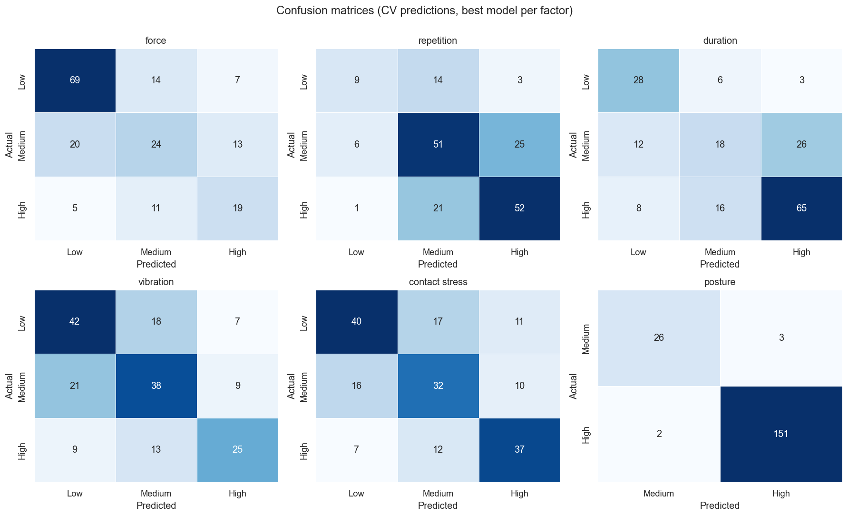
Figure 4.6: Confusion matrices for the best model per factor (rows = true class, columns = predicted class).

Figure 4.7: ROC curves (one-vs-rest) for the best model per factor.

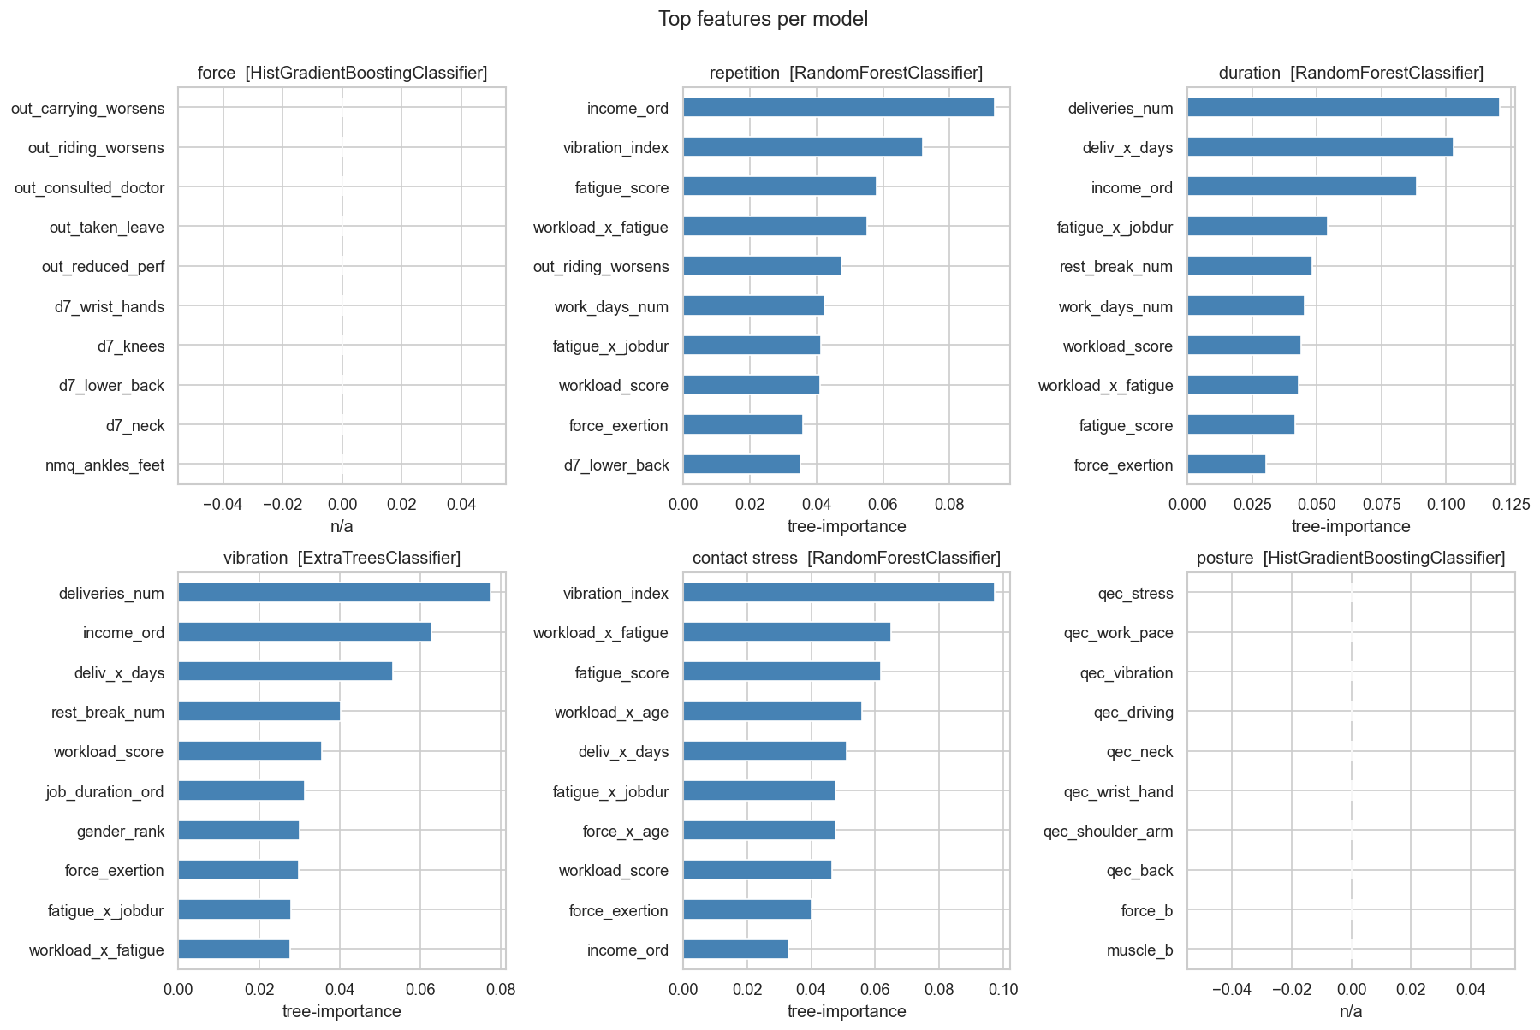
Figure 4.8: Top 10 features by importance for the best model per factor.

Table 2.1: Per-target feature exclusions to prevent label leakage.
Target | Excluded features | Final feature count
Force | force_exertion, force_x_age | 42
Repetition | deliveries_num, work_hours_num, deliv_x_days | 41
Duration | work_hours_num, vibration_index | 42
Vibration | vibration_index, vehicle_rank, work_hours_num | 41
Contact Stress | carrying_contact_rank, work_hours_num | 42
Posture | (none from survey pool) | 44 + 11 + 8 = 63

Table 4.1: NMQ 12-month pain prevalence per body area.
Body area | Prevalence
Lower back | 61.5%
Upper back | 49.5%
Shoulders | 46.7%
Wrists / Hands | 45.1%
Hips / Thighs | 41.2%
Ankles / Feet | 40.7%
Knees | 39.6%
Neck | 37.9%
Elbows | 33.5%

Table 4.2: Chi-square test: risk factor vs self-reported discomfort.
Factor | chi-square | p | Significant
Posture | 45.665 | <0.001 | Yes
Repetition | 8.617 | 0.014 | Yes
Force | 6.718 | 0.035 | Yes
Duration | 0.623 | 0.733 | No
Vibration | 0.600 | 0.741 | No
Contact Stress | 0.544 | 0.762 | No

Table 4.3: Significant predictors of discomfort from per-predictor (univariable) logistic regression.
Predictor | OR | 95% CI | p
Workload score (per unit) | 1.06 | 1.02 to 1.09 | 0.0005
Age (per band) | 3.58 | 1.70 to 7.56 | 0.0008
Job duration (per band) | 2.89 | 1.54 to 5.41 | 0.001
Fatigue score (per unit) | 1.43 | 1.13 to 1.80 | 0.003
Income (per band) | 2.00 | 1.25 to 3.20 | 0.004
Education (per band) | 0.33 | 0.12 to 0.94 | 0.04
Deliveries per day | 1.05 | 1.00 to 1.10 | 0.045

Table 4.4: Stage-1 risk band counts per factor (n = 182).
Factor | Low | Medium | High
Force | 90 | 57 | 35
Repetition | 26 | 82 | 74
Duration | 37 | 56 | 89
Vibration | 67 | 68 | 47
Contact Stress | 68 | 58 | 56
Posture | 0 | 29 | 153

Table 4.5: Best Stage-2 model per risk factor after 5-fold stratified CV.
Factor | Best model | Acc. | F1 macro | Macro AUC | Features
Force | HistGradientBoosting | 62% | 57% | 71% | 42
Repetition | RandomForest | 62% | 57% | 73% | 41
Duration | RandomForest | 61% | 58% | 76% | 42
Vibration | ExtraTrees | 58% | 57% | 72% | 41
Contact Stress | RandomForest | 60% | 59% | 74% | 42
Posture | HistGradientBoosting | 97% | 95% | 98% | 63

Table 4.6: Per-class ROC AUC (one-vs-rest) for the best model per factor.
Factor | Low | Medium | High
Force | 0.798 | 0.580 | 0.760
Repetition | 0.745 | 0.669 | 0.782
Duration | 0.822 | 0.649 | 0.797
Vibration | 0.775 | 0.615 | 0.779
Contact Stress | 0.763 | 0.651 | 0.791
Posture | - | - | 0.984

Table 4.7: Per-class precision, recall, F1, and support.
Factor | Class | Precision | Recall | F1 | Support
Force | Low | 0.734 | 0.767 | 0.750 | 90
Force | Medium | 0.490 | 0.421 | 0.453 | 57
Force | High | 0.487 | 0.543 | 0.514 | 35
Repetition | Low | 0.562 | 0.346 | 0.429 | 26
Repetition | Medium | 0.593 | 0.622 | 0.607 | 82
Repetition | High | 0.650 | 0.703 | 0.675 | 74
Duration | Low | 0.583 | 0.757 | 0.659 | 37
Duration | Medium | 0.450 | 0.321 | 0.375 | 56
Duration | High | 0.691 | 0.730 | 0.710 | 89
Vibration | Low | 0.583 | 0.627 | 0.604 | 67
Vibration | Medium | 0.551 | 0.559 | 0.555 | 68
Vibration | High | 0.610 | 0.532 | 0.568 | 47
Contact Stress | Low | 0.635 | 0.588 | 0.611 | 68
Contact Stress | Medium | 0.526 | 0.552 | 0.539 | 58
Contact Stress | High | 0.638 | 0.661 | 0.649 | 56
Posture | Medium | 0.929 | 0.897 | 0.912 | 29
Posture | High | 0.981 | 0.987 | 0.984 | 153

Table 4.8: Winning hyperparameters per target after GridSearchCV.
Factor | Best model | Hyperparameters | SMOTE k
Force | HistGBM | max_depth=None, learning_rate=0.05 | 5
Repetition | RandomForest | n_estimators=300, max_depth=None | 5
Duration | RandomForest | n_estimators=500, max_depth=5 | 5
Vibration | ExtraTrees | n_estimators=300, max_depth=None | 5
Contact Stress | RandomForest | n_estimators=500, max_depth=None | 5
Posture | HistGBM | max_depth=5, learning_rate=0.05 | 5

