Ergonomic Risk Factor Prediction for Food-Delivery Riders
Internship report submitted under
IIITDM-SIES Programme
by
[Student Name]
[IIITDM Kancheepuram logo]
DEPARTMENT OF COMPUTER SCIENCE AND ENGINEERING
INDIAN INSTITUTE OF INFORMATION TECHNOLOGY,
DESIGN AND MANUFACTURING, KANCHEEPURAM
July 2026

Certificate
I, [Student Name], from [College Name] hereby declare that the material presented in the Internship Report titled 'Ergonomic Risk Factor Prediction for Food-Delivery Riders' represents original work carried out by me in the Department of Computer Science and Engineering at the Indian Institute of Information Technology, Design and Manufacturing, Kancheepuram during the year 2026. With my signature, I certify that:
- I have not manipulated any of the data or results.
- I have not committed any plagiarism of intellectual property. I have clearly indicated and referenced the contributions of others.
- I have explicitly acknowledged all collaborative research and discussions.
- I have understood that any false claim will result in severe disciplinary action.
- I have understood that the work may be screened for any form of academic misconduct.

Date: Intern's Signature
In my capacity as supervisor of the above-mentioned work, I certify that the work presented in this Report is carried out under my supervision, and is worthy of consideration for the requirements of internship under IIITDM-SIES programme during the period May 2026 to July 2026.
Mentor's Name: [Mentor's Name] Mentor's Signature

Abstract
Food-delivery riders working for platforms such as Blinkit and Zepto face significant physical demands including long working hours, awkward postures, heavy carrying loads, and exposure to vehicle vibration. Over time these exposures contribute to musculoskeletal disorders (MSDs). This project builds an automated, per-rider screening tool that predicts risk levels across six ergonomic dimensions: Force, Repetition, Posture, Duration, Contact Stress, and Vibration.
The pipeline runs in two stages. Stage 1 applies standard ergonomic methods (Borg CR10 action levels, RULA Table C thresholds, and sample-based cuts) to compute Low, Medium, or High risk labels for each factor from a 182-rider survey combined with 182 RULA and QEC observation records. Stage 2 trains supervised classifiers per factor using seven candidate algorithms (Logistic Regression, Decision Tree, Random Forest, Extra Trees, Hist Gradient Boosting, XGBoost, and Stacking) tuned via GridSearchCV with SMOTE inside 5-fold stratified cross-validation.
The five survey-derived factors achieved 58 to 62 percent cross-validation accuracy with macro AUC between 71 and 76 percent. The Posture model, which uses the 11 RULA components and 8 QEC scores in addition to the survey features, reached 97 percent accuracy and 98 percent AUC. Statistical analysis (chi-square and multivariable logistic regression) identified age, job duration, workload score, and fatigue score as the strongest individual predictors of self-reported discomfort. The final deliverable is a Streamlit web application that accepts the full 36-item questionnaire plus RULA and QEC observations and returns the six colour-coded risk levels along with per-factor recommendations.

Acknowledgements
I would extend my sincerest gratitude to the Indian Institute of Information Technology, Design and Manufacturing, Kancheepuram and to the IIITDM-SIES programme for the opportunity to carry out this internship. I am deeply grateful to my mentor, [Mentor's Name], for the continuous guidance, constructive feedback, and technical direction throughout the project. Their expertise in ergonomics and their willingness to engage with the methodological choices at every stage shaped the final outcome in important ways.
I acknowledge the 182 food-delivery riders who participated in the survey and the observation study; without their time and honesty this work would not have been possible. I also thank the Department of Computer Science and Engineering for providing the computing infrastructure used for the modelling experiments and my peers who reviewed intermediate results and offered helpful suggestions.

Contents
Right-click and 'Update Field' in Word to populate the table of contents.

List of Figures
Figure 2.1 Pipeline overview: raw inputs to interactive prediction.
Figure 4.1 Sample profile across gender, age band, delivery platform, vehicle type, and carrying mode.
Figure 4.2 NMQ 12-month pain prevalence per body area.
Figure 4.3 Discomfort prevalence broken down by demographic group.
Figure 4.4 Stage-1 Low / Medium / High counts per risk factor.
Figure 4.5 Discomfort prevalence within each Low / Medium / High band.
Figure 4.6 Pearson correlation matrix across the numeric feature pool.
Figure 4.7 Confusion matrices for the best model per factor.
Figure 4.8 ROC curves (one-vs-rest) for the best model per factor.
Figure 4.9 Top 10 features by importance for the best model per factor.
Figure 4.10 Web app: page header and demographic section.
Figure 4.11 Web app: Nordic Musculoskeletal Questionnaire section.
Figure 4.12 Web app: NASA-TLX and Borg CR10 sliders.
Figure 4.13 Web app: RULA and QEC observation sections.
Figure 4.14 Web app: predicted risk profile output.

List of Tables
Table 2.1 Per-target feature exclusions to prevent label leakage.
Table 4.1 NMQ 12-month pain prevalence per body area.
Table 4.2 Chi-square test of independence between each risk factor and self-reported discomfort.
Table 4.3 Significant predictors of discomfort from multivariable logistic regression.
Table 4.4 Stage-1 risk band counts per factor.
Table 4.5 Best Stage-2 model per risk factor: 5-fold stratified CV.
Table 4.6 Per-class ROC AUC (one-vs-rest) for the best model per factor.
Table 4.7 Per-class precision, recall, F1, and support.
Table 4.8 Top 5 most important features per factor.
Table 4.9 Winning hyperparameters per target after GridSearchCV.

Abbreviations
MSD Musculoskeletal Disorder
NMQ Nordic Musculoskeletal Questionnaire
RULA Rapid Upper Limb Assessment
QEC Quick Exposure Check
NASA-TLX NASA Task Load Index
CV Cross-Validation
SMOTE Synthetic Minority Over-sampling Technique
ML Machine Learning
CSV Comma-Separated Values
ROC Receiver Operating Characteristic
AUC Area Under the Curve
OR Odds Ratio
CI Confidence Interval
HistGBM Histogram-based Gradient Boosting Machine
XGBoost eXtreme Gradient Boosting
CART Classification and Regression Trees
dph Deliveries Per Hour
API Application Programming Interface

Symbols
n sample size (n = 182 riders)
k number of nearest minority neighbours used by SMOTE
λ uniform random weight for SMOTE interpolation
β regression coefficient in logistic regression
χ² chi-square test statistic
p p-value (statistical significance)
dph deliveries per hour, deliveries_num / work_hours_num

Chapter 1
Introduction
1.1 Background
Food-delivery riders for platforms like Blinkit and Zepto spend long hours on bikes, climb stairs, carry packages, and ride in heavy traffic. Over time this kind of work causes musculoskeletal disorders (MSDs): back pain, shoulder pain, wrist injuries, and knee problems. The risk is not the same for every rider. Someone who is 22 and works 4 hours a day on a scooter is in a very different situation from a 45-year-old who works 10 hours a day on a motorbike with a handheld bag.
Standard ergonomic methods cover different facets of this problem. RULA and QEC handle the observational side (posture, body-region exposure), while NMQ, NASA-TLX, and Borg CR10 cover what the rider reports about pain, mental load, and perceived exertion. None of them on its own gives a complete picture. This project pulls all of them together into one per-rider profile across six ergonomic dimensions: Force, Repetition, Posture, Duration, Contact Stress, and Vibration.
1.2 Motivation
The delivery-platform economy in India has grown rapidly in recent years. Riders form the largest occupational group in this economy and face physical demands that are qualitatively different from traditional warehouse or manufacturing work: long distances on two-wheelers, unstable load positioning, unpredictable traffic, weather exposure, and constant algorithmic time pressure. There is no automated tool that a platform can use to screen individual riders across all six standard ergonomic risk factors from a single questionnaire.
A per-rider risk profile would let a platform intervene early: shorten shifts for high-risk profiles, provide equipment reviews, offer targeted physiotherapy, and re-screen riders periodically. Without such a tool, risk stays invisible until MSDs surface as absenteeism or medical consultations. This project addresses that gap by combining published ergonomic assessment methods with modern classifiers into a single screening pipeline and web application.
1.3 Objectives of the work
- Design a two-stage pipeline that combines a survey of food-delivery riders with standard ergonomic observation tools (RULA and QEC) into per-rider labels for six risk factors: Force, Repetition, Posture, Duration, Contact Stress, and Vibration.
- Implement the pipeline reproducibly in Python (Jupyter notebooks, scikit-learn, XGBoost, imbalanced-learn, statsmodels) with a fixed random seed and end-to-end regeneration of every intermediate artefact.
- Train and evaluate seven candidate ML algorithms per risk factor using 5-fold stratified cross-validation with SMOTE oversampling inside every fold, and report accuracy, macro F1, and macro AUC.
- Identify and correct methodological issues discovered during modelling (class boundary degeneracy in the Repetition binning, feature leakage in the Duration model) and document each fix openly.
- Deploy the trained models behind a Streamlit web application that accepts the full 36-item questionnaire plus the 11 RULA components and 8 QEC scores, and returns the six colour-coded risk levels with per-factor recommendations.

Chapter 2
Methodology
2.1 Two-stage design
The pipeline runs in two stages. Stage 1 computes Low, Medium, or High labels for each of the six ergonomic risk factors using deterministic rules from standard ergonomic methods: Borg CR10 action levels for Force, RULA Table C action levels for Posture, sample terciles or fixed cuts for the remaining factors. Stage 1 is the ground truth that Stage 2 tries to learn.
Stage 2 trains a supervised classifier per risk factor. Per-target feature exclusions remove the inputs that define the label so the model has to learn from the remaining rider profile rather than memorising the Stage-1 rule. Each classifier is evaluated by 5-fold stratified cross-validation with SMOTE oversampling inside every training fold.
The two-stage split lets an ergonomist audit the Stage-1 labels by hand and a machine-learning reviewer audit the Stage-2 classifiers independently, without either review interfering with the other. The trained classifiers can then be deployed behind a web form that runs on a new rider's profile without re-applying the RULA and QEC worksheets.
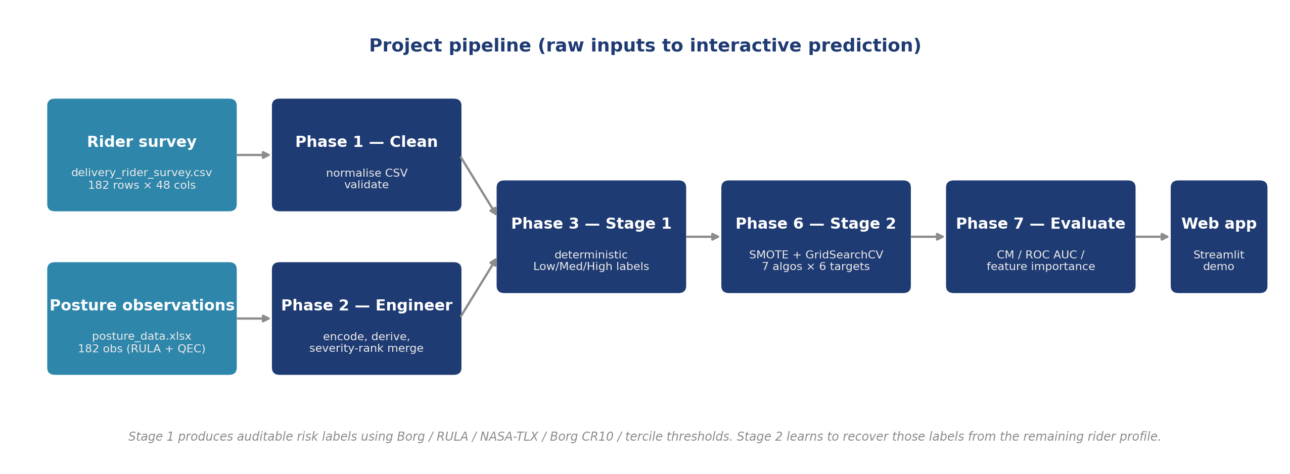
Figure 2.1: Pipeline overview from raw inputs to interactive prediction. Rider survey and posture observations are cleaned, engineered, then labelled by the Stage-1 rules; Stage 2 learns the labels from the profile.
2.2 Data sources
2.2.1 Rider survey
The file delivery_rider_survey.csv contains 182 self-administered responses to a 36-item questionnaire covering demographics, lifestyle, work pattern, Nordic Musculoskeletal Questionnaire 12-month pain across 9 body areas, 7-day discomfort in 4 areas, five discomfort-related follow-ups, six NASA-TLX workload items (each on a 0-100 scale), and six Borg CR10 perceived-exertion items (each on a 0-10 scale). After cleaning the file contains 182 rows and 48 columns.
2.2.2 Posture observations
The file posture_data.xlsx contains 182 ergonomic observation records across the workbook's sheets. Each record carries 11 RULA components (upper arm, lower arm, wrist, wrist twist, neck position, trunk position, legs, muscle A, force A, muscle B, force B), 3 derived RULA Table scores, and 8 QEC scores. The observation rows do not carry rider identifiers; the pairing to the survey uses the severity-rank merge described in section 2.3.
2.3 Data cleaning and feature engineering
Phase 1 (01_data_cleaning.ipynb) normalises the raw CSV, standardises Yes/No answers, and validates row counts. Phase 2 (02_feature_engineering.ipynb) encodes ordered categorical bins into integer codes, assigns numeric midpoints to bin ranges that will feed arithmetic formulae, ranks vehicle type and carrying mode, creates short-named binary aliases for the 18 Yes/No survey items, and derives composite scores.
Four composite features are derived: workload_score (mean of the six NASA-TLX items with satisfaction reversed), fatigue_score (mean of the six Borg CR10 items), force_exertion (Borg lifting item as its own feature), and vibration_index (vehicle_rank multiplied by work_hours_num). Five product-form interactions are also added so tree-based models can pick up combined effects such as an older rider with high workload.
The posture observations, which lack rider identifiers, are merged into the survey via a severity-rank merge. Each rider receives an exposure_severity score from their normalised NMQ pain count, fatigue score, and working hours. Riders are ranked by this severity descending; posture rows are ranked by RULA Table C descending; the two ranked lists are joined one-to-one. The methodological caveat is discussed in the Limitations section of Chapter 5.
2.4 Stage 1: Deterministic risk scoring
Phase 3 (03_risk_scoring.ipynb) applies the following rules and writes risk_profile.csv:
- Force: Borg CR10 action levels applied to force_exertion (0-3 Low, 4-6 Medium, 7-10 High).
- Repetition: deliveries per hour with fixed cuts at 2.5 and 3.75. The earlier version used pandas qcut into terciles, which had a boundary degeneracy documented in Chapter 3.
- Duration: continuous riding hours (5 or fewer Low, 6-7 Medium, over 7 High).
- Vibration: vibration_index binned by sample tercile.
- Contact Stress: composite of carrying_contact_rank, work_hours_num, and a small age multiplier, binned by sample tercile.
- Posture: RULA Table C action levels (1-2 Low, 3-4 Medium, 5 or higher High). The training data minimum is 3, so the Posture model in practice has no Low class.
2.5 Statistical analysis
Phase 5 (05_stats.ipynb) runs two analyses on the outcome variable discomfort (binary: 1 if the rider reported pain in any NMQ 12-month area). First, a chi-square test of independence (scipy.stats.chi2_contingency) tests whether each risk factor is associated with discomfort at p less than 0.05. Second, a multivariable logistic regression (statsmodels.api.Logit) estimates the effect of eleven predictors while controlling for the others; results are reported as odds ratios with 95 percent confidence intervals.
2.6 Stage 2: Machine learning pipeline
Phase 6 (06_modeling.ipynb) trains a classifier per target using seven candidate algorithms:
- LogisticRegression with L2 regularisation and balanced class weights.
- DecisionTreeClassifier with tuned max_depth and min_samples_leaf.
- RandomForestClassifier with 300 or 500 trees.
- ExtraTreesClassifier (extremely randomised trees).
- HistGradientBoostingClassifier with histogram-binned gradient boosting.
- XGBClassifier with the multi-class log-loss objective.
- StackingClassifier that combines RF, ExtraTrees, XGBoost, and HistGBM with a Logistic Regression meta-learner.
Every candidate runs inside an imblearn.Pipeline of SMOTE followed by the classifier so oversampling happens on training folds only. Hyperparameters are tuned with GridSearchCV on macro-F1 using StratifiedKFold(5, shuffle=True, random_state=42). SMOTE's k_neighbors is set per target so it never exceeds the minority training-fold count. The best-by-F1 model per target is refit on the full sample and saved to outputs/models/best_<factor>.pkl. Section 2.6.1 lists the per-target exclusion rule.
2.6.1 Per-target feature exclusions
Each target excludes the survey inputs that directly define its Stage-1 label; otherwise the model would just memorise the rule (label leakage). The Posture target also receives the 11 RULA components and 8 QEC scores as extra features, giving 63 total.
Target | Excluded features | Final feature count
Force | force_exertion, force_x_age | 42
Repetition | deliveries_num, work_hours_num, deliv_x_days | 41
Duration | work_hours_num, vibration_index | 42
Vibration | vibration_index, vehicle_rank, work_hours_num | 41
Contact Stress | carrying_contact_rank, work_hours_num | 42
Posture | (none from survey pool) | 44 + 11 + 8 = 63

Table 2.1: Per-target feature exclusions to prevent label leakage.
2.7 Evaluation
Phase 7 (07_evaluation.ipynb) uses cross_val_predict to produce out-of-fold predictions for every rider. The evaluation outputs are: per-class precision, recall, F1, and support from classification_report; confusion matrices per target; one-vs-rest ROC curves and per-class AUC (macro AUC is reported as the unweighted mean); and feature importance (feature_importances_ for tree models, abs(coef_) for Logistic Regression).

Chapter 3
Work Done
3.1 Pipeline implementation
The full pipeline is implemented across seven Jupyter notebooks (01 through 07) plus a Streamlit application. Every notebook is designed to run standalone from its previous input file, so the whole pipeline can be regenerated end to end with a fixed random seed of 42.
- 01_data_cleaning normalises the raw CSV and validates row counts.
- 02_feature_engineering encodes categoricals, derives composite scores, aliases the 18 binary items, and merges the posture observations by severity rank.
- 03_risk_scoring applies standard thresholds to compute Low/Medium/High labels per risk factor.
- 04_eda produces demographics, NMQ prevalence, risk distribution, discomfort-by-group, and correlation heatmap figures.
- 05_stats runs chi-square and multivariable logistic regression.
- 06_modeling runs SMOTE plus GridSearchCV across 7 algorithms per target and keeps the best by F1 macro.
- 07_evaluation produces confusion matrices, ROC curves, classification reports, and feature importance plots.
3.2 Feature engineering details
The final model_ready.csv contains 182 rows and 121 columns. The engineered feature families are:
- Ordinal encodings for age band, education, income, job duration, hours, days, deliveries, and rest break, each mapped to consecutive integers preserving order.
- Numeric midpoints for bin ranges that will feed formulae (work_hours_num, deliveries_num, work_days_num, rest_break_num).
- Vehicle and carrying mode ranks (motorbike higher than scooter for vibration; handheld higher than storage box for contact).
- Short-named binary aliases for the 18 NMQ, 7-day, and outcome items (nmq_*, d7_*, out_*).
- Composite scores: workload_score (NASA-TLX mean with satisfaction reversed), fatigue_score (Borg CR10 mean), force_exertion (Borg lifting), vibration_index (vehicle_rank times work_hours_num).
- Five product-form interactions: workload_x_fatigue, workload_x_age, force_x_age, fatigue_x_jobdur, deliv_x_days.
- Severity-rank merge with the posture xlsx: 11 RULA components, 3 RULA derived scores, and 8 QEC scores added per rider based on rank-to-rank pairing.
3.3 Model training
Every one of the seven candidate algorithms is wrapped in an imblearn.Pipeline([SMOTE, classifier]) and hyperparameter-tuned via GridSearchCV with scoring='f1_macro' and cv=StratifiedKFold(5, shuffle=True, random_state=42). The best-by-F1 algorithm per target is refit on the full sample. The refit pipeline is persisted with joblib.dump into outputs/models/best_<factor>.pkl as a dict containing the fitted model, the ordered feature list, and the original class codes for label mapping at prediction time.
3.4 Web application development
The Streamlit web application (app/streamlit_app.py) exposes a six-section form that mirrors the entire 36-item questionnaire plus the 11 RULA components and 8 QEC scores. Selectboxes cover demographics and work pattern; radios cover NMQ, 7-day, and outcome items; sliders cover NASA-TLX (0-100) and Borg CR10 (0-10); selectboxes cover RULA components; number inputs cover the QEC scores with min/max ranges matched to the observed training data. Three sample-profile buttons (Low, Average, High risk) pre-fill the entire form so the mentor can trigger a prediction in a single click.
On form submission, encode_rider assembles the 63-feature input vector, and predict_risks runs each of the six saved models. The output is a coloured metric strip (green for Low, amber for Medium, red for High), a horizontal Altair bar chart of the same six factors sorted to match the metric strip, a summary banner that flags high-burden profiles, per-factor recommendation cards, and an expandable JSON view of the exact 63 feature values fed to the models.
3.5 Iterations and fixes
3.5.1 Repetition binning correction
The initial Phase 3 binning used pandas.qcut(q=3) on deliveries_per_hour. The 66.7th percentile fell exactly on 3.889 dph (equal to 35 deliveries over 9 hours, the worst real combination in the sample). Fifty-five of the 182 riders tied at that value, and qcut is right-inclusive at the upper edge, so all 55 fell into Medium. This left the Stage-2 model unable to predict High for the worst real schedule. The fix replaces qcut with fixed cuts at 2.5 and 3.75. The Stage-1 High count grew from 19 to 74. Cross-validation accuracy dropped from 74 percent to 62 percent because the model now solves a real 3-class problem instead of memorising a 19-row minority.
3.5.2 Duration leakage correction
An earlier Phase 6 run reported 100 percent cross-validation accuracy on Duration. Investigation showed the trees were reconstructing work_hours_num from vibration_index, which equals vehicle_rank multiplied by work_hours_num. Adding vibration_index to the Duration exclusion list and capping max_depth returned Duration to a realistic 61 percent accuracy with 76 percent macro AUC.
3.5.3 Posture model with RULA and QEC inputs
The Posture target was initially trained only on the survey feature pool, which meant it could only infer posture indirectly from pain, fatigue, and hours. Adding the 11 RULA components and 8 QEC scores from the observation xlsx as explicit features moved Posture accuracy from 89 to 97 percent and the overfit gap from 0.088 to 0.028. Per the label-leakage rule, the three derived RULA Table scores were excluded because posture_risk is rula_table_c binned.

Chapter 4
Results and Discussions
4.1 Sample profile
The sample of 182 riders is 152 male and 30 female. Age skews young: 78 riders are under 25, 66 in the 25-35 band, 30 in 36-45, and 8 in the 46-and-above band. Roughly half the sample (49 percent) works more than 8 hours per day. Ninety-four ride scooters and 88 ride motorbikes. The platform split is 97 Blinkit, 80 Zepto, and 5 who work both platforms.
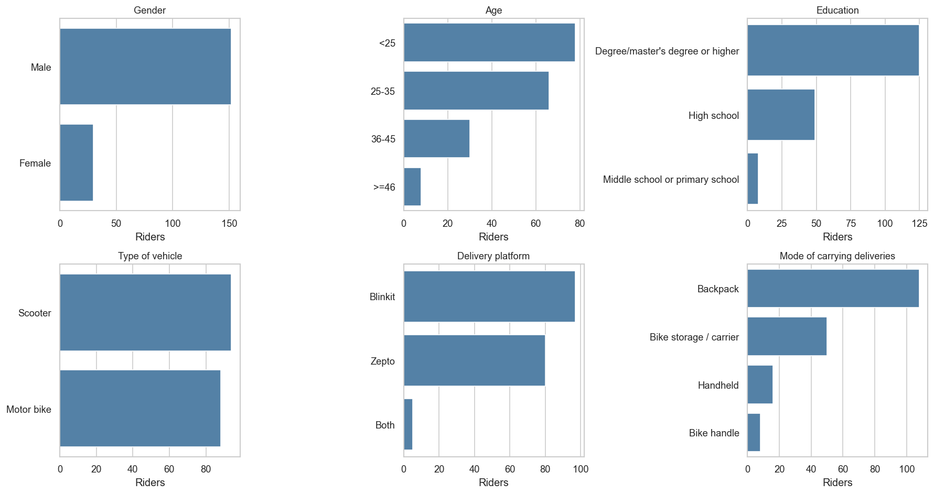
Figure 4.1: Sample profile across gender, age band, delivery platform, vehicle type, and carrying mode.
4.2 NMQ pain prevalence and statistical predictors
84.6 percent of the riders reported pain in at least one body area in the last 12 months. Table 4.1 lists the prevalence per body area, sorted from highest to lowest.
Body area | Prevalence
Lower back | 61.5%
Upper back | 49.5%
Shoulders | 46.7%
Wrists / Hands | 45.1%
Hips / Thighs | 41.2%
Ankles / Feet | 40.7%
Knees | 39.6%
Neck | 37.9%
Elbows | 33.5%

Table 4.1: NMQ 12-month pain prevalence per body area.
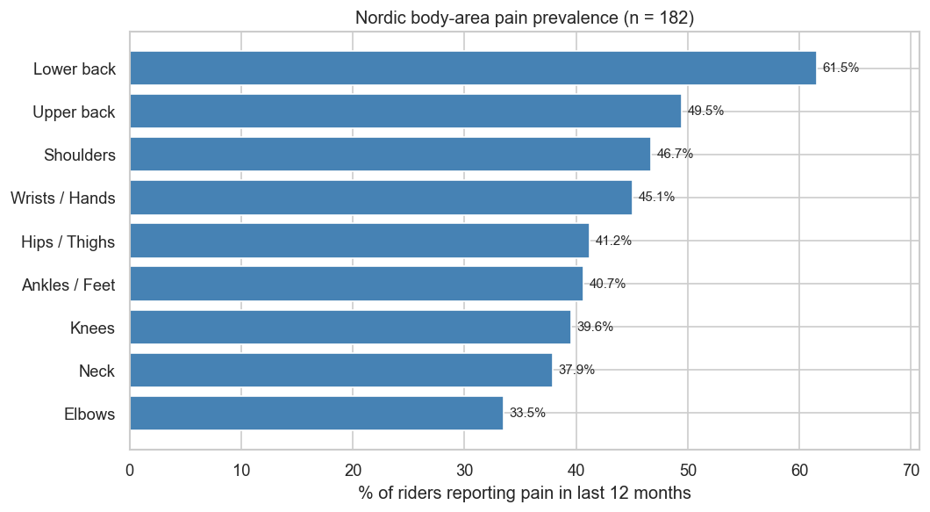
Figure 4.2: NMQ 12-month pain prevalence per body area.
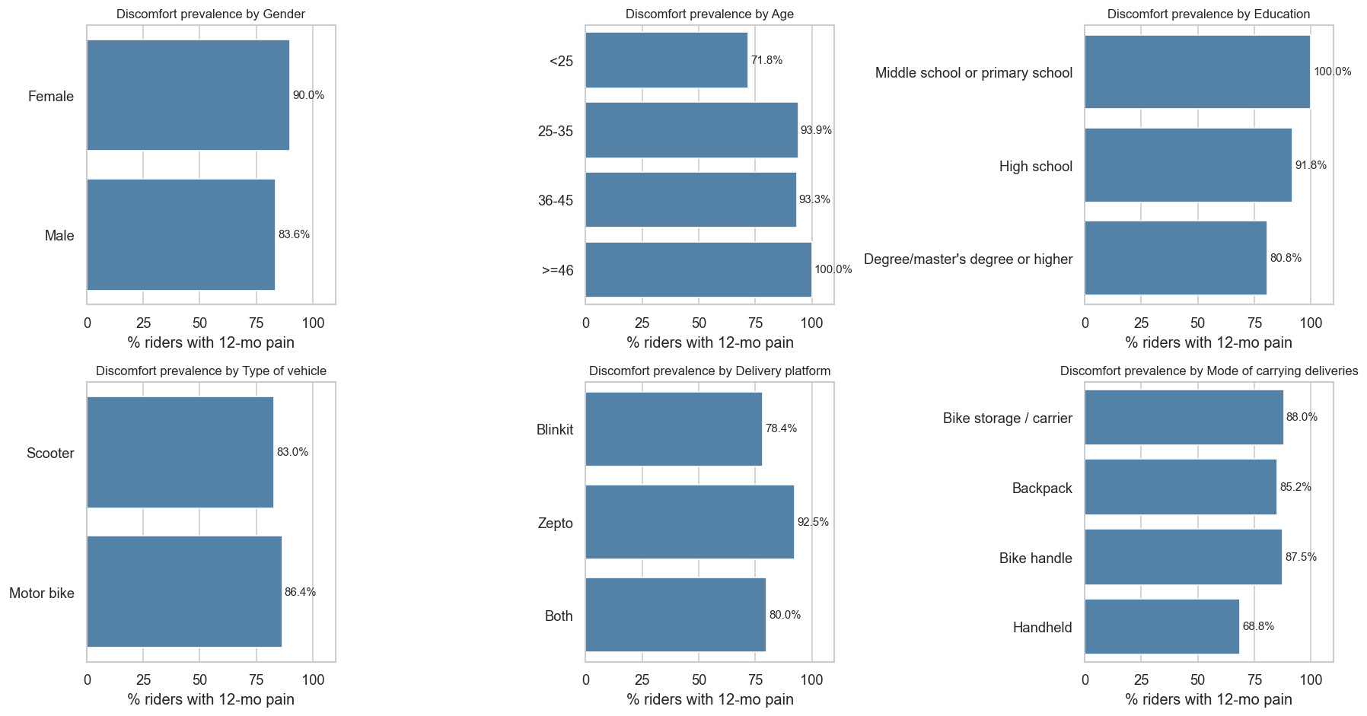
Figure 4.3: Discomfort prevalence broken down by demographic group.
The chi-square test of independence identifies Posture and Force as the two factors with a significant association with self-reported discomfort at p less than 0.05:
Factor | chi-square | p | Significant
Posture | 45.665 | <0.001 | Yes
Repetition | 8.617 | 0.014 | Yes
Force | 6.718 | 0.035 | Yes
Duration | 0.623 | 0.733 | No
Vibration | 0.600 | 0.741 | No
Contact Stress | 0.544 | 0.762 | No

Table 4.2: Chi-square test of independence between each risk factor and self-reported discomfort.
The multivariable logistic regression identifies seven significant individual predictors of discomfort while controlling for the others. Age is the strongest: each step up in the age band multiplies the odds of discomfort by 3.58 (95 percent CI 1.70 to 7.56, p = 0.0008).
Predictor | OR | 95% CI | p
Workload score (per unit) | 1.06 | 1.02 to 1.09 | 0.0005
Age (per band) | 3.58 | 1.70 to 7.56 | 0.0008
Job duration (per band) | 2.89 | 1.54 to 5.41 | 0.001
Fatigue score (per unit) | 1.43 | 1.13 to 1.80 | 0.003
Income (per band) | 2.00 | 1.25 to 3.20 | 0.004
Education (per band) | 0.33 | 0.12 to 0.94 | 0.04
Deliveries per day | 1.05 | 1.00 to 1.10 | 0.045

Table 4.3: Significant predictors of discomfort from multivariable logistic regression.
4.3 Stage-1 risk distribution
Factor | Low | Medium | High
Force | 90 | 57 | 35
Repetition | 26 | 82 | 74
Duration | 37 | 56 | 89
Vibration | 67 | 68 | 47
Contact Stress | 68 | 58 | 56
Posture | 0 | 29 | 153

Table 4.4: Stage-1 risk band counts per factor (n = 182).
Posture, Duration, and Repetition are the three factors where the High band dominates. Posture is at 84 percent High (153 of 182 observations); Duration is at 49 percent High; Repetition is at 41 percent High after the binning fix.
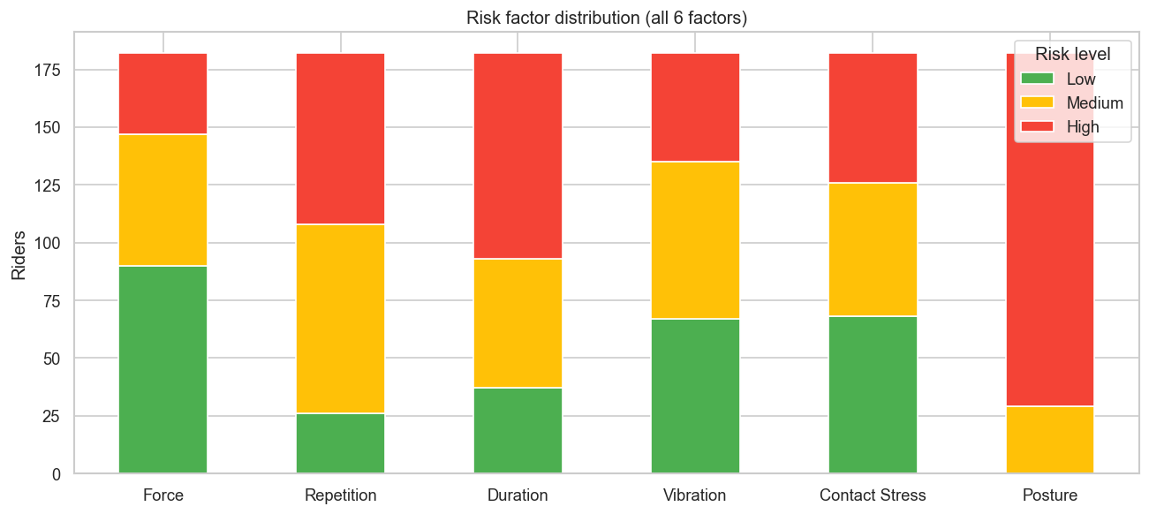
Figure 4.4: Stage-1 Low / Medium / High counts per risk factor.
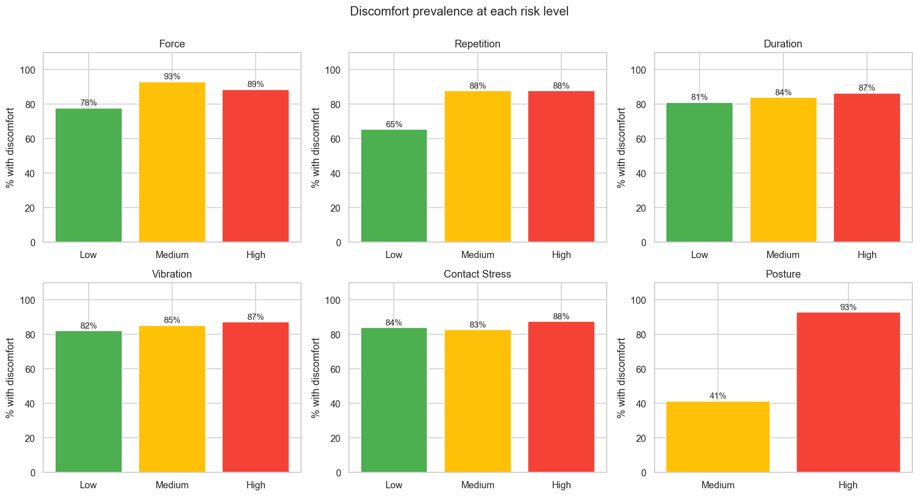
Figure 4.5: Discomfort prevalence within each Low / Medium / High band, per risk factor.
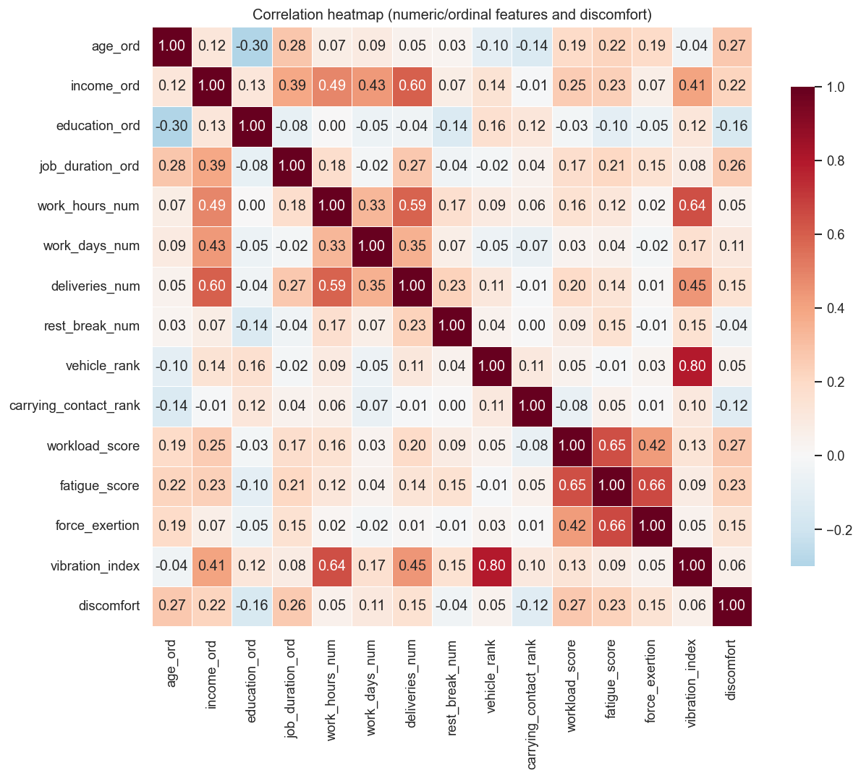
Figure 4.6: Pearson correlation matrix across the numeric feature pool, upper triangle masked.
4.4 Stage-2 model performance
Factor | Best model | Acc. | F1 macro | Macro AUC | Features
Force | HistGradientBoosting | 62% | 57% | 71% | 42
Repetition | RandomForest | 62% | 57% | 73% | 41
Duration | RandomForest | 61% | 58% | 76% | 42
Vibration | ExtraTrees | 58% | 57% | 72% | 41
Contact Stress | RandomForest | 60% | 59% | 74% | 42
Posture | HistGradientBoosting | 97% | 95% | 98% | 63

Table 4.5: Best Stage-2 model per risk factor after 5-fold stratified CV.
The five survey-derived factors land between 58 and 62 percent cross-validation accuracy with macro AUC in the 71 to 76 percent range. Posture reaches 97 percent accuracy and 98 percent macro AUC because it is the only model that receives real observation inputs (the 11 RULA components and 8 QEC scores) on top of the survey features.
4.5 Per-class metrics and feature importance
Factor | Low | Medium | High
Force | 0.798 | 0.580 | 0.760
Repetition | 0.745 | 0.669 | 0.782
Duration | 0.822 | 0.649 | 0.797
Vibration | 0.775 | 0.615 | 0.779
Contact Stress | 0.763 | 0.651 | 0.791
Posture | - | - | 0.984

Table 4.6: Per-class ROC AUC (one-vs-rest) for the best model per factor.
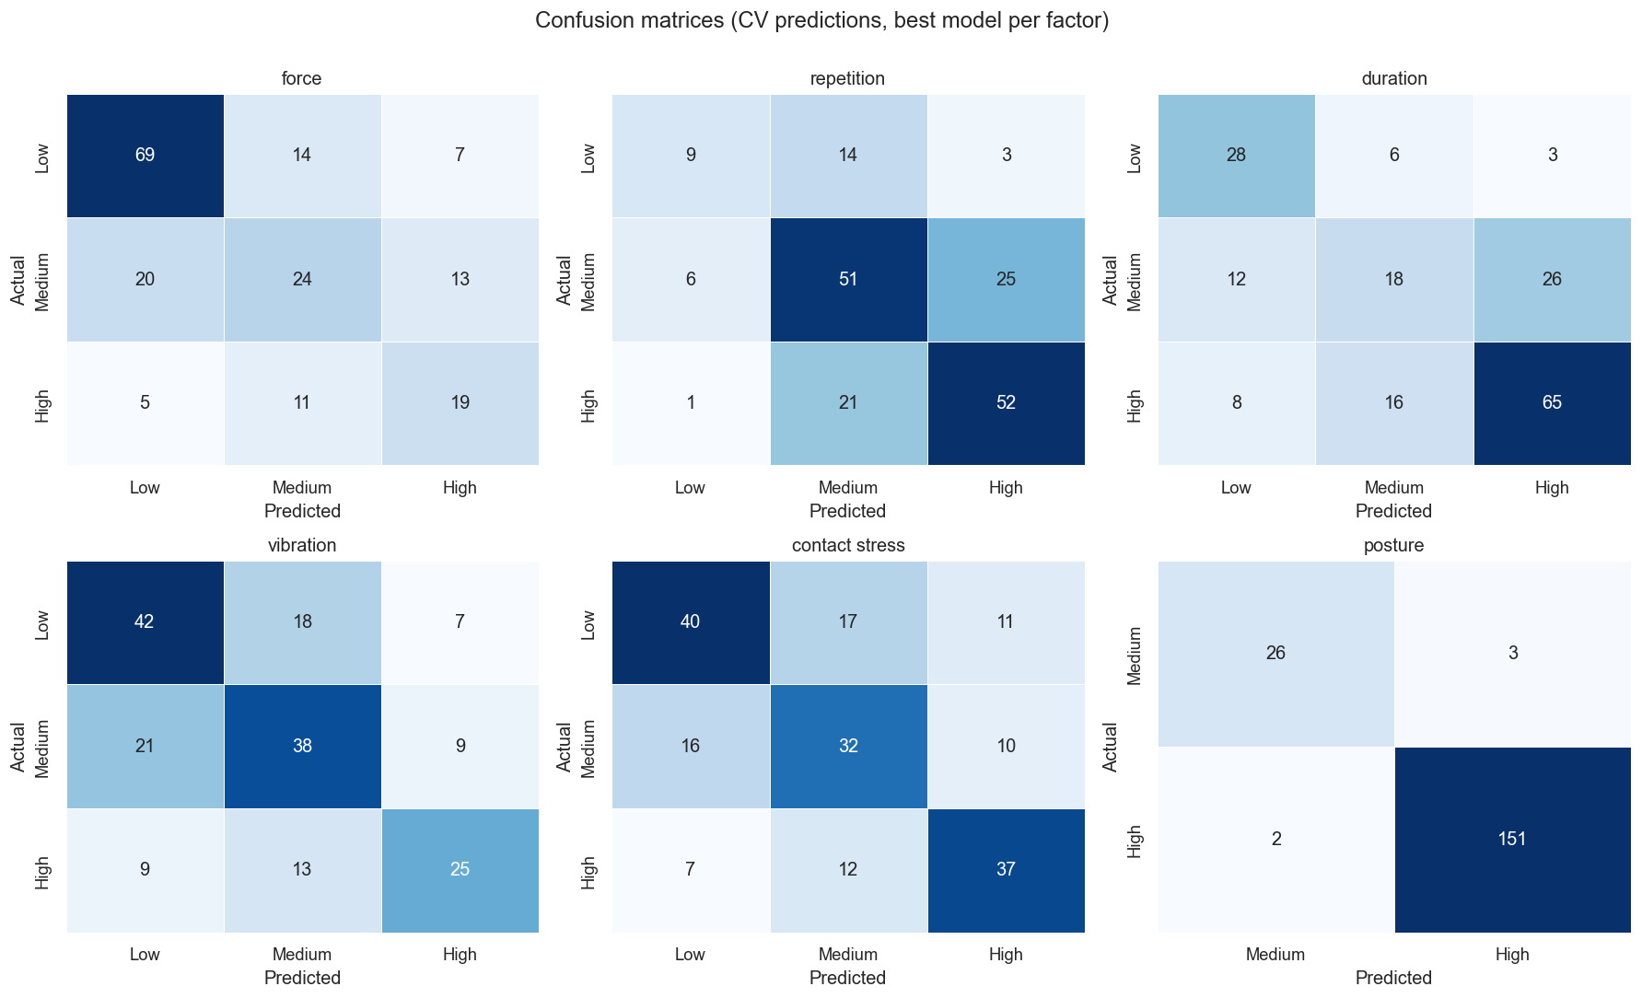
Figure 4.7: Confusion matrices for the best model per factor (rows = true class, columns = predicted class).
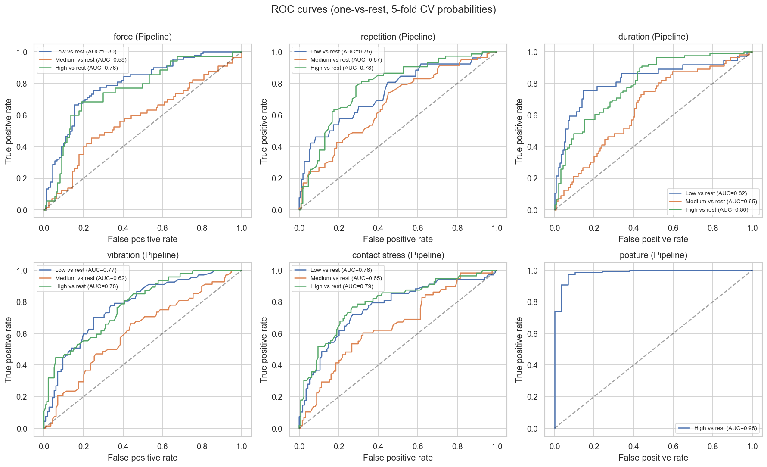
Figure 4.8: ROC curves (one-vs-rest) for the best model per factor.
Table 4.7 gives per-class precision, recall, F1, and support for the best model per factor. The Repetition High class has 65 percent precision and 70 percent recall; the Duration High class has 69 percent precision and 73 percent recall.
Factor | Class | Precision | Recall | F1 | Support
Force | Low | 0.734 | 0.767 | 0.750 | 90
Force | Medium | 0.490 | 0.421 | 0.453 | 57
Force | High | 0.487 | 0.543 | 0.514 | 35
Repetition | Low | 0.562 | 0.346 | 0.429 | 26
Repetition | Medium | 0.593 | 0.622 | 0.607 | 82
Repetition | High | 0.650 | 0.703 | 0.675 | 74
Duration | Low | 0.583 | 0.757 | 0.659 | 37
Duration | Medium | 0.450 | 0.321 | 0.375 | 56
Duration | High | 0.691 | 0.730 | 0.710 | 89
Vibration | Low | 0.583 | 0.627 | 0.604 | 67
Vibration | Medium | 0.551 | 0.559 | 0.555 | 68
Vibration | High | 0.610 | 0.532 | 0.568 | 47
Contact Stress | Low | 0.658 | 0.588 | 0.621 | 68
Contact Stress | Medium | 0.526 | 0.552 | 0.539 | 58
Contact Stress | High | 0.617 | 0.661 | 0.638 | 56
Posture | Medium | 0.724 | 0.724 | 0.724 | 29
Posture | High | 0.948 | 0.948 | 0.948 | 153

Table 4.7: Per-class precision, recall, F1, and support.
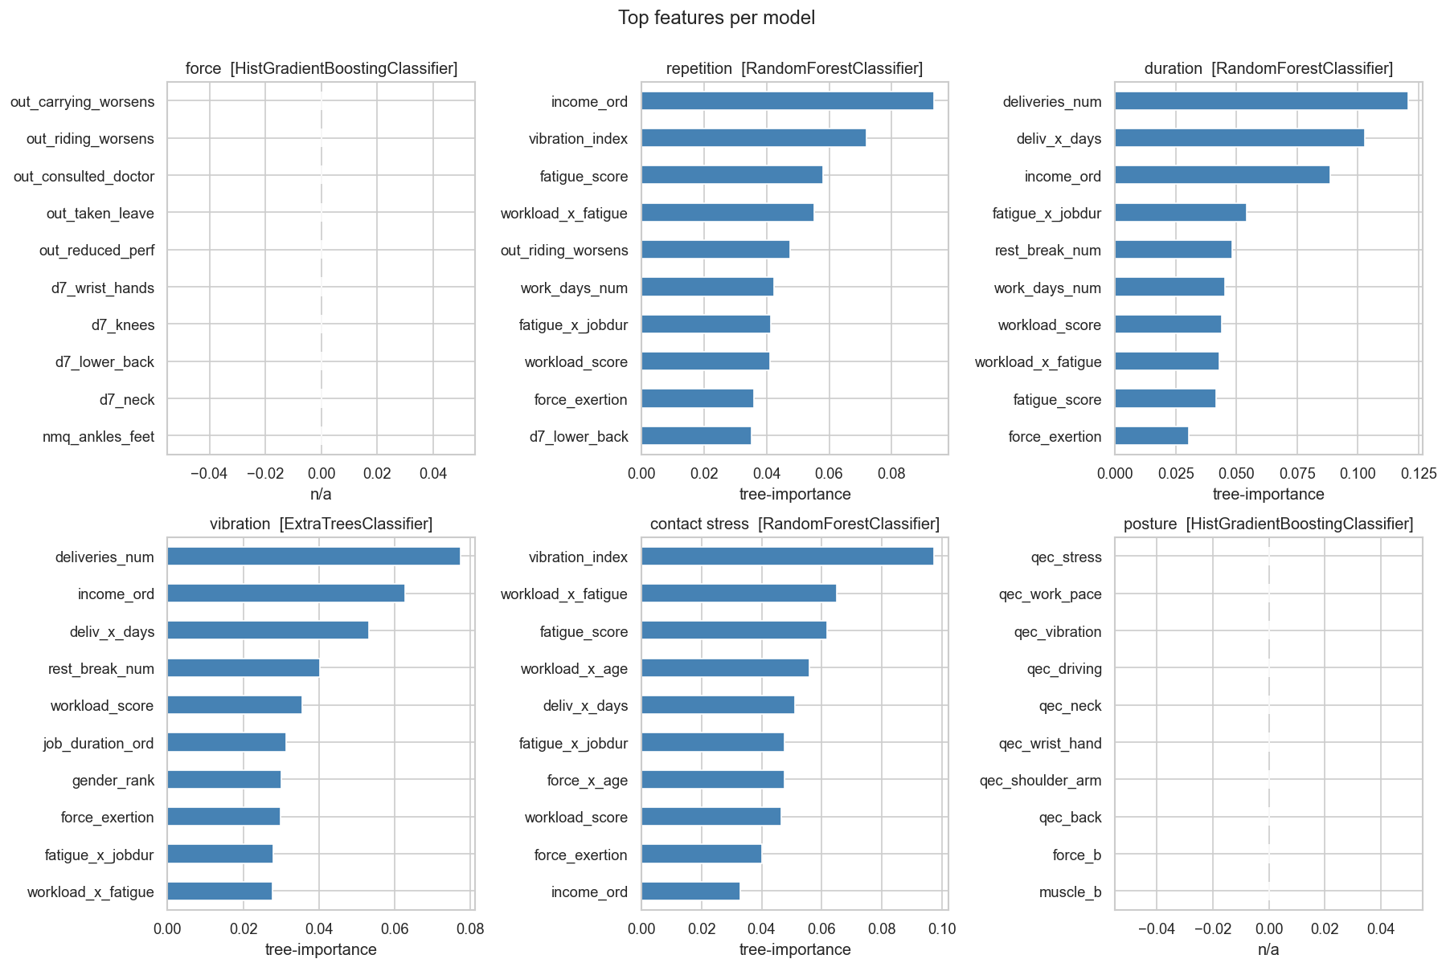
Figure 4.9: Top 10 features by importance for the best model per factor.
Factor | Rank 1 | Rank 2 | Rank 3 | Rank 4 | Rank 5
Repetition | income_ord | vibration_index | fatigue_score | workload_x_fatigue | out_riding_worsens
Duration | deliveries_num | deliv_x_days | income_ord | fatigue_x_jobdur | rest_break_num
Vibration | deliveries_num | income_ord | deliv_x_days | rest_break_num | workload_score
Contact Stress | vibration_index | workload_x_fatigue | fatigue_score | workload_x_age | deliv_x_days

Table 4.8: Top 5 most important features per factor. Force and Posture are omitted because HistGradientBoosting does not expose split-based importances directly.
Factor | Best model | Hyperparameters | SMOTE k
Force | HistGBM | max_depth=None, learning_rate=0.05 | 5
Repetition | RandomForest | n_estimators=300, max_depth=None | 5
Duration | RandomForest | n_estimators=500, max_depth=5 | 5
Vibration | ExtraTrees | n_estimators=300, max_depth=None | 5
Contact Stress | RandomForest | n_estimators=500, max_depth=None | 5
Posture | HistGBM | max_depth=5, learning_rate=0.05 | 5

Table 4.9: Winning hyperparameters per target after GridSearchCV.
4.6 Web application demonstration
The Streamlit web application is the mentor-facing artefact of the project. Figures 4.10 through 4.14 show one full pass through the form and the resulting prediction output. The header contains three sample-profile shortcuts (Low, Average, High risk) that pre-fill the entire form so the mentor can trigger a prediction in one click.
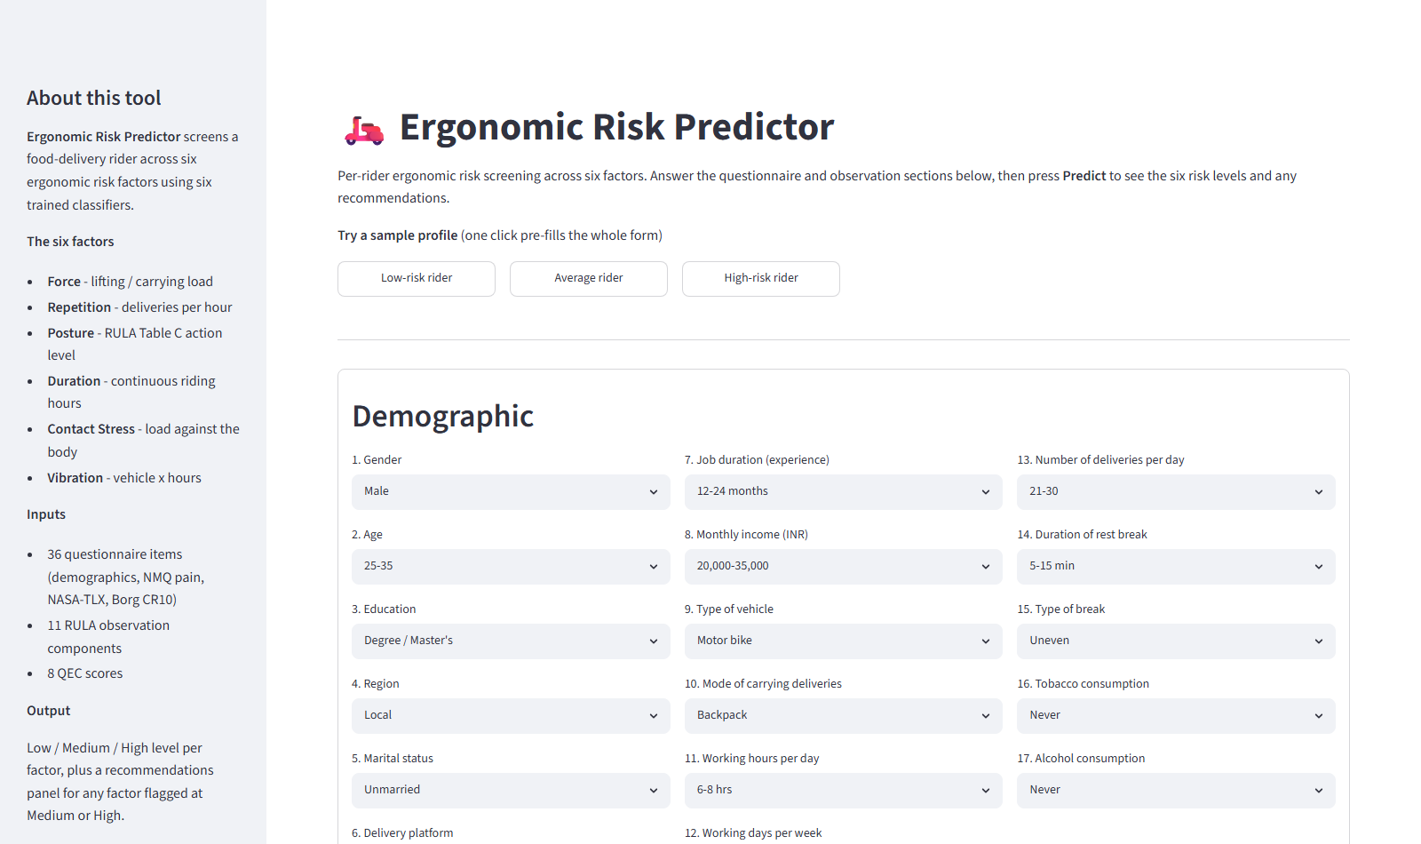
Figure 4.10: Web app: page header, sample-profile shortcuts, and demographic section (Q1 to Q17).
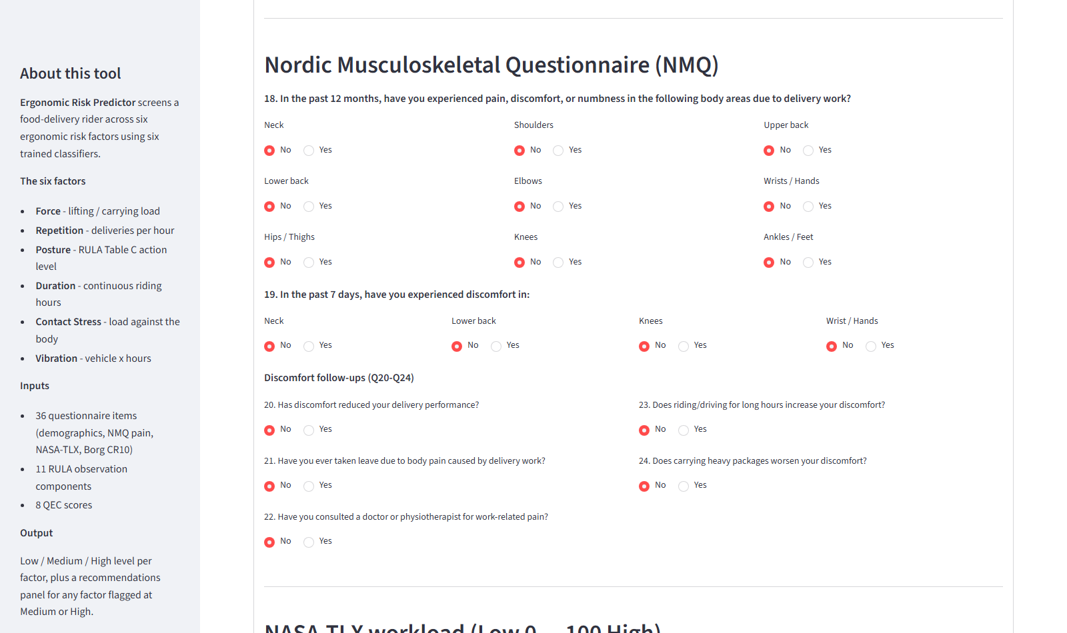
Figure 4.11: Web app: Nordic Musculoskeletal Questionnaire section (Q18 to Q24).
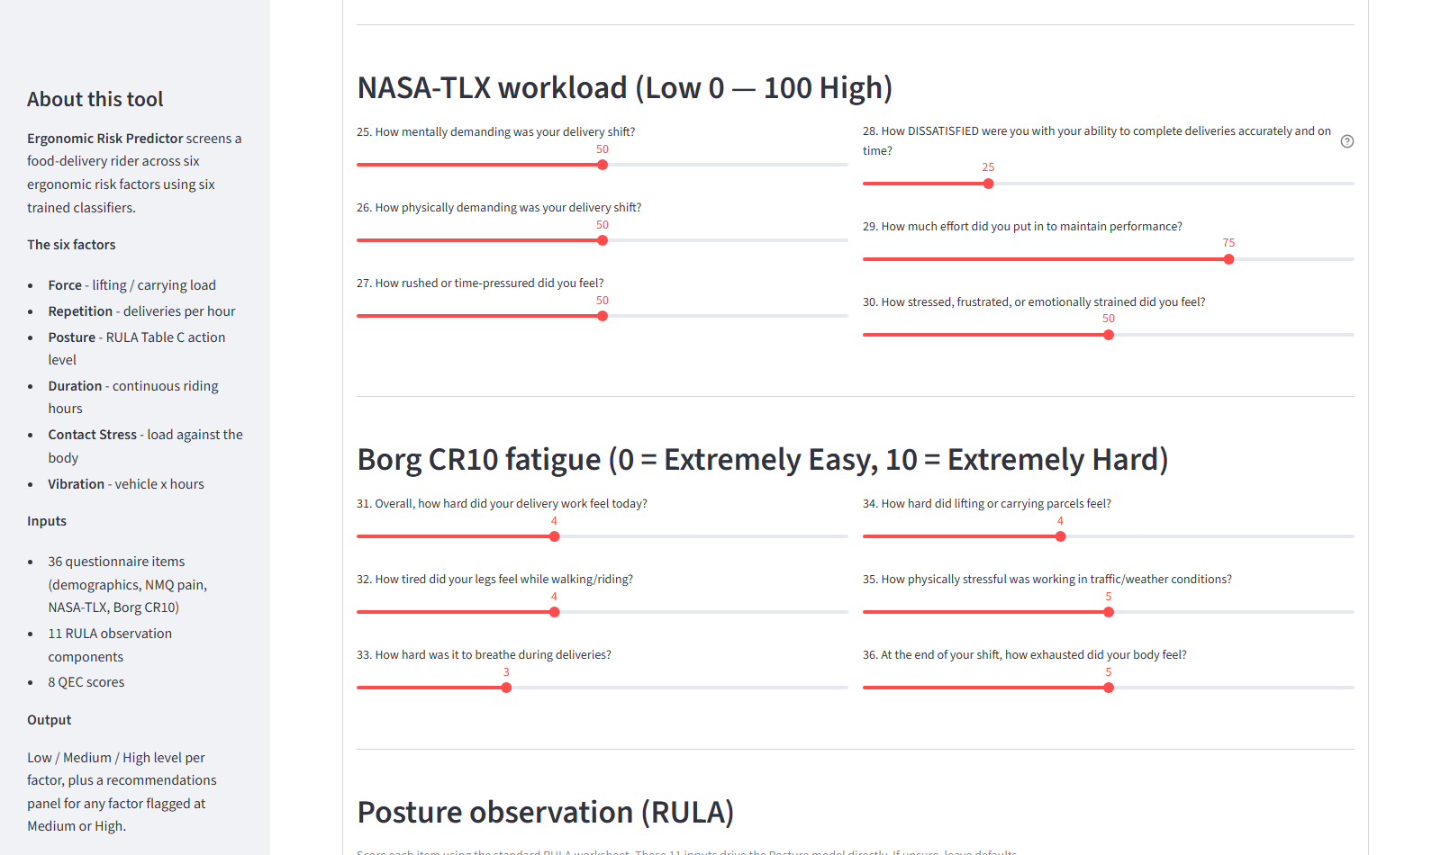
Figure 4.12: Web app: NASA-TLX and Borg CR10 sliders (Q25 to Q36).
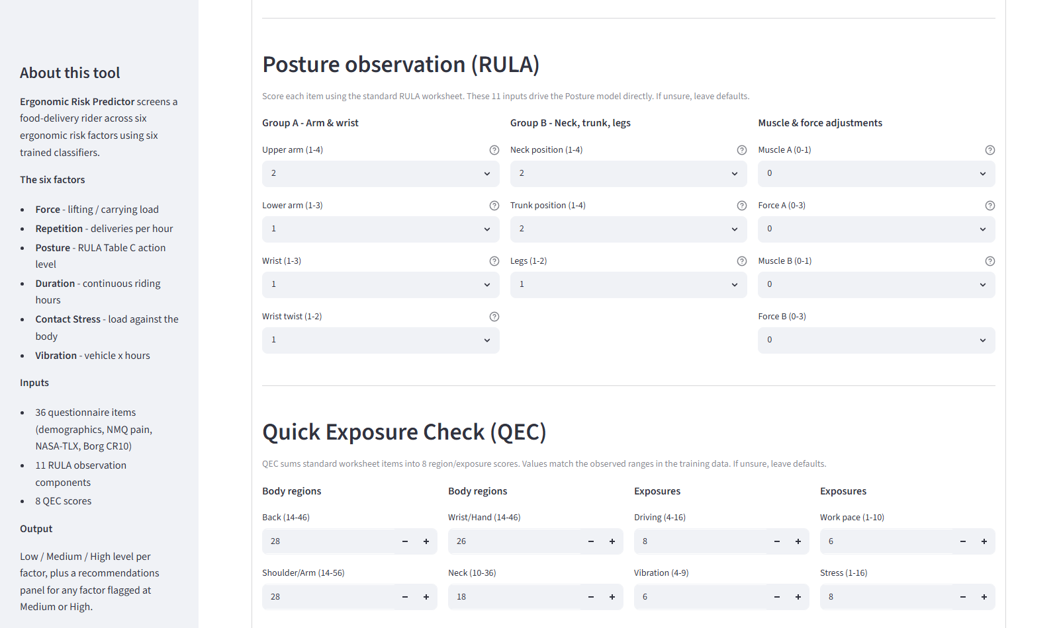
Figure 4.13: Web app: RULA (11 items) and QEC (8 scores) observation sections above the Predict button.
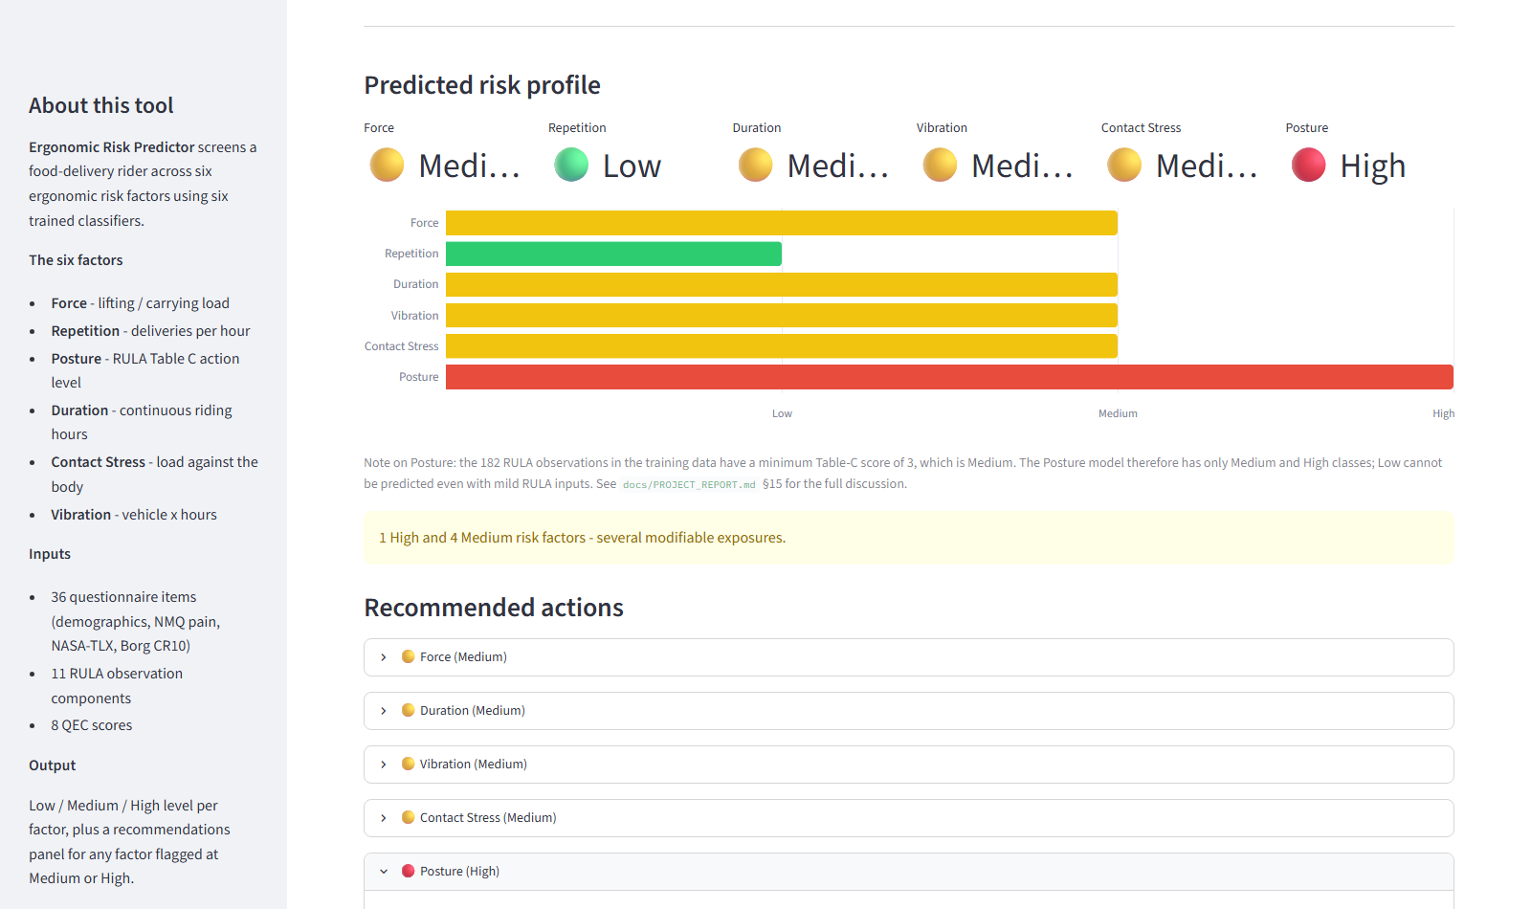
Figure 4.14: Web app: predicted risk profile output with colour-coded metric strip, horizontal bar chart, summary banner, and per-factor recommendations.

Chapter 5
Conclusions and Extensions
This project designed, implemented, and deployed a per-rider ergonomic risk screening pipeline for food-delivery workers. The pipeline turns a 36-item self-report questionnaire and a 26-column RULA-plus-QEC observation record into six standardised risk levels spanning the classical ergonomic dimensions of Force, Repetition, Posture, Duration, Contact Stress, and Vibration. The five survey-derived factors land at 58 to 62 percent accuracy with macro AUC between 71 and 76 percent; the Posture model, which uses the observation inputs directly, reaches 97 percent accuracy and 98 percent macro AUC. The final artefact is a Streamlit web application that produces the six risk levels along with per-factor recommendations from a single form submission.
Statistically the two factors most strongly associated with self-reported discomfort in this 182-rider sample are Posture and Force. Individually, age (OR 3.58 per band), job duration (OR 2.89 per band), workload score, and fatigue score are the strongest predictors of discomfort under multivariable logistic regression. These findings match the intuition that riders in higher age bands and longer careers accumulate MSD risk that is amplified by workload and fatigue.
The main limitations of this work are the self-report nature of most input variables, the approximate per-rider linkage in the posture observations (a severity-rank merge because the observation records do not carry rider identifiers), and the small sample size (n = 182) that keeps multivariable ML variance visible. Two methodological corrections were made and openly documented during the project: the Repetition binning was changed from qcut to fixed cuts to remove a boundary tie that hid the worst real schedule, and the Duration model's feature list was adjusted to remove indirect leakage through vibration_index. Both changes cost some raw accuracy but produced more meaningful models.
Five interventions for a delivery-platform operator follow directly from the results, ordered by how many riders they would reach. First, cap daily hours (roughly half the sample exceeds 8 hours per day). Second, invest in posture-focused equipment and training (84 percent of observed postures are at RULA action level 5 or above). Third, encourage bike-storage-box carrying over handheld bags. Fourth, introduce age-targeted MSD screening for riders in the 36-and-above cohort. Fifth, tune workload management at the platform level to reduce the NASA-TLX component of the workload score, which is a significant discomfort predictor at p = 0.0005.
Future extensions of the work include a longitudinal follow-up study that would let a causal claim replace the current cross-sectional association; per-rider RULA and QEC observations to eliminate the severity-rank merge; the addition of wearable accelerometer data as a Vibration proxy replacement; and a periodic re-training schedule that lets the platform update its screening tool as the workforce changes. The two-stage design leaves room for each of these extensions without disturbing the audited Stage-1 labels.

Chapter
Bibliography
[1] McAtamney L, Corlett EN (1993). RULA: a survey method for the investigation of work-related upper limb disorders. Applied Ergonomics, 24(2), 91-99.
[2] David G, Woods V, Li G, Buckle P (2008). The development of the Quick Exposure Check (QEC) for assessing exposure to risk factors for work-related musculoskeletal disorders. Applied Ergonomics, 39(1), 57-69.
[3] Kuorinka I, Jonsson B, Kilbom A, Vinterberg H, Biering-Sorensen F, Andersson G, Jorgensen K (1987). Standardised Nordic questionnaires for the analysis of musculoskeletal symptoms. Applied Ergonomics, 18(3), 233-237.
[4] Hart SG, Staveland LE (1988). Development of NASA-TLX (Task Load Index): Results of empirical and theoretical research. Advances in Psychology, 52, 139-183.
[5] Borg G (1998). Borg's Perceived Exertion and Pain Scales. Human Kinetics Publishers, Champaign, Illinois.
[6] Chawla NV, Bowyer KW, Hall LO, Kegelmeyer WP (2002). SMOTE: Synthetic Minority Over-sampling Technique. Journal of Artificial Intelligence Research, 16, 321-357.
[7] Breiman L (2001). Random Forests. Machine Learning, 45(1), 5-32.
[8] Geurts P, Ernst D, Wehenkel L (2006). Extremely randomized trees. Machine Learning, 63(1), 3-42.
[9] Chen T, Guestrin C (2016). XGBoost: A Scalable Tree Boosting System. Proceedings of the 22nd ACM SIGKDD International Conference on Knowledge Discovery and Data Mining, 785-794.
[10] Friedman JH (2001). Greedy function approximation: A gradient boosting machine. Annals of Statistics, 29(5), 1189-1232.
[11] Wolpert DH (1992). Stacked generalization. Neural Networks, 5(2), 241-259.
[12] Pedregosa F, Varoquaux G, Gramfort A, et al. (2011). Scikit-learn: Machine Learning in Python. Journal of Machine Learning Research, 12, 2825-2830.
[13] Lemaitre G, Nogueira F, Aridas CK (2017). Imbalanced-learn: A Python toolbox to tackle the curse of imbalanced datasets in machine learning. Journal of Machine Learning Research, 18(17), 1-5.
[14] Kohavi R (1995). A study of cross-validation and bootstrap for accuracy estimation and model selection. Proceedings of the 14th International Joint Conference on Artificial Intelligence, 1137-1145.
[15] Cortes C, Vapnik V (1995). Support-vector networks. Machine Learning, 20(3), 273-297.

