A Predictive Machine Learning Framework for Ergonomic Risk in Last-Mile Quick-Commerce Delivery Operations
Internship report submitted under
IIITDM-SIES Programme
by
AILA VISHNU VARDHAN

SCHOOL OF INTERDISCIPLINARY DESIGN AND INNOVATION (SIDI)
INDIAN INSTITUTE OF INFORMATION TECHNOLOGY,
DESIGN AND MANUFACTURING, KANCHEEPURAM
July 2026

Certificate
I, AILA VISHNU VARDHAN, from Vidya Jyothi Institute of Technology hereby declare that the material presented in the Internship Report titled 'A Predictive Machine Learning Framework for Ergonomic Risk in Last-Mile Quick-Commerce Delivery Operations' represents original work carried out by me in the School of Interdisciplinary Design and Innovation (SIDI) at the Indian Institute of Information Technology, Design and Manufacturing, Kancheepuram during the year 2026. With my signature, I certify that:
- I have not manipulated any of the data or results.
- I have not committed any plagiarism of intellectual property. I have clearly indicated and referenced the contributions of others.
- I have explicitly acknowledged all collaborative research and discussions.
- I have understood that any false claim will result in severe disciplinary action.
- I have understood that the work may be screened for any form of academic misconduct.

Date: Intern's Signature
In my capacity as supervisor of the above-mentioned work, I certify that the work presented in this Report is carried out under my supervision, and is worthy of consideration for the requirements of internship under IIITDM-SIES programme during the period May 2026 to July 2026.
Mentor's Name: Dr. Arunachalam Muthiah Mentor's Signature

Abstract
Delivery riders working for companies such as Blinkit and Zepto have to tend to their customers while standing in uncomfortable body shapes for a long time or transporting heavy loads, which may result in musculoskeletal disorders. Risk varies across the people involved in the delivery: age, experience, working hours, the type of vehicle, and carrying methods influence the level of risk experienced by every rider, but the companies providing the delivery services do not pay attention to this difference. Different ergonomic approaches capture only certain aspects of the situation: on the one hand, some methods (RULA and QEC) are applicable to direct observations, while others, like Borg CR10, NMQ, and NASA-TLX apply to self-reporting methods. This paradigm enables the authors to offer automated screening based on a study involving 182 riders from the city of Chengalpattu and Chennai conducted in March and April 2026
The pipeline runs in two stages. Stage 1 applies standard ergonomic methods (Borg CR10 action levels, RULA Table C thresholds, and sample-based cuts) to compute Low, Medium, or High risk labels for each factor from a 182-rider survey combined with 182 RULA and QEC observation records. Stage 2 trains supervised classifiers per factor using seven candidate algorithms (Logistic Regression, Decision Tree, Random Forest, Extra Trees, Hist Gradient Boosting, XGBoost, and Stacking) tuned via GridSearchCV with SMOTE inside 5-fold stratified cross-validation.
The five factors which were taken from the survey received a validation accuracy of 58-62% and a macro AUC of 71-76%. The Posture model which incorporates 11 components of RULA and 8 QEC scores in addition to the results received an accuracy of 97% and AUC of 98%. Statistical analysis including chi-square and multiple logistic regression determined that the most powerful individual predictors of self-reported discomfort are age, length of work history, workload score and fatigue score. The final product is a Streamlit web application that takes a complete questionnaire of 36 items together with RULA and QEC results and produces six levels of risk and offers recommendations by factors.

Acknowledgements
I would like to express my gratitude to my mentor, Dr. Arunachalam Muthiah, who guided me throughout this project. I show deep appreciation for his support, patience, and technical direction, from the study design through the modelling and the final web application.
I would also like to extend my gratitude to the School of Interdisciplinary Design and Innovation (SIDI), IIITDM Kancheepuram, for hosting the internship and providing the resources that made this work possible. I would like to thank Vidya Jyothi Institute of Technology, my home institution, for the academic foundation that let me take on this project.
I acknowledge the 182 quick-commerce delivery riders in the Chengalpattu and Chennai regions who participated in the survey and the observation study. Without their time and honesty this work would not have been possible.
Finally, I would like to thank my friends and family for keeping me motivated throughout the internship.

Contents
Certificate i
Abstract ii
Acknowledgements iii
Contents iv-v
List of Figures vi
List of Tables vii
Abbreviations viii
Symbols ix
1 INTRODUCTION 1
1.1 Background 1
1.2 Motivation 1
1.3 Objectives of the work 1
2 METHODOLOGY 3
2.1 Two-stage design 3
2.2 Study design and data sources 3
2.2.1 Rider survey 4
2.2.2 Posture observations 4
2.3 Data cleaning and feature engineering 4
2.4 Stage 1: Deterministic risk scoring 4
2.5 Statistical analysis 5
2.6 Stage 2: Machine learning pipeline 5
2.6.1 Logistic Regression 5
2.6.2 Decision Tree 5
2.6.3 Random Forest 5
2.6.4 Extra Trees 5
2.6.5 Histogram Gradient Boosting 5
2.6.6 XGBoost 6
2.6.7 Stacking Classifier 6
2.6.8 SMOTE and cross-validation 6
2.6.9 Per-target feature exclusions 6
2.7 Evaluation 6
3 WORK DONE 7
3.1 Notebook pipeline 7
3.2 Instrument design and preparation 7
3.3 Data collection execution 8
3.4 Data cleaning, encoding, and integration 8
3.5 Statistical analysis and model training runs 9
3.6 Web application development and deployment 9
3.7 Iterations and fixes 10
3.7.1 Repetition binning correction 10
3.7.2 Duration leakage correction 10
3.7.3 Posture model with RULA and QEC inputs 10
4 RESULTS AND DISCUSSION 11
4.1 Sample profile 11
4.2 NMQ pain prevalence and statistical predictors 11
4.3 Stage-1 risk distribution 13
4.4 Stage-2 model performance 14
4.5 Per-class metrics and feature importance 15
4.6 Web application demonstration 17
5 CONCLUSIONS AND EXTENSIONS 19
BIBLIOGRAPHY 20

List of Figures
Figure 2.1 Pipeline overview: raw inputs to interactive prediction. 3
Figure 4.1 Sample profile: age, platform, vehicle, and carrying mode. 11
Figure 4.2 NMQ 12-month pain prevalence per body area. 12
Figure 4.3 Discomfort prevalence broken down by demographic group. 12
Figure 4.4 Discomfort prevalence within each Low / Medium / High band. 13
Figure 4.5 Pearson correlation matrix across the numeric feature pool. 14
Figure 4.6 Confusion matrices for the best model per factor. 15
Figure 4.7 ROC curves (one-vs-rest) for the best model per factor. 15
Figure 4.8 Top 10 features by importance for the best model per factor. 16
Figure 4.9 Web app: sample-profile shortcuts and demographic section. 17
Figure 4.10 Web app: Nordic Musculoskeletal Questionnaire section. 17
Figure 4.11 Web app: NASA-TLX and Borg CR10 sliders. 18
Figure 4.12 Web app: RULA and QEC observation sections. 18
Figure 4.13 Web app: predicted risk profile output. 18

List of Tables
Table 2.1 Per-target feature exclusions to prevent label leakage. 6
Table 4.1 NMQ 12-month pain prevalence per body area. 11
Table 4.2 Chi-square test: risk factor vs self-reported discomfort. 12
Table 4.3 Significant predictors of discomfort from per-predictor (univariable) logistic regression. 13
Table 4.4 Stage-1 risk band counts per factor. 13
Table 4.5 Best Stage-2 model per risk factor: 5-fold stratified CV. 14
Table 4.6 Per-class ROC AUC (one-vs-rest) for the best model per factor. 15
Table 4.7 Per-class precision, recall, F1, and support. 16
Table 4.8 Winning hyperparameters per target after GridSearchCV. 16

Abbreviations
MSD Musculoskeletal Disorder
NMQ Nordic Musculoskeletal Questionnaire
RULA Rapid Upper Limb Assessment
QEC Quick Exposure Check
NASA-TLX NASA Task Load Index
CV Cross-Validation
SMOTE Synthetic Minority Over-sampling Technique
ROC Receiver Operating Characteristic
AUC Area Under the Curve
OR Odds Ratio
CI Confidence Interval
HistGBM Histogram-based Gradient Boosting Machine
XGBoost eXtreme Gradient Boosting
CART Classification and Regression Trees
dph Deliveries Per Hour
MSK Musculoskeletal
CR10 Category-Ratio 10-point scale (Borg)
RF Random Forest
ET Extra Trees
LR Logistic Regression
DT Decision Tree
GBM Gradient Boosting Machine
OvR One-vs-Rest
SD Standard Deviation

Symbols
n sample size (n = 182 riders)
k number of nearest minority neighbours used by SMOTE
λ uniform random weight for SMOTE interpolation
β regression coefficient in logistic regression
χ² chi-square test statistic
p p-value (statistical significance)
dph deliveries per hour, deliveries_num / work_hours_num
α significance threshold (α = 0.05)
df degrees of freedom (chi-square test)
F1 harmonic mean of precision and recall

Chapter 1. Introduction

1.1 Background
Last-mile quick-commerce delivery riders for platforms like Blinkit and Zepto spend long hours on bikes, climb stairs, carry packages, and ride in heavy traffic. Prior Indian last-mile MSK studies [1, 2] report similar exposure patterns among app-based delivery riders. Over time this kind of work causes musculoskeletal disorders (MSDs): back pain, shoulder pain, wrist injuries, knee problems. The risk is not the same for every rider. Someone who is 22 and works 4 hours a day on a scooter is in a very different situation from a 45-year-old who works 10 hours a day on a motorbike with a handheld bag.
Standard ergonomic methods cover different facets of this problem. RULA and QEC handle the observational side (posture, body-region exposure), while NMQ, NASA-TLX, and Borg CR10 cover what the rider reports about pain, mental load, and perceived exertion. None of them on its own gives a complete picture. The project pulls all of them together into one per-rider profile across six ergonomic dimensions: Force, Repetition, Posture, Duration, Contact Stress, Vibration.

1.2 Motivation
The delivery economy in India has grown rapidly in recent years. Quick-commerce riders form a large occupational group with working conditions unlike traditional warehouse or manufacturing labour: long-distance riding, carrying goods in a moving vehicle where the load position cannot be controlled, exposure to bad weather, and constant pressure from platform routing algorithms. No screening tool exists that lets a platform assess a rider on all six standard ergonomic factors from a single questionnaire.
By producing a risk profile for each rider, platforms can intervene early: shortening shifts for high-risk riders, reviewing the equipment they use, arranging physiotherapy, and re-screening regularly. Without this approach the risks stay invisible until the rider becomes symptomatic. This project addresses that gap by combining published ergonomic assessment methods with modern classifiers into a single screening pipeline and web application.

1.3 Objectives of the work
- Develop a two-step pipeline that integrates data obtained from a survey of quick-commerce delivery couriers with the conventional ergonomic assessment methods (RULA and QEC) into per-courier categorizations for 6 risk indicators: Force, Repetition, Posture, Duration, Contact Stress and Vibration.
- Conduct the pipeline reproducibly in Python (Jupyter notebooks, scikit-learn, XGBoost, imbalanced-learn, statsmodels) with an assigned seed and the entire regeneration of the output at every part of the process.
- Train and validate 7 potential ML techniques for each of the risk indicators through 5-fold stratified cross-validation, implementing SMOTE oversampling during training using all of the folds, and give out results including the accuracy values, macro F1 and macro AUC.
- Identify issues with the methodology found during the construction of the model and take actions to fix them (class boundary degeneration within the Repetition categorization, leakage of variables within Duration model).
- Deliver the created models as part of a Streamlit web service accepting information from complete and full 36-item questionnaire plus 11 items about RULA and 8 items about QEC and giving out risk measurements for every category according to 6 CTQs.

Chapter 2. Methodology

2.1 Two-stage design
The pipeline runs in two stages. Stage 1 assigns Low, Medium, and High labels for six ergonomic risks using deterministic rules from standard methods (Borg CR10 for Force, RULA Table C for Posture, sample terciles or fixed cuts for the rest); these labels are the ground truth Stage 2 has to learn. Stage 2 trains a supervised classifier per factor with per-target feature exclusions removing the inputs that define the label, and evaluates via 5-fold stratified cross-validation with SMOTE oversampling inside every training fold.
The two-stage split lets an ergonomist audit Stage 1 by hand and an ML reviewer audit Stage 2 independently, and the trained classifiers can then be deployed behind a web form that runs on a new rider's profile without re-applying the RULA and QEC worksheets.
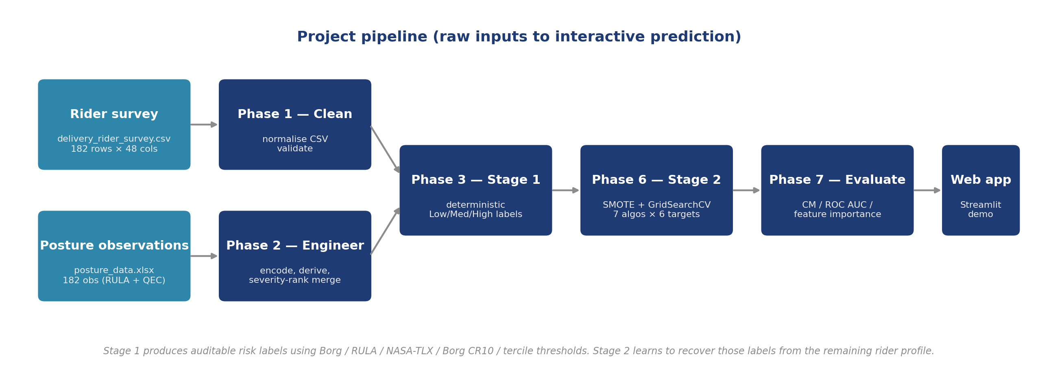
Figure 2.1: Pipeline overview from raw inputs to interactive prediction.

2.2 Study design and data sources
This is a cross-sectional study of Blinkit and Zepto quick-commerce delivery partners conducted in the Chengalpattu and Chennai regions in March-April 2026 using convenience sampling. The same 182 participants supplied both data streams: rider self-report through a Google Form and posture recorded during a delivery task by a trained observer.
Inclusion criteria
- Full-time delivery partners working on either the Blinkit or the Zepto platform.
- Minimum three months of continuous delivery experience.
- Both men and women, aged between 18 and 55 years.
Exclusion criteria
- Chronic musculoskeletal disorders that developed before the start of delivery work.
- Accidental surgery within the past three months.

2.2.1 Rider survey
The dataset delivery_rider_survey.csv contains the 182 responses to the 36-item questionnaire: demographics and work pattern, NMQ 12-month pain (nine body areas), 7-day discomfort restricted to four high-load rider areas (neck, lower back, wrist / hands, knees) as a space-saving modification of the standard NMQ, five discomfort follow-ups, six NASA-TLX items (0 to 100), and six Borg CR10 items (0 to 10).

2.2.2 Posture observations
The dataset posture_data.xlsx holds 182 observation records, each carrying the 11 RULA components, 3 RULA Table scores, and 8 QEC scores. The rows lack rider identifiers; pairing to the survey uses the severity-rank merge described in §2.3.

2.3 Data cleaning and feature engineering
Phase 1 (01_data_cleaning.ipynb) normalises the raw CSV, standardises Yes/No answers, and validates row counts. Phase 2 (02_feature_engineering.ipynb) encodes ordered categorical bins to integers, assigns numeric midpoints to bin ranges, ranks vehicle type and carrying mode, aliases the 18 Yes/No items, and derives four composite features -- workload_score (mean of the six NASA-TLX items with satisfaction reversed), fatigue_score (mean of the six Borg CR10 items), force_exertion (the Borg lifting item), and vibration_index (vehicle_rank x work_hours_num) -- plus five product-form interactions so tree-based models can pick up combined effects.
The posture observations are merged into the survey via a severity-rank merge: riders are ranked by an exposure_severity index (normalised NMQ pain count + fatigue score + hours), posture rows by RULA Table C, and the two ranked lists are joined one-to-one. Caveats are noted in Chapter 5.

2.4 Stage 1: Deterministic risk scoring
Phase 3 (03_risk_scoring.ipynb) applies the following rules and writes risk_profile.csv:
- Force: Borg CR10 lifting (0-3 Low, 4-6 Medium, 7-10 High).
- Repetition: deliveries per hour, fixed cuts at 2.5 and 3.75.
- Duration: continuous riding hours (<=5 Low, 6-7 Medium, >7 High).
- Vibration: vibration_index binned by sample tercile.
- Contact Stress: carrying_contact_rank x work_hours_num x age multiplier, sample tercile.
- Posture: RULA Table C grand score (1-2 Low, 3-4 Medium, >=5 High); the High band merges standard RULA Action Levels 3 (grand score 5-6) and 4 (grand score 7). Training minimum is 3, so Posture has no Low class.

2.5 Statistical analysis
Phase 4 (04_eda.ipynb) then produces demographic breakdowns, per-factor risk-band distributions, Nordic 12-month discomfort prevalence, discomfort rates split by demographic and by risk level, and a Pearson correlation heatmap on 15 columns (14 numeric and ordinal features plus the discomfort outcome).
Phase 5 (05_stats.ipynb) comprises two analyses on discomfort i.e. the binary: pain as per NMQ for 12 months. Chi-square test (scipy.stats.chi2_contingency) is performed to see if a given risk factor is connected with discomfort at a significance level of 5%. Then multivariate logistic regression (statsmodels.api.Logit) is conducted to look at the weight of 11 determinants at a time, controlling all the others with the results displayed in odds ratios at 95% confidence intervals.

2.6 Stage 2: Machine learning pipeline
Phase 6 (06_modeling.ipynb) trains a classifier per target from seven candidate algorithms. GridSearchCV tunes hyperparameters on macro-F1 inside 5-fold stratified cross-validation, and the best model per target is refit on the full sample and saved as outputs/models/best_<factor>.pkl.

2.6.1 Logistic Regression
Regularized linear classifier used as the baseline (L2 penalty, class_weight balanced). Any tree-based method that fails to beat it on a factor is either overfitting or getting nothing from feature interactions.
2.6.2 Decision Tree
Utilized a single CART tree where max_depth ranged from 3 to 7, and min_samples_leaf varied from 1 to 5 for fine-tuning using grid search.
2.6.3 Random Forest
Bagged ensemble of 300-500 trees with bootstrap sampling and sqrt(p) features per split. Low-variance predictions and mixed feature-type handling made it the winner on Repetition, Duration, and Contact Stress.
2.6.4 Extra Trees
Like Random Forest but with fully random splits per node. The extra randomisation lowers between-tree correlation and helped it win on Vibration.
2.6.5 Histogram Gradient Boosting
Sequential residual-fit ensemble with histogram-binned features for training speed. Won on Force (Borg CR10 cutoffs are nonlinear) and Posture (strongest signal from RULA and QEC features).

2.6.6 XGBoost
Gradient-boosted trees with L2 regularisation on the leaf weights. Placed second on Duration and Contact Stress but did not win any at the default search budget.

2.6.7 Stacking Classifier
Meta-learner (Logistic Regression) trained on the out-of-fold predictions of Random Forest, Extra Trees, HistGBM, and XGBoost as base learners. Failed to strictly outperform the strongest base learner on any of the six targets.

2.6.8 SMOTE and cross-validation
SMOTE synthesises new minority-class samples along segments between k nearest minority neighbours. Wrapping it in imblearn.Pipeline keeps the synthesis inside training folds only, so validation-fold accuracy is never inflated. GridSearchCV picks hyperparameters on macro-F1 with StratifiedKFold(5, shuffle=True, random_state=42).

2.6.9 Per-target feature exclusions
Each target does not use survey questions that have given it its Stage-1 label (otherwise it would learn the rule). The Posture target additionally receives an additional 11 RULA components and 8 QEC scores, resulting in an overall of 63 features.
Target | Excluded features | Final feature count
Force | force_exertion, force_x_age | 42
Repetition | deliveries_num, work_hours_num, deliv_x_days | 41
Duration | work_hours_num, vibration_index | 42
Vibration | vibration_index, vehicle_rank, work_hours_num | 41
Contact Stress | carrying_contact_rank, work_hours_num | 42
Posture | (none from survey pool) | 44 + 11 + 8 = 63

Table 2.1: Per-target feature exclusions to prevent label leakage.

2.7 Evaluation
Phase 7 (07_evaluation.ipynb) involves cross_val_predict for out of fold predictions and generates class-wise metrics such as precision, recall, F1 score, support, confusion matrices, one-vs-all ROC curves with AUC per class (macro AUC is simply the average of all classes) and feature importance (feature_importances_ in case of tree models, abs(coef_) for the Logistic Regression classifier).

Chapter 3. Work Done

3.1 Notebook pipeline
The complete pipeline comprises a total of 7 Jupyter notebooks (notebooks 01 to 07) together with a Streamlit application. Each of the notebooks is programmed in such a way that it is capable of functioning independently of the previous notebook. Thus, the total pipeline can be fully produced with a random seed set at 42.
- 01_data_cleaning normalises the raw CSV, standardises Yes / No answers, and validates row counts.
- 02_feature_engineering transforms categorical features into a numerical format, combines score estimates, creates acronyms for 18 binary features, and combines observations about different postures based on their level of severity.
- 03_risk_scoring applies standard thresholds to compute Low/Medium/High labels per risk factor.
- 04_eda reads model_ready.csv and risk_profile.csv and writes six figures under outputs/figures. It covers demographics, value_counts on the six risk columns, per body-area Nordic 12-month pain prevalence, discomfort split by demographic and by risk level, and a Pearson correlation heatmap on 15 columns (14 numeric and ordinal features plus the discomfort outcome). No CSVs or pickles are produced at this stage; the figures feed the Results chapter and motivate the tests in 05_stats.
- 05_stats implements chi-square tests and multivariate logistic regression.
- 06_modeling conducts SMOTE and GridSearchCV for seven algorithms per target being scored.
- 07_evaluation performs confusion matrices, ROC curves, classification reports, and feature importance graphs.

3.2 Instrument design and preparation
Two data-collection instruments were prepared before fieldwork began. The self-report instrument was a 36-item Google Form structured in five modules: demographics and work pattern (seventeen items), the Nordic Musculoskeletal Questionnaire covering 12-month pain across nine body areas (Q18) and 7-day discomfort across four rider-relevant areas (neck, lower back, wrist / hands, knees) as a space-saving modification of the standard 9-region NMQ (Q19), five discomfort-related follow-up items on performance impact, leave taken, medical consultation, and worsening triggers (Q20 to Q24), six NASA-TLX workload items on 0 to 100 sliders (Q25 to Q30), and six Borg CR10 perceived-exertion items on 0 to 10 sliders (Q31 to Q36). The NASA-TLX performance item is worded as satisfaction (higher = better performance), so at analysis time it is reversed to 100 minus the raw value; the workload composite is then the unweighted mean of the six items (Raw TLX).
The observation instrument was a paper form carrying the eleven standard RULA elements (upper arm, lower arm, wrist, wrist twist, neck position, trunk position, legs, muscle A, force A, muscle B, force B), the three RULA Table lookup scores (A, B, C), and the eight QEC region and exposure scores (back, shoulder / arm, wrist / hand, neck, driving, vibration, work pace, stress). Both instruments were piloted with three delivery partners outside the study region so the item wording, response options, and observer worksheet layout could be revised before real fieldwork began.

3.3 Data collection execution

Fieldwork ran in the Chengalpattu and Chennai areas in March and April 2026. Riders were recruited at hand-off points between shifts. Verbal consent was taken before each interview. Participants filled the 36-item questionnaire on a smartphone in about 15 to 20 minutes, and posture was recorded on paper by a trained observer while the rider performed a delivery task. Riders with incomplete demographic or NMQ data were dropped, leaving a final sample of 182. Personal identifiers were stripped during data entry.

3.4 Data cleaning, encoding, and integration
Data preparation ran in two notebooks. 01_data_cleaning loaded the raw Google Form CSV, standardised text answers to canonical Yes/No values, corrected a handful of column-name typos, and dropped rows that were incomplete after follow-up. The cleaned CSV was 182 rows and 48 columns.
02_feature_engineering converted the cleaned CSV into the model-ready feature set. Ordered categorical bands (age, education, income, job duration, working hours, working days, deliveries per day, rest break) were encoded to consecutive integers preserving order. Vehicle type and carrying mode were converted to ranks so motorbike ranks higher than scooter for vibration exposure and handheld ranks higher than backpack and bike storage for contact stress. Composite scores were computed: workload_score as the mean of the six NASA-TLX items (with the dissatisfied item reversed), fatigue_score as the mean of the six Borg items, force_exertion as the Borg lifting item, and vibration_index as vehicle_rank times work_hours_num. Five product-form interactions were added (workload times fatigue, workload times age, force times age, fatigue times job duration, deliveries times days). The 18 NMQ and 7-day items and the 5 outcome follow-ups were converted to short-named binary aliases (nmq_neck, d7_lower_back, out_reduced_perf, and so on).
The posture xlsx did not carry rider identifiers, so it had to be paired with the survey without a natural join key. A severity-rank merge was used: riders were ranked by an aggregate discomfort score (NMQ pain count plus fatigue score plus daily hours), observations were ranked by RULA Table C, and the two ranked lists were matched one-to-one by position. The merged model_ready.csv contains 182 rows and 121 columns.
Phase 3 (03_risk_scoring.ipynb) applied the Stage-1 rules from §2.4 to the merged frame and wrote risk_profile.csv with per-rider Low / Medium / High labels on the six ergonomic factors. Phase 4 (04_eda.ipynb) then produced the descriptive figures used in Chapter 4 (demographics, per-factor risk distribution, Nordic prevalence, discomfort split by demographic and by risk level, and a Pearson correlation heatmap) under outputs/figures/.

3.5 Statistical analysis and model training runs
Two independent statistical analyses were run in 05_stats on the model-ready CSV. First, six chi-square tests of independence checked whether each Stage-1 risk-factor band was associated with a binary discomfort outcome; the tests reported chi2, degrees of freedom, and a raw p-value. Second, a per-predictor (univariable) logistic regression fitted with statsmodels estimated odds ratios for fourteen predictors (age, income, education, job duration, workload score, fatigue score, force exertion, vibration index, contact rank, hours, days) with self-reported discomfort as the outcome. Results were reported as OR with 95 percent confidence intervals.
Model training ran in 06_modeling. Each of the seven candidate algorithms was wrapped in an imblearn. Pipeline of SMOTE followed by the classifier and hyperparameter-tuned via GridSearchCV. For each of the six risk-factor targets, this expanded to a full five-fold stratified cross-validation over the algorithm's hyperparameter grid. Across the six targets and seven algorithms, forty-two target-algorithm training runs were carried out. Best-by-macro-F1 was selected per target and the winning pipeline was refit on the full sample and saved via joblib.dump to outputs/models as best_<factor>.pkl. The per-target feature exclusions listed in §2.6.9 were applied before each training run so no model could memorise its Stage-1 rule.
07_evaluation produced the reporting artefacts. cross_val_predict was used to generate out-of-fold predictions on the training set, and the following outputs were written: per-class precision, recall, F1, and support numbers via classification_report; confusion matrices per target; one-vs-rest ROC curves with per-class AUC (macro AUC is the unweighted mean of per-class AUCs); and feature importance plots (feature_importances_ for the tree-based winners, absolute value of coef_ for the Logistic Regression floor).

3.6 Web application development and deployment
The Streamlit application (app/streamlit_app.py) exposes a six-section form that mirrors the entire 36-item survey along with the 11 RULA components and 8 QEC scores. Selectboxes cover demographics and work pattern; radios cover NMQ, 7-day discomfort, and the outcome follow-ups; sliders cover NASA-TLX (0 to 100) and Borg CR10 (0 to 10); and QEC score entries are bounded by their allowed range. Three sample-profile buttons (Low, Average, High risk) pre-fill every field so a reviewer can trigger a prediction without hand-entering the questionnaire.
On form submission, encode_rider builds the shared 63-column feature frame (each model then applies its own per-target exclusions per Table 2.1) and predict_risks runs all six saved models. The Results page renders a colour-coded metric strip (green for Low, amber for Medium, red for High), a horizontal Altair bar chart of the same six factors, a summary banner that flags high-burden profiles, and per-factor recommendation cards. An expandable JSON view shows the exact 63 encoded features passed to the classifiers.
The application was deployed to Streamlit Community Cloud from the public GitHub repository. Deployment required pinning every runtime dependency in requirements.txt to the exact versions used during training (streamlit 1.58, pandas 2.3, scikit-learn 1.7, xgboost 3.2, imbalanced-learn 0.14) because sklearn and xgboost pickles are not portable across versions. runtime.txt pins Python to 3.13 to match the training environment.

3.7 Iterations and fixes

3.7.1 Repetition binning correction
The initial Phase 3 binning used pandas.qcut(q=3) on deliveries_per_hour. The 66.7th percentile fell exactly on 3.889 dph (35 deliveries over 9 hours, the worst real schedule in the sample). Fifty-five of the 182 riders tied at that value and qcut pushed all of them into Medium, leaving the Stage-2 model unable to predict High for the worst schedule. Replacing qcut with fixed cuts at 2.5 and 3.75 raised the Stage-1 High count from 19 to 74. CV accuracy fell from 74 percent to 62 percent because the model now solves a real 3-class problem instead of memorising a 19-row minority.

3.7.2 Duration leakage correction
An earlier Phase 6 run reported 100 percent cross-validation accuracy on Duration. Investigation showed the trees were reconstructing work_hours_num from vibration_index, which equals vehicle_rank multiplied by work_hours_num. Adding vibration_index to the Duration exclusion list and capping max_depth returned Duration to a realistic 61 percent accuracy with 76 percent macro AUC.

3.7.3 Posture model with RULA and QEC inputs
The Posture target was initially trained only on the survey feature pool, which meant it could only infer posture indirectly from pain, fatigue, and hours. Adding the 11 RULA components and 8 QEC scores from the observation xlsx as explicit features moved Posture accuracy from 89 to 97 percent and the overfit gap from 0.088 to 0.028. Per the label-leakage rule, the three derived RULA Table scores were excluded because posture_risk is rula_table_c binned.

Chapter 4. Results and Discussions

4.1 Sample profile
The sample of 182 riders is 152 male and 30 female. Age skews young: 78 riders are under 25, 66 in the 25-35 band, 30 in 36-45, and 8 in the 46-and-above band. Roughly half the sample (49 percent) works more than 8 hours per day. Ninety-four ride scooters and 88 ride motorbikes. The platform split is 97 Blinkit, 80 Zepto, and 5 who work both platforms.
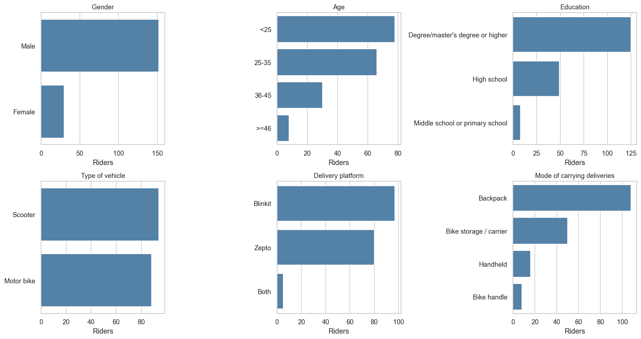
Figure 4.1: Sample profile: age, platform, vehicle, and carrying mode.

4.2 NMQ pain prevalence and statistical predictors
84.6 percent of the riders reported pain in at least one body area in the last 12 months. Table 4.1 lists the prevalence per body area, sorted from highest to lowest.
Body area | Prevalence
Lower back | 61.5%
Upper back | 49.5%
Shoulders | 46.7%
Wrists / Hands | 45.1%
Hips / Thighs | 41.2%
Ankles / Feet | 40.7%
Knees | 39.6%
Neck | 37.9%
Elbows | 33.5%

Table 4.1: NMQ 12-month pain prevalence per body area.
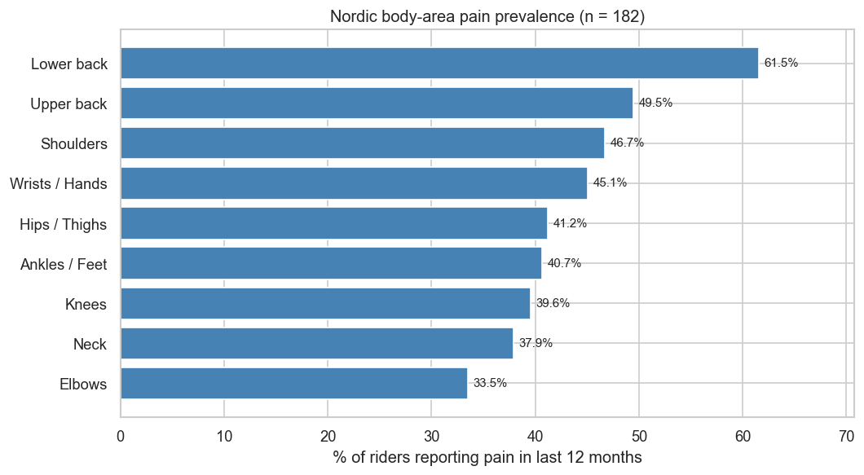
Figure 4.2: NMQ 12-month pain prevalence per body area.
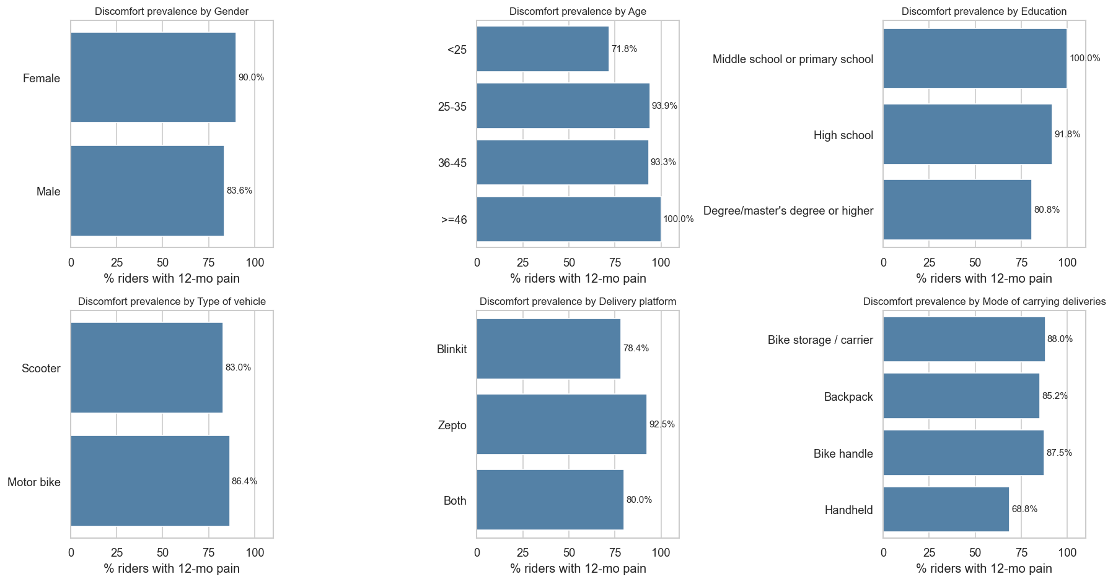
Figure 4.3: Discomfort prevalence broken down by demographic group.
The chi-square test of independence identifies Posture, Repetition, and Force as the three factors with a significant association with self-reported discomfort at p less than 0.05:
Factor | chi-square | p | Significant
Posture | 45.665 | <0.001 | Yes
Repetition | 8.617 | 0.014 | Yes
Force | 6.718 | 0.035 | Yes
Duration | 0.623 | 0.733 | No
Vibration | 0.600 | 0.741 | No
Contact Stress | 0.544 | 0.762 | No

Table 4.2: Chi-square test: risk factor vs self-reported discomfort.
The per-predictor (univariable) logistic regressions identify seven predictors as individually significant. Age is the strongest: each step up in the age band multiplies the odds of discomfort by 3.58 (95 percent CI 1.70 to 7.56, p = 0.0008).
Predictor | OR | 95% CI | p
Workload score (per unit) | 1.06 | 1.02 to 1.09 | 0.0005
Age (per band) | 3.58 | 1.70 to 7.56 | 0.0008
Job duration (per band) | 2.89 | 1.54 to 5.41 | 0.001
Fatigue score (per unit) | 1.43 | 1.13 to 1.80 | 0.003
Income (per band) | 2.00 | 1.25 to 3.20 | 0.004
Education (per band) | 0.33 | 0.12 to 0.94 | 0.04
Deliveries per day | 1.05 | 1.00 to 1.10 | 0.045

Table 4.3: Significant predictors of discomfort from per-predictor (univariable) logistic regression.

4.3 Stage-1 risk distribution
Factor | Low | Medium | High
Force | 90 | 57 | 35
Repetition | 26 | 82 | 74
Duration | 37 | 56 | 89
Vibration | 67 | 68 | 47
Contact Stress | 68 | 58 | 56
Posture | 0 | 29 | 153

Table 4.4: Stage-1 risk band counts per factor (n = 182).
Posture and Duration are the factors where the High band dominates; Repetition is close to a three-way split with Medium as the modal class (82 of 182 riders). Posture is at 84 percent High (153 of 182 observations); Duration is at 49 percent High; Repetition is at 41 percent High after the binning fix.
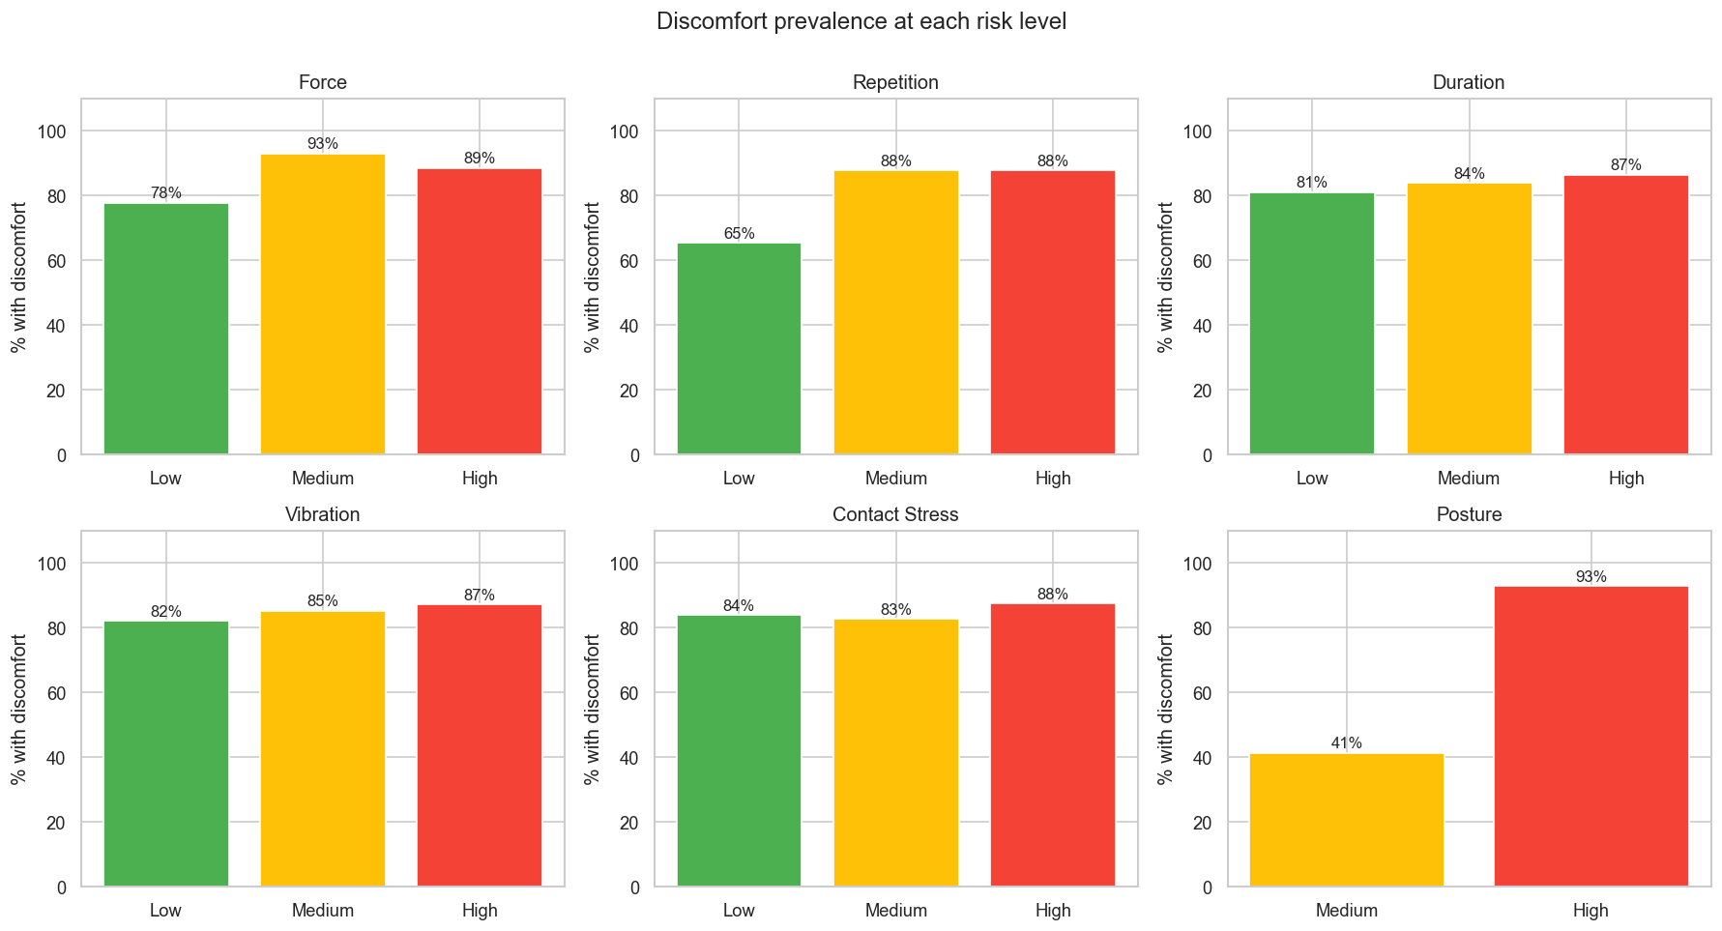
Figure 4.4: Discomfort prevalence within each Low / Medium / High band, per risk factor.
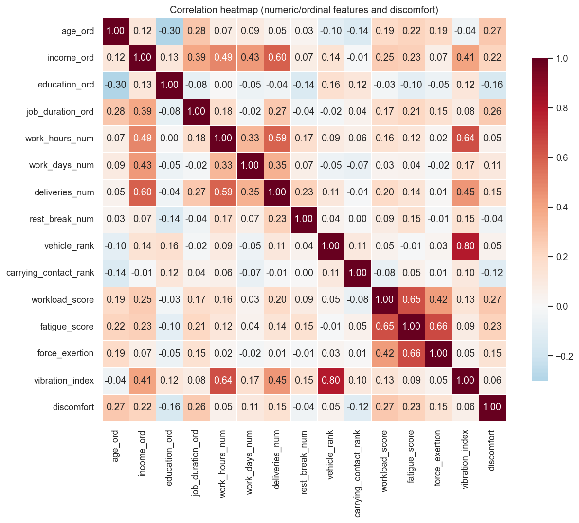
Figure 4.5: Pearson correlation matrix across the numeric feature pool, upper triangle masked.

4.4 Stage-2 model performance
Factor | Best model | Acc. | F1 macro | Macro AUC | Features
Force | HistGradientBoosting | 62% | 57% | 71% | 42
Repetition | RandomForest | 62% | 57% | 73% | 41
Duration | RandomForest | 61% | 58% | 76% | 42
Vibration | ExtraTrees | 58% | 57% | 72% | 41
Contact Stress | RandomForest | 60% | 59% | 74% | 42
Posture | HistGradientBoosting | 97% | 95% | 98% | 63

Table 4.5: Best Stage-2 model per risk factor after 5-fold stratified CV.
The five survey-derived factors land between 58 and 62 percent cross-validation accuracy with macro AUC in the 71 to 76 percent range. Posture reaches 97 percent accuracy and 98 percent macro AUC because it is the only model that receives real observation inputs (the 11 RULA components and 8 QEC scores) on top of the survey features.

4.5 Per-class metrics and feature importance
Factor | Low | Medium | High
Force | 0.798 | 0.580 | 0.760
Repetition | 0.745 | 0.669 | 0.782
Duration | 0.822 | 0.649 | 0.797
Vibration | 0.775 | 0.615 | 0.779
Contact Stress | 0.763 | 0.651 | 0.791
Posture | - | - | 0.984

Table 4.6: Per-class ROC AUC (one-vs-rest) for the best model per factor.
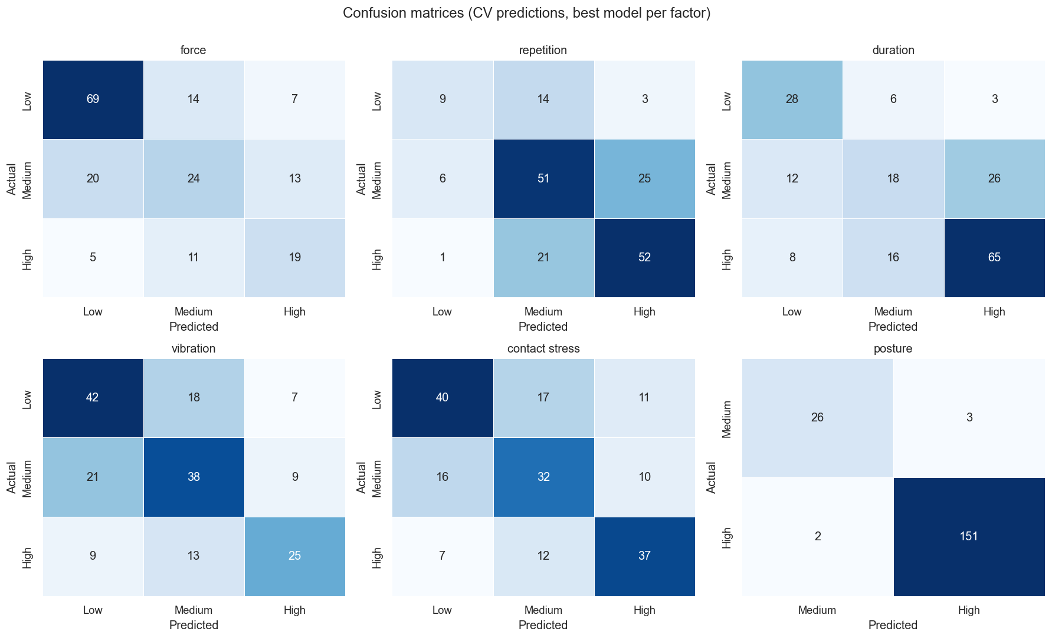
Figure 4.6: Confusion matrices for the best model per factor (rows = true class, columns = predicted class).
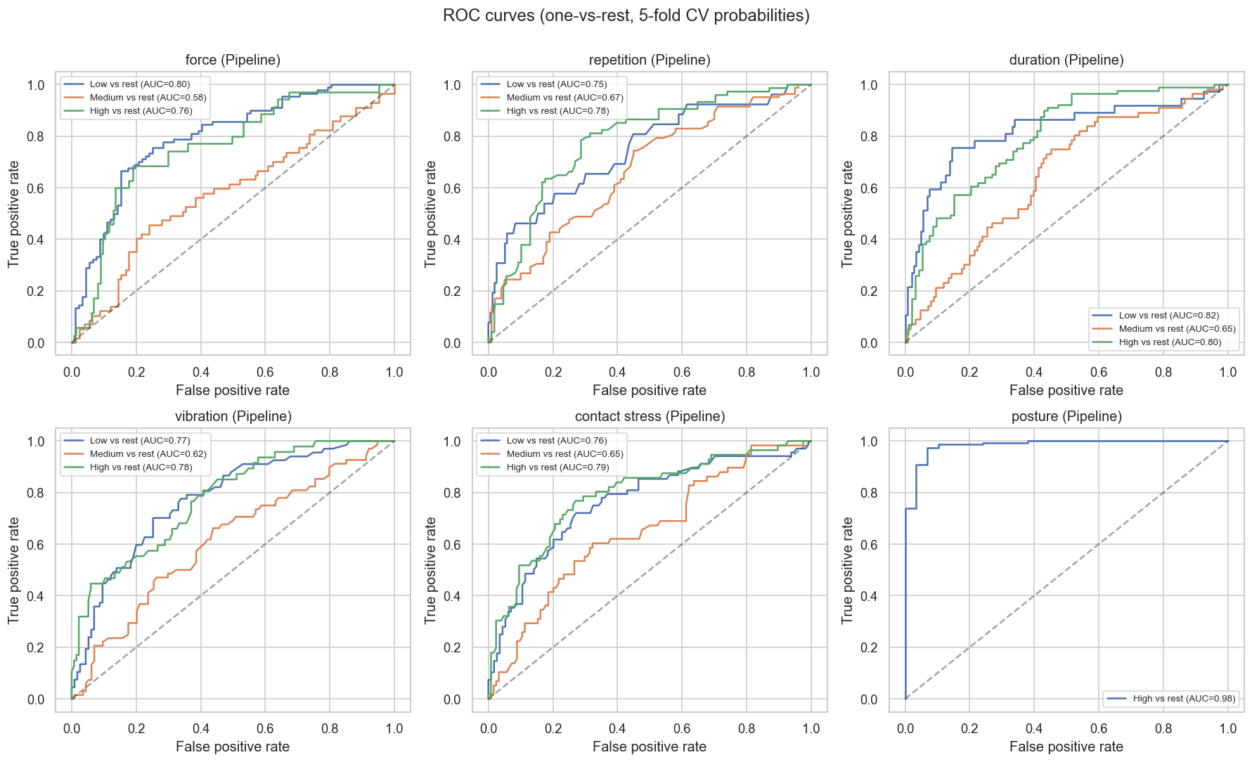
Figure 4.7: ROC curves (one-vs-rest) for the best model per factor.
Table 4.7 gives per-class precision, recall, F1, and support for the best model per factor. The Repetition High class has 65 percent precision and 70 percent recall; the Duration High class has 69 percent precision and 73 percent recall.
Factor | Class | Precision | Recall | F1 | Support
Force | Low | 0.734 | 0.767 | 0.750 | 90
Force | Medium | 0.490 | 0.421 | 0.453 | 57
Force | High | 0.487 | 0.543 | 0.514 | 35
Repetition | Low | 0.562 | 0.346 | 0.429 | 26
Repetition | Medium | 0.593 | 0.622 | 0.607 | 82
Repetition | High | 0.650 | 0.703 | 0.675 | 74
Duration | Low | 0.583 | 0.757 | 0.659 | 37
Duration | Medium | 0.450 | 0.321 | 0.375 | 56
Duration | High | 0.691 | 0.730 | 0.710 | 89
Vibration | Low | 0.583 | 0.627 | 0.604 | 67
Vibration | Medium | 0.551 | 0.559 | 0.555 | 68
Vibration | High | 0.610 | 0.532 | 0.568 | 47
Contact Stress | Low | 0.635 | 0.588 | 0.611 | 68
Contact Stress | Medium | 0.526 | 0.552 | 0.539 | 58
Contact Stress | High | 0.638 | 0.661 | 0.649 | 56
Posture | Medium | 0.929 | 0.897 | 0.912 | 29
Posture | High | 0.981 | 0.987 | 0.984 | 153

Table 4.7: Per-class precision, recall, F1, and support.
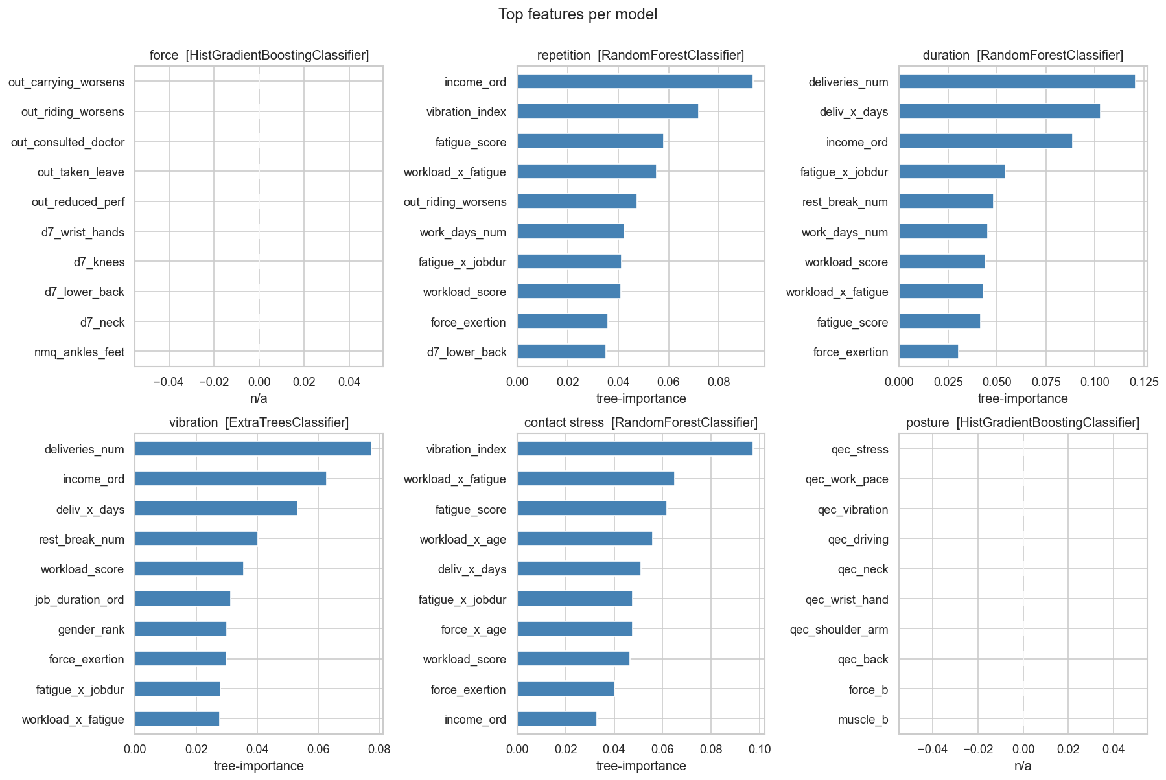
Figure 4.8: Top 10 features by importance for the best model per factor.
Factor | Best model | Hyperparameters | SMOTE k
Force | HistGBM | max_depth=None, learning_rate=0.05 | 5
Repetition | RandomForest | n_estimators=300, max_depth=None | 5
Duration | RandomForest | n_estimators=500, max_depth=5 | 5
Vibration | ExtraTrees | n_estimators=300, max_depth=None | 5
Contact Stress | RandomForest | n_estimators=500, max_depth=None | 5
Posture | HistGBM | max_depth=5, learning_rate=0.05 | 5

Table 4.8: Winning hyperparameters per target after GridSearchCV.

4.6 Web application demonstration
Figures 4.9 through 4.13 show one full pass through the form and the resulting prediction output. Three sample-profile shortcuts at the top of the form (Low, Average, High risk) pre-fill every field for a one-click demo.
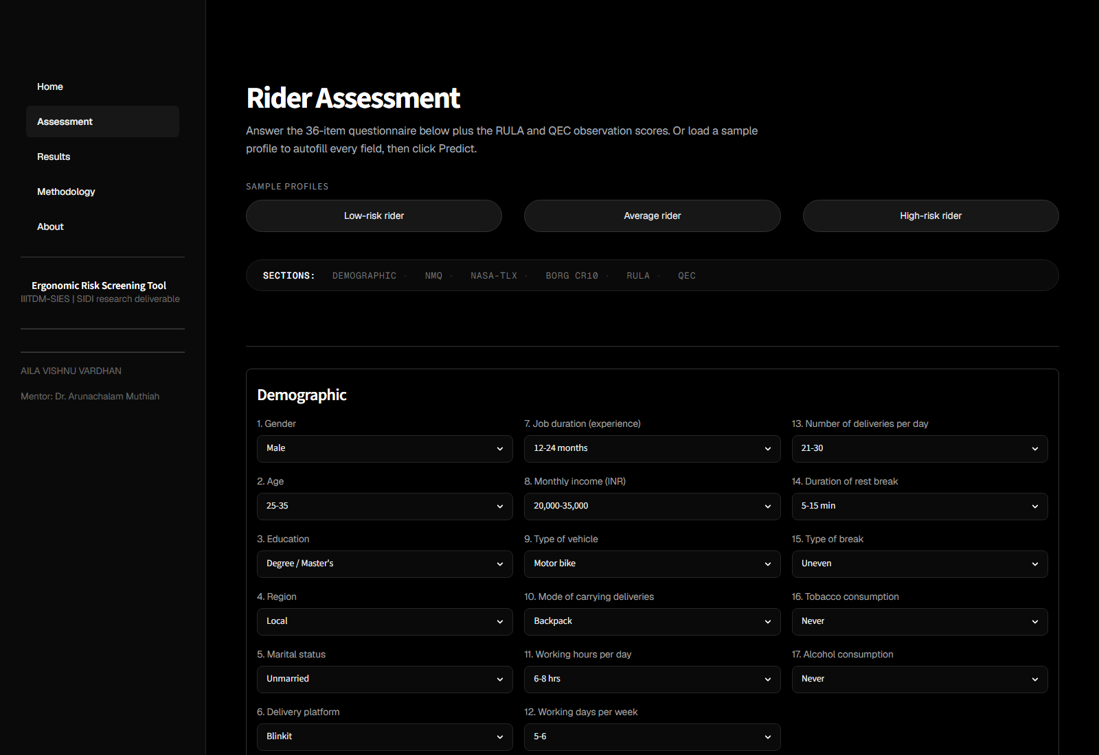
Figure 4.9: Web app: sample-profile shortcuts and demographic section (Q1 to Q17).

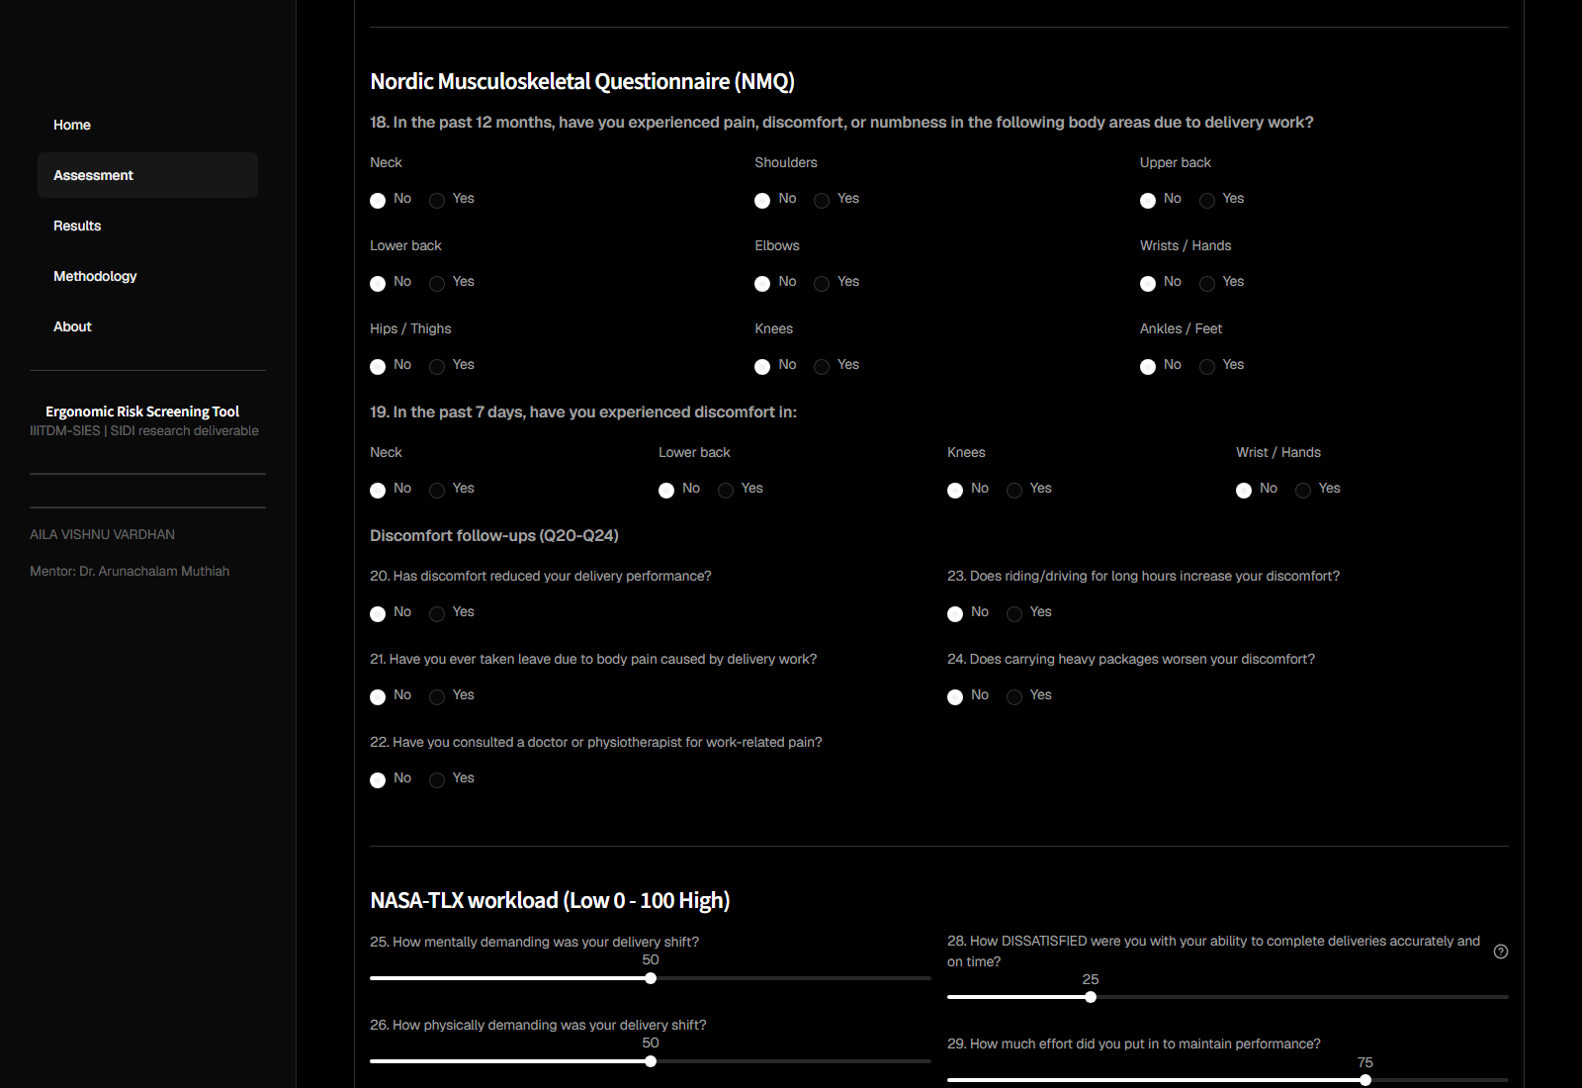
Figure 4.10: Web app: Nordic Musculoskeletal Questionnaire section (Q18 to Q24).
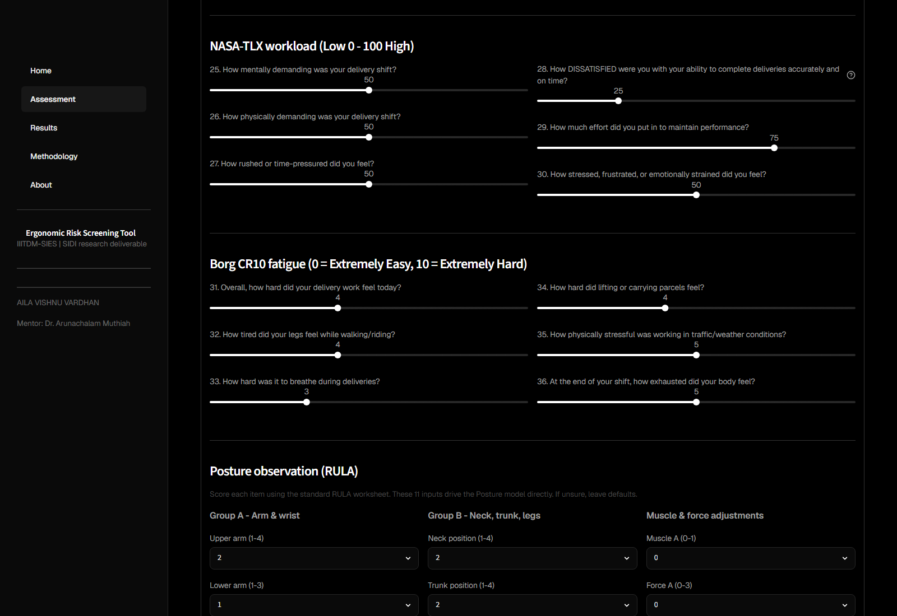
Figure 4.11: Web app: NASA-TLX and Borg CR10 sliders (Q25 to Q36).
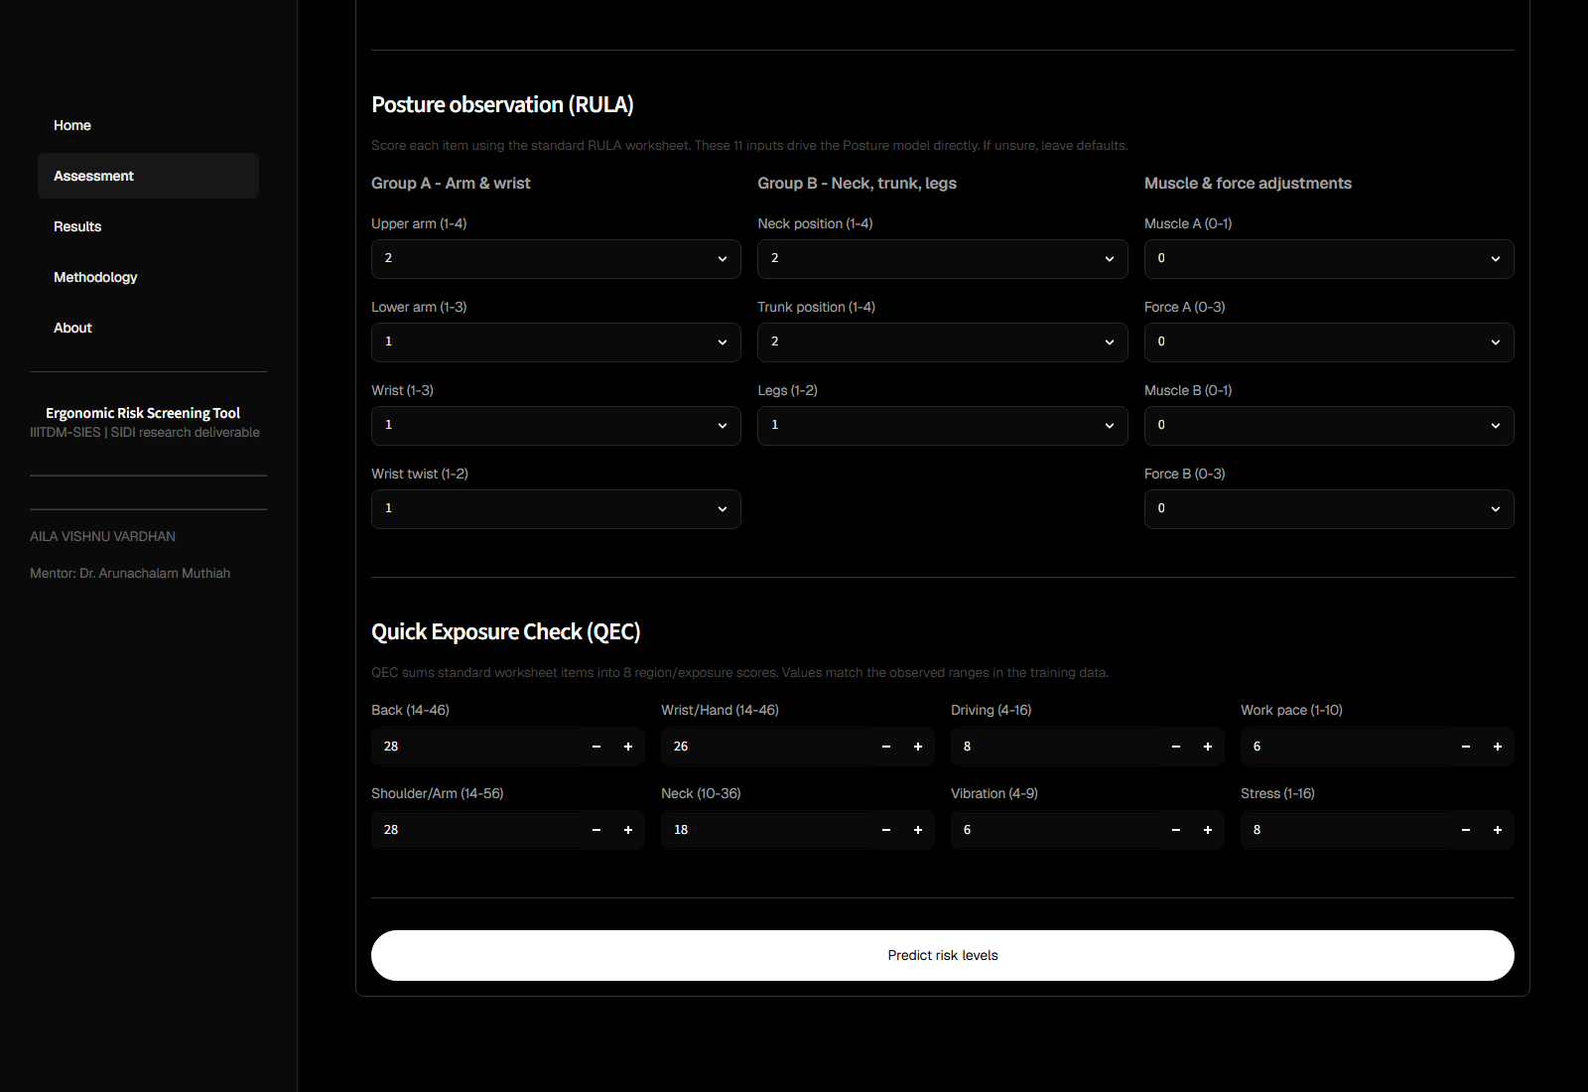
Figure 4.12: Web app: RULA (11 items) and QEC (8 scores) observation sections above the Predict button.
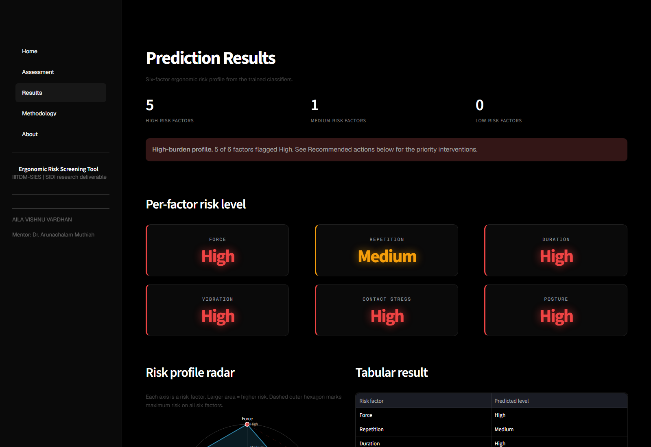
Figure 4.13: Web app: predicted risk profile output with colour-coded level cards, radar chart, tabular result, and per-factor recommendations.

Chapter 5. Conclusions and Extensions
This project designed, implemented, and deployed a per-rider ergonomic risk screening pipeline for last-mile quick-commerce delivery workers, turning a 36-item self-report questionnaire and a RULA + QEC observation record into six standardised risk levels across Force, Repetition, Posture, Duration, Contact Stress, and Vibration. The five survey-derived factors land at 58-62 percent cross-validation accuracy with macro AUC between 71 and 76 percent; the Posture model, which receives the RULA and QEC observation inputs directly, reaches 97 percent accuracy and 98 percent AUC. Chi-square identifies Posture, Repetition, and Force as the risk factors significantly associated with self-reported discomfort, and per-predictor (univariable) logistic regression flags age (OR 3.58 per band), job duration (OR 2.89), workload score, and fatigue score as the strongest individual predictors.
The main limitations are the self-report nature of most input variables, the severity-rank merge used to pair the identifier-less posture xlsx with the survey, and the small sample (n = 182) that keeps ML variance visible. Two methodological corrections were made and openly documented: Repetition binning moved from qcut to fixed cuts to remove a boundary tie that hid the worst real schedule, and vibration_index was added to the Duration exclusion list to remove indirect leakage.
Five interventions for a delivery-platform operator follow directly from the results: (i) cap daily hours (49 percent of the sample exceeds 8 hours per day); (ii) invest in posture-focused equipment and training (84 percent of observed postures at RULA grand score 5 or above, corresponding to action level 3 or 4); (iii) encourage bike-storage-box carrying over handheld bags; (iv) age-targeted MSD screening for the 36-and-above cohort; and (v) platform-level workload management to reduce the NASA-TLX component of the workload score, a significant discomfort predictor at p = 0.0005.
Future extensions include a longitudinal follow-up so a causal claim can replace the cross-sectional association, per-rider RULA and QEC observations to eliminate the severity-rank merge, wearable accelerometer data as a Vibration proxy, and a periodic re-training schedule so the screening tool tracks a changing workforce. The two-stage design leaves room for each of these without disturbing the audited Stage-1 labels.

Bibliography
[1] Benson TM, Sathiyarajeswaran NS, Radhakrishnan R, Gafoor AA, Krupalakshme M, Samal J (2025). Factors and prevalence of musculoskeletal pain among the app-based food delivery riders in Tamil Nadu: a community-based cross-sectional study. Cureus, 17(3), e56132.
[2] Pandit S, Adhikari P (2023). Ergonomics Issues Among Last Mile Delivery Riders in Jabalpur, India. Springer Ergonomics Proceedings, 209-215.
[3] McAtamney L, Corlett EN (1993). RULA: a survey method for the investigation of work-related upper limb disorders. Applied Ergonomics, 24(2), 91-99.
[4] David G, Woods V, Li G, Buckle P (2008). The development of the Quick Exposure Check (QEC) for assessing exposure to risk factors for work-related musculoskeletal disorders. Applied Ergonomics, 39(1), 57-69.
[5] Kuorinka I, Jonsson B, Kilbom A, Vinterberg H, Biering-Sorensen F, Andersson G, Jorgensen K (1987). Standardised Nordic questionnaires for the analysis of musculoskeletal symptoms. Applied Ergonomics, 18(3), 233-237.
[6] Hart SG, Staveland LE (1988). Development of NASA-TLX (Task Load Index): Results of empirical and theoretical research. Advances in Psychology, 52, 139-183.
[7] Borg G (1998). Borg's Perceived Exertion and Pain Scales. Human Kinetics Publishers, Champaign, Illinois.
[8] Chawla NV, Bowyer KW, Hall LO, Kegelmeyer WP (2002). SMOTE: Synthetic Minority Over-sampling Technique. Journal of Artificial Intelligence Research, 16, 321-357.
[9] Lemaitre G, Nogueira F, Aridas CK (2017). Imbalanced-learn: A Python Toolbox to Tackle the Curse of Imbalanced Datasets in Machine Learning. Journal of Machine Learning Research, 18(17), 1-5.
[10] Breiman L (2001). Random Forests. Machine Learning, 45(1), 5-32.
[11] Geurts P, Ernst D, Wehenkel L (2006). Extremely randomized trees. Machine Learning, 63(1), 3-42.
[12] Chen T, Guestrin C (2016). XGBoost: A Scalable Tree Boosting System. Proceedings of the 22nd ACM SIGKDD International Conference on Knowledge Discovery and Data Mining, 785-794.
[13] Friedman JH (2001). Greedy function approximation: A gradient boosting machine. Annals of Statistics, 29(5), 1189-1232.
[14] Pedregosa F, Varoquaux G, Gramfort A, et al. (2011). Scikit-learn: Machine Learning in Python. Journal of Machine Learning Research, 12, 2825-2830.

