September 15, 2017

Dear Editors,

Please consider our paper, entitled “**Phenological sequences: how early-season events define those that follow**” for publication as a “Brief Communication” in the *American Journal of Botany.*

Phenology, or the timing of life events such as spring flowering and leafout, has gained increasing prominence in ecology as one of the most widely documented biological impacts of anthropogenic climate change 1-3 . Spring phenology has generally shifted earlier with warmer temperatures 1, 4 , but there is dramatic variation over space and time: some species and populations have *not* shifted their phenology consistently with recent climate change 5 , and others have actually shifted later, rather than earlier 6, 7 . Understanding the drivers of this variation has far-reaching applications, as phenology is critical to global carbon models, accurate predictions of future climate change, and estimates of future shifts in natural resources.

An important, but poorly studied, aspect of plant phenology is that phenological events are inherently linked through their order: leaf budburst typically occurs before flowering, and flowering always precedes fruiting. This ordering may constrain how some phenological events can respond to climate change. However, the extent to which previous phenological events are correlated with later phenological events is not known because few studies to date have integrated across multiple phenological events within a growing season. Instead, previous studies have focused either on events related to leaf phenology (including spring budburst, leafout, and fall senescence), or reproductive events, especially flowering 8 .

In this paper, we offer the first study reporting on observations of consecutive phenophases from the start through the end of the growing season, across 25 temperate tree species with divergent flowering phenologies, grown in a common environment. We test if previous phenological events constrain later events; e.g., do late-fruiting species set fruit late in the season because they flower and leafout late? In addition, we test whether inter-phenophase duration constrains phenology; e.g., late-fruiting species set fruit late in the season because they require longer fruit maturation time. We find strong effects of both early phenology and inter-phenophase duration, highlighting the need for much more research in these areas.

Our findings have implications that are broadly important for improved forecasting of climate change, as well as for climate change induced shifts in phenology. Our finding that early phenological events constrain later events suggests that climatic shifts in one season, even if they directly affect only one phenophase, will have cascading effects on phenology later in the season. We also found that inter-phenophase duration constrains reproductive phenology (flowering and fruiting); for example, species with longer fruit maturation times fruit later, regardless of flowering time. Phenological constraints therefore appear to be species-specific, so accurate forecasts of community-wide phenological shifts will require species-level information, in addition to climate data.

We suggest as potential reviewers Abe Miller-Rushing, David Inouye, who else?. Thank you for your time and consideration of our paper.

Sincerely,

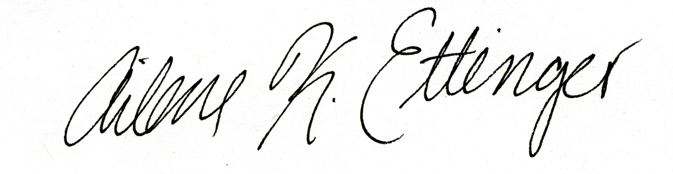

Ailene K. Ettinger (on behalf of all authors)

NSF Postdoctoral Fellow in Intersections of Biology and Mathematical and Physical Sciences

Phone: 781-296-4821

Email: [aettinger@fas.harvard.edu](mailto:aettinger@fas.harvard.edu)

References

1. Parmesan, C. Ecological and evolutionary responses to recent climate change. *Annual Review of Ecology Evolution and Systematics* **37**, 637-669 (2006).

2. IPCC. Climate Change 2014: Impacts, Adaptation, and Vulnerability. Part A: Global and Sectoral Aspects. Contribution of Working Group II to the Fifth Assessment Report of the Intergovernmental Panel on Climate Change. , 1132 pp (2014).

3. Root, T. L. *et al*. Fingerprints of global warming on wild animals and plants. *Nature* **421**, 57-60 (2003).

4. Primack, D., Imbres, C., Primack, R., Miller-Rushing, A. & Del Tredici, P. Herbarium specimens demonstrate earlier flowering times in response to warming in Boston. *Am. J. Bot.* **91**, 1260-1264 (2004).

5. Wolkovich, E. M. *et al*. Temperature-Dependent Shifts in Phenology Contribute to the Success of Exotic Species with Climate Change. *Am. J. Bot.* **100**, 1407-1421 (2013).

6. Iler, A. M., Hoye, T. T., Inouye, D. W. & Schmidt, N. M. Long-term trends mask variation in the direction and magnitude of short-term phenological shifts. *Am. J. Bot.* **100**, 1398-1406 (2013).

7. Munson, S. M. & Sher, A. A. Long-term shifts in the phenology of rare and endemic Rocky Mountain plants. *Am. J. Bot.* **102**, 1268-1276 (2015).

8. Wolkovich, E. M. & Ettinger, A. K. Back to the future for plant phenology research. *New Phytol.* **203**, 1021-1024 (2014).