April 2017

Dear Editors,

Please consider our paper, entitled “**How do climate change experiments actually change climate?**” for publication as a “Perspective” in *Nature Climate Change.* The paper is coauthored by I. Chuine, B.I. Cook, J.S. Dukes, A.M. Ellison, M.R. Johnston, A.M. Panetta, C.R. Rollinson, Y. Vitasse, E.M. Wolkovich, and myself. This international team of researchers is comprised of many of the scientists who executed major warming experiments 1-5, and bridges perspectives from ecology, climatology, and land surface modeling.

Our paper offers an important step forward in understanding the biological impacts of climate change. These impacts have been widely observed around the world, from shifting species’ distributions to altered timing of important life events 6-8. Ecologists are now challenged to not only document such impacts, but also to make quantitative, robust predictions for future ecological effects of a changing climate 9, 10. Experiments that alter temperature and precipitation (e.g., with infrared heaters, rain shields, and supplemental watering) are critical tools that scientists have been using for over three decades to understand and forecast these effects 11, 12. They offer the ability to create “no-analog" climate scenarios forecasted for the future, to isolate effects of temperature and precipitation from other environmental changes, and to examine non-linear responses to climatic changes. These advantages come at a cost, however: active warming experiments require $80–500 per m2 per year, for heating alone 13.

The expensive nature of these experiments, as well as their crucial role for understanding biological impacts of climate change, make it essential that we interpret and apply results accurately. Despite decades of implementation, a rigorous assessment of how active warming experiments alter the climate conditions experienced by organisms has not been conducted. An assessment of data from current and past experiments would allow us to better understand how changes in climate alter ecological processes, and to design better experiments in the future.

In this paper, we offer the first meta-analysis of high-resolution climate data from multiple field-based climate change experiments. We find that results from these experiments may be interpreted in misleading ways, because the common practice of summarizing and analyzing only the mean changes across treatments hides variation in treatment effects over space and time. In addition, we identify secondary, unintended treatment effects that are rarely described or interpreted in isolated studies (e.g. soil drying with warming treatments). We argue that there is a need to rethink the design and interpretation of climate change experiments. Based on our findings, we make specific recommendations for future experimental design, analysis, and data sharing that will improve the ability of climate change experiments to accurately identify and forecast species' responses to changes in climate.

In addition to the ideas presented in the paper, we present a new, publicly accessible database that we hope will spur further discussion by other scientists. We believe this compilation and additional analyses of it will lead to improved mechanistic understanding of climatic drivers of biological responses, and inspire innovations of enhanced experimental design and analysis.

We suggest Josep Peñuelas (CREAF-CSIC**,** [josep.penuelas@uab.cat](mailto:josep.penuelas@uab.cat)) and Osvaldo Sala (Arizona State University, [Osvaldo.Sala@ASU.edu](mailto:Osvaldo.Sala@ASU.edu)) as potential reviewers. Thank you for your time and consideration of our paper.

Sincerely,

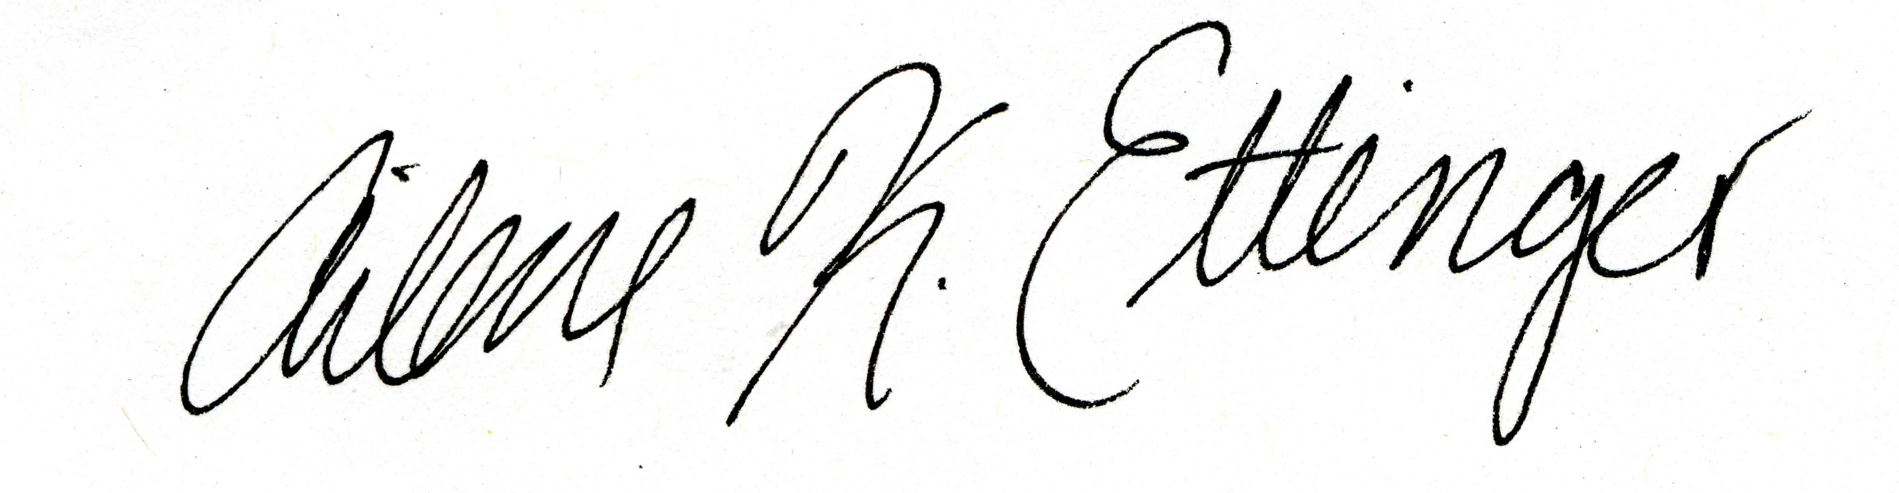

Ailene K. Ettinger (on behalf of all authors)

NSF Postdoctoral fellow in Intersections of Biology and Mathematical and Physical Sciences

Phone: 781-296-4821

Email: [aettinger@fas.harvard.edu](mailto:aettinger@fas.harvard.edu)

References

1. Hoeppner, S. S. & Dukes, J. S. Interactive responses of old‐field plant growth and composition to warming and precipitation. *Global Change Biol.* **18**, 1754-1768 (2012).

2. Del Toro, I., Ribbons, R. R. & Ellison, A. M. Ant‐mediated ecosystem functions on a warmer planet: effects on soil movement, decomposition and nutrient cycling. *J. Anim. Ecol.* **84**, 1233-1241 (2015).

3. Rollinson, C. R. & Kaye, M. W. Experimental warming alters spring phenology of certain plant functional groups in an early successional forest community. *Global Change Biol.* **18**, 1108-1116 (2012).

4. Morin, X., Roy, J., Sonié, L. & Chuine, I. Changes in leaf phenology of three European oak species in response to experimental climate change. *New Phytol.* **186**, 900-910 (2010).

5. Fu, Y. S. *et al*. Variation in leaf flushing date influences autumnal senescence and next year's flushing date in two temperate tree species. *Proc. Natl. Acad. Sci. U. S. A.* **111**, 7355-7360 (2014).

6. Parmesan, C. Ecological and evolutionary responses to recent climate change. *Annual Review of Ecology Evolution and Systematics* **37**, 637-669 (2006).

7. IPCC. Climate Change 2014: Impacts, Adaptation, and Vulnerability. Part A: Global and Sectoral Aspects. Contribution of Working Group II to the Fifth Assessment Report of the Intergovernmental Panel on Climate Change. , 1132 pp (2014).

8. Root, T. L. *et al*. Fingerprints of global warming on wild animals and plants. *Nature* **421**, 57-60 (2003).

9. Thuiller, W. Biodiversity - Climate change and the ecologist. *Nature* **448**, 550-552 (2007).

10. Fordham, D. A. *et al*. Predicting and mitigating future biodiversity loss using long-term ecological proxies. *Nature Climate Change* **6**, 909-916 (2016).

11. Harte, J. & Shaw, R. Shifting dominance within a montane vegetation community: results of a climate-warming experiment. *Science* **267**, 876 (1995).

12. Cleland, E. E., Chiariello, N. R., Loarie, S. R., Mooney, H. A. & Field, C. B. Diverse responses of phenology to global changes in a grassland ecosystem. *Proc. Natl. Acad. Sci. U. S. A.* **103**, 13740-13744 (2006).

13. Kimball, B. Theory and performance of an infrared heater for ecosystem warming. *Global Change Biol.* **11**, 2041-2056 (2005).