June 12, 2017

Dear Editors,

Please consider our paper, entitled “**How do climate change experiments actually change climate?**” for publication as a “Perspective” in *Nature Climate Change.*

The biological impacts of climate change have been widely observed around the world, from shifting species’ distributions to altered timing of important life events1-3. With growing evidence and interest in these impacts, ecologists today are challenged to make quantitative, robust predictions of the ecological effects of climate change. One of the most important methods to achieve this goal is field climate change experiments.

For over three decades, ecologists have relied on field climate change experiments, which alter temperature and often also precipitation, to understand and forecast the ecological impacts of climate change4, 5. These experiments critically offer the ability to create “no-analog" climate scenarios forecasted for the future, to isolate effects of temperature and precipitation from other environmental changes, and to examine non-linear responses to climatic changes. The utility of these experiments, however, is directly dependent on the climate change they produce. Despite this crucial link, a rigorous assessment of how these experiments alter climate conditions has never been conducted.

In this paper, we offer the first meta-analysis of high-resolution climate data from field-based climate change experiments. We find that results from these experiments may be interpreted in misleading ways, because the common practice of summarizing and analyzing only the mean changes across treatments hides variation in treatment effects over space and time. In addition, we identify secondary, unintended treatment effects that are rarely described or interpreted (e.g. soil drying with warming treatments). All of these complications challenge our interpretation of how experimental warming studies can be applied to forecast effects of climate change.

Based on our findings, we believe there is a need to rethink the design and interpretation of climate change experiments. We make specific recommendations for future experimental design, analysis, and data sharing that will improve the ability of climate change experiments to accurately identify and forecast species' responses to changes in climate. In addition to the results and ideas presented in the paper, we present a new, publicly accessible database. We expect future analyses of this database will lead to improved mechanistic understanding of climatic drivers of biological responses, and inspire innovative experimental design and analysis.

This paper brings together an international and interdisciplinary team of researchers that bridges perspectives from ecology, climatology, and land surface modeling. Importantly it is comprised of many of the scientists who executed the major warming experiments6-10 and those who have raised concerns over the findings of such experiments11.

We suggest Josep Peñuelas (CREAF-CSIC**,** [josep.penuelas@uab.cat](mailto:josep.penuelas@uab.cat)), Osvaldo Sala (Arizona State University, [Osvaldo.Sala@ASU.edu](mailto:Osvaldo.Sala@ASU.edu)), Hans De Boeck (University of Antwerp, Antwerpen, [hans.deboeck@uantwerpen.be](mailto:hans.deboeck@uantwerpen.be)), and Lara Kueppers (Lawrence Berkeley National Laboratory, [lmkueppers@lbl.gov](mailto:lmkueppers@lbl.gov)) as potential reviewers. Thank you for your time and consideration of our paper.

Sincerely,

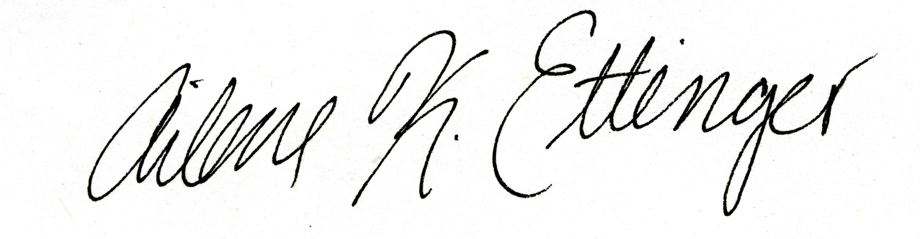

Ailene K. Ettinger (on behalf of all authors)

NSF Postdoctoral Fellow in Intersections of Biology and Mathematical and Physical Sciences

Phone: 781-296-4821

Email: [aettinger@fas.harvard.edu](mailto:aettinger@fas.harvard.edu)

References

1. Parmesan, C. Ecological and evolutionary responses to recent climate change. *Annual Review of Ecology Evolution and Systematics* **37**, 637-669 (2006).

2. IPCC. Climate Change 2014: Impacts, Adaptation, and Vulnerability. Part A: Global and Sectoral Aspects. Contribution of Working Group II to the Fifth Assessment Report of the Intergovernmental Panel on Climate Change. , 1132 pp (2014).

3. Root, T. L. *et al*. Fingerprints of global warming on wild animals and plants. *Nature* **421**, 57-60 (2003).

4. Harte, J. & Shaw, R. Shifting dominance within a montane vegetation community: results of a climate-warming experiment. *Science* **267**, 876 (1995).

5. Cleland, E. E., Chiariello, N. R., Loarie, S. R., Mooney, H. A. & Field, C. B. Diverse responses of phenology to global changes in a grassland ecosystem. *Proc. Natl. Acad. Sci. U. S. A.* **103**, 13740-13744 (2006).

6. Hoeppner, S. S. & Dukes, J. S. Interactive responses of old‐field plant growth and composition to warming and precipitation. *Global Change Biol.* **18**, 1754-1768 (2012).

7. Del Toro, I., Ribbons, R. R. & Ellison, A. M. Ant‐mediated ecosystem functions on a warmer planet: effects on soil movement, decomposition and nutrient cycling. *J. Anim. Ecol.* **84**, 1233-1241 (2015).

8. Rollinson, C. R. & Kaye, M. W. Experimental warming alters spring phenology of certain plant functional groups in an early successional forest community. *Global Change Biol.* **18**, 1108-1116 (2012).

9. Morin, X., Roy, J., Sonié, L. & Chuine, I. Changes in leaf phenology of three European oak species in response to experimental climate change. *New Phytol.* **186**, 900-910 (2010).

10. Fu, Y. S. *et al*. Variation in leaf flushing date influences autumnal senescence and next year's flushing date in two temperate tree species. *Proc. Natl. Acad. Sci. U. S. A.* **111**, 7355-7360 (2014).

11. Wolkovich, E. M. *et al*. Warming experiments underpredict plant phenological responses to climate change. *Nature* **485**, 494-497 (2012).