April 2017

Dear Editors,

Please consider our paper, entitled “**How do climate change experiments actually change climate?**” for publication as a “Perspective” in *Nature Climate Change.* The paper is coauthored by I. Chuine, B.I. Cook, J.S. Dukes, A.M. Ellison, M.R. Johnston, A.M. Panetta, C.R. Rollinson, Y. Vitasse, E.M. Wolkovich, and myself.

Our paper offers an important step forward in understanding the biological impacts of climate change. These impacts have been widely observed around the world, from shifting species’ distributions to altered timing of important life events 1-3 . Ecologists are now challenged to not only document such impacts, but also to make quantitative, robust predictions for future ecological effects of a changing climate 4, 5 . Experiments that alter temperature and precipitation (e.g., with infrared heaters, rain shields, and supplemental watering) are critical tools that scientists have been using for over three decades to understand and forecast these effects6, 7 .

We argue here that there is a need to rethink the design and interpretation of these climate change experiments for the next generation of climate change experiments, if we are to fully realize their potential to improve ecological forecasting. We present a new database that, for the first time, compiles daily experimental climate data from multiple field-based climate change experiments. This compilation allows for a more full understanding of how these experiments actually alter climate. Through our analyses, we identify secondary and unintended treatment effects that are rarely described or interpreted in isolated studies.

Our paper makes specific recommendations for future experimental design, analysis, and data sharing that will improve the ability of climate change experiments to accurately identify and forecast species' responses to changes in climate. The database we present is publicly available. We believe that, beyond the ideas presented in the paper, it will spur further discussion by other scientists, lead to improved mechanistic understanding of climatic drivers of biological responses, and drive innovations of enhanced experimental design and analysis.

We suggest Josep Penuelas and Osvlada Salaas as potential reviewers. Thank you for your time and consideration of our paper.

Sincerely,

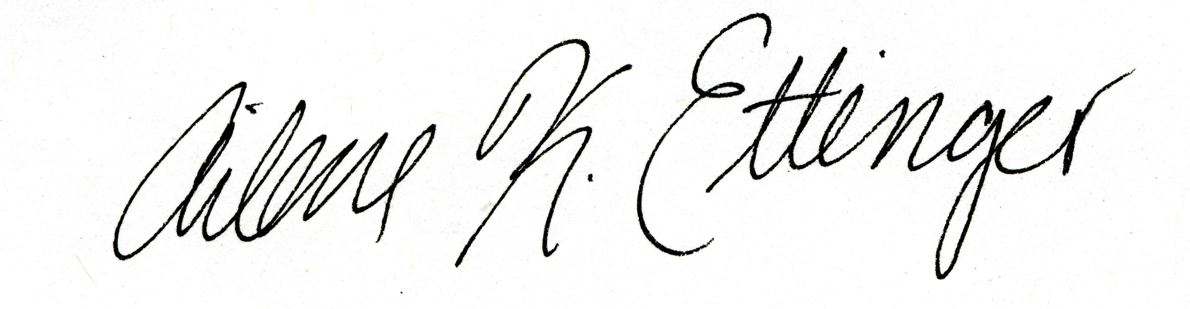

Ailene K. Ettinger (on behalf of all authors)

Postdoctoral fellow

Phone: 781-296-4821, Email: [aettinger@fas.harvard.edu](mailto:aettinger@fas.harvard.edu)

**References**

1. Parmesan, C. Ecological and evolutionary responses to recent climate change. *Annual Review of Ecology Evolution and Systematics* **37**, 637-669 (2006).

2. IPCC. Climate Change 2014: Impacts, Adaptation, and Vulnerability. Part A: Global and Sectoral Aspects. Contribution of Working Group II to the Fifth Assessment Report of the Intergovernmental Panel on Climate Change. , 1132 pp (2014).

3. Root, T. L. *et al*. Fingerprints of global warming on wild animals and plants. *Nature* **421**, 57-60 (2003).

4. Thuiller, W. Biodiversity - Climate change and the ecologist. *Nature* **448**, 550-552 (2007).

5. Fordham, D. A. *et al*. Predicting and mitigating future biodiversity loss using long-term ecological proxies. *Nature Climate Change* **6**, 909-916 (2016).

6. Harte, J. & Shaw, R. Shifting dominance within a montane vegetation community: results of a climate-warming experiment. *Science* **267**, 876 (1995).

7. Cleland, E. E., Chiariello, N. R., Loarie, S. R., Mooney, H. A. & Field, C. B. Diverse responses of phenology to global changes in a grassland ecosystem. *Proc. Natl. Acad. Sci. U. S. A.* **103**, 13740-13744 (2006).