Functional Description Document
ID | AN231009
Title | Nvidia_Agx_Orin_Driver_Compilation_Manual
Version | V1.0
Author | andy.Yuan
Date | 2023.10.09
Version History
V1.0 | Initial Draft

- Download the NVIDIA Developer Package
Official Website Link：
https://developer.nvidia.com/embedded/downloads#?tx=$product,jetson_agx_orin
- Download the JetPack (5.0.2) and L4T 35.1 Package
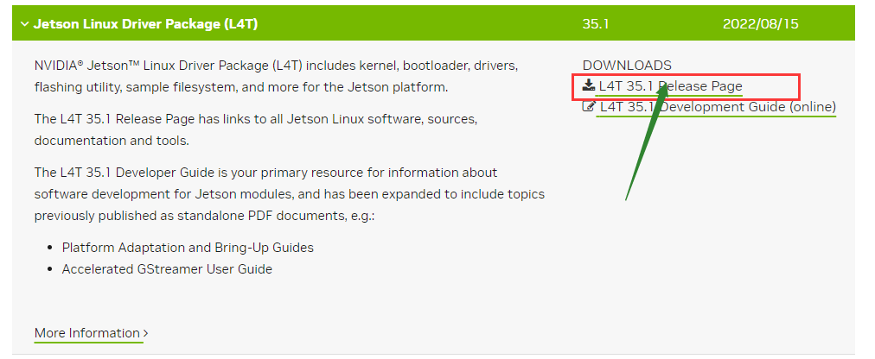
Download the flashing package, driver source code package, and cross-compilation toolchain package：
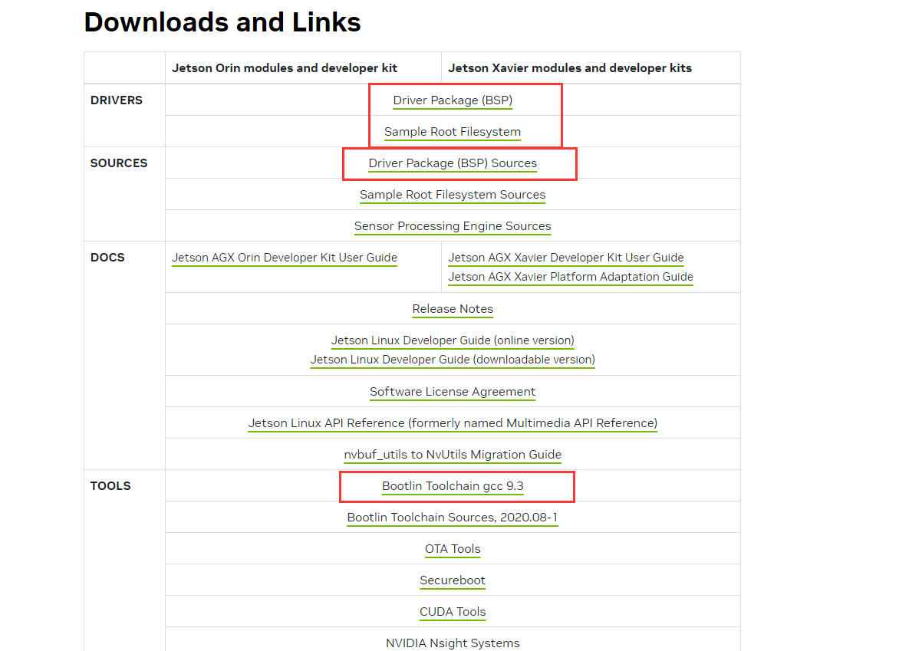

The files after downloading.：
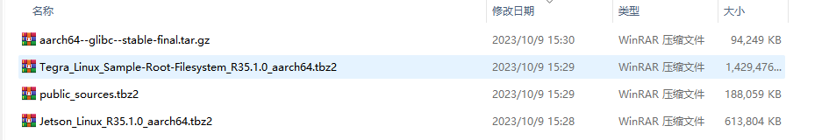

3. Prepare the Ubuntu Build Environment

1）Import the kernel source code and cross-compilation toolchain packages
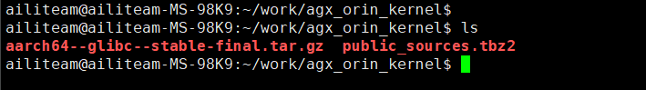
- Configure the cross-compilation environment
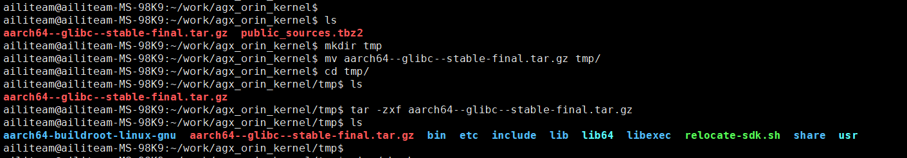
ailiteam@ailiteam-MS-98K9:~$vi ~/.bashrc
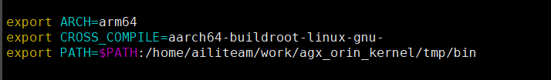
ailiteam@ailiteam-MS-98K9:~/work/agx_orin_kernel/tmp$ source ~/.bashrc
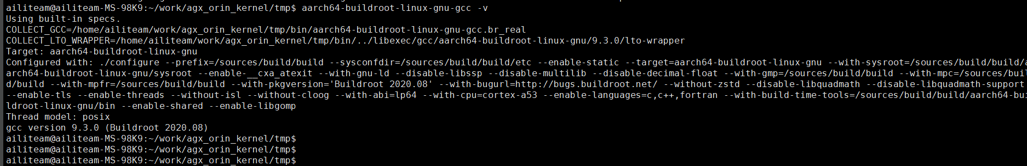

3）Unpack the kernel source code package
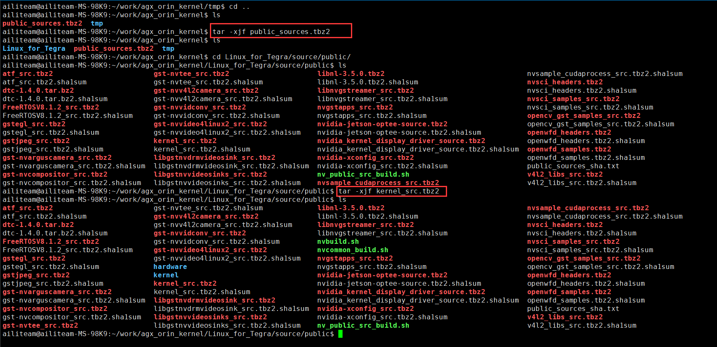
- Proceed with the kernel source code compilation
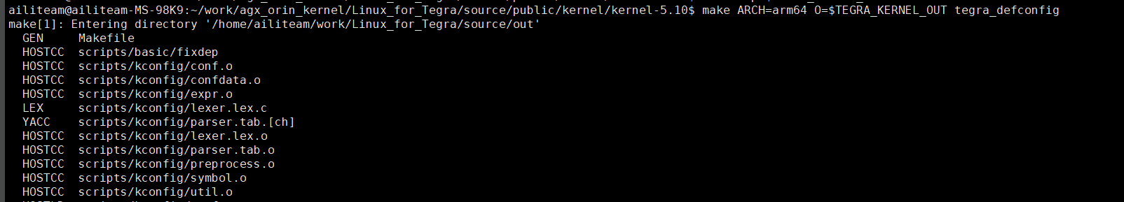
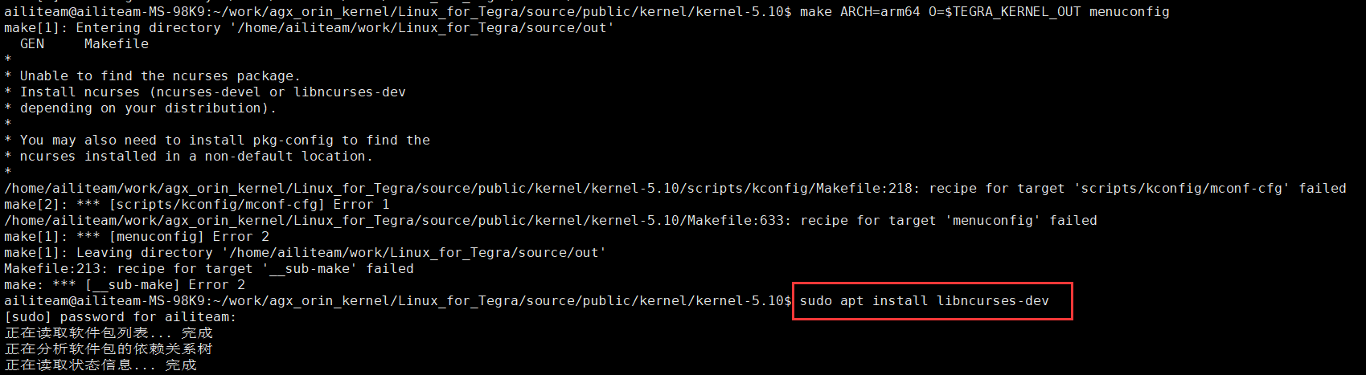
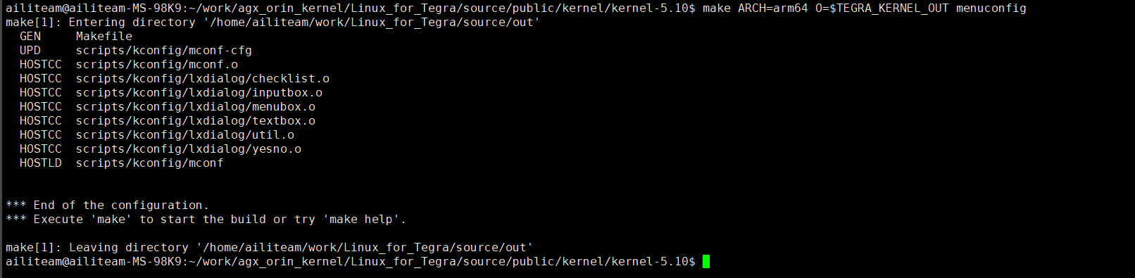
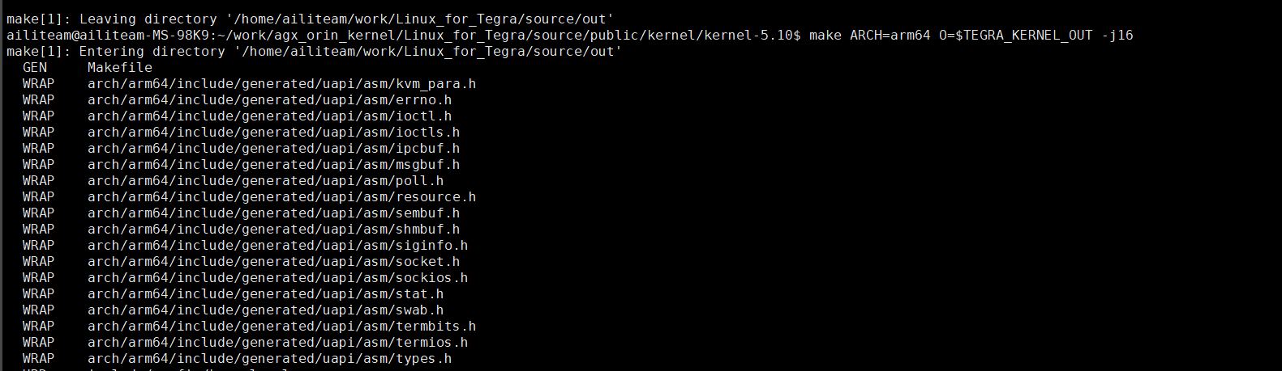
Wait for the compilation to complete; the first compilation time depends on the PC's performance. After the compilation is finished, the output Image and dtb files can be found in the previous $OUT directory.
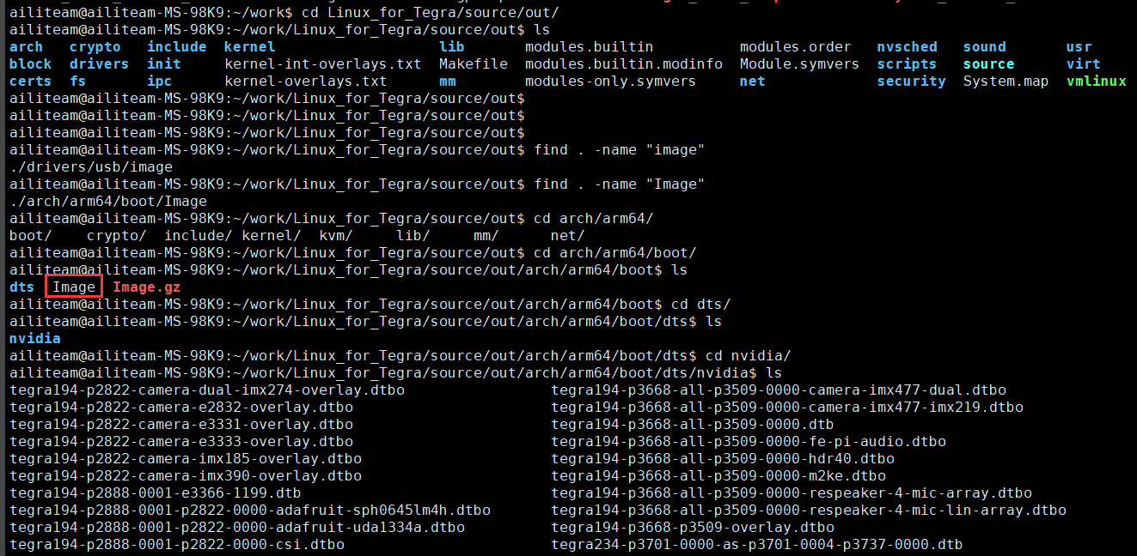
Replacing the dtb and Image Files:
  - Rename the output tegra234-p3701-0000-p3737-0000.dtb file to kernel_tegra234-p3701-0000-p3737-0000.dtb and import it into the Agx_Orin development kit environment, replacing the file in /boot/dtb.
  - Import the output Image kernel file into the Agx_Orin development kit environment and replace the file in /boot.
  - A successful reboot indicates that the kernel compilation was successful.

