MPEG-1/MPEG-2 Coding Standards

1. Introduction

The Moving Picture Coding Experts Group (MPEG) was established in January 1988 with the mandate to develop standards for coded representation of moving pictures, audio and their combination. It operates in the framework of the Joint ISO/IEC Technical Committee (JTC 1) on Information Technology and is formally WG11 of SC29. Their titles respectively are:

- MPEG-1: Coding of moving pictures and associated audio for digital storage media at up to about
1.5 Mbit/s

- MPEG-2: Generic coding of moving pictures and associated audio information

MPEG-1 and MPEG-2 are formally referred to as ISO/IEC International Standard 11172 and International Standard 13818 respectively. The video part of MPEG-2 (ie ISO/IEC DIS 13818-2) has also been incorporated into ITU-T's H-series audiovisual communication systems and bears the name of ITU-T Recommendation H.262.

2. Applications

2.1 What is it mainly used for?

- MPEG-1: a standard for storage and retrieval of moving pictures and audio on storage media.
- MPEG-2: a standard for digital television

2.2 Other Applications

MPEG-1 [1]

This standard was developed in response to the growing need for a common format for representing compressed video on various digital storage media such as CDs, DATs, Winchester disks and optical drives. The standard specifies a coded representation that can be used for compressing video sequences to bitrates around 1.5 Mbit/s. The use of this standard means that motion video can be manipulated as a form of computer data and can be transmitted and received over existing and future networks. The coded representation can be used with both 625-line and 525-line television and provides flexibility for use with workstation and personal computer displays.

MPEG-2 [2]

MPEG-2 was targeted to be a generic coding standards, as such, it is supposed to be application independent. The range of possible applications listed in the standards document [2] includes:

• Broadcasting Satellite Service (to the home)
• Cable TV Distribution on optical networks, copper, etc.
• Cable Digital Audio Distribution
• Digital Audio Broadcasting (terrestrial and satellite broadcasting)
• Digital Terrestrial Television Broadcast
• Electronic Cinema
• Electronic News Gathering (including Satellite News Gathering)
• Fixed Satellite Service (eg. to head ends)
• Home Television Theatre
• Interpersonal Communications (video-conferencing, videophone etc.)
• Interactive Storage Media (optical disks, etc.)
• Multimedia Mailing
• News and Current Affairs
• Networked Database Services (via ATM etc.)
• Remote Video_ Surveillance_
• Serial Storage Media (digital VTR, etc.)

2.3 Constrained Parameters Bitstream, Profiles & Levels

MPEG-1 Constrained Parameters Bitstream:

Because of the large range of the characteristics of this bitstreams that can be represented by this standard, a sub-set of these coding parameters known as the "Constrained Parameters bitstream" has been defined (Table 1). The aim in defining the constrained parameters is to offer guidance about a widely useful range of parameters. Conforming to this set of constraints in not a requirement of this standard. A flag in the bitstream indicates whether or not it is a Constrained Parameters bitstream.

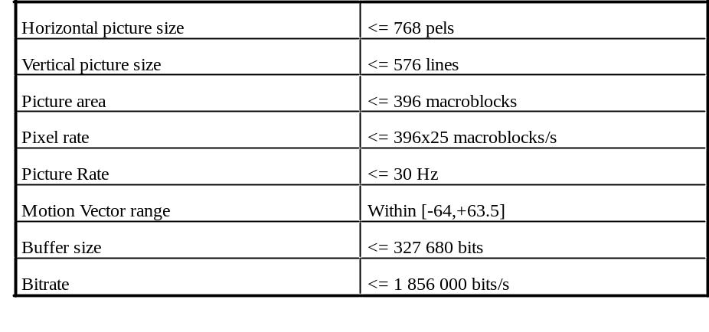Table 1 MPEG-1 Constrained Parameters Bitstream.

MPEG-2 Profiles & Levels:

MPEG-2 Video Main Profile and Main Level is analogous to MPEG-1's Constrained Parameters bitstream, with sampling limits at CCIR 601 parameters (720x480x30 Hz or 720x576x24 Hz). "Profiles" limit syntax (ie. algorithms), whereas "Levels" limit coding parameters (sample rates, frame dimensions, coded bitrates, etc.). These are grouped together and shown in the Table 2 below. Combinations marked with an "" are recognised by the standard while "" are illegitimate.

Video Main Profile and Main Level (abbreviated as MP@ML) normalise complexity within feasible limits of 1994 VLSI technology (0.5 micron), yet still meet the needs of the majority of applications. MP@ML is the conformance point for most cable and satellite TV systems.

 | Simple Profile | Main Profile | SNR Scalable Profile | Spatially Scalable Profile | High Profile | 4:2:2 Profile
High Level |  |  |  |  |  | 
High-1440  Level |  |  |  |  |  | 
Main Level |  |  |  |  |  | 
Low Level |  |  |  |  |  | 

Table 2 MPEG-2 Profiles & Levels

The following Table 3 [13] expresses the parameter bounds for MPEG-2 Main Profile at Main Level video streams.

Parameter | Bound
Samples/line | 720
Lines/frame | 576
Frames/second | 30
Samples/second | 10,368,000
Bitrate | 15 Mbits/s
Buffer size | 1,835,008 bits
Chroma format | 4:2:0
Image aspect ratio | 4:3, 16:9 and square pels

Table 3 Parameter bounds for MPEG-2 MP@ML

3. Parts & Status of MPEG document

MPEG-1 is a standard in 5 parts [4]:

ISO/IEC 11172-1:1993 Information technology -- Coding of moving pictures and associated audio for digital storage media at up to about 1.5 Mbit/s -- Part 1: Systems

ISO/IEC 11172-2:1993 Information technology -- Coding of moving pictures and associated audio for digital storage media at up to about 1.5 Mbit/s -- Part 2: Video

ISO/IEC 11172-3:1993 Information technology -- Coding of moving pictures and associated audio for digital storage media at up to about 1.5 Mbit/s -- Part 3: Audio

ISO/IEC 11172-4:1995 Information technology -- Coding of moving pictures and associated audio for digital storage media at up to about 1.5 Mbit/s -- Part 4: Conformance testing

ISO/IEC DTR 11172-5 Information technology -- Coding of moving pictures and associated audio for digital storage media up to about 1.5 Mbit/s -- Part 5: Software simulation

Part 1 addresses the problem of combining one or more data streams from the video and audio parts of the MPEG-1 standard with timing information to form a single stream as in Figure 1 below. This is an important function because, once combined into a single stream, the
data are in a form well suited to digital storage or transmission.

Part 2 specifies a coded representation that can be used for compressing video sequences -both 625-line and 525-lines - to bitrates around 1.5 Mbit/s. Part 2 was developed to operate principally from storage media offering a continuous transfer rate of about 1.5 Mbit/s. Nevertheless it can be used more widely than this because the approach taken is generic. This part of the standards is the main interest in this report. The technical details of the coding scheme will be described in the following Section 4.

Part 3 specifies a coded representation that can be used for compressing audio sequences - both mono and stereo. The algorithm is illustrated in Figure 2 below. Input audio samples are fed into the encoder. The mapping creates a filtered and subsampled representation of the input audio stream. A psychoacoustics model creates a set of data to control the quantiser and coding. The quantiser and coding block creates a set of coding symbols from the mapped input samples. The block 'frame packing' assembles the actual bitstream from the output data of the other blocks, and adds other information (eg. error correction) if necessary.

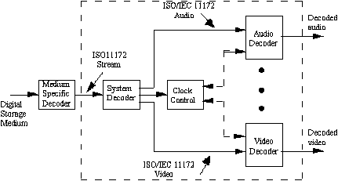

Figure 1 -- Prototypical ISO/IEC 11172 decoder.

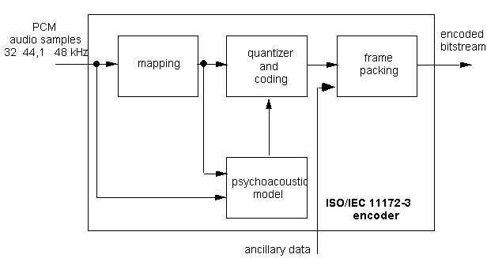
Figure 2 -- Basic structure of the audio encoder

Part 4 specifies how tests can be designed to verify whether bitstreams and decoders meet the requirements as specified in parts 1, 2 and 3 of the MPEG-1 standard. These tests can be used by:

• manufacturers of encoders, and their customers, to verify whether the encoder produces valid bitstreams.
• manufacturers of decoders and their customers to verify whether the decoder meets the requirements specified in parts 1,2 and 3 of the standard for the claimed decoder capabilities.
• applications to verify whether the characteristics of a given bitstream meet the application requirements, for example whether the size of the coded picture does not exceed the maximum value allowed for the application.

Part 5, technically not a standard, but a technical report, gives a full software implementation of the first three parts of the MPEG-1 standard. The source code is not publicly available.

MPEG-2 in 9 parts [5]

MPEG-2 is a standard currently in 9 parts. The first three parts of MPEG-2 have reached International Standard status, other parts are at different levels of completion. One has been withdrawn

ISO/IEC DIS 13818-1 Information technology -- Generic coding of moving pictures and associated audio information: Systems

ISO/IEC DIS 13818-2 Information technology -- Generic coding of moving pictures and associated audio information: Video

ISO/IEC 13818-3:1995 Information technology -- Generic coding of moving pictures and associated audio information -- Part 3: Audio

ISO/IEC DIS 13818-4 Information technology -- Generic coding of moving pictures and associated audio information -- Part 4: Compliance testing

ISO/IEC DTR 13818-5 Information technology -- Generic coding of moving pictures and associated audio -- Part 5: Software simulation (Future TR)

ISO/IEC DIS 13818-6 Information technology -- Generic coding of moving pictures and associated audio information -- Part 6: Extensions for DSM-CC is a full software
implementation

ISO/IEC DIS 13818-9 Information technology -- Generic coding of moving pictures and associated audio information -- Part 9: Extension for real time interface for systems decoders

Part 1 of MPEG-2 addresses the combining of one or more elementary streams of video and audio, as well as, other data into single or multiple streams which are suitable for storage or transmission. This is specified in two forms: the Program Stream and the Transport Stream. Each is optimised for a different set of applications. A model is given in Figure 3.

The Program Stream is similar to MPEG-1 Systems Multiplex. It results from combining one or more Packetised Elementary Streams (PES), which have a common time base, into a single stream. The Program Stream is designed for use in relatively error-free environments and is suitable for applications which may involve software processing. Program stream packets may be of variable and relatively great length, as shown schematically in Figure 4.

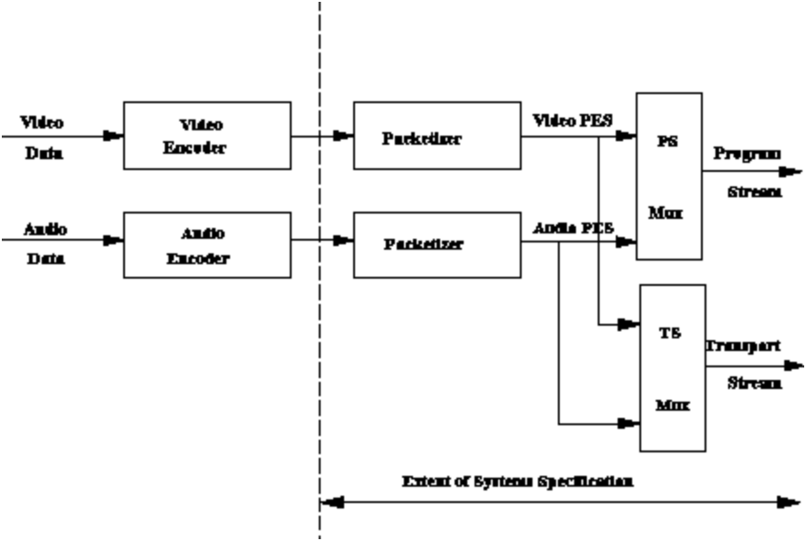

Figure 3 -- Model for MPEG-2 Systems

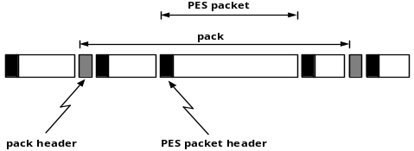
Figure 4 MPEG-2 Program Stream

The Transport Stream combines one or more Packetized Elementary Streams (PES) with one or more independent time bases into a single stream. Elementary streams sharing a common time base form a program. The Transport Stream is designed for use in environments where errors are likely, such as storage or transmission in lossy or noisy media. Transport stream packets are 188 bytes long. The schematic diagram is shown in Figure 5.
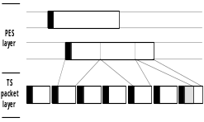
Figure 5. MPEG-2 Transport Stream.

Part 2 of MPEG-2 builds on the powerful video compression capabilities of the MPEG-1 standard to offer a wide range of coding tools. These have been grouped in profiles to offer different functionalities, which have been mentioned in Section 2.2 earlier. This part of the standards is the main interest in this report. The technical details of the coding scheme will be described in the following section.

Since the final approval of MPEG-2 Video in November 1994, one additional profile has been developed. This uses existing coding tools of MPEG-2 Video but is capable to deal with pictures having a colour resolution of 4:2:2 and a higher bitrate. Even though MPEG-2 Video was not developed having in mind studio applications, a set of comparison tests carried out by MPEG confirmed that MPEG-2 Video was at least good, and in many cases even better than standards or specifications developed for high bitrate or studio applications.

The 4:2:2 profile has been finally approved in January 1996 and is now an integral part of MPEG-2 Video.

The Multiview Profile (MVP) is an additional profile currently being developed. By using existing MPEG-2 Video coding tools it is possible to encode in an efficient way tow video sequences issued from two cameras shooting the same scene with a small angle between them. This profile has been approved in July 1996.

Part 3 of MPEG-2 is a backwards-compatible multichannel extension of the MPEG-1 Audio standard. Figure 6 below gives the structure of an MPEG-2 Audio block of data showing this property.
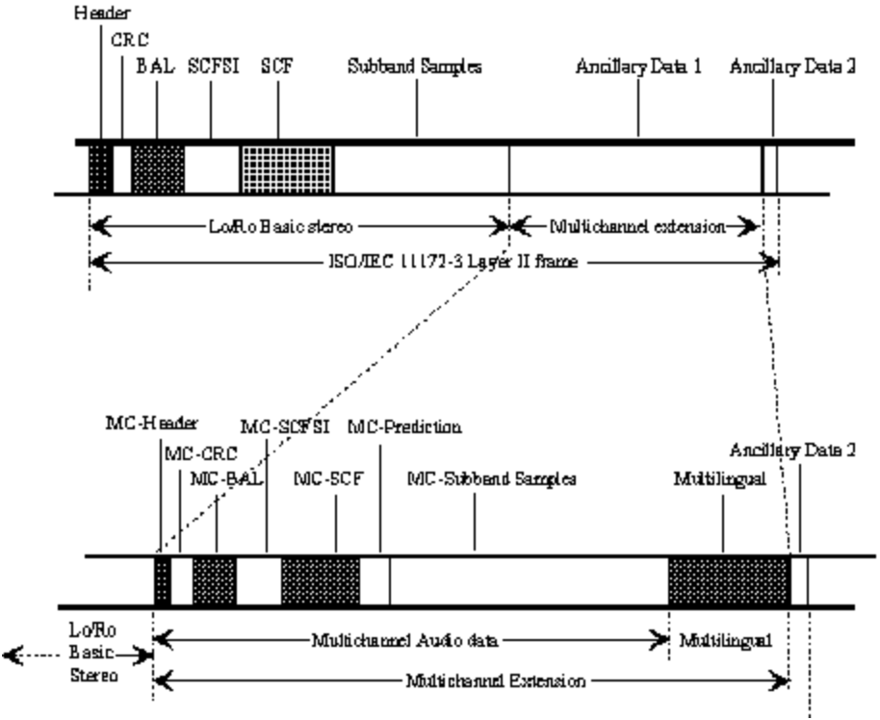
Figure 6-- Structure of an MPEG-2 Audio block of data

Part 4 and 5 of MPEG-2 correspond to part 4 and 5 of MPEG-1. They have been finally approved in March 1996.

Part 6 of MPEG-2 - Digital Storage Media Command and Control (DSM-CC) is the specification of a set of protocols which provides the control functions and operations specific to managing MPEG-1 and MPEG-2 bitstreams. These protocols may be used to support applications in both stand-alone and heterogeneous network environments. In the DSM-CC model, a stream is sourced by a Server and delivered to a Client. Both the Server and the Client are considered to be Users of the DSM-CC network. DSM-CC defines a logical entity called the Session and Resource Manager (SRM) which provides a (logically) centralised management of the DSM-CC Sessions and Resources (see Figure 7). Part 6 has been approved as an International Standard in July 1996.
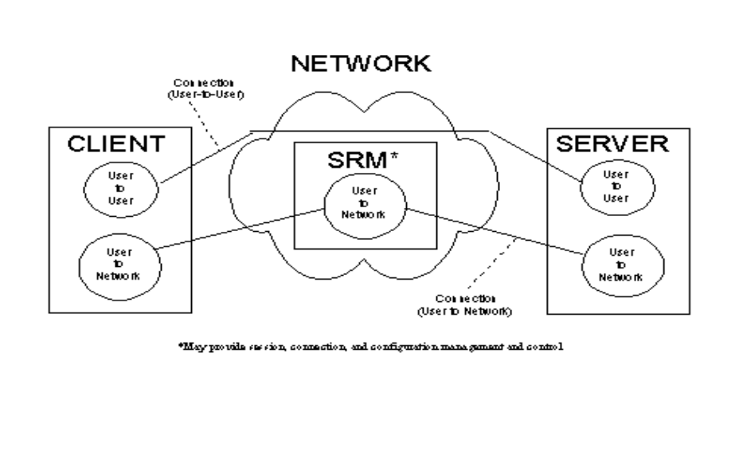
Figure 7 - DSM-CC Reference Model

Part 7 of MPEG-2 will be the specification of a multichannel audio coding algorithm not constrained to be backwards-compatible with MPEG-1 Audio. The standard will be approved in April 1997.

Part 8 of MPEG-2 was originally planned to be coding of video when input samples are 10 bits. Work on this part was discontinued when it became apparent that there was insufficient interest from industry for such a standard.

Part 9 of MPEG-2 is the specification of the Real-time Interface (RTI) to Transport Stream decoders which may be utilised for adaptation to all appropriate networks carrying Transport Streams (see Figure 8). Part 9 has been finally approved as an International Standard in July 1996.

Part 10 will be the conformance testing part of DSM-CC.

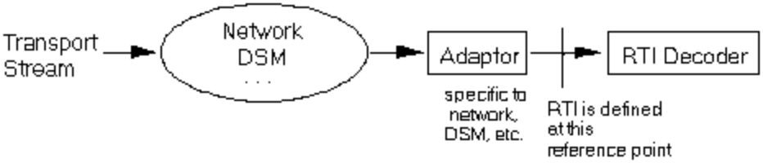
Figure 8 - Reference configuration for the Real-Time Interface

3.2 Adoptation of the standards

Since the development of MPEG-1 standards, a number of applications have already incorporated these standards in their implementation. Theses include:
CD, Interactive CD, Delivering of Video through Internet.

Likewise, MPEG-2 has spawned areas of applications such as DVD, Betacam-digital, VoD systems, Cable TV, HDTV, Video Conferencing. Digital Versatile Disk (DVD) in particular is expected to dominate digital video market in the coming years, as CD-ROM technology had dominated the audio industry in the past. DVD storage capacity (17 Gbyte) is much higher than CD-ROM (600 Mbyte) and DVD can deliver the data at a higher rate than CD-ROM. With the help of MPEG and Dolby compression technologies, a DVD disk can hold hours of high quality Audio-Visual contents. DVD is predicted to be the unavoidable replacement for the old VCR technology in the coming years.

The popularity of these standards is an indication of the market demand, and the speed in which the standards are adopted reflects the accelerated pace of the underlying technologies.

4. Technical Description of Video in MPEGs

4.1 MPEG-1, Part 2: Video.

MPEG-1's coding scheme is illustrated in the Encoder/Decoder Block diagrams of Figure 9 and 10 respectively. The underlying theoretical bases for the compression are actually the same as in H.261 and H.263, viz., it uses DCT transform to reduce the spatial redundancy, and motion compensation for temporal redundancy. Note however, because of the greater complexity, (eg bidirectional prediction) the codecs need to store both the previous picture and the future picture.

4.1.1 Video Bitstream Syntax [11]

The MPEG standard defines a hierarchy of data structures in the video stream as shown schematically in Figure 11.
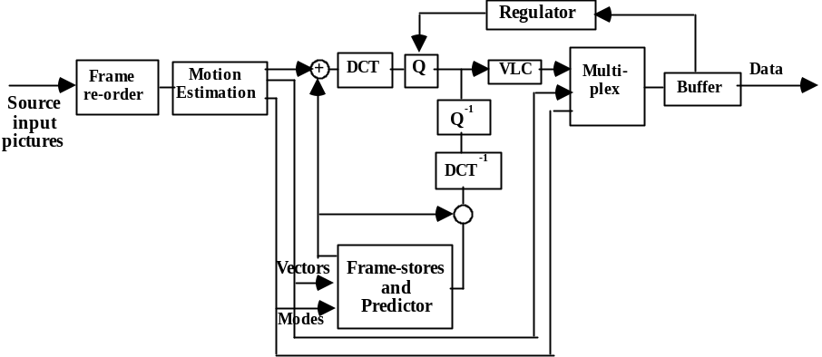Figure 9: Typical Encoder Block Diagram
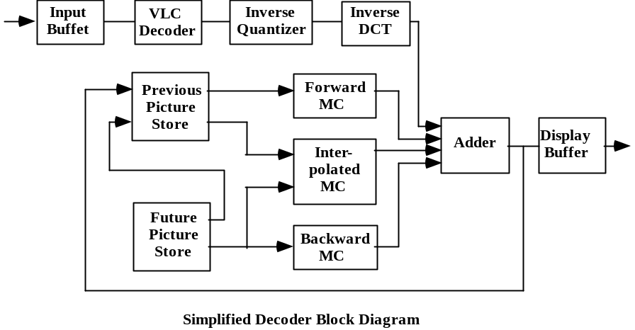
Figure 10: Simplified Decoder Block Diagram
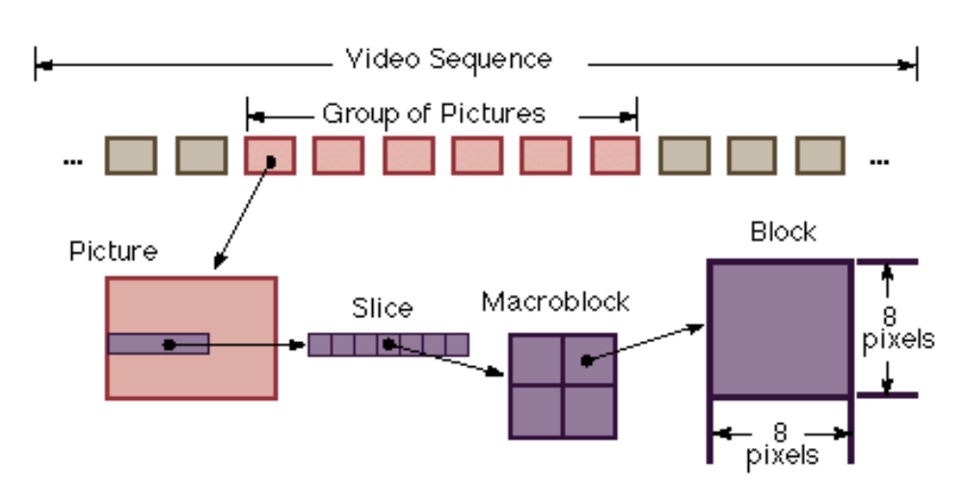
Figure 11 MPEG Data Hierarchy
• Video Sequence

Begins with a sequence header (may contain additional sequence headers), includes one or more groups of pictures, and ends with an end-of-sequence code.

• Group of Pictures (GOP)

A header and a series of one or more pictures intended to allow random access into the sequence.

• Picture

The primary coding unit of a video sequence. A picture consists of three rectangular matrices representing luminance (Y) and two chrominance (Cb and Cr) values. The Y matrix has an even number of rows and columns. The Cb and Cr matrices are one-half the size of the Y matrix in each direction (horizontal and vertical).

Figure 12 shows the relative x-y locations of the luminance and chrominance components. Note that for every four luminance values, there are two associated chrominance values: one Cb value and one Cr value. (The location of the Cb and Cr values is the same, so only one circle is shown in the figure.)
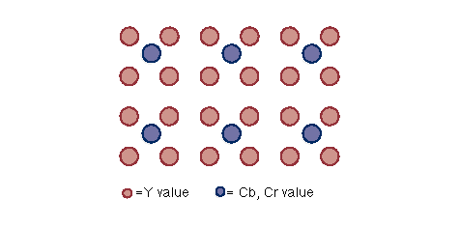
Figure 12 Location of Luminance and Chrominance Values

• Slice

One or more ``contiguous'' macroblocks. The order of the macroblocks within a slice is from left-to-right and top-to-bottom.

Slices are important in the handling of errors. If the bitstream contains an error, the decoder can skip to the start of the next slice. Having more slices in the bitstream allows better error concealment, but uses bits that could otherwise be used to improve picture quality.

• Macroblock

A 16-pixel by 16-line section of luminance components and the corresponding 8-pixel by 8-line section of the two chrominance components. See Figure 2-3 for the spatial location of luminance and chrominance components. A macroblock contains four Y blocks, one Cb block and one Cr block as shown in Figure 13. The numbers correspond to the ordering of the blocks in the data stream, with block 1 first.


Figure 13 Macroblock Composition
• Block

A block is an 8-pixel by 8-line set of values of a luminance or a chrominance component. Note that a luminance block corresponds to one-fourth as large a portion of the displayed image as does a chrominance block.

4.1.2 Inter-Picture Coding [11]

Much of the information in a picture within a video sequence is similar to information in a previous or subsequent picture. The MPEG standard takes advantage of this temporal redundancy by representing some pictures in terms of their differences from other (reference) pictures, or what is known as inter-picture coding. This section describes the types of coded pictures and explains the techniques used in this process.

Picture Types:

The MPEG standard specifically defines three types of pictures: intra, predicted, and bidirectional.

• Intra Pictures (or I-Pictures)

I-pictures are coded using only information present in the picture itself. I-pictures provide potential random access points into the compressed video data. I-pictures use only transform coding (as explained in the Intra-picture (Transform) Coding section) and provide moderate compression. I-pictures typically use about two bits per coded pixel.

• Predicted Pictures (or P-pictures)

P-pictures are coded with respect to the nearest previous I- or P-picture. This technique is called forward prediction and is illustrated in Figure 14.

Like I-pictures, P-pictures serve as a prediction reference for B-pictures and future P-pictures.
However, P-pictures use motion compensation (see the Motion Compensation section) to provide more compression than is possible with I-pictures. Unlike I-pictures, P-pictures can propagate coding errors because P-pictures are predicted from previous reference (I- or P-) pictures.
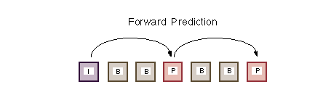
Figure 14 Forward Prediction

• Bidirectional Pictures (or B-Pictures)

B-pictures are pictures that use both a past and future picture as a reference. This technique is called bidirectional prediction and is illustrated in Figure 15. B-pictures provide the most compression and do not propagate errors because they are never used as a reference. Bidirectional prediction also decreases the effect of noise by averaging two pictures.
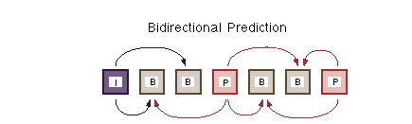

Figure 15 Bidirectional Prediction

4.1.3 Video Stream Composition [11]

The MPEG algorithm allows the encoder to choose the frequency and location of I-pictures. This choice is based on the application's need for random accessibility and the location of scene cuts in the video sequence. In applications where random access is important, I-pictures are typically used two times a second.

The encoder also chooses the number of B-pictures between any pair of reference (I- or P-) pictures. This choice is based on factors such as the amount of memory in the encoder and the characteristics of the material being coded. For example, a large class of scenes have two bidirectional pictures separating successive reference pictures. A typical arrangement of I-, P-, and B-pictures is shown in Figure 16 in the order in which they are displayed.
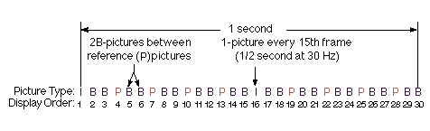

Figure 16 Typical Display Order of Picture Types

The MPEG encoder reorders pictures in the video stream to present the pictures to the decoder in the most efficient sequence. In particular, the reference pictures needed to reconstruct B-pictures are sent before the associated B-pictures. Figure 17 demonstrates this ordering for the first section of the example shown above.
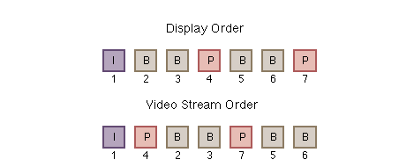

Figure 17 Video Stream versus Display Ordering

4.1.4 Motion Compensation [11]

Motion compensation is a technique for enhancing the compression of P- and B-pictures by eliminating temporal redundancy. Motion compensation typically improves compression by about a factor of three compared to intra-picture coding. Motion compensation algorithms work at the macroblock level.

When a macroblock is compressed by motion compensation, the compressed file contains this information:

• The spatial vector between the reference macroblock(s) and the macroblock being coded (motion vectors)
• The content differences between the reference macroblock(s) and the macroblock being coded (error terms)

Not all information in a picture can be predicted from a previous picture. Consider a scene in which a door opens: The visual details of the room behind the door cannot be predicted from a previous frame in which the door was closed. When a case such as this arises--ie., a macroblock in a P-picture cannot be efficiently represented by motion compensation--it is coded in the same way as a macroblock in an I-picture using transform coding techniques (see Intra-picture (Transform) Coding Section).

The difference between B- and P-picture motion compensation is that macroblocks in a P-picture use the previous reference (I- or P-picture) only, while macroblocks in a B-picture are coded using any combination of a previous or future reference picture.

Four codings are therefore possible for each macroblock in a B-picture:

• Intra coding: no motion compensation
• Forward prediction: the previous reference picture is used as a reference
• Backward prediction: the next picture is used as a reference
• Bidirectional prediction: two reference pictures are used, the previous reference picture and the next reference picture

Backward prediction can be used to predict uncovered areas that do not appear in previous pictures.

4.1.5 Intra-picture (Transform) Coding [11]

The MPEG transform coding algorithm includes these steps:

• Discrete cosine transform (DCT)
• Quantisation
• Run-length encoding

Both image blocks and prediction-error blocks have high spatial redundancy. To reduce this redundancy, the MPEG algorithm transforms 8 x 8 blocks of pixels or 8 x 8 blocks of error terms from the spatial domain to the frequency domain with the Discrete Cosine Transform (DCT).

Next, the algorithm quantises the frequency coefficients. Quantisation is the process of approximating each frequency coefficient as one of a limited number of allowed values. The encoder chooses a quantisation matrix that determines how each frequency coefficient in the 8 x 8 block is quantised. Human perception of quantisation error is lower for high spatial frequencies, so high frequencies are typically quantised more coarsely (ie., with fewer allowed values) than low frequencies.

The combination of DCT and quantisation results in many of the frequency coefficients being zero, especially the coefficients for high spatial frequencies. To take maximum advantage of this, the coefficients are organised in a zigzag order to produce long runs of zeros (see Figure 18). The coefficients are then converted to a series of run-amplitude pairs, each pair indicating a number of zero coefficients and the amplitude of a non-zero coefficient. These run-amplitude pairs are then coded with a variable-length code, which uses shorter codes for commonly occurring pairs and longer codes for less common pairs. The intra-picture coding procedure is summarised schematically in Fig. 19 below.

Some blocks of pixels need to be coded more accurately than others. For example, blocks with smooth intensity gradients need accurate coding to avoid visible block boundaries. To deal with this inequality between blocks, the MPEG algorithm allows the amount of quantisation to be modified for each macroblock of pixels. This mechanism can also be used to provide smooth adaptation to a particular bit rate.
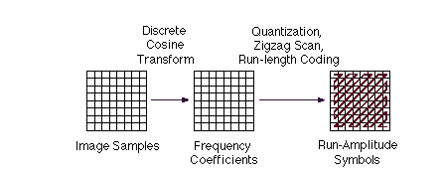
Figure 18 Transform Coding Operations

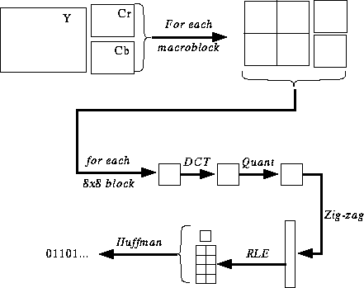

Figure 19 Intra-picture coding scheme.

4.2 MPEG-2, Part 2: Video [7]

Part 2 of MPEG-2 builds on the powerful video compression capabilities of the MPEG-1 standard to offer a wide range of coding tools. Essentially, it extrapolates the results of MPEG-1 to a quality comparable to composite TV at about 4 times the typical MPEG-1 bitrate. There were expectations at the time that VLSI technology would be ready to implement a video decoder handling full-size pictures at bitrates up to 10 Mbit/s.

4.2.1 MPEG-2 versus MPEG-1

The main differences in MPEG-1 and MPEG-2 applications are listed as follows:

MPEG-1 | MPEG-2
Medium Bandwidth (up to 1.5 Mbits/sec) | Higher Bandwidth (up to 40 Mbits/sec)
1.25 Mbits/sec video 352 x 240 x 30 Hz | Wider range of frame sizes
250 Kbits/sec audio (two channels) | Up to 5 audio channels (ie. surround sound)
Non-interlaced video | Can deal with interlaced video
Optimised for CD-rom | Can cover HDTV as a part of MPEG-2 High-1440 Level and High Level toolkit.

MPEG-2 was able to achieve these increases in functionarities by using:

• Flexible chroma format (4:4:4, 4:2:2, 4:2:0)

• Flexible picture structure

• Adaptive field/frame processing (DCT & MC)

• Alternative intra coefficient VLCs

• Alternative coefficient scanning order

• Flexible intra

• DC precision

• Alternative quantiser scaling

• Special prediction modes

• Concealment motion vectors

4.2.2 Decoder Block diagram

As in MPEG-1 coding architecture, MPEG-2 uses DCT for spatial domain redundancy reduction, and motion compensation for temporal domain redundancy reduction. A typical decoder block diagram is shown in Figure 20.
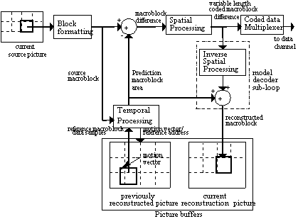

Figure 20 Typical MPEG-2 Decoder Block Diagram

4.2.3 Major differences between MPEG-1 and MPEG-2 method of coding

In Section 4.2.1, it was mentioned that there are quite a few differences between MPEG-1 and -2. In this section, we shall high-light some of these differences and explain how MPEG-2 increases its quality and functionality over those of MPEG-1.

One major difference is that MPEG-2 can handle both interlaced and progressive video sequences, whereas MPEG-1 is strictly meant for progressive sequences. In MPEG-2, a frame may be coded progressively or interlaced. In interlaced frames, frames may then be coded as either a frame picture or as two separately coded field pictures. Progressive frames are a logical choice for video material which originated from film, where all "pixels" are integrated or captured at the same time instant. Most electronic cameras today capture pictures in two separate stages: a top field consisting of all "odd lines" of the picture are nearly captured in the time instant, followed by a bottom field of all "even lines.". Frame pictures provide the option of coding each macroblock locally as either field or frame. An encoder may choose field pictures to save memory storage or reduce the end-to-end encoder-decoder delay by one field period. These features are illustrated in the diagrams below

4.2.3.1 MPEG-2 Bit stream Syntax
The bit stream syntax for MPEG-2 is illustrated in the Figure 21 below (compared with that in Figure 11 for MPEG-1):
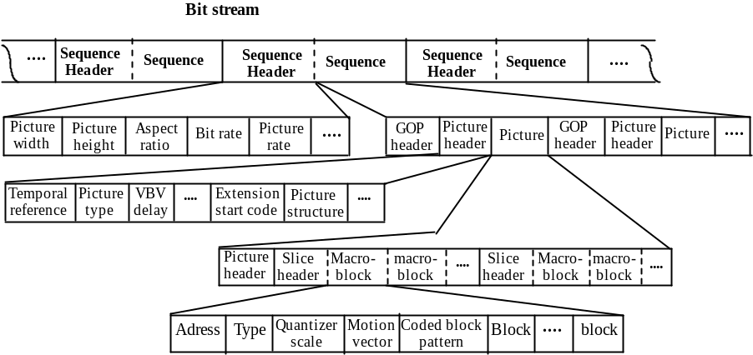

Figure 21 MPEG-2 Bit Stream Syntax

4.2.3.2 Field-pictures & Frame pictures

• Field pictures: The two fields are coded independently of one another. They occur in pairs, one top field and one bottom field.

• Frame pictures: The two fields are interleaved and coded together as a single frame.

• In frame pictures, the internal organisation within the macroblock can be frame-based or field-based:

Frame DCT coding scheme in frame pictures (4:2:0) is shown in Figure 22.
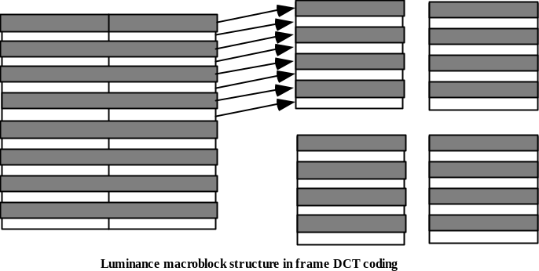
Figure 22 Frame DCT coding in frame pictures.

Field DCT coding scheme in frame pictures (4:2:0) is shown in Figure 23

• The chrominance blocks shall always be organised in frame structure for DCT coding (avoiding 4x8 IDCT).
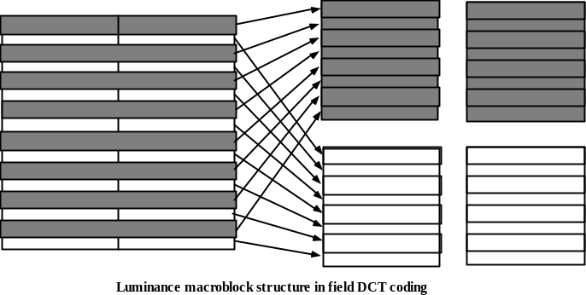

Figure 23 Frame DCT coding in frame pictures.

Dependencies between fields in the field prediction mode

As a result of the field/frame distinction, the options on dependency for the I,P,B-pictures, as illustrated in Figures 14 & 15 for MPEG-1, multiply greatly in MPEG-2. Figure 24 and Figure 25 below illustrate these dependency relationship in a typical GOP structure of MPEG-2 video stream.
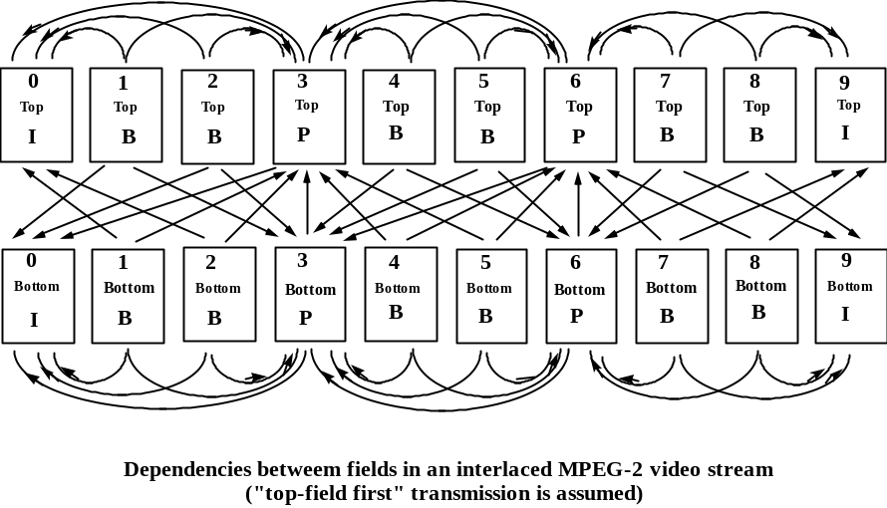

Figure 24 Dependencies between fields in the field prediction mode

Dependencies between fields in the frame prediction mode
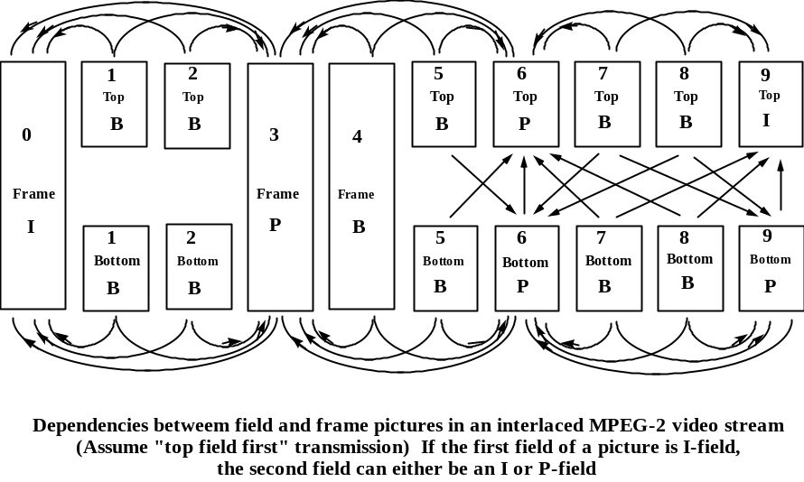

Figure 25 Dependencies between fields in the frame prediction mode

4.2.3.3 Motion Estimation/Compensation

• There are five possible motion vector modes in MPEG-2 [13]. These are listed in the Table 4 below, together with the restrictions.

Motion Vector Mode | Use in Field Pictures? | Use in Frame Pictures?
Frame Prediction for Frame Pictures |  | 
Field Prediction for Field Pictures |  | 
Field Prediction for Frame Pictures |  | 
Dual-Prime for P-Pictures |  | 
16x8 MC for Field Pictures |  | 

Table 4 MPEG-2 5 motion vector modes

4.2.3.4 MPEG-2 Macroblock Modes [3]
As a result of the Field/Frame pictures and the five motion vector modes, there are a large number of macroblock options available to the encoder. Some 56 macroblock modes are possible for B pictures and between 22 and 31 modes are available to P pictures depending on the absence or presence of B pictures in the MPEG-2 bit stream. Table 5 enumerate these legitimate modes.
The table also shows the number of motion vectors generated for each macroblock mode. Typically, there is a trade-off between spending bits on coding the motion vectors and spending bits on coding the Discrete Cosine Transform (DCT) coefficients.
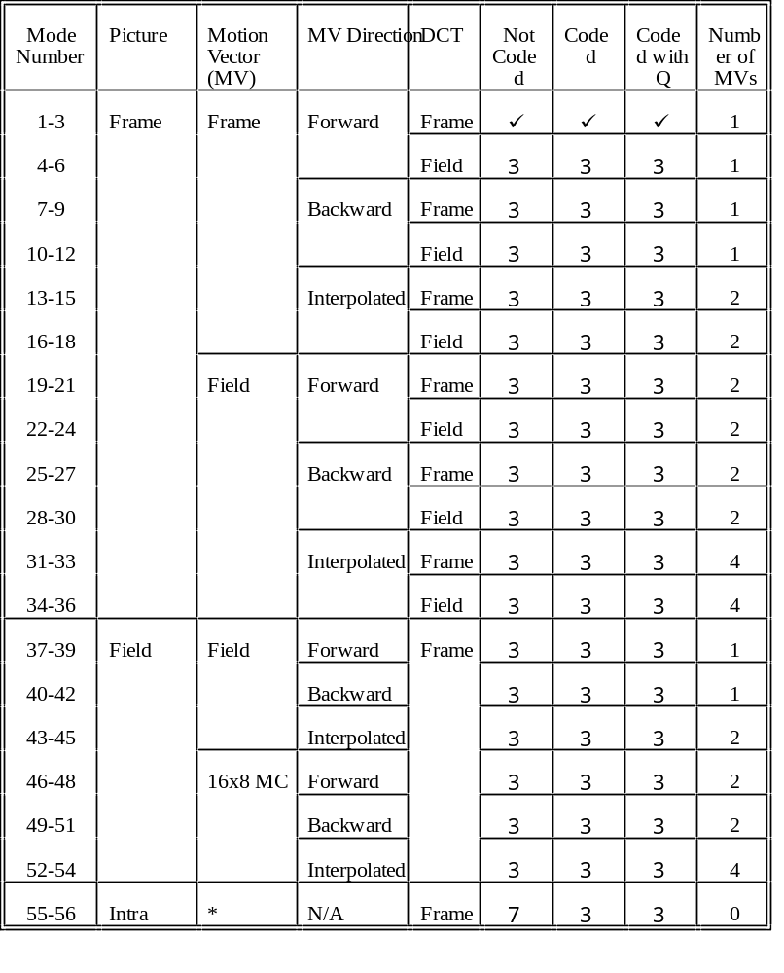* Concealment motion vectors may be included.
Table 5(a): Macroblock modes for B pictures.

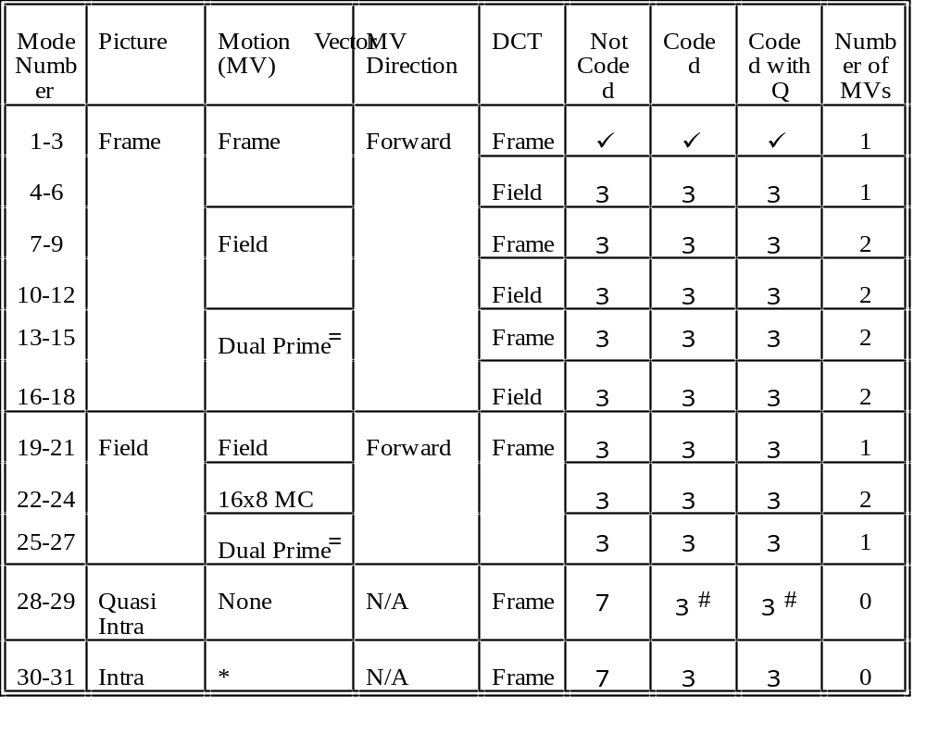
* Concealment motion vectors may be included.
 Only in bit streams without B pictures. Differential motion vectors are also transmitted for each MV.
# Not all blocks need to be coded.

Table 5(b): Macroblock modes for P pictures.
Neither the MPEG-1 nor the MPEG-2 standards prescribe which encoding methods to use, the encoding process, or details of encoders. The standards only specify formats for representing data input to the input to the decoder, and a set of rules for interpreting these data. The vast range of encoding options for choosing the macroblock modes pose a formidable problem to the designer of the MPEG encoders: How does one chose the optimum macroblock type, in real time, which will result in the best reconstructed quality of the coded picture at a given bit rate?

Most existing MPEG encoding algorithms use some simple and heuristic methods to decide which mode to use. While it has been shown that these methods perform satisfactorily, they are by no means optimal. A more analytical and theoretical justifiable way of modes selection is a subject of research at this moment [3].

5. References

[1] ISO/IEC International Standard 11172-2, “Coding of Moving Pictures and Associated Audio for Digital Storage Media at up to about 1.5 Mbit/s”, 1993.
[2] ISO/IEC International Standard 13818-2, “Generic Coding of Moving Pictures and Associated Audio Information: Video”, 1995.
[3] Geoffrey J.J. Tham, Andrew W. Johnson and Khee K. Pang, "MPEG-2 Macroblock Mode Decision Algorithms", Australian Telecommunications Networks and Applications Conference 1996, ATNAC'96, pp.383-388, Melbourne 3-6 December 1996.
[4] Leonardo Chiariglione, "Short MPEG-1 description", http://www.cselt.stet.it/mpeg/mpeg_1.
[5] Leonardo Chiariglione, "Short MPEG-2 description", http://www.cselt.stet.it/mpeg/mpeg_2.
[6] K.K. Pang, "Video Coding for Telecommunications", ECS 4349 Lecture Notes, Monash University.
[7] Leonardo Chiariglione, "MPEG and Multimedia Communications". http://www.cselt.stet.it/ufv/leonardo/paper.
[8] Leonardo Chiariglione, "MPEG achievements and current activities". http://www.cselt.stet.it/mpeg/current_activities.
[9] MPEG web site, "MPEG Home Page", http://drogo.cselt.stet.it/mpeg/
[10] MPEG web site, "MPEG Starting Points",http://www.bok.net/~tristan/MPEG/starting-points.html
[11] C-Cube Microsystems, "Compression Technology--MPEG Overview" http://www.c-cube.com/mpeg.
[12] Chad Fogg, "MPEG-2 FAQ", http://bmrc.berkeley.edu/projects/mpeg/faq/MPEG-2-FAQ.html.
[13] B.G. Haskell, A. Puri, and A. N. Netravali, Digital Video: An Introduction to MPEG-2, Chapman and Hall, Copy Right @ 1997.

