Using Ziling’s repository as an example:

For others, use

1). Select your repository from here:

<https://github.com/Stempro-Education>

2). select your repo.

<https://github.com/Stempro-Education/Zilin-Fang>

3). You will see this:

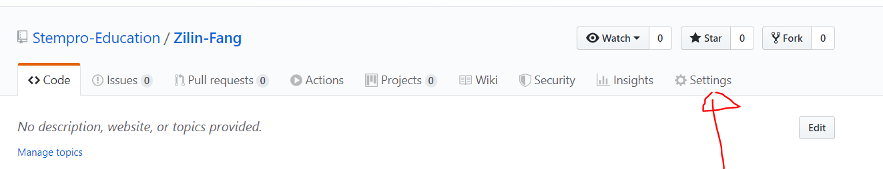

4). Click “Settings”

Scroll to the bottom of the page.

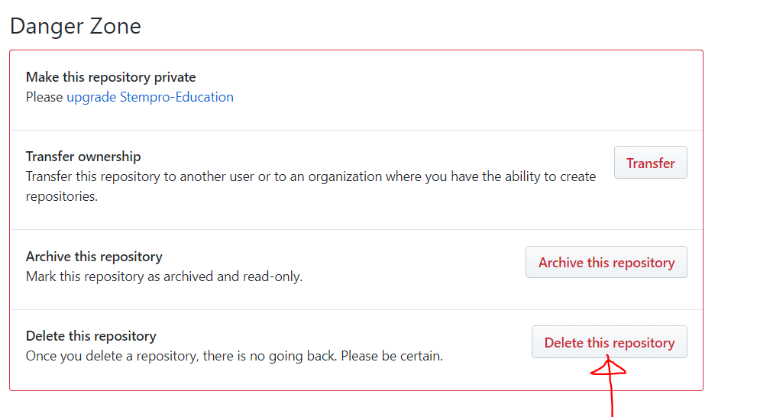

5). Click “delete this repository”. Follow this step:

