**Department of Electrical Engineering**

**Faculty Member: MISS RAFIA Dated: 25 – 02 - 25**

**Semester: 2ND Section:BS DS 02A**

*Group No.:*

**EE-221: Digital Logic Design**

**Lab 5: Minimization of Boolean Functions**

|  |  |  |  |  |  |  |  |
| --- | --- | --- | --- | --- | --- | --- | --- |
|  |  | **PLO4/CLO4** | **PLO4/CLO4** | **PLO5/CLO5** | **PLO8/CLO6** | **PLO9/CLO7** |  |
| **Name** | **Reg. No** | **Viva / Lab Performance** | **Analysis of data in Lab Report** | **Modern Tool Usage** | **Ethics and Safety** | **Individual and Team Work** | **Total marks Obtained** |
|  |  | **5 Marks** | **5 Marks** | **5 Marks** | **5 Marks** | **5 Marks** | **25 Marks** |
| **AILYA ZAINAB** | **523506** |  |  |  |  |  |  |
| **IMAN NAEEM** | **525378** |  |  |  |  |  |  |
| **LAIBA NASIR** | **510419** |  |  |  |  |  |  |
| **LUQMAN SHEHZAD** | **507599** |  |  |  |  |  |  |

## Lab 5: Minimization of Boolean Functions

This Lab has been divided into two parts.

The first part is the hardware implementation of a Boolean function given to you. But you have to first minimize the Boolean functions to minimum number of literals.

In next part you will simulate the same circuit using Verilog.

**Objectives:**

* Understand Minimization of Boolean Functions
* Simulate Basic Circuits using Verilog
* Hardware Implementation of Basic Logic Circuits

**Lab Instructions**

* This lab activity comprises three parts, namely Pre-lab, Lab tasks, and Post-Lab Viva session.
* The lab report will be uploaded on LMS three days before scheduled lab date. The students will get hard copy of lab report, complete the Pre-lab task before coming to the lab and deposit it with teacher/lab engineer for necessary evaluation. Alternately each group to upload completed lab report on LMS for grading.
* The students will start lab task and demonstrate design steps separately for step-wise evaluation ( course instructor/lab engineer will sign each step after ascertaining functional verification)
* Remember that a neat logic diagram with pins numbered coupled with nicely patched circuit will simplify trouble-shooting process.
* After the lab, students are expected to unwire the circuit and deposit back components before leaving.
* The students will complete lab task and submit complete report to Lab Engineer before leaving lab
* There are related questions at the end of this activity. Give complete answers.

.

**Pre-Lab Tasks (2 marks)**

1. Write the Boolean expression of the following two functions. Simplify the expression using algebraic manipulation and draw the **logic diagram**.

**F (A, B, C) = ∑ (2, 3, 7)**

* A’BC’ + A’BC + ABC
* A’BC’ + BC(A + A’)
* A’BC’ + BC(1)
* A’BC’ + BC
* B(A’C’+C)
* B(A’+C)
* A’B+BC
* B(A’+C)

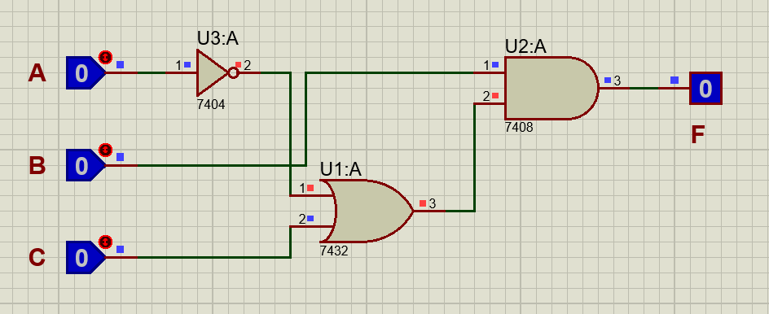

**G (A, B, C) = ∑ (4, 5, 7)**

* AB’C’ + AB’C + ABC
* AB’C’ + AC(B’+B)
* AB’C’ + AC(1)
* AB’C’ + AC
* A(B’C’+C)
* A(B’+C)
* AB’+AC
* **A(B’+C)**

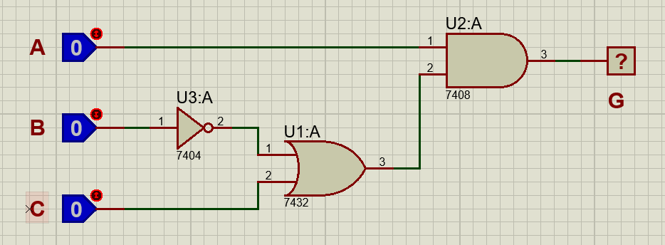

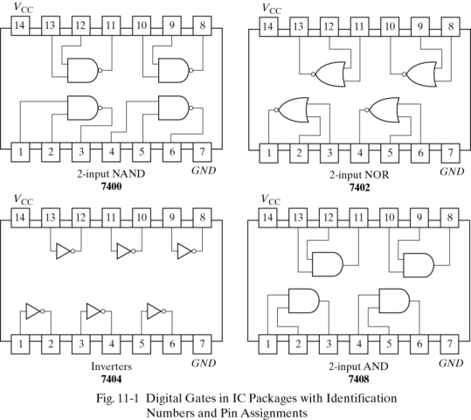

**Lab Tasks (8 marks)**

**Lab Task 1: (5)**

Implement the Boolean functions in hardware you simplified in your Pre-Lab Task. Make truth table and run the simulation in Proteus. Mention what and how many gates you would be using?

**Truth Table:**

|  |  |  |  |
| --- | --- | --- | --- |
| **A** | **B** | **C** | **G** |
| 0 | 0 | 0 | 0 |
| 0 | 0 | 1 | 0 |
| 0 | 1 | 0 | 0 |
| 0 | 1 | 1 | 0 |
| 1 | 0 | 0 | 1 |
| 1 | 0 | 1 | 1 |
| 1 | 1 | 0 | 0 |
| 1 | 1 | 1 | 1 |

|  |  |  |  |
| --- | --- | --- | --- |
| **A** | **B** | **C** | **F** |
| 0 | 0 | 0 | 0 |
| 0 | 0 | 1 | 0 |
| 0 | 1 | 0 | 1 |
| 0 | 1 | 1 | 1 |
| 1 | 0 | 0 | 0 |
| 1 | 0 | 1 | 0 |
| 1 | 1 | 0 | 0 |
| 1 | 1 | 1 | 1 |

**Hardware SS (3)**

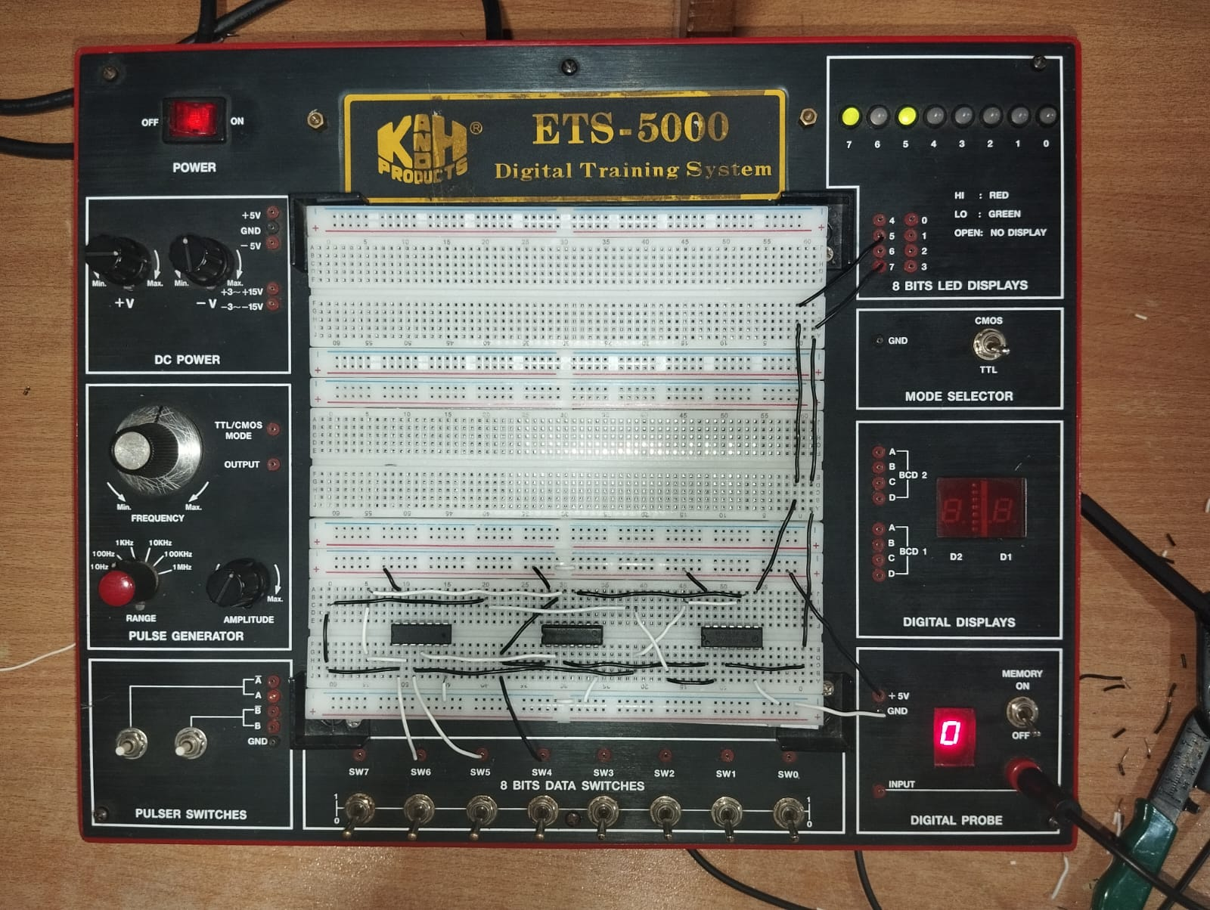

**INPUT: 000**

**OUTPUT: 00**

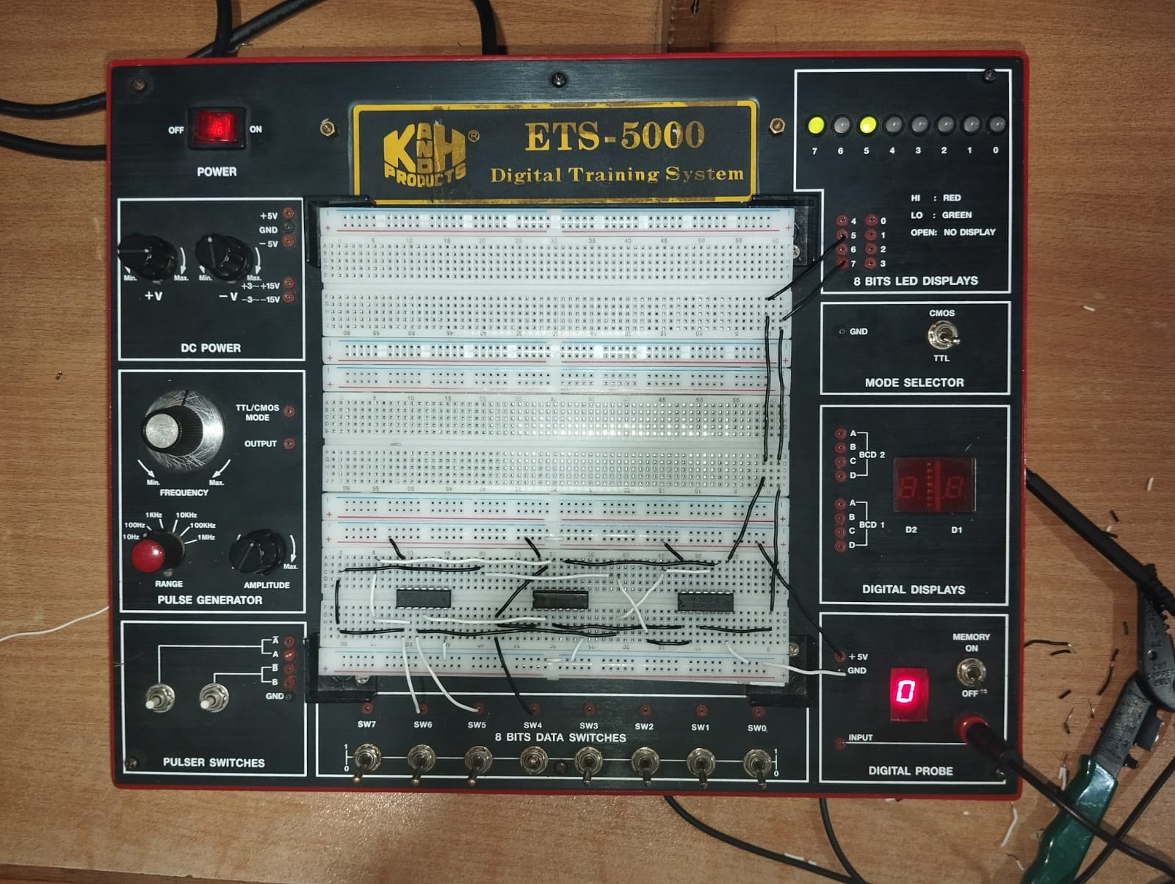

**INPUT: 001**

**OUTPUT: 00**

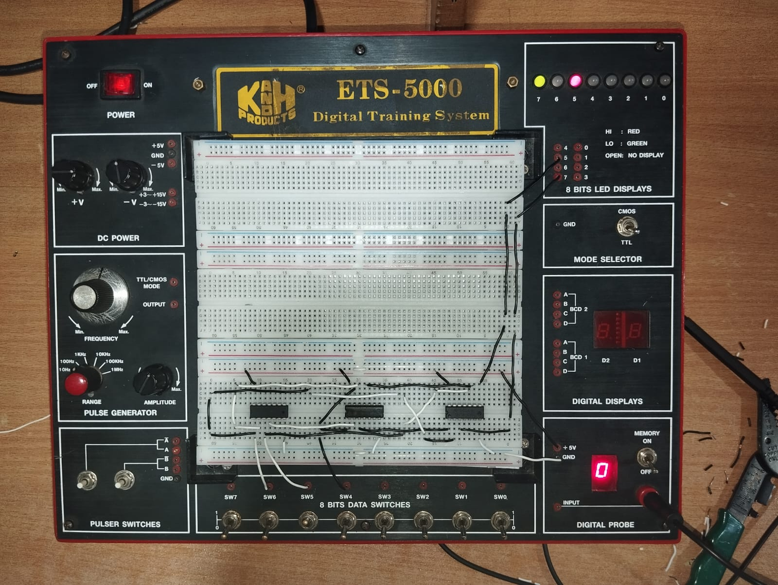

**INPUT: 010**

**OUTPUT: 10**

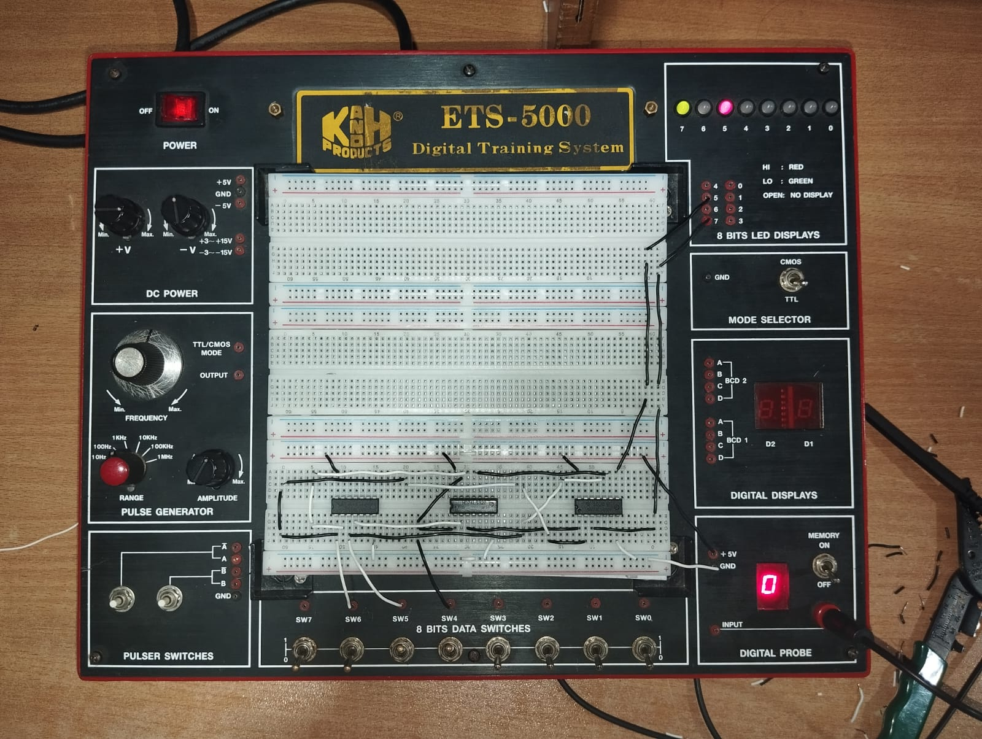

**INPUT: 011**

**OUTPUT: 10**

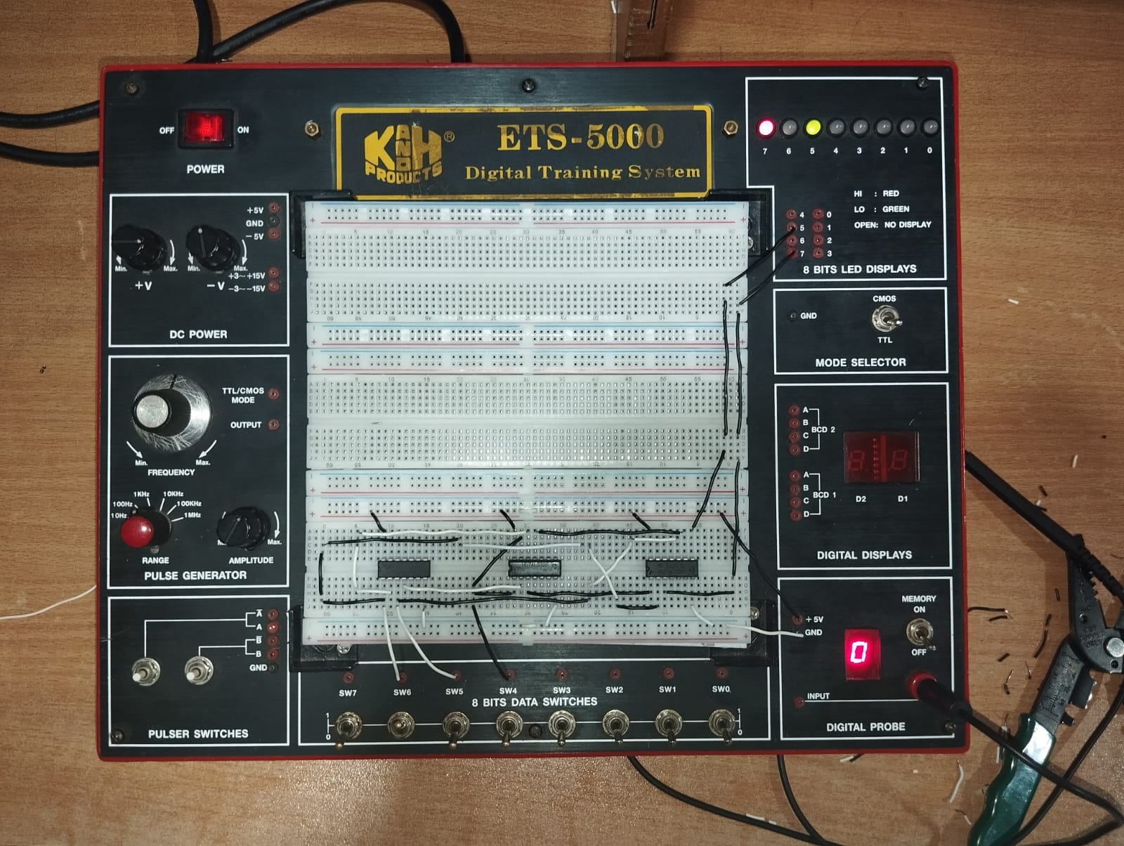

**INPUT: 100**

**OUTPUT: 10**

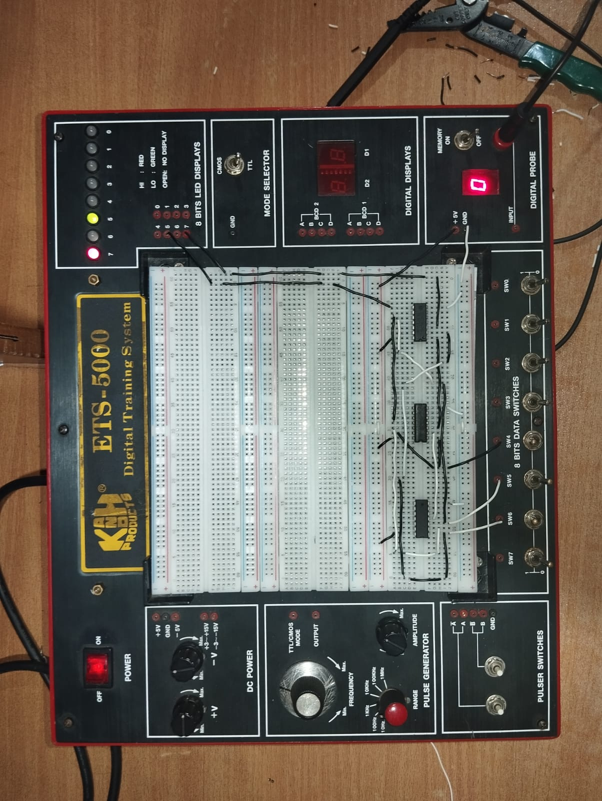

**INPUT: 101**

**OUTPUT: 10**

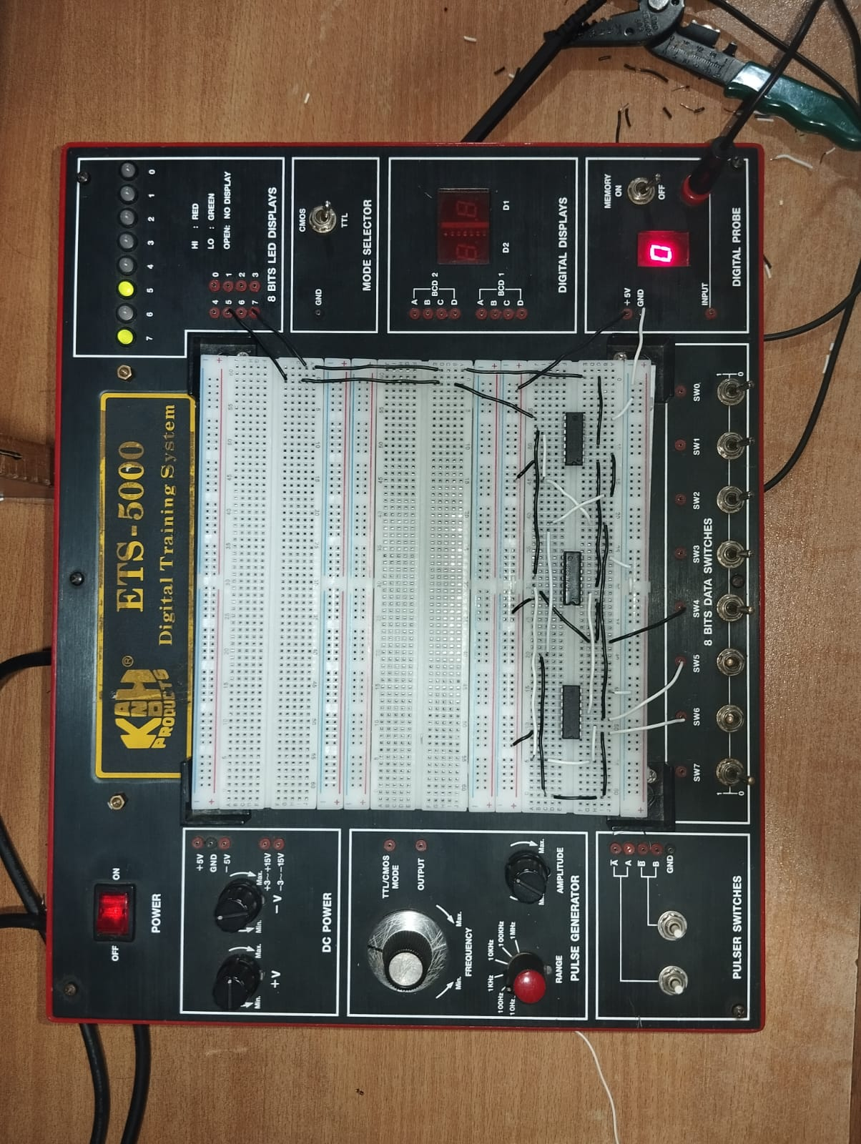

**INPUT: 100**

**OUTPUT: 00**

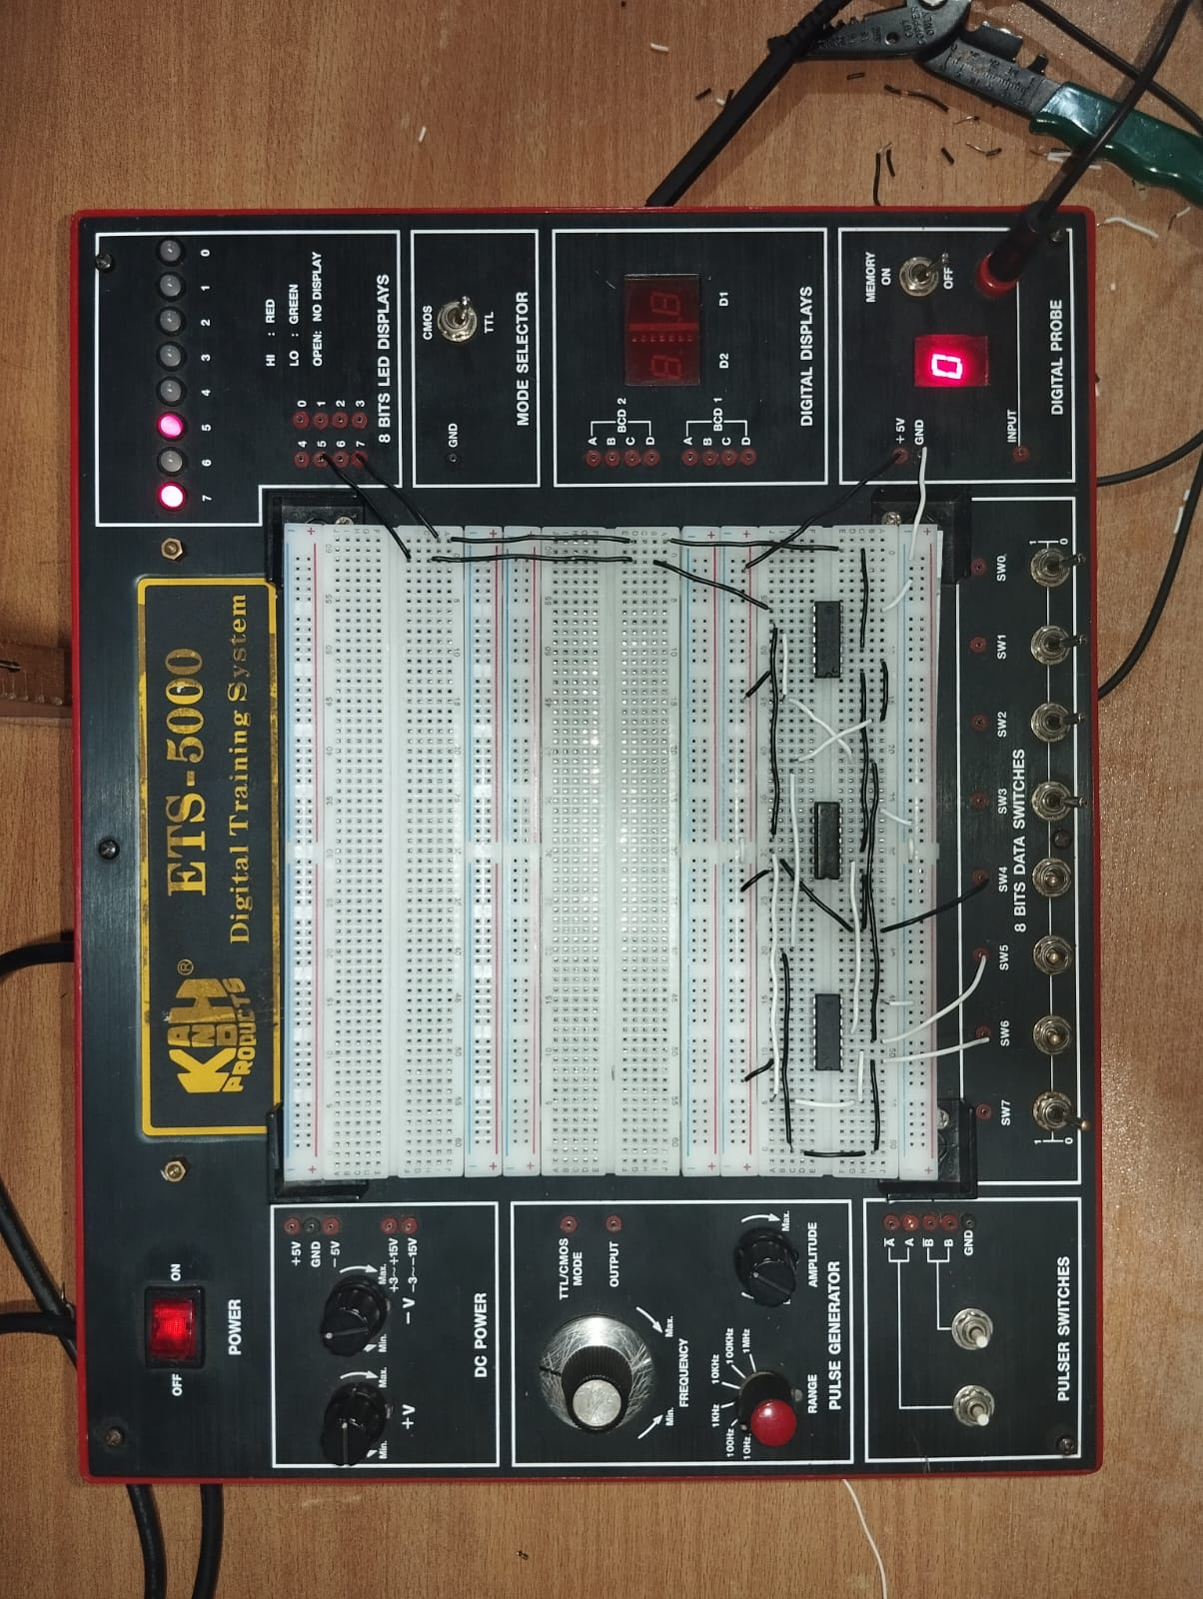

**INPUT: 111**

**OUTPUT: 11**

**Proteus Simulation (2)**

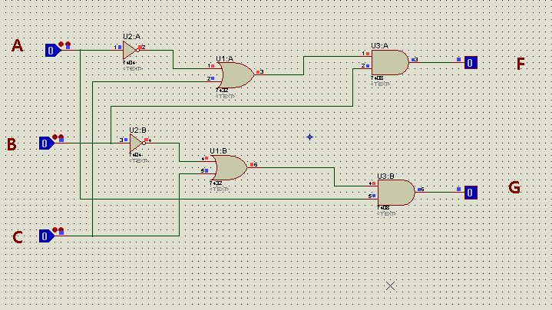

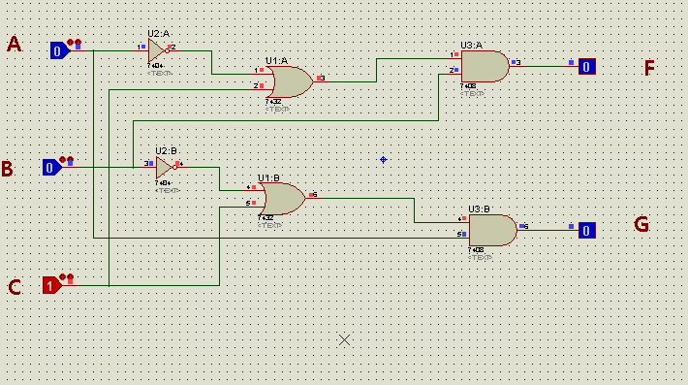

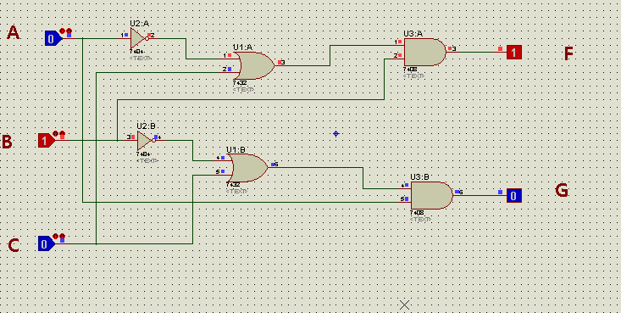

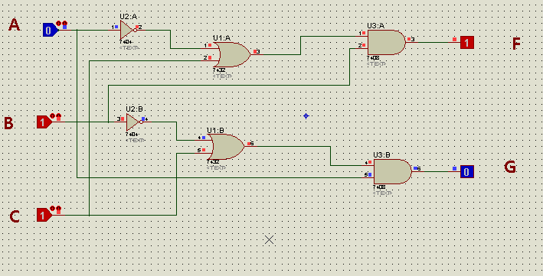

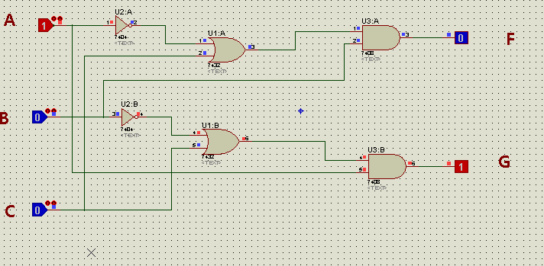

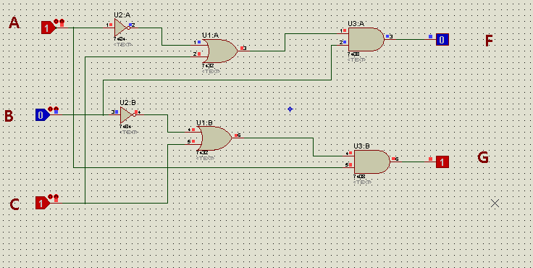

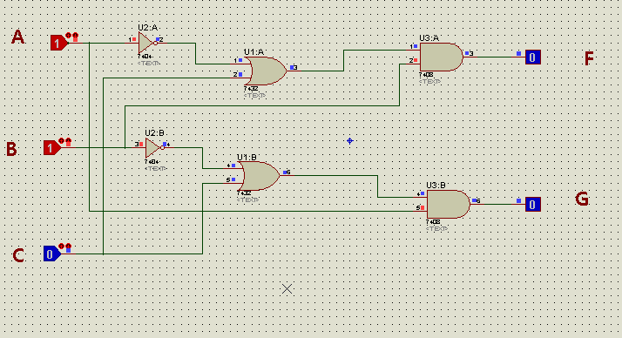

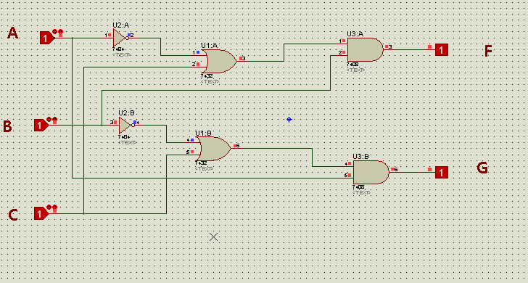

**Lab Task 2: (3)**

Write Verilog code for the minimized functions at gate-level and perform simulation. Attach the relevant snapshots below.

**CODE IN VERILOG**

module task01(A, B, C, F);

input A, B, C;

output F;

wire w1, w2;

not n1(w1, A);

or o1(w2, w1, C);

and a1(F, w2, B);

endmodule

module testTask01;

reg a, b, c;

wire f, g;

taskLab05 t1(a, b, c, f);

taskLab05 t2(b, a, c, g);

initial

begin

a=1'b0; b=1'b0; c=1'b0;

#100 a=1'b0; b=1'b0; c=1'b1;

#100 a=1'b0; b=1'b1; c=1'b0;

#100 a=1'b0; b=1'b1; c=1'b1;

#100 a=1'b1; b=1'b0; c=1'b0;

#100 a=1'b1; b=1'b0; c=1'b1;

#100 a=1'b1; b=1'b1; c=1'b0;

#100 a=1'b1; b=1'b1; c=1'b1;

end

endmodule

**VERILOG CODE:**

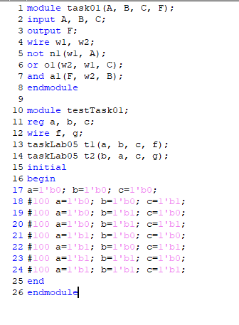

**WAVE OUTPUT:**

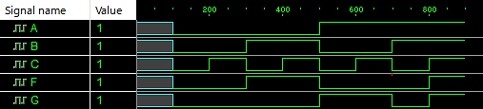

**Observations/Comments:**

In this lab, we implemented a logical circuit that is more optimal than its original counterpart, i.e. we simplified the sum of **standard minterms** to reduce and minimize the use of gates, essentially making it both efficient and cost effective.

We have also confirmed/verified the circuit’s output as it conforms to the truth table laid out in the Pre – lab and that it serves the purpose for what it was designed conclusively.