

**Department of Computing**

**School of Electrical Engineering and Computer Science**

**CS 212: Object Oriented Programming**

**Class: BSDS -02A**

**AILYA ZAINAB**

**( 5 2 3 5 0 6 )**

**Lab 1: Getting Started with Java**

**TASK#01**

**INPUT:**

**1:**

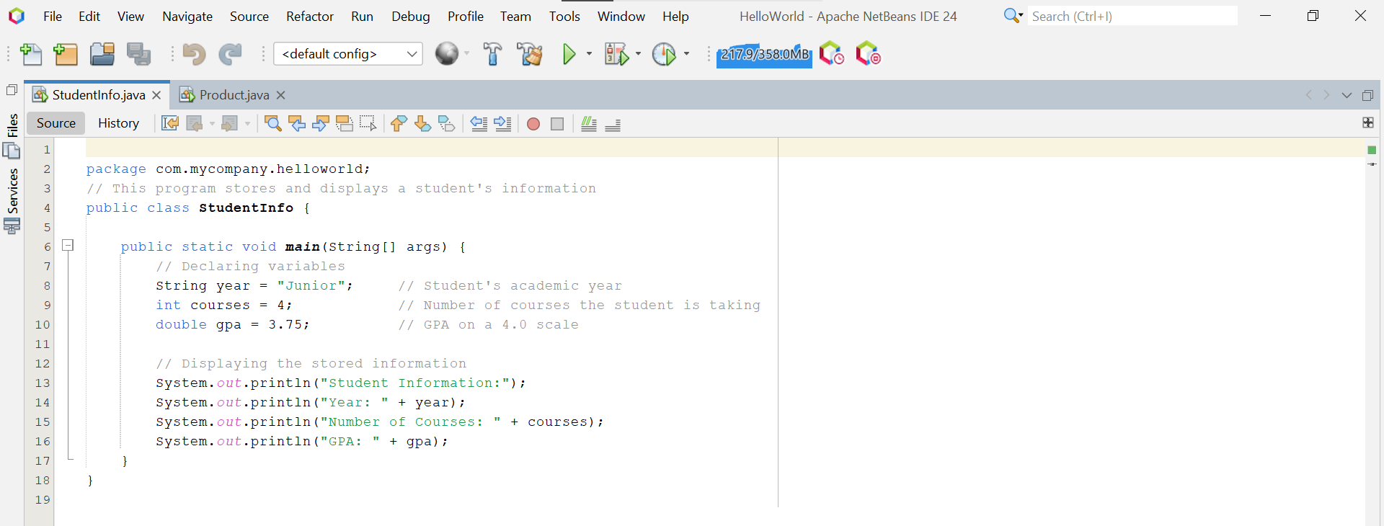

**2:**

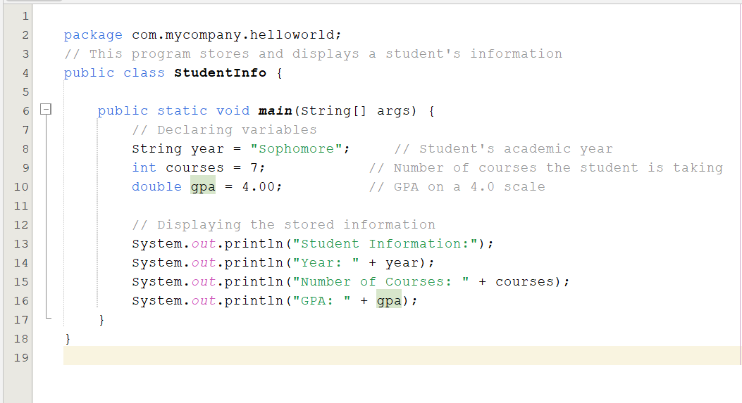

**OUTPUT:**

**1:**

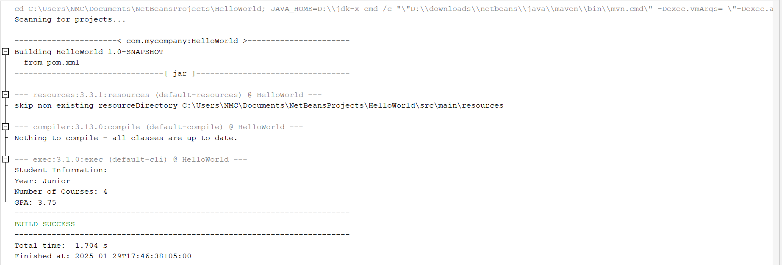

**2:**

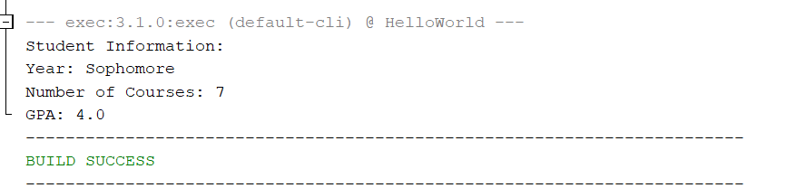

**TASK #02**

**INPUT:**

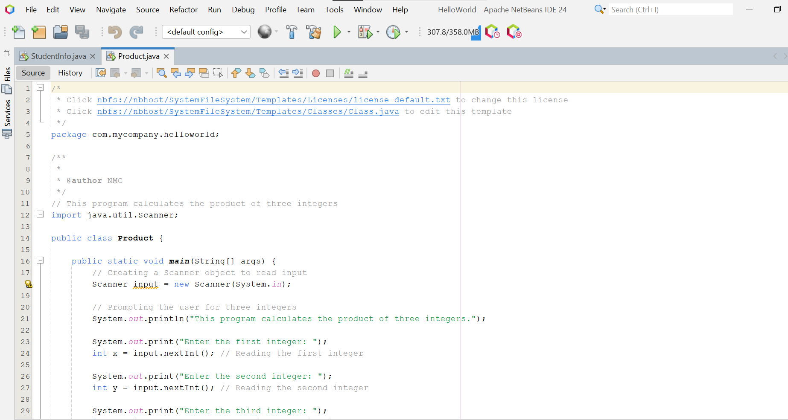

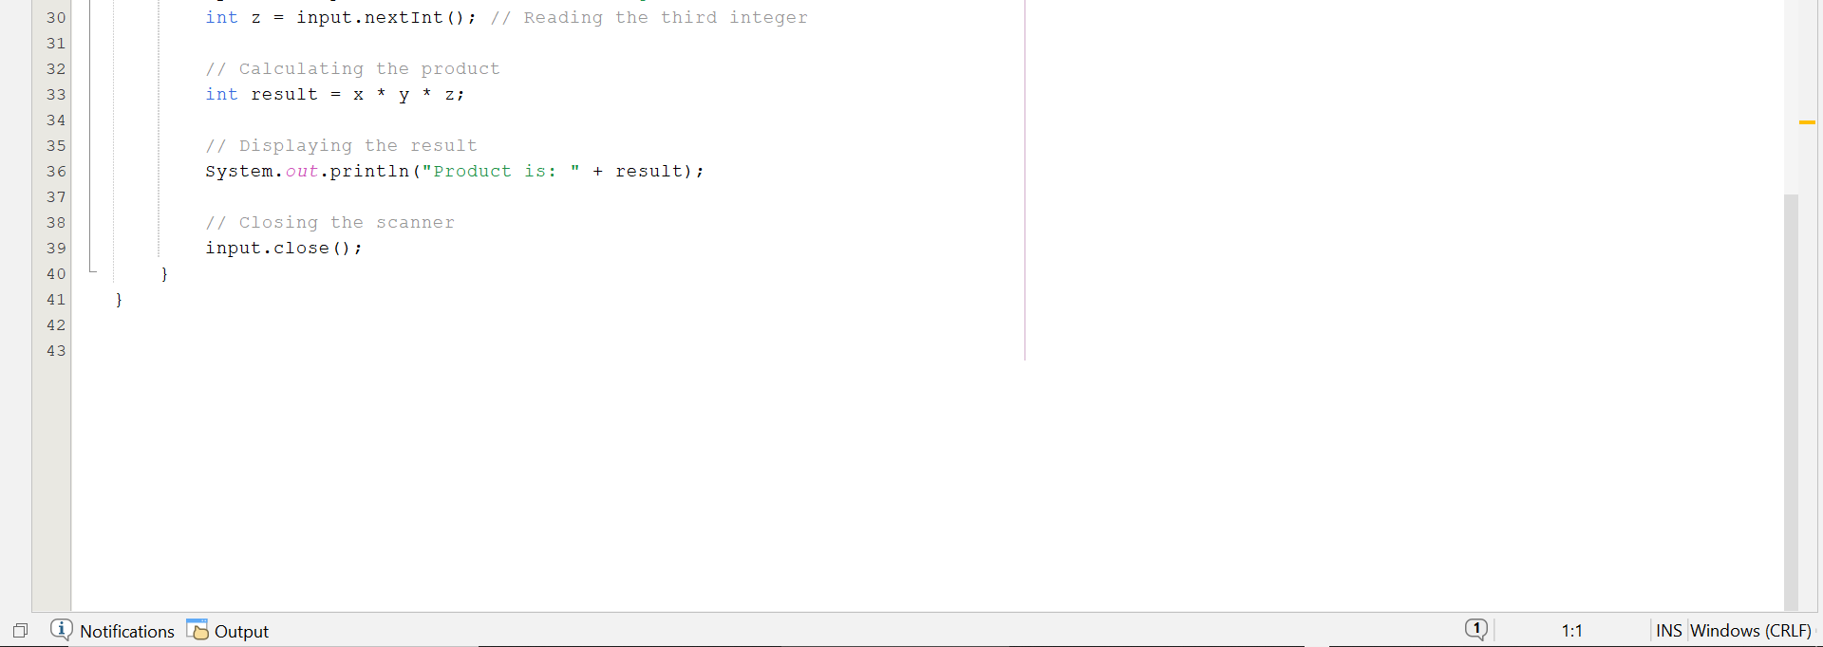

**OUTPUT:**

**1:**

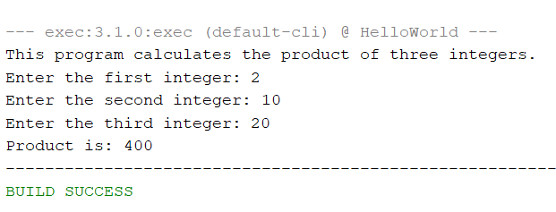

**2:**

