**Department of Computing**

**CS 212: Object Oriented Programming**

**Class: BSDS**

**Lab 02: Basic Programming in Java**

**Date: 4rd February 2025**

**Time: 2:00pm- 4:50pm**

**Instructor: Dr Nazia Pervaiz**

**Lab Engineer: Ms. Bareera Anam**

**Class: BSDS -02A**

**AILYA ZAINAB**

**( 5 2 3 5 0 6 )**

**TASK#01**

**INPUT:**

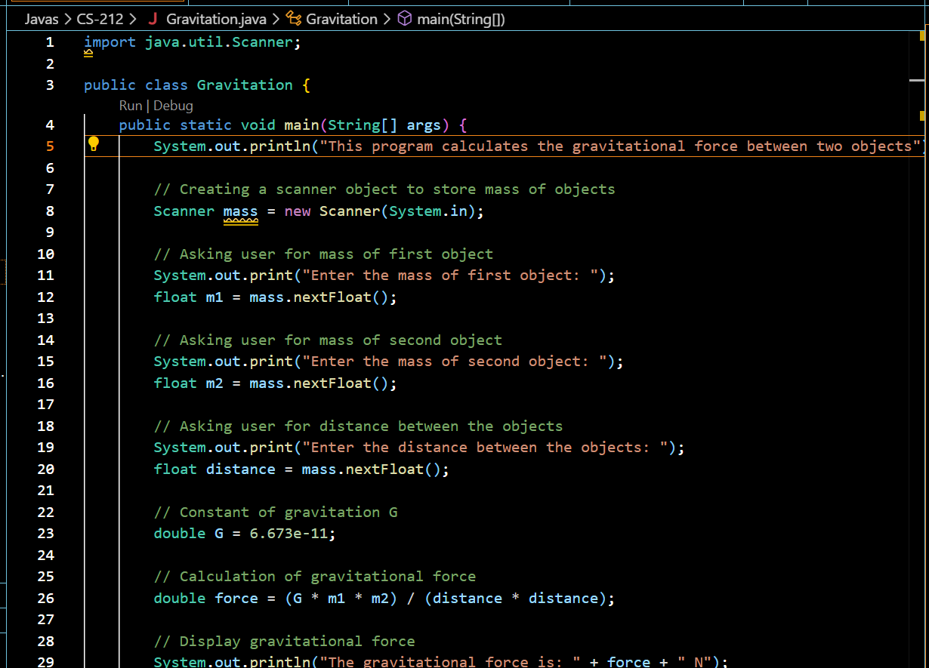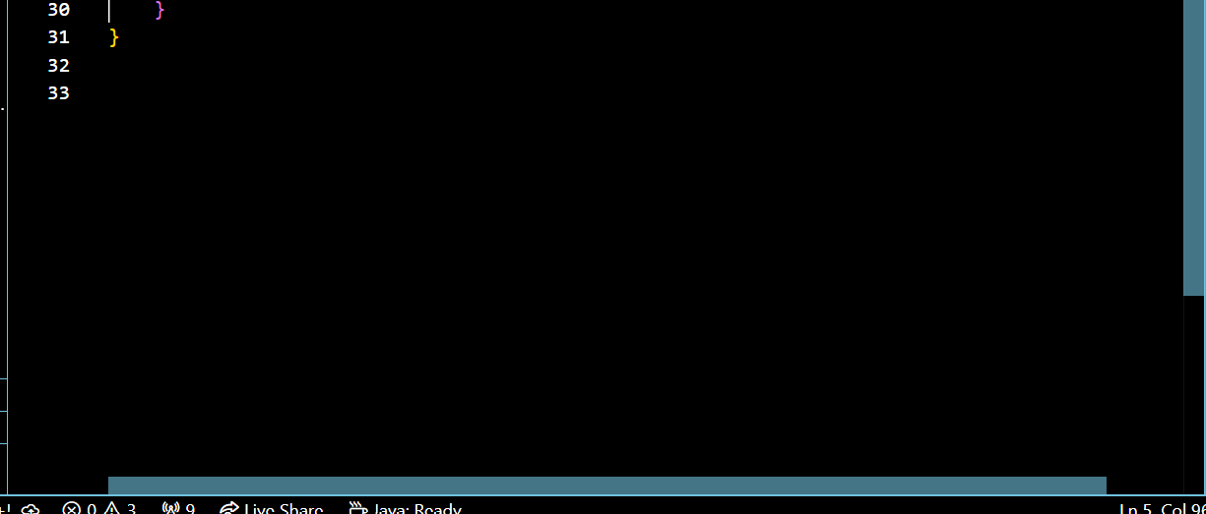

**OUTPUT:**

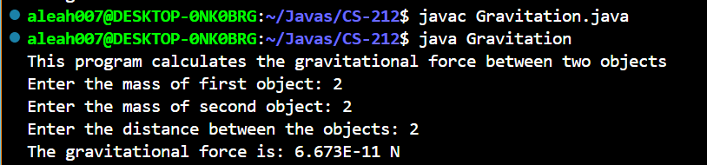

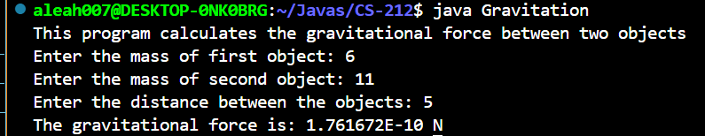

**TASK#02**

**INPUT:**

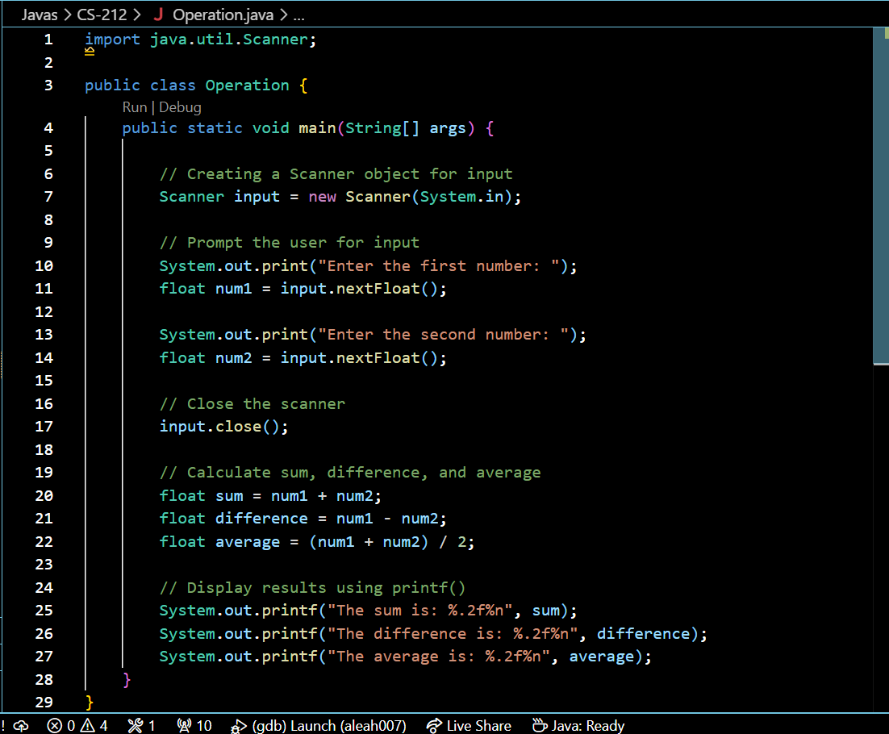

**OUTPUT:**

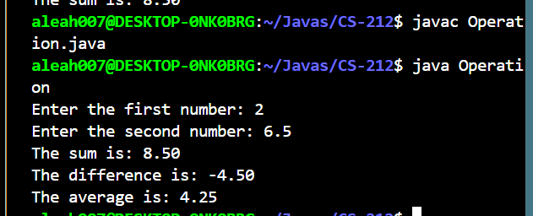

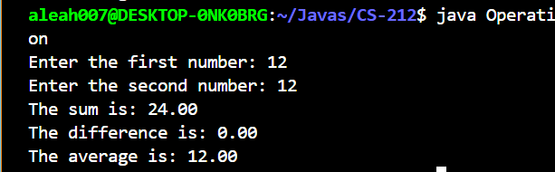

**TASK#03**

**INPUT:**

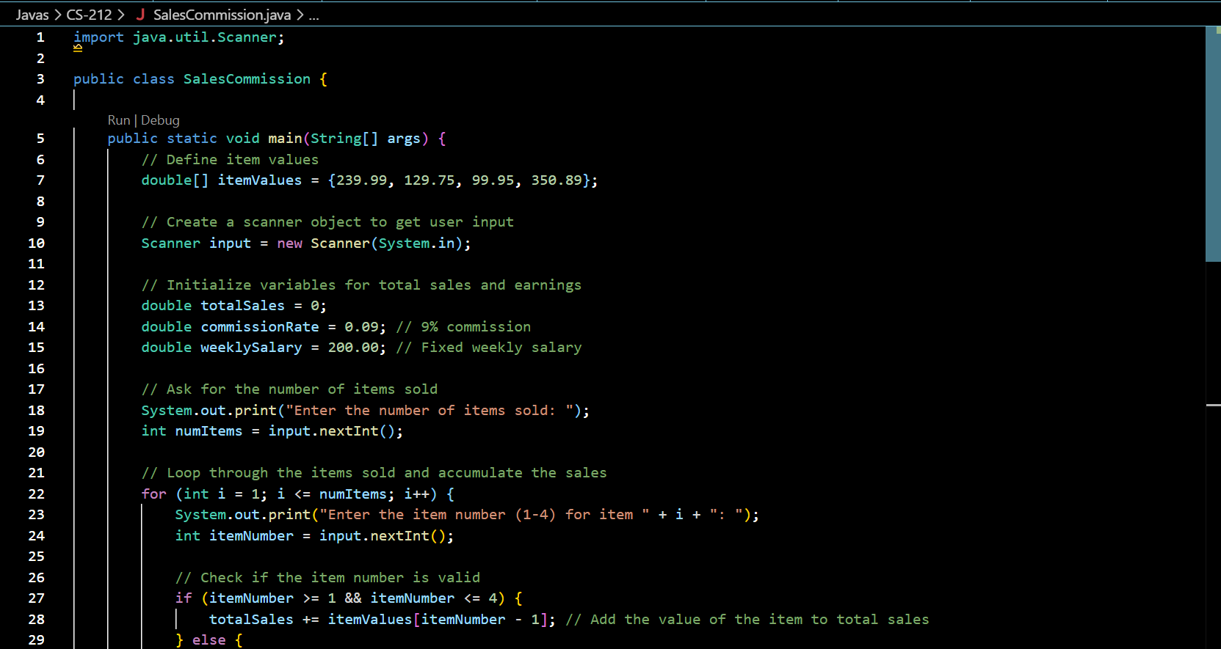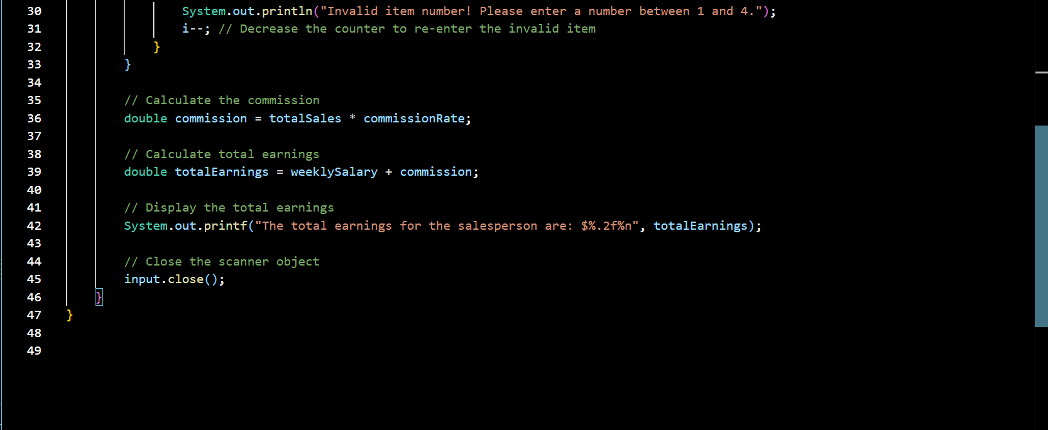

**OUTPUT:**

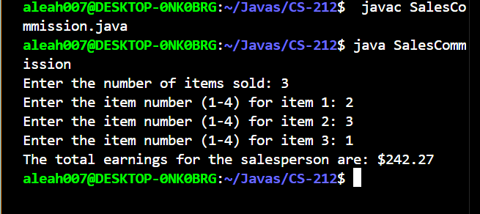

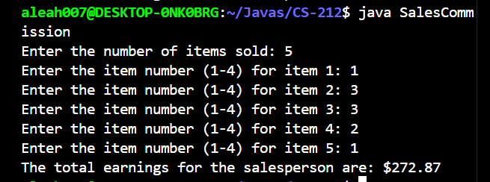

**TASK#04**

**INPUT:**

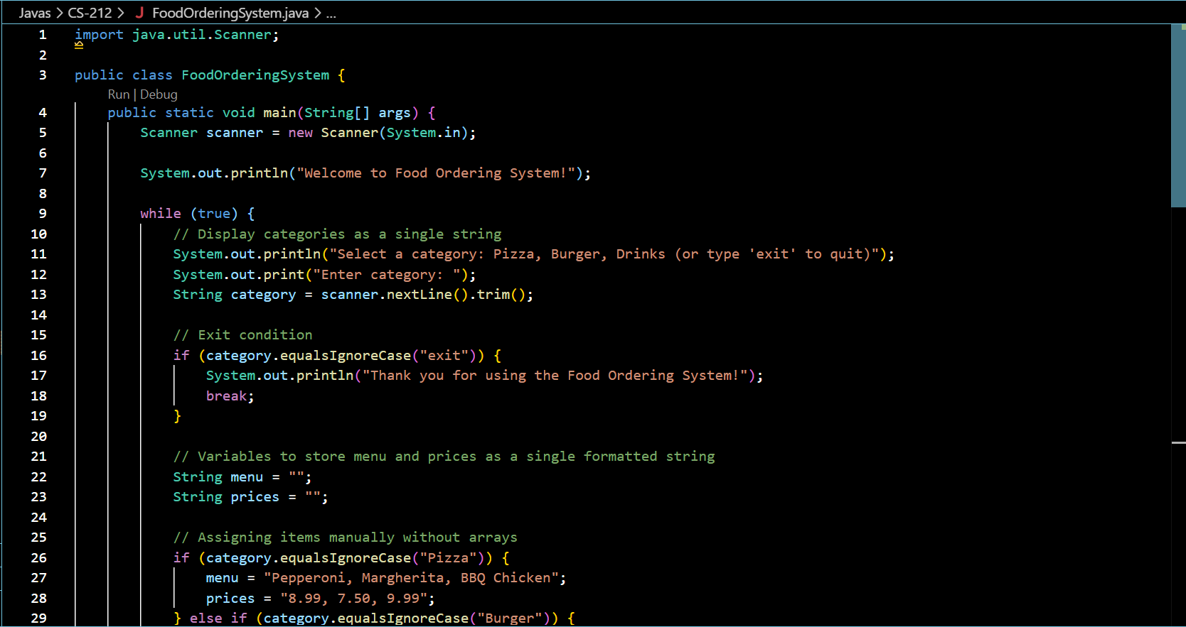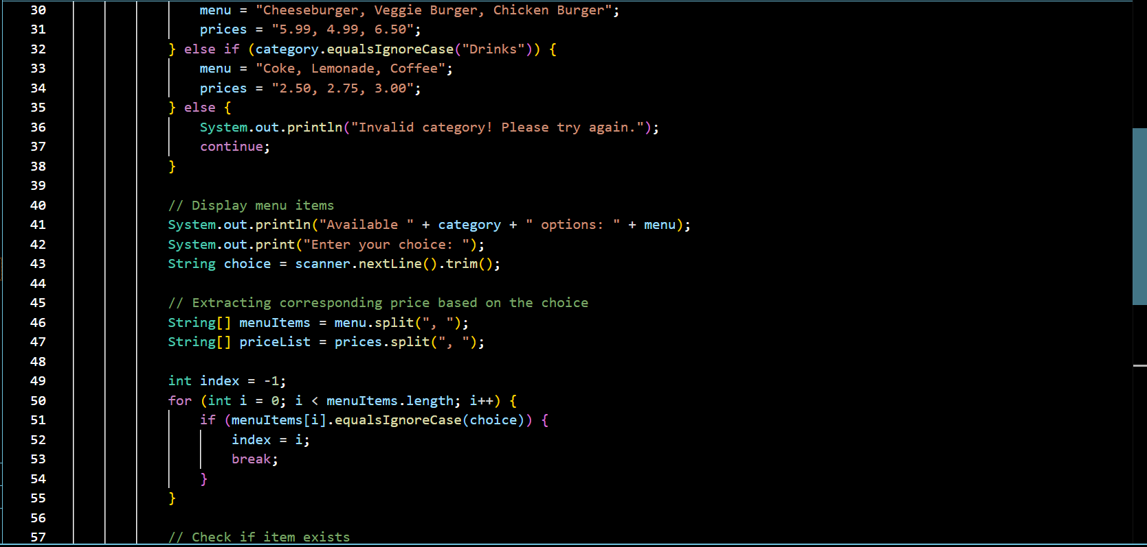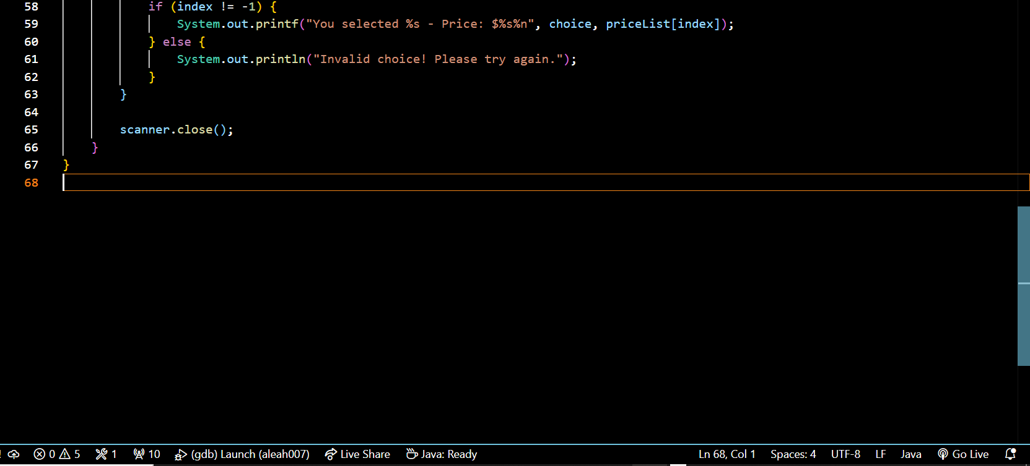

**OUTPUT:**

