**Department of Computing**

**CS 212: Object Oriented Programming**

**Class: BSDS**

**Lab 4: Introduction to Classes & Objects**

**Date: 18th February 2025**

**Time: 2:00pm- 4:50pm**

**Instructor: Dr Nazia Pervaiz**

**Lab Engineer: Ms. Bareera Anam**

**Class: BSDS -02A**

**AILYA ZAINAB**

**( 5 2 3 5 0 6 )**

**TASK#01**

**INPUT:**

**Employee.java**

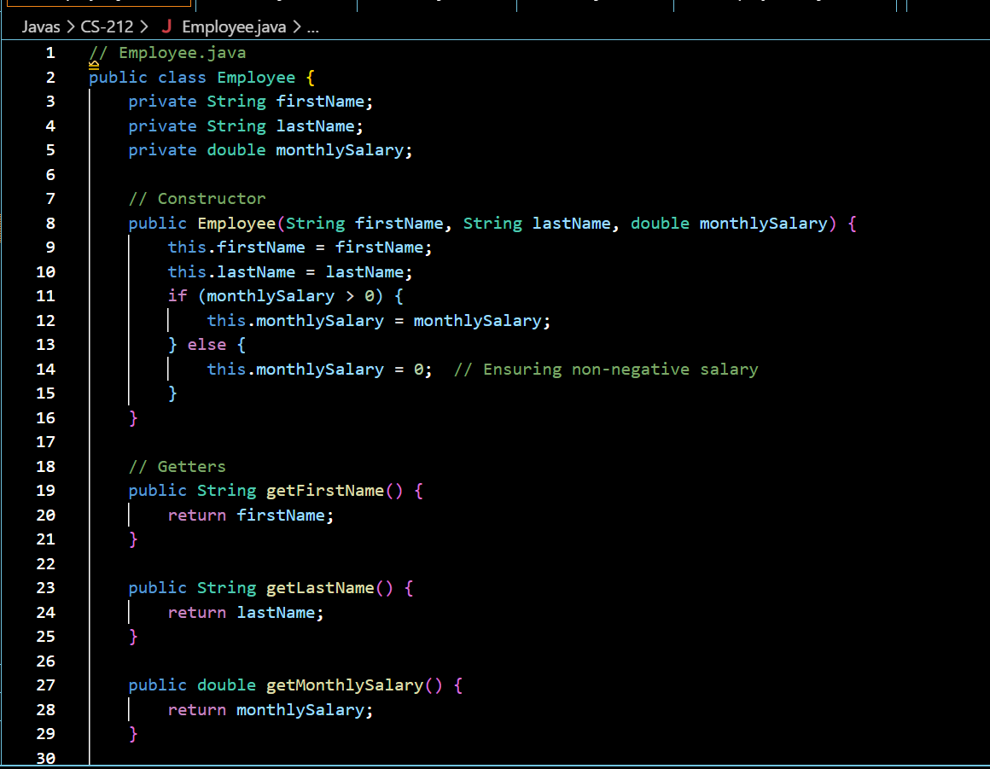

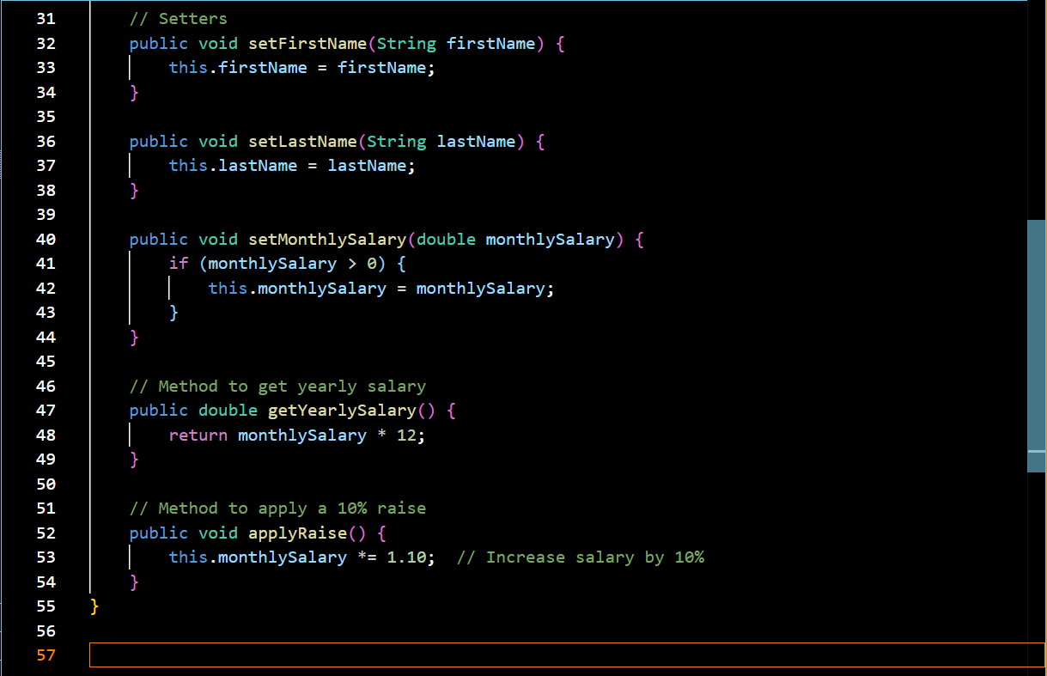

**EmployeeTest.java**

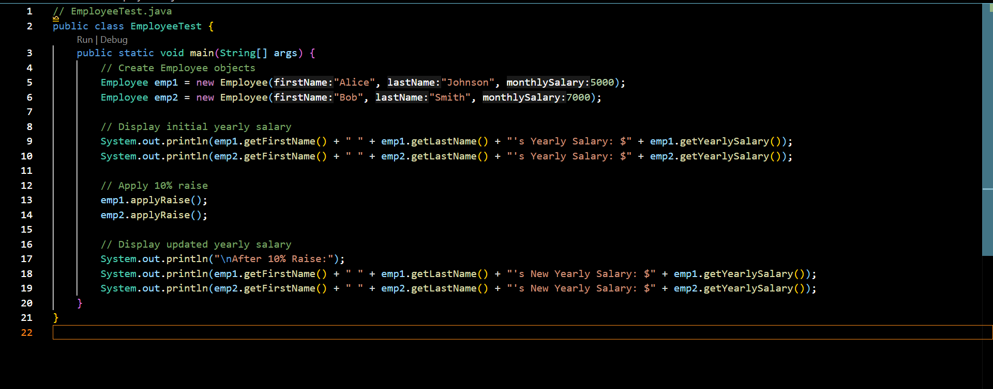

**OUTPUT:**

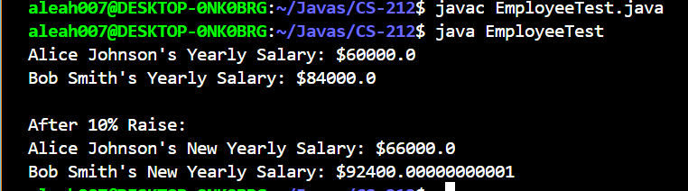

**TASK#02**

**INPUT:**

**Date.java**

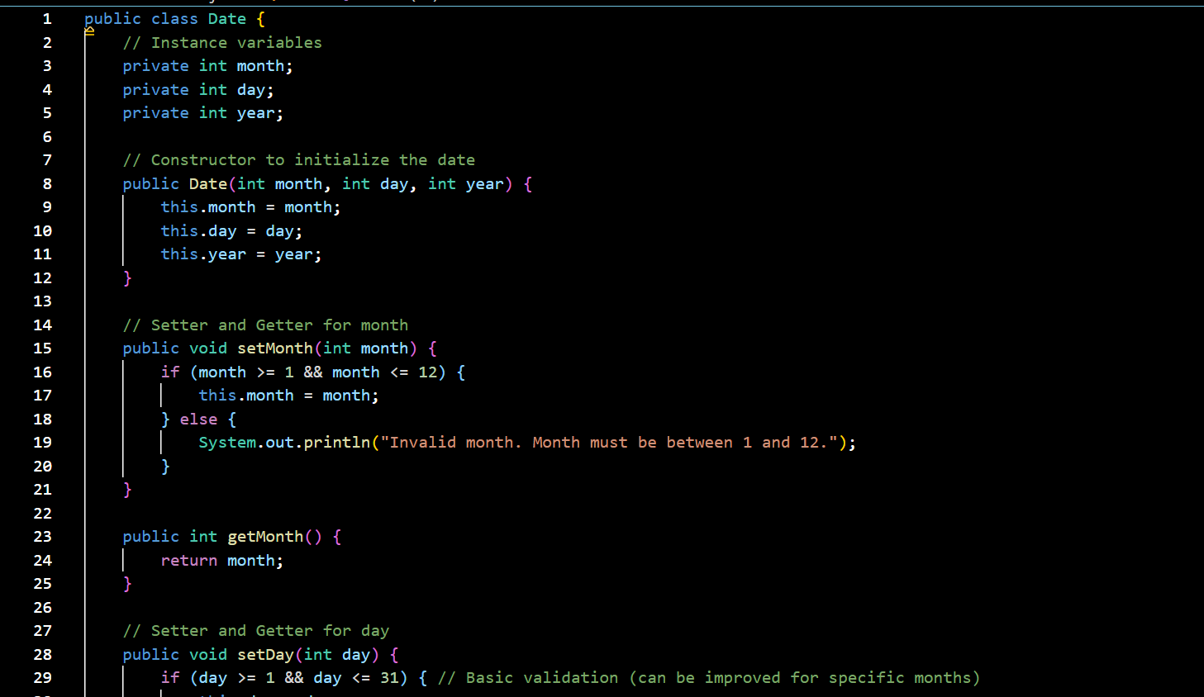

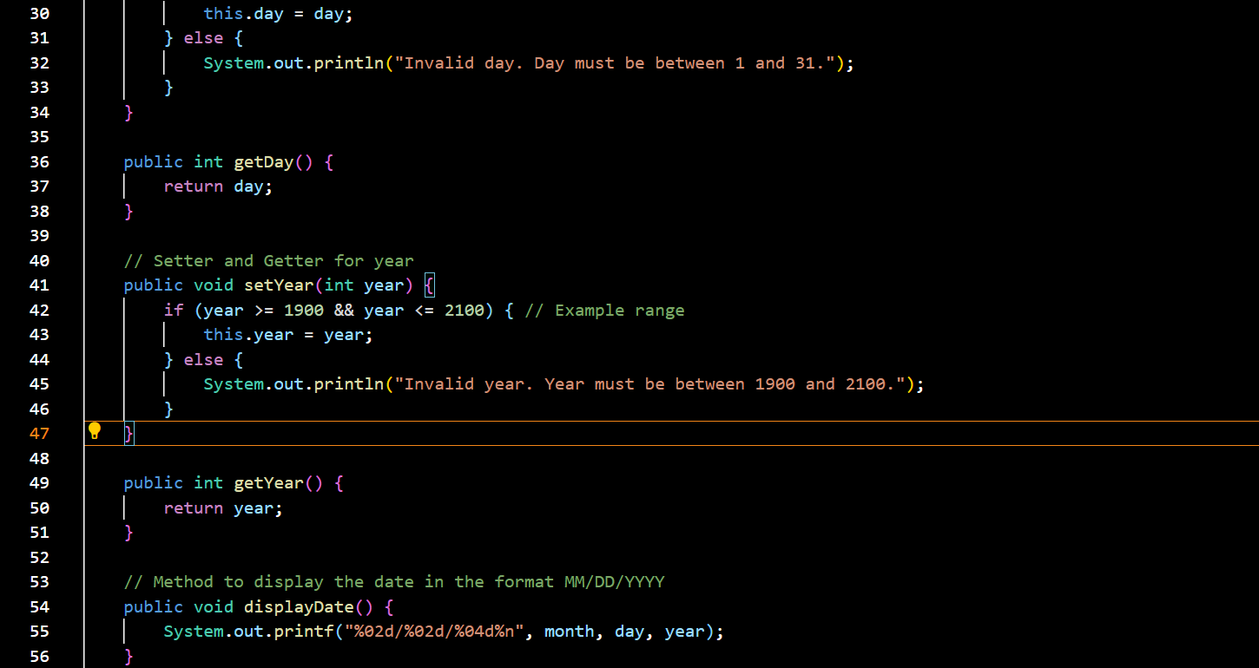

}

**DateTest.java**

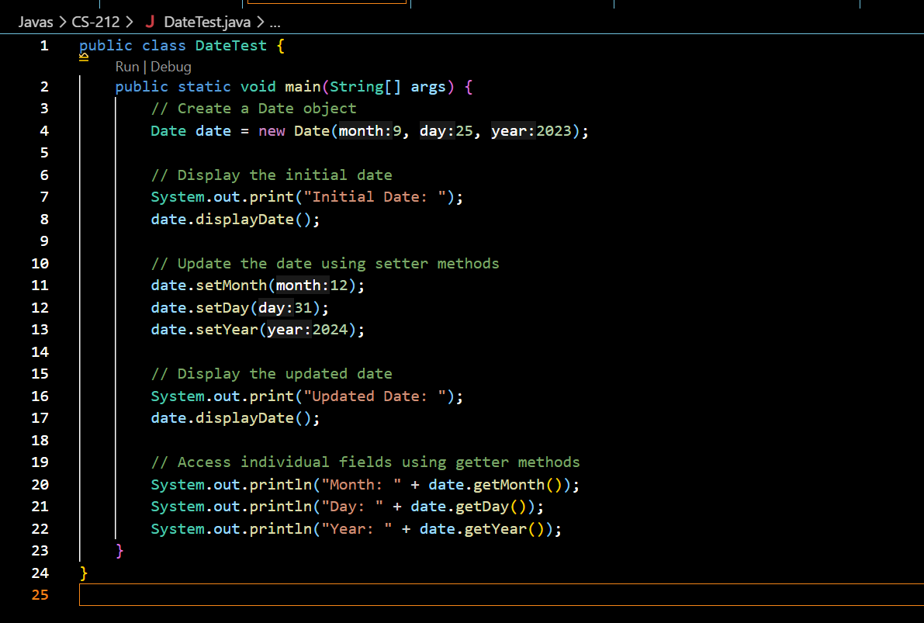

**OUTPUT:**

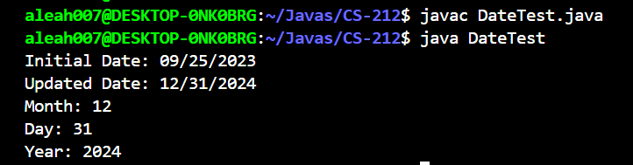

**TASK#03**

**INPUT:**

**Stack.java**

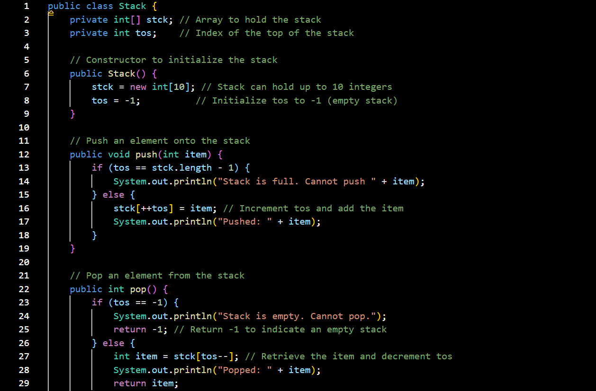

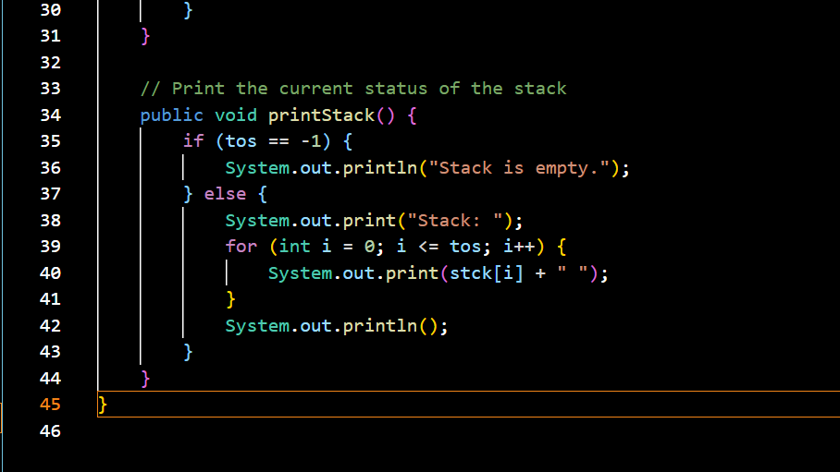

**StackTest.java**

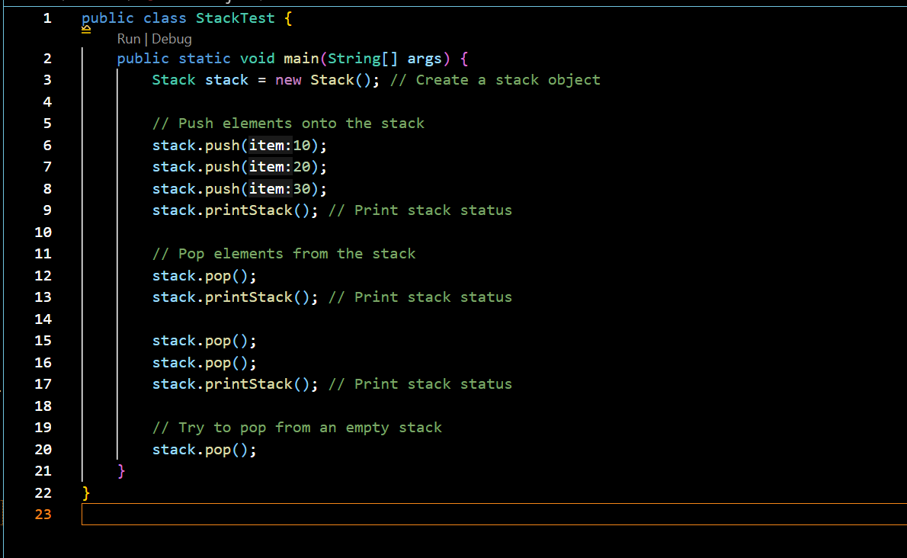

**OUTPUT:**

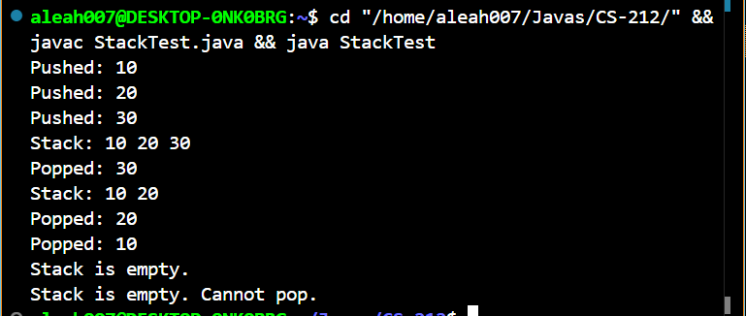

**TASK#04**

**INPUT:**

**StopWatch.java**

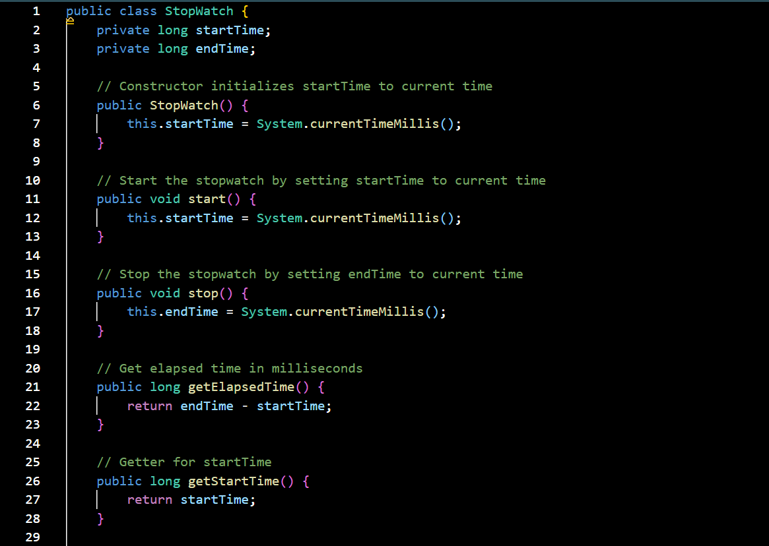

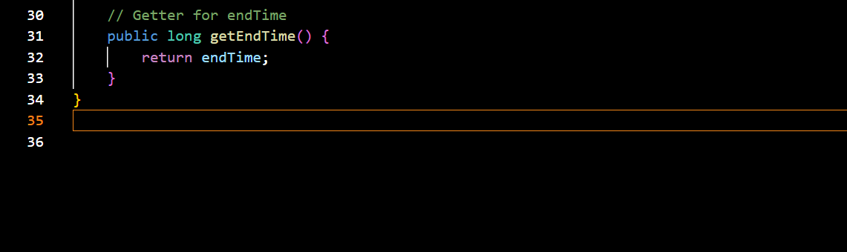

**TestStopWatch.java**

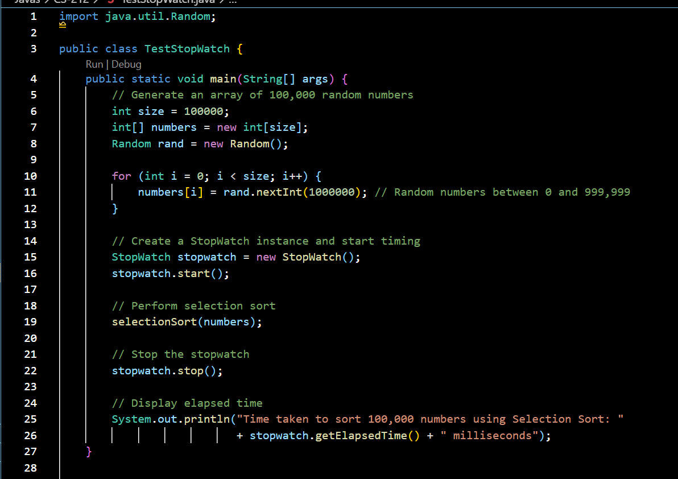

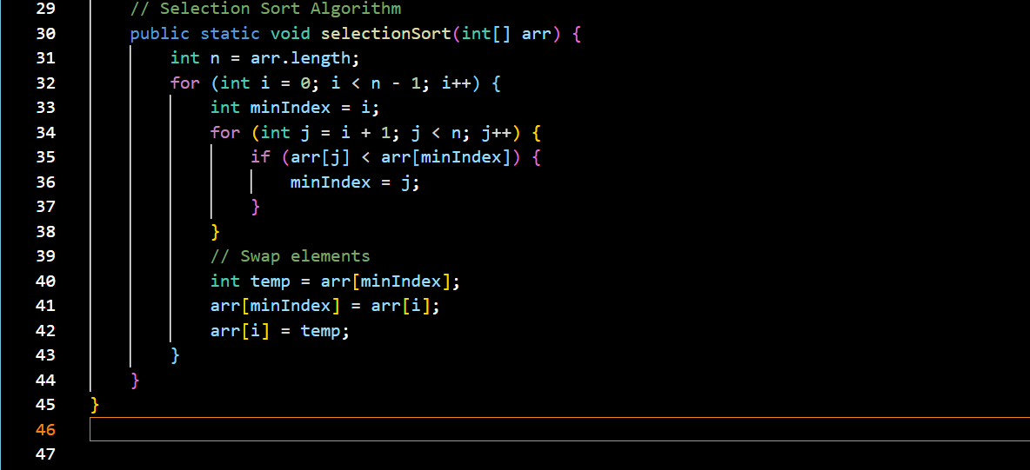

**OUTPUT:**

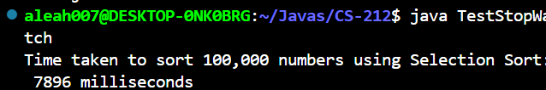

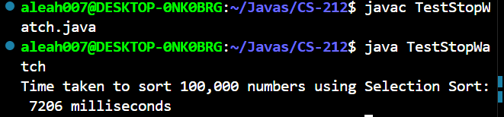

**UML BLUPRINT**

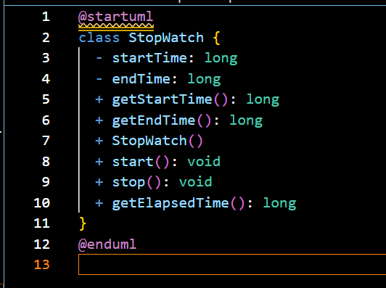

**UML**

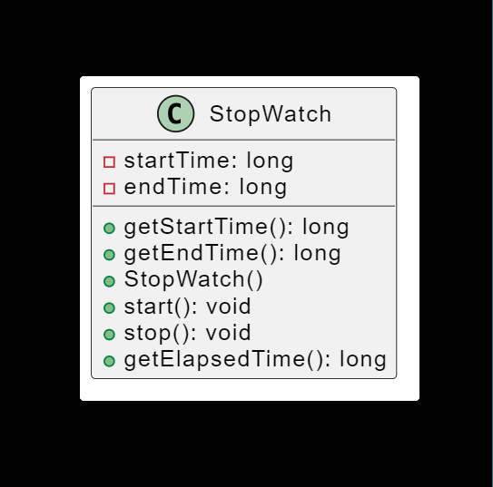

**TASK#05**

**INPUT:**

**Fan.java**

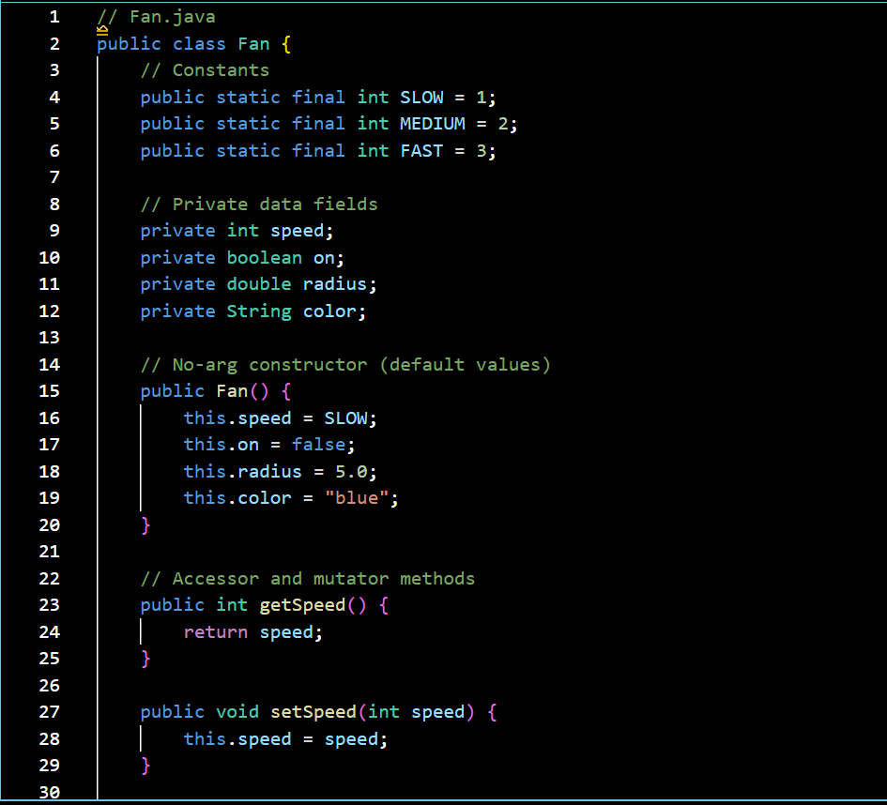

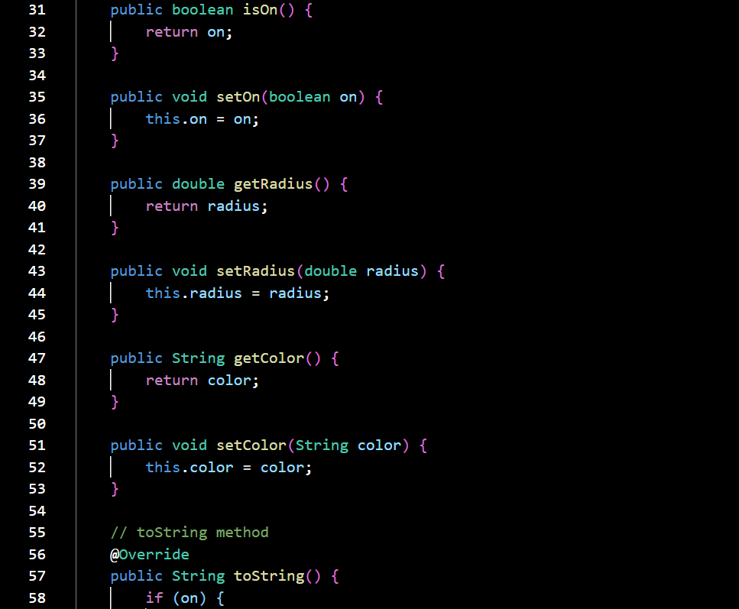

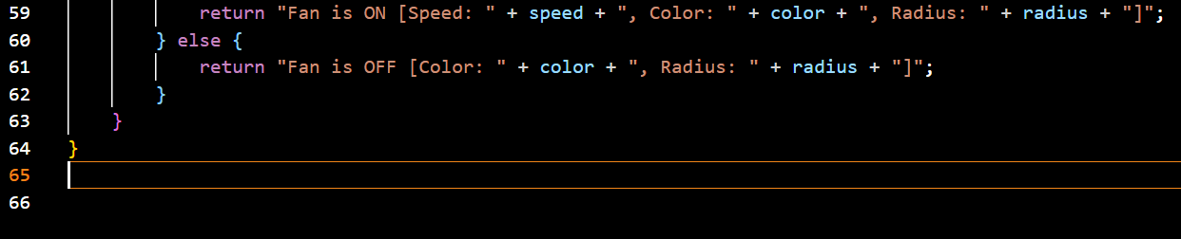

**FanTest.java**

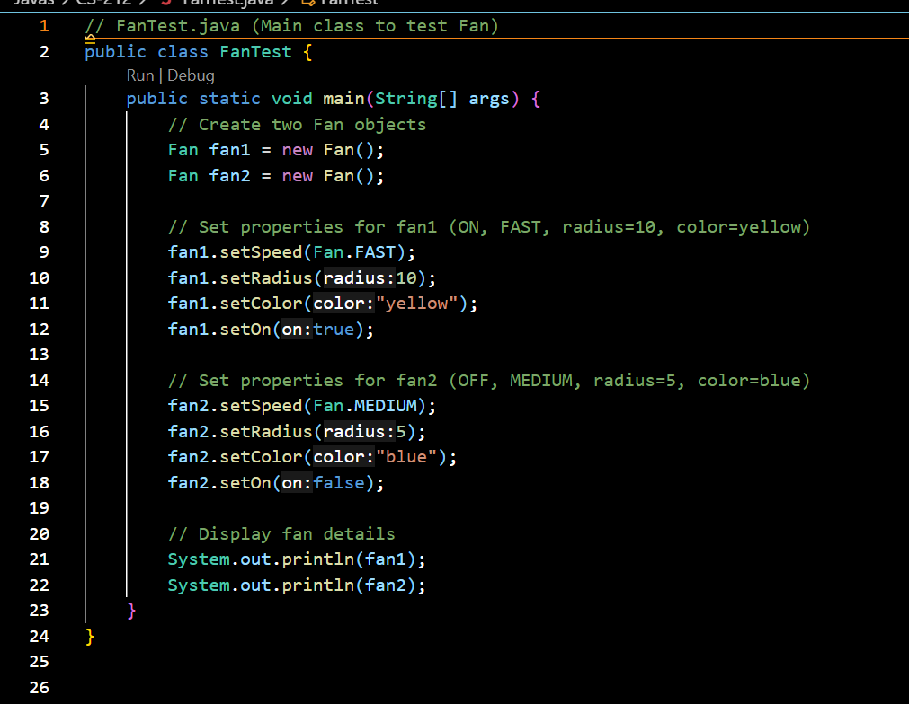

**OUTPUT:**

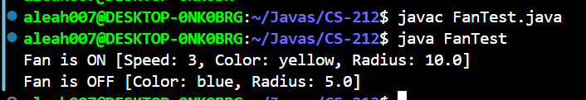

**UML BLUPRINT**

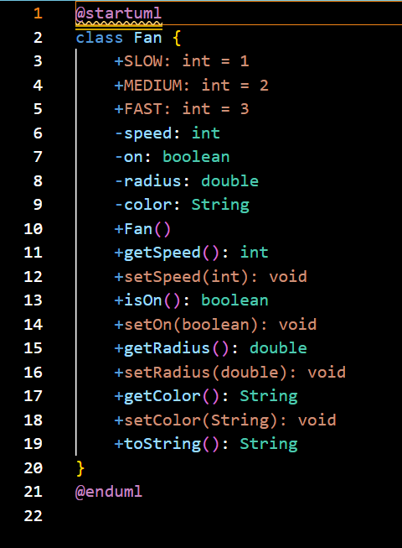

**UML**

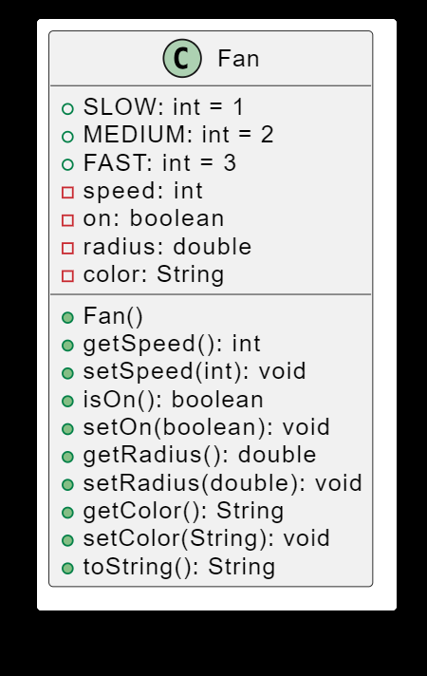

**TASK#06**

**INPUT:**

**QuadraticEquation.java**

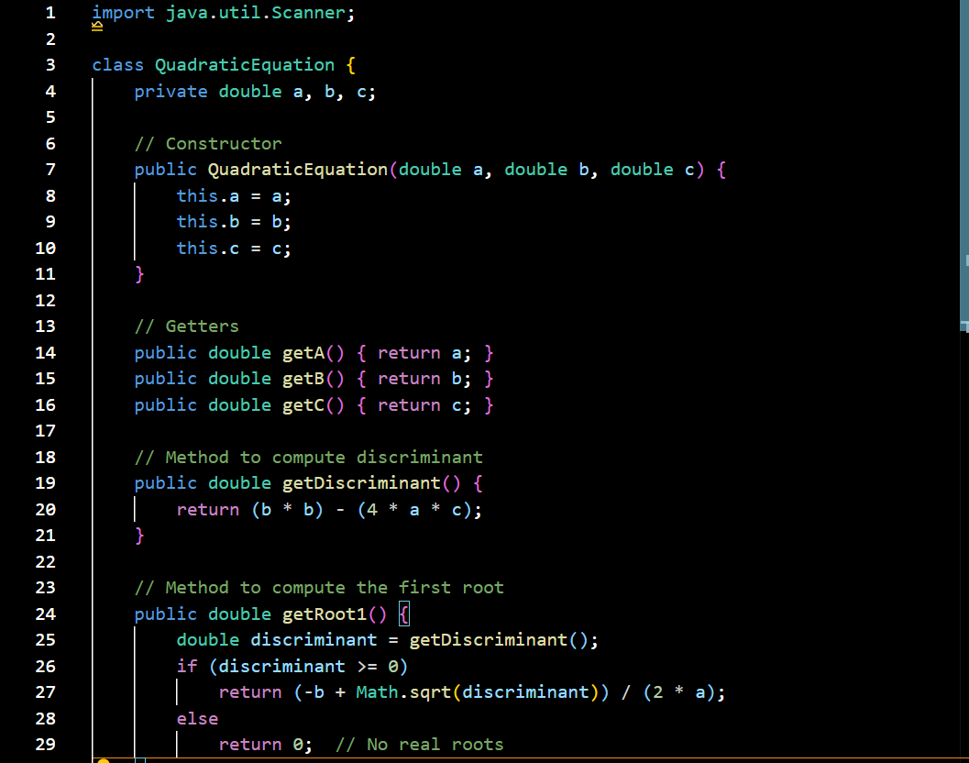

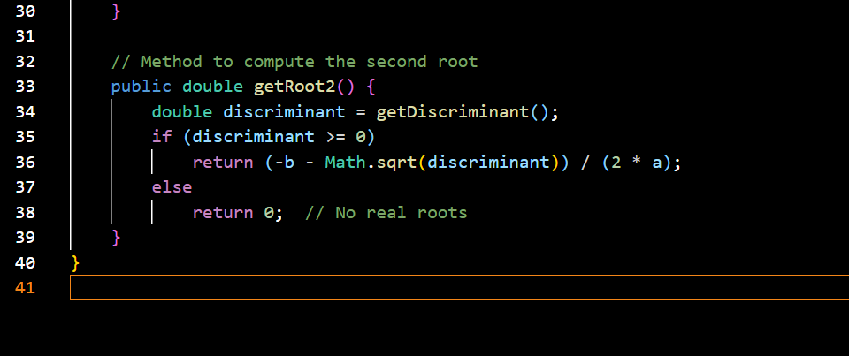

**QuadraticEquationTest.java**

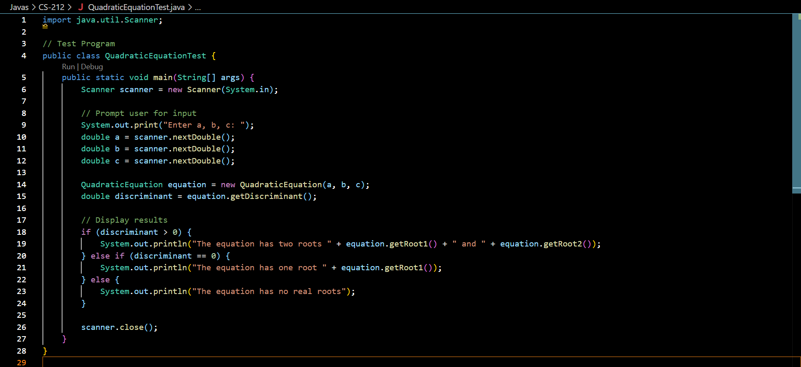

**OUTPUT:**

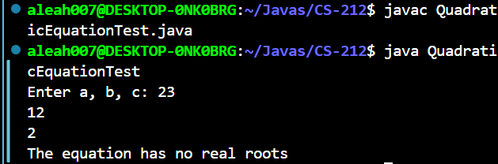

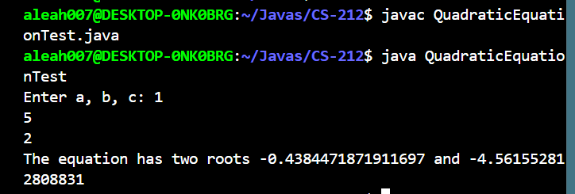

**UML BLUEPRINT:**

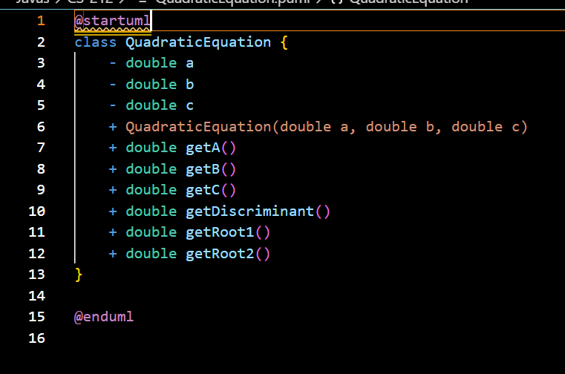

**UML:**

