**Department of Computing**

**School of Electrical Engineering and Computer Science**

**CS 212: Object Oriented Programming**

**Class: BSCS 14-AB**

**Lab 7: Polymorphism**

**Class: BSDS -02A**

**AILYA ZAINAB**

**( 5 2 3 5 0 6 )**

**TASK#01**

**INPUT:**

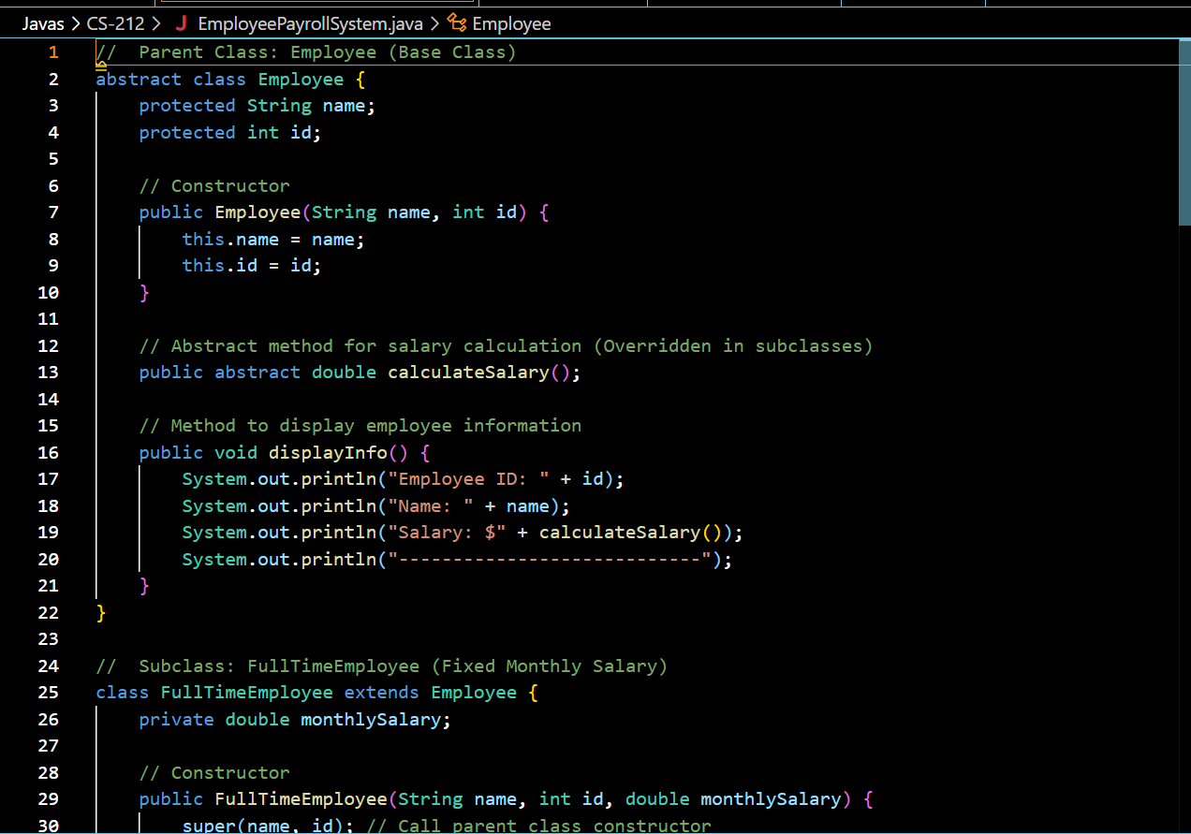

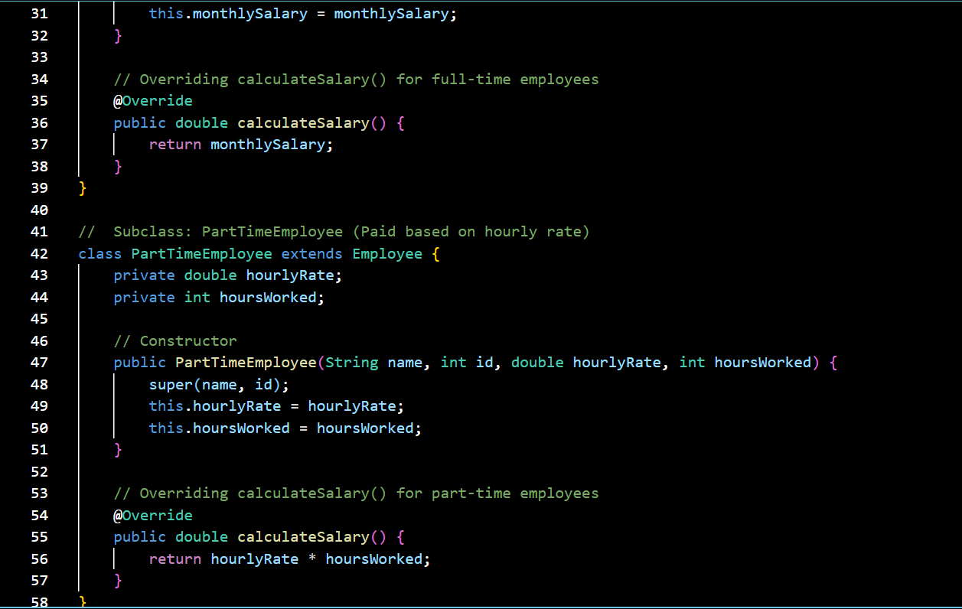

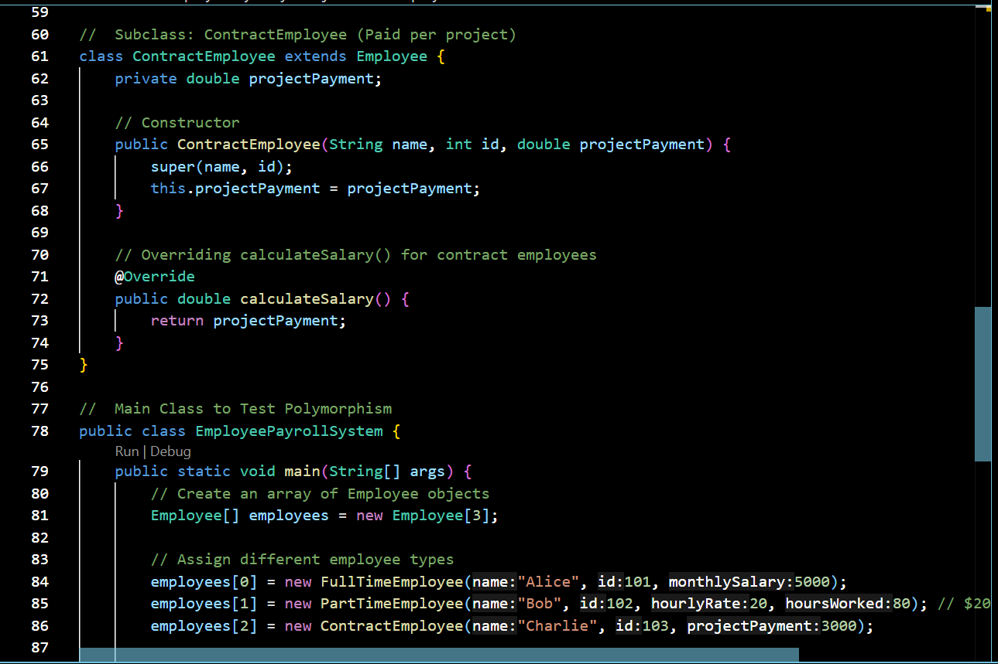

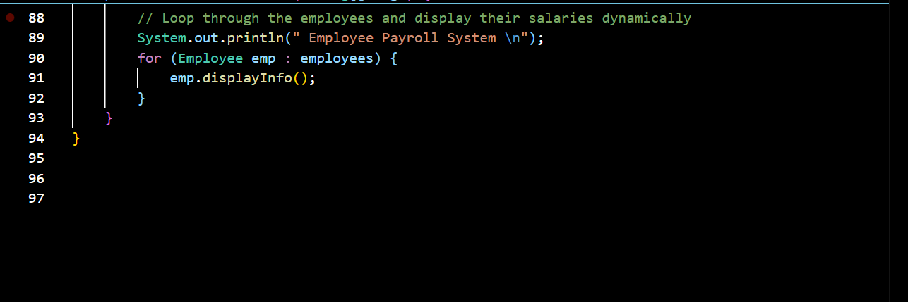

**OUTPUT:**

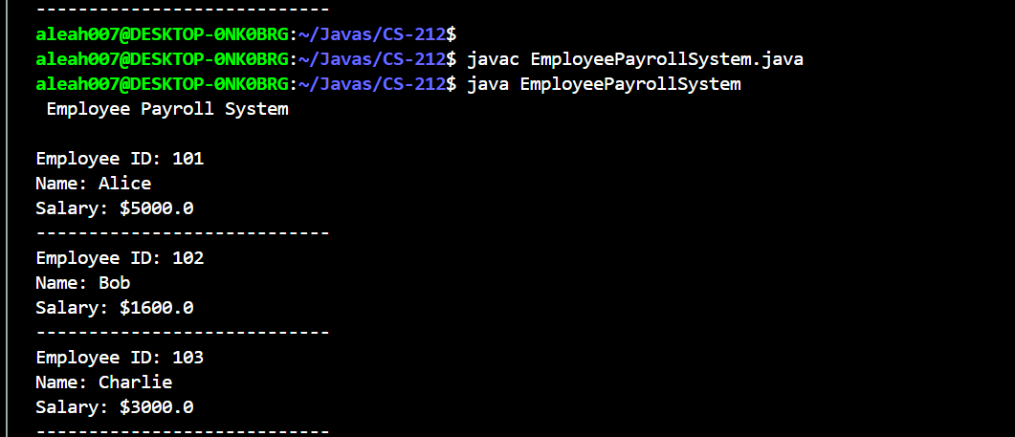

**TASK#02**

**INPUT:**

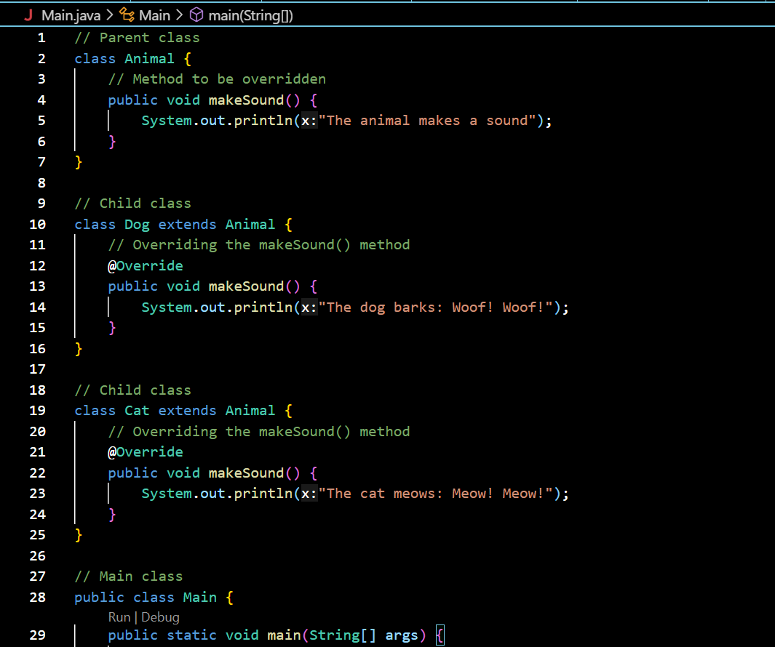

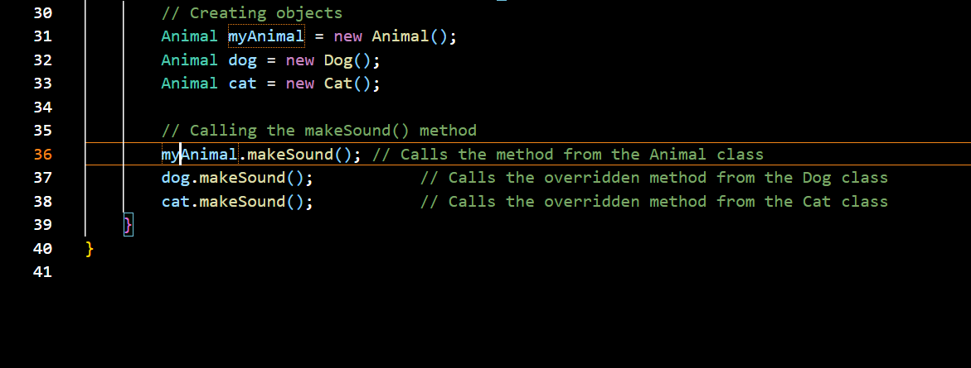

**OUTPUT:**

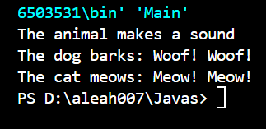

CHILD CLASS METHODS OVERRIDE THE PARENT CLASS METHODS WHEN CALLED IN MAIN

**TASK#03**

**INPUT:**

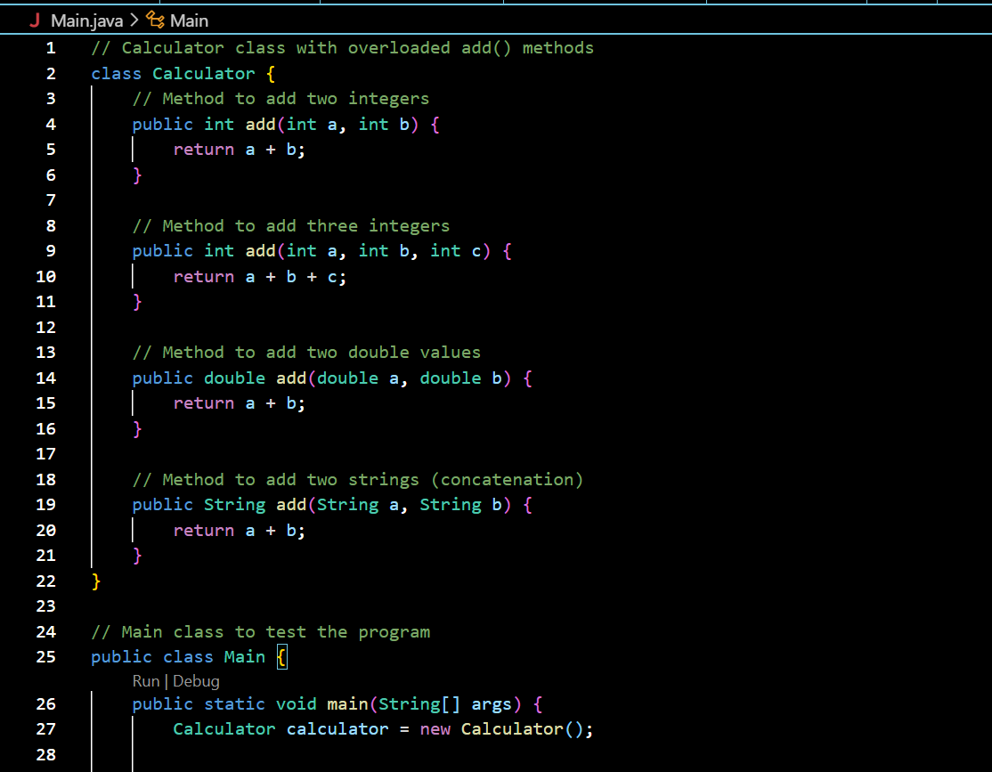

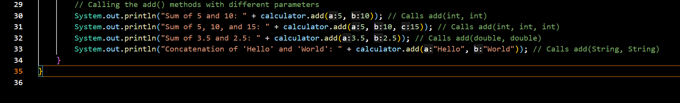

**OUTPUT:**

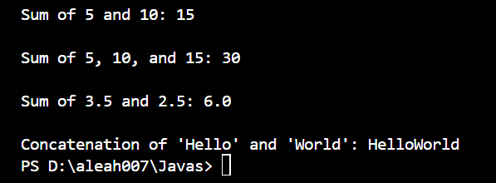

**TASK#04**

**INPUT:**

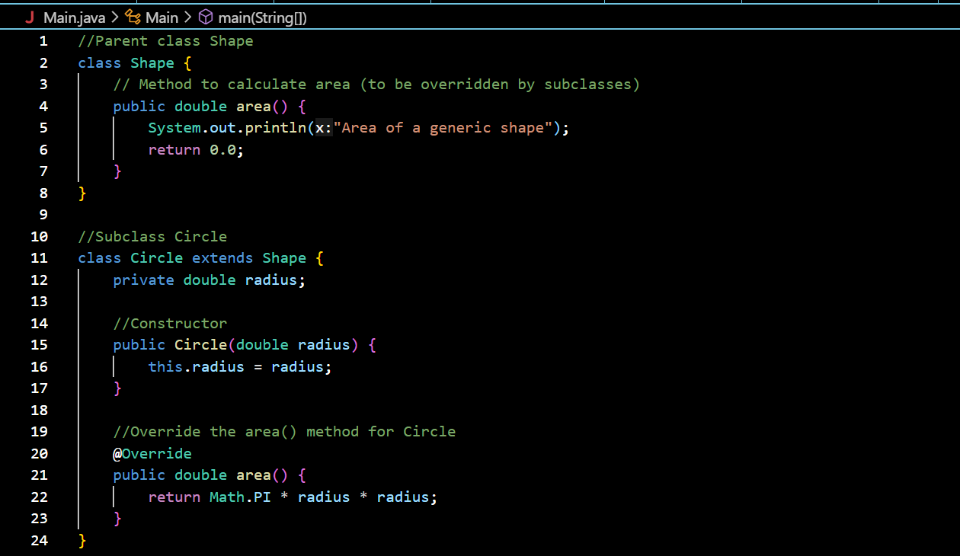

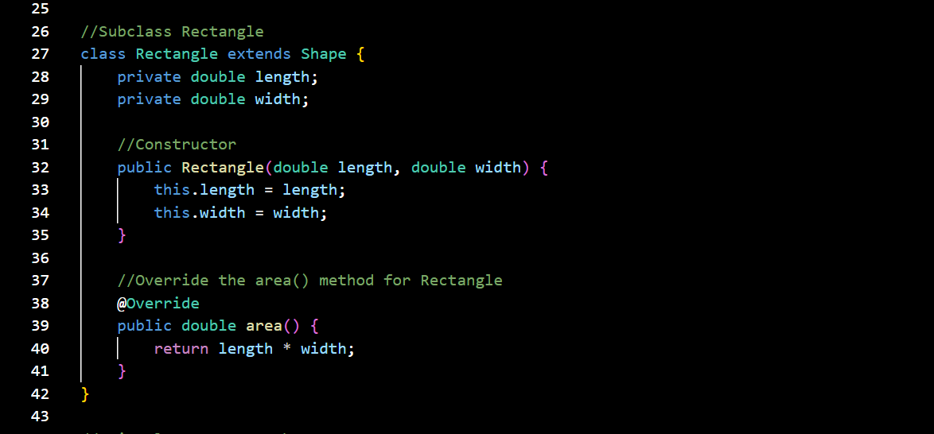

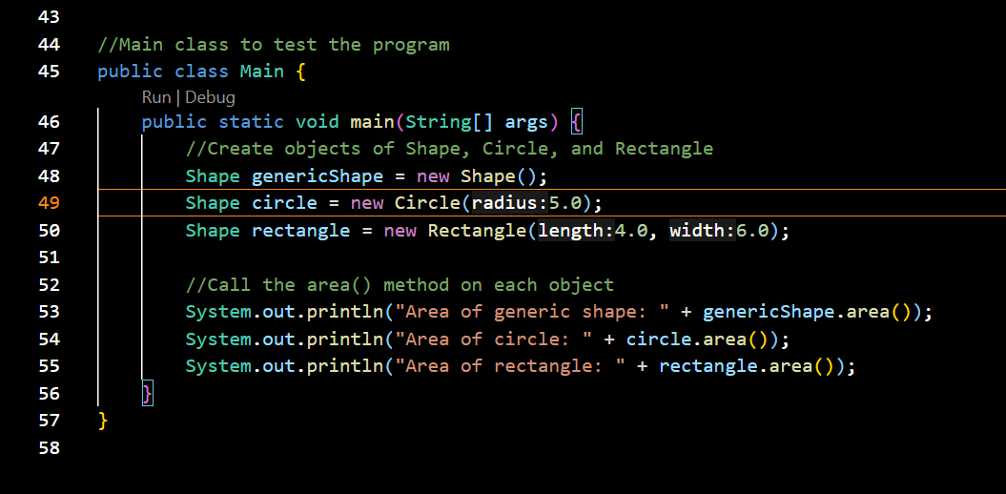

**OUTPUT:**

