### **Lab 10: Interfaces and Abstract Classes in Java**

### **Department of Computing**

### 

### **CS 212: Object Oriented Programming**

### **Lab 08: Function Overriding**

**Instructor: DR. Nazia Pervaiz**

### **Lab Engineer: Ms Bareera Anam**

**Class: BSDS -02A**

**AILYA ZAINAB**

**( 5 2 3 5 0 6 )**

**TASK #01**

**INPUT:**

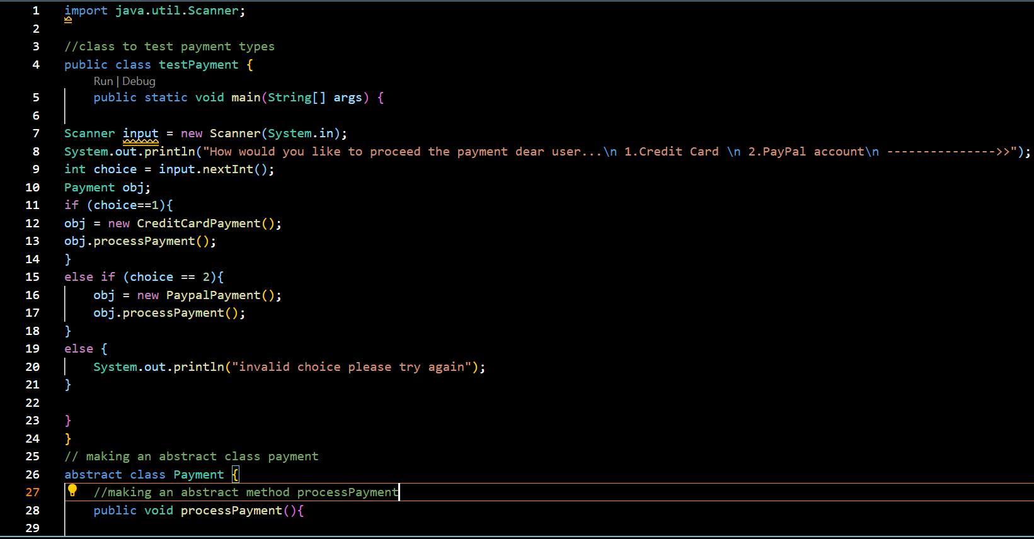

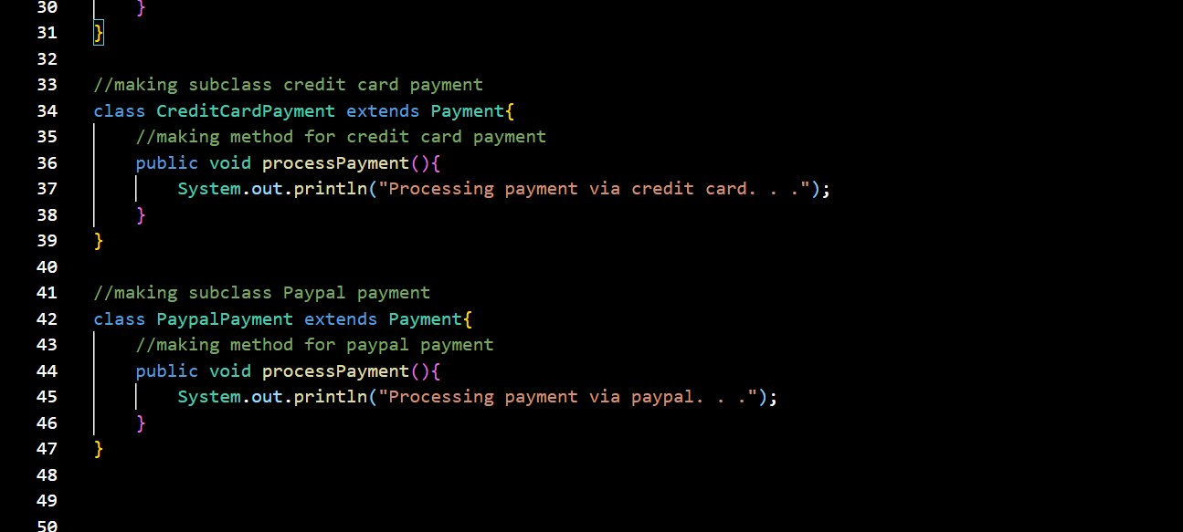

**OUTPUT:**

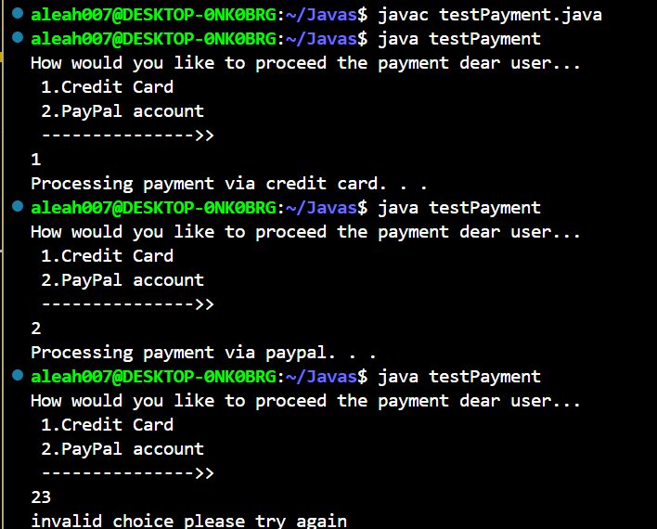

**TASK#02**

**INPUT:**

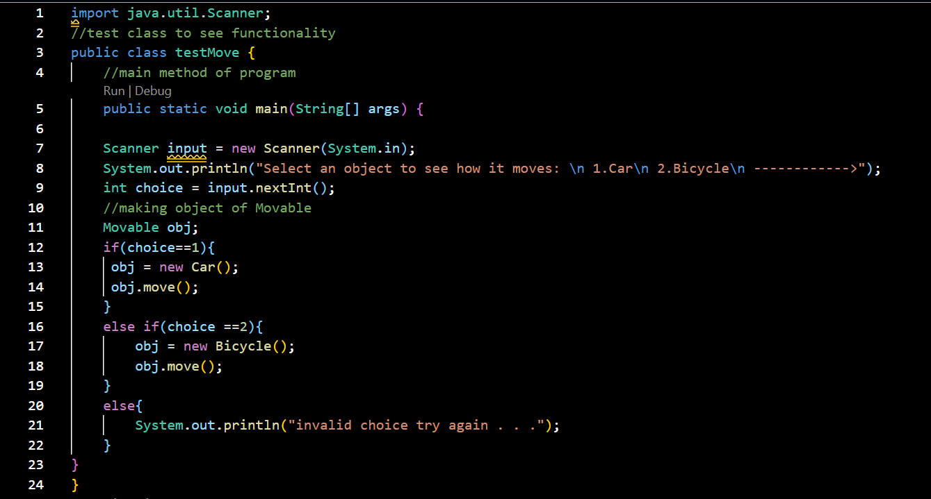

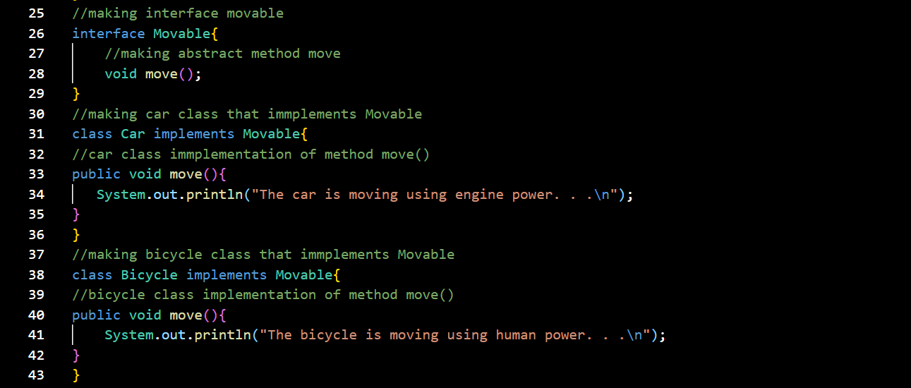  
**OUTPUT:**

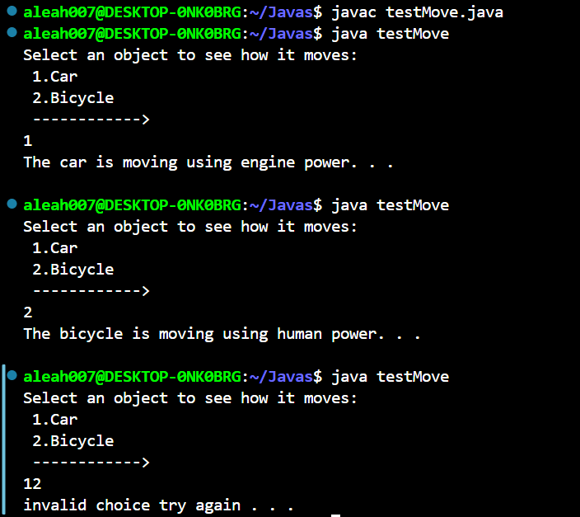

**TASK#03**

**INPUT:**

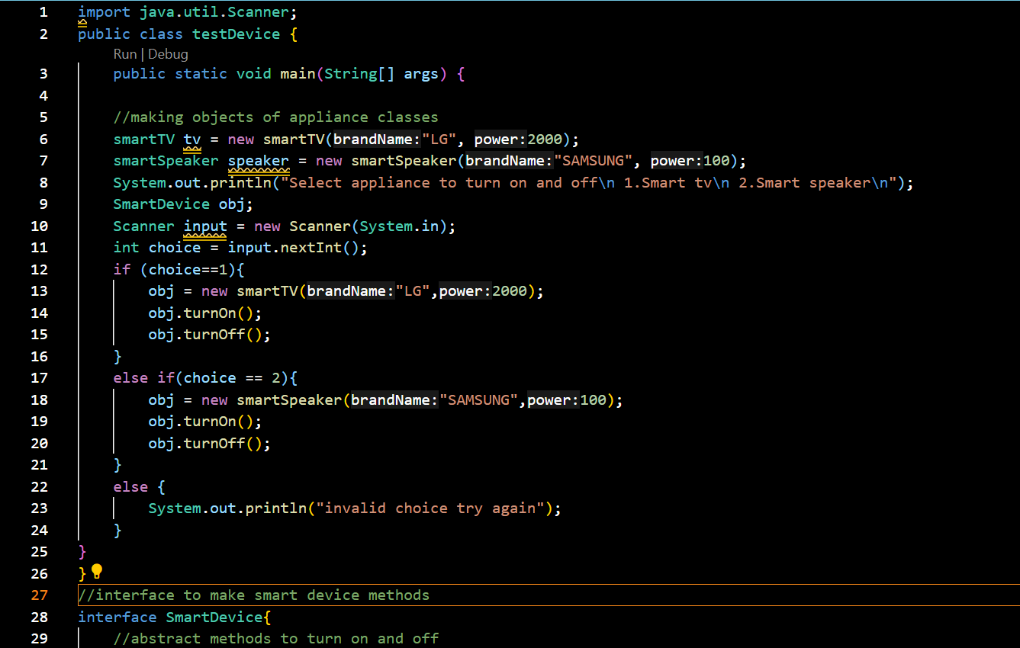

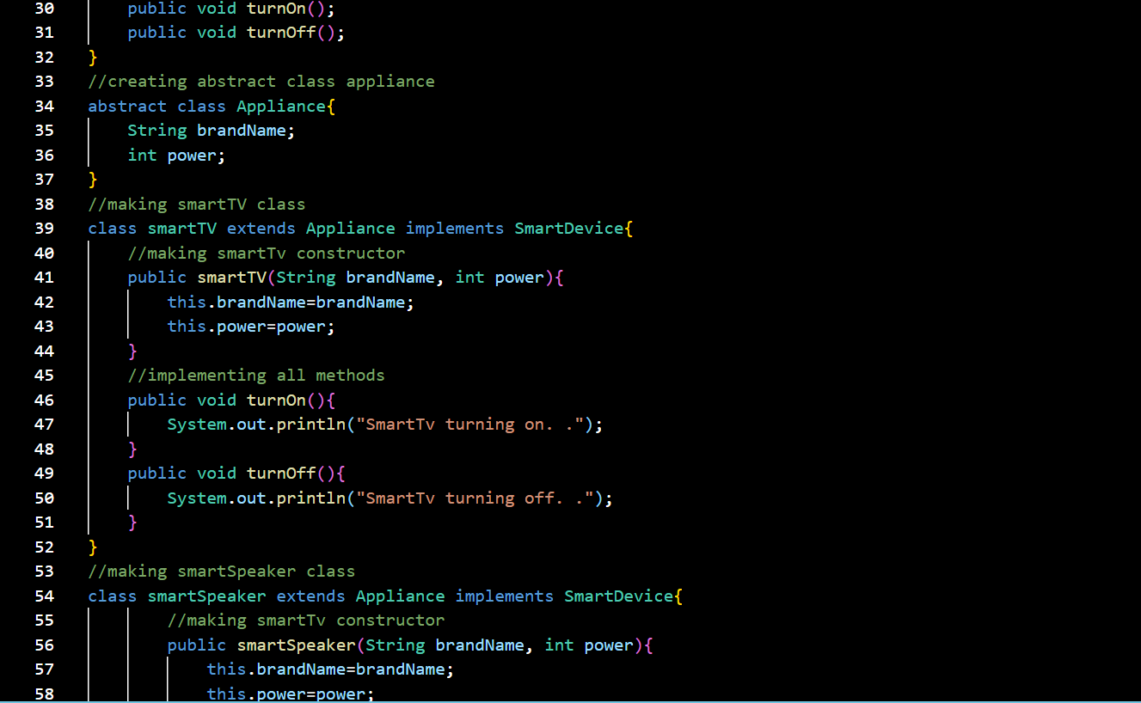

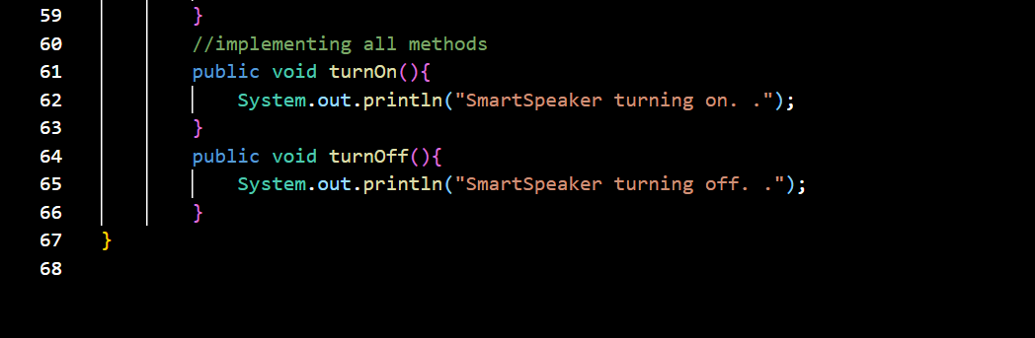

**Output:**

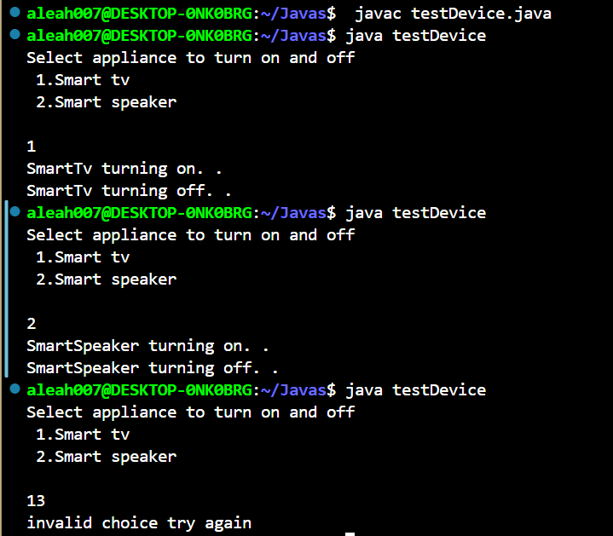

**TASK#04**

**INPUT:**

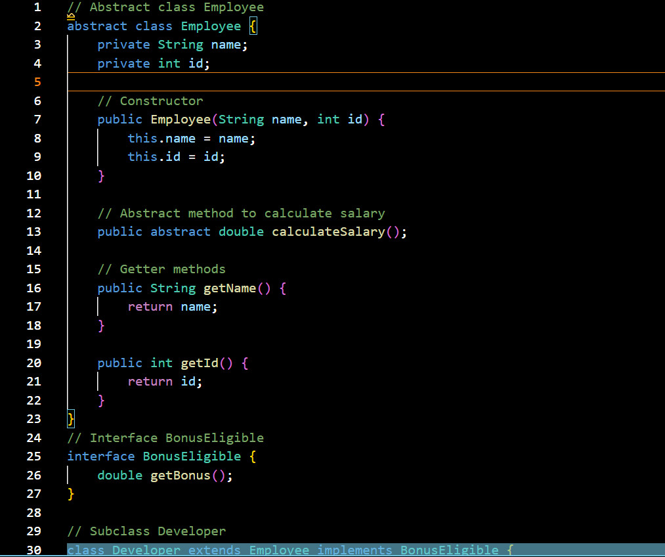

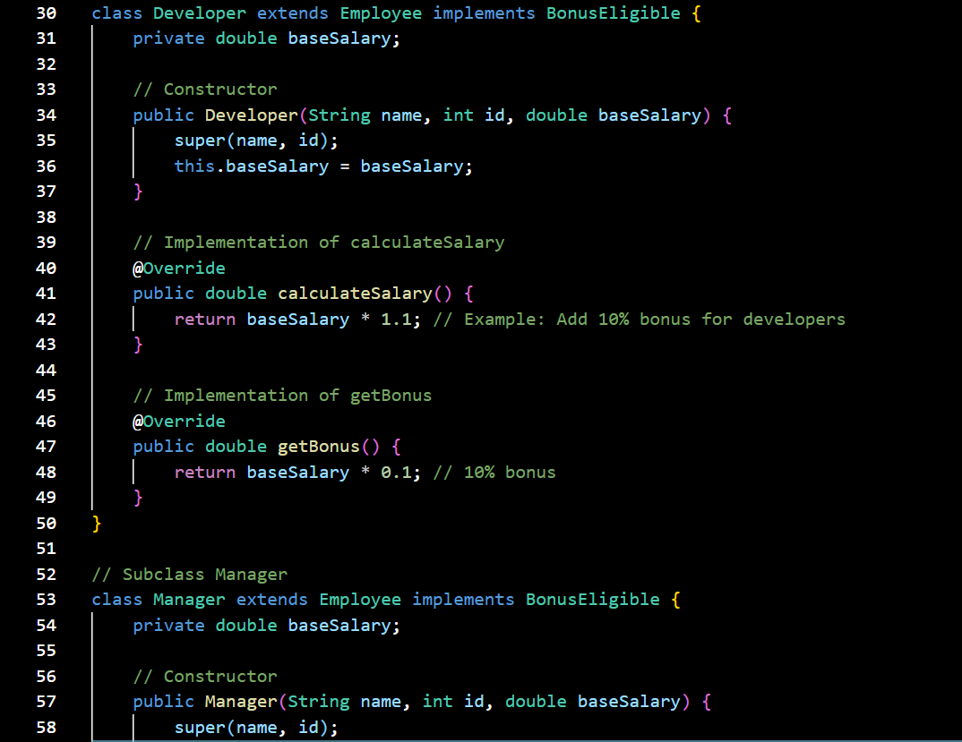

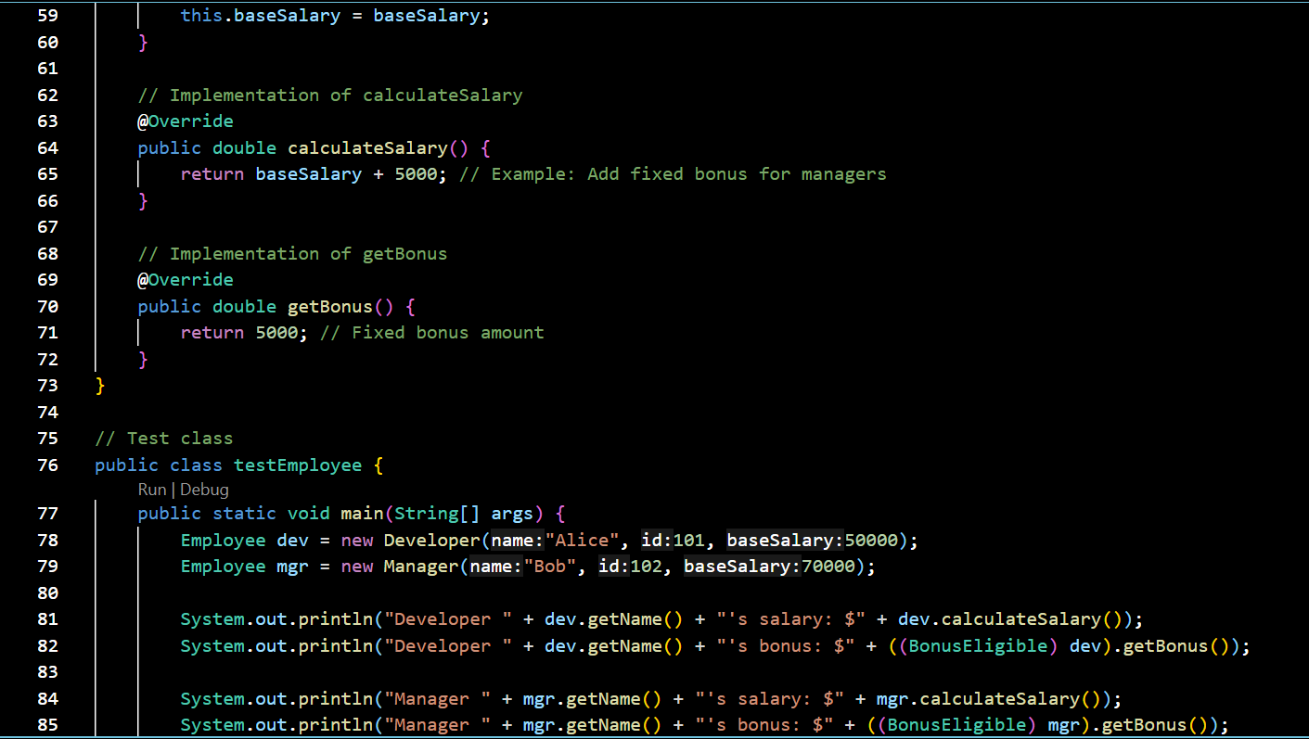



**OUTPUT:**

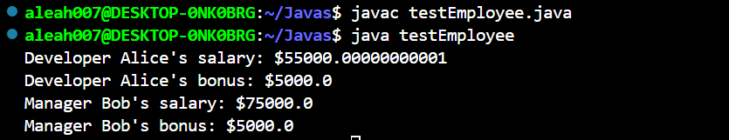

**TASK#05**

**INPUT:**

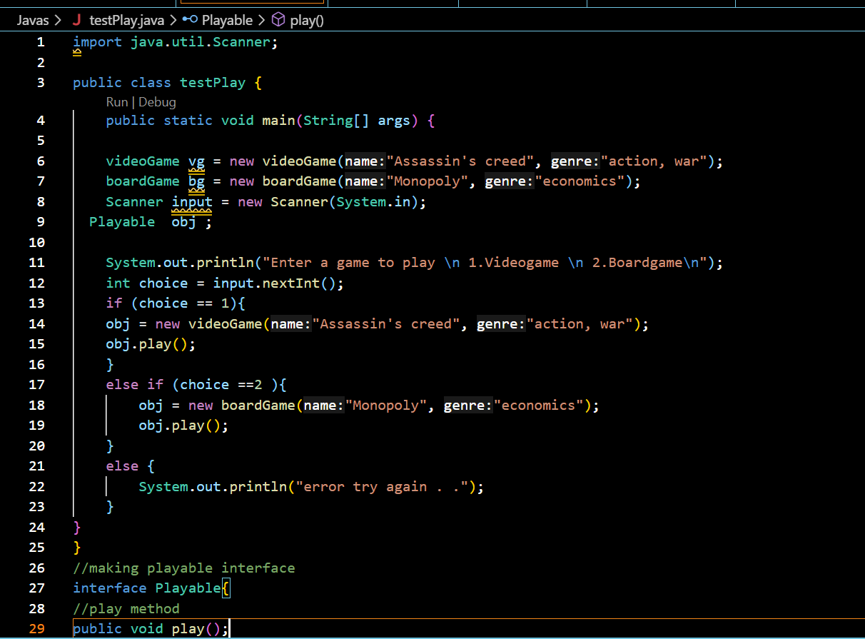

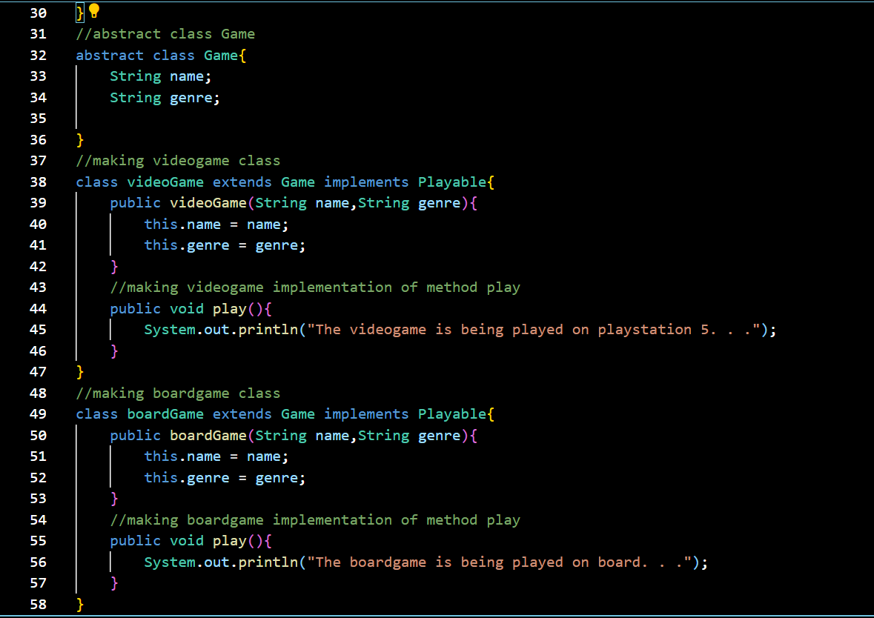

**OUTPUT:**

