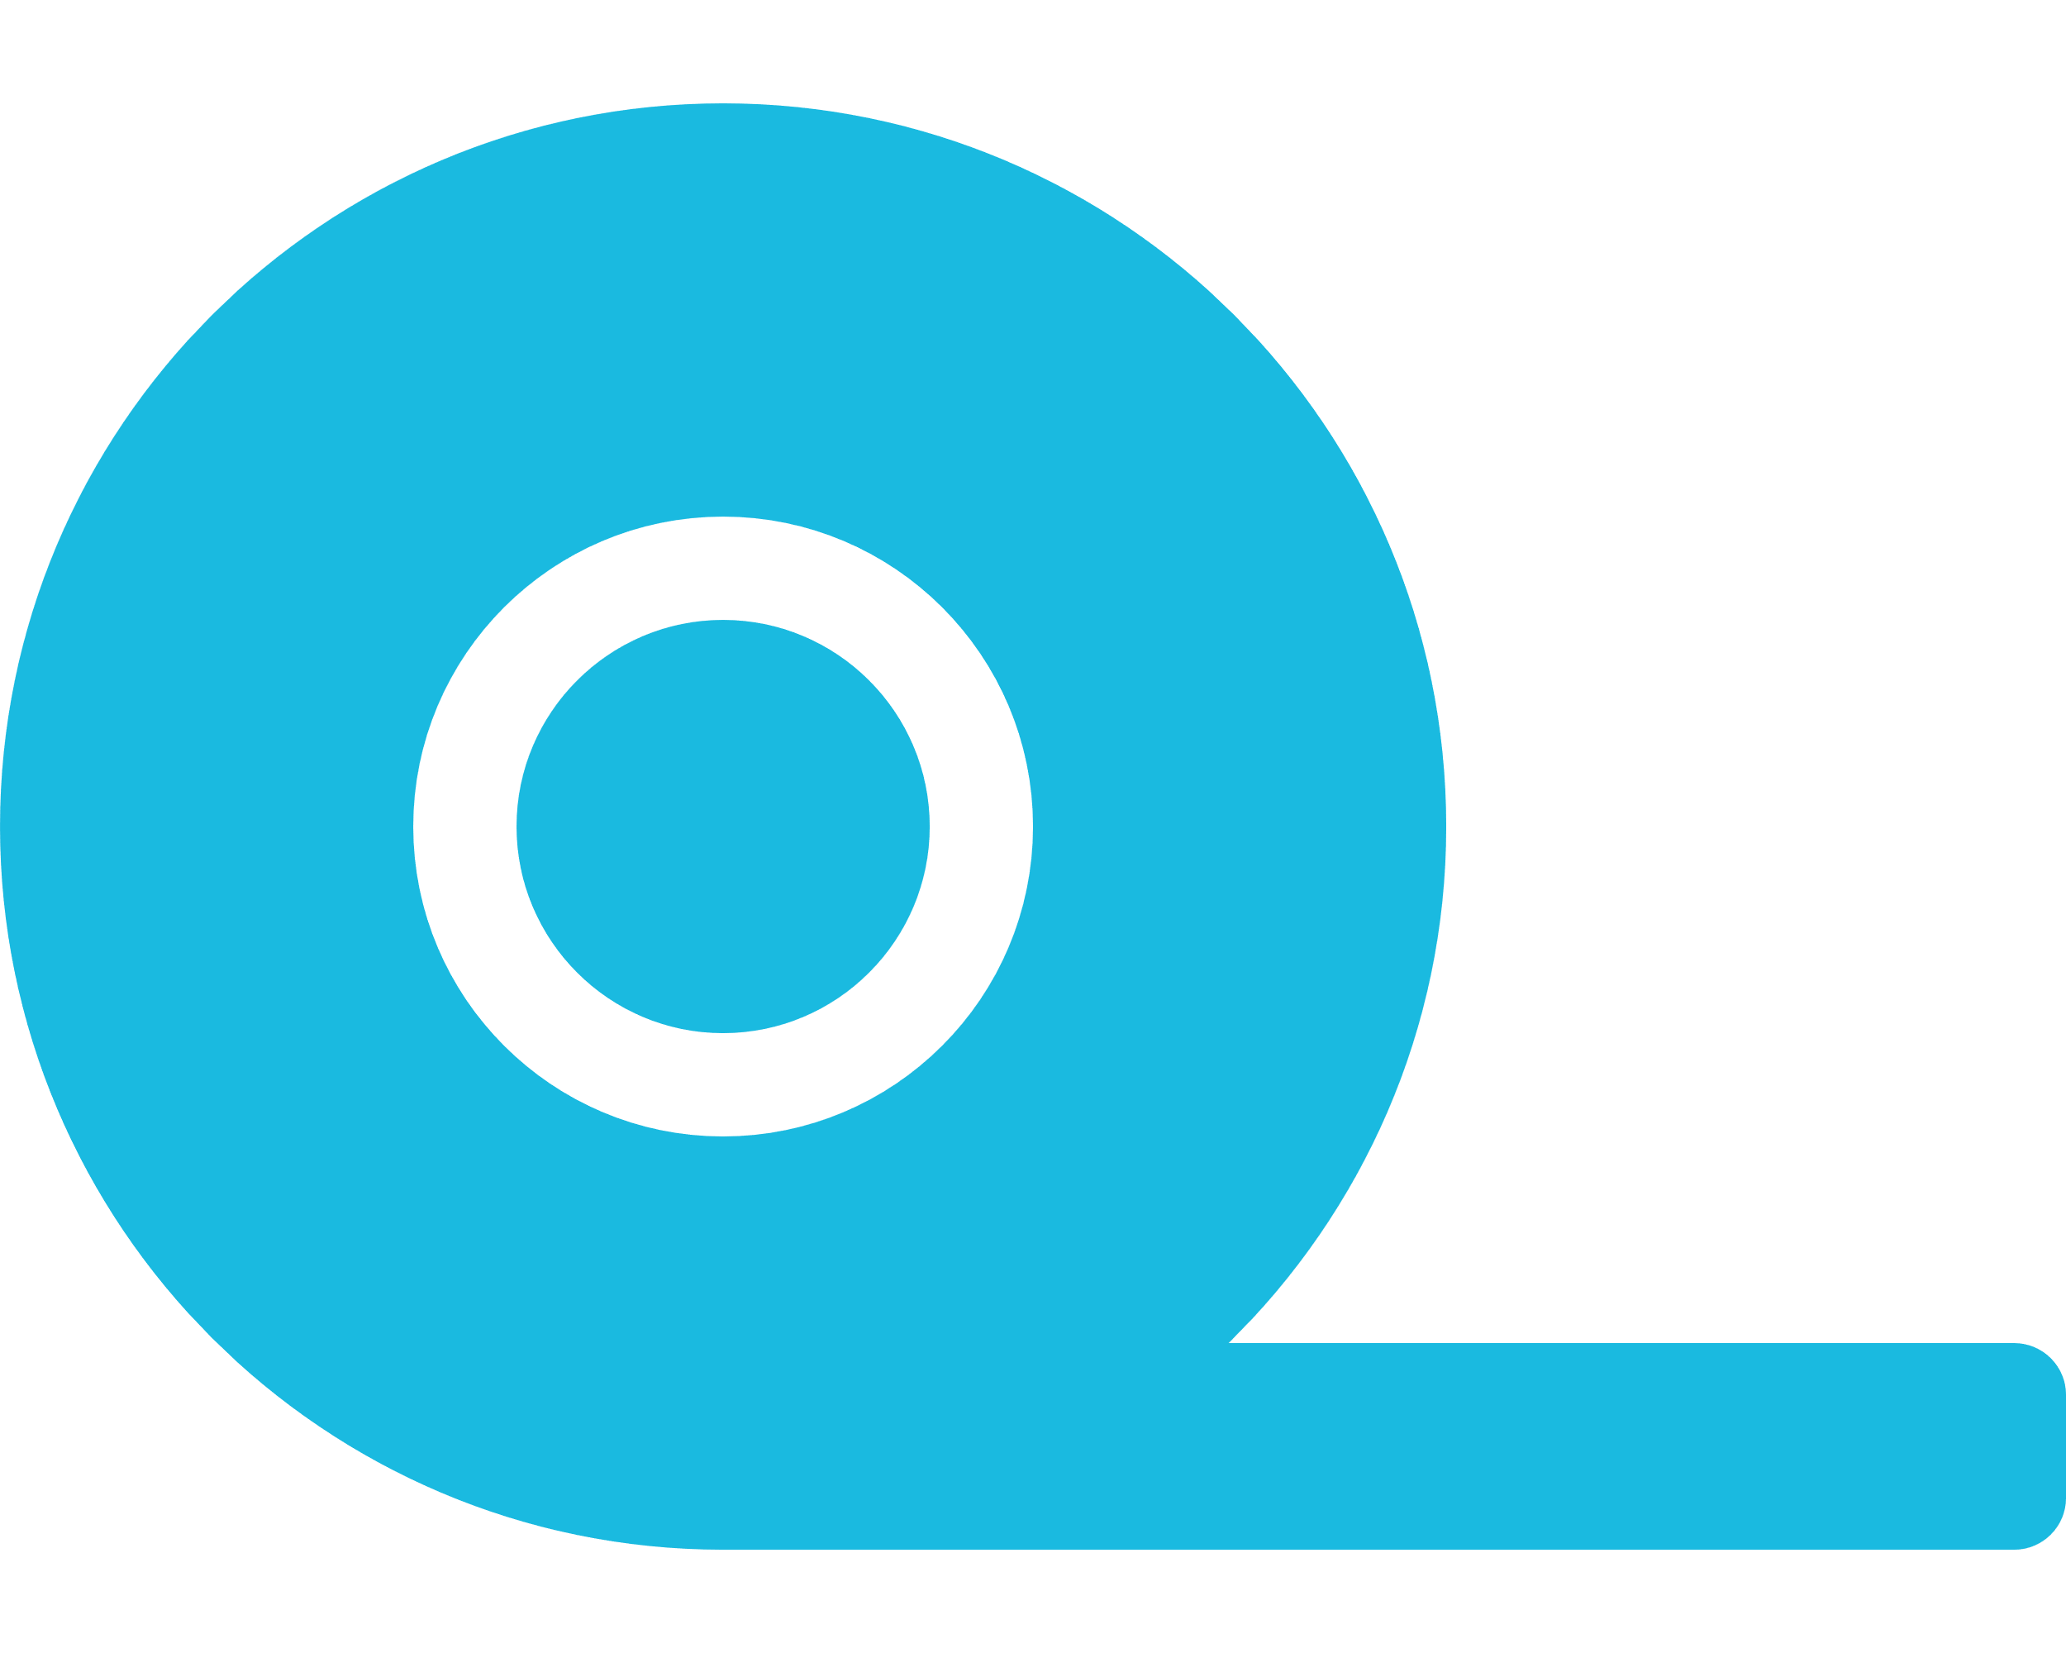20/10/2020

Jan 2020

At the start of a new year I started to tutor many students how to programme and bolster their progress to becoming job ready.

Video Editing

Rest API

Django

JavaScript

HTML & CSS

French

Photoshop

Self-teaching myself helped me learn great design skills for the front-end and the tools to help me make my websites to life using my back-end skills

English

Web Developer

Bilal

Uddin

**MY SKILLS**

**EXPERIENCE**

Bilaluddin474@gmail.com

www.bilaluddin.me

Young and determined to give value for your business or personal website. Years spend coding on personal projects and now ready to work on a real world project.

**ABOUT ME**

**Tools I Use**

**EDUCATION**

SQLite

Modern Design

Back-End Python

Deployment

**Self-taught Web Development**

This is where I learn computer science with cluster of other subjects along with it. I did not learn web development directcly here but I learn’t to make useful projects with python.

**Bingley Grammar School**

Bootstrap

PhotoShop

**LANGUAGES**

+44 7577 738489