**Pokemua**

**Created by**

Chayakorn Kittikoon 6531310321

Pannawich Lohanimit 6532120621

**2110215 Programming Methodology**

**Semester 2 Year 2023**

**Chulalongkorn University**

**Pokemua**

**Introduction**

Pokemua is inspired by famous video games, Pokemon Red, and Pokemon Blue. However, this game is battle royale, so player need to survive in this game.

**Rules**

When player start this game for the first time, player will need to choose their first Pokemua**.** In each game, player can choose up to 3 Pokemua to play in the game. Player needs to survive from another player(bot) and from wild Pokemua. Player will win when they can be the last player in the game and the Exp and their Pokemua will be level up too. When Pokemua have reached required level they can get new skill and new stat. For each Pokemua, they can have maximum skill at 4 skills so when they get new skill, they need to remove the old one.

**First Pokemua scene**

**Home scene**

**Select Pokemua scene**

**Fight scene**

**Fight lose scene**

**Fight win scene**

**Class diagram**

1. **Package action**
   1. Class Action
      1. Method



1.2 Class ChangePokemuaAction

1.2.1 Constructor

1.2.2 Field



1.2.3 Method

1.3 Class UseSkillAction

1.3.1 Constructor



1.3.2 Field

1.3.3 Method

**2. Package application**

2.1 Class Main

2.1.1 Field



2.1.2 Method

**3. Package controllers**

3.1 Class Controller

3.1.1 Constructor



3.1.2 Field

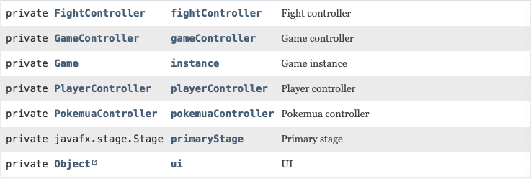

3.1.3 Method

3.2 Class EventController<T extends Event>

3.2.1 Constructor



3.2.2 Method



3.3 Class FightController

3.3.1 Constructor



3.3.2 Field

3.3.3 Method

3.4 Class GameController

3.4.1 Constructor



3.4.2 Field



3.4.3 Method

3.5 Class PlayerController

3.5.1 Constructor



3.5.2 Method

3.6 Class PokemuaController

3.6.1 Constructor



3.6.2 Method



3.7 Class SubController

3.7.1 Constructor



3.7.2 Field



3.7.3 Method

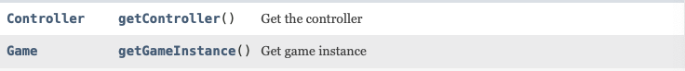

3.8 Class UIEventEmitter<T extends Event>

3.8.1 Method



**4. Package event**

4.1 Package event.fight

4.1.1 Class ActionEndEvent

4.1.1.1 Constructor



4.1.1.2 Field

4.1.1.3 Method

4.1.2 Class ActionStartEvent

4.1.2.1 Constructor



4.1.2.2 Field

4.1.2.3 Method

4.1.3 Class ChangePokemuaEvent

4.1.3.1 Constructor



4.1.3.2 Field



4.1.3.3 Method

4.1.4 Class FightEndEvent

4.1.4.1 Nested Class



4.1.4.2 Constructor



4.1.4.3 Method

4.1.5 Class FightDeadEvent

4.1.5.1 Constructor



4.1.5.2 Field



4.1.5.3 Method

4.1.6 Class FightEvent

4.1.6.1 Constructor



4.1.6.2 Nested Class



4.1.6.3 Method



4.1.7 Class TickEvent

4.1.7.1 Constructor



4.1.7.2 Field



4.1.7.3 Method

4.2 Package event.player

4.2.1 Class LevelUpEvent

4.2.1.1 Constructor



4.2.1.2 Field



4.2.1.3 Method



4.2.2 Class PlayerEvent

4.3 Package event.pokemua

4.3.1 Class Pokemua Event

4.3.1.1 Nested Class



4.3.1.2 Constructor



4.3.1.3 Method



4.3.2 Class PokemuaSkillChangeEvent

4.3.2.1 Constructor



4.2.2.3 Field



4.2.2.3 Method

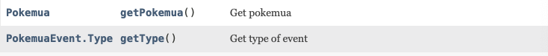

**5. Package logic**

5.1 Package logic.fighter

5.1.1 Class EngagedBot

5.1.1.1 Constructor



5.1.1.2 Field

5.1.1.3 Method

5.1.2 Class EngagedBotRandomizer

5.1.2.1 Method



5.1.3 Class Engaged Player

5.1.3.1 Constructor



5.1.3.2 Field

5.1.3.3 Method

5.1.4 Interface Fighter

5.1.4.1 Method

5.1.5 Class WildPokemua

5.1.5.1 Constructor



5.1.5.2 Field



5.1.5.3 Method

5.2 Package logic.pokemua

5.2.1 Class Pokemua

5.2.1.1 Field

5.2.1.2 Constructor



5.2.1.3 Method

5.2.2 Class PokemuaLoader

5.2.2.1 Field

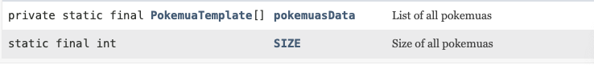

5.2.2.2 Method

5.2.3 Class PokemuaRandomizer

5.2.3.1 Method

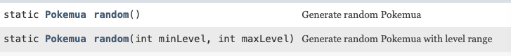

5.2.4 Class PokemuaTemplate

5.2.4.1 Nested Class



5.2.4.2 Field

5.2.4.3 Constructor

5.2.4.4 Method

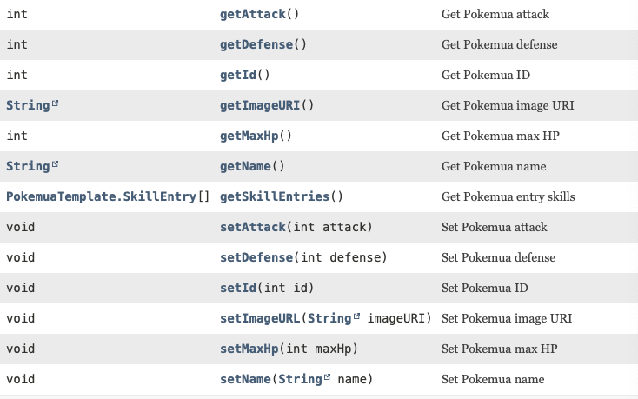

5.3 Package logic.skill

5.3.1 Class AttackSkill

5.3.1.1 Constructor



5.3.1.2 Field



5.3.1.3 Method

5.3.2 Class AttackSkillTemplate

5.3.2.1 Field



5.3.2.1 Constructor



5.3.2.1 Method

5.3.3 Class Skill

5.3.3.1 Nested Class



5.3.3.2 Constructor

5.3.3.3 Field

5.3.3.4 Method

5.3.4 Class SkillLoader

5.3.4.1 Field



5.3.4.2 Method



5.3.5 Class SkillTemplate

5.3.5.1 Constructor



5.3.5.2 Field

5.3.5.3 Method

5.4 Class Fight

5.4.1 Nested Class



5.4.2 Field

5.4.3 Constructor



5.4.4 Method

5.5 Class FightReward

5.5.1 Constructor



5.5.2 Field

5.5.3 Method

5.6 Class Game

5.6.1 Constructor



5.6.2 Field

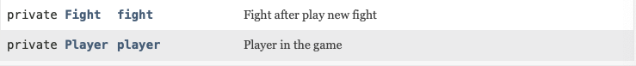

5.6.3 Method

5.7 Class Player

5.7.1 Constructor



5.7.2 Field

5.7.3 Method

**6. Package serial**

6.1 Class Deserializer

6.1.1 Constructor



6.1.2 Field

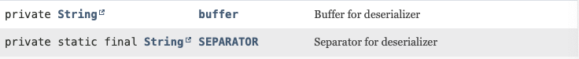

6.1.3 Method

6.2 Class Serialize

6.2.1 Method



6.3 Class Serializer

6.3.1 Constructor



6.3.2 Field

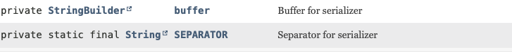

6.3.3 Method

