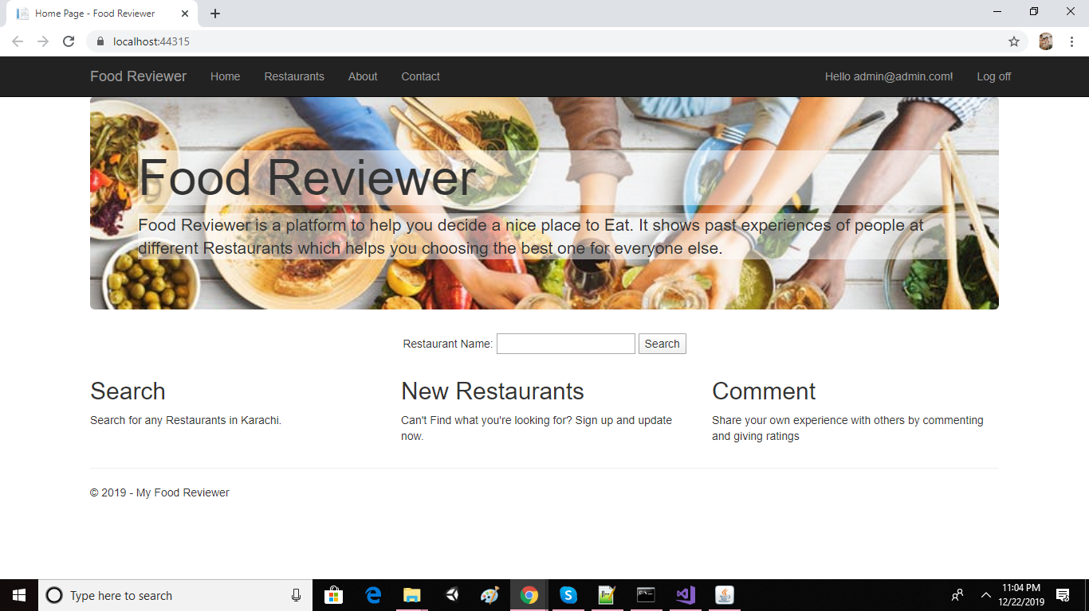

This is the landing page of the website.

On top left it has Home, Restaurants, about and Contact, The restaurant button takes the user to a new page which lists all the restaurants.

On top right it has login and register button from where user can login from and while the new users can register for an account.

In the middle of the page, there is a search bar where a user can search for a specific restaurant using the name or the type of cuisine.

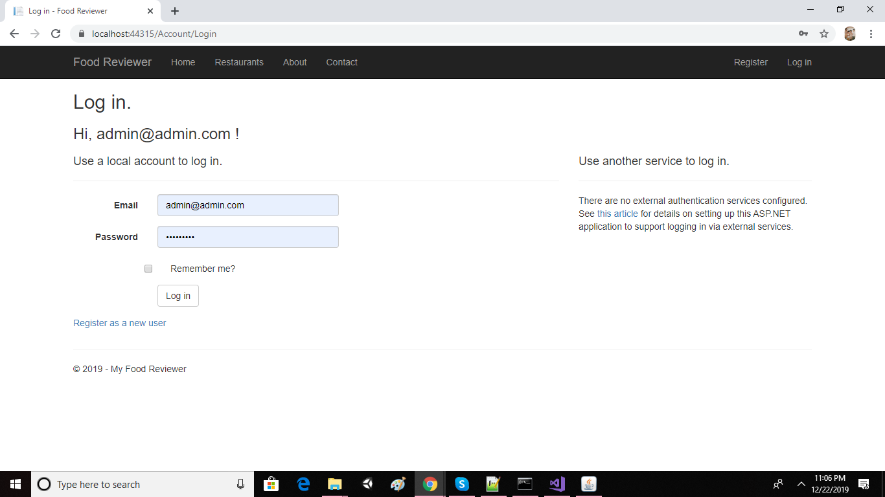

Here on the login portal the user can login using the email and password and can also register as a new user.

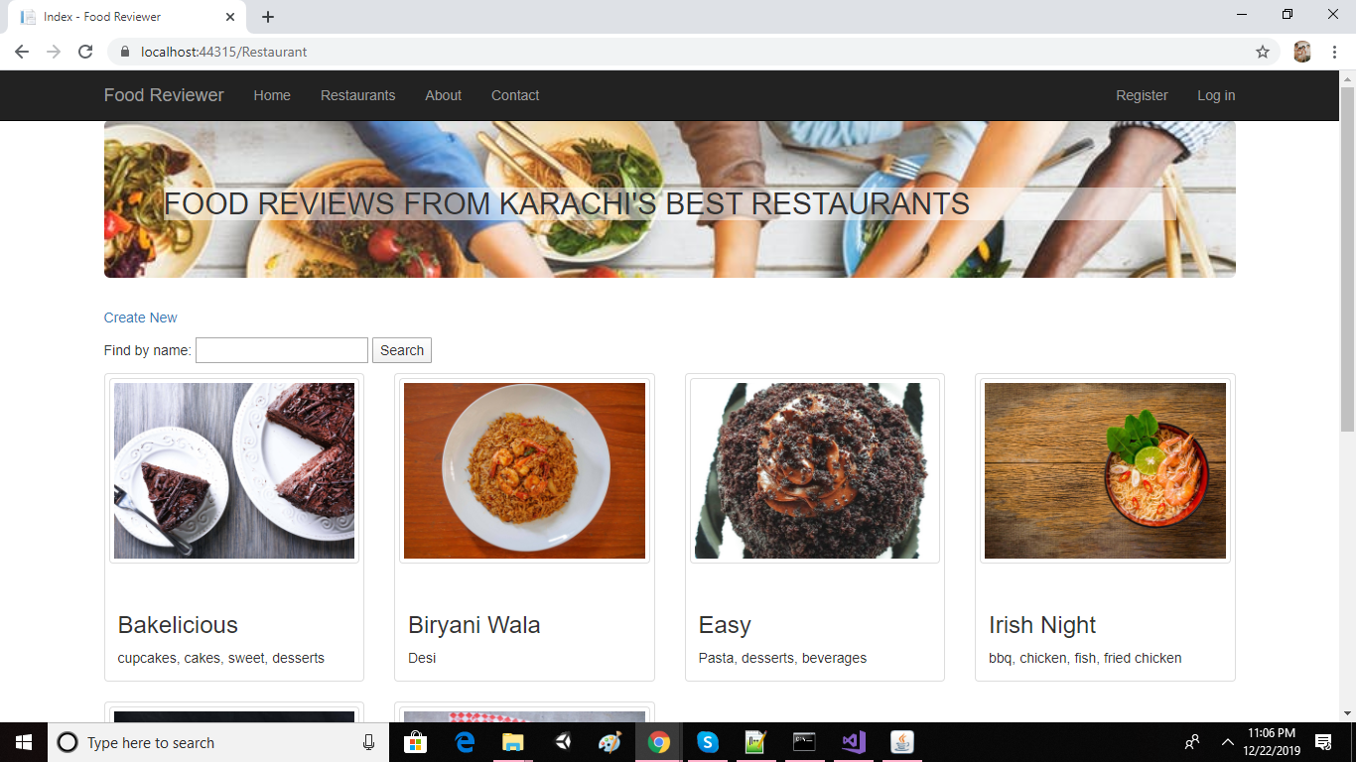

This is the restaurant page where all the restaurants are listen along with their picture, name and type of the restaurant.

The user can also search here for a specific restaurant

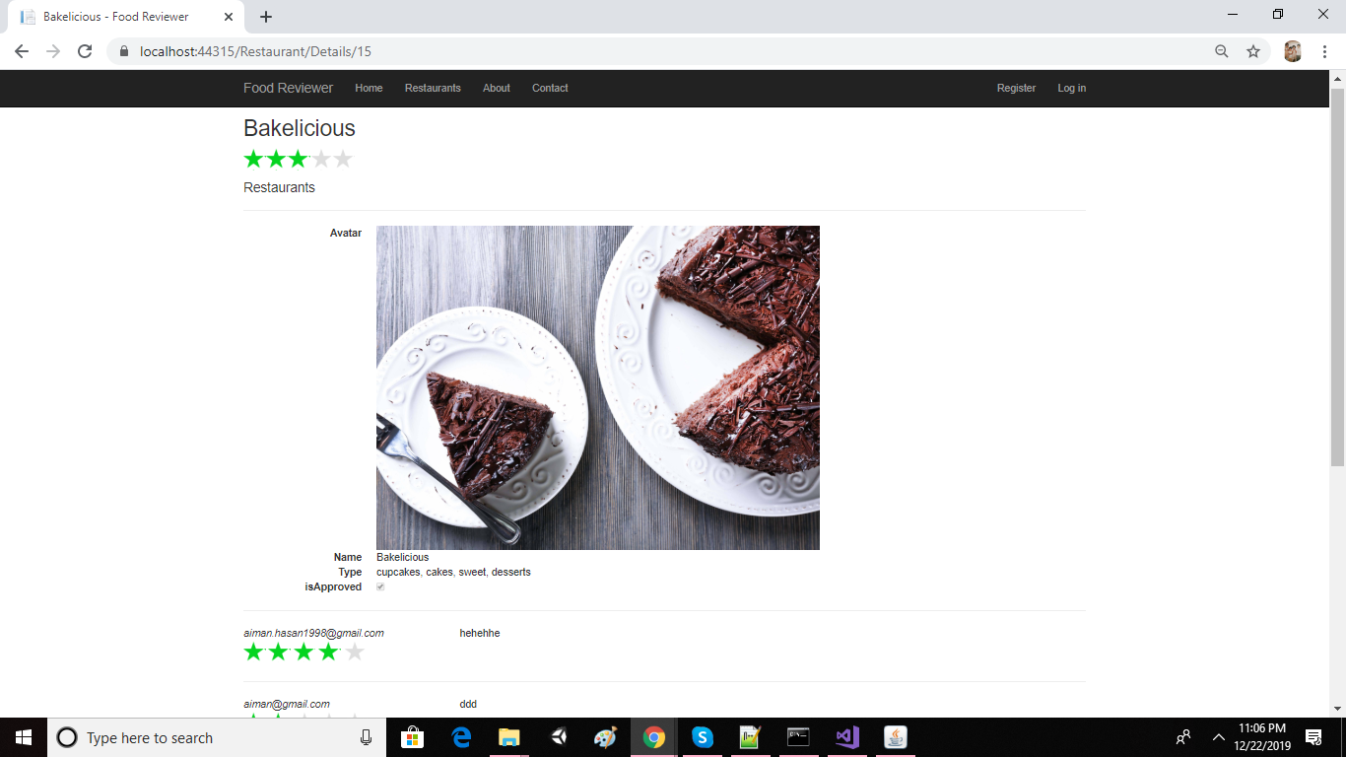

The user can click on any restaurant image to see the details of that restaurant. The details includes ratings by other users and comments made by other users as well.

While in order to comment and rate a restaurant the user should be logged in. 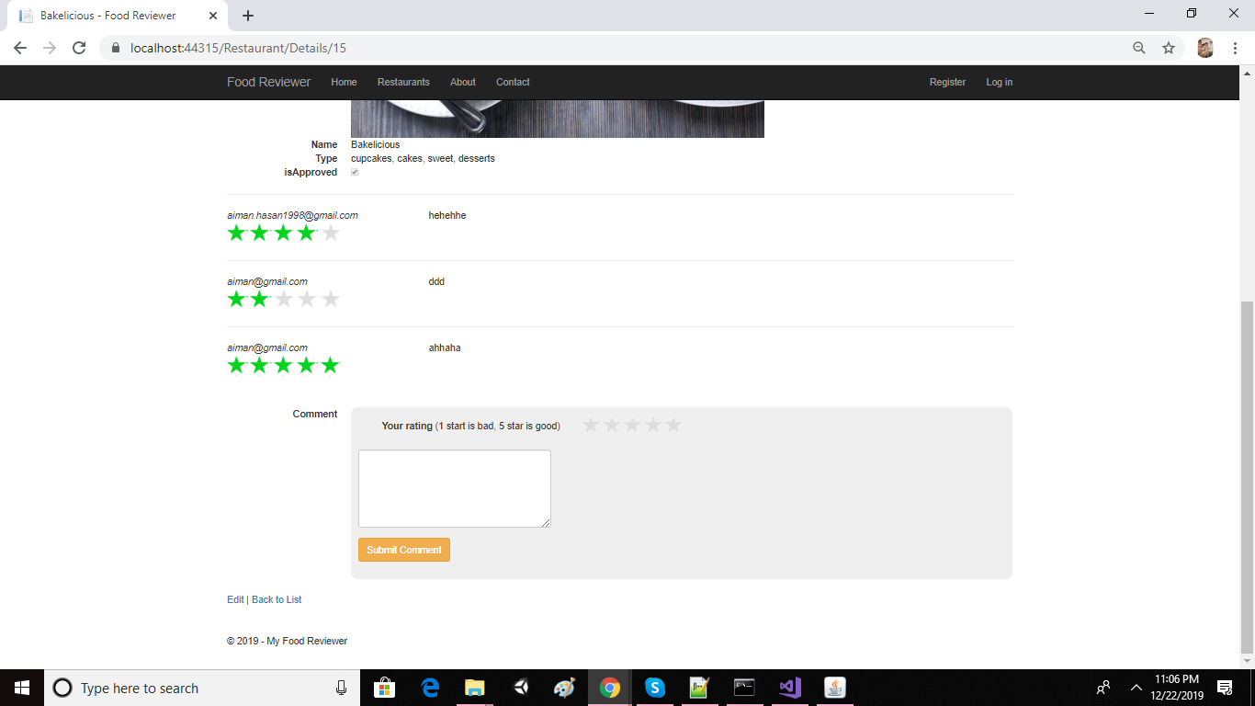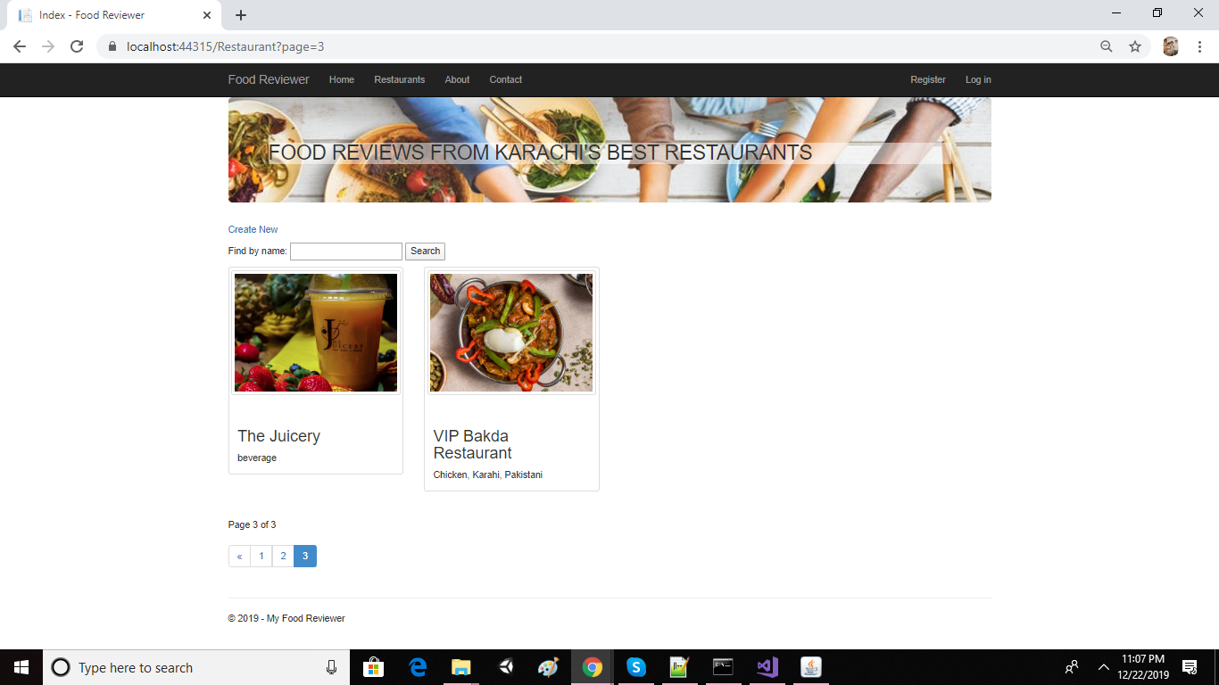

If a user wishes to browse through different restaurants, a paging system is included which means that a maximum of seven restaurants on each page.

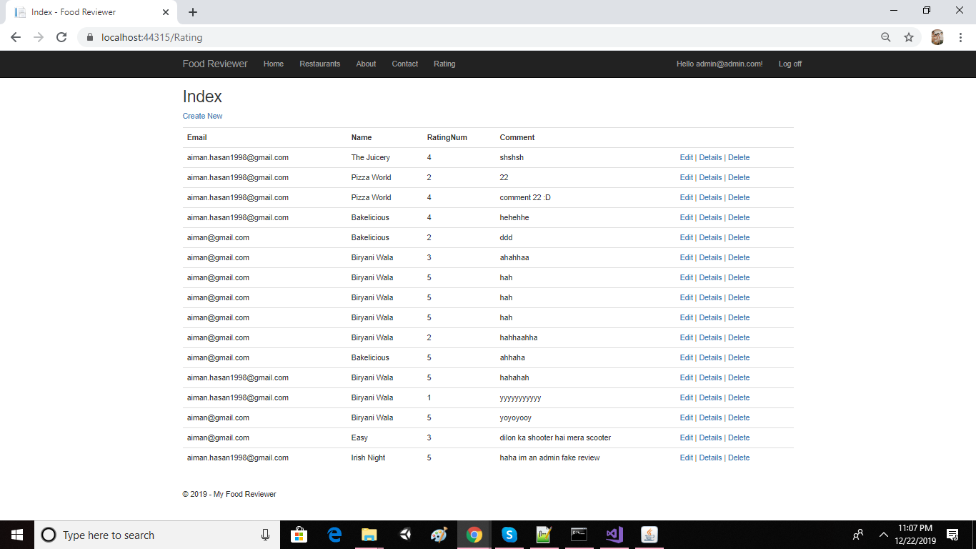

This is rating page where all the ratings made by users are shown to the admin. An admin can Edit, delete any ratings made by user

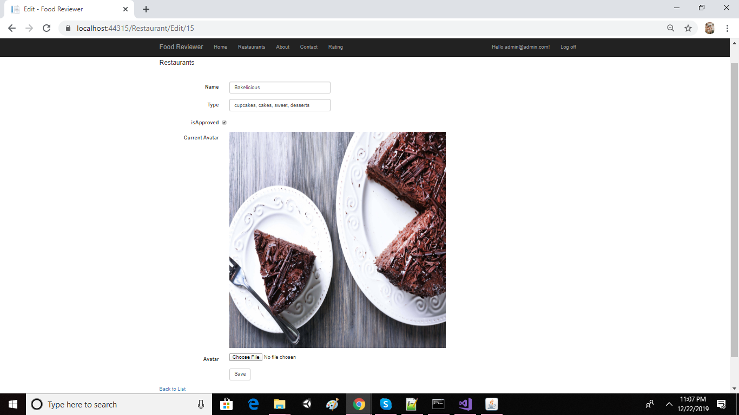

If a user wishes to make a new restaurant entry, they can do it by filling the form which will then be gone to the admin for approval. After an admin has approved the restaurant entry, it will be shown to the rest of the users as well

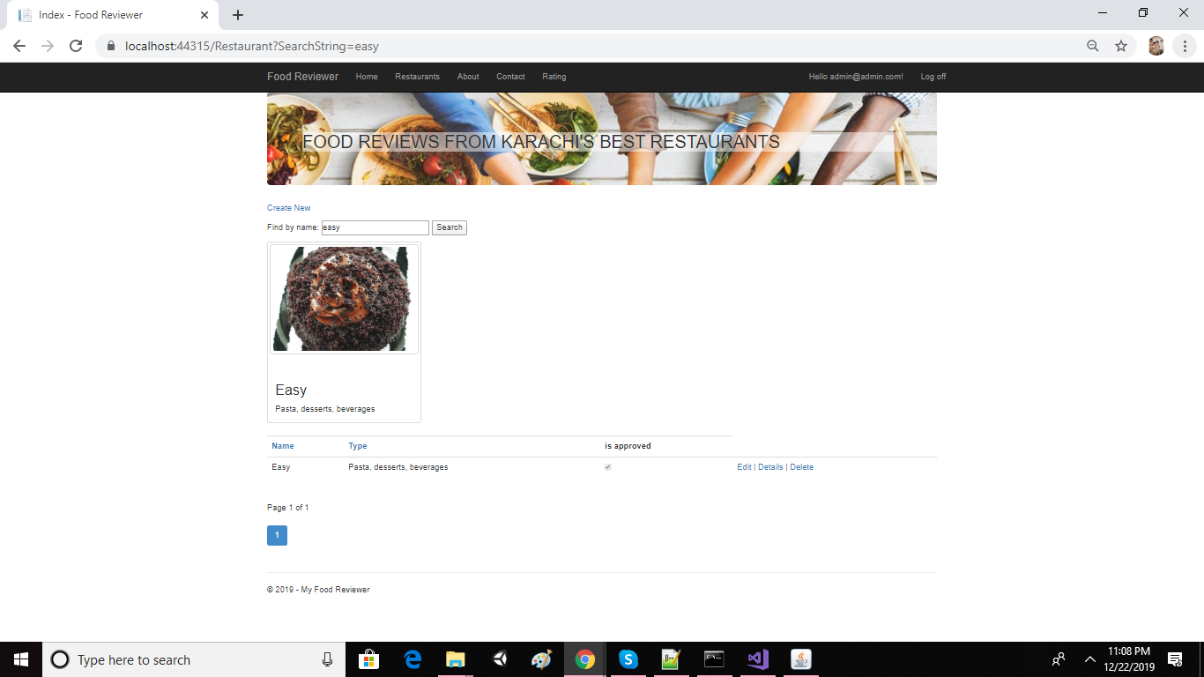

An admin can Edit and delete any restaurant as well.