**JAVA EE REST SERVICE DOCUMENTATON – AIRLINE SYSTEM PROJECT**

Class Name: AirlineServiceRest

1. **getAll** (<http://localhost:8080/airlinesWebApp-0.0.1-SNAPSHOT/rs/airline>)

A get type method which is used to display all the added airlines along with flight details. There are no parameters required.

Example Request: <http://localhost:8080/airlinesWebApp-0.0.1-SNAPSHOT/rs/airline>

Example Response:

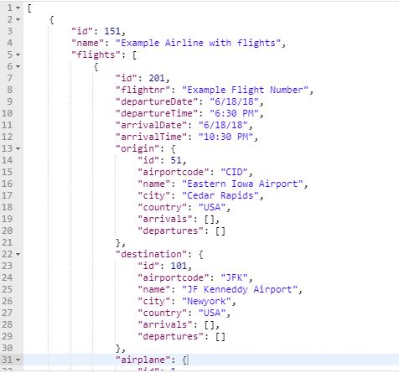

1. **create** (<http://localhost:8080/airlinesWebApp-0.0.1-SNAPSHOT/rs/airline>)

A post type method which is used to create an airline entity. It is also a way to add flights into the system. Accepts a JSON string as parameter.

Example Request: <http://localhost:8080/airlinesWebApp-0.0.1-SNAPSHOT/rs/airline>

We need to pass the following json string with-in request body which specifies the airline name that we aim to create and the flights that are associated with it.

{

"airlineName" : "Example Airline with flights",

"flightCreationDetails":[

{

"flightnr" : "Example Flight Number",

"departureDate" : "6/18/18",

"departureTime" : "6:30 PM",

"arrivalDate" : "6/18/18",

"arrivalTime" : "10:30 PM",

"originName": "Eastern Iowa Airport",

"destinationName": "JF Kenneddy Airport",

"serialNumberAirPlane": "456"

}

]

}

Example Response:



1. **find** (<http://localhost:8080/airlinesWebApp-0.0.1-SNAPSHOT/rs/airline/find>)

A post type method used to find a particular airline entity details by id. Accepts a JSON string as parameter specifying the ID of the airline that we wish to find.

Example Request:

<http://localhost:8080/airlinesWebApp-0.0.1-SNAPSHOT/rs/airline/find>

{

"id": 151

}

Example Response:



1. **update** (<http://localhost:8080/airlinesWebApp-0.0.1-SNAPSHOT/rs/airline>)

A put type method which updates an airline entity. It accepts a JSON string as parameter specifying the airline entity details that we wish to update. We also need to specify the ID of the airline with-in the request else it will create a new airline entry.

Example Request:

http://localhost:8080/airlinesWebApp-0.0.1-SNAPSHOT/rs/airline

{

"id": 251,

"name": "Example Airline with flights Updated",

"flights": [

{

"id": 301,

"flightnr": "Example Flight Number",

"departureDate": "6/18/18",

"departureTime": "6:30 PM",

"arrivalDate": "6/18/18",

"arrivalTime": "10:30 PM",

"origin": {

"id": 51,

"airportcode": "CID",

"name": "Eastern Iowa Airport",

"city": "Cedar Rapids",

"country": "USA",

"arrivals": [],

"departures": []

},

"destination": {

"id": 101,

"airportcode": "JFK",

"name": "JF Kenneddy Airport",

"city": "Newyork",

"country": "USA",

"arrivals": [],

"departures": []

},

"airplane": {

"id": 1,

"serialnr": "456",

"model": "A380",

"capacity": 120,

"flights": []

}

}

]

}

Example Response:



1. **delete** (<http://localhost:8080/airlinesWebApp-0.0.1-SNAPSHOT/rs/airline/{name>})

A delete type method which is available for deleting an airline entity by specifying its name in the URL as @PathParam

Example Request: http://localhost:8080/airlinesWebApp-0.0.1-SNAPSHOT/rs/airline/Emirates

Example Response:



1. **findbyname** (<http://localhost:8080/airlinesWebApp-0.0.1-SNAPSHOT/rs/airline/findbyname/{airlienName>})

A get type method which searches an airline entity by name. We need to specify the airline name in the URL

Example Request: http://localhost:8080/airlinesWebApp-0.0.1-SNAPSHOT/rs/airline/Emirates

Example Response:

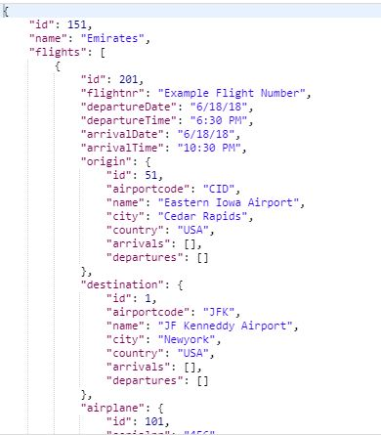

1. **findbyflight** (<http://localhost:8080/airlinesWebApp-0.0.1-SNAPSHOT/rs/airline/findbyflight>)

A post type request that retrieves the airline entity details with a provided flight id parameter. The parameter needs to be provided in requets body as JSON string.

Example Request: <http://localhost:8080/airlinesWebApp-0.0.1-SNAPSHOT/rs/airline/findbyflight>

{

"id": 201

}

Example Response:

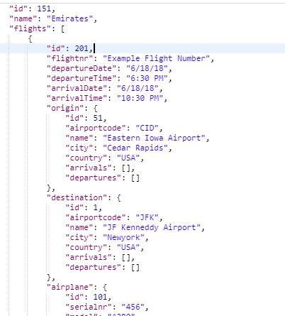

Class Name: AirplaneServiceRest

1. **create** (<http://localhost:8080/airlinesWebApp-0.0.1-SNAPSHOT/rs/airplane>)

A post type method which creates an airplane entity by accepting a JSON String in as parameter in requets body

Example Request:

<http://localhost:8080/airlinesWebApp-0.0.1-SNAPSHOT/rs/airplane>

{

"serialnr":"456",

"model": "A380",

"capacity":120

}

Example Response:



1. **getAll** (<http://localhost:8080/airlinesWebApp-0.0.1-SNAPSHOT/rs/airplane>)

A get type method which displays all the airplane entities that are present in datatabase. We do not need to pass any parameter herewith.

Example Request:

<http://localhost:8080/airlinesWebApp-0.0.1-SNAPSHOT/rs/airplane>

Example Response:

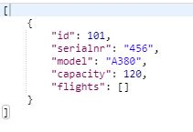

1. **delete** (<http://localhost:8080/airlinesWebApp-0.0.1-SNAPSHOT/rs/airplane/{serialNumber>})

A delete type method which deletes an airplane entity by serial number. We provide the serial number as part of the URL. It is important to consider that if an airplane serial number is serving as a foreign key for other entities I.e. Airports etc. than the entity will NOT be deleted.

Example Request:

http://localhost:8080/airlinesWebApp-0.0.1-SNAPSHOT/rs/airplane/356

Example Response:



1. **find** (http://localhost:8080/airlinesWebApp-0.0.1-SNAPSHOT/rs/airplane/find)

A post type method used to find a particular airplane entity details by id. Accepts a JSON string as parameter specifying the ID of the airplane that we wish to find.

Example Request:

http://localhost:8080/airlinesWebApp-0.0.1-SNAPSHOT/rs/airplane/find

{

"id": 101

}

Example Response:



1. **update** (<http://localhost:8080/airlinesWebApp-0.0.1-SNAPSHOT/rs/airplane>)

A put type method which updates an airplane entity. It accepts a JSON string as parameter specifying the airplane entity details that we wish to update. We also need to specify the ID of the airplane with-in the request else it will create a new airplane entry.

Example Request:

<http://localhost:8080/airlinesWebApp-0.0.1-SNAPSHOT/rs/airplane>

{

"id": 101,

"serialnr": "456",

"model": "A380",

"capacity": 150,

"flights": []

}

Example Response:



1. **findbyserialnumber** (<http://localhost:8080/airlinesWebApp-0.0.1-SNAPSHOT/rs/airplane/findbyserialnumber/{serialNumber>})

A get type method used to find airplane entities by serial number. We need to provide serial number as part of the URL.

Example Request:

http://localhost:8080/airlinesWebApp-0.0.1-SNAPSHOT/rs/airplane/findbyserialnumber/456

Example Response:

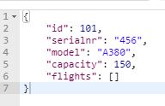

1. **findbyflight** (<http://localhost:8080/airlinesWebApp-0.0.1-SNAPSHOT/rs/airplane/findbyflight>)

A post type method available to find airplane entities based on a provided flight id. This method accepts a JSON string with-in request body.

Example Request:

<http://localhost:8080/airlinesWebApp-0.0.1-SNAPSHOT/rs/airplane/findbyflight>

{

"id": 251

}

1. **findbymodel** (<http://localhost:8080/airlinesWebApp-0.0.1-SNAPSHOT/rs/airplane/findbymodel/{model>})

A get type method that finds airplane entities based on a provided model in URL. It returns a list of airplane entities.

Example Request: <http://localhost:8080/airlinesWebApp-0.0.1-SNAPSHOT/rs/airplane/findbymodel/A380>

Example Response:

