K21-3906  
DB_LAB 6  
  
  
  
QUESTION 1

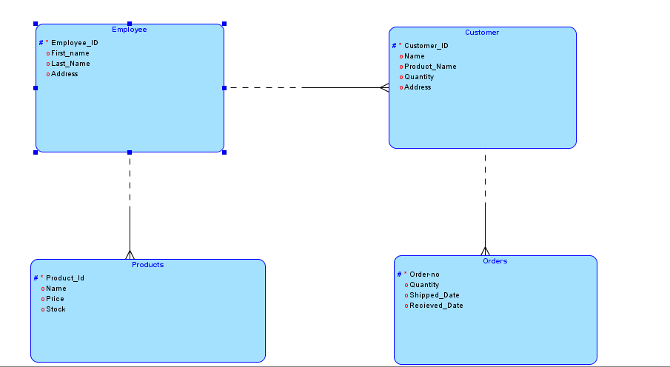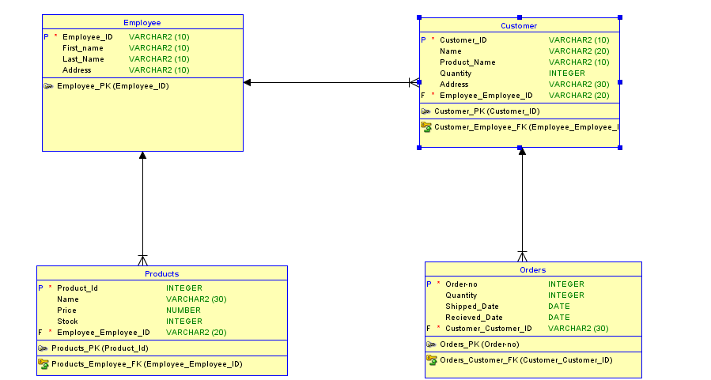-- Generated by Oracle SQL Developer Data Modeler 4.1.2.888

-- at: 2023-10-08 10:45:21 PKT

-- site: Oracle Database 11g

-- type: Oracle Database 11g

CREATE

TABLE Customer

(

Customer_ID VARCHAR2 (10) NOT NULL ,

Name VARCHAR2 (20) ,

Product_Name VARCHAR2 (10) ,

Quantity INTEGER ,

Address VARCHAR2 (30) ,

Employee_Employee_ID VARCHAR2 (20) NOT NULL

) ;

ALTER TABLE Customer ADD CONSTRAINT Customer_PK PRIMARY KEY ( Customer_ID ) ;

CREATE

TABLE Employee (

Employee_ID VARCHAR2 (10) NOT NULL ,

First_name VARCHAR2 (10) ,

Last_Name VARCHAR2 (10) ,

Address VARCHAR2 (10)

) ;

ALTER TABLE Employee ADD CONSTRAINT Employee_PK PRIMARY KEY ( Employee_ID ) ;

CREATE

TABLE Orders(

"Order-no" INTEGER NOT NULL ,

Quantity INTEGER ,

Shipped_Date DATE ,

Recieved_Date DATE ,

Customer_Customer_ID VARCHAR2 (30) NOT NULL

) ;

ALTER TABLE Orders ADD CONSTRAINT Orders_PK PRIMARY KEY ( "Order-no" ) ;

CREATE

TABLE Products (

Product_Id INTEGER NOT NULL ,

Name VARCHAR2 (30) ,

Price NUMBER ,

Stock INTEGER ,

Employee_Employee_ID VARCHAR2 (20) NOT NULL

) ;

ALTER TABLE Products ADD CONSTRAINT Products_PK PRIMARY KEY ( Product_Id ) ;

ALTER TABLE Customer ADD CONSTRAINT Customer_Employee_FK FOREIGN KEY (

Employee_Employee_ID ) REFERENCES Employee ( Employee_ID ) ;

ALTER TABLE Orders ADD CONSTRAINT Orders_Customer_FK FOREIGN KEY (

Customer_Customer_ID ) REFERENCES Customer ( Customer_ID ) ;

ALTER TABLE Products ADD CONSTRAINT Products_Employee_FK FOREIGN KEY (

Employee_Employee_ID ) REFERENCES Employee ( Employee_ID ) ;

-- **Oracle SQL Developer Data Modeler Summary Report:**

--

-- CREATE TABLE 4

-- CREATE INDEX 0

-- ALTER TABLE 7

-- CREATE VIEW 0

-- ALTER VIEW 0

-- CREATE PACKAGE 0

-- CREATE PACKAGE BODY 0

-- CREATE PROCEDURE 0

-- CREATE FUNCTION 0

-- CREATE TRIGGER 0

-- ALTER TRIGGER 0

-- CREATE COLLECTION TYPE 0

-- CREATE STRUCTURED TYPE 0

-- CREATE STRUCTURED TYPE BODY 0

-- CREATE CLUSTER 0

-- CREATE CONTEXT 0

-- CREATE DATABASE 0

-- CREATE DIMENSION 0

-- CREATE DIRECTORY 0

-- CREATE DISK GROUP 0

-- CREATE ROLE 0

-- CREATE ROLLBACK SEGMENT 0

-- CREATE SEQUENCE 0

-- CREATE MATERIALIZED VIEW 0

-- CREATE SYNONYM 0

-- CREATE TABLESPACE 0

-- CREATE USER 0

--

-- DROP TABLESPACE 0

-- DROP DATABASE 0

--

-- REDACTION POLICY 0

--

-- ORDS DROP SCHEMA 0

-- ORDS ENABLE SCHEMA 0

-- ORDS ENABLE OBJECT 0

--

-- ERRORS 0

-- WARNINGS 0

Question2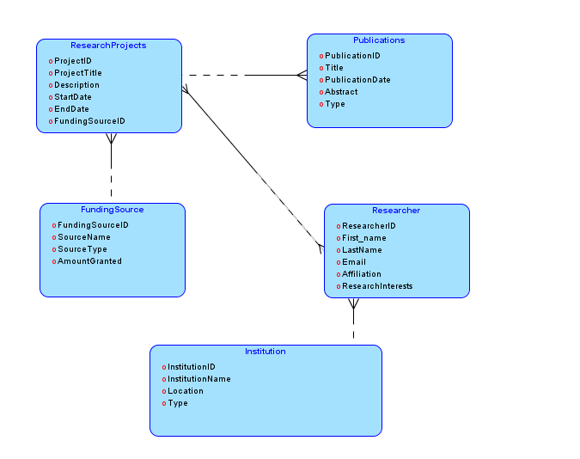

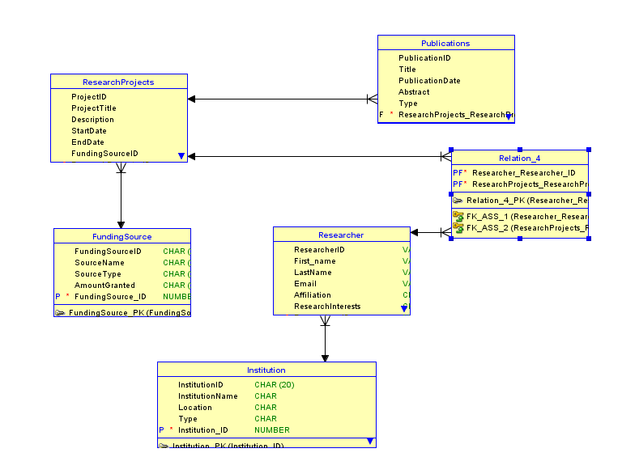-- Generated by Oracle SQL Developer Data Modeler 4.1.1.888

-- at: 2023-10-08 11:12:57 PKT

-- site: Oracle Database 11g

-- type: Oracle Database 11g

CREATE

TABLE FundingSource (

FundingSourceID CHAR (20) ,

SourceName CHAR (20) ,

SourceType CHAR (20) ,

AmountGranted CHAR (20) ,

FundingSource_ID NUMBER NOT NULL

) ;

ALTER TABLE FundingSource ADD CONSTRAINT FundingSource_PK PRIMARY KEY (

FundingSource_ID ) ;

CREATE

TABLE Institution

(

InstitutionID CHAR (20) ,

InstitutionName CHAR

-- WARNING: CHAR size not specified

,

Location CHAR

-- WARNING: CHAR size not specified

,

Type CHAR

-- WARNING: CHAR size not specified

,

Institution_ID NUMBER NOT NULL

) ;

ALTER TABLE Institution ADD CONSTRAINT Institution_PK PRIMARY KEY (

Institution_ID ) ;

CREATE

TABLE Publications

(

PublicationID CHAR (20) ,

Title CHAR (30) ,

PublicationDate DATE ,

Abstract CHAR (20) ,

Type CHAR (20) ,

ResearchProjects_ResearchProjects_ID NUMBER NOT NULL

) ;

CREATE

TABLE Relation_4

(

Researcher_Researcher_ID NUMBER NOT NULL ,

ResearchProjects_ResearchProjects_ID NUMBER NOT NULL

) ;

ALTER TABLE Relation_4 ADD CONSTRAINT Relation_4_PK PRIMARY KEY (

Researcher_Researcher_ID, ResearchProjects_ResearchProjects_ID ) ;

CREATE

TABLE ResearchProjects

(

ProjectID CHAR (20) ,

ProjectTitle CHAR (20) ,

Description CHAR (20) ,

StartDate DATE ,

EndDate DATE ,

FundingSourceID CHAR (20) ,

ResearchProjects_ID NUMBER NOT NULL ,

FundingSource_FundingSource_ID NUMBER NOT NULL

) ;

ALTER TABLE ResearchProjects ADD CONSTRAINT ResearchProjects_PK PRIMARY KEY (

ResearchProjects_ID ) ;

CREATE

TABLE Researcher

(

ResearcherID VARCHAR2 (20) ,

First_name VARCHAR2 (10) ,

LastName VARCHAR2 (20) ,

Email VARCHAR2 (20) ,

Affiliation CHAR (20) ,

ResearchInterests CHAR (20) ,

Researcher_ID NUMBER NOT NULL ,

Institution_Institution_ID NUMBER NOT NULL

) ;

ALTER TABLE Researcher ADD CONSTRAINT Researcher_PK PRIMARY KEY ( Researcher_ID

) ;

ALTER TABLE Relation_4 ADD CONSTRAINT FK_ASS_1 FOREIGN KEY (

Researcher_Researcher_ID ) REFERENCES Researcher ( Researcher_ID ) ;

ALTER TABLE Relation_4 ADD CONSTRAINT FK_ASS_2 FOREIGN KEY (

ResearchProjects_ResearchProjects_ID ) REFERENCES ResearchProjects (

ResearchProjects_ID ) ;

-- ERROR: FK name length exceeds maximum allowed length(30)

ALTER TABLE Publications ADD CONSTRAINT Publications_ResearchProjects_FK

FOREIGN KEY ( ResearchProjects_ResearchProjects_ID ) REFERENCES

ResearchProjects ( ResearchProjects_ID ) ;

-- ERROR: FK name length exceeds maximum allowed length(30)

ALTER TABLE ResearchProjects ADD CONSTRAINT ResearchProjects_FundingSource_FK

FOREIGN KEY ( FundingSource_FundingSource_ID ) REFERENCES FundingSource (

FundingSource_ID ) ;

ALTER TABLE Researcher ADD CONSTRAINT Researcher_Institution_FK FOREIGN KEY (

Institution_Institution_ID ) REFERENCES Institution ( Institution_ID ) ;

CREATE SEQUENCE FundingSource_FundingSource_ID START WITH 1 NOCACHE ORDER ;

CREATE OR REPLACE TRIGGER FundingSource_FundingSource_ID BEFORE

INSERT

ON FundingSource FOR EACH ROW WHEN

(

NEW.FundingSource_ID IS NULL

)

BEGIN :NEW.FundingSource_ID := FundingSource_FundingSource_ID.NEXTVAL;

END;

/

CREATE SEQUENCE Institution_Institution_ID_SEQ START WITH 1 NOCACHE ORDER ;

CREATE OR REPLACE TRIGGER Institution_Institution_ID_TRG BEFORE

INSERT

ON Institution FOR EACH ROW WHEN

(

NEW.Institution_ID IS NULL

)

BEGIN :NEW.Institution_ID := Institution_Institution_ID_SEQ.NEXTVAL;

END;

/

CREATE SEQUENCE ResearchProjects_ResearchProje START WITH 1 NOCACHE ORDER ;

CREATE OR REPLACE TRIGGER ResearchProjects_ResearchProje BEFORE

INSERT

ON ResearchProjects FOR EACH ROW WHEN

(

NEW.ResearchProjects_ID IS NULL

)

BEGIN :NEW.ResearchProjects_ID := ResearchProjects_ResearchProje.NEXTVAL;

END;

/

CREATE SEQUENCE Researcher_Researcher_ID_SEQ START WITH 1 NOCACHE ORDER ;

CREATE OR REPLACE TRIGGER Researcher_Researcher_ID_TRG BEFORE

INSERT

ON Researcher FOR EACH ROW WHEN

(

NEW.Researcher_ID IS NULL

)

BEGIN :NEW.Researcher_ID := Researcher_Researcher_ID_SEQ.NEXTVAL;

END;

/

-- Oracle SQL Developer Data Modeler Summary Report:

--

-- CREATE TABLE 6

-- CREATE INDEX 0

-- ALTER TABLE 10

-- CREATE VIEW 0

-- ALTER VIEW 0

-- CREATE PACKAGE 0

-- CREATE PACKAGE BODY 0

-- CREATE PROCEDURE 0

-- CREATE FUNCTION 0

-- CREATE TRIGGER 4

-- ALTER TRIGGER 0

-- CREATE COLLECTION TYPE 0

-- CREATE STRUCTURED TYPE 0

-- CREATE STRUCTURED TYPE BODY 0

-- CREATE CLUSTER 0

-- CREATE CONTEXT 0

-- CREATE DATABASE 0

-- CREATE DIMENSION 0

-- CREATE DIRECTORY 0

-- CREATE DISK GROUP 0

-- CREATE ROLE 0

-- CREATE ROLLBACK SEGMENT 0

-- CREATE SEQUENCE 4

-- CREATE MATERIALIZED VIEW 0

-- CREATE SYNONYM 0

-- CREATE TABLESPACE 0

-- CREATE USER 0

--

-- DROP TABLESPACE 0

-- DROP DATABASE 0

--

-- REDACTION POLICY 0

--

-- ORDS DROP SCHEMA 0

-- ORDS ENABLE SCHEMA 0

-- ORDS ENABLE OBJECT 0

--

-- ERRORS 4

-- WARNINGS 0