**Report on CIFAR-10 Image classification using a Convolution Neural** **Network (CNN) (Part-B)**

1. **Problem Understanding:**

The CIFAR-10 dataset is a widely-used dataset for image classification tasks, consisting of 60,000 32x32 color images across 10 classes: Airplane, Automobile, Bird, Cat, Deer, Dog, Frog, Horse, Ship, and Truck. Each class has 6,000 images, split into training and testing sets. The objectives are to develop a model that can accurately classify images into these categories.

1. **Model Design:**
   1. **Data Preprocessing:**

* Normalization: Pixel values were scaled to the range [0,1] to facilitate faster and more stable training.
* One-Hot Encoding: Labels were converted to one-hot format to match the output layer of the model.
* Data Augmentation: The training data was augmented using transforming such as random rotation, horizontal flips and shifts.
  1. **CNN architecture:**

The model was built using the following layers:

* Convolution Layer: Three convolution layers with increasing filter sizes (32, 64, 128), each followed by:
  + Batch Normalization to stabilize training.
  + MaxPooling to downsample feature maps.
  + Dropout to prevent overfitting.
* Fully Connected Layers:
  + A Dense layer with 256 units and ReLU activation.
  + A final output layer with 10 units (softmax activation) for classification.

1. **Result and Discussion:**
   1. **Model Performance**

* The model achieved a test accuracy of approximately 60% after 3 epochs.
* Training and validation accuracy increased steadily, while losses decreased, indicating effective learning. The classification accuracy report is also calculate.

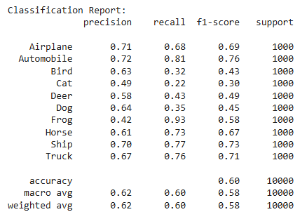 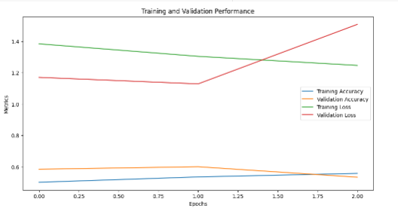

Fig-1: Classification report Fig-2 : Validation curve

* 1. **Confusion matrix**

A confusion matrix revealed the exact classes being misclassified. Visual inspection of sample predictions further confirmed that misclassifications were often due to subtle visual similarities.

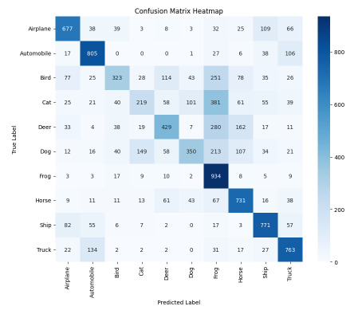

Fig-3: Confusion matrix

* Frog (class 6) and Ship (class 8) have higher accuracy. This model correctly classified them others.
* There is a confusion among some classes:
  + “Cat” vs “Dog”: Notable confusion exists between these classes. The model incorrectly classified 213 cat images as Dog and vice versa. This reflects the semantic similarity between these categories.
  + “Truck” vs “Automobile”: There is misclassification between trucks and automobiles. The model misclassified 106 Truck samples as automobiles, likely due to their shared features like wheels and structure.
  1. **Error analysis**
* **Misclassification of similar classes (semantic overlap:**

Confusion classes like “cat” and “dog” or “Truck” and “Automobile” due to their similar visual features.

**Solution:** Using data augmentation techniques to introduce more variations, helping the model learn distinguishing features. Implementing a more complex architecture. Use class-specific loss weights to penalize errors in commonly confused classes more heavily.

* **Misclassification due to background noise:**

Misclassifying “Frog” as “Bird” when both are in natural environments with cluttered backgrounds.

**Solution:** Apply region-based data augmentation or saliency maps to help the model focus on the object of interest. Introducing bounding box annotations or use object detection models to isolate objects from the background.

* **Misclassification of Rare or Underrepresented classes:**

Predicting “Airplane” as another class due to fewer training samples or variations.

**Solution:** Use class balancing techniques like oversampling the rare classes or undersampling the frequent ones. Implementing focal loss to focus the learning on difficult samples. And using synthetic data generation to increases the diversity of underrepresentd classes.

**Conclusion:**

The CNN model achieved satisfactory performance on the CIFAR-10 dataset, with an accuracy of 60%. However, the model still faces challenges in distinguishing between similar classes and underrepresented ones.