|  |  |
| --- | --- |
| Company Chatting VIOP Application  ANALYSIS AND DESIGN |  |
| By Abdulrahman Alduais, Rasheed Mohammed, Aymen Alswidi, Aiman Almureish  Supervisor T. Rasha Alarasi  Faculty of Computer and Information Technology Sana’a University |  |

Table of Contents

Background 1.1 4

Problem Statements 1.2 5

Objectives 1.3 5

Acceptance Criteria 1.4 5

System Definition 1.5 5

Purpose 1.6 5

Goal 1.7 5

User Characteristics 1.8 6

Limitations 1.9 6

Assumptions and Dependencies 1.10 6

Scope 1.11 6

Life Cycle Model 1.12 7

Related Work 1.13 7

Project Plan 1.14 7

Technical Feasibility 1.15.1 8

Financial Feasibility 1.15.2 9

Operational Feasibility 1.15.3 10

Scheduling Feasibility (planning the time) 1.15.4 11

Identifying Benefits and Costs 1.15.5 11

Current system 14

Overview 3.1 16

Fact Finding Tools 3.2 16

Requirement specifications 3.3 16

User Requirements 3.3.1 16

Functional Requirements 3.3.2 16

Non-Functional Requirements 3.3.3 17

Usability 3.3.3.1 17

Dependability 3.3.3.2 17

Performance 3.3.3.3 17

Supportability 3.3.3.4 18

Validation 3.3.3.5 18

Other 3.3.3.6 19

|  |
| --- |
| Chapter 1 |
| ­Introduction |

CHAPTER 1

# Background 1.1

Company Chatting is an application that provides communication services within a local network, works on the Windows and Android environment, the application provides three main services which are voice communication, text messaging and file sharing.

Voice communication allows the exchange of communications between two devices connected to the same LAN network using network protocol.

Messaging allows the user to exchange messages with any other user linked in the same network.

File transfer allows the exchange of files (doc, pdf, video, image) over the network.

# Problem Statements 1.2

1. The cost of creating an extension.
2. Shunt maintenance cost.
3. The cost of extending the shunt.
4. The extension is limited to providing voice communication only.
5. Not to exploit resources like a computer.

# Objectives 1.3

1. Eliminate the electric shunt and wired connections within the organization by adding the voice communication service through an application that installs via a computer or phone.
2. The application provides several services for communication.
3. More and better use of the computer systems.

# Acceptance Criteria 1.4

1. Create an account for each user within the same network.
2. Providing voice communication, message exchange and file exchange service.
3. The application is safe because it works on the local network and does not work through the internet.

# System Definition 1.5

It is an application that works on the Android and Windows environment dedicated to various institutions and is characterized by its provision of voice communication services and the exchange of files and messages within the institution's local network

# Purpose 1.6

Facilitating the process of communication within the organization, the optimal utilization of resources, and the provision of infrastructure through dispensing of switching networks.

# Goal 1.7

Creating an application for Windows and Android devices dedicated to communication over the local network.

# User Characteristics 1.8

|  |  |  |  |
| --- | --- | --- | --- |
| Tasks | Required skills | Qualifications | User type |
| 1- Distribute the program to all devices connected to the network  2- Installation, maintenance, and administration of the program. | 1 - Windows server 2- Full knowledge of the enterprise network 3- Full knowledge of how the application works | 1- CCNA, CCNP, MCSA  2- Bachelor's degree in 3- Computer Specializations | Administrator |
| Choose any device connected to the network and communicate with | Use of the computer | - | Employee |

# Limitations 1.9

1. Low programming of TCP / IP resources.
2. The geographical distance between the team members is making it difficult to communicate.
3. Availability of the internet permanently.
4. Some of the devices used in the system building process do not have the required resources.

# Assumptions and Dependencies 1.10

1. Hiring an expert in programming the network protocols.
2. Dividing business among team members.
3. Insert a mobile internet provider
4. Borrowing devices that meet the required standards

# Scope 1.11

Institutions and companies.

# Life Cycle Model 1.12

We will be using agile method in our implementation progress.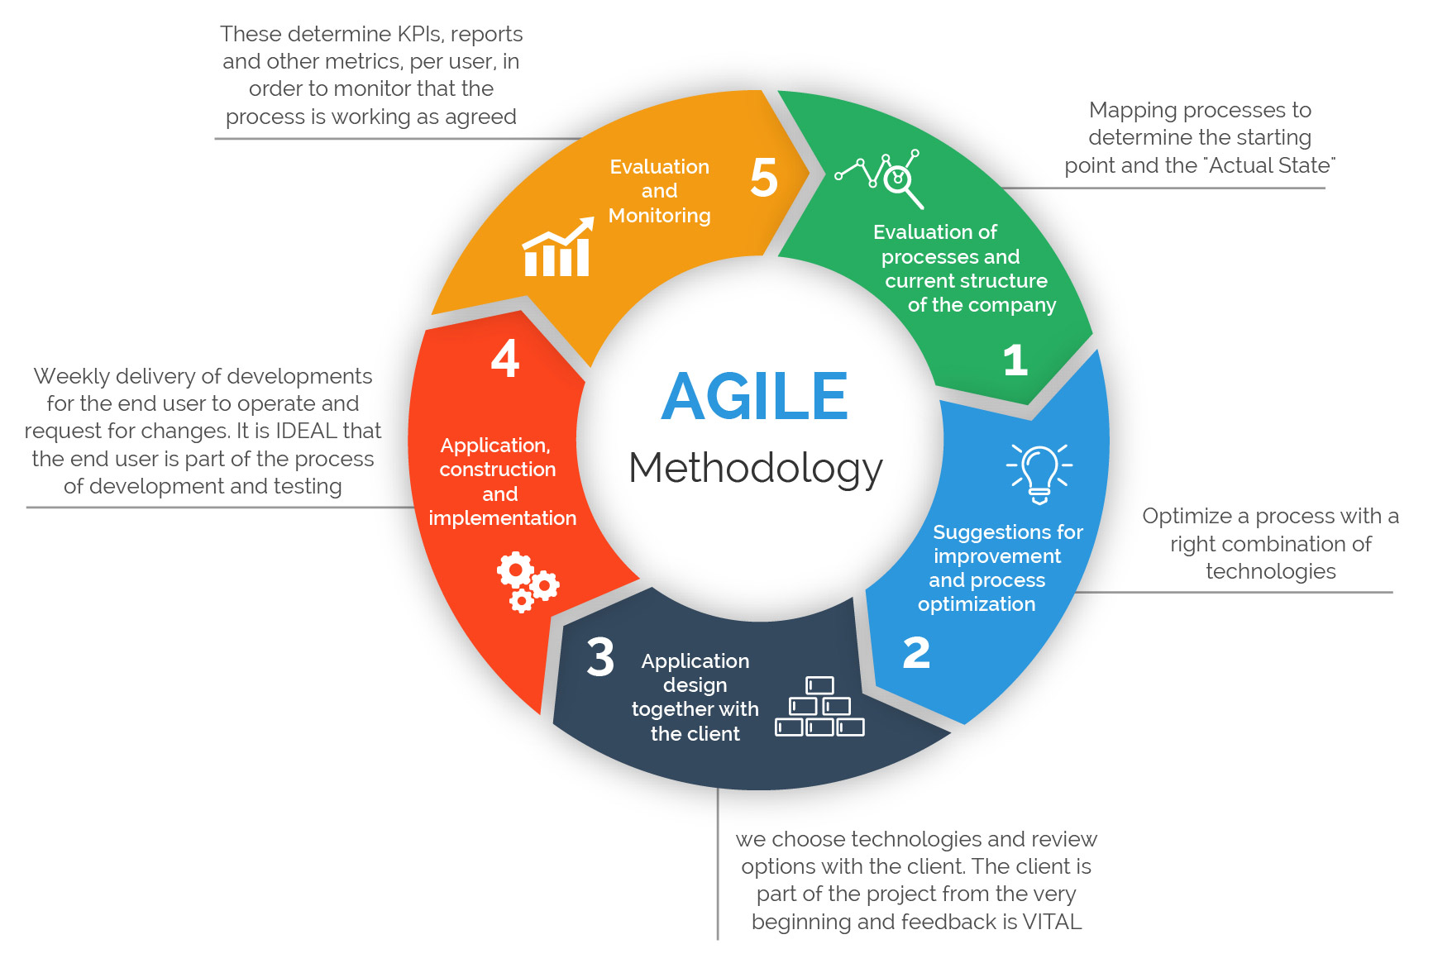

# Related Work 1.13

Needs fixing

# Project Plan 1.14

Needs fixing

Feasibility Study 1.15

# Technical Feasibility 1.15.1

* **Needed Hardware**

1. 6 number of laptops
2. Modem
3. Twisted pair cable

* **Available Hardware**

1. 6 number of laptops
2. Modem
3. Twisted pair cable

* **Needed Software**

1. Win10
2. Win server
3. Visual studio
4. Android studio
5. Microsoft Project
6. Web browser
7. Microsoft SQL server
8. Virtual machine manager

* **Needed Experts**

1. Specialist in TCP/IP
2. Specialist in creating android apps

# Financial Feasibility 1.15.2

|  |  |  |  |  |
| --- | --- | --- | --- | --- |
| Total | Cost | Quantity | Type | Category |
| 1200$ | 200$ | 6 | laptop | HW |
| 22 | 22 | 1 | modem |  |
| 4$ | 4$ | 10m | Cable |  |
|  |  |  |  |  |
| 6$ | 1$ | 6 | Win10 | SW |
| 1$ | 1$ | 1 | Win server |  |
| 12$ | 2$ | 6 | Visual studio |  |
| 8$ | 4$ | 2 | Android studio |  |
| 1$ | 1$ | 1 | MS project |  |
| 6$ | 1$ | 6 | MS world |  |
| 12$ | 2$ | 6 | SQL server |  |
| 6$ | 1$ | 6 | Virtual Machine |  |
|  |  |  |  |  |
| 6000R.y | Kw300 | Kw20 | Electricity Budget | Other |
| 60000 R .Y | 60000R.Y | ------- | Transportation |  |
| 23 R.Y | 4750\36GB | 150GB | Internet |  |
|  |  |  |  |  |

# Operational Feasibility 1.15.3

* **Performance**

Throughput 500\MS

* Response time

1\S

* **Economy**

**Cost**

Mentioned in the financial feasibility study.

**Profits**

The application is free only for first organization which will use it.

* **Control**

The application must be controlled to ensure privacy of users.

* **Efficiency**

**Wasted Time**

The application's data is stored locally to enhance performance of the application.

**Waste Materials**

No wasted materials.

* **Effort**

The effort is too big due to multiple tasks that are included concurrently.

**Required Materials**

Mentioned in the financial feasibility study.

* **Services**

1. Easy to learn \ use.
2. Application provides usability requirements because of using UX user experience.
3. Flexibility
4. The application is flexible so it can be used easily
5. Compatibility
6. It is not dependable on another application or system, but it needs Microsoft windows or android platform

* **Legal Feasibility**

**Laws**

This application does not breach any rules

**Copyrights**

This application is protected by international copyright and intellectual property laws for application development team.

# Scheduling Feasibility (planning the time) 1.15.4

# Identifying Benefits and Costs 1.15.5

**Tangible benefits**

1. Ease of communication between users within the network.
2. Easily share files between users within the network.
3. Save the cost of creating a transfer within the organization
4. Ease of the use and the management of the program.

**Intangible benefits**

Maintaining safety and secure communication.

**Tangible costs**

Mentioned in financial feasibility point number 1.15.2

**Intangible costs**

1. The time taken to collect data.
2. The time taken to build the application.
3. The effort to build the application.

|  |  |  |  |  |  |  |
| --- | --- | --- | --- | --- | --- | --- |
|  | | | | |  | |
|  |  | |  | |  | |
|  | |  | | --- | | Chapter 2 | | Current system | | |  | |  | |
|  |  | |  | |  | |
|  | | | | |  | |
|  | |  | |  | |

# Current system

Needs Fixing

|  |
| --- |
| Chapter 3 |
| Proposed System |

# Overview 3.1

In this chapter, will refer to clarification of application requirements that include functional and nonfunctional requirements and other requirements.

# Fact Finding Tools 3.2

1. Searching at professional web sites (e.g. Stackoverflow , Github , Codepen,…etc.).
2. Books about TCP/IP programming.
3. Blogs and forums.
4. Technical YouTube channels.
5. Similar existing applications.

# Requirement specifications 3.3

# User Requirements 3.3.1

1. Ease of use by providing simple user interfaces which make user recognizes them quickly.
2. High security while data transmitted back and forth.
3. High performance at processing requests.

# Functional Requirements 3.3.2

**Making Calls**

The application allows users to make calls through organization's local network by user logging in when he / she connected to the network, then selecting the desired device to call via list contains all connected devices.

**File Sharing**

The application allows users to share files calls through organization's local network with predefined extensions (e.g. *.jpg, *.pdf, *.docx ,*.mp3,... etc.) which determined by administrator previously.

**Instant Messages**

The application allows users to exchange messages between each other when they connected to organization's local network.

# Non-Functional Requirements 3.3.3

# Usability 3.3.3.1

The Application offers easy and simple graphical interfaces, which means user can understands and uses the application easily which result in obtaining user satisfaction.

# Dependability 3.3.3.2

**Dependability**

The application effectively carries out all tasks that mentioned in the functional requirements so that it performs tasks quickly and accurately.

**Robustness**

The application can handle with errors, which cannot lead to failure. For example, if the user enter invalid datatype of a particular field it shows an error message to inform the user that there is an error and how to fix the error.

**Safety**

The application does not pose any risks at worst because it is not kind of critical systems, which consider safety as an important factor to keep running.

**Security**

The application is difficult to be tracked by any external entity because connecting to the internet is not required and working only at the organization's local network and the administrator have all privileges to do what is needed if there is any violations or breaches.

# 

# Performance 3.3.3.3

**Response Time**

It has been considered that response time should quickly even if in the peak time, but there are several factors to determine response time such as hardware infrastructure, number of users, geographical space and other factors not mentioned.

**Throughput**

It depends on process type that is required to be performed in addition to the network response.

**Availability**

The application must be available when the device is connected to the network.

**Accuracy**

The application is accurate as it sends only valid data and if there is an error user is informed.

# Supportability 3.3.3.4

**Adaptability**

The application is compatible with computers that working on Microsoft Windows or smart phones working on Android.

**Maintainability**

The application is flexible, so it is possible to add, remove, or modify services and updates available by developers of the application and easily solving problems when they occur.

**Internationalization**

The application is universal as it supports Arabic, English language and any other languages ​​if needed.

**Portability**

The application can be moved to another environment if one condition is met, in which the previous and new environment infrastructure is the same.

# Validation 3.3.3.5

**Completeness**

The application is integrated, in terms of user can interact with others within the organization by making voice calls and sending or receiving messages.

**Consistent**

There is no conflict between elements and other processes because it cannot occur any overlap in executing processes among users, which performed separately and accurate to ensure that processes are not overlapped.

**Unambiguous**

The application is clear and does not contain ambiguity.

**Correctness**

The program works according to criteria that ensure work continuation with high accuracy and reliability to avoid problems and errors that may occur.

# Other 3.3.3.6

**Verification**

The application undergoes several rigorous tests to ensure the safety of the application in terms of performance and processing.

**Realistic**

The application is realistic that it implements requirements under restrictions.

**Traceable**

The application can be traceable, that all processes are recorded in central database which allows administrator to check records if problems happened.