Analysis and Comparison of Traditional Machine Learning Algorithms (Decision Tree, KNN, SVM) in Crime Classification: An Applied Study on the
[New Offense Data 2024] Dataset
Name | ID
ayman mohsen abdu hasan
mazen sulan abduljalil

Introduction
Crime prediction and classification represent a vital area of research, as highlighted by the pioneering academic work 'Crime Prediction Using Machine Learning and Deep Learning.' This field aims to leverage historical data to develop proactive security strategies. The ability to accurately and effectively identify the type of crime (Category) is considered a crucial step in enhancing analytical capability.
This project focuses on processing and classifying a real and recent dataset ('New Offense Data 2024'). The challenge lies in handling multi-dimensional data and solving the multi-class classification problem, which requires high accuracy in distinguishing between more than 30 different types of crimes.
Methodology
Dataset New Offense Data 2024
The recent dataset titled 'New Offense Data 2024' was used, which contains detailed records of crime incidents. It represents a realistic and up-to-date dataset to support analytical power. Target variable (Label): The most important feature in this data, which determines whether the incident is of type Assault, Theft, or Homicide, is the OffenseCategory column.
Column Structure
The dataset includes features necessary for crime classification.
Temporal features:
- Occur Date
- Occur Time
- Report Date
Spatial features:
- Council District
- Neighborhood
- Address

Descriptive features:
- Crime Against
- Offense Type.
Dataset Composition:
- Total samples: 57,143
- Files processed: 3 daily capture files
- Dominant Class: Larceny Offenses, comprising 24,826 samples.
- Other categories: There are 21 other categories with much lower representation, indicating a significant variation in category distribution (for example, Bribery recorded only a single instance).
Preprocessing
Data preprocessing constitutes a critical step for preparing raw crimes flow data for machine learning algorithms. Several preprocessing operations were applied systematically:
Missing Value and Anomaly Handling:
- Missing values (NaN) in numeric and temporal columns (such as parts extracted from date and time) were handled by filling them with zero (0).
- Removing unnecessary columns: Columns that do not contribute to classification or cause redundancy of information (such as CaseNumber or raw geographic columns that were replaced with area encoding) were removed.
Feature Engineering:
- Temporal feature transformation: The date and time columns (OccurDate and OccurTime) were analyzed to create separate temporal features that enhance the models' ability to learn from seasonal and daily patterns. These features include:
- Year
- Month
- Day
- Hour
- Day Of Week.
Data Encoding:
- Categorical encoding was applied to convert textual and categorical features into a numerical format that algorithms can handle. This included encoding the independent variables (such as Neighborhood) and the target variable (OffenseCategory).
Train-Test Split:
- Test proportion: 20% (11407 samples)
- Training proportion: 80% (45626 samples)
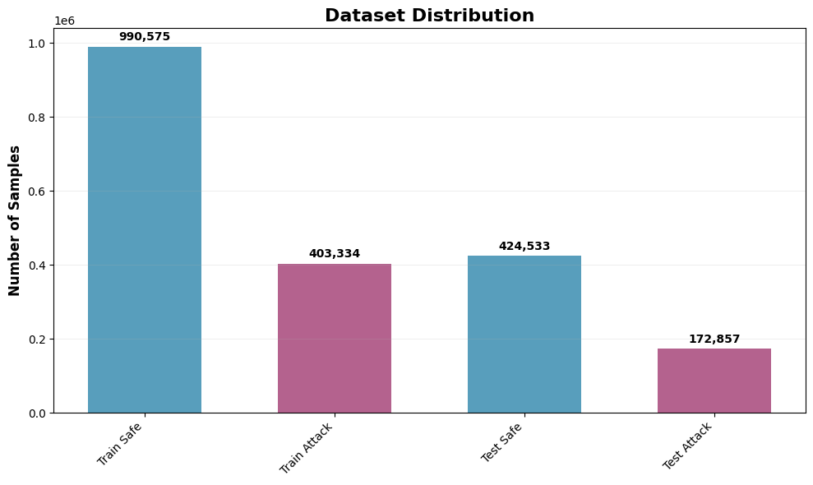
Number of samples
Models and Algorithms
Decision Tree Classifier
A non-parametric tree model that relies on a set of decision rules to extract patterns from data.

Objective: To assess the ability to construct an interpretable model that determines the Feature Importance sequence in the classification of crime categories.

The base model was initialized with random_state=42 to ensure the reproducibility of results and allow for reliable comparison.

Convolutional Neural Networks (CNN)
CNNs represent deep learning architectures originally designed for image analysis but increasingly applied to sequential and structured data including network traffic. CNNs utilize local connectivity patterns and weight sharing to extract hierarchical features through multiple convolutional layers. The architecture employed in this study:
- It takes input of shape (18,1)(18,1), so it uses the same 18 basic flow features as a 1-D sequence.​
- The feature extractor part has two Conv1D layers (64 then 128 filters) with batch normalization and max-pooling in between to learn local patterns in the feature sequence.​
- A global average pooling layer compresses the feature maps into a 128-dimensional vector, followed by a Dense layer (128 units) and Dropout for regularization.​
- The final Dense layer with 1 neuron outputs the binary prediction (safe vs. attack) using a sigmoid activation.​
The CNN was trained using binary cross entropy loss with Adam optimizer over 20 epochs with batch size 32. Dropout regularization (0.5) was applied to dense layers to prevent overfitting on the large dataset. This architecture balances depth for feature extraction with regularization to maintain generalization.
Results:
- Training accuracy is about 99.51%, showing the CNN learns the training patterns very well.​
- Test accuracy is about 99.52%, which means it generalizes strongly to unseen network flows.​
- For the Normal (class 0) traffic, precision, recall, and F1-score are all approximately 1.00, so almost all benign flows are correctly identified and rarely confused with attacks.​
- For the Attack (class 1) traffic, precision, recall, and F1-score are around 0.99, indicating that most attacks are detected and there are few false alarms or misses for this class.​
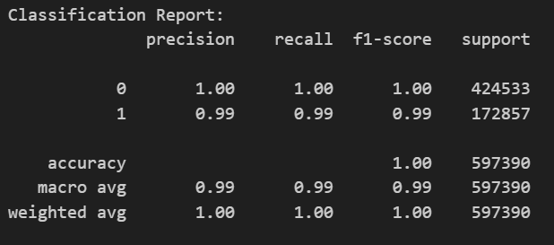
- The confusion matrix shows:
  - 423,189 normal flows correctly predicted as normal (true negatives).​
  - 171,340 attack flows correctly predicted as attack (true positives).​
  - 1,344 normal flows wrongly predicted as attack (false positives).​
  - 1,517 attack flows wrongly predicted as normal (false negatives).​
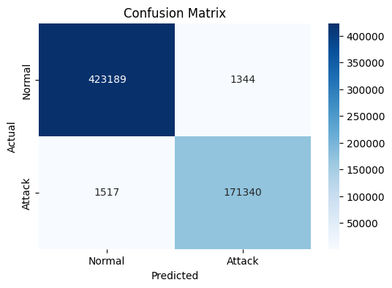

- Overall, the CNN provides highly accurate intrusion detection, with slightly more errors than the Random Forest but still very strong performance for both normal and attack classes.​
Isolation Forest
Isolation Forest is an unsupervised anomaly detection algorithm that operates through a fundamentally different principle than supervised methods. Rather than explicitly modeling normal behavior, Isolation Forest isolates anomalies by randomly selecting features and split values. Anomalies require fewer isolations and thus have shorter average path lengths in isolation trees. Configuration:
- Number of trees (n_estimators): 100
- Contamination parameter: 0.27 (matching dataset attack proportion)
- Maximum samples: 256 per tree
- Random state: 42 for reproducibility
Isolation Forest requires no labeled training data, making it applicable to zero-day attack detection where attack patterns are unknown. However, performance depends on setting the contamination parameter appropriately for the specific network environment.
Results:
- Overall accuracy is about 61.81%, so the model correctly labels only around two-thirds of flows.​
- For Safe traffic, precision is 0.6828 and recall is 0.8638, meaning most predicted safe flows are truly safe, and most real safe flows are detected.​
- For Attack traffic, precision (0.0419), recall (0.0146), and F1-score (0.0217) are very low; the model rarely identifies attacks correctly.​
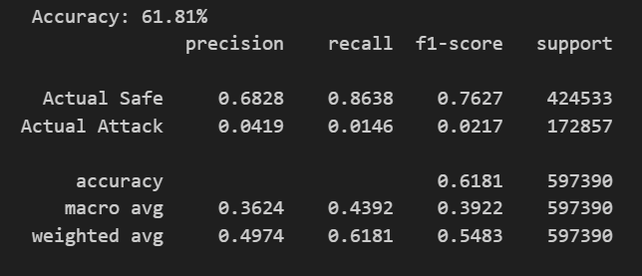
- From the confusion matrix:
  - 366,696 safe flows are correctly predicted as safe (true negatives).​
  - 2,531 attack flows are correctly predicted as attack (true positives).​
  - 57,837 safe flows are wrongly flagged as attacks (false positives).​
  - 170,326 attack flows are missed and predicted as safe (false negatives).​
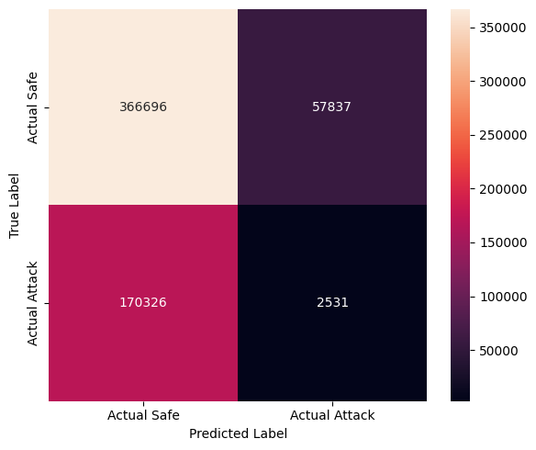

Discussion
- Both Random Forest and CNN give very strong results, with test accuracy above 99.5% and high precision/recall for both Safe and Attack traffic.
- Random Forest is slightly better and more stable: it makes only a few hundred mistakes and almost perfectly separates benign and malicious flows.
- Isolation Forest performs much worse: it correctly detects many Safe flows but misses most Attack flows and produces many false alarms, so it is not suitable as a main IDS model for this dataset.
Model results comparison
Model | Type | Accuracy | Attack precision | Attack recall | Main comment
Random Forest | Supervised | 0.9996 | ≈0.9993 | ≈0.9993 | Best performance, very few errors
1D-CNN | Supervised DL | ≈0.9952 | ≈0.99 | ≈0.99 | Very strong, slightly below RF
Isolation Forest | Unsupervised | 0.6181 | 0.0419 | 0.0146 | Misses most attacks, many false alarms

