CY2004

Cyber Security

Project

Wifi-Pumpkin

Submitted by: Aiman Qureshi,Haiqa Usman
Roll number: 23i-2051,23i-2059
Date: 17/11/2024

Table of Contents

Introduction 3
Installation 4
Starting the tool: 6
Using tool: 7
Conclusion 14
References 14

Wifi pumpkin

Introduction
In today’s digital world, cybersecurity plays a critical role in protecting data integrity, user privacy, and network security. Network security tools are essential for identifying vulnerabilities, monitoring traffic, and enhancing the protection mechanisms of Wi-Fi networks. One such tool, WiFi-Pumpkin, is an open-source security framework designed for network penetration testing and Wi-Fi network emulation.
WiFi-Pumpkin provides a platform to simulate a rogue access point, which can be used for man-in-the-middle attacks (MITM), network traffic monitoring, and credential extraction. Through this project, we will explore WiFi-Pumpkin’s setup and functions, including creating a Wi-Fi network, monitoring connected devices, and testing user interaction with a simulated login page.
This report covers the installation, configuration, and practical usage of WiFi-Pumpkin to understand how rogue networks operate and to highlight the importance of security awareness for users on public Wi-Fi networks.

Ethical Considerations:
This project is conducted purely for educational purposes to understand the risks associated with untrusted Wi-Fi networks and the importance of securing such networks. Tools like WiFi-Pumpkin3 are powerful when used responsibly in controlled environments and help raise awareness about cybersecurity threats.

Cyber security domain : offensive
Installation source : github
tool based language : python
wifi adapter: alfa 802.11n (model 3001N) uses rtl8188eus driver
os: kali linux on virtual box

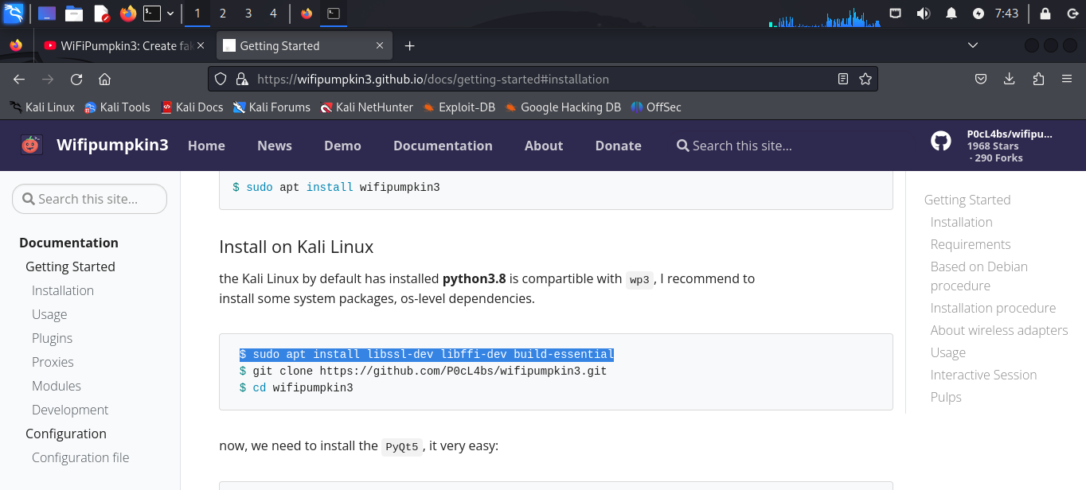

Installation
Following are the commands used for installation
(Kali linux is already installed)
First installing required packages for python as wifi pumpkin3 is built on python sudo apt install libssl-dev libffi-dev build-essential
Now cloning wifipumpkin3
git clone https://github.com/P0cL4bs/wifipumpkin3.git
cd wifipumpkin3
sudo apt install python3-pyqt5 hostapd
sudo apt install wifipumpkin3
sudo wifipumpkin3
Now the wifipumpkin is installed
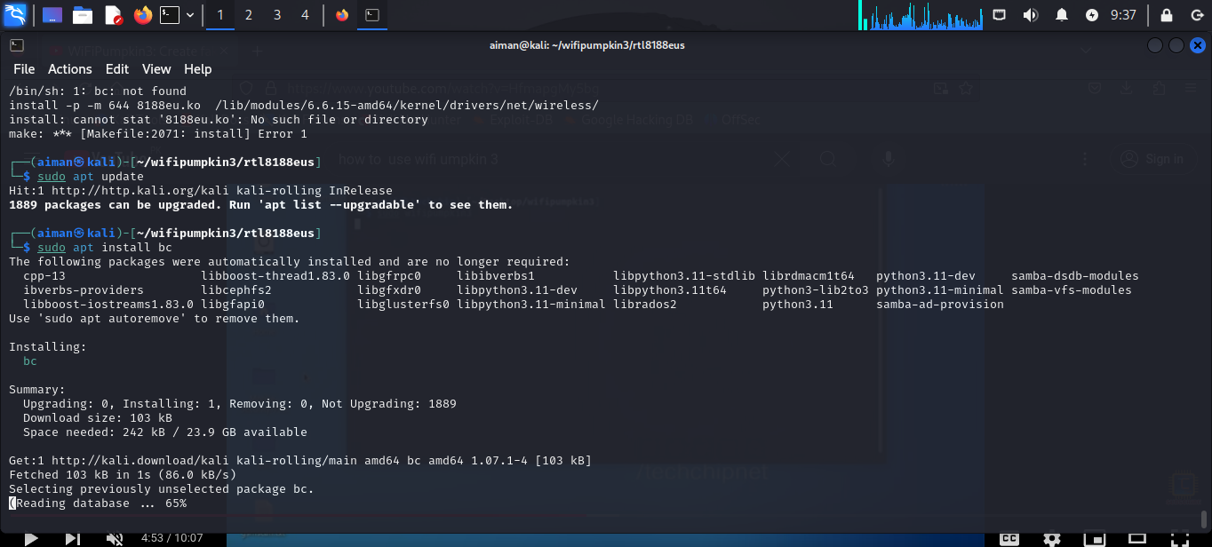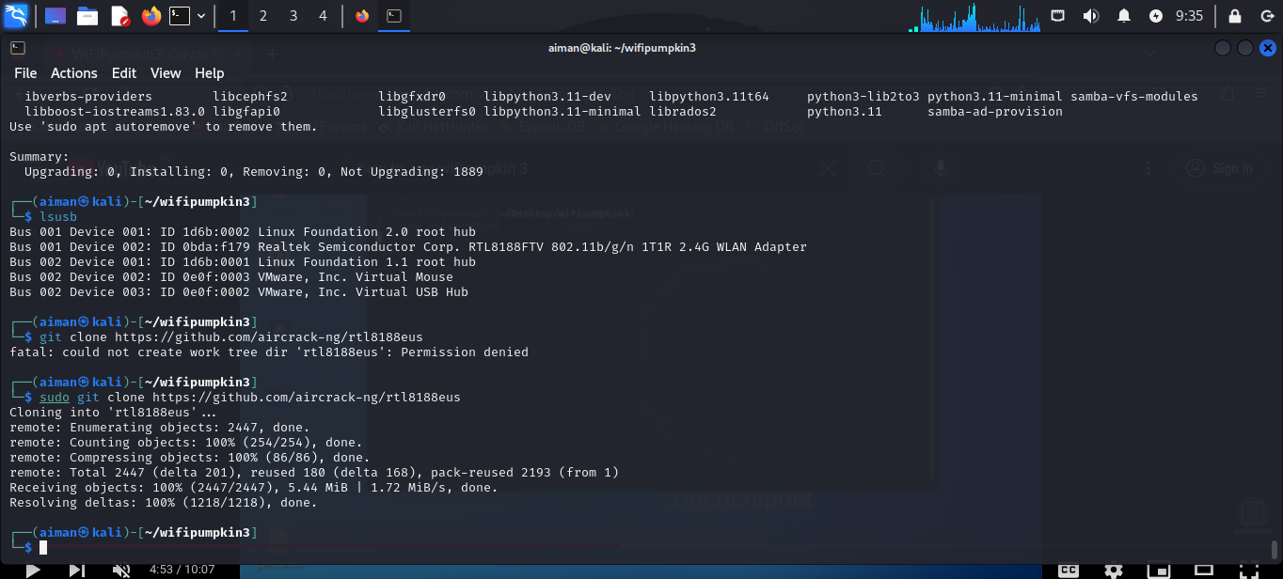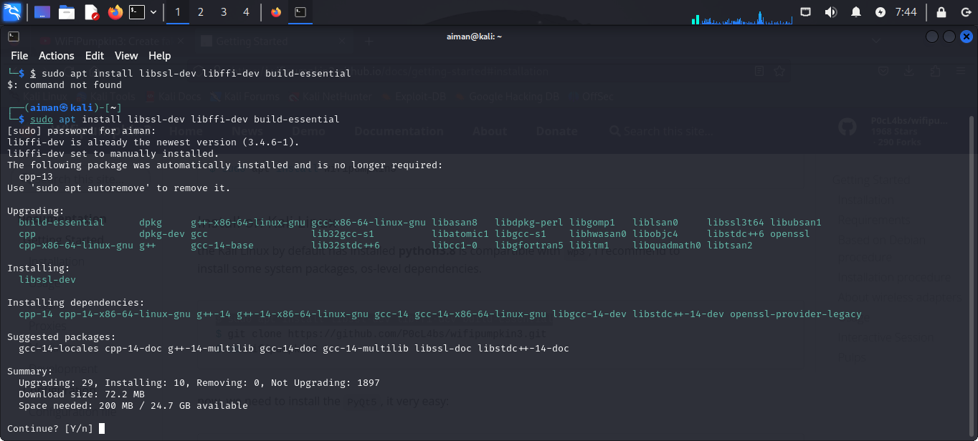

Setting:
setting interface set interface wlan0
setting name set ssid freeWifi
ignore pydns_server
Setting password as empty set security false

Starting the tool:

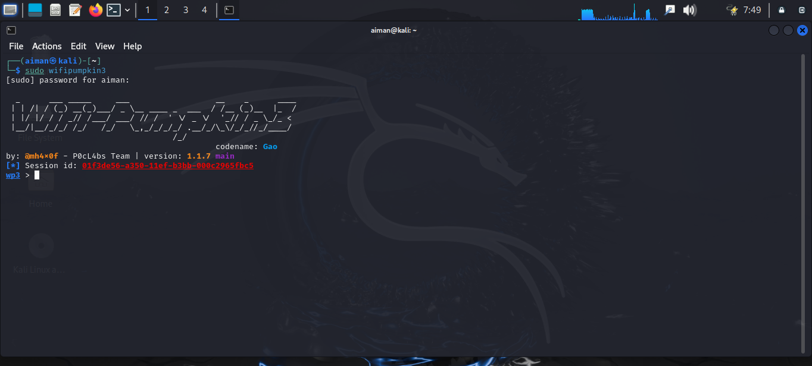
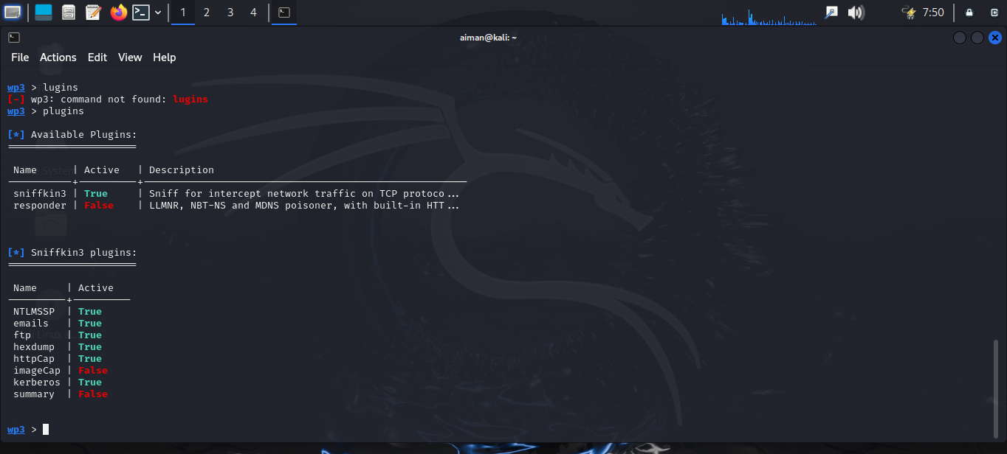
Setting wifi password:
To make it look legitimate, we can also set security as true, which enables the user to enter a wifi password,
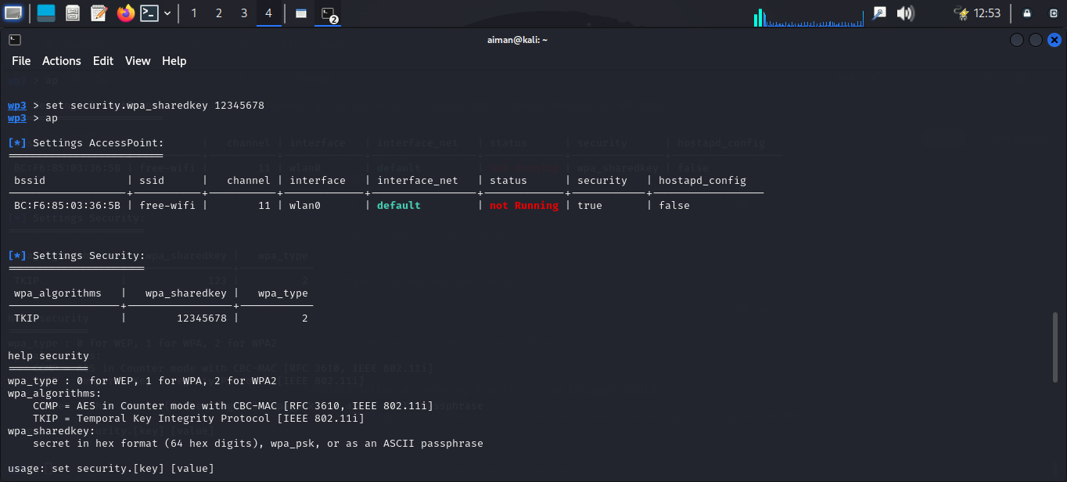

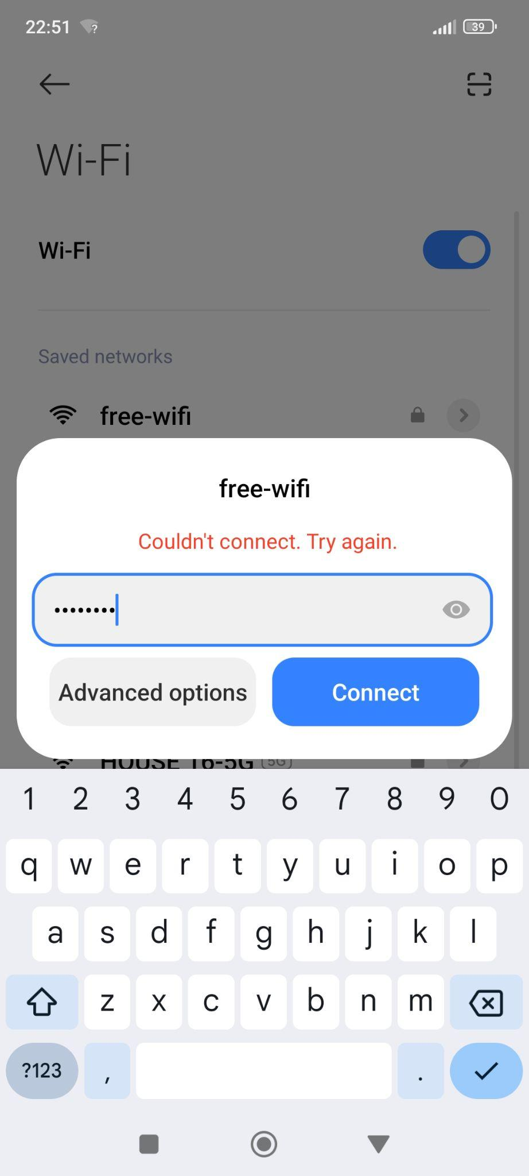

Using tool:
There are multiple uses of the tool, we chose the most common ones
First we will make a free wifi rogue access point by setting as shown above and then starting the wifi pumpkin.
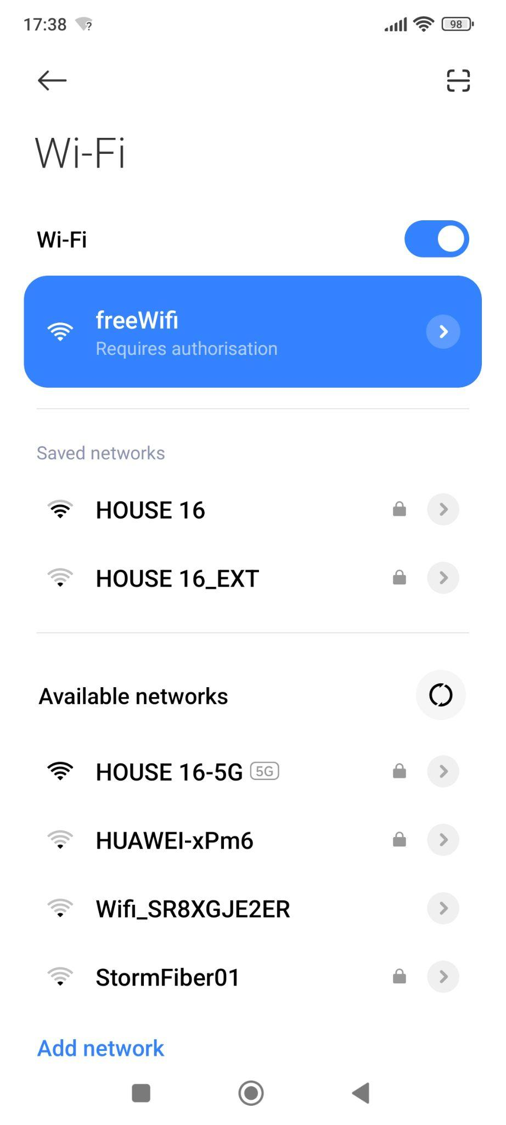
As shown in the screenshot, a free wifi is available that we just created.

Credential harvesting:
Credential harvesting is a technique used to collect sensitive information, such as usernames, passwords, or other login credentials, by tricking users into willingly providing them. Attackers often use fake login pages or phishing portals to capture this data, exploiting the trust users place in seemingly legitimate systems.

WiFi-Pumpkin3 facilitates credential harvesting by enabling the creation of a rogue access point that simulates a legitimate Wi-Fi network. When users connect to this network, they are redirected to a captive portal—a fake login page that prompts them to enter their credentials to gain internet access. WiFi-Pumpkin3 logs these credentials, demonstrating how attackers can collect sensitive information in real-world scenarios. This feature highlights the risks associated with connecting to untrusted Wi-Fi networks and underscores the importance of user awareness and secure practices.
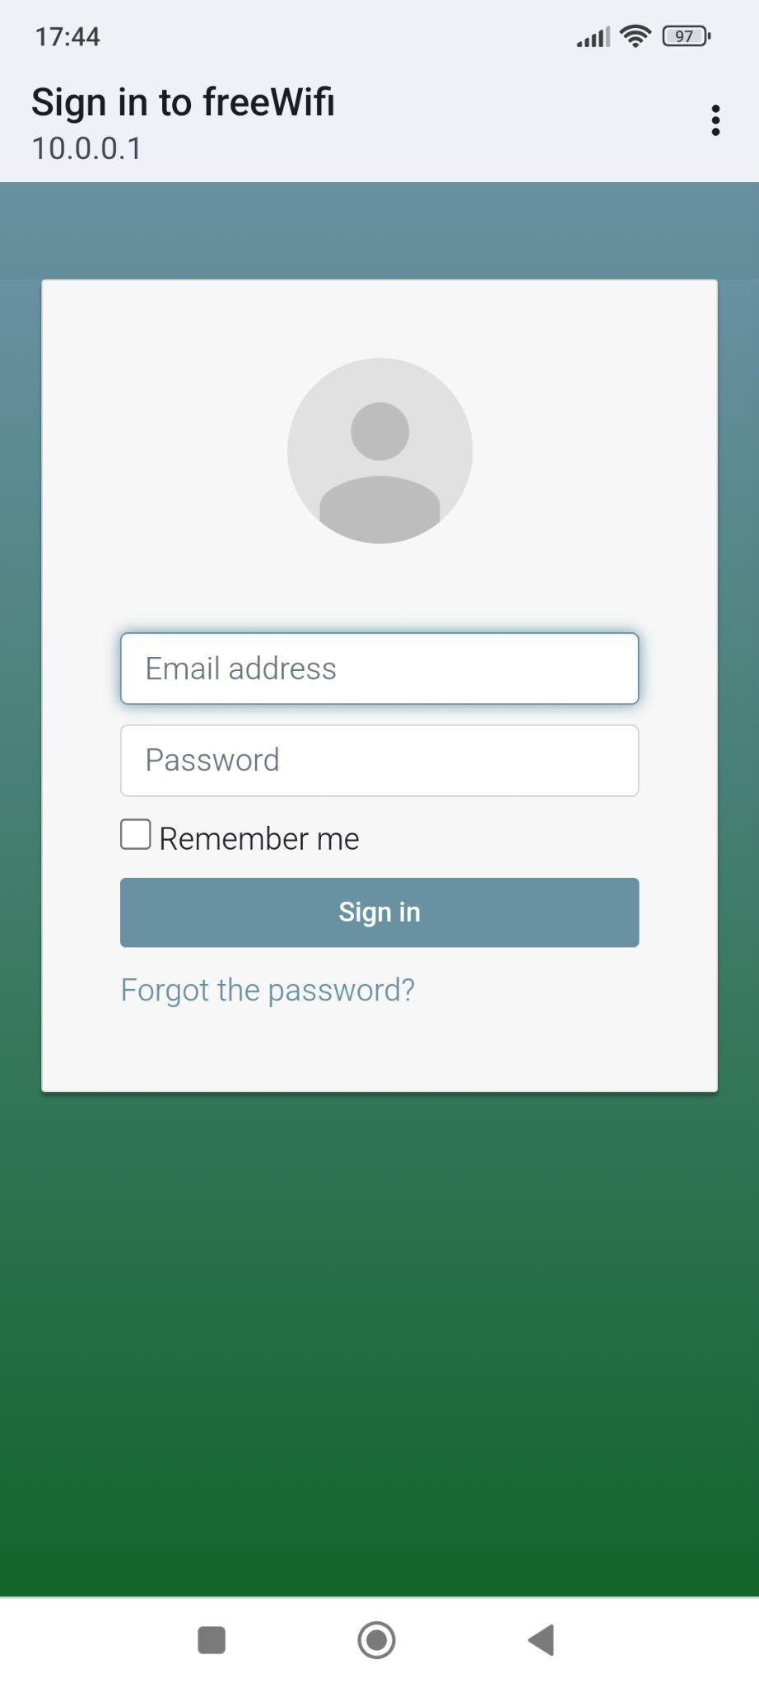
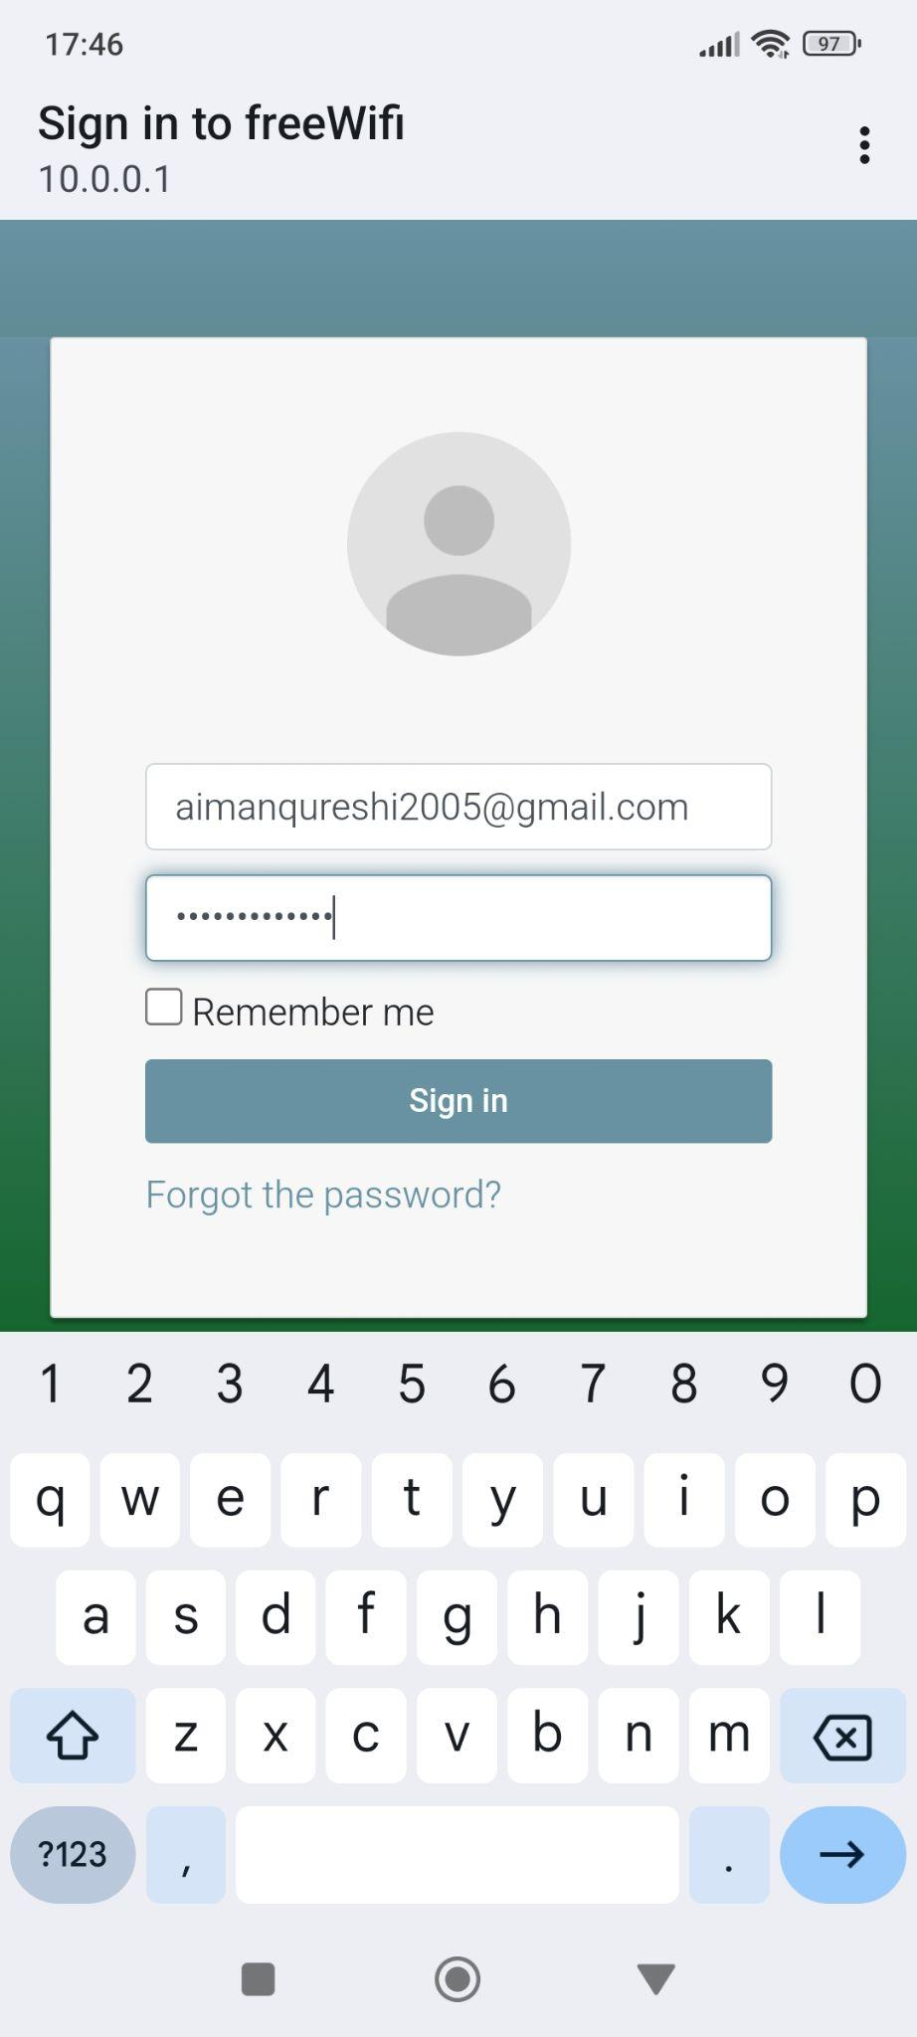
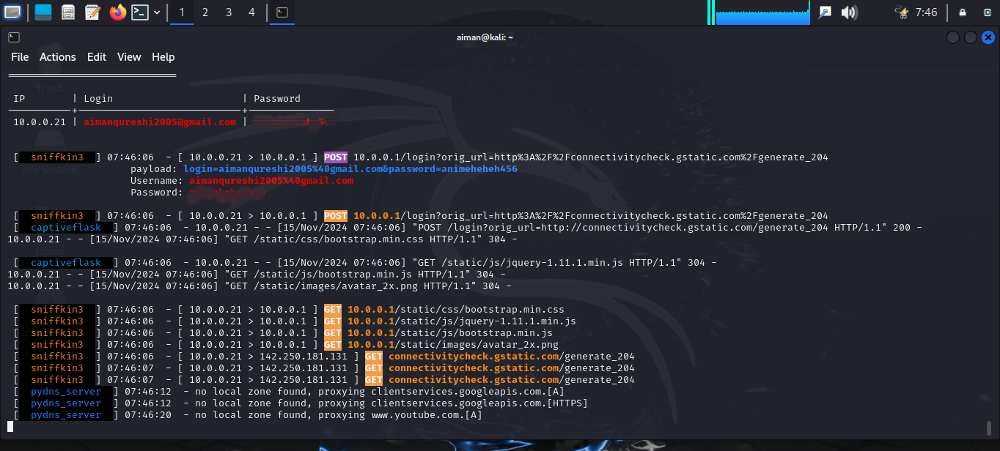
The same credentials are being shown on our wifi pumpkin that the user entered to login to use the free wifi.
Countermeasures:
To protect against credential harvesting, users should avoid connecting to public or untrusted Wi-Fi networks. Using a VPN or ensuring all connections are through HTTPS can encrypt data, making it difficult for attackers to intercept sensitive information. Additionally, users should verify the authenticity of login pages and be cautious about sharing personal information.
Like in the screenshot below, we used a vpn to protect our device

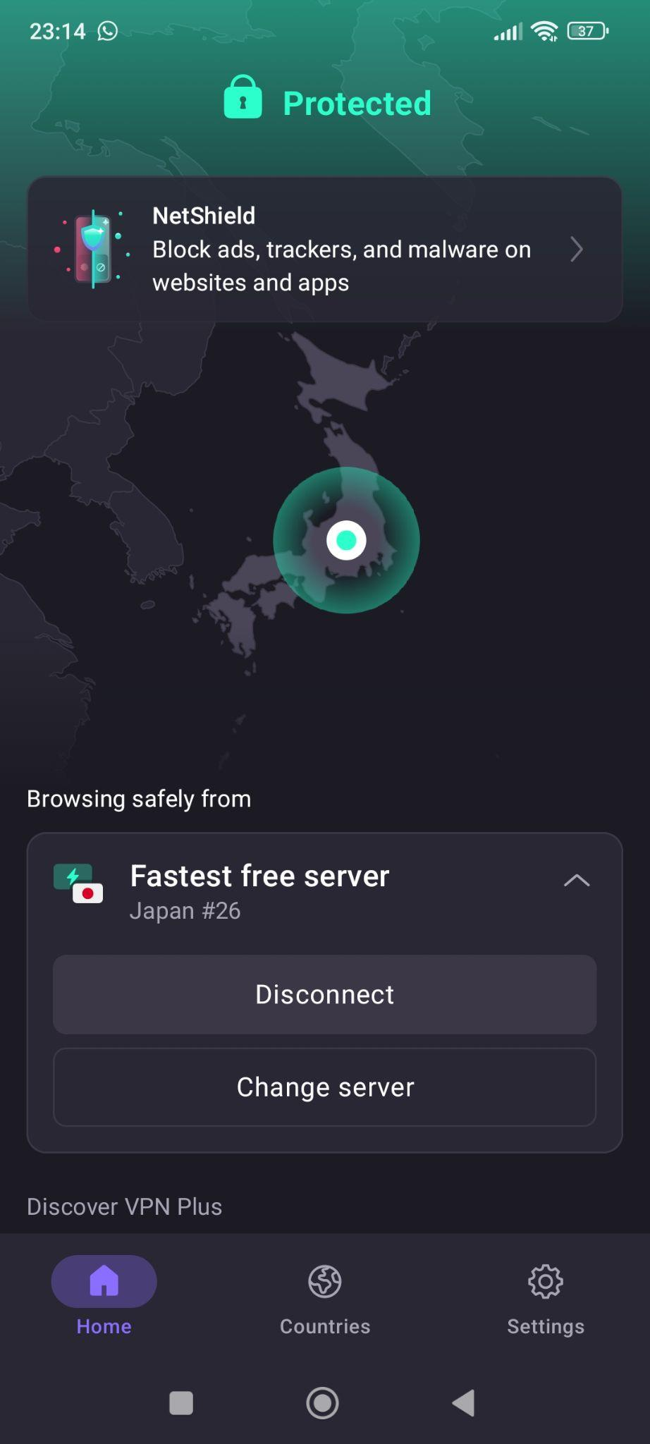
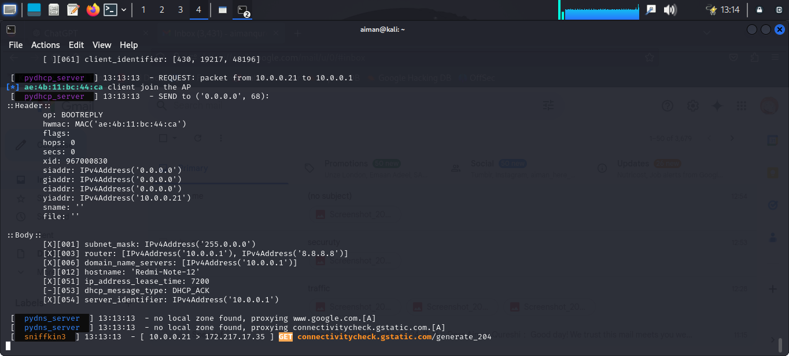
When the user is connected to a vpn, its network packets are secure and as shown above there is no information received about its activity, as soon as we disconnect from the vpn, the information starts showing again as shown in the screenshot below.
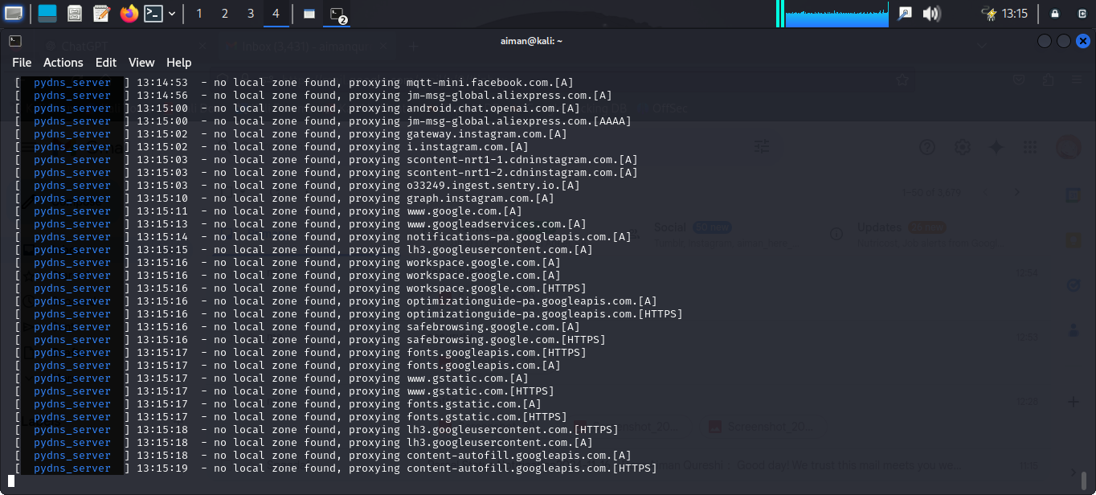

WiFi deauth attack:
A WiFi deauthentication attack forces devices to disconnect from a network, disrupting user connections. WiFi Pumpkin 3 makes it easy for security testers to simulate this type of attack to check a network’s vulnerability. By targeting specific devices or broadcasting to all, testers can see how a network reacts and identify weak spots. It's important to use this tool ethically to improve network security and prevent real attacks.
For this, we first need to set the wlan0 type monitor mode and then perform a scan using wifi.wifi deauth module to get the IP address of the wifis near us and then set that IP address as the target.
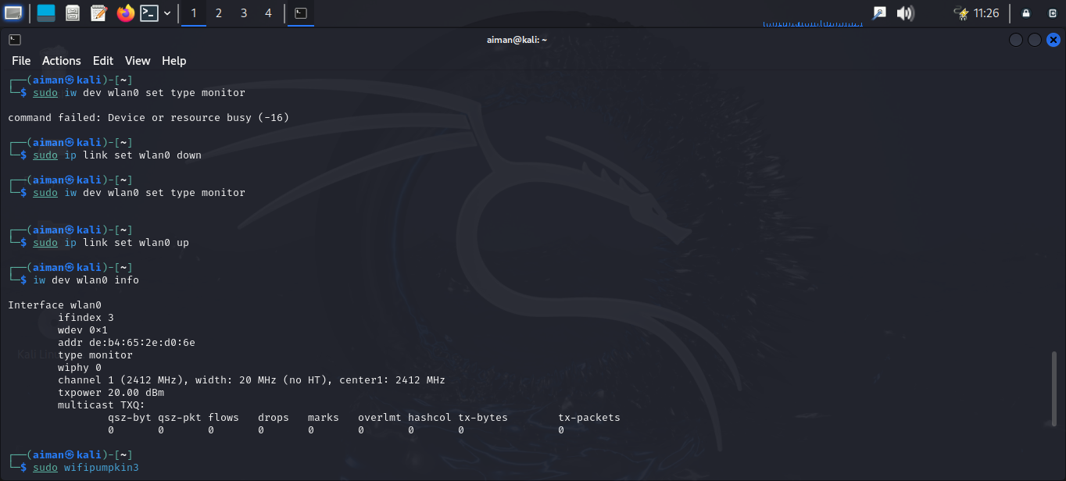
After scanning, the available wifi and their ids are shown , which we then set as target.
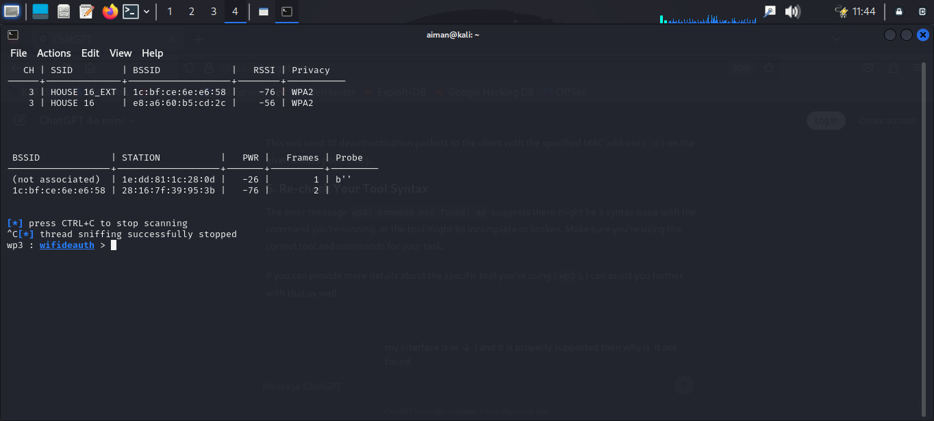
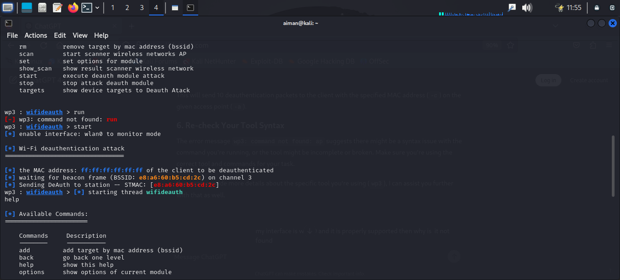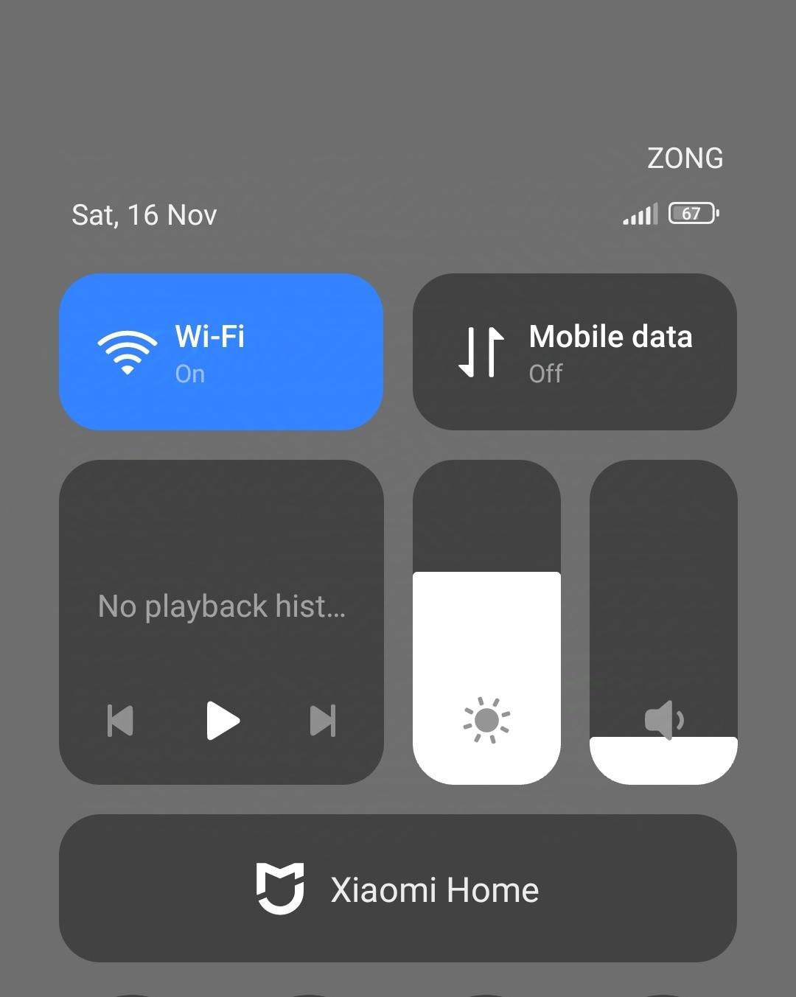
Like shown in the above screen shot, the mobile phone connected to the targeted WiFi was forcefully disconnected.
Performing a deauth attack can be useful since we can name our WiFi the same name as the targeted WiFi and after disconnecting the user would have to connect to our WiFi instead of the original one.
Ethical Use of Deauthentication Attacks:
Deauth attacks, as demonstrated in this project, must only be used in controlled environments with proper permissions. Security professionals use these techniques to test network vulnerabilities and improve defenses. Unauthorized use of such attacks is unethical and illegal, as it disrupts legitimate user connections.

Monitoring traffic:
WiFi Pumpkin is basically a tool for monitoring and testing wireless networks. It creates a fake Wi-Fi hotspot to attract users and capture their network traffic, this is used to monitor the traffic and check what types of sites the user visits.
As shown in the screenshot below,
the wifi pumpkin starts and a fake access point is shown in the devices nearby
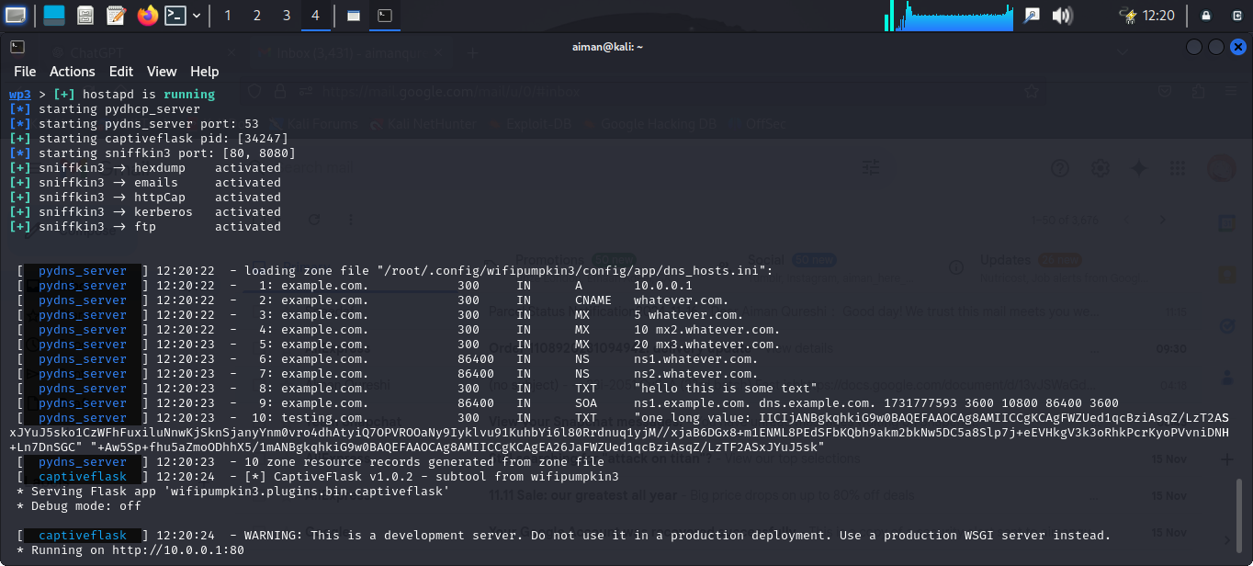
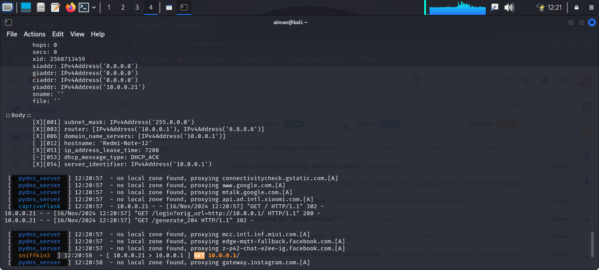
Now, as shown in the screenshot, the device “Redmi note 12” is connected to our fake wifi.

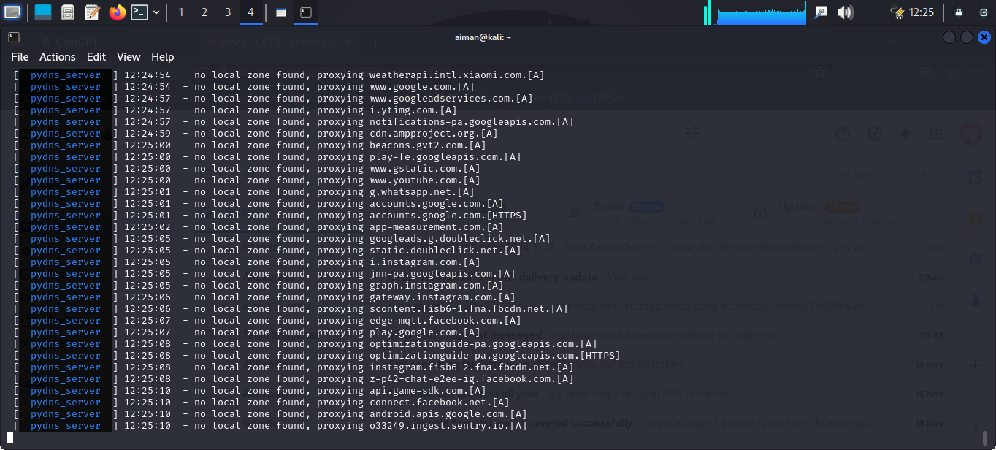
the information of all the sites visited and the activities are shown above.
Limitations of Traffic Monitoring:
While WiFi-Pumpkin3 effectively captures traffic, it cannot decrypt HTTPS connections. This limitation emphasizes the importance of encryption in securing user data. As more websites adopt HTTPS, attackers face greater challenges in monitoring user activities, highlighting the need for widespread adoption of encryption standards.

Conclusion
In this project, we explored the setup and usage of WiFi-Pumpkin3 to simulate common Wi-Fi attacks, including credential harvesting, Wi-Fi deauthentication, and traffic monitoring. These demonstrations reveal how attackers exploit untrusted networks to compromise user privacy and security.
Through this project, we also emphasized the importance of user awareness and preventive measures, such as avoiding public Wi-Fi, using VPNs, and ensuring secure connections through HTTPS. Tools like WiFi-Pumpkin3 are invaluable for educational purposes, helping cybersecurity professionals understand and mitigate real-world threats. However, their use must remain ethical, highlighting the dual responsibility of enhancing security while respecting user privacy.

References
github link

