Table of Contents

VIFM Assessment Center — User Guide
A custom-built Assessment Center management platform that runs the VIFM-AC Framework end-to-end: from engagement design and candidate management, through structured exercises and assessor observation, to wash-up consensus and a 6-page bilingual candidate report. Plus a self-serve learning track with AI-generated quizzes and a recommender that bridges every diagnostic gap to a VIFM training programme.
This guide walks through the full lifecycle for each role.

Table of contents
- At a glance
- Roadmaps — the journey for each role
  - Consultant (admin) roadmap
  - Assessor roadmap
  - Delegate (candidate) roadmap
  - Client roadmap
- Detailed walkthroughs
  - Consultant — designing and running an engagement
  - Assessor — observing, rating, and consensus-building
  - Delegate — completing the assessment journey
  - Client — reading reports and acting on outputs
- Reference

At a glance
Who uses it | VIFM consultants/admins (run engagements), assessors (observe + rate), candidates/delegates (complete assessments), clients (read reports)
Framework | VIFM-AC: 4 domains (THINKING / RESULTS / PEOPLE / SELF), 8 clusters, 38 competencies, 249 behavioural indicators, 114 development tips
Exercises | In-Basket · Role Play · Group Exercise · Case Study · Oral Presentation · CBI
Scoring | BARS 1–5 per competency; Overall Assessment Rating (OAR) 1–5 → Ready Now / Ready with Development / Not Ready
Reports | 6-page bilingual candidate report + 4-page personalised Learning Plan (30/60/90-day roadmap + recommended VIFM programmes)
Compliance | UAE PDPL · Saudi PDPL · GDPR · ISO 10667 · ITF AC Guidelines (6th ed.)
Entry points by role:
- /admin — admin/consultant portal (engagements, candidates, exercises, role profiles, courses)
- /assessor — assessor portal (assignments, observation, washup)
- /candidate/welcome/[id] — candidate entry (welcome → consent → assessments → skills → report)
- /client — client portal (engagements, candidates, analytics)
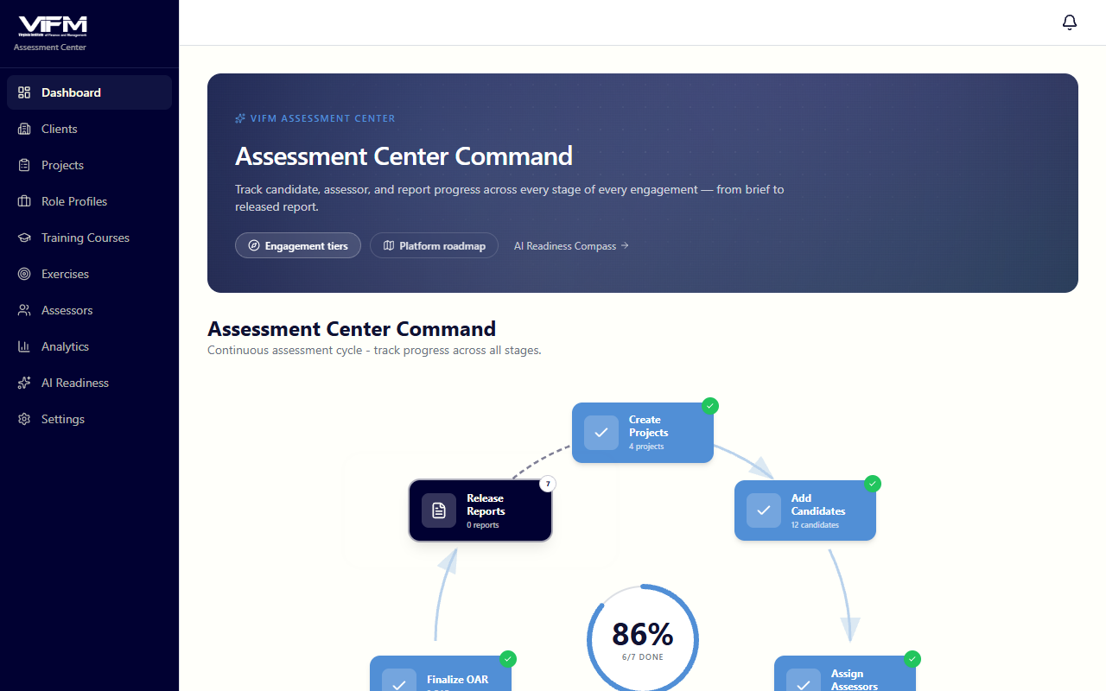

Roadmaps

Consultant (admin) roadmap
The end-to-end path for a VIFM consultant running an Assessment Center engagement. From client intake through report release.
Key checkpoints:
Step | Where | Notes
Client org | /admin/clients | One organisation = one client account; engagements live under it
Engagement wizard | /admin/engagements/new | 5 steps. Step 2 includes the JD-to-competency extractor + role profile picker
Add candidates | Engagement detail · candidates tab | Per-row role-profile dropdown; CSV bulk import via /admin/role-profiles/bulk-assign
Assign assessors | /assessor/assignments/[engagementId] | Grid view: each row a candidate, each column an exercise
Wash-up | /assessor/washup/[engagementId]/[candidateId] | Realtime via Supabase Realtime; radar chart + colour-coded score summary
Release report | Engagement detail → "Release reports" | Sets per-candidate report_status='released' so candidates can view
Re-engage | Engagement detail → "Re-engage cohort" | Copies design + candidates with prior_*_id links → OAR delta pill on the new run

Assessor roadmap
The path for an assessor — receiving assignments, observing the candidate, capturing behavioural notes, scoring on BARS, building consensus with co-assessors.
![Roadmap diagram 2: A[Receive assignmentemail or dashboard] --> BOpen assignment/assessor
Per-exercise observation tabs (4):
- Overview — exercise type, candidate, target competencies, timing, brief
- Observe — free-text behavioural notes with AI-suggested competency tags + +/- indicators
- Rate — BARS scoring (1–5 or NE) per competency with strength + development split
- Q&A — three question prompts per competency for follow-up dialogue

Delegate (candidate) roadmap
The candidate-side journey — from the welcome email through the report.
![Roadmap diagram 3: A[Receive welcome emailor token URL] --> BWelcome page/candidate/welc
What candidates see at each step:
Step | URL | Notes
Welcome | /candidate/welcome/[id] | Engagement details, role profile name, what to expect
Consent | /candidate/consent/[id] | GDPR / UAE PDPL form. Required before any data collection
Assessments | /candidate/assessments/[id] | Exercise schedule with timing
Skills dashboard | /candidate/skills/[candidateId] | Per-competency gap badges + 3-chart stats panel + Start AI Quiz buttons
Quiz | /candidate/quiz/[attemptId] | 7-question AI-generated quiz: 4 MCQ + 2 T/F + 1 cognitive pattern, 5-min timer
Quiz results | /candidate/quiz/[attemptId]/results | Score + per-question review with AI explanations in a Lightbulb tip box
Report | /candidate/report/[id] | Final 6-page bilingual report (gated until release)
Learning Plan | (download from report page) | 4-page React-PDF: Cover · 30/60/90 roadmap · per-competency cards · top-5 VIFM programmes

Client roadmap
The client-side path — sponsoring organisations review their cohort and act on the diagnostic.
![Roadmap diagram 4: A[Engage VIFMscope + commercials] --> BProvide candidate list+ role p
What the client sees:
- Engagement list — /client/engagements — all their engagements with VIFM
- Engagement results — /client/engagements/[id] — candidate roster with OAR + gap-severity badges
- Reports — /client/reports — cross-engagement report viewer
- Analytics — /client/analytics — cohort strengths and development areas

Detailed walkthroughs

Consultant — designing and running an engagement

1. Sign in
/admin opens the admin/consultant portal. The collapsible sidebar shows the process map and module sections.
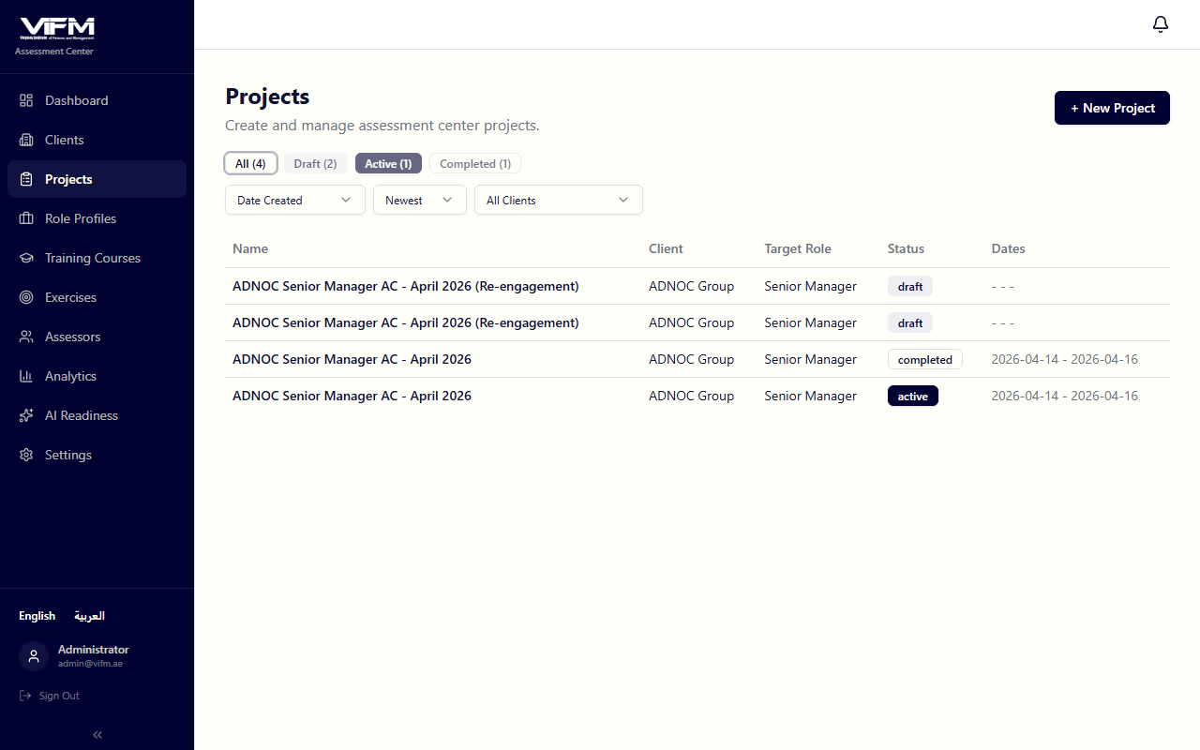

2. Set up the client organisation
/admin/clients. Each client corresponds to one sponsoring organisation; engagements live under it.

3. Create the engagement (5-step wizard)
/admin/engagements/new. The wizard walks through:
Step 1 — Identity: Engagement name · client org · target role · start/end dates.
Step 2 — Competency profile: Choose the competencies the AC will assess. Two paths:
(a) JD-to-competency extractor. Paste or upload a job description (Arabic or English, text or PDF). Claude extracts the most relevant 6–10 VIFM competencies and surfaces them with weight + priority + reasoning + a domain tally card (THINKING / RESULTS / PEOPLE / SELF chips with counts).
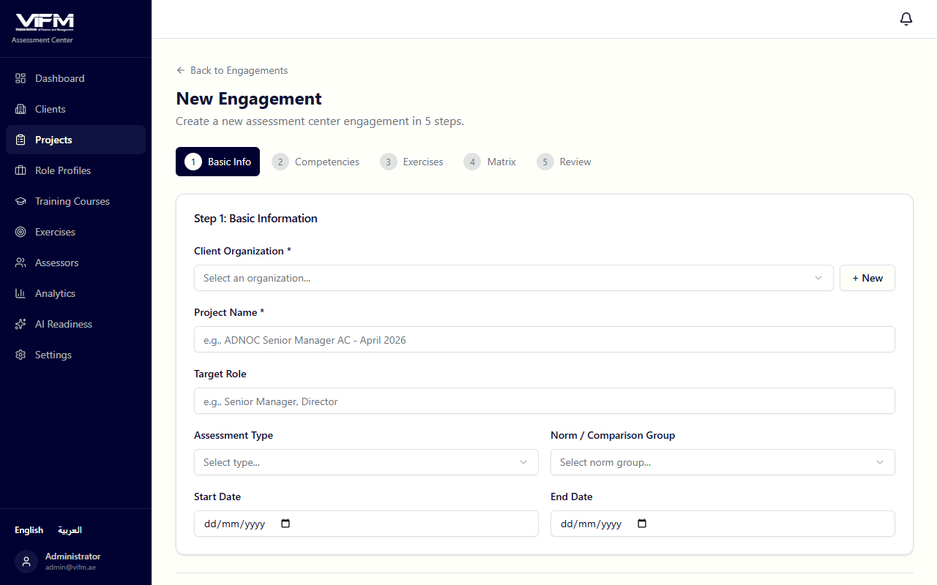
(b) Role profile picker. Reuse a pre-built competency pack from /admin/role-profiles. Six GCC banking + government profiles seeded; build your own via the Role Profile editor or bulk-import via /admin/role-profiles/bulk-import.
Each competency must appear in at least 2 exercises (enforced by Zod validation) so the AC has triangulated evidence.
Step 3 — Exercise selection: Pick from the exercise library and tune the exercise-to-competency matrix.
Step 4 — Assessors: Assign assessors at the engagement level (specific exercise assignments come later).
Step 5 — Review: Final pass before save.

4. Add candidates
On the engagement detail page → candidates tab.
For each candidate:
- Name + email
- Role profile (per-row dropdown) — drives the skill dashboard's target levels
- Demographic fields (department, gender, age range, seniority — optional)
CSV bulk-assign of role profiles by email at /admin/role-profiles/bulk-assign.
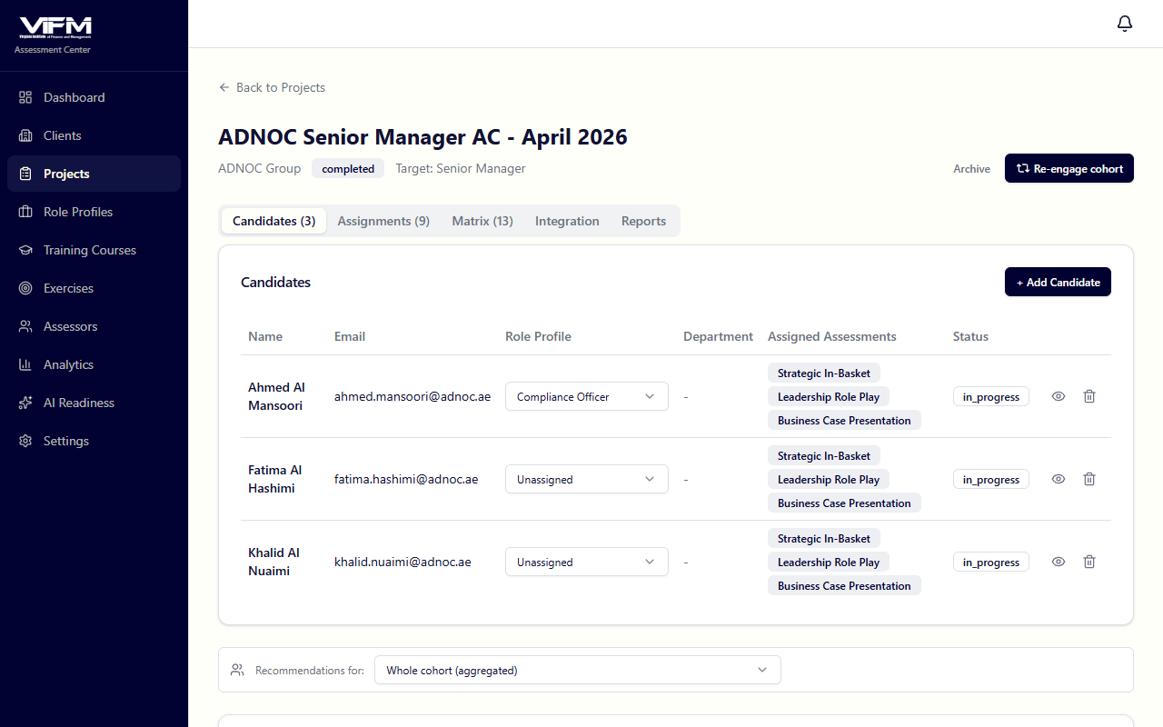
The candidates table also shows:
- Per-row "view as candidate" eye icon — opens /candidate/welcome/[id]?asAdmin=1 in a new tab with an amber banner, lets you see exactly what the candidate sees
- OAR delta pill — when this is a re-engagement run (G7), shows ↑+1 / ↓-1 vs the prior assessment
- Gap-severity badges when scores are in

5. Assign assessors per exercise
/assessor/assignments/[engagementId]. Grid view — rows = candidates, columns = exercises. Click a cell to assign an assessor.

6. Monitor the engagement
The engagement detail page shows progress. Below the candidates table:
- VIFM training recommendations panel — cohort-aggregated gaps × course relevance. Use a ?candidate=<id> URL filter to switch to per-candidate view
- Notifications bell in the header — rose unread badge; popover shows the 20 newest items (e.g., a candidate completed a quiz)

7. Wash-up engine
After all assessors have rated, run the wash-up at /assessor/washup/[engagementId]/[candidateId] (consultants are typically present too).
Features:
- Supabase Realtime — multiple users see edits live without refresh
- Radar chart of consensus ratings vs target
- Colour-coded score summary — strengths in emerald, gaps in rose
- Per-competency consensus discussion + final score
- OAR recommendation — drops out of the consensus discussion

8. Release the report
Once the OAR is set, on the engagement detail click Release reports. This flips per-candidate report_status='released', allowing candidates to access their reports.
The 6-page bilingual report is generated on demand at /api/reports/[engId]/[candId]/pdf:
- Cover
- About AC (methodology)
- Summary (overall + competency table with gap-severity badges)
- Per-competency detail with strength/development split
- Development recommendations
- (Stage extension) Year-on-year if applicable

9. Re-engage the cohort
Engagement detail header → Re-engage cohort (visible when status is completed or archived). Modal asks whether to carry candidates; on confirm:
- Copies the engagement design (competencies, exercises, exercise-competency matrix)
- Copies the candidates (preserving role-profile binding, demographics) with prior_candidate_id links
- Does NOT copy assessor assignments, observations, ratings, reports — the new run scores fresh
- OAR delta pill renders on each candidate row once the new run scores

10. Curate VIFM courses + role profiles + exercises
For ongoing maintenance:
- /admin/courses — VIFM training catalogue (127 imported as of Apr 2026). Drag-and-drop AI extraction at /admin/courses/import. Per-course AC competency + ARA pillar mapping. Levenshtein duplicate-finder at /admin/courses/duplicates.
- /admin/role-profiles — reusable competency packs. Bulk-import JDs at /admin/role-profiles/bulk-import. JSON export at /api/role-profiles/[id]/export.
- /admin/exercises — exercise library with 4 detail tabs (Overview · Briefing · Timing · Role-player guides).
- /admin/analytics — ICC inter-rater reliability, bias detection, Recharts visualisations.
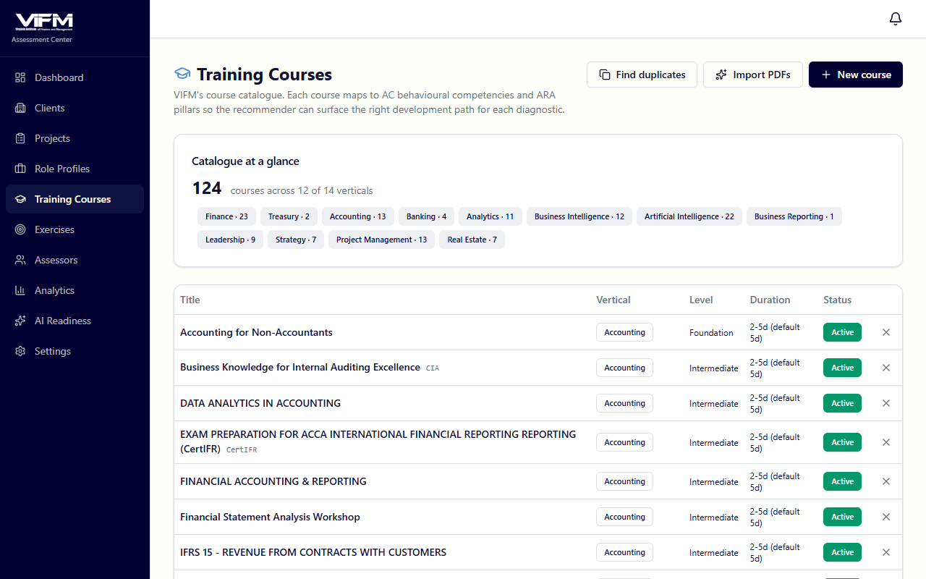

Assessor — observing, rating, and consensus-building

1. Open the assessor portal
/assessor/assignments — engagement picker + assignment grid.
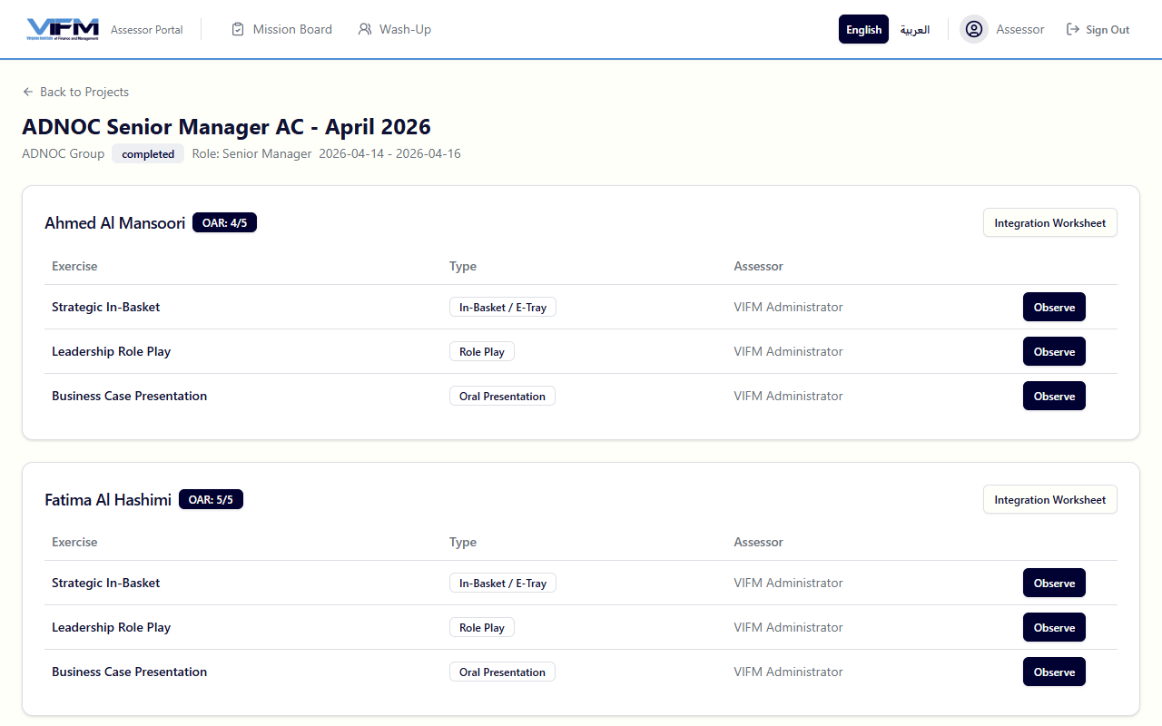
The grid shows rows for candidates and columns for exercises. Each cell is your observation slot — Observe button opens the 4-tab observation form.

2. Observation form (4 tabs)
/assessor/observation/[assignmentId].
Tab 1 — Overview: Exercise type, candidate, target competencies, timing breakdown (instructions / prep / meeting), participant brief, scenario context.
Tab 2 — Observe: Free-text behavioural notes. As you type, an AI classifier suggests the closest VIFM competency and a +/- indicator. You can override; suggestions are advisory.
Tab 3 — Rate: BARS 1–5 per competency, plus NE (No Evidence). Strength notes and development notes split visually so the wash-up has anchored evidence.
BARS | Label
5 | Significant Strength
4 | Strength
3 | Competent
2 | Development Needed
1 | Significant Development Needed
NE | No Evidence
Tab 4 — Q&A: Three question prompts per competency for follow-up dialogue with the candidate.

3. Integration worksheet
After observing all your assigned exercises for a candidate, run the integration worksheet at /assessor/integration/[engagementId]/[candidateId]. This is your pre-wash-up consolidation — a unique constraint at the DB level prevents duplicates per (engagement, assessor, candidate, competency).

4. Wash-up
/assessor/washup/[engagementId]/[candidateId]. Joint session with co-assessors. Realtime consensus → final consensus score per competency → OAR recommendation.
The wash-up is the single most important differentiator of the VIFM AC method — bring observed evidence, listen, integrate, agree.

Delegate — completing the assessment journey

1. Welcome page
/candidate/welcome/[id]. Personalised greeting with engagement details, role profile name, and what to expect.
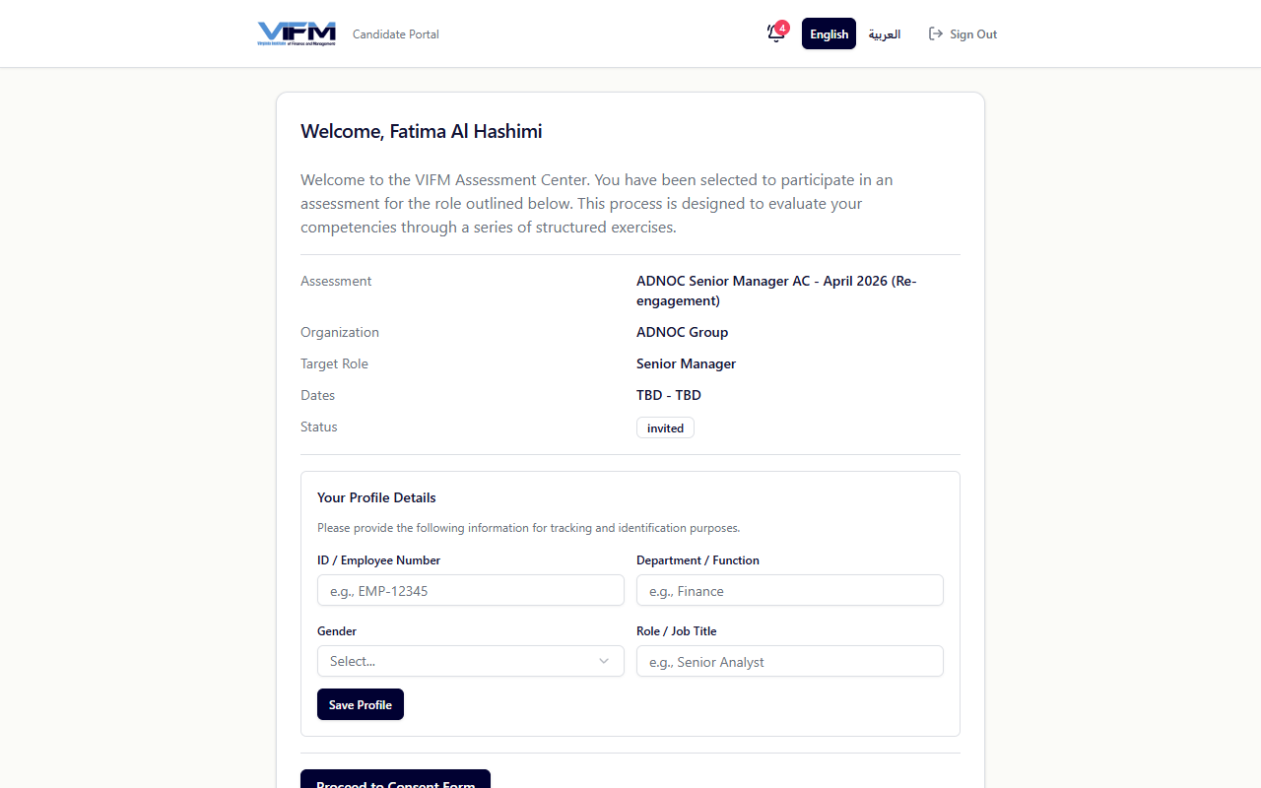

2. Consent form
/candidate/consent/[id]. GDPR / UAE PDPL consent. Required before any further data collection. Admins can see whether candidates have consented in the engagement detail.

3. Assessment schedule
/candidate/assessments/[id]. Shows the scheduled exercises with timing. The actual Assessment Center is run in person or via video — this page is the briefing.

4. Skills dashboard
/candidate/skills/[candidateId]. Linked from the post-consent welcome page.
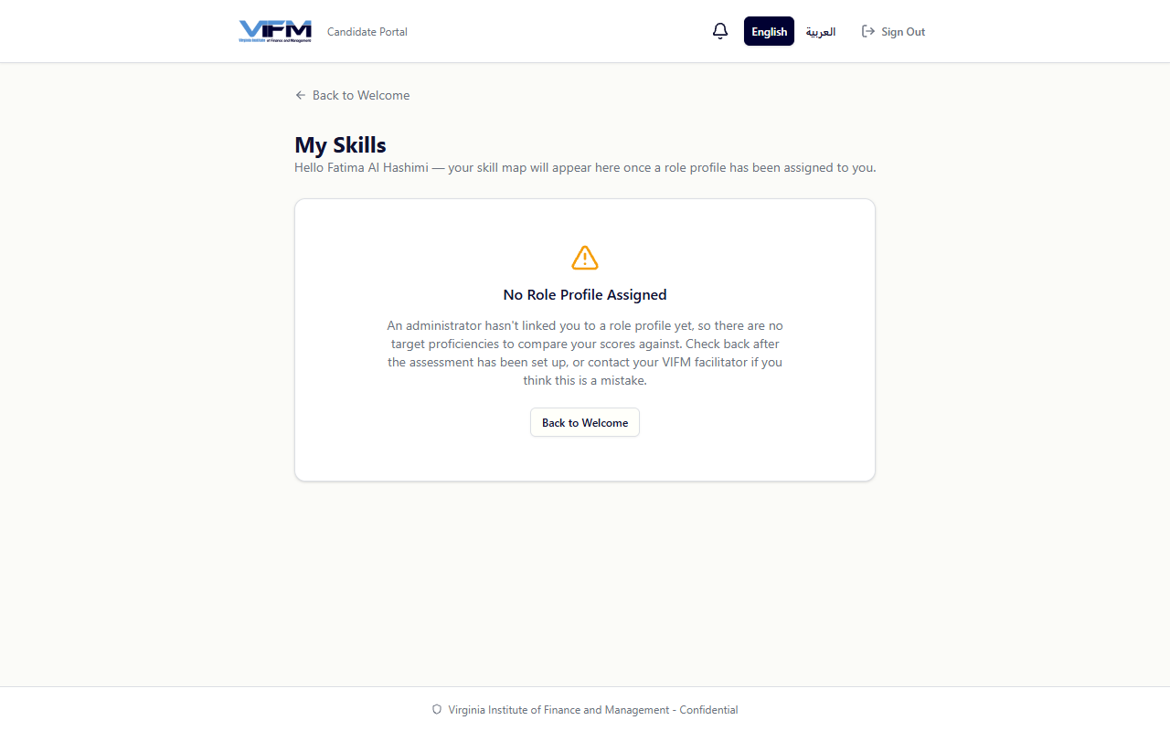
What's on this page:
- 4 stat cards — Total · Assessed · Skills with Gaps · Average Score
- Personal-statistics charts — Assessment Progress donut · Skills by Domain donut · Average Score by Domain bar chart (4 VIFM domain colours: THINKING blue / RESULTS green / PEOPLE orange / SELF violet)
- Per-skill cards grouped by VIFM domain with target / current BARS / gap badge
- Start AI Quiz button on each skill card

5. Self-serve AI quiz
Click Start AI Quiz on any skill card → /candidate/quiz/[attemptId].
- 7 questions mixing 4 multiple-choice + 2 true/false + 1 cognitive pattern-recognition
- Mixed difficulty — Easy / Medium / Hard pills
- 5-minute timer with graceful "End Session" option
- Bilingual EN/AR via i18n
Results page (/candidate/quiz/[attemptId]/results):
- Score circle + 3 stat cards
- Per-question review with AI-generated explanation in a Lightbulb tip box — the highest-value learning moment
- Retake quiz button if the candidate wants another attempt with fresh AI-generated questions

6. Notifications bell
In the header of every /candidate/* page. Rose unread badge. Click for the 20 newest items (e.g., role-profile bound, quiz completed, report released).

7. Final report
/candidate/report/[id]. Gated behind report_status='released' per-candidate. Shows:
- 6-page bilingual report
- Two PDF downloads: Full report (/api/reports/[engId]/[candId]/pdf) and Learning Plan (/api/reports/[engId]/[candId]/learning-plan)
The report uses gap-severity badges to communicate where the candidate stands per competency: Significant Gap (N levels) · On Target · Strength.

8. Learning Plan PDF
A 4-page React-PDF personalised plan:
- Cover — candidate name, engagement, generation date
- 30/60/90-Day Roadmap — concrete actions per phase
- Per-competency action cards with <GapPill> mirroring the on-screen badges
- Top-5 recommended VIFM programmes with ★ HIGH FIT badges, per-driver chips, AI rationale

Client — reading reports and acting on outputs

1. Sign in
/client. Top nav with process map.

2. Engagement list
/client/engagements. All your engagements with VIFM. Click one to see its candidate roster.
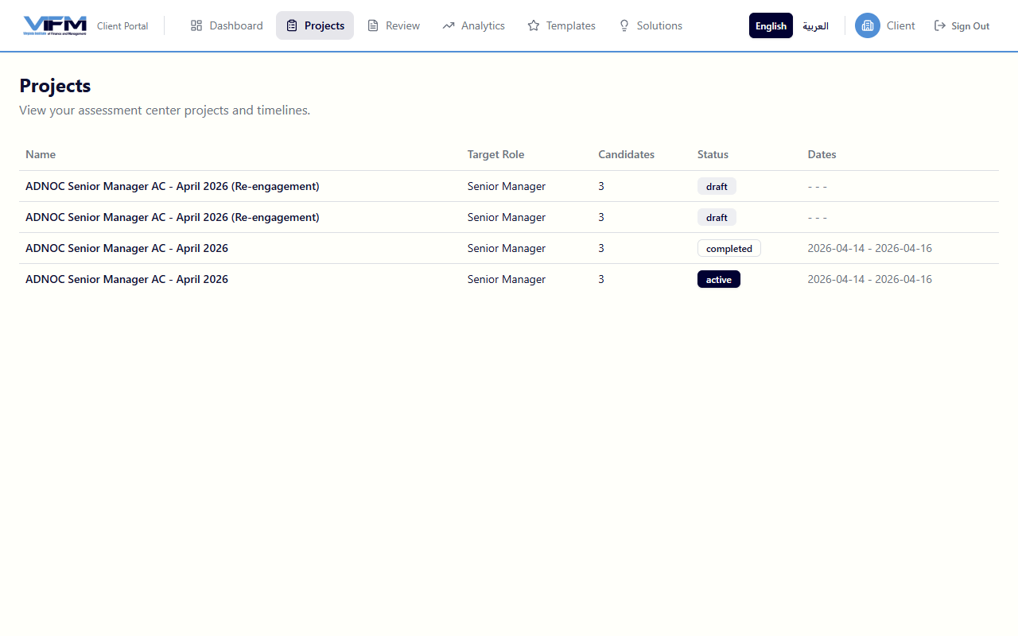

3. Engagement detail
/client/engagements/[id]. Per-candidate row with:
- Name + role
- OAR (Ready Now / Ready with Development / Not Ready)
- Gap-severity badges for top 3 gaps
- Download links for each candidate's released report + Learning Plan

4. Reports
/client/reports. Cross-engagement report viewer — useful for clients with multiple engagements over time.

5. Analytics
/client/analytics. Cohort-level strengths and development areas with Recharts visualisations.

Reference

The VIFM-AC Framework
Layer | Count
Domains | 4 (THINKING · RESULTS · PEOPLE · SELF)
Clusters | 8
Competencies | 38
Behavioural indicators | 249 (positive + negative per competency)
Development tips | 114 (3 per competency)
Tags | 5 per competency
Q&A questions | 3 per competency

BARS scale
Score | Label
5 | Significant Strength
4 | Strength
3 | Competent
2 | Development Needed
1 | Significant Development Needed
NE | No Evidence

Overall Assessment Rating (OAR)
OAR | Recommendation
4–5 | Ready Now
3–3.99 | Ready with Development
< 3 | Not Ready

Gap-severity badges
Computed as target - current on the consensus rating:
Gap | Tone | Label
≥ 2 levels | rose | Significant Gap (N levels)
1 level | amber | Gap
0 | neutral | On Target
-1 | sky | Slight Strength
≤ -2 | emerald | Strength

Compliance & retention
- UAE Federal Decree-Law No. 45 of 2021 (Data Protection)
- Saudi Arabia PDPL
- GDPR for EU/UK operations
- ISO 10667 — Assessment of People in Work and Organisational Settings
- International Taskforce on Assessment Center Guidelines (6th Edition)
- Default retention: 2 years post-engagement (extendable contractually)
- Audit trail on all significant actions (immutable)

URL map
URL | Who | Purpose
/admin | Admin | Process map dashboard
/admin/clients | Admin | Client orgs
/admin/engagements | Admin | Engagement list
/admin/engagements/new | Admin | 5-step engagement wizard
/admin/engagements/[id] | Admin | Engagement detail (candidates, recommendations, analytics)
/admin/exercises | Admin | Exercise library
/admin/role-profiles | Admin | Reusable competency packs
/admin/role-profiles/bulk-import | Admin | Drag-drop multi-JD AI extraction
/admin/role-profiles/bulk-assign | Admin | CSV email-to-role-profile linker
/admin/courses | Admin | VIFM training catalogue
/admin/courses/import | Admin | AI PDF course extraction
/admin/courses/duplicates | Admin | Levenshtein near-match finder
/admin/courses/[id] | Admin | Course detail + AC/ARA tag mapping
/admin/analytics | Admin | ICC, bias detection, Recharts
/admin/settings | Admin | Integration status, compliance, env info
/assessor/assignments/[engagementId] | Assessor | Candidate × exercise grid
/assessor/observation/[assignmentId] | Assessor | 4-tab observation form
/assessor/integration/[engagementId]/[candidateId] | Assessor | Pre-wash-up consolidation
/assessor/washup/[engagementId]/[candidateId] | Assessor | Realtime consensus engine
/candidate/welcome/[id] | Candidate | Welcome page
/candidate/consent/[id] | Candidate | GDPR / UAE PDPL consent
/candidate/assessments/[id] | Candidate | Schedule
/candidate/skills/[candidateId] | Candidate | Skills dashboard with quizzes
/candidate/quiz/[attemptId] | Candidate | AI quiz interface
/candidate/quiz/[attemptId]/results | Candidate | Score + AI explanations
/candidate/report/[id] | Candidate | Final 6-page bilingual report
/api/reports/[engId]/[candId] | Candidate / Client | Full report PDF
/api/reports/[engId]/[candId]/learning-plan | Candidate / Client | 4-page Learning Plan PDF
/client/engagements | Client | Engagement list
/client/engagements/[id] | Client | Candidate roster + OAR
/client/reports | Client | Cross-engagement viewer
/client/analytics | Client | Cohort strengths + gaps

Last updated: 2026-04-29.

