Table of Contents

VIFM AI Readiness Compass — User Guide
A bilingual (EN / AR) diagnostic platform that measures how ready an organisation — or an individual — is to make AI work in the GCC context. Calibrated against UAE and Saudi regulatory frameworks, scored across 8 organisational pillars and 4 personal factors, and packaged in a board-grade bilingual PDF report.
This guide walks through the full lifecycle for each role.

Table of contents
- At a glance
- Roadmaps — the journey for each role
  - Consultant roadmap
  - Delegate (respondent) roadmap
  - Client roadmap
- Detailed walkthroughs
  - Consultant — running an organisational engagement
  - Delegate — completing a respondent survey
  - Personal — taking the free snapshot
  - Client — receiving and using the report
- Admin tasks — curating the knowledge base
- Reference

At a glance
Who uses it | VIFM consultants (run engagements), respondents/delegates (answer the survey), client sponsors (read reports), admins (curate question bank, regulatory docs)
Languages | English + Gulf Arabic with full RTL support
Stages | Personal · Department · Division · Enterprise
Scoring | 1–5 maturity scale on 8 organisational pillars (Strategy, Data, Technology, Talent, Culture, Governance, Operations, Model Management) and 4 personal factors (AI Sense-Check, AI Working Practice, AI Collaboration, AI Adaptive Mindset)
Output | Bilingual PDF report (8–60 pages depending on stage) + Personal Snapshot 1-page PDF
Region calibration | UAE (PDPL, NCA ECC, etc.) · Saudi Arabia (SDAIA NDGF, DCAI, ADDA, Vision 2030, etc.) — 16 frameworks, 56 mapped requirements
Entry points:
- /ara — public landing page
- /ara/engage — sales pitch / stage comparison
- /ara/personal/start — free Personal Snapshot (anonymous, self-served)
- /ara/consultant — consultant dashboard
- /ara/admin — admin console (question bank, regulatory docs, retention)
- /ara/respond/[token] — respondent survey (token-gated, no account required)
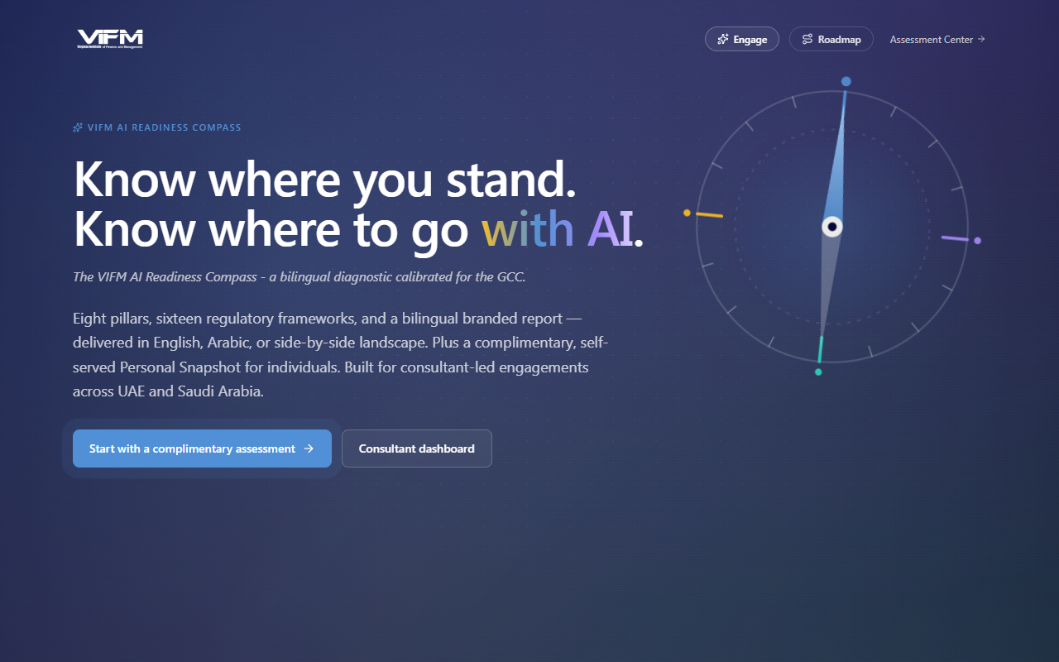

Roadmaps

Consultant roadmap
The end-to-end path for a VIFM consultant running an organisational AI Readiness engagement. From client intake to report delivery.
![Roadmap diagram 1: A[Client intakebrief + scope] --> BCreate organisationregion · sector
Key checkpoints:
Step | Where | Notes
Create assessment | /ara/consultant/assessments/new | 2-step wizard. Stage drives pillar count, report length, fee model
Add respondents | Assessment detail · Respondents tab | Each respondent gets an access_token URL — no account needed
Issue invitations | Respondents tab → "Send invitation" | Bilingual EN/AR/bilingual email; sandbox redirects in dev
Monitor progress | Assessment detail · Progress | Per-respondent completion %, last seen, distortion warnings
Validate scores | Assessment detail · Phase 2 tab | Edit each pillar's validated score and add bilingual consultant notes
Generate report | "Generate PDF" button → /api/ara/reports/[id]/pdf?language=... | Pick EN, AR, or side-by-side (Stage 3 only)
Annual reassessment | Detail page → "Start reassessment" | Copies design + opt-in respondent carry-over

Delegate (respondent) roadmap
The path for a person answering the survey — whether on behalf of an organisation (Mode B / C) or as a free Personal Snapshot (Mode A).
![Roadmap diagram 2: A[Receive invitationemail + token URL] --> BOpen survey/ara/respond/t
Three deployment modes for delegates:
Mode | Stage | Items | Issued by
A — Free snapshot | individual snapshot | 24 (6 / factor) | Self-served at /ara/personal/start
B — Paid deep-dive | individual deep-dive | 48 (12 / factor) | Consultant at /ara/consultant/personal-deep-dive/new
C — Org-engagement layer | dept/division/enterprise + include_individual_layer=true | Pillars + 24 or 48 personal items | Consultant on the org wizard

Client roadmap
The client-side path is intentionally small — VIFM controls report delivery to keep narrative integrity.
![Roadmap diagram 3: A[Engage VIFMscope + commercials] --> BProvide stakeholder listnames
What the client receives:
- Bilingual PDF report (8 pages Stage 1, 27 pages Stage 2, 27–60 pages Stage 3)
- Side-by-side EN/AR landscape format on Stage 3
- Optional walkthrough session led by the VIFM consultant
- Year-on-year reassessment package on Enterprise tier
ℹ️ There is no client-facing portal in the ARA module today. The client receives the PDF directly. A self-service browse + quote portal is on the roadmap — see post-parity-roadmap.md.

Detailed walkthroughs

Consultant — running an organisational engagement

1. Sign in to the consultant dashboard
Navigate to /ara/consultant. This is the home for all your engagements. Personal-layer assessments (engagement_stage = individual) are filtered out — those live in their own panel near the bottom.
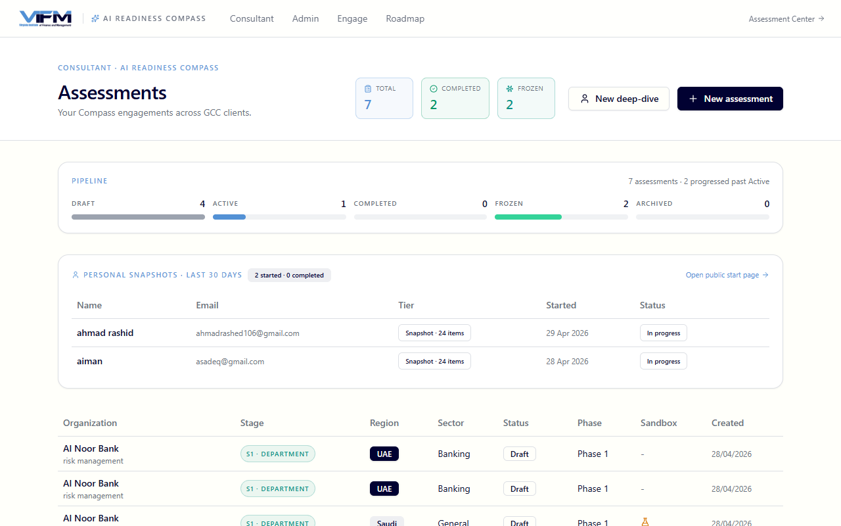
What you see here:
- Active assessments — drafts, in-progress, ready-to-validate, ready-to-publish
- Personal snapshots — last 30 days (panel) — separate from org engagements; shows snapshot vs deep-dive distinction
- Quick actions — New assessment, New deep-dive, Year-on-year reassessment

2. Create the client organisation
Before creating an assessment you need an organisation record. Go to /ara/admin/organizations.
Required fields:
- Name (EN) — anonymisable for case studies
- Name (AR) — optional but recommended
- Region — uae or saudi. Drives which regulatory frameworks appear.
- Sector — banking · government · corporate · etc.
⚠️ Region is locked once you start collecting respondent answers — set it correctly upfront.
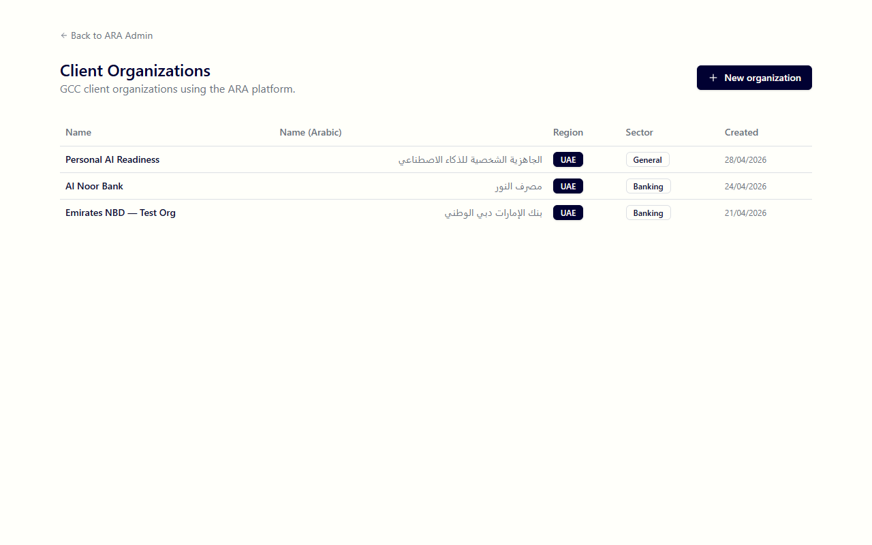

3. Create the assessment
Click New assessment from the consultant dashboard, or visit /ara/consultant/assessments/new.
Step 1 — pick a stage:
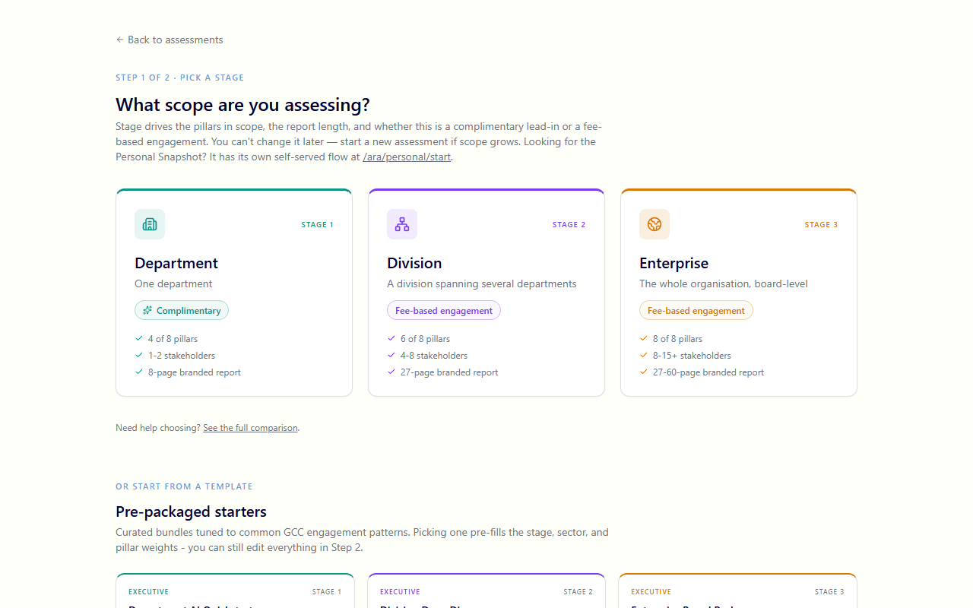
Personal is filtered out of this picker (it has its own self-served flow). Choose between Department / Division / Enterprise.
Pre-packaged starter templates appear below the stage cards — picking one pre-fills stage, region, sector, and pillar weights.
Step 2 — configure the assessment:
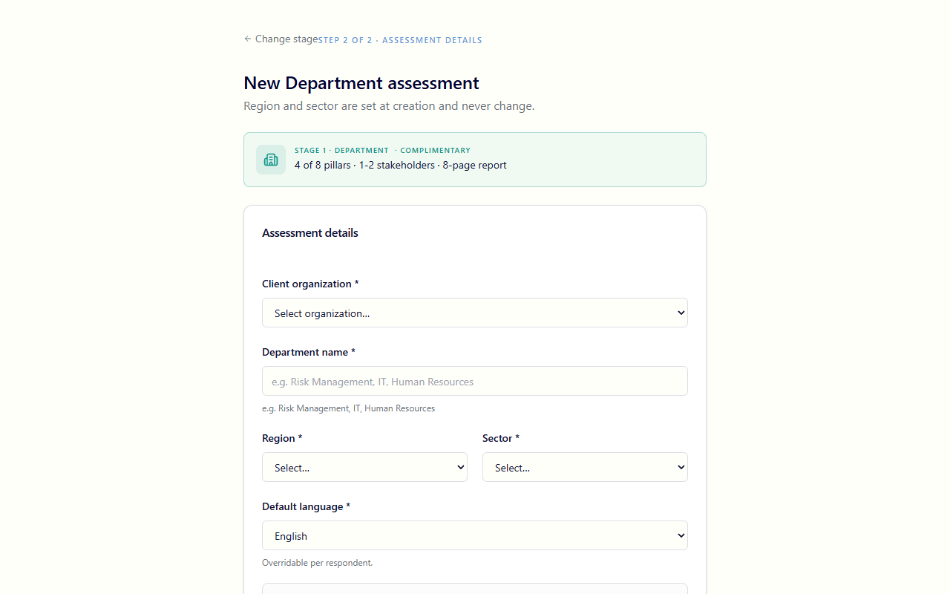
Key fields:
- Organisation — pick from dropdown
- Region / Sector — defaulted from the organisation; locked at creation
- Default language — what the respondent form opens in (they can still toggle)
- Question bank version — defaulted to the active version
- Scope label — required for Department/Division (e.g., "Risk Management"), optional for Enterprise
- Include individual layer (Mode C) — opt in to a per-respondent personal-readiness rollup alongside the org pillar items
- Tier — snapshot (24 personal items) or deep_dive (48). Only relevant when individual layer is on
- Sandbox — toggle on for training/demo runs; protects real consultant dashboards from clutter

4. Add respondents
On the assessment detail page → Respondents tab.
For each respondent:
- Name (EN + AR)
- Email
- Role (e.g., "CIO", "Head of Risk")
- Language preference (EN / AR)
- Pillar assignments — which of the 8 pillars they should answer for. Stage 1 has 4 in scope, Stage 2 has 6, Stage 3 has all 8.
- Individual-only flag (Mode C) — when ticked, the respondent skips the pillar items and only answers the 4-factor personal layer
CSV import is also supported — paste or upload name, email, role, language, pillar_assignments and the wizard validates row by row.
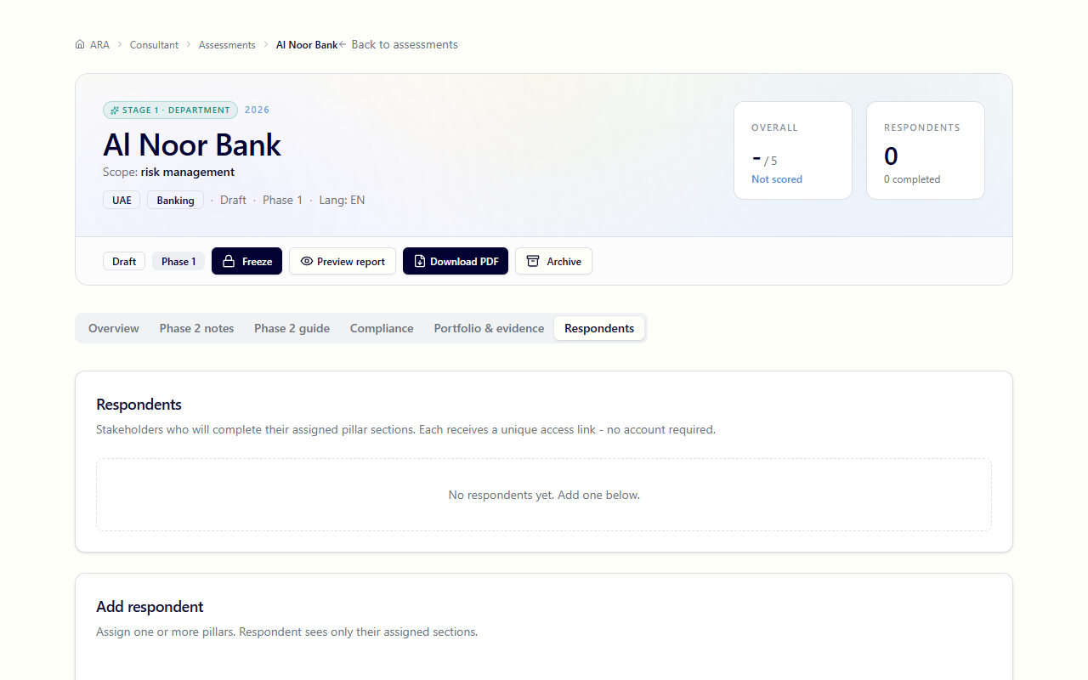

5. Issue invitations
Tick the respondents you want to invite, click Send invitations. The system:
- Generates a unique access_token for each
- Sends a bilingual email (EN / AR / side-by-side) via Microsoft Graph
- Logs the send to ara_email_log for audit
- (In sandbox or when SANDBOX_EMAIL_REDIRECT is set) routes to a single email for testing

6. Monitor progress
The Progress panel on the detail page shows a per-respondent table:
- Status — not_started · in_progress · completed
- % complete
- Last seen
- Distortion warnings — if a respondent's pattern looks like uniform-tap or speed-clicking, a flag appears here for the consultant to address

7. Phase 2 workshop (Stage 2 / 3 only)
For Division and Enterprise stages, after Layer 1 self-assessment is complete the consultant runs a Phase 2 validation workshop. This is the Phase 2 tab on the assessment detail.
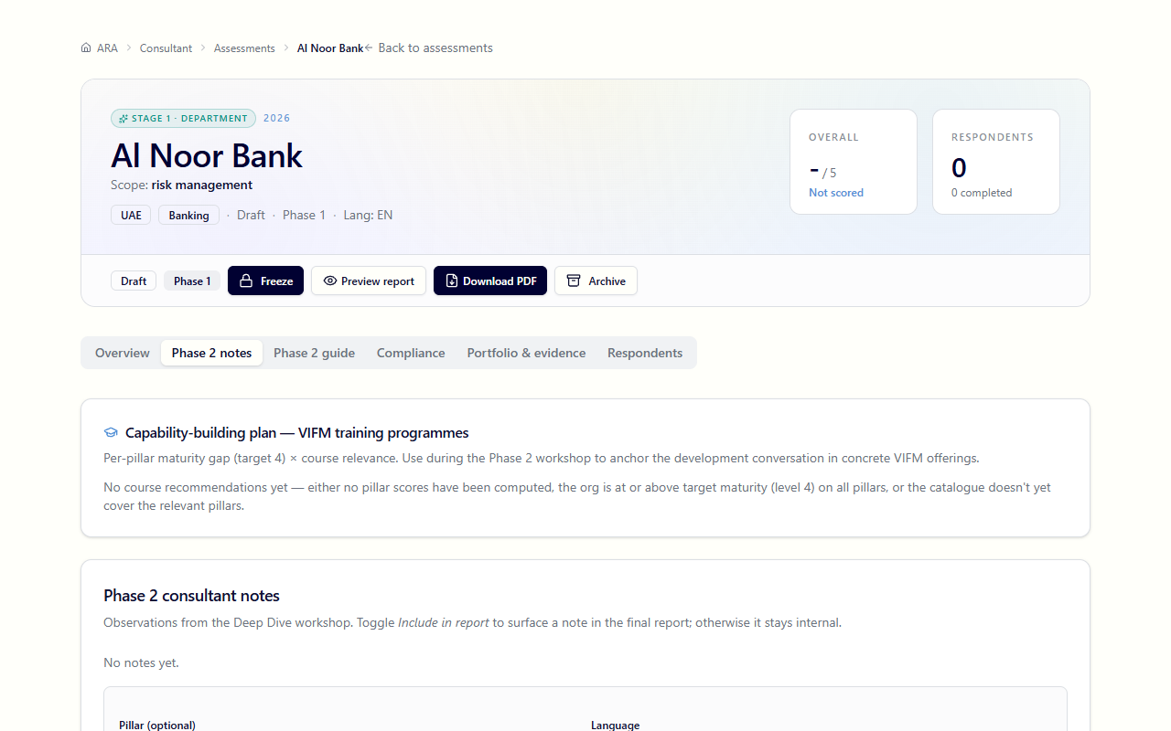
What's in this tab:
- Layer 2 consultant guide questions — bilingual probing questions per pillar to dig into the gap between perception (Layer 1) and observed reality
- Validated scores — for each pillar, edit the auto-scored maturity band based on workshop findings
- Bilingual consultant notes — write findings; if you write in EN the system translates to AR via Claude on save (you can edit the AR after)
- Capability-building plan — VIFM course recommender ranked by per-pillar gap × course relevance
- Workforce readiness rollup card — appears when Mode C is on; cohort overall + 4 factor cards + per-respondent breakdown table + a development-demand histogram (% of cohort below target per factor)

8. Generate the PDF report
Click Generate report → /api/ara/reports/[id]/pdf?language=en|ar|bilingual.
- English — portrait, 8 pages (Stage 1) to 60 pages (Stage 3)
- Arabic — same layout, RTL, with proper Arabic shaping via Puppeteer
- Side-by-side bilingual — landscape, each page split EN | AR (Stage 3 only)
The Workforce AI Readiness section appears in the PDF when include_individual_layer=true and respondents have answered.

9. Deliver and re-engage
Once generated, the PDF stays attached to the assessment record (it survives even if the assessment is later archived — VIFM business records per retention §15.3). Deliver to the client out-of-band (email, secure file share).
For year-on-year, on the assessment detail action rail click Start reassessment — copies the design (org, stage, weights, scope) into a new draft and gives you the option to carry over the same respondents (with fresh tokens). The new assessment links back via prior_assessment_id.

Delegate — completing a respondent survey

1. Receive the invitation
The respondent receives a bilingual email with a unique token URL. The link looks like https://your-tenant.vifm.ae/ara/respond/<token>. No account or login is needed — the token is the credential.

2. Open the survey
Clicking the link opens the respondent form. The first prompt asks for language preference (EN or AR), defaulted from what the consultant configured.
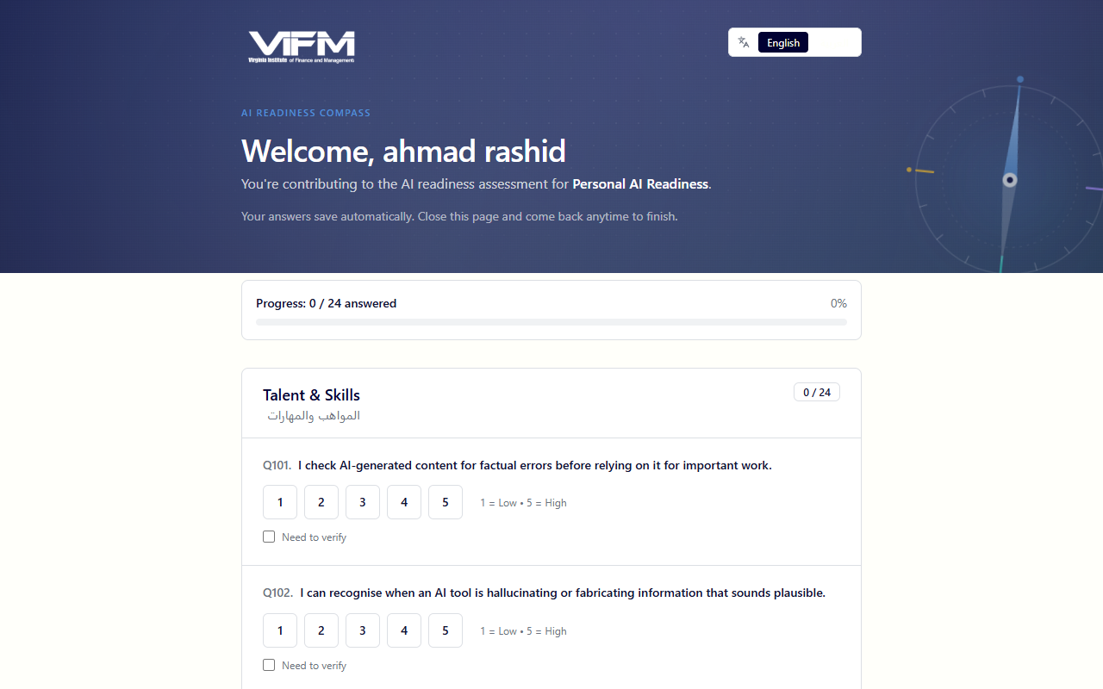

3. Answer the questions
The form serves Layer 1 questions for the pillars you were assigned, plus (if Mode C is on) the four-factor personal items.
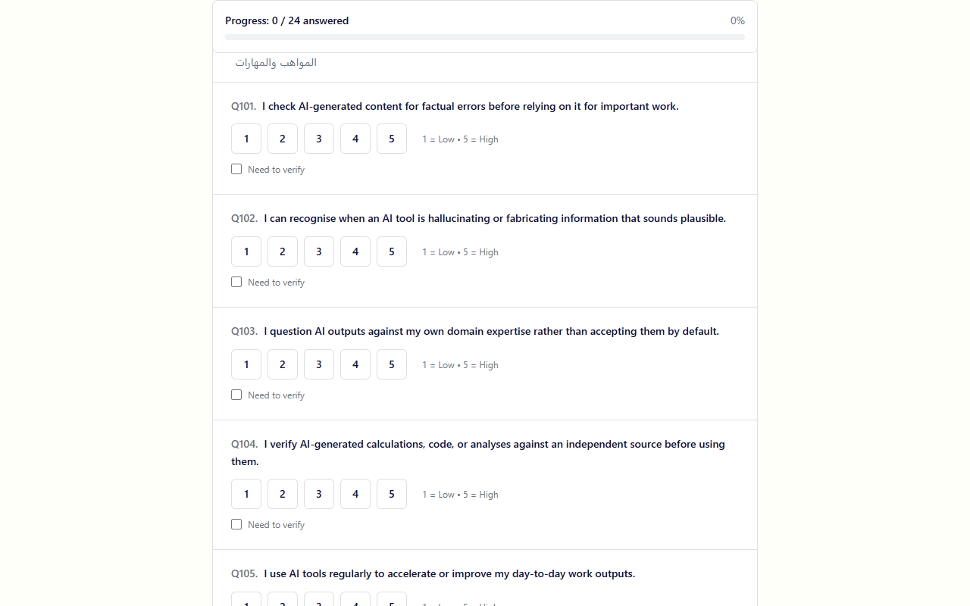
Features the respondent gets:
- Auto-save — every answer saves immediately. Close the tab and come back any time using the same link.
- Offline detection — if the network drops, a banner appears and the form caches answers locally
- Language toggle — switch EN ↔ AR mid-survey without losing progress
- Supporting materials — optional uploads per pillar (no size limit) for evidence (policies, training records, etc.)
- AI use-case portfolio — for Stage 2/3 respondents, list the AI initiatives currently in play

4. Submit
Once every required item is answered, the Submit button enables. After submission:
- The token still works for read-only access (you can re-open and download a copy if entitled)
- For Personal / Mode C respondents — a results email fires with a link to your personal snapshot

Personal — taking the free snapshot
The free Mode A path. Anonymous self-served at /ara/personal/start.

1. Start the snapshot
Visit /ara/personal/start. Enter your name + email (used only to email you the results link — no account is created).
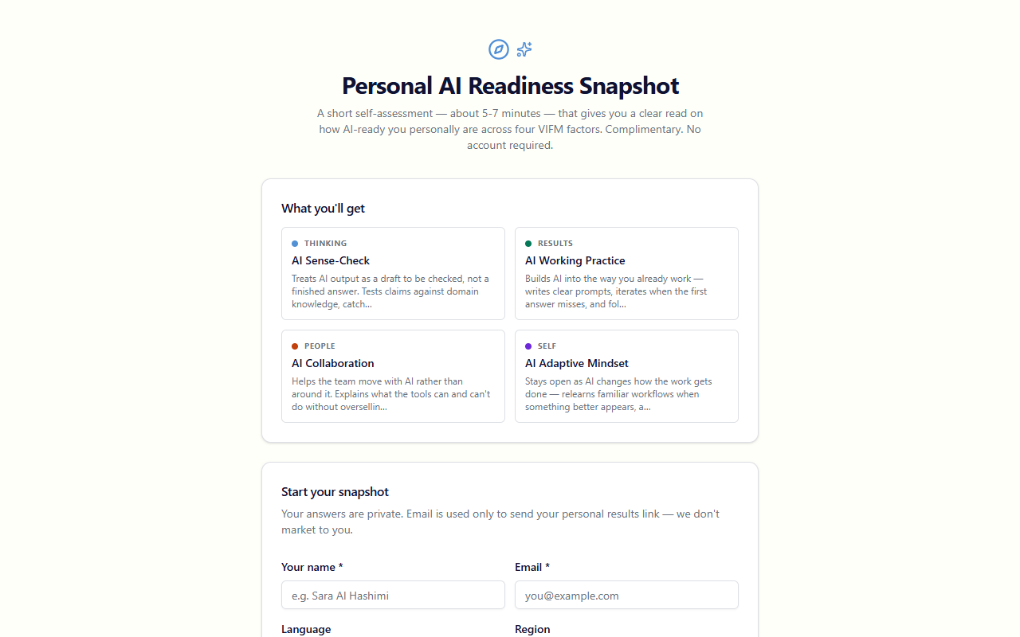

2. Answer 24 four-factor items
The 24-item snapshot covers the four VIFM-native personal factors:
- AI Sense-Check (THINKING) — critical evaluation of AI output
- AI Working Practice (RESULTS) — hands-on use of AI in real work
- AI Collaboration (PEOPLE) — leading or supporting team adoption
- AI Adaptive Mindset (SELF) — curiosity, openness, responsible posture
Each item is a 5-point Likert ("Strongly disagree" → "Strongly agree"). Auto-saves on each answer.

3. Receive results
On submission:
- An email fires with your unique results URL (/ara/personal/results/<token>)
- The results page shows your overall score, maturity stage, per-factor breakdown, and recommended VIFM courses ranked by your lowest factors
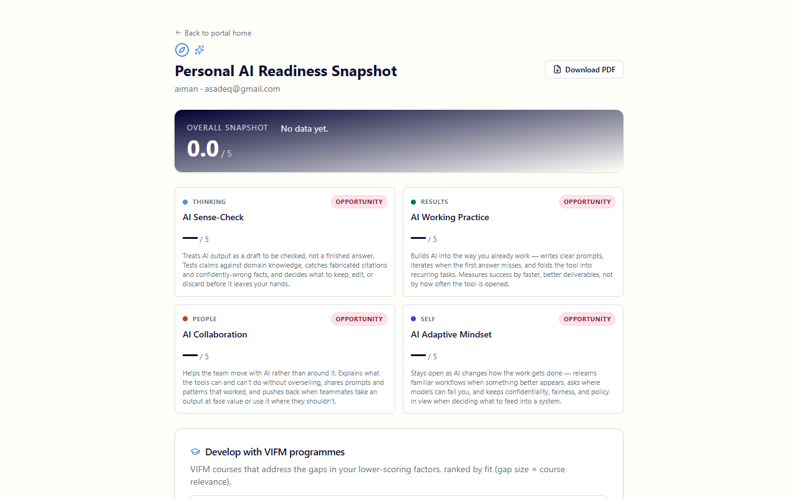
The results page surfaces:
- Overall score with maturity stage badge (Emerging / Practising / Embedded)
- Per-factor cards with score, tone (Strong/Developing/Opportunity), and a sharp behavioural description
- Vs cohort delta pill — when you're part of a Mode C engagement, shows your score vs the cohort peer mean (excludes self)
- Recommended VIFM programmes — ranked by gap × course relevance × ★ HIGH FIT badge for high-confidence matches

4. Download the PDF
Click Download PDF on the results page → /api/ara/personal/<token>/pdf. One-page bilingual mini-report with your snapshot + course recs.

Client — receiving and using the report
The client side is currently passive. The VIFM consultant delivers the bilingual PDF directly. Optional walkthrough session for Stage 2/3 engagements.
The PDF includes:
- Cover with org name, stage, generation date
- Executive summary — overall maturity, top 3 strengths, top 3 gaps
- Per-pillar deep dives (one section per applicable pillar)
- Gap heatmap — visual matrix of gap severity × business impact
- Investment priority matrix — Stage 2/3 — quick-wins vs strategic-bets
- 12-month action roadmap — gantt-style with owner, dependencies, target maturity
- Compliance summary — mapped against the UAE/Saudi regulatory frameworks in scope
- Use-case portfolio review — Stage 2/3
- Workforce AI Readiness — when Mode C is on; cohort + 4 factor table + tier badge
- Year-on-year comparison — Stage 3 reassessments

Admin tasks
The admin console at /ara/admin is for VIFM staff who curate the knowledge base. Most consultants don't need to touch this.

Question bank versions
/ara/admin/questions
- One version active at a time (is_active=true, enforced by partial unique index)
- Each version locks question-text/scoring at the time of an assessment so historical reports remain reproducible
- Version 1.1 is the current active production bank — 218 items (135 pillar + 24 snapshot personal + 32 deep-dive personal + 27 admin extensions)
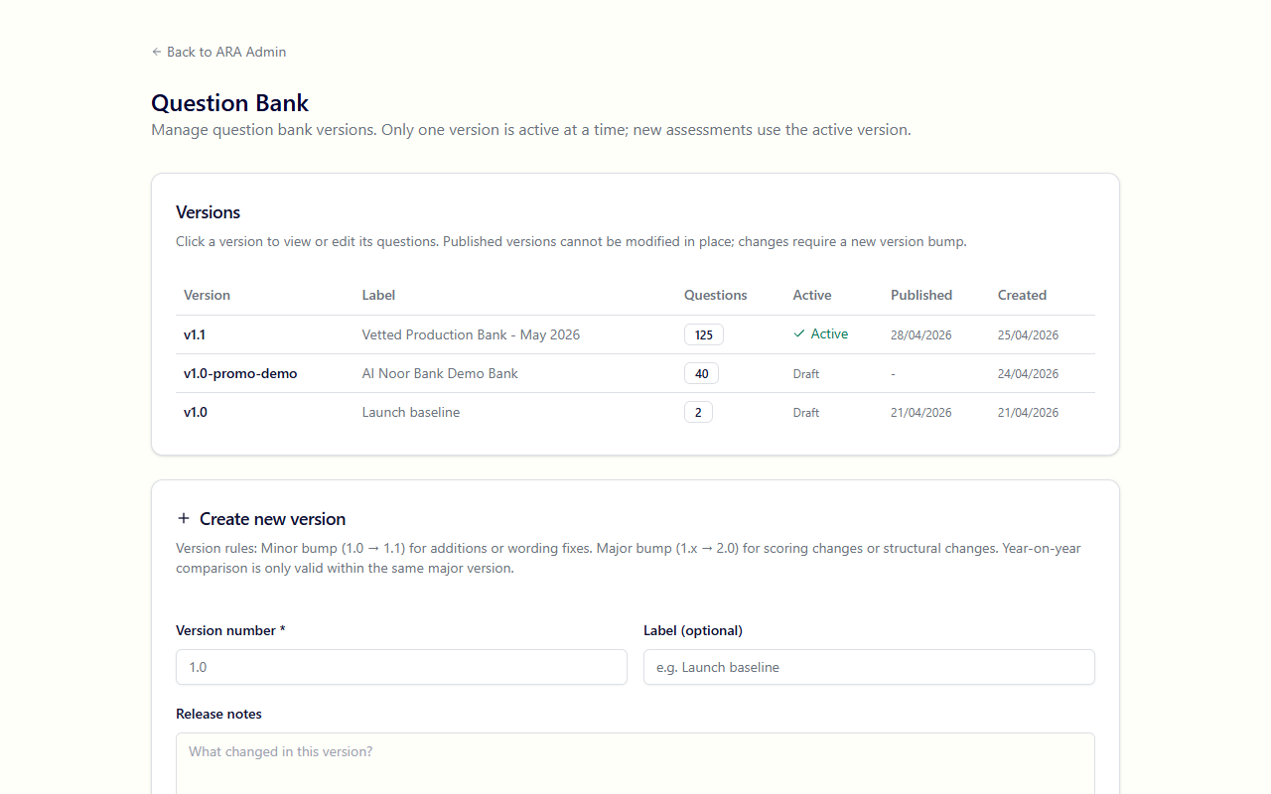

Regulatory document upload + AI extraction
/ara/admin/regulatory
Upload a regulatory PDF (UAE PDPL, NCA ECC, etc.) and Claude reads it, extracts requirements, maps them to pillars, and stages them for review.
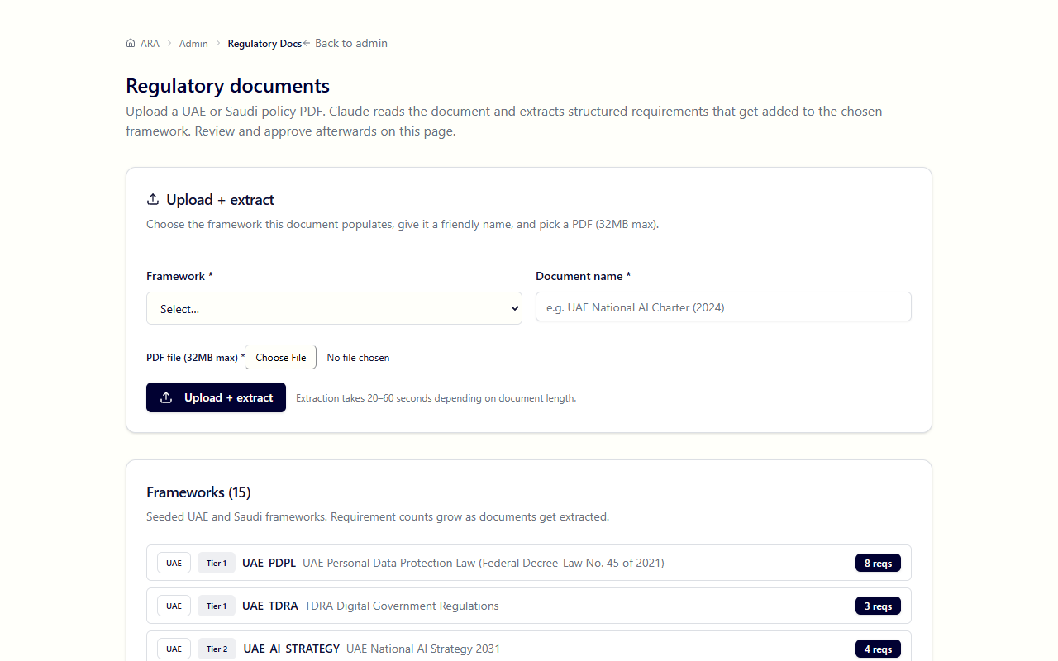

Sandbox cleanup
/ara/admin/sandbox
Hard-delete every assessment marked is_sandbox=true. Confirmation phrase required ("DELETE SANDBOX DATA"). Useful after training sessions / demos.

Retention purge
/ara/admin/retention
Hard-delete archived assessments past the retention window (default 3 years). Generated reports are detached and survive — they're VIFM business records.
A daily cron at /api/ara/admin/retention/cron runs the same logic automatically (gated on CRON_SECRET).

Reference

The four engagement stages
Stage | Pillars | Stakeholders | Report | Price
Personal | 4 personal factors | 1 | 1-page bilingual snapshot | Free, self-served
Stage 1 — Department | 4 of 8 | 1–2 | 8-page bilingual | Complimentary
Stage 2 — Division | 6 of 8 | 4–8 | 27-page bilingual | Fee-based
Stage 3 — Enterprise | 8 of 8 | 8–15+ | 27–60-page side-by-side | Fee-based

The eight organisational pillars
Pillar | What it covers
Strategy | AI vision, alignment to business goals, executive sponsorship
Data | Data quality, accessibility, lineage, governance, sovereignty
Technology | Compute, MLOps platforms, integration, vendor selection
Talent | Skills inventory, hiring, retention, training programmes
Culture | Adoption mindset, change readiness, psychological safety with AI
Governance | Ethics, risk frameworks, model cards, audit trail
Operations | Day-to-day AI deployment patterns, incident response
Model Management | Version control, monitoring, retraining, drift detection

The four personal factors
Factor | Domain | What it measures
AI Sense-Check | THINKING | Critical evaluation of AI output, hallucination detection
AI Working Practice | RESULTS | Productive hands-on use of AI in real workflows
AI Collaboration | PEOPLE | Helping the team move with AI, shaping shared norms
AI Adaptive Mindset | SELF | Curiosity, openness to relearning, responsible posture

The maturity-stage narrative
Applied to a respondent's overall four-factor average:
Score | Stage | What it means
< 3.0 | Emerging | Foundation-laying — early exposure, room to build core habits and judgment
3.0–3.99 | Practising | Building rhythm — using AI on real work, sharpening prompts and review habits
≥ 4.0 | Embedded | Operating fluently — AI is part of how you work, with confident judgment about when to lean on it

Scoring scale
Likert 1–5 across all factors and pillars:
Score | Label
1 | Initial — ad-hoc, no structure
2 | Developing — pockets of activity
3 | Defined — documented, repeatable
4 | Managed — measured, governed
5 | Optimised — continuously improved

Regulatory frameworks calibrated
UAE (7): PDPL · NCA ECC · DCAI · ADDA · UAE AI Strategy 2031 · NESA · TDRA AI Ethics
Saudi Arabia (9): SDAIA NDGF · NCA ECC · NDGA · DCAI Health · SDAIA AI Ethics · Vision 2030 · Cyber Security Framework · Cloud Computing Regulatory Framework · NDMO

URL map
URL | Who | Purpose
/ara | Public | Landing page
/ara/engage | Public | Stage comparison + sales pitch
/ara/roadmap | Public | Platform overview
/ara/personal/start | Public | Free Mode A snapshot entry
/ara/personal/results/[token] | Respondent | Personal results + cohort delta
/api/ara/personal/[token]/pdf | Respondent | Personal snapshot PDF
/ara/respond/[token] | Respondent | Survey form (token-gated)
/ara/consultant | Consultant | Dashboard
/ara/consultant/assessments/new | Consultant | New assessment wizard (org-side)
/ara/consultant/personal-deep-dive/new | Consultant | New paid Mode B deep-dive
/ara/consultant/assessments/[id] | Consultant | Assessment detail (Phase 2 tab)
/api/ara/reports/[id]/pdf | Consultant | Bilingual PDF report endpoint
/ara/admin | Admin | Admin console
/ara/admin/questions | Admin | Bank version management
/ara/admin/regulatory | Admin | Regulatory doc import
/ara/admin/sandbox | Admin | Sandbox cleanup
/ara/admin/retention | Admin | Retention purge

Last updated: 2026-04-29.

