End-to-End MLOps Workflow for Travel Analytics Models
By Aiman Sahay

1. Introduction
This document outlines the end-to-end MLOps workflow implemented across multiple machine learning projects, including a Flight Price Prediction model, Gender Classification model, and a Hotel Recommendation system.
The focus of this document is on the deployment, automation, and scalability aspects of machine learning systems. It covers key stages such as API development, application deployment, containerization, orchestration, workflow scheduling, and model tracking.

2. REST API (Flask Deployment)
A REST API was developed using Flask to serve machine learning models for real-time predictions. The API accepts input features, processes them using the trained preprocessing pipeline, and returns predictions.
Key aspects:
- Model and preprocessing objects (scaler, encoders) are loaded using pickle
- Input data is transformed to match training format
- Predictions are returned in JSON format
- API can be tested using browser or tools like Postman

Flask API serving real-time predictions for the flight price model


Output displayed in Streamlit WebApp
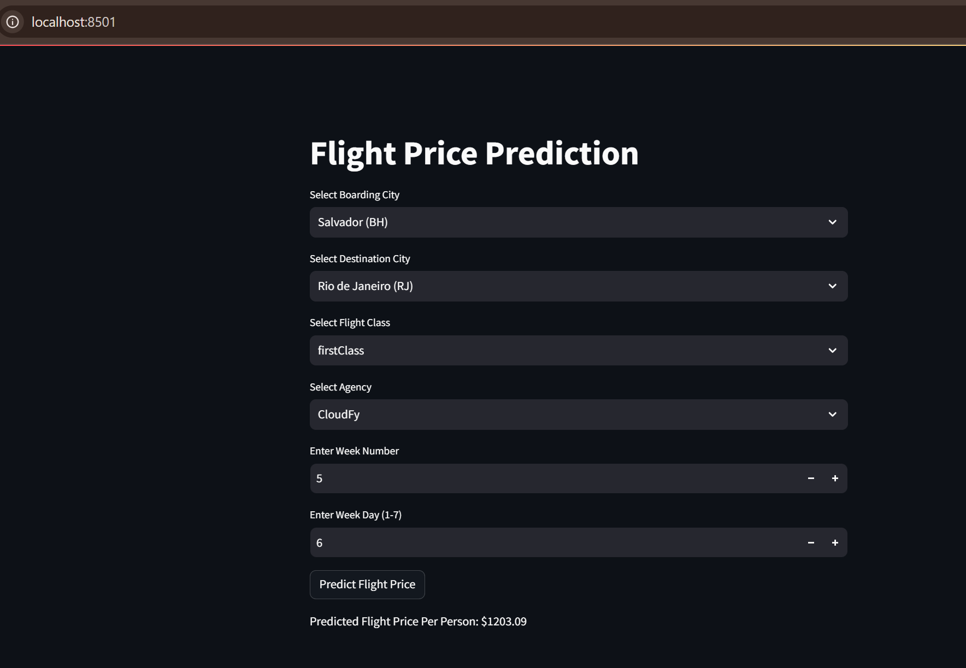

3. Streamlit Web Application
Interactive web applications were built using Streamlit for:
- Gender Classification
- Hotel Recommendation System
The Streamlit apps allow users to input data through a UI and view predictions or recommendations instantly.
Key aspects:
- User-friendly interface for non-technical users
- Real-time prediction display
- Integration with trained models
- Visualization of outputs (recommendations, predictions)

Gender Classification – Flask API
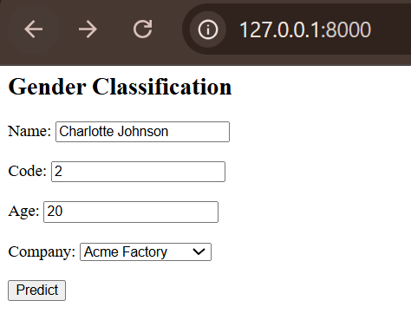
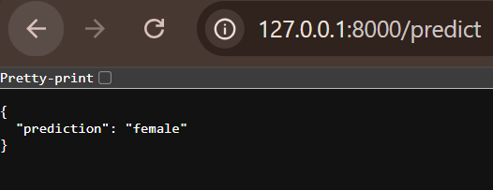
Gender Classification – Streamlit interface for user input and real-time model predictions 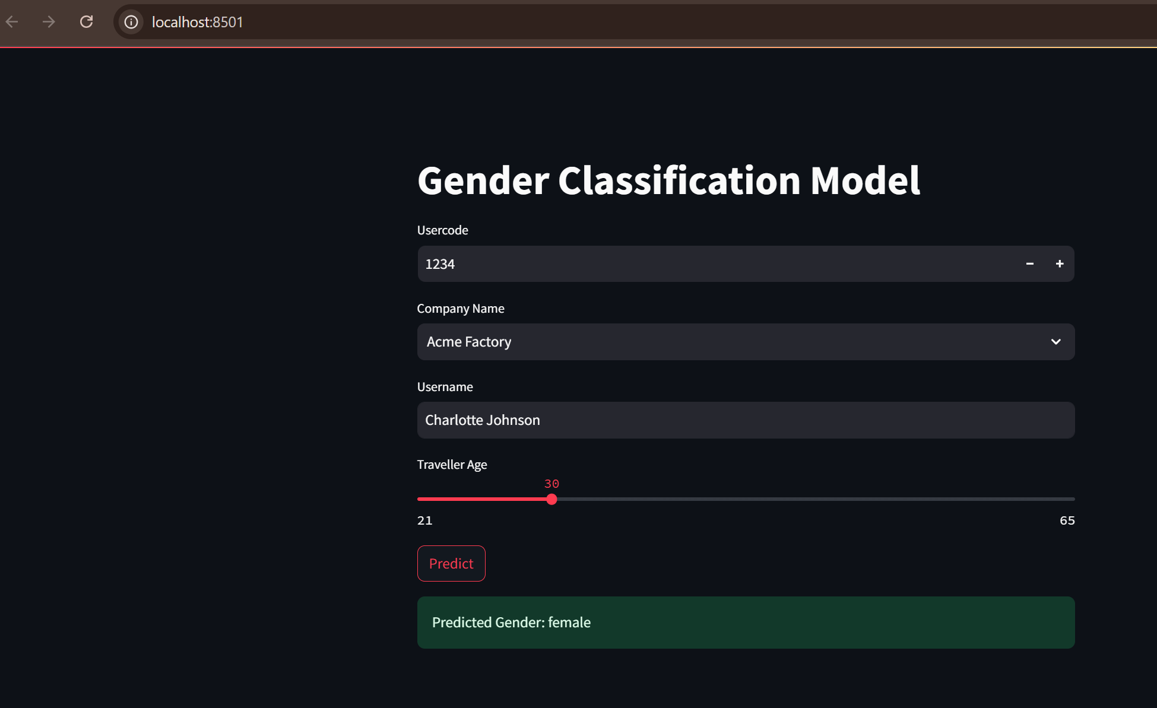

Hotel Recommendation System - Streamlit interface for user input and real-time model predictions
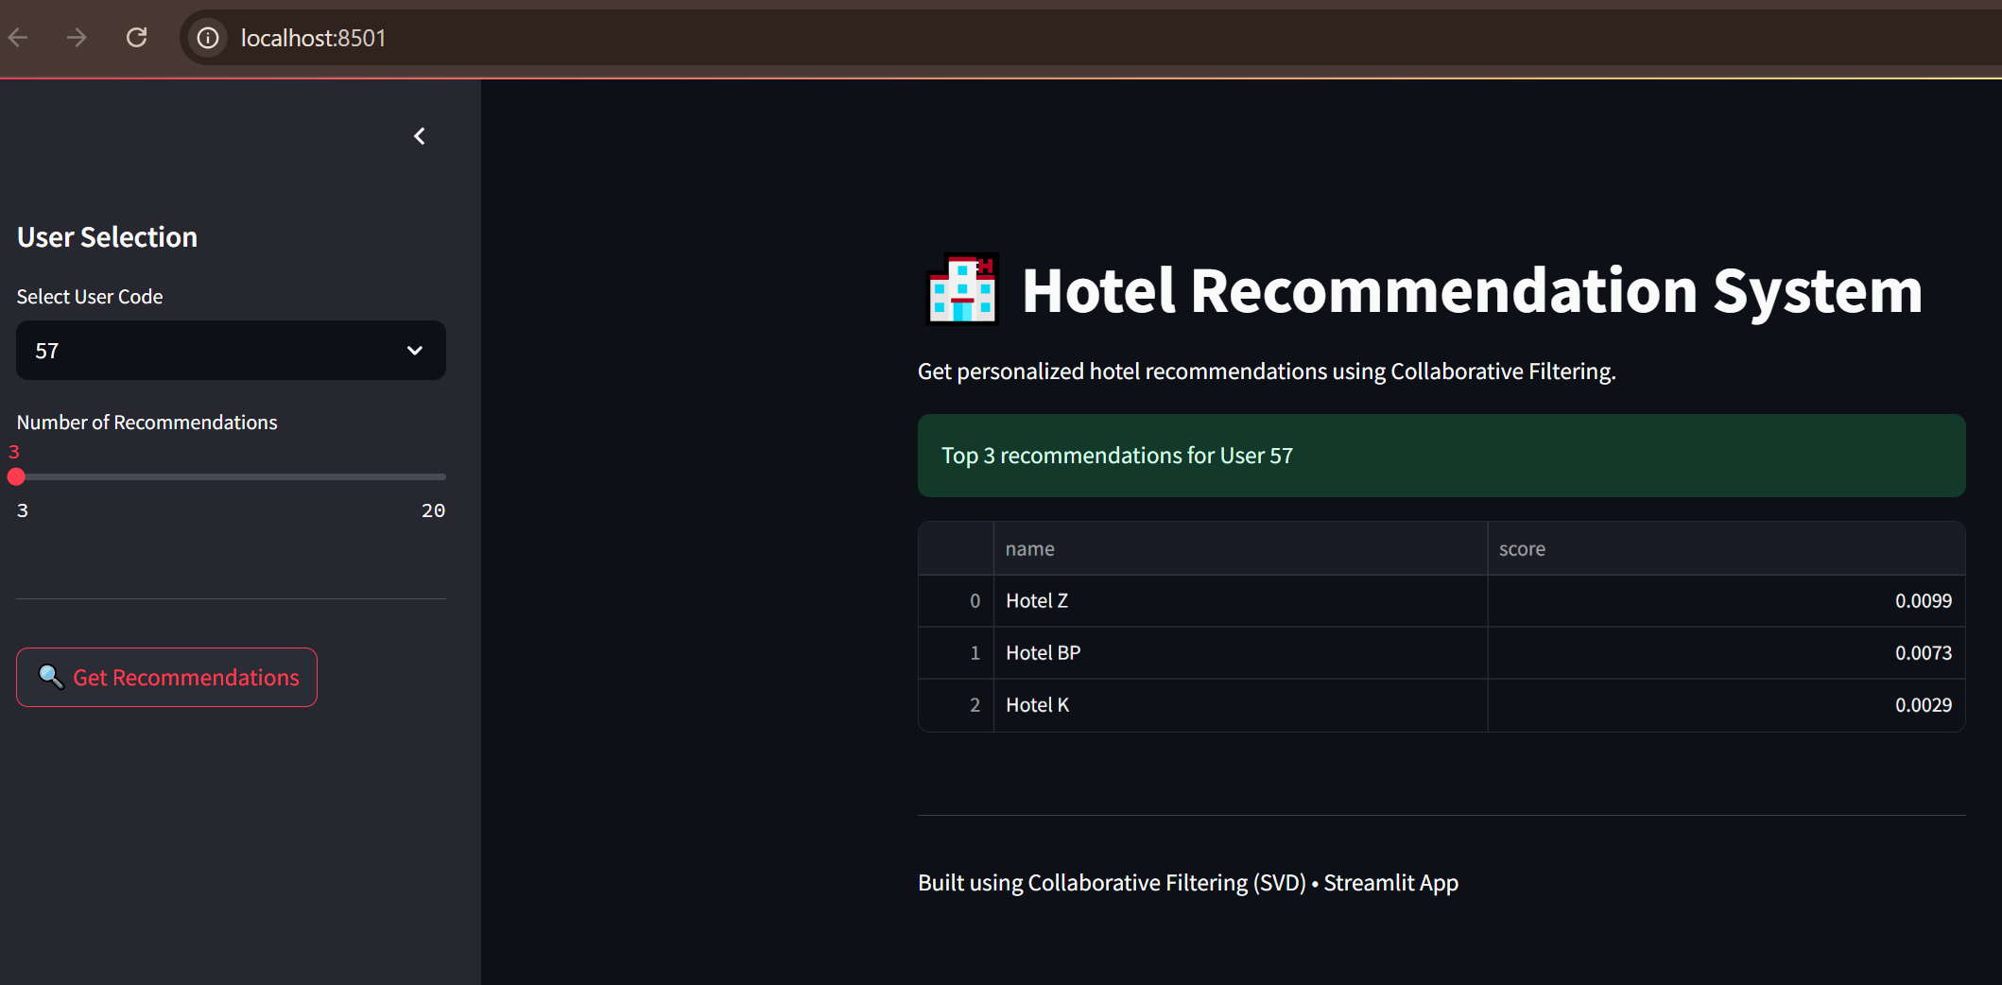

4. Docker Deployment (Containerization)
Docker was used to containerize the applications to ensure portability and consistency across environments.
Key aspects:
- Created Dockerfile to package application and dependencies
- Ensured consistent runtime environment
- Simplified deployment across systems

Docker container running the machine learning application
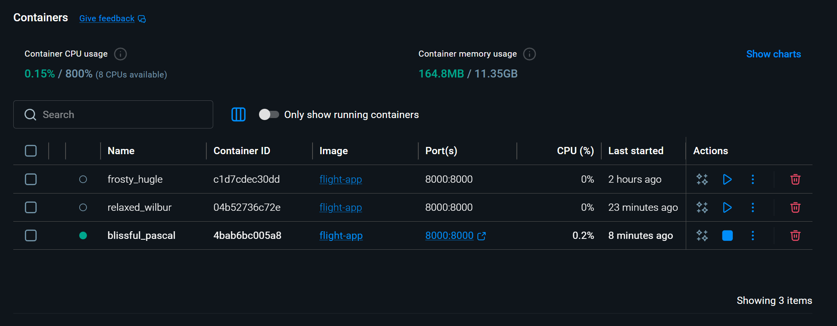

5. Kubernetes Deployment (Scalability)
Kubernetes was used to deploy the Dockerized application and manage scalability.
Key aspects:
- Deployment configuration using YAML files
- Load balancing and scaling support
- Efficient resource utilization
Kubernetes managing containerized ML application for scalability
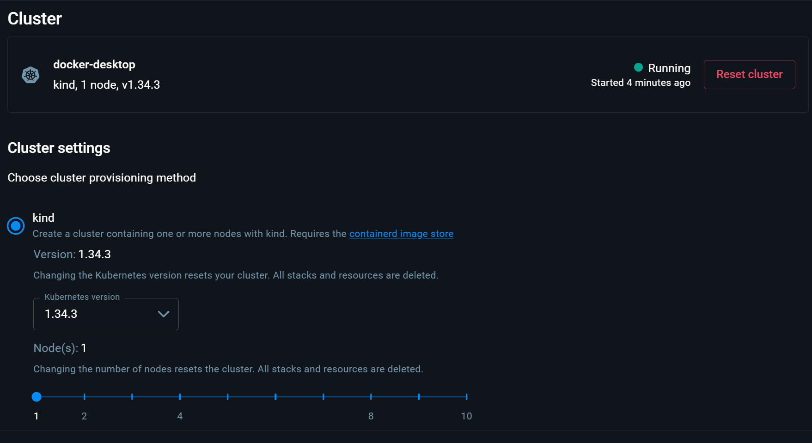
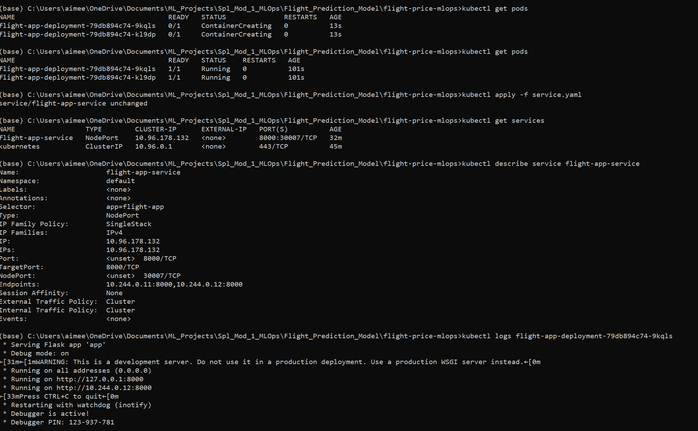

6. Workflow Scheduling using Apache Airflow
Apache Airflow was used to automate workflows for data processing and model-related tasks.
Key aspects:
- DAG (Directed Acyclic Graph) created for workflow orchestration
- Task dependencies defined for sequential execution
- Automated pipeline execution
Airflow DAG orchestrating machine learning workflow tasks
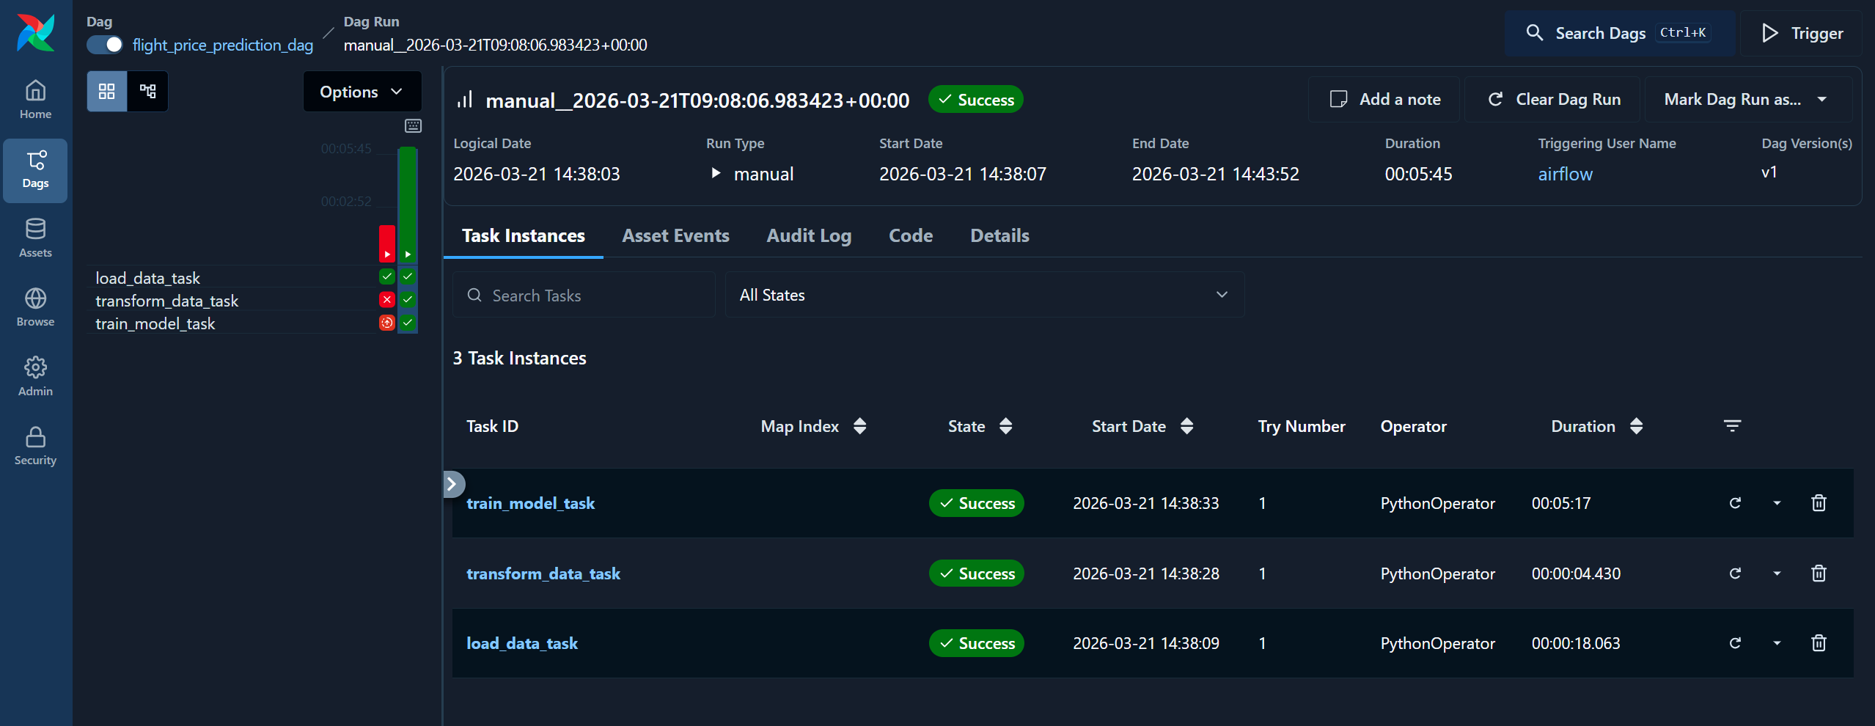
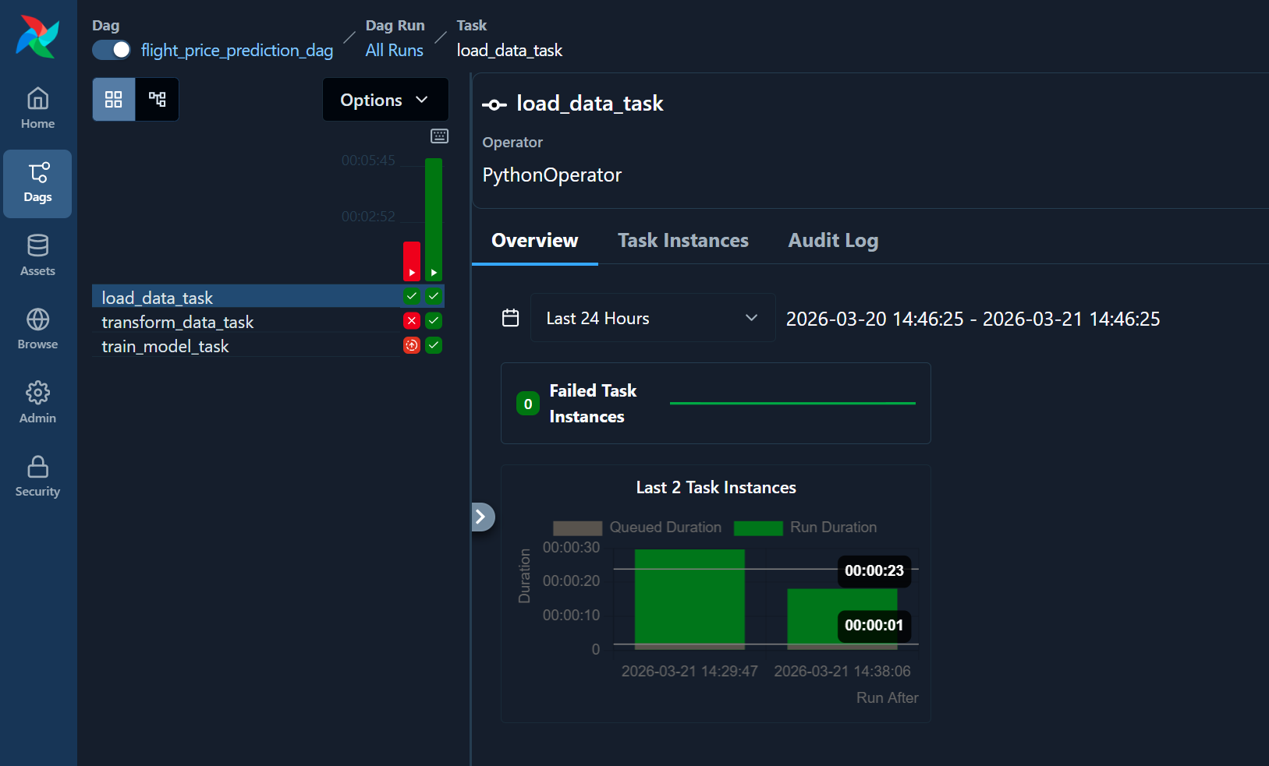
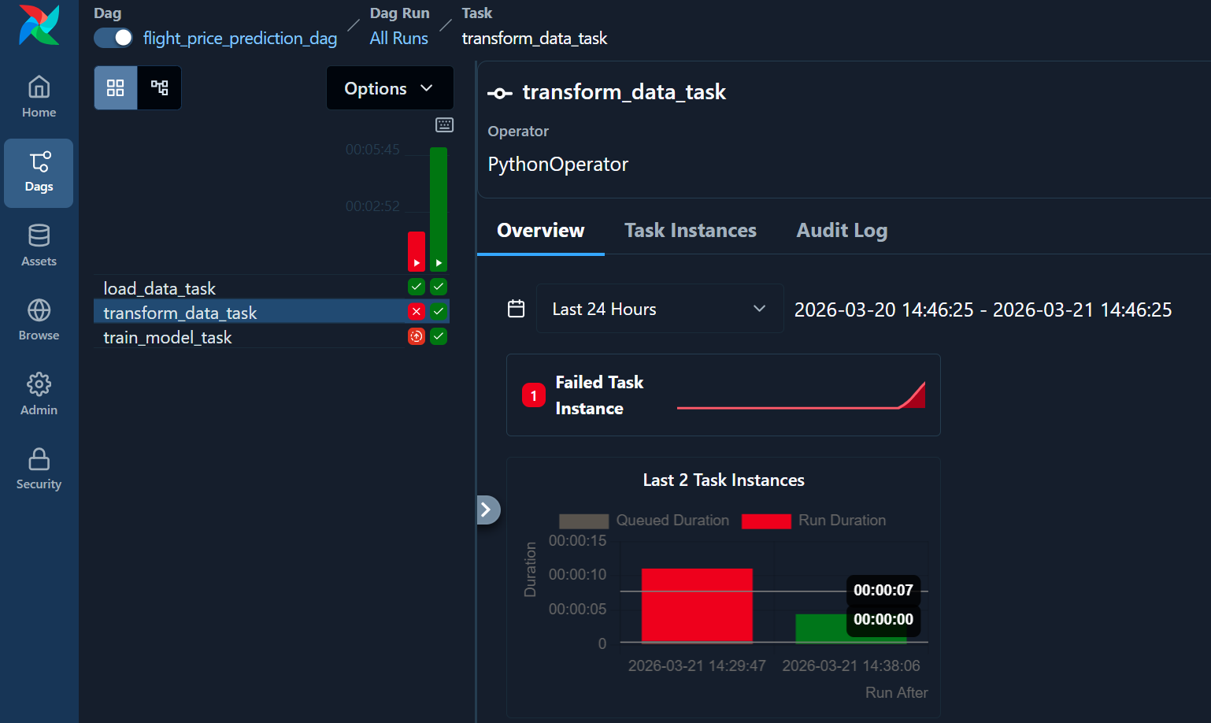
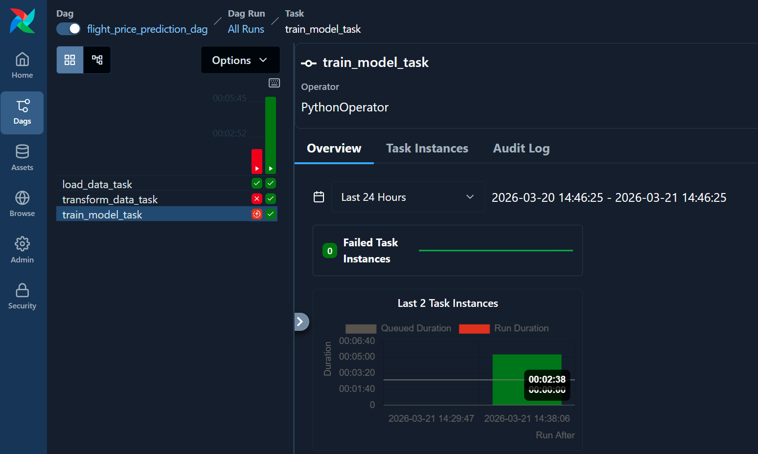

7. Model Tracking using MLflow
MLflow was used to track experiments, manage models, and monitor performance.
Key aspects:
- Logging parameters, metrics, and models
- Comparing multiple model runs
- Version control for models

MLflow dashboard tracking model experiments and performance metrics
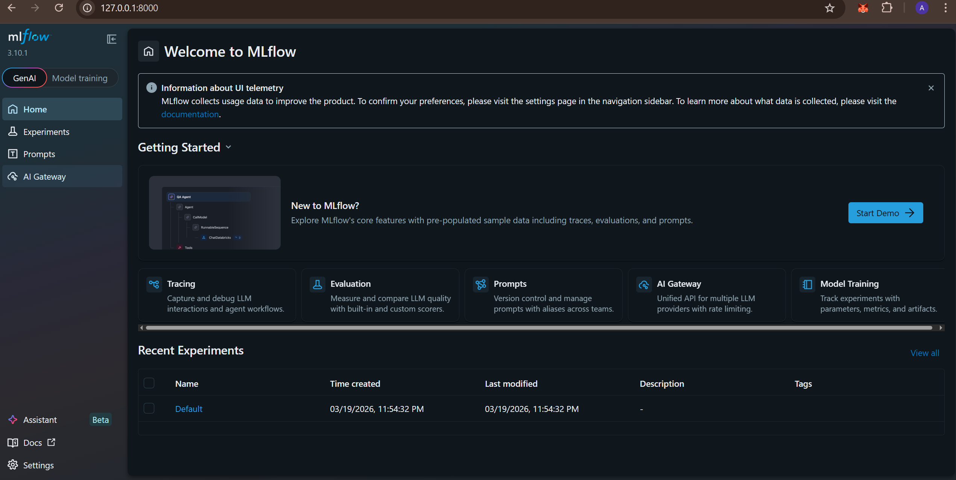
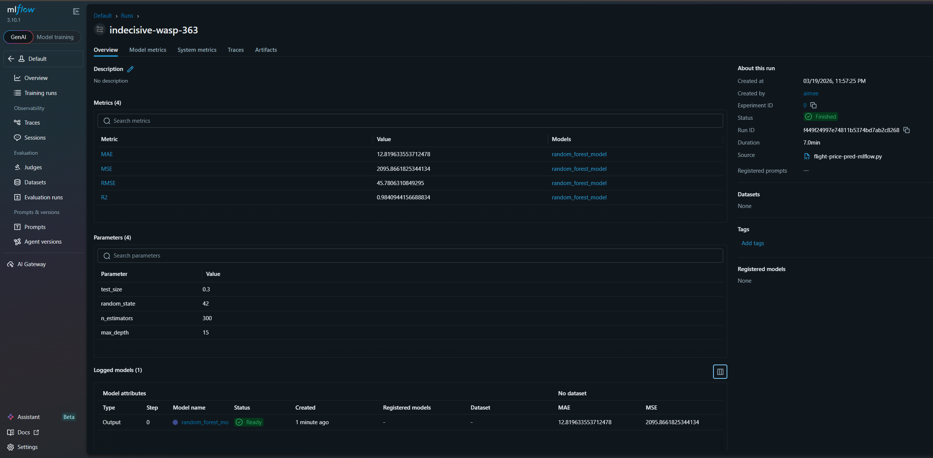
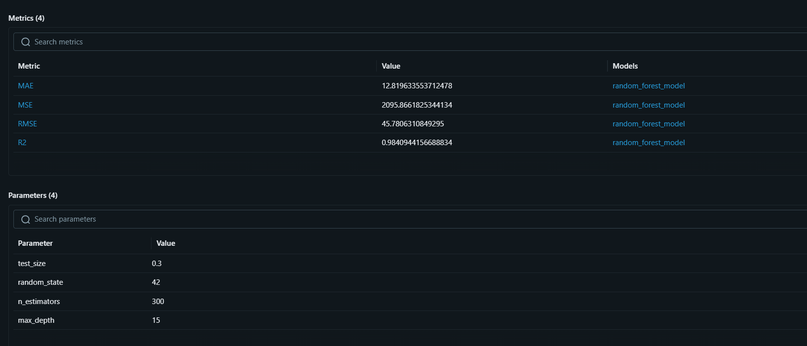

8. CI/CD Pipeline
A conceptual CI/CD pipeline was designed to automate the integration, testing, and deployment of machine learning models. While not implemented in this project, this design demonstrates how the system can be extended for production-grade deployment.
Key Components:
- Continuous Integration (CI):
  - Automatically triggers on code changes (e.g., GitHub commits)
  - Runs unit tests for data preprocessing and model pipelines
  - Validates model performance metrics before deployment
- Continuous Deployment (CD):
  - Builds Docker images for updated models
  - Pushes images to a container registry (e.g., Docker Hub)
  - Deploys updated containers to Kubernetes clusters
- Automation Workflow:
  - Code commit → Build → Test → Dockerize → Deploy
Tools:
- Jenkins or GitHub Actions for pipeline automation
- Docker for packaging
- Kubernetes for deployment
This pipeline ensures faster, reliable, and consistent model updates in a production environment.

9. Conclusion
This project demonstrates a complete MLOps lifecycle, covering model deployment, containerization, orchestration, workflow automation, and experiment tracking.
By integrating tools such as Flask, Streamlit, Docker, Kubernetes, Airflow, and MLflow, the project ensures that machine learning models are not only accurate but also scalable, reproducible, and production-ready.

