**Bahria University,**

**Karachi Campus**



**COURSE: SEN-401**

**CLOUD COMPUTING**

**TERM: SPRING 2024, CLASS: BSE- 6(B)**

**Submitted By:**

**AIMAN ZIA SATTI__________________________79301**

**Name Reg. No.**

**Submitted To:**

**Engr. Faisal/Engr. Noor us Sabah**

**Signed Remarks: Score:_____**

# INDEX

|  |  |  |  |  |
| --- | --- | --- | --- | --- |
| **SNO** | **DATE** | **LAB NO** | **LAB OBJECTIVE** | **SIGN** |
| 01 | 15/Feb/2024 | 01 | Intro To Cloud Computing |  |
|  |  |  |  |  |
|  |  |  |  |  |
|  |  |  |  |  |
|  |  |  |  |  |
|  |  |  |  |  |
|  |  |  |  |  |
|  |  |  |  |  |
|  |  |  |  |  |
|  |  |  |  |  |
|  |  |  |  |  |
|  |  |  |  |  |

**Bahria University,**

**Karachi Campus**



**LAB EXPERIMENT NO.**

**_1_**

**LIST OF TASKS**

|  |  |
| --- | --- |
| TASK NO | **OBJECTIVE** |
| 01 | Setting up First cloud account using Microsoft azure. |
|  |  |
|  |  |

**Submitted On:**

**Date: 15/feb/2024**

**Task No. 01: Setting up First cloud account using Microsoft azure.**

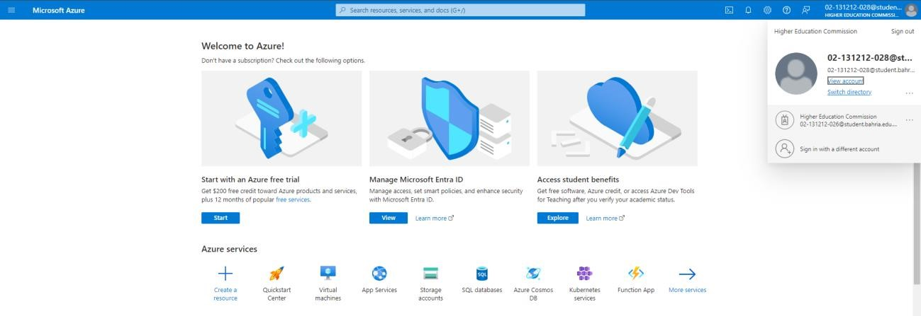

**Solution:**

