# **Bahria University,**

**Karachi Campus**



**LAB EXPERIMENT NO.**

**06**

**LIST OF TASKS**

|  |  |
| --- | --- |
| **Task no** | **Task** |
| 01 | Design and implement a web service that provides currency conversion functionality. The web service should accept requests to convert an amount from one currency to another and return the converted amount. |
| 02 | Design and implement a web service that provides scientific calculator functionality over the internet. The web service should allow users to perform various mathematical operations, including basic arithmetic, trigonometric functions, logarithms, and more. |

**Submitted On:**

**Date: _28th March 2024**

**TASK # 1:** Design and implement a web service that provides currency conversion functionality. The web service should accept requests to convert an amount from one currency to another and return the converted amount.

using System;

using System.Collections.Generic;

using System.Linq;

using System.Web;

using System.Web.Services;

namespace CCLAB06

{

[WebService(Namespace = "http://tempuri.org/")]

[WebServiceBinding(ConformsTo = WsiProfiles.BasicProfile1_1)]

[System.ComponentModel.ToolboxItem(false)]

public class converter : System.Web.Services.WebService

{

private readonly Dictionary<string, double> conversionRates = new Dictionary<string, double>

{

{"USD", 1.0},

{"EUR", 0.85},

{"GBP", 0.75}

};

[WebMethod]

public double ConvertCurrency(string fromCurrency, string toCurrency, double amount)

{

if (!conversionRates.ContainsKey(fromCurrency) || !conversionRates.ContainsKey(toCurrency))

{

throw new ArgumentException("Invalid currency specified");

}

double fromRate = conversionRates[fromCurrency];

double toRate = conversionRates[toCurrency];

double convertedAmount = amount * (toRate / fromRate);

return convertedAmount;

} } }

}

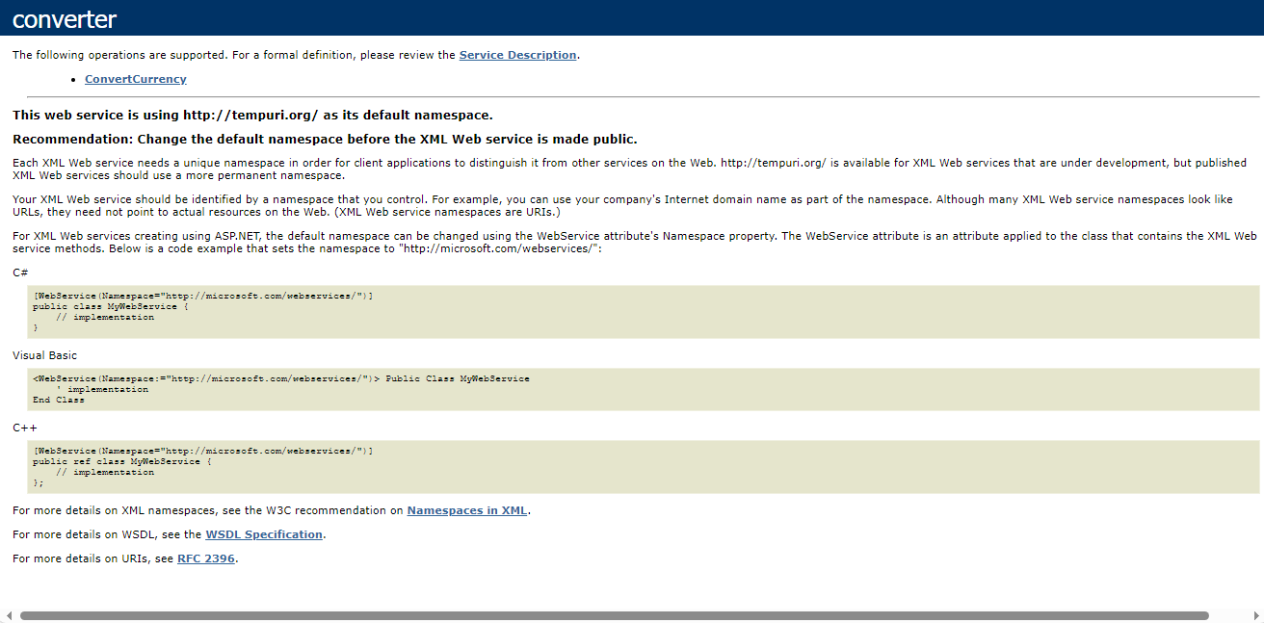

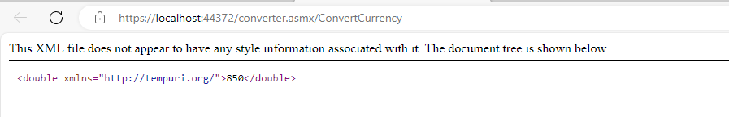

**TASK # 2:** Design and implement a web service that provides scientific calculator functionality over the internet. The web service should allow users to perform various mathematical operations, including basic arithmetic, trigonometric functions, logarithms, and more.

using System;

using System.Collections.Generic;

using System.Linq;

using System.Web;

using System.Web.Services;

namespace CCLAB06

{

[WebService(Namespace = "http://tempuri.org/")]

[WebServiceBinding(ConformsTo = WsiProfiles.BasicProfile1_1)]

[System.ComponentModel.ToolboxItem(false)]

public class converter : System.Web.Services.WebService

{

[WebMethod]

public double Add(double operand1, double operand2)

{

return operand1 + operand2;

}

[WebMethod]

public double Subtract(double operand1, double operand2)

{

return operand1 - operand2;

}

[WebMethod]

public double Multiply(double operand1, double operand2)

{

return operand1 * operand2;

}

[WebMethod]

public double Divide(double operand1, double operand2)

{

if (operand2 == 0)

throw new DivideByZeroException("Cannot divide by zero.");

return operand1 / operand2;

}

[WebMethod]

public double Square(double operand)

{

return Math.Pow(operand, 2);

}

}

}



