**Bahria University,**

**Karachi Campus**



**LAB EXPERIMENT NO.**

**_09**

**LIST OF TASKS**

|  |  |
| --- | --- |
| TASK NO | **OBJECTIVE** |
| 01 | Create a microservice for user profile management, including registration, login, and profile updates, using ASP.NET Core Identity. |
| 02 | Build a microservice for managing inventory and stock levels of products using ASP.NET. |
|  |  |

**Submitted On:**

**Date: 02/May/2024**

**TASK # 1:** Create a microservice for user profile management, including registration, login, and profile updates, using ASP.NET Core Identity.

using Microsoft.AspNetCore.Identity;

using Microsoft.EntityFrameworkCore;

using UserProfileManagement.Models;

var builder = WebApplication.CreateBuilder(args);

builder.Services.AddControllers();

builder.Services.AddDbContext<UserProfileContext>(options =>

options.UseInMemoryDatabase("UserProfileDB"));

builder.Services.AddIdentity<ApplicationUser, IdentityRole>()

.AddEntityFrameworkStores<UserProfileContext>()

.AddDefaultTokenProviders();

builder.Services.AddEndpointsApiExplorer();

builder.Services.AddSwaggerGen();

var app = builder.Build();

if (app.Environment.IsDevelopment())

{

app.UseSwagger();

app.UseSwaggerUI();

}

app.UseHttpsRedirection();

app.UseAuthorization();

app.MapControllers();

app.Run();

using Microsoft.AspNetCore.Identity.EntityFrameworkCore;

using Microsoft.EntityFrameworkCore;

namespace UserProfileManagement.Models

{

public class UserProfileContext : IdentityDbContext<ApplicationUser>

{

public UserProfileContext(DbContextOptions<UserProfileContext> options) : base(options) { }

} }

using Microsoft.AspNetCore.Identity;

namespace UserProfileManagement.Models

{

public class ApplicationUser : IdentityUser

{

public string Name { get; set; }

public string Designation { get; set; }

} }

**USERPROFILE CONTROLLER:**

using Microsoft.AspNetCore.Identity;

using Microsoft.AspNetCore.Mvc;

using UserProfileManagement.Models;

namespace UserProfileManagement.Controllers

{

[Route("api/[controller]")]

[ApiController]

public class UserProfileController : ControllerBase

{

private readonly UserManager<ApplicationUser> _userManager;

private readonly SignInManager<ApplicationUser> _signInManager;

public UserProfileController(UserManager<ApplicationUser> userManager, SignInManager<ApplicationUser> signInManager)

{

_userManager = userManager;

_signInManager = signInManager;

}

[HttpPost("register")]

public async Task<IActionResult> Register([FromBody] RegisterModel model)

{

var user = new ApplicationUser

{

UserName = model.Email,

Email = model.Email,

Name = model.Name,

Designation = model.Designation

};

var result = await _userManager.CreateAsync(user, model.Password);

if (result.Succeeded)

{

return Ok(new { Message = "User registered successfully" });

}

return BadRequest(result.Errors);

}

[HttpPost("login")]

public async Task<IActionResult> Login([FromBody] LoginModel model)

{

var result = await _signInManager.PasswordSignInAsync(model.Email, model.Password, false, false);

if (result.Succeeded)

{

return Ok(new { Message = "User logged in successfully" });

}

return Unauthorized();

}

[HttpPut("{id}")]

public async Task<IActionResult> UpdateUserProfile(string id, [FromBody] UpdateProfileModel model)

{

var user = await _userManager.FindByIdAsync(id);

if (user == null)

{

return NotFound();

}

user.Name = model.Name;

user.Designation = model.Designation;

user.Email = model.Email;

user.UserName = model.Email;

var result = await _userManager.UpdateAsync(user);

if (result.Succeeded)

{

return Ok(new { Message = "User profile updated successfully" });

}

return BadRequest(result.Errors);

} }

public class RegisterModel

{

public string Name { get; set; }

public string Designation { get; set; }

public string Email { get; set; }

public string Password { get; set; }

}

public class LoginModel

{

public string Email { get; set; }

public string Password { get; set; }

}

public class UpdateProfileModel

{

public string Name { get; set; }

public string Designation { get; set; }

public string Email { get; set; }

} }

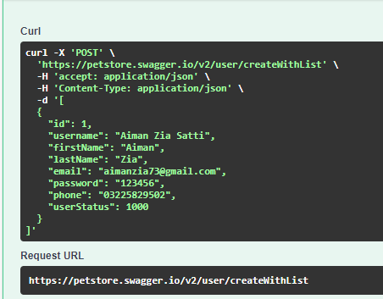 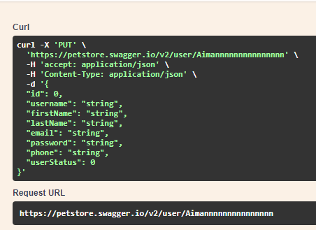

**TASK # 2:** Build a microservice for managing inventory and stock levels of products using ASP.NET.

**Model:**

namespace CC_LAB_9_Product.Model

{

public class Product

{

public int Id { get; set; }

public string Name { get; set; }

public string Description { get; set; }

public double Price { get; set; }

} }

**Controller:**

using CC_LAB_9_Product.Model;

using CC_LAB_9_Product.Repository;

using Microsoft.AspNetCore.Http;

using Microsoft.AspNetCore.Mvc;

using System.Transactions;

namespace CC_LAB_9_Product.Controllers

{

[Route("api/[controller]")]

[ApiController]

public class ProductController : ControllerBase

{

private readonly IProductRepository _productRepository;

public ProductController(IProductRepository productRepository)

{

_productRepository = productRepository;

}

[HttpGet]

public IActionResult Get()

{

var products = _productRepository.GetProducts();

return new OkObjectResult(products);

}

[HttpGet("{id}", Name = "Get")]

public IActionResult Get(int id)

{

var product = _productRepository.GetProductByID(id);

return new OkObjectResult(product);

}

[HttpPost]

public IActionResult Post([FromBody] Product product)

{

using (var scope = new TransactionScope())

{

_productRepository.InsertProduct(product); scope.Complete();

return CreatedAtAction(nameof(Get), new { id = product.Id },

product);

}

}

[HttpPut]

public IActionResult Put([FromBody] Product product)

{

if (product != null)

{

using (var scope = new TransactionScope())

{

_productRepository.UpdateProduct(product); scope.Complete();

return new OkResult();

}

}

return new NoContentResult();

}

[HttpDelete("{id}")]

public IActionResult Delete(int id)

{

_productRepository.DeleteProduct(id); return new OkResult();

}} }

**REPOSITORIES:**

using CC_LAB_9_Product.DbContexts;

using CC_LAB_9_Product.Model;

using Microsoft.EntityFrameworkCore;

namespace CC_LAB_9_Product.Repository

{

public class ProductRepository : IProductRepository

{

private readonly ProductContext _dbContext;

public ProductRepository(ProductContext dbContext)

{

_dbContext = dbContext;

}

public void DeleteProduct(int productId)

{

var product = _dbContext.Products.Find(productId);

_dbContext.Products.Remove(product);

Save();

}

public Product GetProductByID(int productId)

{

return _dbContext.Products.Find(productId);

}

public IEnumerable<Product> GetProducts()

{

return _dbContext.Products.ToList();

}

public void InsertProduct(Product product)

{

_dbContext.Add(product);

Save();

}

public void UpdateProduct(Product product)

{

_dbContext.Entry(product).State = EntityState.Modified;

Save();

}

public void Save()

{

_dbContext.SaveChanges();

}

public void save()

{

throw new NotImplementedException();

} } }

using CC_LAB_9_Product.Model;

namespace CC_LAB_9_Product.Repository

{

public interface IProductRepository

{

Product GetProductByID(int productid);

IEnumerable<Product> GetProducts();

void DeleteProduct(int productid);

void InsertProduct(Product product);

void UpdateProduct(Product product);

void save();

} }

**CONTROLLER:**

using CC_LAB_9_Product.Model;

using CC_LAB_9_Product.Repository;

using Microsoft.AspNetCore.Http;

using Microsoft.AspNetCore.Mvc;

using System.Transactions;

namespace CC_LAB_9_Product.Controllers

{

[Route("api/[controller]")]

[ApiController]

public class ProductController : ControllerBase

{

private readonly IProductRepository _productRepository;

public ProductController(IProductRepository productRepository)

{

_productRepository = productRepository;

}

[HttpGet]

public IActionResult Get()

{

var products = _productRepository.GetProducts();

return new OkObjectResult(products);

}

[HttpGet("{id}", Name = "Get")]

public IActionResult Get(int id)

{

var product = _productRepository.GetProductByID(id);

return new OkObjectResult(product);

}

[HttpPost]

public IActionResult Post([FromBody] Product product)

{

using (var scope = new TransactionScope())

{

_productRepository.InsertProduct(product); scope.Complete();

return CreatedAtAction(nameof(Get), new { id = product.Id },

product);

} }

[HttpPut]

public IActionResult Put([FromBody] Product product)

{

if (product != null)

{

using (var scope = new TransactionScope())

{

_productRepository.UpdateProduct(product); scope.Complete();

return new OkResult();

}}

return new NoContentResult();

}

[HttpDelete("{id}")]

public IActionResult Delete(int id)

{

_productRepository.DeleteProduct(id); return new OkResult();

} } }



