import pandas as pd

import ipywidgets as widgets

from IPython.display import display

books_df = pd.DataFrame(columns=['Title', 'Author', 'Genre', 'Year'])

members_df = pd.DataFrame(columns=['Name', 'Email', 'Contact', 'Membership_Status'])

def add_book(title, author, genre, year):

    global books_df

    new_book = pd.DataFrame({'Title': [title], 'Author': [author], 'Genre': [genre], 'Year': [year]})

    books_df = pd.concat([books_df, new_book], ignore_index=True)

def edit_book(index, title, author, genre, year):

    global books_df

    books_df.loc[index] = [title, author, genre, year]

def delete_book(index):

    global books_df

    books_df.drop(index, inplace=True)

def add_member(name, email, contact, membership_status):

    global members_df

    new_member = pd.DataFrame({'Name': [name], 'Email': [email], 'Contact': [contact], 'Membership_Status': [membership_status]})

    members_df = pd.concat([members_df, new_member], ignore_index=True)

def search_member(name):

    global members_df

    return members_df[members_df['Name'] == name]

def search_book(title):

    global books_df

    return books_df[books_df['Title'] == title]

def book_input_form():

    title = widgets.Text(description="Title:")

    author = widgets.Text(description="Author:")

    genre = widgets.Text(description="Genre:")

    year = widgets.IntText(description="Year:")

    display(title, author, genre, year)

    return title, author, genre, year

def member_input_form():

    name = widgets.Text(description="Name:")

    email = widgets.Text(description="Email:")

    contact = widgets.Text(description="Contact:")

    membership_status = widgets.Dropdown(description="Membership Status:", options=['Active', 'Inactive'])

    display(name, email, contact, membership_status)

    return name, email, contact, membership_status

def book_search_form():

    title = widgets.Text(description="Title:")

    display(title)

    return title

def member_search_form():

    name = widgets.Text(description="Name:")

    display(name)

    return name

def book_actions_form():

    action = widgets.Dropdown(description="Action:", options=['Edit', 'Delete'])

    display(action)

    return action

def member_actions_form():

    action = widgets.Dropdown(description="Action:", options=['Search'])

    display(action)

    return action

print("Add Book:")

title, author, genre, year = book_input_form()

add_book(title.value, author.value, genre.value, year.value)

print("Book added successfully.")

print("\nEdit or Delete Book:")

book_title = book_search_form()

book_action = book_actions_form()

if book_action.value == 'Edit':

    book_index = search_book(book_title.value).index[0]

    new_title, new_author, new_genre, new_year = book_input_form()

    edit_book(book_index, new_title.value, new_author.value, new_genre.value, new_year.value)

    print("Book edited successfully.")

elif book_action.value == 'Delete':

    book_index = search_book(book_title.value).index[0]

    delete_book(book_index)

    print("Book deleted successfully.")

print("\nAdd Member:")

name, email, contact, membership_status = member_input_form()

add_member(name.value, email.value, contact.value, membership_status.value)

print("Member added successfully.")

print("\nSearch Member:")

member_name = member_search_form()

search_result = search_member(member_name.value)

print("Search Result:")

print(search_result)

print("\nSearch Book:")

book_title = book_search_form()

search_result = search_book(book_title.value)

print("Search Result:")

print(search_result)

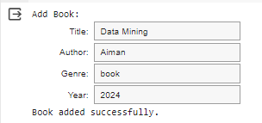

TASK 2: You work for an e-commerce company and have been given a dataset with information on customer orders over the past year. Load the data into Pandas, analyze it using methods like .info(), .describe(), Which products have the highest/lowest sales? Which customer segments spend the most?

import pandas as pd

df = pd.read_csv("Pakistan Largest Ecommerce Dataset.csv")

print("Dataset Information:") print(df.info())

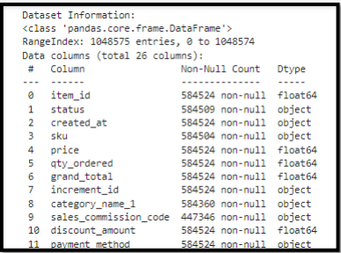

print("\nSummary Statistics:")

print(df.describe())

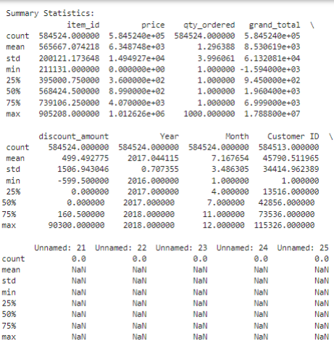

product_sales = df.groupby('Product')['Quantity'].sum().sort_values(ascending=False) highest_sales_product = product_sales.idxmax()

lowest_sales_product =product_sales.idxmin()

print("\nProduct with the Highest Sales:", highest_sales_product)

print("Product with the Lowest Sales:", lowest_sales_product)

customer_segment_spending = df.groupby('Customer_Segment')['Sales'].sum().sort_values(ascending=Fal se) most_spending_segment = customer_segment_spending.idxmax()

print("\nCustomer Segment with the Highest Spending:", most_spending_segment)

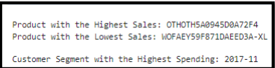

TASK 3: You are a data analyst at a real estate company. You have been given a dataset of housing sale prices in different regions over the past 5 years. Load the data into Pandas and preprocess it by handling missing values and formatting columns.

import pandas as pd df = pd.read_csv('RealEstateAU_1000_Samples.csv')

print("Dataset Information:") print(df.info())

print("\nSummary Statistics:")

print(df.describe())

df.dropna(inplace=True)

df['sale_price'] = pd.to_numeric(df['sale_price'].str.replace('$', '').str.replace(',', '')) print("\nPreprocessed DataFrame:")

print(df.head())

**TASK 4:** You are a data analyst working for an automobile company. You have been provided with the Vega dataset which contains details on different vehicle models like price, engine size, horsepower, dimensions etc.

import pandas as pd

import matplotlib.pyplot as plt

import seaborn as sns

from vega_datasets

import data df = data.cars()

print(df.head())

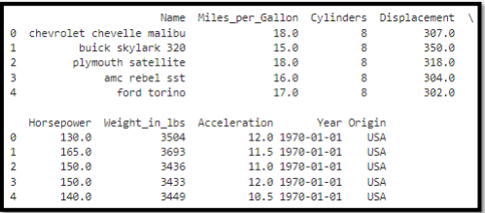

plt.figure(figsize=(10, 6))

sns.scatterplot(x='Displacement', y='Horsepower', data=df) plt.title('Scatterplot of Engine Size vs. Horsepower')

plt.xlabel('Engine Size')

plt.ylabel('Horsepower')

plt.show()

plt.figure(figsize=(10, 6))

sns.histplot(df['Weight_in_lbs'], bins=20, kde=True) plt.title('Histogram of Weight_in_lbs Distribution')

plt.xlabel('Weight in lbs')

plt.ylabel('Frequency')

plt.show()

body_style_stats = df.groupby('Origin').agg({'Miles_per_Gallon': 'mean', 'Acceleration': 'mean'}).reset_index() alt.Chart(body_style_stats).mark_bar().encode( x='Origin', y='Miles_per_Gallon', color=alt.Color('Origin', legend=None), tooltip=['Origin', 'Miles_per_Gallon'] ).properties( title='Average Miles_per_Gallon by Origin' ).interactive() alt.Chart(body_style_stats).mark_bar().encode( x='Origin', y='Acceleration', color=alt.Color('Origin', legend=None), tooltip=['Origin', 'Acceleration'] ).properties( title='Average Acceleration by Origin' ).interactive()