Attack 1: SQL injection, so that to get logged in without any real password.
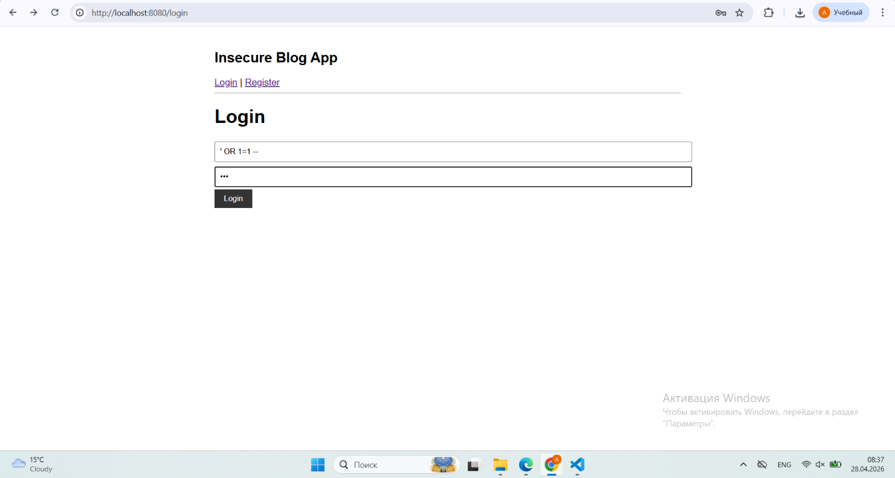
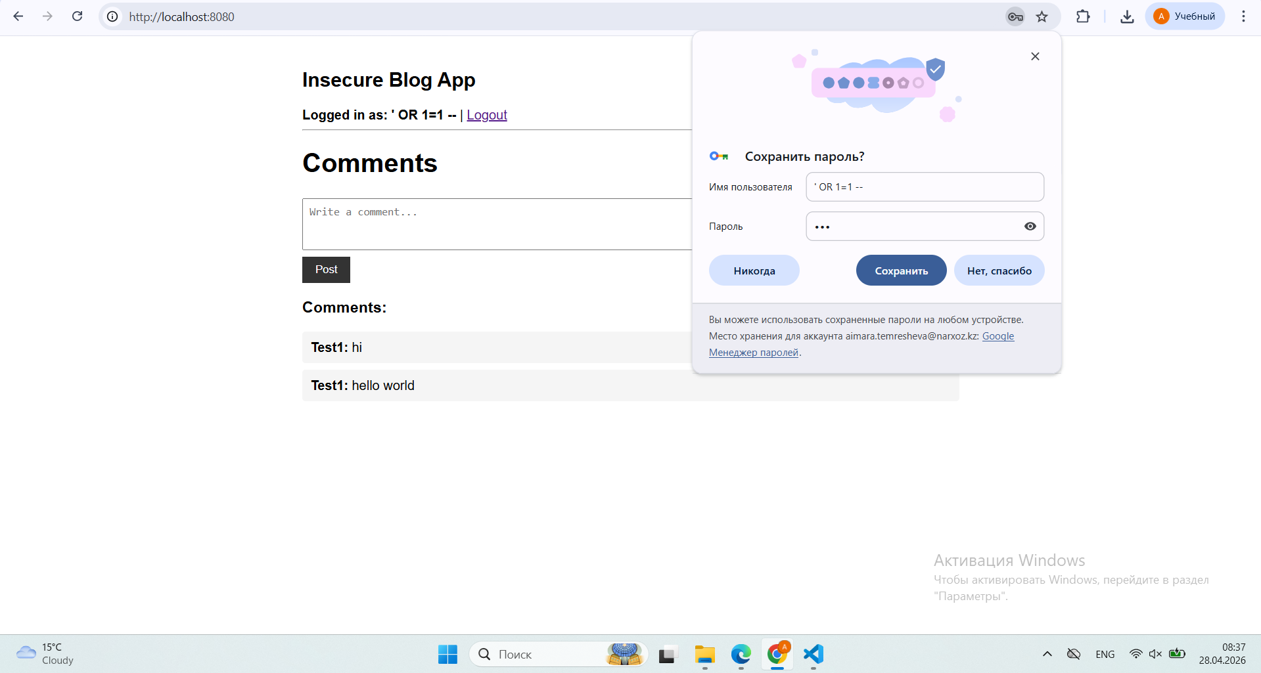
Works easily on an insecure app, because SQL query becomes: SELECT * FROM users WHERE username='' OR 1=1 --' AND password='...' ;
the login query is built by gluing user input directly into the SQL string: query = f"SELECT * FROM users WHERE username='{username}' AND password='...'" ; When you type ' OR 1=1 -- as the username, the quote character breaks out of the string and becomes part of the SQL logic itself. The database executes a completely different query than intended.
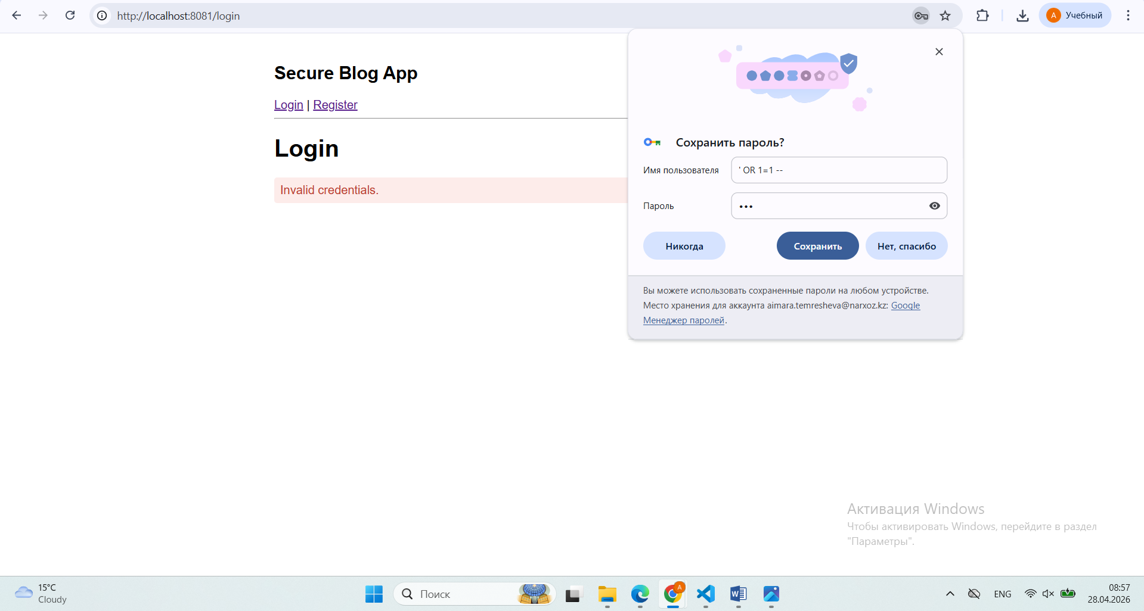

Secure - parameterized queries send the SQL structure and the data separately:
c.execute("SELECT password_hash FROM users WHERE username = ?", (username,))
The ? placeholder tells the database "this is data, not code." No matter what the user types, it can never alter the query structure. ' OR 1=1 -- is treated as a literal string to search for, no user is found - login fails.
Attack 2: xss cross site scripting.
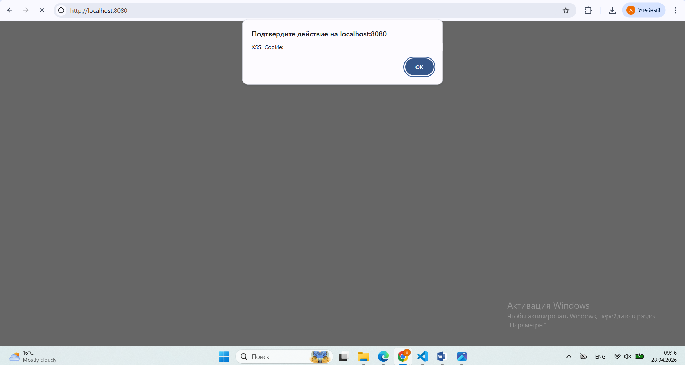
Insecure - comment content is inserted directly into the HTML page:
comments_html += f'<div>{username}: {content}</div>'
The browser receives actual <script> tags and executes them as JavaScript code.

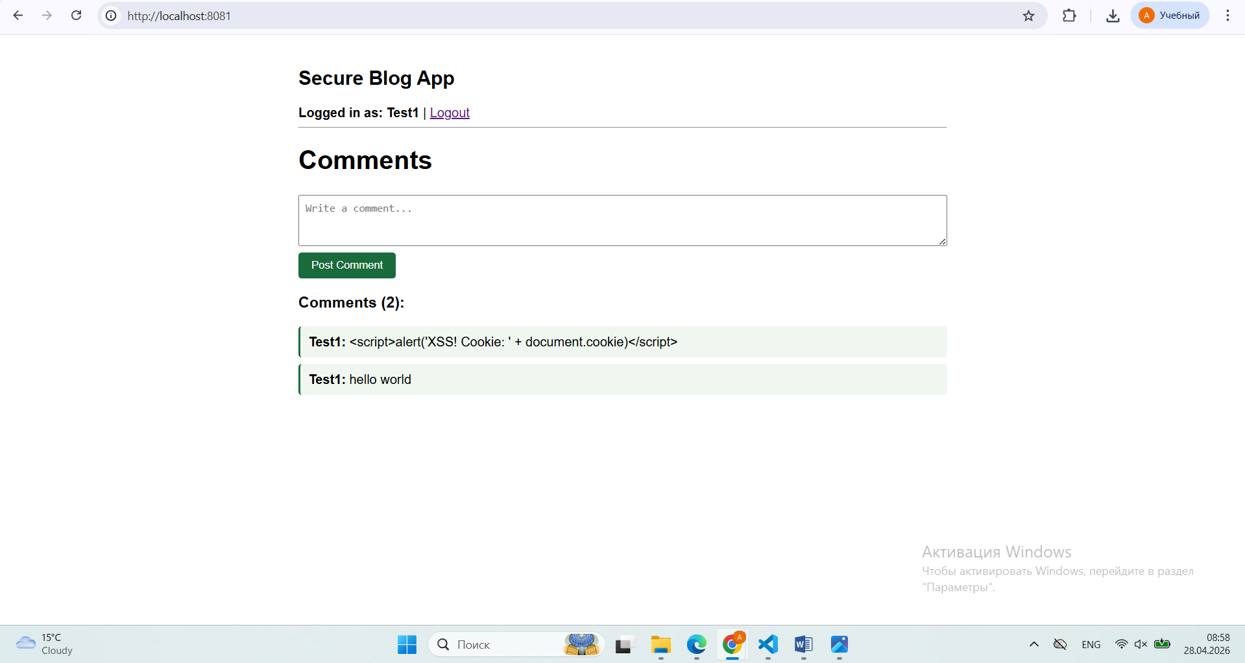
Secure - all user content is escaped before being put into HTML:
safe_content = html.escape(content)
html.escape() converts < to &lt; and > to &gt;. The browser displays them as visible text characters, never as executable code.
Attack 3: Weak password hashing.
Insecure - passwords are hashed with MD5, which is fast and has no salt:
hashlib.md5(password.encode()).hexdigest()
Because MD5 is fast, attackers have pre-computed billions of password→hash pairs into rainbow tables. Your hash is looked up and reversed in seconds.
Secure - bcrypt automatically adds a unique random salt and uses a slow algorithm:
bcrypt.hashpw(password.encode(), bcrypt.gensalt())
The salt means the same password produces a different hash every time — rainbow tables are useless. The slowness means brute forcing takes years instead of seconds.
Attack 4: vulnerable cookie session id.
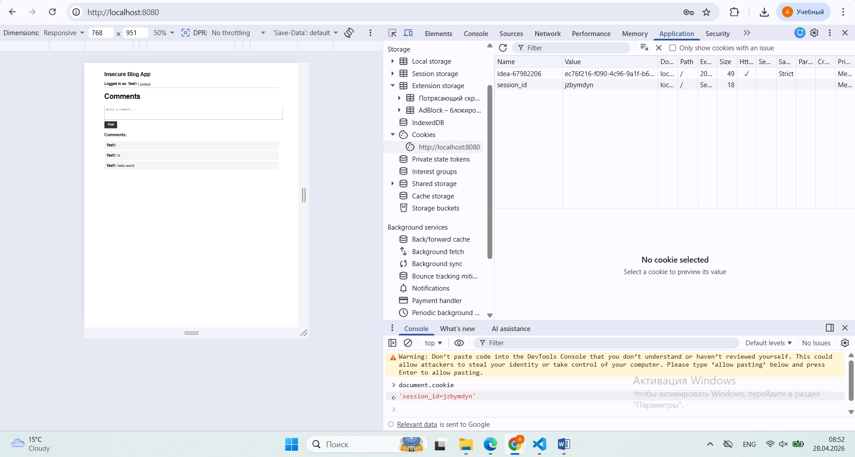
In the insecure app we can see vulnerable data about cookies session id. An attacker can also steal the session via XSS since the cookie has no protection flags. JavaScript can read it, CSRF attacks are possible, and the browser has no instructions to block unsafe behavior.
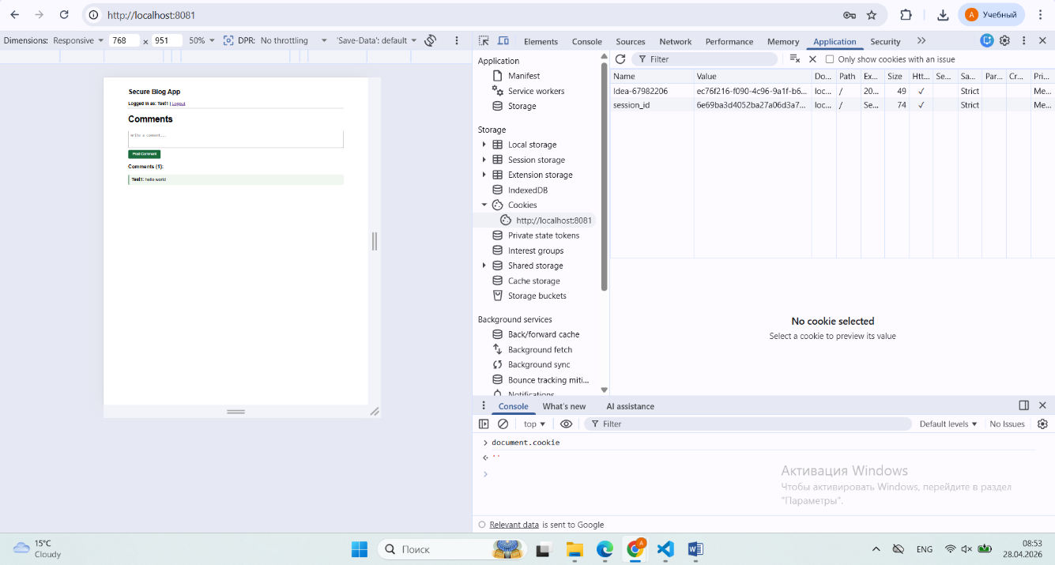
In the secure app cookie has protective flags, and every response includes security headers. Session id is produced by: secrets.token_hex(32) # generates 64 random hex characters.

