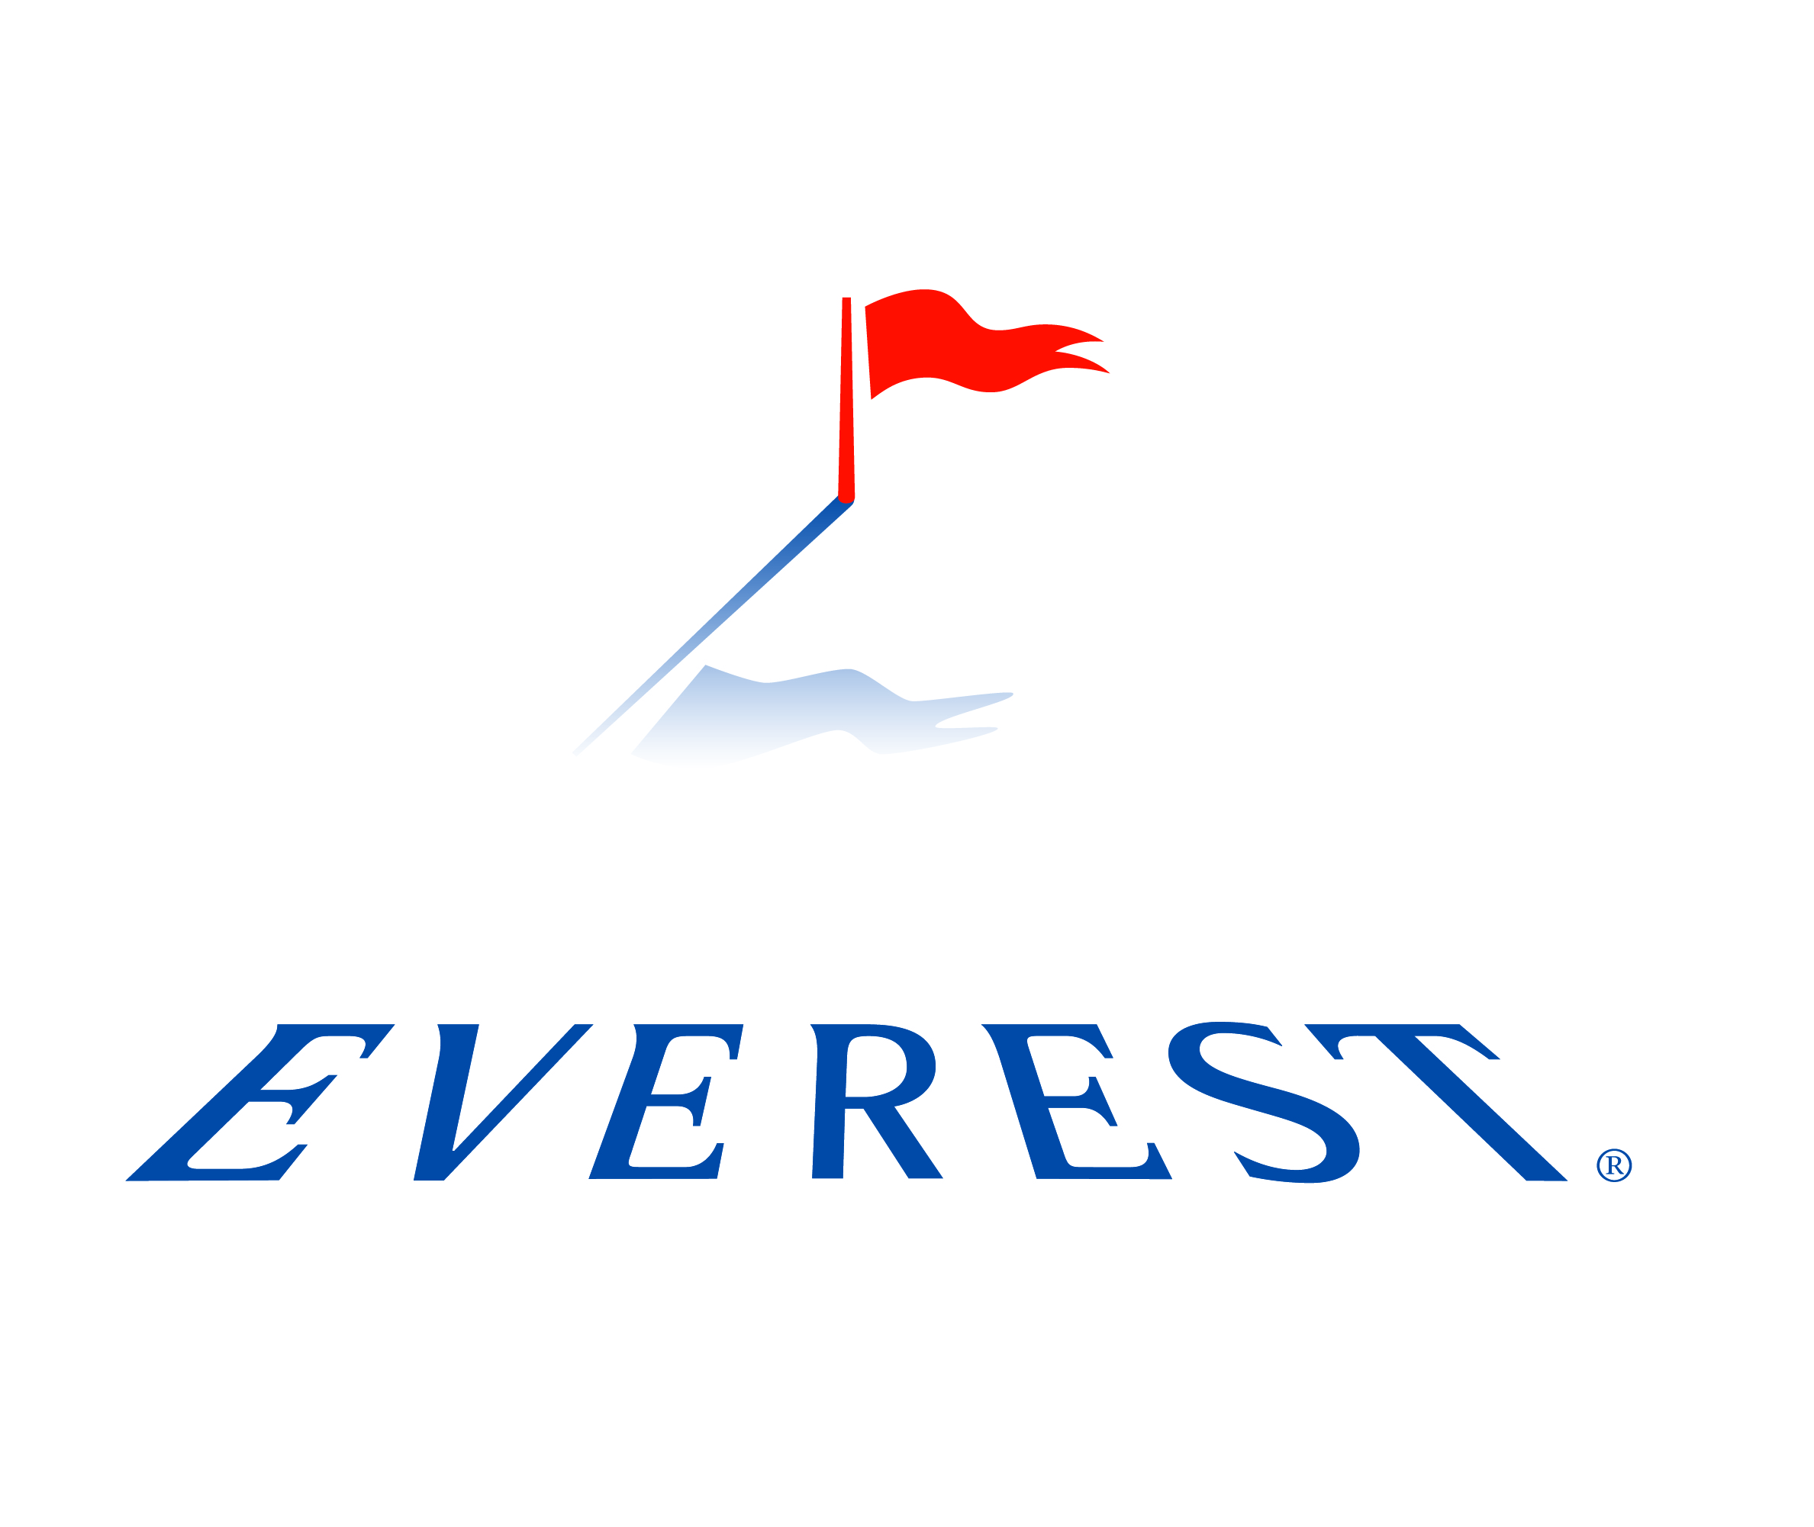
EVEREST HIRED AND NON-OWNED AUTO
SUPPLEMENTAL APPLICATION

Insured: |  | Eff. Date:

NON-OWNED:

- How many employees (full-time, part-time, occasional) regularly use their own vehicles on company business?

- How often do employees use personal vehicles for company business?

- Does the insured have a formal written policy on personal usage that addresses acceptable business use of personal vehicles? Yes No
Do employees sign in acknowledgement of this policy? Yes No

- What types of vehicles are used and what are their gross vehicle weights? For what purpose?

- Do employees transport clients in their own vehicles? Yes No
If so, for what reason?

- Is non-owned auto mileage incurred by employees reimbursed by the insured? Yes No
If yes, what is the percentage of employees who were reimbursed last year? ____%
What was the total mileage reimbursed for the last fiscal year? miles

- Do only pre-qualified drivers use personal cars on company business? Yes No
Pre-qualification includes:
- Confirmation that the driver has a valid driver’s license from their state of residence
- MVRs should be obtained initially and annually thereafter for each driver
- MVR should be compared against the company’s established criteria to assess driving eligibility

- Does the insured have policies in place that outline their expectations for safe driving practices? Yes No
Policies should address issues such as:
- Following all traffic laws
- Following company policy on distracted driving
- Seatbelt use
- Proper maintenance of their vehicles

- Are vehicle maintenance standards in place for personal vehicles used for business? Yes No
The vehicles must be maintained in safe condition according to the operator’s manual and pass required state and/or company required inspections. The vehicle must be registered in the name of the employee.

- Does the insured establish minimum insurance limits for employee’s personal auto insurance? Yes No
What are these limits?
How do they verify this? None Certificates of Insurance Copy of auto ID card
Copy of auto policy Other:

- Are drivers who use their own vehicles for company business required to follow the company fleet safety program including required driver safety training? Yes No

HIRED:

- Are vehicles (cars, trucks, tractors) hired or borrowed each year? Yes No

If so, how many? ________

- What are the hired or borrowed vehicles used for?

- How many days are the vehicles rented for? ________ rental days/per year

- What is the average length of time these vehicles are hired or borrowed? ________ days

- What is the total annual cost for all hired and borrowed vehicles? $ in the full year

- What is the average cost per rental (by types of vehicle):
Van: $
Light Truck: $
PPT: $
Heavy Truck: $

- Does the insured rent any vehicles that are over 10,000 gross vehicle weight? Yes No
If so, for what reason?

- In what states does the insured hire or borrow vehicles?

Previous hired and non-owned auto liability coverage:
Insurance company:
Policy Number:
Limits of Liability:
Deductible:
Policy Period:
Premium:

The undersigned is an authorized representative of the applicant and certifies that reasonable enquiry has been made to obtain the answers to the questions on this supplemental application. He/She certifies that the answers are true, correct and complete to the best of his/her knowledge. He/She certifies that the applicable fraud notices herein have been read and understood. He/She acknowledges their continuation under the applicable state insurance fraud acts and certifies that all such information provided herein complies with such acts in disclosure and truthfulness.

The undersigned as an authorized representative of the applicant, agrees to conduct electronic commerce and to accept an electronic insurance policy and other documents issued by Everest. You may always request a written policy.

Completed by (Signature and Title of Applicant): __________________________________________

Date: ________________________

