Project 1

Aimee Orozco-Perez

C++ Summer 2014

46023

Table of Contents

|  |  |
| --- | --- |
| Introduction | 3 |
| Design Details | 3 |
| Variable List | 4 |
| Topics Covered | 4 |
| Flowchart | 5 |
| Code | 6 |
|  |  |
|  |  |
|  |  |
|  |  |
|  |  |
|  |  |
|  |  |

Introduction

Most people know how to play at least one card game; it is an activity done to pass the time or interact with others. Blackjack, or 21, is one such card game, usually seen in casinos. I have done a very simplified version of this game where the main goal is kept the same: reach closest to 21 without going over. First the program deals out two cards to the player which are both visible, and two cards for itself, one of which is hidden. The player must then decide if they want to hit, meaning take another card, or stay where they are and risk the dealer, aka the program, reaching a higher number than them. From here, it is based on chance and whether the next card will send them over or closer to their goal.

Design Details

1. My original plan was more complicated than the final design however knowledge and time constraints proved to be restricting. In the original card game, a player is allowed to place a bet, however including this game option would include more variables and complicated the game further. I left that detail out so that I could focus on game itself. The game is played with only one stack of 52 cards, meaning there is a certain number of times one card can appear. I did not put in a limit like this to the game, so it is possible that one card can show up more than four times. In addition, the ace is a card variable that was not included as well. In the game, you can choose to make this card value at 11 or at 1. In my program the values are assigned so the player cannot choose. It’s a very simple game with only the values of the cards included.
2. As can be seen in the code, there are many if statements that need to be accounted for, as there are many different possibilities for the game to go. It is based around the cards and what the player wants to do. I was going to make the game more interactive but keeping track of the statements and different outcomes took a lot of the code. The if statements then began to overlap with each other and would sometimes give the wrong answer.
3. For the next project, I will expand more on my idea as my knowledge by then will have grown. I will attempt to include the ace variable and limit the card choice to those in a 52 stack. Also I will try to make it so that not just the value of the cards comes up but also the names such as jack, queen and king. Those were not included here and they increase the chance of the value 10 being pulled out. Though there are problems, the main objective of the game has not changed and there will be improvements in the second model.

Variable list

1. Letters a-h: these are the different variables chosen for the different numbers generated from the random number seed. The variables cannot have the same name as that would make it confusing to which card belongs to which player.
2. Choice: this is the variable name chosen for the choice the player makes on whether or not to take another card.
3. Seed: this is the random number generator with the limits of higher than zero, but less than 11.

Topics Covered

* Data types: int, short
* System Level Libraries: cstdlib, iostream, iomanip, cmath
* Operators: &&, ||, >=, <=, !=, ==
* Conditionals: if/else, switch statements, do/while
* Menu: allow the user to choose an option

FlowChart

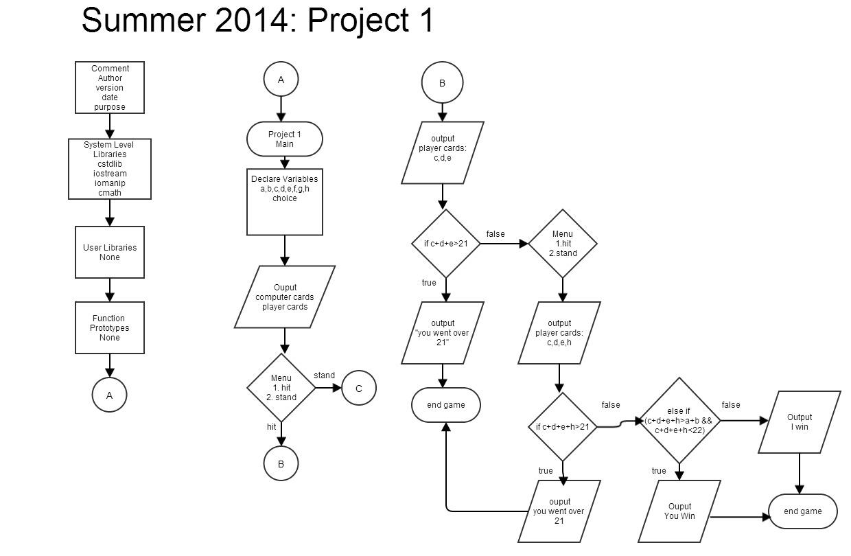

Code

/*

* File: main.cpp

* Author: Aimee Orozco-Perez

* Created on July 9, 2014, 11:24 AM

* Purpose: Project One

*/

#include <cstdlib>

#include <iostream>

#include <iomanip>

#include <cmath>

using namespace std;

//User Libraries

//Global Constants

//Function Prototypes

//Execution Begins Here

int main(int argc, char** argv) {

unsigned short a, b, c, d, e, f, g, h;//1-10 the cards of face value

unsigned int choice=0;//yes or no variable

unsigned seed=time(0);

srand(seed);

a=1+rand()%9+1;

b=1+rand()%9+1;

c=1+rand()%9+1;

d=1+rand()%9+1;

e=1+rand()%9+1;

f=1+rand()%9+1;

g=1+rand()%9+1;

h=1+rand()%9+1;

cout<<"Computer Cards: "<<a<<endl;

cout<<"Player Cards: "<<c<<" "<<d<<endl;

cout<<"Hit? \n 1.Yes \n 2.No"<<endl;

cin>>choice;

switch (choice)

{

case 1:

{

cout<<"Player cards: \n"<<c

<<" "<<d<<" "<<e<<endl;

cout<<"Computer Cards: "<<a<<endl;

if (c+d+e>21)

{

cout<<"You went over 21. You lose.\n";

}

else

{

cout<<"Player Cards: "<<c<<" "<<d<<" "<<e<<endl;

cout<<"Hit? \n 1.Yes \n 2.No"<<endl;

cin>>choice;

switch (choice)

{

case 1:

{

cout<<"Player cards: \n"<<c

<<" "<<d<<" "<<e<<" "<<h<<endl;

if (c+d+e+h>21)

{

cout<<"You went over 21. You lose.\n";

return 0;

}

else if (c+d+e+h>a+b && c+d+e+h<22)

{

cout<<"You Win!\n";

}

else if (a+b>c+d+e+h && a+b<22)

{

cout<<"I win\n";

}

break;

}

default:

{

cout<<"player cards: \n"<<c

<<" "<<d<<" "<<e<<endl;

break;

}

}

}

break;

}

case 2:

{

cout<<"player cards: \n"<<c

<<" "<<d<<endl;

break;

}

if (a+b<=15)

{

a+b+f;

if (a+b+f<=15)

{

a+b+f+g;

if (a+b==21)

{

cout<<"Computer cards: "<<a<<" "<<b<<endl;

cout<<"I win."<<endl;

}

else if (a+b+f==21)

{

cout<<"Computer cards: "<<a<<" "<<b<<" "<<f<<endl;

cout<<"I win."<<endl;

}

else if (a+b+f+g==21)

{

cout<<"Computer cards: "<<a<<" "<<b<<" "<<f<<" "<<g<<endl;

cout<<"I win."<<endl;

}

else if(c+d==21 || c+d+e==21)

{

cout<<"Computer cards: "<<a<<" "<<b<<endl;

cout<<"You Win."<<endl;

}

else if (c+d>a+b+f && c+d<=21)//

{

cout<<"Computer cards: "<<a<<" "<<b<<" "<<f<<endl;

cout<<"You win"<<endl;

}

else if (c+d>a+b+f+g && c+d<=21)

{

cout<<"Computer cards: "<<a<<" "<<b<<" "<<f<<endl;

cout<<"You win"<<endl;

}

else if (c+d<a+b && a+b<=21)//duplicated

{

cout<<"Computer cards: "<<a<<" "<<b<<endl;

cout<<"I win"<<endl;

}

else if (a+b+f>c+d && a+b+f<=21)

{

cout<<"Computer cards: "<<a<<" "<<b<<" "<<f<<endl;

cout<<"I win"<<endl;

}

else if (a+b+f+g>c+d && a+b+f+g<=21)

{

cout<<"Computer cards: "<<a<<" "<<b<<" "<<f<<" "<<g<<endl;

cout<<"I win"<<endl;

}

else if (c+d>a+b && c+d<=21)//duplicated

{

cout<<"Computer cards: "<<a<<" "<<b<<endl;

cout<<"You win"<<endl;

}

else if (c+d+e>a+b && c+d+e<=21)//duplicated

{

cout<<"Computer cards: "<<a<<" "<<b<<endl;

cout<<"You Win"<<endl;

}

else if (c+d+e>a+b+f+g && c+d+e<=21)

{

cout<<"Computer cards: "<<a<<" "<<b<<" "<<f<<" "<<g<<endl;

cout<<"You Win"<<endl;

}

else if (c+d+e>a+b+f && c+d+e<=21)

{

cout<<"Computer cards: "<<a<<" "<<b<<" "<<f<<endl;

cout<<"You Win"<<endl;

}

else if (c+d+e>21)

{

cout<<"You scored higher than 21. You lose."<<endl;

}

else if (a+b==c+d+e || a+b==c+d)//duplicate

{

cout<<"Computer cards: "<<a<<" "<<b<<endl;

cout<<"It's a draw."<<endl;

}

else if (a+b+f==c+d+e || a+b+f==c+d)

{

cout<<"Computer cards: "<<a<<" "<<b<<" "<<f<<endl;

cout<<"It's a draw."<<endl;

}

else if (a+b+f+g==c+d+e || a+b+f+g==c+d)

{

cout<<"Computer cards: "<<a<<" "<<b<<" "<<f<<" "<<g<<endl;

cout<<"It's a draw."<<endl;

}

}

}

}

return 0;

}